FixMyHostel - Complete Documentation
1. Main Login Page
The login page allows all users to access the system and redirects them based on roles.
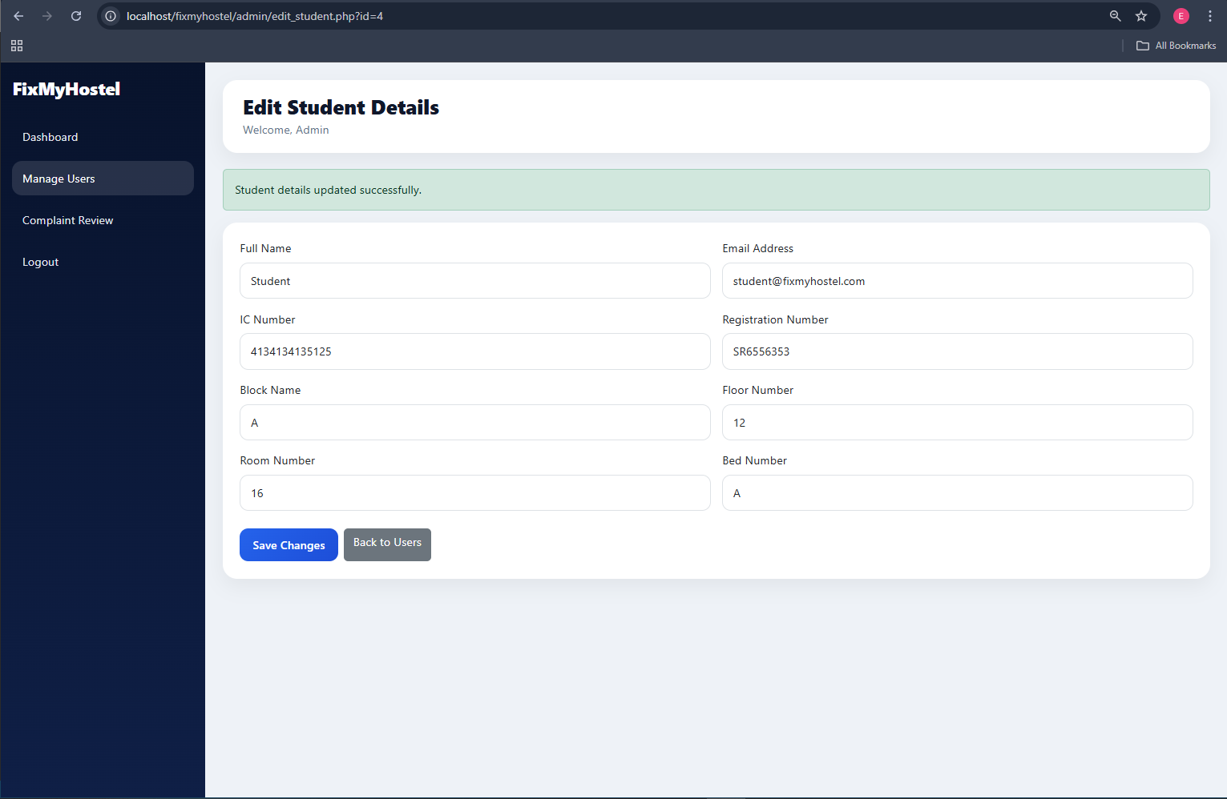
Figure 1: 1. Main Login Page
2. Student Dashboard
Displays complaint statistics and overview of submitted complaints.
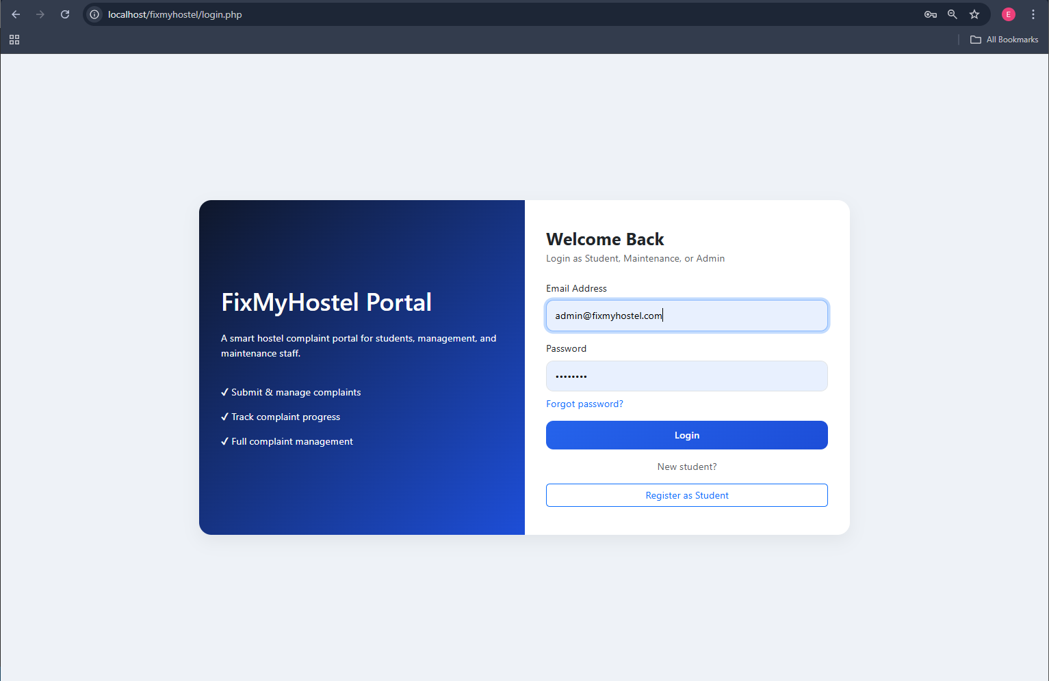
Figure 2: 2. Student Dashboard
3. Submit Complaint
Students can submit complaints with title, category, priority and description.
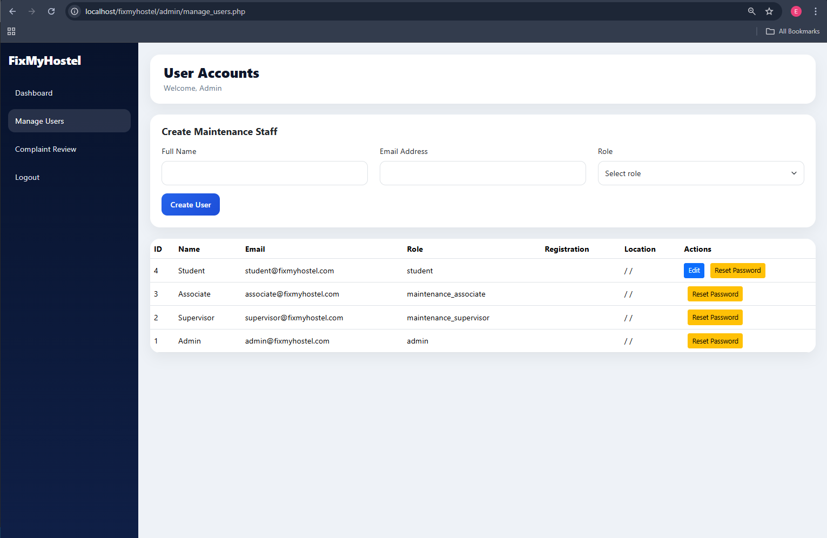
Figure 3: 3. Submit Complaint
4. Track Complaints
Students can track, edit or delete pending complaints.
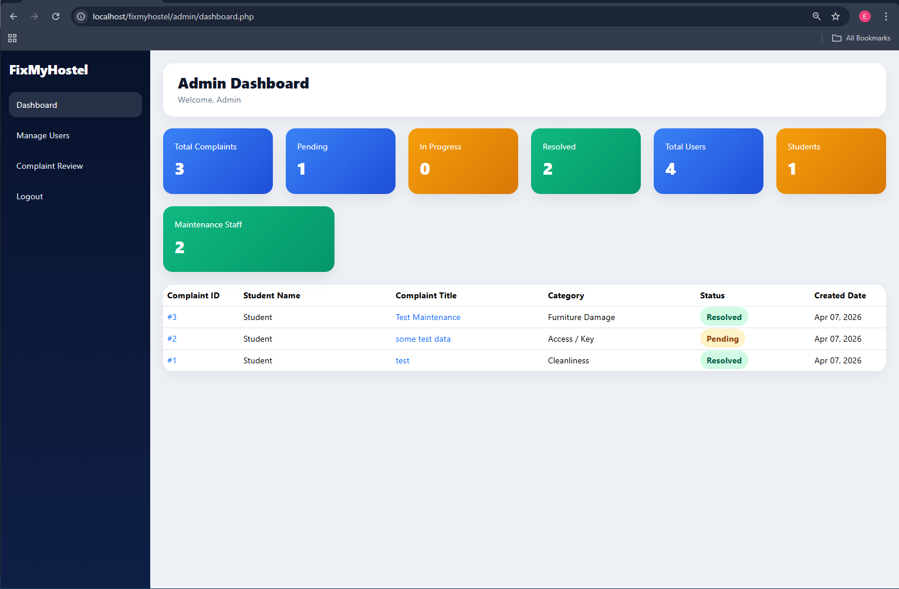
Figure 4: 4. Track Complaints
5. Maintenance Dashboard
Shows all complaints assigned to maintenance staff.
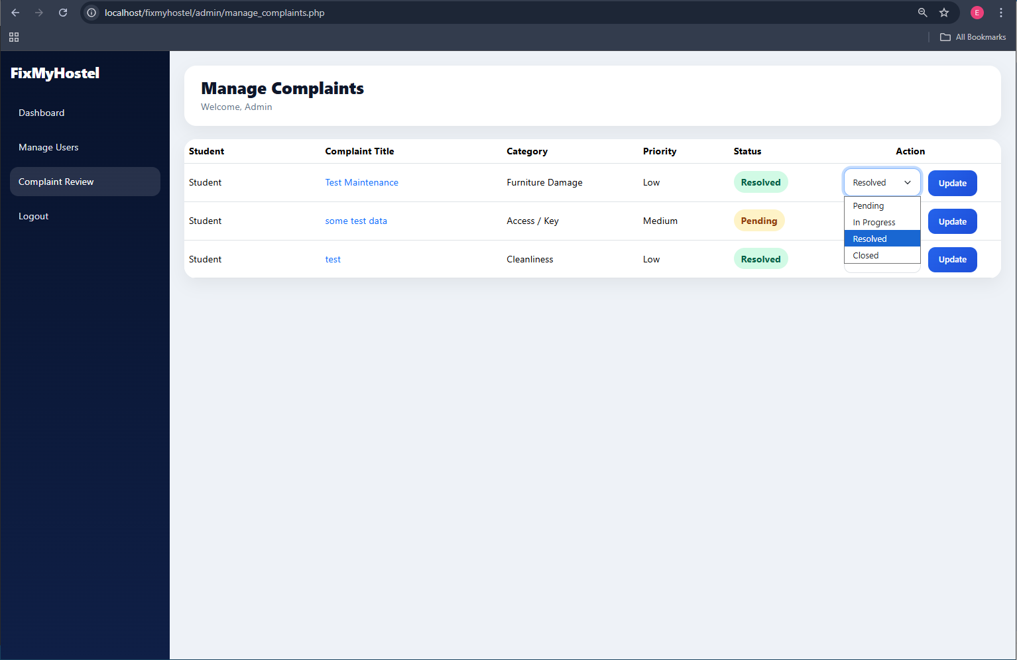
Figure 5: 5. Maintenance Dashboard
6. Pick Up Complaint
Associates can pick complaints and mark them as in progress.
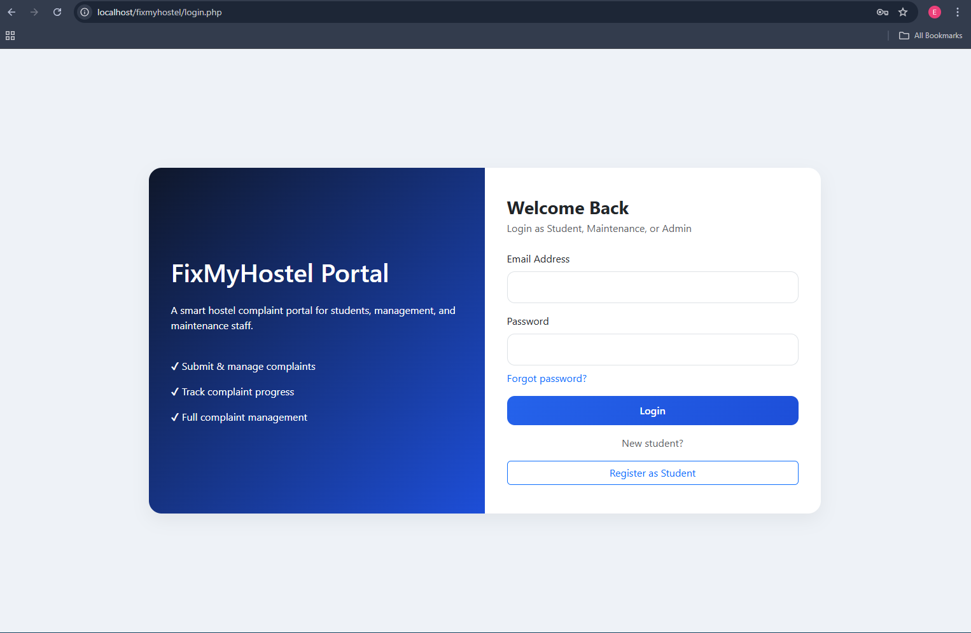
Figure 6: 6. Pick Up Complaint
7. Supervisor Dashboard
Supervisors monitor and validate complaints.
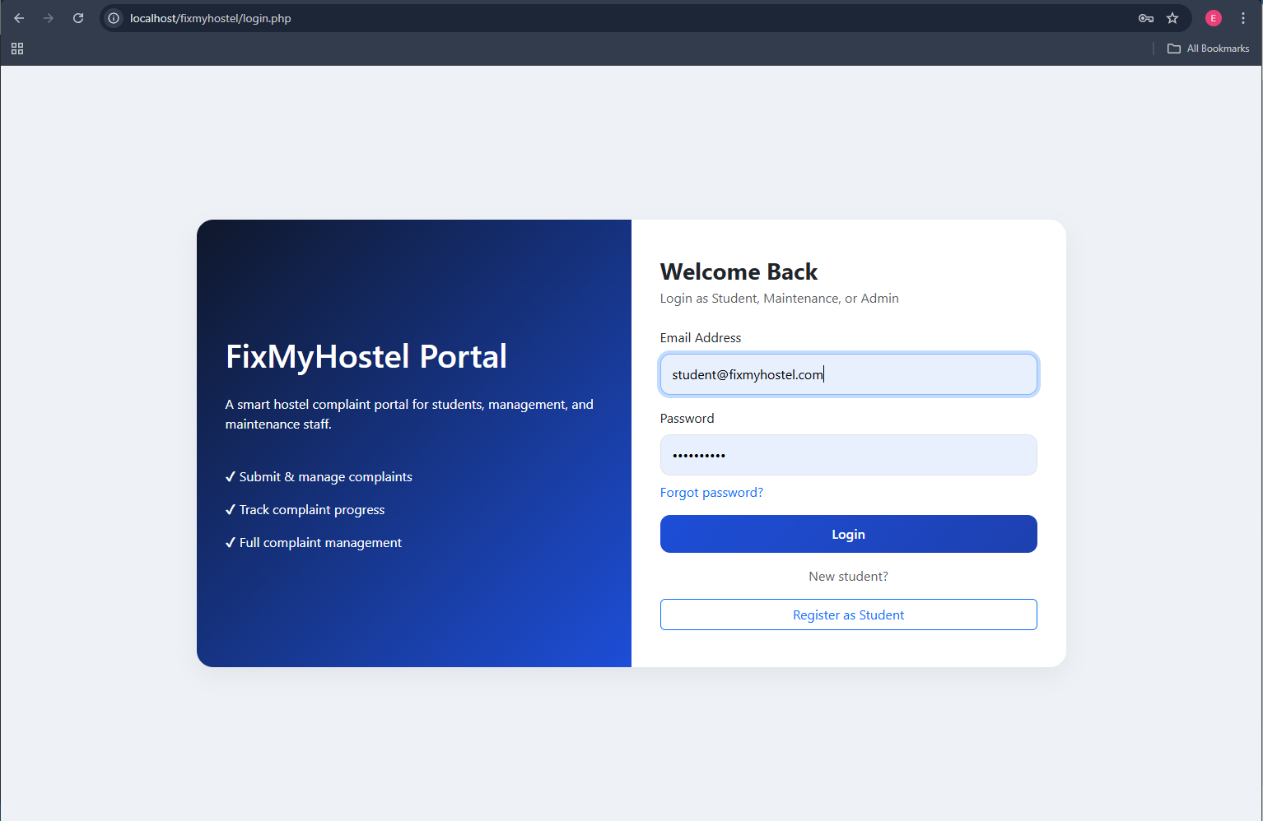
Figure 7: 7. Supervisor Dashboard
8. Resolve Complaint
Supervisors mark complaints as resolved after verification.
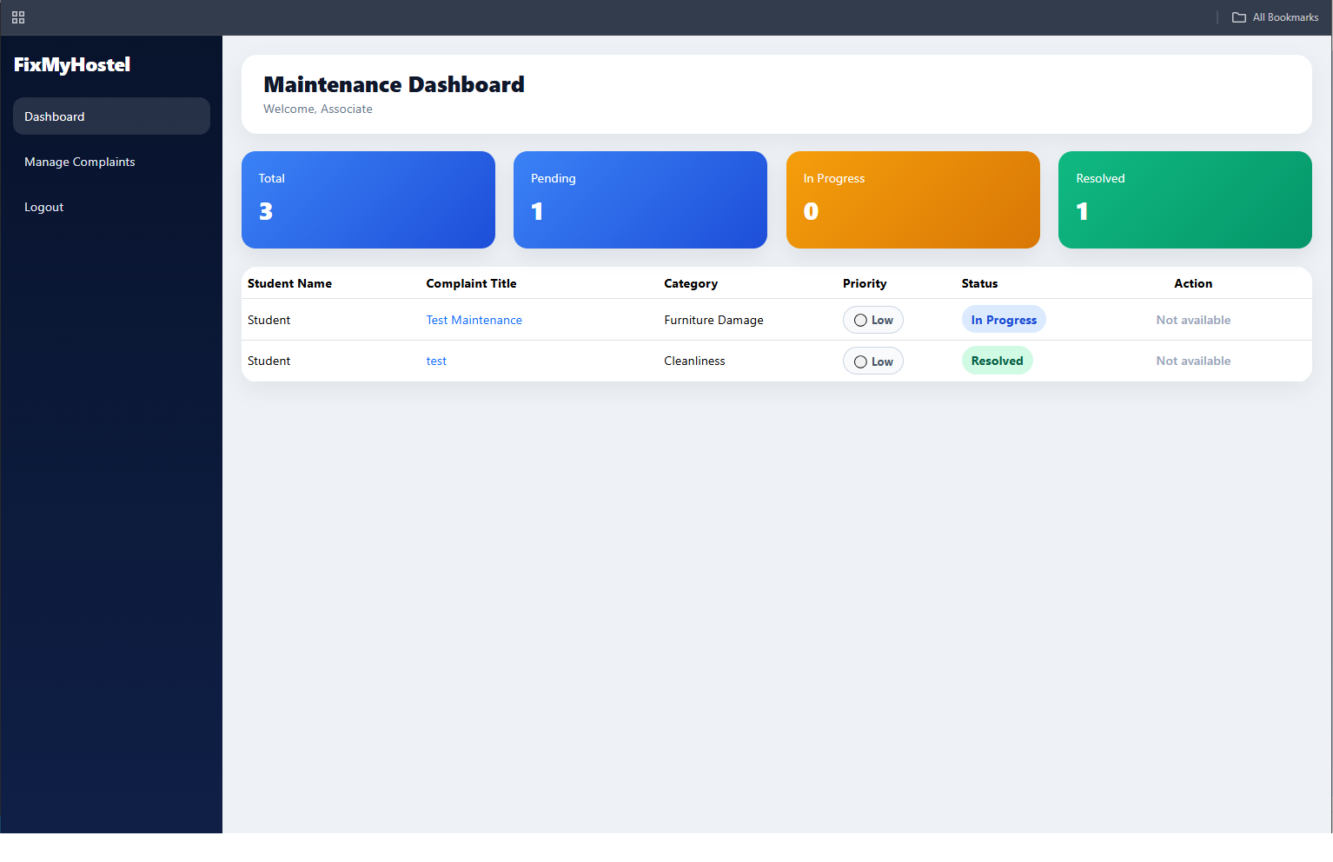
Figure 8: 8. Resolve Complaint
9. Admin Dashboard
Provides full system overview and statistics.
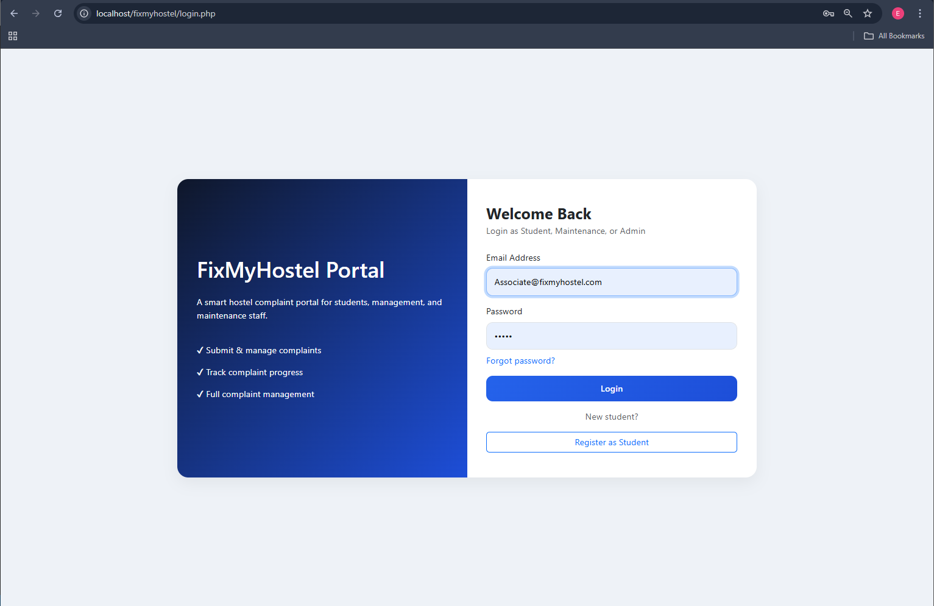
Figure 9: 9. Admin Dashboard
10. Manage Users
Admins can edit users and manage access.
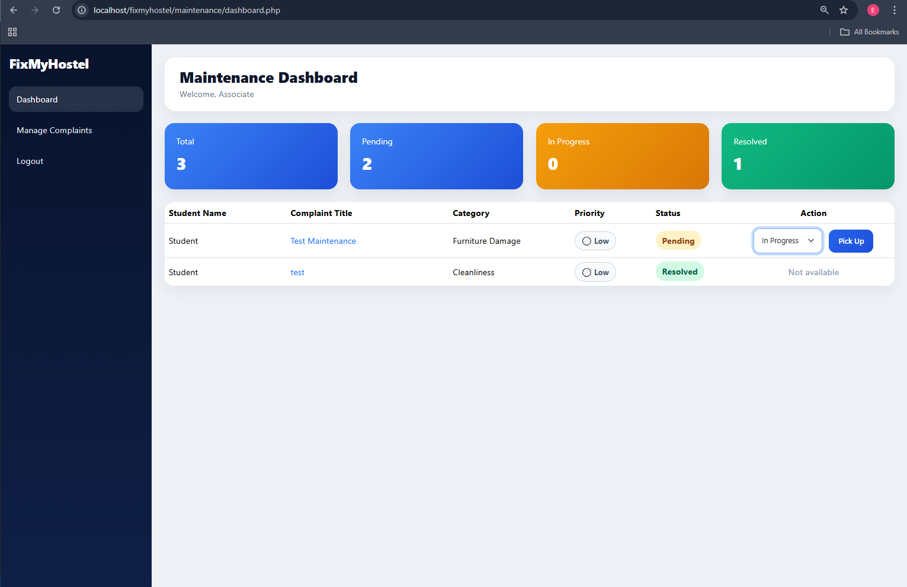
Figure 10: 10. Manage Users

