**Postman sprint**

# User Case Procedure Sprint

## Command

## Chart

### Sprint 1

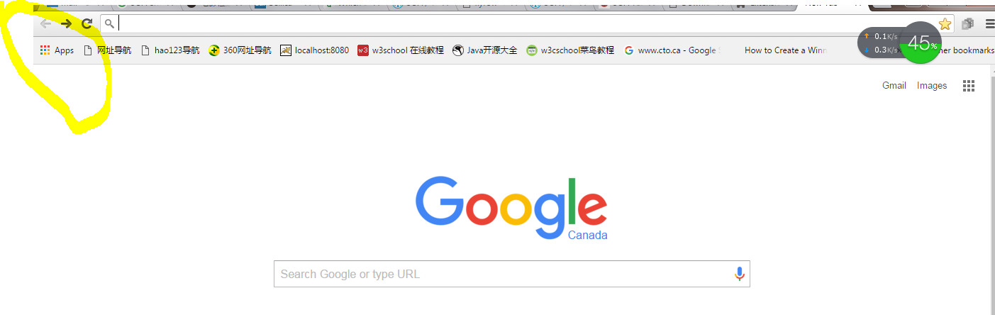

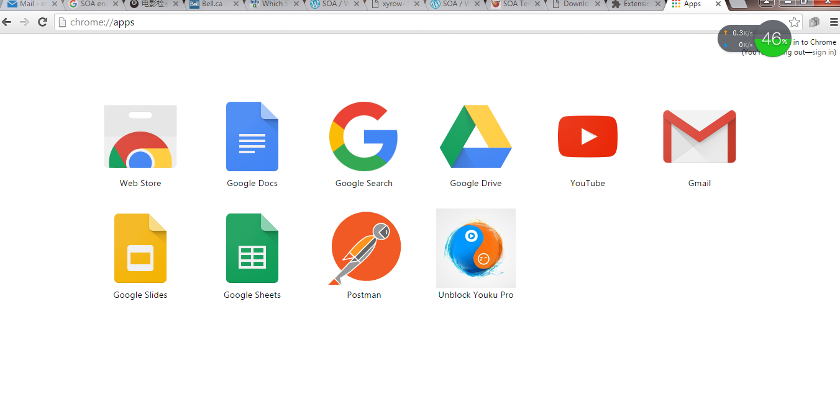

## 

### Sprint 2

# MyActivitis:

# Diagram

# All excerpt