Audio Player
Design and Implementation of a Touch-Controlled Audio Player Based on STM32F469 and TouchGFX

Abstract
This paper presents an embedded audio player implemented on the STM32F469I-DISCO development board. The system integrates SD card storage, the CS43L22 audio DAC, a TouchGFX touch interface, FATFS file management, and DMA-based audio streaming. It supports WAV playback, touch-based playback control, playlist navigation, volume adjustment, and real-time display of playback information. The project demonstrates practical skills in hardware interface configuration, embedded software architecture, multimedia data processing, and systematic debugging.
Keywords: STM32F469; TouchGFX; WAV audio; DMA; FATFS; embedded systems

1. Project Overview
The project is an embedded audio player running on the STM32F469I-DISCO development board. It completes the full path from reading WAV files on an SD card to audio output, touch interaction, and playback control, demonstrating integrated hardware-software development and engineering troubleshooting.
Hardware platform | STM32F469I-DISCO, CS43L22 audio DAC, MicroSD card, and 800 × 480 touch display
Software stack | STM32 HAL, FATFS, TouchGFX 4.21.1, C/C++
Audio capability | WAV format; 44.1 kHz / 48 kHz; 16-bit stereo; continuous playback
Interaction | Play, pause, stop, previous, next, volume control, song information, and progress display

2. User Interface and Functions
The TouchGFX interface places playback controls and runtime information on one screen. The playlist, current song, sampling rate, file size, playback progress, volume slider, and play, pause, track-switching, and mute buttons can all be operated through touch input.
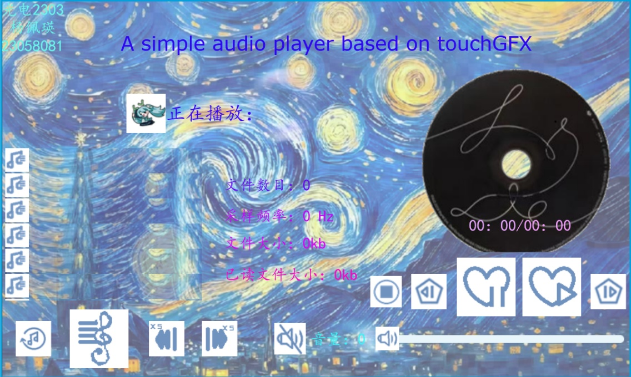
Figure 1. TouchGFX touch-controlled audio player interface

3. System Architecture and Audio Path
The system adopts a layered modular architecture. The hardware layer handles the clock, GPIO, SDIO, I2C, SAI, and DMA peripherals. The middleware layer provides FATFS, FreeRTOS, and TouchGFX. The application layer implements file management, the playback state machine, and interface logic.
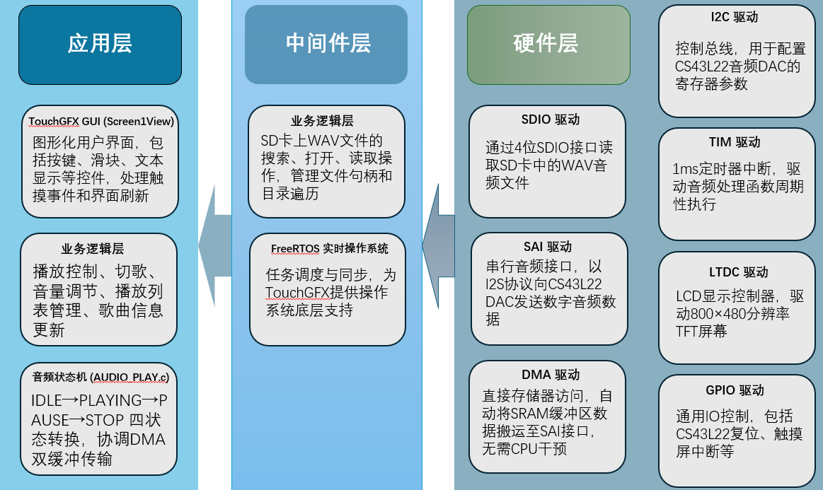
Figure 2. Relationship between software layers and hardware drivers

3.1 Audio Data Path
The complete audio data path is:
SD card WAV file → SDIO + FATFS → SRAM double buffer → DMA → SAI / I2S → CS43L22 DAC → Headphones or speaker

3.2 Hardware Platform
The STM32F469 coordinates peripheral operation and playback control. The MicroSD card provides WAV files through four-bit SDIO mode. The CS43L22 performs digital-to-analog conversion and drives headphones or the onboard speaker. The FT6x06 touch controller and LCD provide the human-machine interface.

4. Core Implementation and Engineering Skills
- Double-buffer DMA: A 16 KB audio buffer is divided into two 8 KB blocks. Half-transfer and transfer-complete callbacks replenish the next block while DMA plays the current block, enabling continuous audio output.
- WAV file parsing: FATFS opens each file and reads the standard 44-byte PCM WAV header. The code validates the RIFF, WAVE, and data markers, extracts the sampling rate and data length, and then streams data from the actual PCM payload.
- Playback state machine: The states IDLE, PLAYING, PAUSE, and STOP regulate operations. Separating pause from stop allows immediate resumption after a pause, while track changes reinitialize the audio path when required.
- TouchGFX interaction: Screen1View.cpp implements event handlers for buttons, sliders, and text widgets, updating the song name, file size, sampling rate, elapsed time, and volume in real time.

5. Typical Problems and Solutions
Problem | Diagnosis | Solution
Only electrical noise was heard | The audio stream started after an incorrect 30-byte offset. | Read and validate the complete 44-byte WAV header, locate the data chunk, and then feed PCM data to DMA.
A pop occurred when changing tracks | Powering down the DAC directly caused a transient voltage jump at the output. | Mute the output, wait 5 ms, and then stop the DAC and DMA.
The system froze after several track changes | Directory arrays and temporary buffers were allocated repeatedly without releasing old memory. | Add free-before-alloc protection, remove duplicate allocation, and close file handles and temporary buffers.
Table 2. Representative debugging cases and corrective actions

6. Results and Competencies Demonstrated
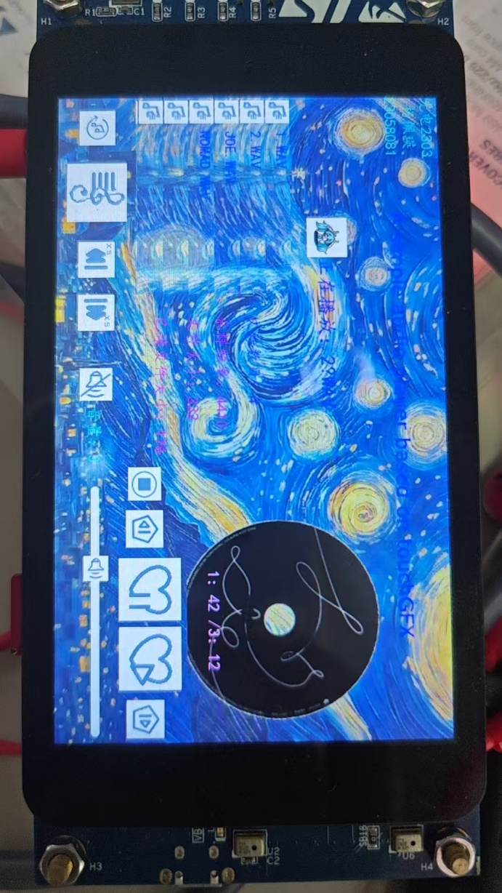
Figure 3. STM32F469I-DISCO board running the audio player
The project delivers a functional, interactive, and debuggable embedded audio player. The implementation covers hardware interface configuration, driver integration, file-system porting, DMA audio transfer, GUI development, and root-cause analysis. Together, these tasks demonstrate system integration skills from the hardware layer to the application layer.
Future work may include shuffle playback, single-track repeat, and richer interface animations.

