Design of a Four Channel Digital Quiz Buzzer

Abstract
This project presents the logic design and Multisim simulation of a four-channel digital quiz buzzer. A start command opens a 10-second response window. The design captures an initial response, locks subsequent inputs, and displays the contestant number using a seven-segment display. A 555 timer provides clock pulses, while a 74LS161 counter controls the response interval. The system integrates latching, priority encoding, display decoding, and status indication. The project demonstrates modular circuit design, interpretation of device truth tables, and systematic simulation debugging.

1 Introduction
A quiz buzzer must identify a valid response and prevent later inputs from changing the selected contestant. This project translates that requirement into a circuit with four contestant inputs, a host start/reset control, a timed response window, and a numerical display. The principal design task is to coordinate the latch and timer so that the input-enable signal reflects both the response state and the elapsed time.
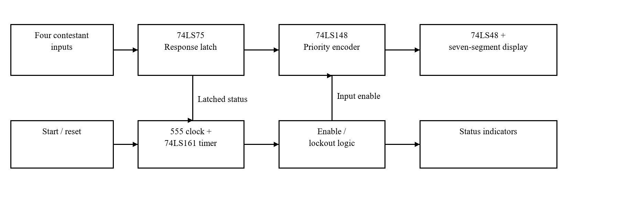
Figure 1. Functional architecture of the four-channel quiz buzzer.
The intended operating sequence is start, accept a response, latch the result, display the contestant number, and reset for the next round. An early response is treated as invalid; once the time limit is reached, further responses are disabled until a new round begins.

2 System Design
The circuit is divided into four functional modules. This organization separates timing, response capture, encoding, and indication, allowing each signal path to be checked before the full circuit is connected. Table 1 summarizes the selected components.
Table 1. Main components and their roles.

Module | Components | Role
Response latch | 74LS75; 74LS20; 74LS00 | Capture a response and inhibit later inputs.
Encoding and display | 74LS148; 74LS48; seven-segment display | Convert the latched input into a contestant number.
Clock and timing | 555 timer; 74LS161 | Generate pulses and define the response interval.
Status indication | 74LS08; indicator LEDs | Represent valid, invalid, and timeout conditions.

2.1 Response Capture and Lockout
The 74LS75 provides level-sensitive latching. During the enabled state, contestant inputs can update the latch. Once a response is detected, feedback logic removes the latch-enable signal, retaining the selected input pattern. The design is intended to preserve the first detected response under sequential input conditions. A priority encoder alone does not establish which of two simultaneous inputs occurred first; that distinction depends on the latch and control timing.

2.2 Encoding and Display
The latched response is connected to the 74LS148 priority encoder. Its output is converted into the code required by the 74LS48 display decoder, accounting for signal polarity and input mapping. The decoder drives the seven-segment display to identify contestants 1 through 4. Truth-table analysis links each valid input state to its displayed number.

2.3 Timing and State Indication
The 555 circuit supplies clock pulses to the 74LS161 counter. The counter uses a ten-state sequence to define the nominal response window. Its terminal-count signal participates in input-enable logic so that new responses are blocked at timeout. Logic gates combine the host control, response status, and counter state to drive the indicators. The 10-second interval requires an appropriately configured clock frequency.

3 Simulation and Verification
The overall circuit was assembled in Multisim. The original report describes a debugging approach that checks power connections first and then examines individual devices and signal paths. The retained schematic in Figure 2 shows the central logic, counter, display circuits, and indicators.
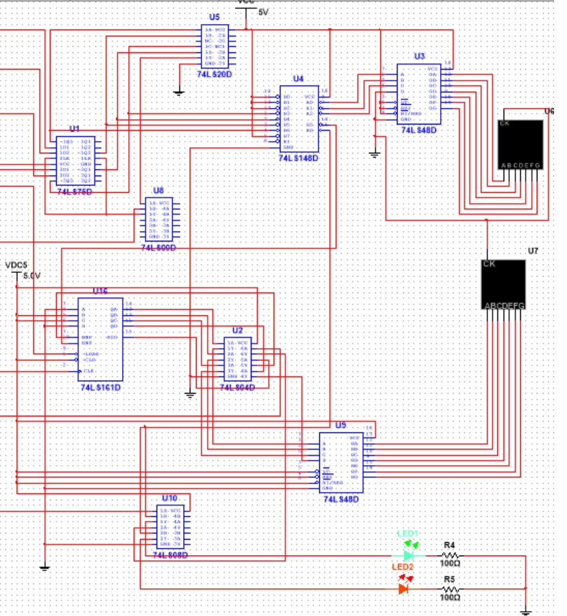
Figure 2. Central logic and display circuitry from the original Multisim schematic.
For troubleshooting, VCC and GND connections are checked for each device, followed by measurements of key node levels with the simulated multimeter. Module-level checks precede full-system testing. Table 2 summarizes the principal functional checks and their expected behavior.
Table 2. Functional checks and expected behavior.

Input condition | Expected behavior
A valid response after start | Display the contestant number and lock later inputs.
Several sequential responses | Retain the initial captured response.
No response within 10 seconds | Disable further inputs and indicate timeout.
Response before start | Identify the invalid response and indicate a violation.
Host reset | Clear the stored response and initialize a new round.

4 Conclusion
The project combines latches, encoders, decoders, counters, logic gates, and a clock source into a coherent quiz-buzzer design. It demonstrates requirements analysis, component selection, truth-table reasoning, schematic construction, and simulation debugging. The documented outcome is a circuit design supported by Multisim materials; physical hardware validation remains a further development step.

