Intelligent License Plate Recognition System

Abstract
This experiment investigates license plate localization and character recognition using a combination of conventional image processing and optical character recognition. Color and edge features identify candidate plate regions, followed by geometric rectification, OTSU binarization, vertical projection, and recognition. EasyOCR and template matching are compared on 500 vehicle images. The reported character recognition accuracies are 91.5% and 82.3%, respectively, while full-plate recognition accuracies are 84.2% and 70.8%. EasyOCR achieves higher accuracy, whereas template matching requires less processing time.
Keywords: license plate recognition; HSV; Canny; OTSU; EasyOCR

1. Experimental Objective and Setup
The experiment establishes a continuous pipeline for extracting plate numbers from vehicle images and evaluates localization, segmentation, recognition accuracy, and processing time. Color and edge features locate the plate; geometric rectification and character segmentation prepare the input for EasyOCR or template matching.
The experimental environment comprises Windows 11, Python 3.9.18, OpenCV 4.8.0, and EasyOCR 1.7. The hardware includes an Intel Core i7-12700H processor, 16 GB of memory, and an NVIDIA RTX 3060 GPU. A Logitech C920 camera captures images at 1920 × 1080 pixels, with a maximum frame rate of 30 fps.

2. System Workflow and Methods
Figure 1 summarizes the processing pipeline. After preprocessing, color and edge information generates candidate regions, which are screened by area and aspect ratio. Selected plates are rectified, segmented, and recognized. The system outputs the plate string and processing time. For video input, motion detection selects candidate frames containing an entering vehicle.
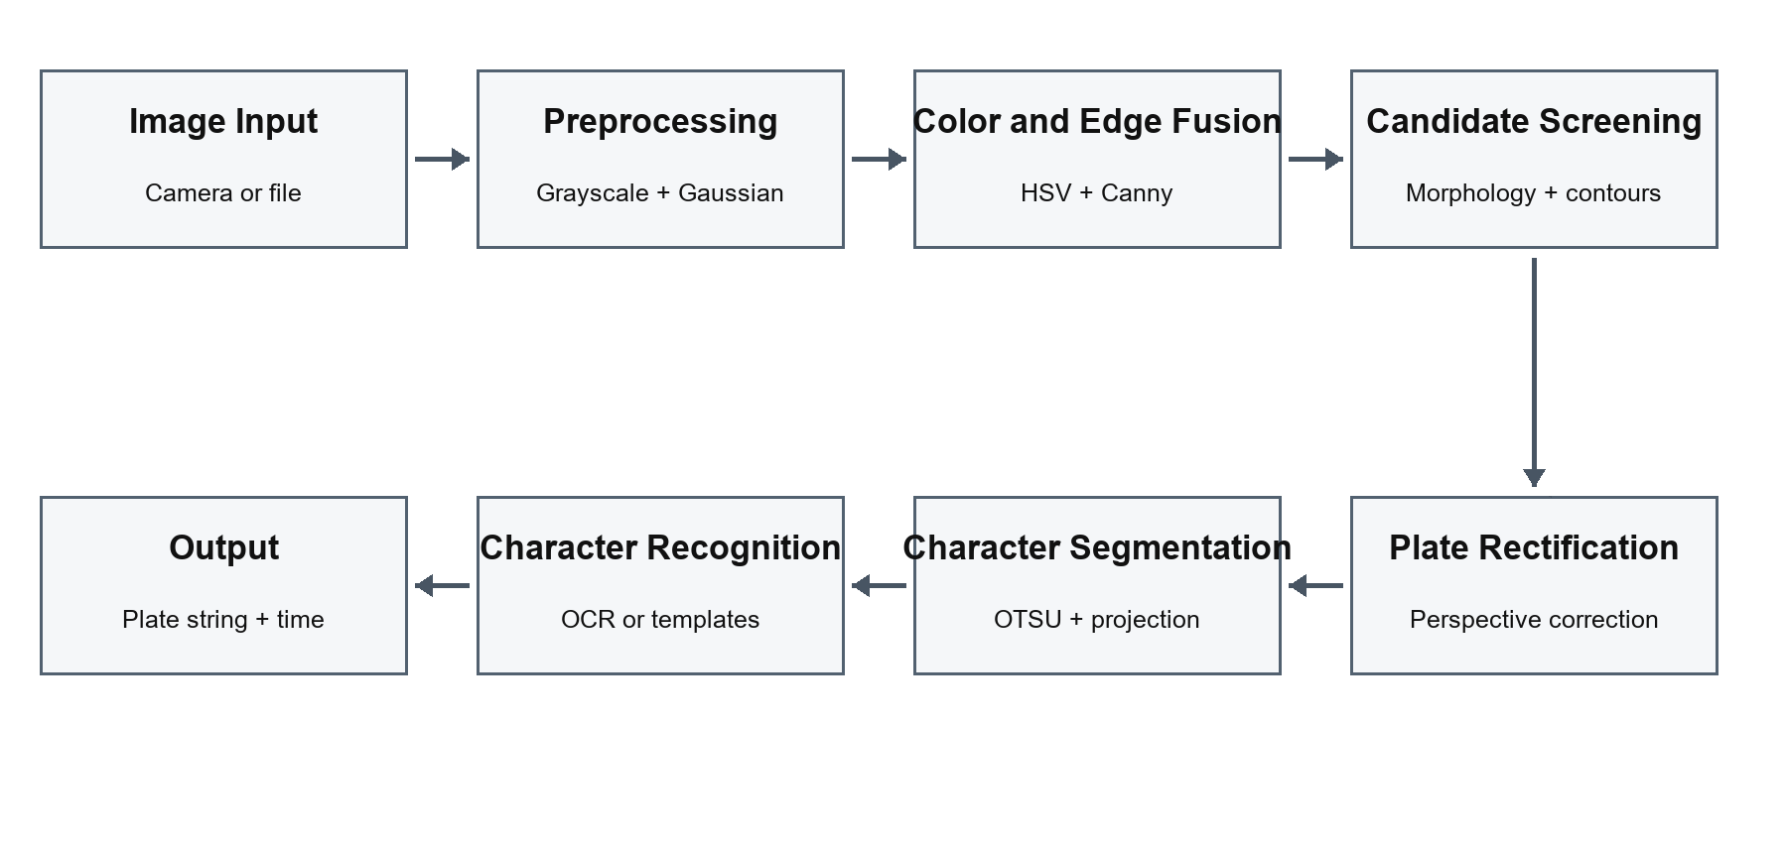
Figure 1. Processing workflow of the license plate recognition system.

2.1. Plate Localization
Color-based localization converts the image to HSV space and uses blue-plate thresholds of H ∈ [100, 124], S ∈ [43, 255], and V ∈ [46, 255] to generate a mask. Edge-based localization applies Gaussian filtering to the grayscale image, followed by Canny edge detection. Morphological closing connects local structures in both outputs. Color and edge evidence is then combined, and candidate regions are screened using contour area and aspect ratio.

2.2. Geometric Rectification and Segmentation
Rectification uses the plate border direction and corner geometry to correct rotation or perspective distortion and align the characters horizontally. OTSU determines an adaptive threshold, while morphological denoising reduces interference from borders and rivets. Vertical projection counts foreground pixels in each column; low-value intervals provide candidate character boundaries.

2.3. Character Recognition
Template matching normalizes character images to 20 × 40 pixels and calculates the normalized cross-correlation (NCC) with the template library. The character corresponding to the highest score is selected, using a matching threshold of 0.7. EasyOCR uses a pretrained recognizer and accepts complete plate regions or segmented characters. Results with confidence below 0.5 are filtered. The two methods are evaluated separately for recognition accuracy and processing speed.

2.4. Sample Processing
Figure 2 shows a real CCPD sample with a plate region drawn from the dataset annotation. Figure 3 presents the actual grayscale conversion and OTSU binarization of this region. The computed threshold is 135. The character foreground is separated from the blue background, but residual borders remain connected to some strokes, indicating the need for border removal and boundary screening before segmentation.
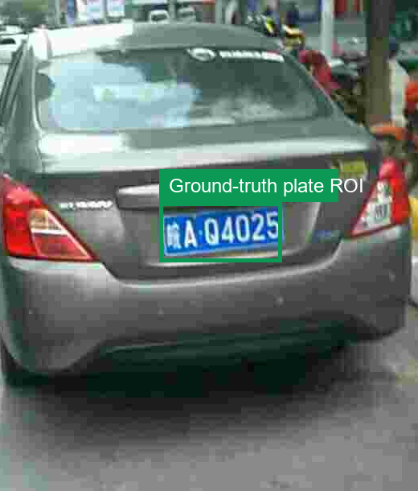
Figure 2. A CCPD vehicle sample with its annotated plate region.

2.4. Sample Processing Results
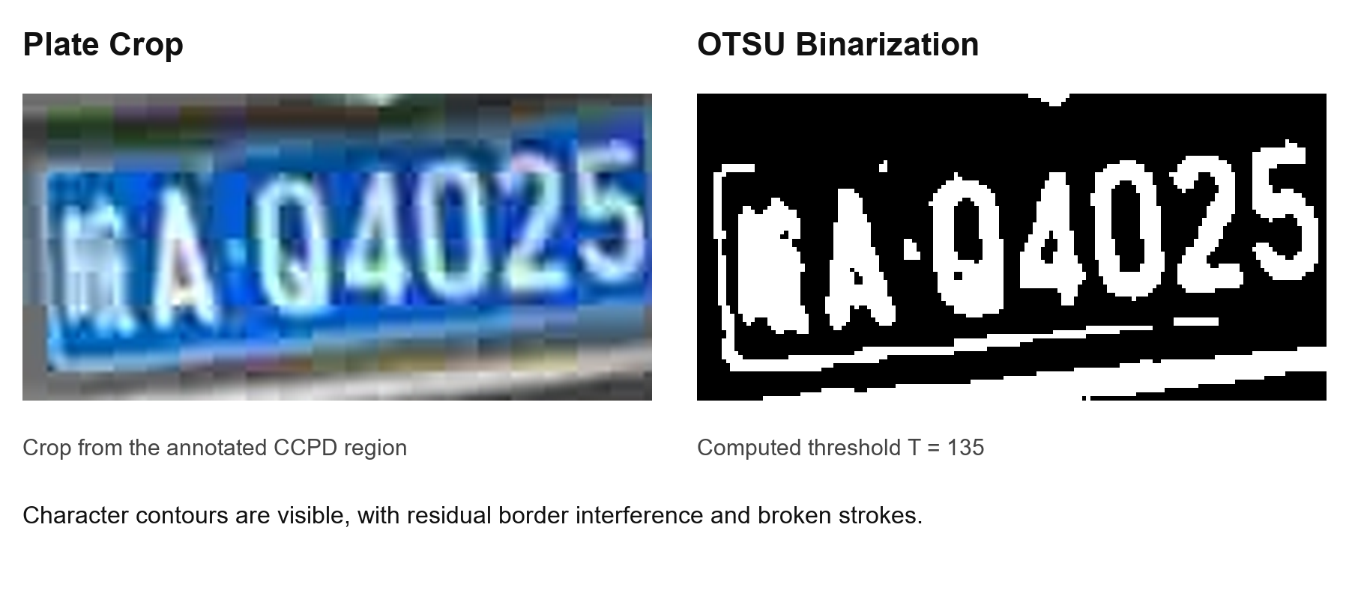
Figure 3. Annotated plate crop and its OTSU binarization result.

3. Experimental Results and Analysis
The test set contains 500 images: 200 captured images, 200 CCPD images, and 100 supplementary images collected online. The images cover varying lighting, viewing angles, dirt, and occlusion. Localization success measures plate-region extraction, segmentation accuracy measures character separation, and character and full-plate recognition accuracies evaluate individual characters and complete plate numbers, respectively.
Table 1. Main results on the test set.
Metric | EasyOCR | Template Matching
Character recognition accuracy | 91.5% | 82.3%
Full-plate recognition accuracy | 84.2% | 70.8%
Chinese character recognition accuracy | 87.6% | 71.2%
Mean processing time | 0.85 s/frame | 0.32 s/frame
The fused localization method achieves a success rate of 92.3%. Character segmentation accuracy is 93.1% on successfully localized plates. Localization precedes recognition and is treated as a common stage rather than an effect of the OCR method.

3.1. Discussion
EasyOCR exceeds template matching by 9.2 percentage points in character recognition accuracy, 13.4 points in full-plate accuracy, and 16.4 points in Chinese character accuracy. Template matching has a shorter mean processing time, indicating a difference between recognition accuracy and computational cost. The EasyOCR timing in Table 1 corresponds to GPU execution; CPU execution requires 2.3 s/frame.
Segmentation and recognition errors propagate to the full-plate result. Lighting changes alter the grayscale distribution of characters and background. Rotation and perspective distortion shift vertical-projection boundaries. Borders, rivets, and touching characters can create additional projection intervals. The residual border and broken strokes in Figure 3 illustrate these error sources: thresholding alone does not guarantee correct character separation.

4. Conclusion
The experiment integrates color and edge-based localization, geometric rectification, OTSU binarization, vertical-projection segmentation, and character recognition into a continuous pipeline. EasyOCR achieves higher character and full-plate recognition accuracies than template matching, while template matching requires less processing time. The sample binarization result also shows that plate borders and character structure influence subsequent segmentation.

