Point Light Source Tracking System
Abstract. This project implements a working point light source tracking system. Four photoelectric sensors detect the direction of a light source; an STM32F411 samples the sensor voltages, computes the position error, and drives a servo through PID control to achieve two-dimensional angular adjustment. The project covers the analog front end, PCB design, embedded firmware, control algorithm, and system debugging. The final prototype forms a demonstrable closed-loop system.
Key indicator | Result | Engineering evidence
Tracking range | Approximately 90° horizontally | Symmetric sensor arrangement and calibration
Dynamic error | ≤ 15° | PID parameter tuning
Response time | ≤ 200 ms | Real-time tasks and PWM output
Acquisition path | 4-channel ADC + DMA | Hardware interface and low-level firmware

1. System Overview
The system is organized into sensing, control, and actuation stages. Four photoelectric sensors are arranged symmetrically to estimate the direction of the light source from voltage differences. The STM32F411 performs synchronized ADC + DMA sampling, calculates the position error, and outputs a 50 Hz PWM signal. An HG14-M digital servo converts a 0.5–2.5 ms pulse width into an angular adjustment of approximately ±90°.
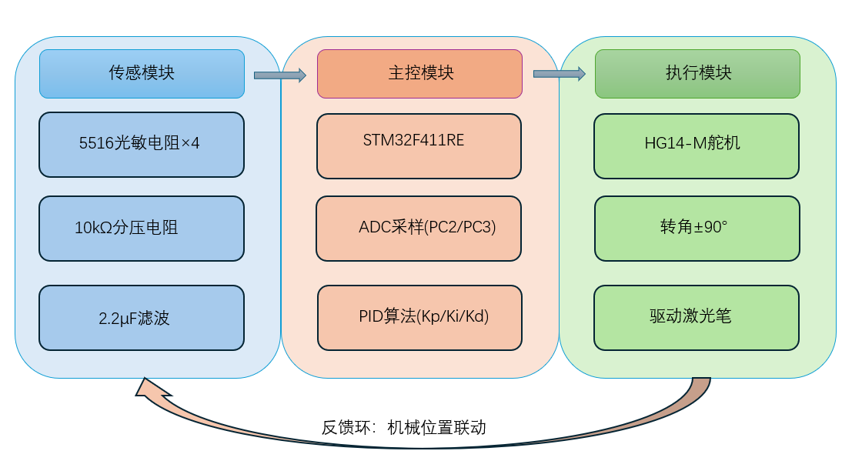
Figure 1. System architecture: photoelectric sensing, STM32F411 control, PID computation, and HG14-M actuation.
The central engineering value of the project is the complete sensing–computation–actuation–feedback loop. The prototype was tested under different illumination conditions and adjusted until it could track a moving light source in a repeatable manner.

2. System Design

2.1 Hardware Design
I completed the circuit schematic, PCB layout, and physical assembly. The PCB uses a 10 cm × 10 cm board with mounting holes at the four corners. The sensors and signal traces follow a symmetric, partitioned layout to reduce interference and simplify mechanical installation.
Module | Key implementation | Engineering purpose
Photoelectric sensing | 5516 photoelectric devices with 10 kΩ voltage-divider circuits; four-channel symmetric layout | Makes directional information comparable and reduces ambient-light influence
Controller and acquisition | STM32F411RE; 12-bit ADC; 500 Hz sampling; circular DMA | Maintains a stable connection between sampling and control tasks
Closed-loop control | PID with Kp = 20000, Ki = 0.5, and Kd = 0.8 | Balances response speed, stability, and overshoot
Actuator | HG14-M servo; 50 Hz PWM; 0.5–2.5 ms pulse width | Converts the computed error into a controllable angle

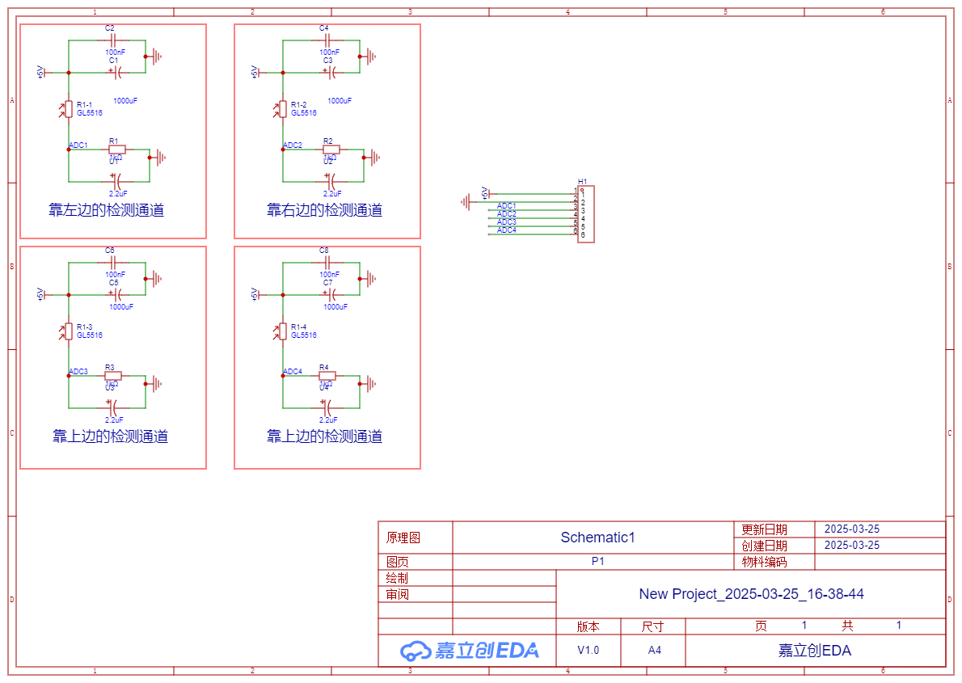
Figure 2. Schematic for the four-channel photoelectric acquisition and control interface.

2.2 Embedded Implementation
The firmware is organized as real-time acquisition, control, and output tasks. The ADC task continuously updates the sensor voltages; the PID task computes the difference between the target and current values; and the PWM task maps the control result to the servo pulse width. The control period is approximately 200 ms, with integral and derivative terms used to reduce static bias and dynamic oscillation.
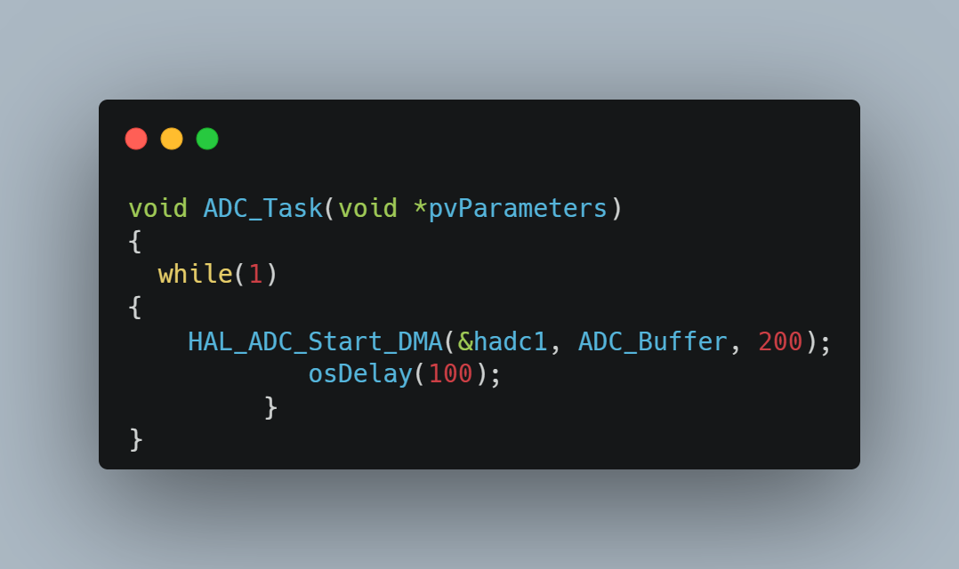  ADC + DMA acquisition task | 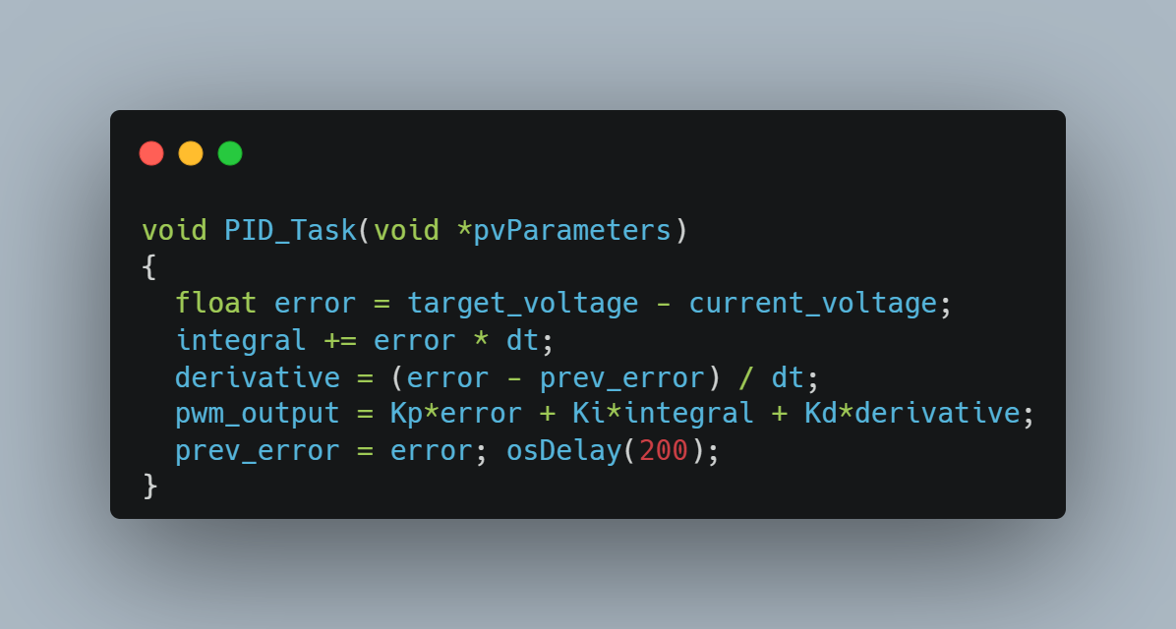  PID computation task
Figure 3. Representative firmware excerpts for acquisition and PID control.
- ADC uses circular DMA mode with a sampling time of 480 Cycles, improving stability for the high-impedance sensor input.
- PID output is synthesized from proportional, integral, and derivative terms and updated at the task interval.
- PWM is generated by TIM3 with a 20 ms period; pulse widths of 0.5 ms, 1.5 ms, and 2.5 ms correspond to −90°, 0°, and +90°, respectively.
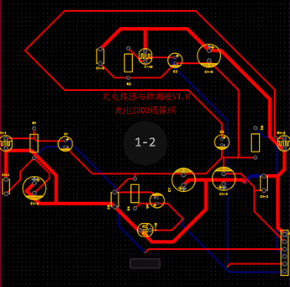  PCB layout and routing | 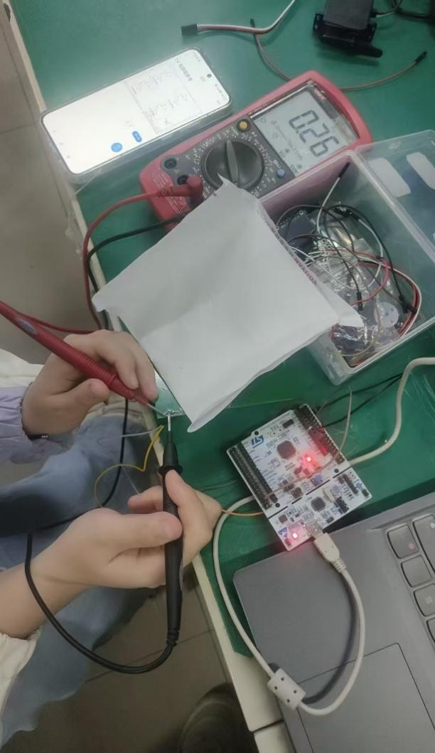  Soldering and hardware integration

3. Testing and Results
A movable point light source was used to simulate a dynamic target. Sensor outputs and servo responses were compared under natural light, full darkness, and strong near-field illumination. The system could identify the light direction consistently and return to a new equilibrium after the target moved.
Test item | Measured result | Interpretation
Dynamic tracking | Response time ≤ 200 ms | Meets the course target; no obvious loss of control during target motion
Angular control | Dynamic error ≤ 15° | Overshoot and oscillation remain controllable after PID tuning
Long-distance test | Direction identifiable at 100 cm | Increasing sensor spacing improves the voltage difference
Environmental stability | About 5% drift after 30 min of strong illumination | Drift reduced to about 1% after decoupling and filtering

3.1 Representative Test Scenes
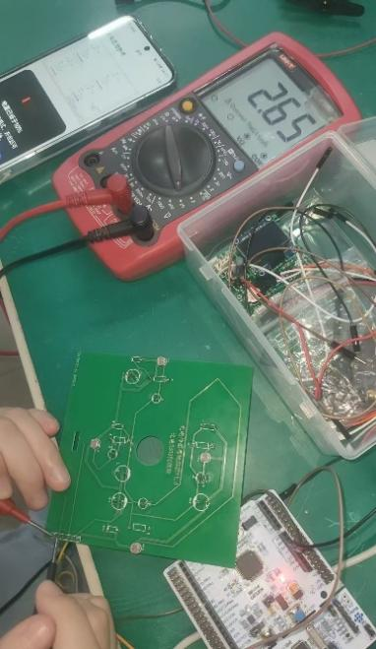  Sensor and servo calibration | 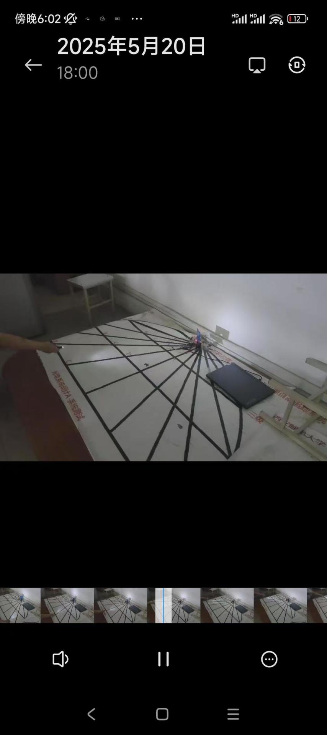  Full-system demonstration
Figure 5. Representative scenes from hardware calibration and full-system demonstration.

3.2 Debugging and Improvements
- Excessive servo speed: constrained the PWM output range and limited the rate of change by the task period.
- Sensor reading drift: added a 100 μF decoupling capacitor, extended the ADC sampling time, and improved the optical shielding structure.
- Insufficient voltage difference at long range: increased the sensor spacing to approximately 8 cm so that directional offsets were easier to distinguish.

4. Conclusion and Demonstrated Capabilities
The project produced a working, explainable, and extensible photoelectric closed-loop system. It can be extended with a two-axis gimbal, trajectory prediction, or multi-sensor fusion to improve tracking under complex illumination conditions.
Capability | Evidence in this project
Hardware design and debugging | Photoelectric front end, symmetric four-channel layout, schematic, PCB, and soldering
STM32 embedded development | ADC/DMA, TIM/PWM, real-time tasks, and servo drive
Control algorithm implementation | PID tuning, error mapping, and dynamic-response optimization
System-level troubleshooting | Progressive diagnosis from waveforms, power, interference, mechanical spacing, and firmware parameters

The complete workflow demonstrates the ability to connect circuit design, embedded programming, control theory, and experimental verification into one functioning prototype.

