Integration testing using mocks
TP2 – VV

Stubbing
Question 1 :
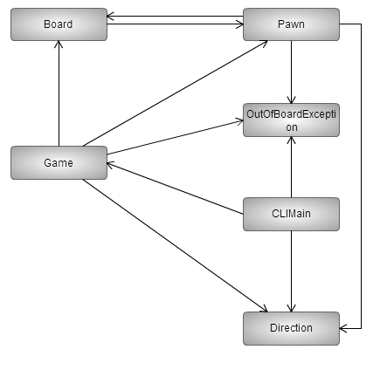
Question 2 :
Plan de test :
(Direction | OutOfBoardException), mock(Pawn), Board, Pawn, Game, CLIMain.

Interactions testing
Question 3 :
On doit mock Pawn.

