|  |
| --- |
| Toi Ohomai |
| **COMP.6215 Graphical User Interface Programming** |
| Assignment 3 |

|  |
| --- |
| Jee Won/Elly Woo  2023-11-7 |

Content

State Transition Diagram 2

Action chart 3

Test plan 4

System Usability Scale 6

# State Transition Diagram

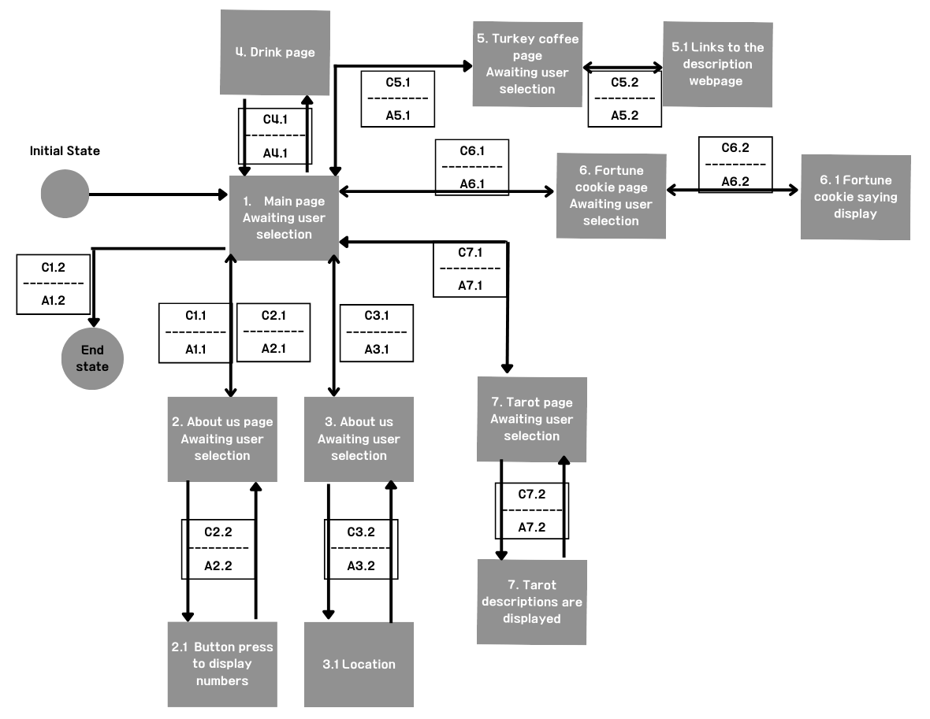

# Action chart

|  |  |  |  |  |  |  |
| --- | --- | --- | --- | --- | --- | --- |
| **No** | **Event** | **No** | **Condition** | **No** | **Actions** | **Notes** |
| 1 | Main page Awaiting user selection | C1.1 | Logo image button click | A1.1 | Navigate to the Lotto page |  |
| C1.2 | The Middle button click | A1.2 | Back to the main page |  |
| 2 | Lotto page Awaiting user input | C2.1 | The left button clicks | A2.1 | Back to the main page |  |
| C2.2 | Button press to display numbers | A2.2 | Lotto numbers are displayed on the screen |  |
| 3 | About us Awaiting user selection | C3.1 | The left button clicks | A3.1 | Back to the main page |  |
| C3.2 | Click the location button | A3.2 | Navigate to the Location page |  |
| 4 | Drink page | C4.1 | Click the drink button | A4.1 | Navigate to the Drink page |  |
| 5 | Turkey coffee page Awaiting user selection | C5.1 | The left button clicks | A5.1 | Back to the main page |  |
| C5.2 | Click the ‘Check the symbol’ button | A5.2 | Navigate to the symbol description website |  |
| 6 | Fortune cookie page Awaiting user selection | C6.1 | The left button clicks | A6.1 | Back to the main page |  |
| C6.2 | The fortune cookie image button clicks | A6.2 | Display the fortune cookie saying |  |
| 7 | Tarot page Awaiting user selection | C7.1 | The left button clicks | A7.1 | Back to the main page |  |
| C7.2 | The tarot image button clicks 3 times | A7.2 | Navigate to the Tarot description page |  |

# Test plan

|  |  |  |  |  |  |
| --- | --- | --- | --- | --- | --- |
| Test No | Purpose | Description | Test Data | Expected Result | Actual Result |
| 1.1 | To test if the logo image button navigated to the Lotto page when it’s clicked | The logo image button is clicked | None | Lotto page is navigated. | Lotto page is navigated. |
| 1.2 | To test if the middle button navigated to the Main page when it’s clicked | The bottom of middle button is clicked | None | Main page is navigated. | Main page is navigated. |
| 2.1 | To test if the left button navigated to the Main page when it’s clicked | The bottom of left button is clicked | None | Main page is navigated. | Main page is navigated. |
| 2.2 | To test if the lotto number row generated on the screen | Input the number of the row(1-20) in the textbox and press the ticket button | 3 | 3 rows of lotto numbers will be displayed. | 3 rows of lotto numbers are displayed. |
| 3.1 | To test if the left button navigated to the Main page when it’s clicked | The bottom of left button is clicked | None | Main page is navigated. | Main page is navigated. |
| 3.2 | To test if the location button navigated to the location page. | The location button is clicked | None | Location page is navigated. | Location page is navigated. |
| 4.1 | To test if the drink button navigated to the drink page. | The drink button is clicked | None | Drink page is navigated. | Drink page is navigated. |
| 5.1 | To test if the left button navigated to the Main page when it’s clicked | The bottom of left button is clicked | None | Main page is navigated. | Main page is navigated. |
| 5.2 | To test if the ‘Check the symbol’ button navigated to the description website. | Click the ‘Check the symbol’ button | None | Turkish coffee reading website is navigated. | Turkish coffee reading website is navigated. |
| 6.1 | To test if the left button navigated to the Main page when it’s clicked | The bottom of left button is clicked | None | Main page is navigated. | Main page is navigated. |
| 6.2 | To test if the cookie image button navigated to the saying page when it’s clicked | The cookie image button is clicked | None | Saying page is navigated. | Saying page is navigated. |
| 7.1 | To test if the left button navigated to the Main page when it’s clicked | The bottom of left button is clicked | None | Main page is navigated. | Main page is navigated. |
| 7.2 | To test if the tarot image button navigated to the tarot description page when it’s clicked | The tarot image button is clicked | None | Tarot description page is navigated. | Tarot description page is navigated. |

# System Usability Scale

|  |  |  |  |  |  |
| --- | --- | --- | --- | --- | --- |
| **Please answer the questions by ticking the appropriate box on the right** | Strongly Disagree | Disagree | Not Sure | Agree | Strongly Agree |
| 1. I think that I would like to use this system frequently | 확인 표시 단색으로 채워진 |  |  |  |  |
| 1. I found the system unnecessarily complex |  | 확인 표시 단색으로 채워진 |  |  |  |
| 1. I thought the system was easy to use |  | 확인 표시 단색으로 채워진 |  |  |  |
| 1. I think that I would need to support of a technical person to be able to use this system |  |  |  | 확인 표시 단색으로 채워진 |  |
| 1. I found the various functions in this system were well integrated |  |  | 확인 표시 단색으로 채워진 |  |  |
| 1. I thought there was too much inconsistency in this system |  |  |  | 확인 표시 단색으로 채워진 |  |
| 1. I would image that most people would learn to use this system very quickly |  |  |  | 확인 표시 단색으로 채워진 |  |
| 1. I found the system very cumbersome to use |  |  | 확인 표시 단색으로 채워진 |  |  |
| 1. I felt very confident using the system |  | 확인 표시 단색으로 채워진 |  |  |  |
| 1. I needed to learn a lot of things before I could get going with this system |  |  |  | 확인 표시 단색으로 채워진 |  |
| Rating:  39.5(E/Awful) | 1 | 2 | 3 | 4 | 5 |

|  |  |  |  |  |  |
| --- | --- | --- | --- | --- | --- |
| **Please answer the questions by ticking the appropriate box on the right** | Strongly Disagree | Disagree | Not Sure | Agree | Strongly Agree |
| 1. I think that I would like to use this system frequently |  |  |  |  | 확인 표시 단색으로 채워진 |
| 1. I found the system unnecessarily complex |  | 확인 표시 단색으로 채워진 |  |  |  |
| 1. I thought the system was easy to use |  |  |  |  | 확인 표시 단색으로 채워진 |
| 1. I think that I would need to support of a technical person to be able to use this system |  |  |  | 확인 표시 단색으로 채워진 |  |
| 1. I found the various functions in this system were well integrated |  |  |  | 확인 표시 단색으로 채워진 |  |
| 1. I thought there was too much inconsistency in this system |  | 확인 표시 단색으로 채워진 |  |  |  |
| 1. I would image that most people would learn to use this system very quickly |  |  |  | 확인 표시 단색으로 채워진 |  |
| 1. I found the system very cumbersome to use |  |  | 확인 표시 단색으로 채워진 |  |  |
| 1. I felt very confident using the system |  |  | 확인 표시 단색으로 채워진 |  |  |
| 1. I needed to learn a lot of things before I could get going with this system |  |  | 확인 표시 단색으로 채워진 |  |  |
| Rating:  67.5(D/Poor) | 1 | 2 | 3 | 4 | 5 |

|  |  |  |  |  |  |
| --- | --- | --- | --- | --- | --- |
| **Please answer the questions by ticking the appropriate box on the right** | Strongly Disagree | Disagree | Not Sure | Agree | Strongly Agree |
| 1. I think that I would like to use this system frequently |  |  | 확인 표시 단색으로 채워진 |  |  |
| 1. I found the system unnecessarily complex |  |  | 확인 표시 단색으로 채워진 |  |  |
| 1. I thought the system was easy to use |  |  |  | 확인 표시 단색으로 채워진 |  |
| 1. I think that I would need to support of a technical person to be able to use this system | 확인 표시 단색으로 채워진 |  |  |  |  |
| 1. I found the various functions in this system were well integrated |  |  |  | 확인 표시 단색으로 채워진 |  |
| 1. I thought there was too much inconsistency in this system |  |  |  | 확인 표시 단색으로 채워진 |  |
| 1. I would image that most people would learn to use this system very quickly |  |  |  |  | 확인 표시 단색으로 채워진 |
| 1. I found the system very cumbersome to use | 확인 표시 단색으로 채워진 |  |  |  |  |
| 1. I felt very confident using the system |  |  |  | 확인 표시 단색으로 채워진 |  |
| 1. I needed to learn a lot of things before I could get going with this system | 확인 표시 단색으로 채워진 |  |  |  |  |
| Rating:  75(B/Good) | 1 | 2 | 3 | 4 | 5 |

|  |  |  |  |  |  |
| --- | --- | --- | --- | --- | --- |
| **Please answer the questions by ticking the appropriate box on the right** | Strongly Disagree | Disagree | Not Sure | Agree | Strongly Agree |
| 1. I think that I would like to use this system frequently |  |  |  |  | 확인 표시 단색으로 채워진 |
| 1. I found the system unnecessarily complex |  | 확인 표시 단색으로 채워진 |  |  |  |
| 1. I thought the system was easy to use |  |  |  |  | 확인 표시 단색으로 채워진 |
| 1. I think that I would need to support of a technical person to be able to use this system |  | 확인 표시 단색으로 채워진 |  |  |  |
| 1. I found the various functions in this system were well integrated |  |  |  | 확인 표시 단색으로 채워진 |  |
| 1. I thought there was too much inconsistency in this system |  | 확인 표시 단색으로 채워진 |  |  |  |
| 1. I would image that most people would learn to use this system very quickly |  |  |  | 확인 표시 단색으로 채워진 |  |
| 1. I found the system very cumbersome to use | 확인 표시 단색으로 채워진 |  |  |  |  |
| 1. I felt very confident using the system |  |  |  |  | 확인 표시 단색으로 채워진 |
| 1. I needed to learn a lot of things before I could get going with this system |  |  | 확인 표시 단색으로 채워진 |  |  |
| Rating:  82.5(A/Excellent) | 1 | 2 | 3 | 4 | 5 |

|  |  |  |  |  |  |
| --- | --- | --- | --- | --- | --- |
| **Please answer the questions by ticking the appropriate box on the right** | Strongly Disagree | Disagree | Not Sure | Agree | Strongly Agree |
| 1. I think that I would like to use this system frequently |  | 확인 표시 단색으로 채워진 |  |  |  |
| 1. I found the system unnecessarily complex |  | 확인 표시 단색으로 채워진 |  |  |  |
| 1. I thought the system was easy to use |  |  | 확인 표시 단색으로 채워진 |  |  |
| 1. I think that I would need to support of a technical person to be able to use this system |  |  |  | 확인 표시 단색으로 채워진 |  |
| 1. I found the various functions in this system were well integrated |  | 확인 표시 단색으로 채워진 |  |  |  |
| 1. I thought there was too much inconsistency in this system |  | 확인 표시 단색으로 채워진 |  |  |  |
| 1. I would image that most people would learn to use this system very quickly |  |  |  | 확인 표시 단색으로 채워진 |  |
| 1. I found the system very cumbersome to use |  |  |  | 확인 표시 단색으로 채워진 |  |
| 1. I felt very confident using the system |  |  | 확인 표시 단색으로 채워진 |  |  |
| 1. I needed to learn a lot of things before I could get going with this system |  |  | 확인 표시 단색으로 채워진 |  |  |
| Rating:  47.5(E/Awful) | 1 | 2 | 3 | 4 | 5 |