**LPS (Land and Property Service)**

**Modules**

* Account Management
* Finance
* Housing benefits
* Collection
* Recovery

**Account Management:**

Account Management module maintains the changes of assessments rates due to be paid by person or organisation on property which is occupied.

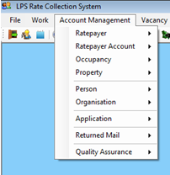

**Sub Modules:**

**Ratepayer Account** - Allow to view account of a person or organisation

**Ratepayer**– Allow to view a person or organisation liable to pay rates liable to pay rates

**Occupancy** – Allows to view occupancy details of possession of property by an occupancy

**Property** – A building (House (Domestic) or Commercial (Non - Domestic)) owned or occupied by an Occupier.

**Person** – Allows to maintain or add person to the system

**Organisation** - Allows to maintain or add organisation to the system.

**Finance:**

* + It’s a process of adjusting rate payer money.
  + When extra or lesser money is collected from the ratepayer it is collected or returned in this process

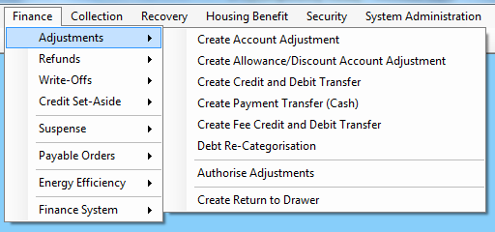

**Sub Modules:**

Adjustments, Refunds, Write-offs, Credit Set-Aside, Suspense, Payable orders, Finance System

**Adjustments:**

**Sub Modules:**

**Allowance/Discount -** Repayment made to the ratepayer

**Credit/Debit Transfer -** The Create Credit and Debit Transfer permits the transferring of a credit amount across multiple occupancies.

**Debit – Re categorization -** There are a number of ratepayer accounts where the debt o/s amount is correct but the rate category and transaction date assignment is wrong.

For this re categorization of debt is done. (Costs, Enforced Rates, SJ Rates, Rates).

**Payment Transfer -** Transfer in the form of cash

**Return to drawer -** A cheque that has not been honoured by the bank is referred to as a ‘Return to Drawer’ payment. The most frequent reason for the bank not honouring the cheque is a lack of funds in the bank account. Therefore, all transaction activity applied to one or more ratepayer LPS accounts as a result of the payment will need to be reversed (inc. discount).

**Credit Set-Aside:**

Indefinite credits on the ratepayer accounts whose ratepayer cannot be tracked or found are maintained separately under Credit Set-Aside.

**Suspense Account**

Unidentified payments are held or tracked in account books under Suspense account. They will be credited back to the appropriate ratepayer upon clarification

**Direct** **Credit**

Direct credit is the term used to refer the payment made directly from the bank for the ratepayer.

**Housing Benefits:**

Housing benefit is a core module in LPS which gives benefits to the person who claims for housing benefits.

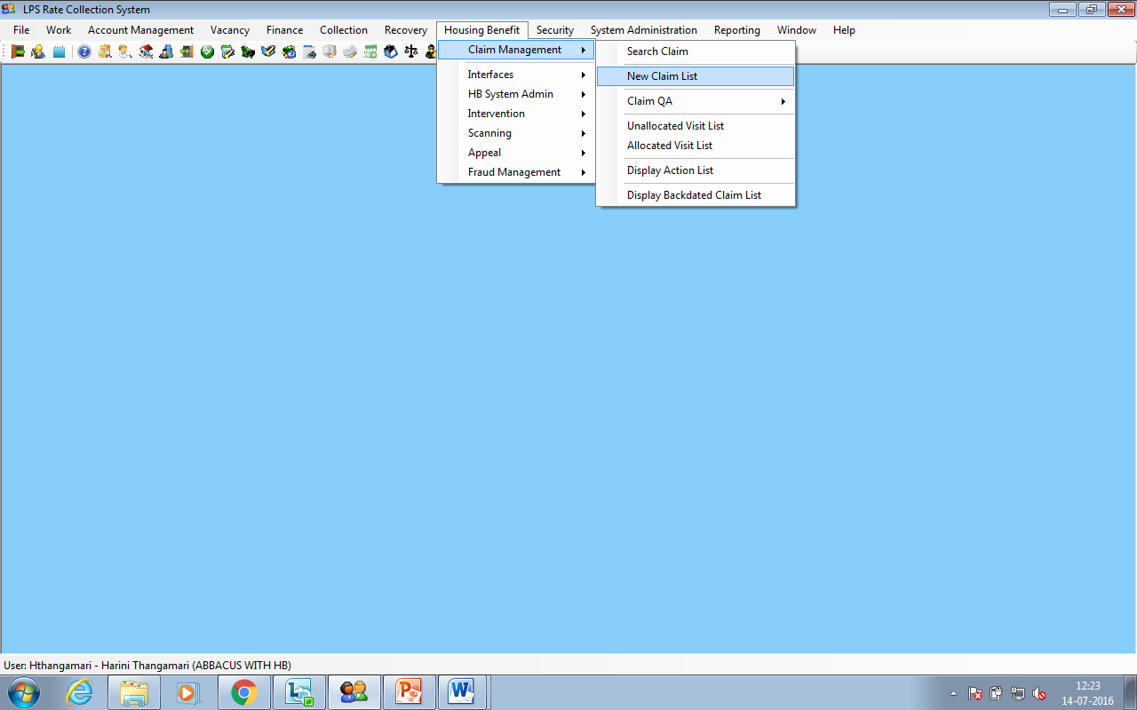

**Eligibility criteria:**

* Ratepayer’s Income
* More household members with his family.
* Based on household members income.

**Sub-Modules:**

* Claim management
* Intervention
* Appeal
* Fraud Management

**Claim Management:**

* Creation of claim is done in claim management.
* Claim denotes the document which needs to be submitted to LPS for assessment of housing benefits.
* Claim can be created if he has NINO(National Insurance number) Number and claimant should be above 18 years of age.

**Additional tab:**

It contains details of any already existing claim associated with the current claim.

**Contacts tab:**

A contact detail of the claimant and other household members are added in the contact tab

**Atlas and CIS:**

It contains the supporting details documents of the claimant.

**Household tab:**

The claimant relations such as

CL – claimant should be more than 18 years.

ND- nondependent should be more than 16 years.

DP- dependent should be lesser than 16 years of age.

PT– partner should be more than 16 years of age.

NC – should be lesser than or equal to 19 years of age

**Finance tab:**

In this tab claimant and claimants relation that the user would have added in the household tab, those members financial income should be added.

**Documents tab:**

The scanned copy of the claimants document will be present as default.

And other supporting files will be present along with it

**Entitlement tab:**

It contains the details of no of entitlements occurred for the following claim.

**Claim action tab:**

It contains the action carried out on the claim.

**Log lines:**

It contains the status details of the claim.

**Appeal:**

When the given housing benefit is not satisfying for the claimant he can go for appeal.

A claimant can go for appeal many times within a time limit.

**Fraud management:**

If a claimant is suspected, he is termed as fraud and officers from LPS will be sent to investigate.

If a claimant is suspected is claim will be marked as fraud, so when enter his claim number in maintain claim, fraud management should be changed to hyperlink in the general tab.

**Collection:**

Collection involves the methods of collecting money from ratepayer.

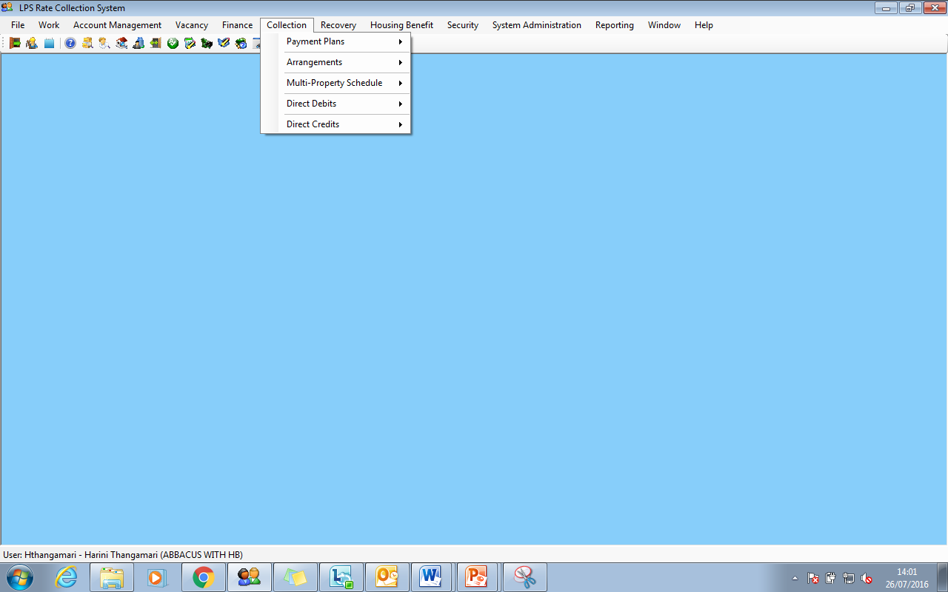

**Payment Plans**

In Payment plans module LPS user can change payment method.

**Arrangements**

Arrangements are mode where ratepayer pays debit amount in weekly or quarterly or monthly. In this type of payment plan can be Single Payment.

**Multi Property Schedule**

If the ratepayer has two accounts and paying for multiple properties of the multi property schedule can be enabled. LPS uses this option to swap the accounts from which debit

amount is paid to that particular property, and moreover both property payment plan should be same.

**Direct debits**

Time period can be set for the debiting the amount from ratepayers account

**Direct Credits**

Direct credit is used for organisation where periodically amount crediting for Particular organisation.

**Recovery:**

Recovery is the process taken by LPS if the person does not pay the rate