

AWS AUTOMATION SERIES #01
- MFA DETECTION

Author | Elmar Scholten
Date | 23/02/2026

Confidentiality and Proprietary Notice
This document contains confidential and proprietary information prepared exclusively by and for Elmar Scholten. The material is protected under applicable copyright and intellectual property laws.
No part of this publication may be copied, reproduced, stored in a retrieval system, or transmitted in any form, electronic, mechanical, photocopying, recording, or otherwise, without prior written permission from the author.
Unauthorized use, disclosure, or distribution of this material is strictly prohibited. Any request for reproduction or permission to quote from this document must be formally submitted and approved in writing by the author.
All rights are reserved.
Table of contents
1. Control Objective 5
2. Prerequisites 5
3. Create the lambda code 7
4. Package lambda + create IAM role 10
5. Create lambda function 13
6. Test invoke once + view results + check logs 14
7. Schedule with EventBridge 16
8. Trigger via EventBridge 17
8. Set Up Monitoring & Alerting (CloudWatch + SNS) 18

1. Control Objective
Automatically detect IAM users without MFA enabled and generate structured output for remediation and audit purposes.
This control improves identity hygiene and reduces account takeover risk within AWS environments.
――――――――――――――――――――――――――――――――――――――――――――――――――――――――――――――――――――――――――――――――――――――――――

2. Prerequisites
• AWS CLI installed and configured
• Access to an AWS account with IAM read permissions
• Dedicated least-privilege IAM role for execution
• Python 3.x installed (if using script-based approach)
CLI- commands
- Tools installed?
aws --version
python3 --version
zip --version # used to package the Lambda
- Target region (Perth -> Sydney region is ap-southeast-2)
export AWS_REGION=ap-southeast-2 (or applicable region)
aws configure set region "$AWS_REGION"
- You’re authenticated to the right account?
aws sts get-caller-identity
- Do you have IAM audit permissions? (this also warms the report cache)
# Expect "ReportInProgress" or similar JSON; success here means your identity can call it.
CLI command
aws iam generate-credential-report
――――――――――――――――――――――――――――――――――――――――――――――――――――――――――――――――――――――――――――――――――――――――――
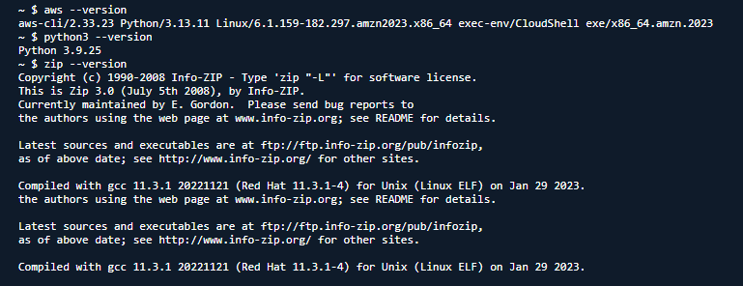

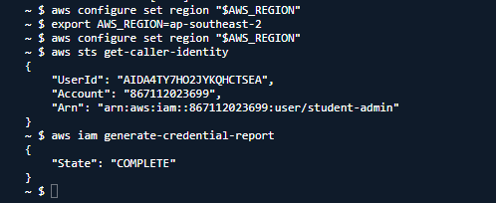

3. Create the lambda code
- Create folder & open nano file
mkdir -p mfa-audit-lambda && cd mfa-audit-lambda
nano lambda_function.py

- Paste this into lambda_function.py
import boto3
import csv
import io
import time
from datetime import datetime

iam = boto3.client("iam")

def _get_credential_report(max_wait_seconds: int = 60) -> bytes:
# Kick off generation (safe to call repeatedly)
iam.generate_credential_report()

# Poll until it's ready
deadline = time.time() + max_wait_seconds
last_err = None

while time.time() < deadline:
try:
resp = iam.get_credential_report()
return resp["Content"] # bytes
except iam.exceptions.ReportInProgressException as e:
last_err = e
time.sleep(2)
except iam.exceptions.CredentialReportNotPresentException as e:
last_err = e
time.sleep(2)

raise RuntimeError(f"Timed out waiting for credential report. Last error: {last_err}")

def _parse_no_mfa_users(report_bytes: bytes):
text = report_bytes.decode("utf-8")
reader = csv.DictReader(io.StringIO(text))
no_mfa = []

for r in reader:
username = (r.get("user") or "").strip()

# Skip root row if present
if username in ("<root_account>", ""):
continue

mfa_active = (r.get("mfa_active") or "").strip().lower()
if mfa_active != "true":
no_mfa.append({
"user": username,
"arn": r.get("arn", ""),
"password_enabled": r.get("password_enabled", ""),
"access_key_1_active": r.get("access_key_1_active", ""),
"access_key_2_active": r.get("access_key_2_active", ""),
})

return no_mfa

def lambda_handler(event, context):
report_bytes = _get_credential_report(max_wait_seconds=90)
no_mfa = _parse_no_mfa_users(report_bytes)

ts = datetime.utcnow().strftime("%Y-%m-%dT%H:%M:%SZ")
if not no_mfa:
print(f"[{ts}] MFA CHECK OK: No IAM users without MFA found.")
return {"status": "ok", "no_mfa_users": 0, "users": []}

print(f"[{ts}] MFA CHECK ALERT: Found {len(no_mfa)} IAM users without MFA:")
for u in no_mfa:
print(
f" - {u['user']} arn={u['arn']} "
f"pwd={u['password_enabled']} ak1={u['access_key_1_active']} ak2={u['access_key_2_active']}"
)

return {"status": "alert", "no_mfa_users": len(no_mfa), "users": no_mfa}

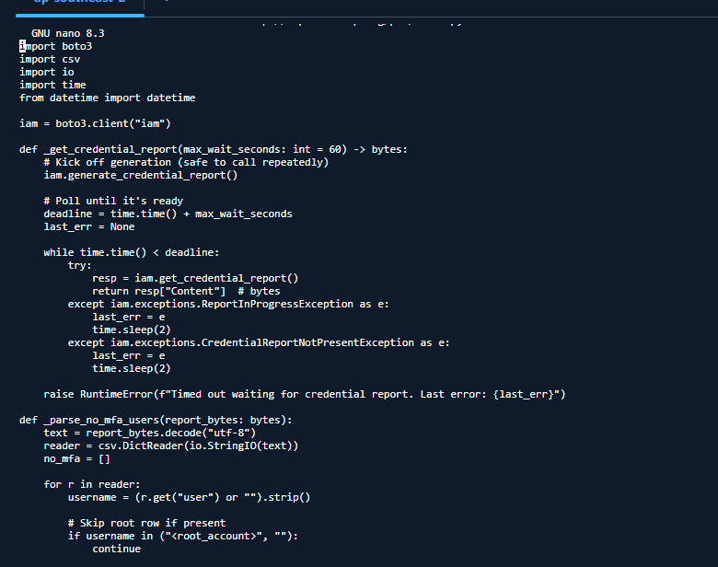

- Confirm file exists
Command:
Ls -la
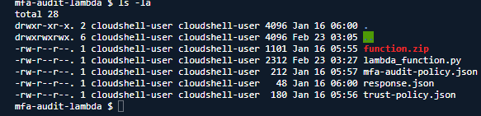

4. Package lambda + create IAM role
- Create the deployment zip
Command:
zip -r function.zip lambda_function.py
ls -la function.zip

- Create trust policy-file
cat > trust-policy.json <<'JSON'
{
"Version": "2012-10-17",
"Statement": [
{
"Effect": "Allow",
"Principal": { "Service": "lambda.amazonaws.com" },
"Action": "sts:AssumeRole"
}
]
}
JSON

- Create the role

Command:

aws iam create-role \
--role-name mfa-audit-lambda-role \
--assume-role-policy-document file://trust-policy.json

- Attach cloudwatch log permissions
Command:
aws iam attach-role-policy \
--role-name mfa-audit-lambda-role \
--policy-arn arn:aws:iam::aws:policy/service-role/AWSLambdaBasicExecutionRole

- Add IAM audit permissions
cat > mfa-audit-policy.json <<'JSON'
{
"Version": "2012-10-17",
"Statement": [
{
"Effect": "Allow",
"Action": [
"iam:GenerateCredentialReport",
"iam:GetCredentialReport"
],
"Resource": "*"
}
]
}
JSON

aws iam put-role-policy \
--role-name mfa-audit-lambda-role \
--policy-name mfa-audit-inline-policy \
--policy-document file://mfa-audit-policy.json

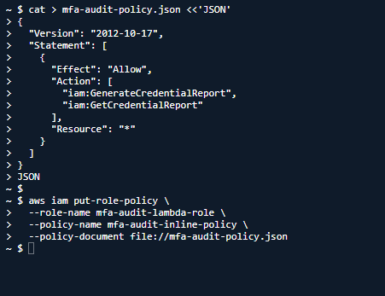

- Grab role ARN (to use in next step)
Command:
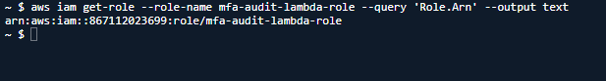
aws iam get-role --role-name mfa-audit-lambda-role --query 'Role.Arn' --output text

5. Create lambda function
- Run this command inside mfa-audit-lambda/
Command:
aws lambda create-function \
--function-name mfa-audit-iam-users-no-mfa \
--runtime python3.11 \
--handler lambda_function.lambda_handler \
--role arn:aws:iam::867112023699:role/mfa-audit-lambda-role \
--zip-file fileb://function.zip

- Then check if lambda function exists.

Command:

aws lambda get-function --function-name mfa-audit-iam-users-no-mfa --query 'Configuration.[FunctionName,Runtime,Role,LastModified]' --output table

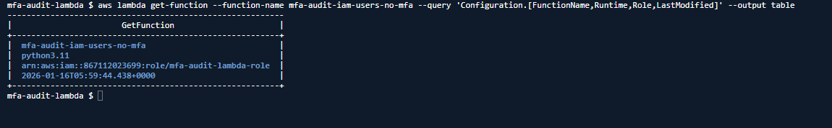

6. Test invoke once + view results + check logs

- Invoke the lambda
Command:
aws lambda invoke \
--function-name mfa-audit-iam-users-no-mfa \
--payload '{}' \
response.json
cat response.json
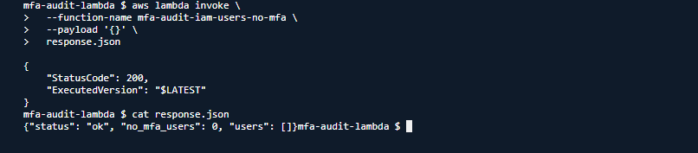

- Check the Cloudwatch log output

Command:

aws logs describe-log-groups \
--log-group-name-prefix /aws/lambda/mfa-audit-iam-users-no-mfa \
--query 'logGroups[0].logGroupName' --output text

- Copy the log group name from previous output, then run

Command:

aws logs describe-log-streams \
--log-group-name /aws/lambda/mfa-audit-iam-users-no-mfa \
--order-by LastEventTime \
--descending \
--max-items 1 \
--query 'logStreams[0]./aws/lambda/mfa-audit-iam-users-no-mfa' --output text

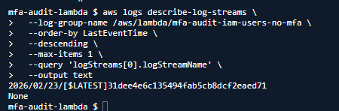

- Take the stream name and return and run:

aws logs get-log-events \
--log-group-name /aws/lambda/mfa-audit-iam-users-no-mfa \
--log-stream-name "<PASTE_STREAM_NAME_HERE>" \
--limit 50 \
--query 'events[*].message' \
--output text
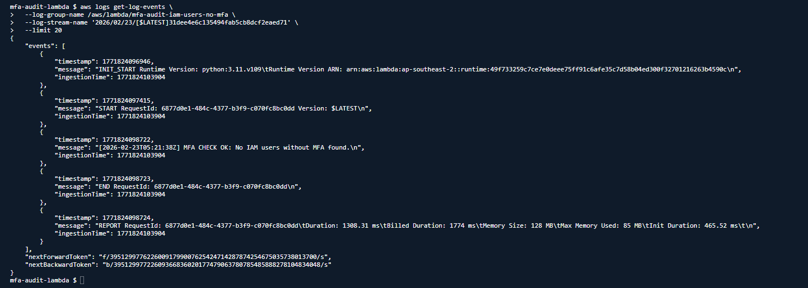

7. Schedule with EventBridge

- Create rule
aws events put-rule \
--name mfa-audit-daily-0900-awst \
--schedule-expression "cron(0 1 * * ? *)" \
--state ENABLED

- Allow EventBridge to invoke your Lambda

aws lambda add-permission \
--function-name mfa-audit-iam-users-no-mfa \
--statement-id allow-eventbridge-invoke-mfa-audit \
--action lambda:InvokeFunction \
--principal events.amazonaws.com \
--source-arn arn:aws:events:ap-southeast-2:867112023699:rule/mfa-audit-daily-0900-awst

- Attach the Lambda as the rule target

aws events put-targets \
--rule mfa-audit-daily-0900-awst \
--targets "Id"="1","Arn"="arn:aws:lambda:ap-southeast-2:867112023699:function:mfa-audit-iam-users-no-mfa"

- Verify target is attached

aws events list-targets-by-rule --rule mfa-audit-daily-0900-awst --output table
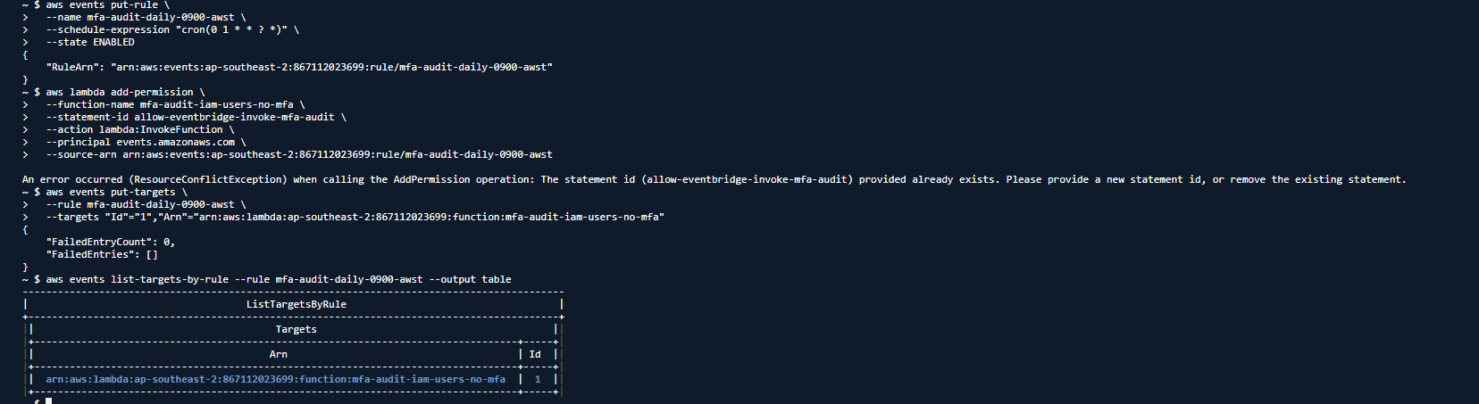

8. Trigger via EventBridge

- Check newest log stream:
aws logs describe-log-streams \
--log-group-name /aws/lambda/mfa-audit-iam-users-no-mfa \
--order-by LastEventTime \
--descending \
--max-items 1 \
--query 'logStreams[0].logStreamName' \
--output text

- Retrieve 50 log lines from that stream

aws logs get-log-events \
--region ap-southeast-2 \
--log-group-name /aws/lambda/mfa-audit-iam-users-no-mfa \
--log-stream-name '2026/02/23/[$LATEST]31dee4e6c135494fab5cb8dcf2eaed71' \
--limit 30 \
--query 'events[*].message' \
--output text

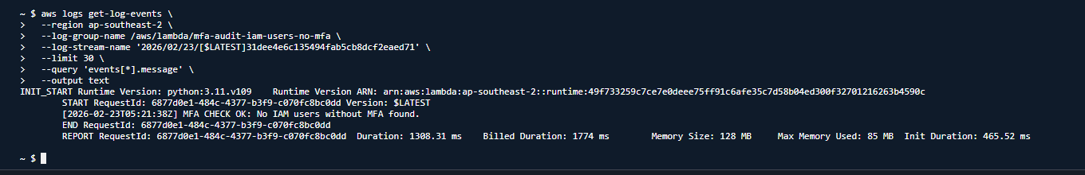

8. Set Up Monitoring & Alerting (CloudWatch + SNS)

This step converts Lambda log output into an automated alert.

8.1 Create CloudWatch Metric Filter

Detects when the Lambda logs a failure.

aws logs put-metric-filter \
--region <REGION> \
--log-group-name <LOG_GROUP_NAME> \
--filter-name <METRIC_FILTER_NAME> \
--filter-pattern "MFA CHECK ALERT" \
--metric-transformations \
metricName=<METRIC_NAME>,metricNamespace=<METRIC_NAMESPACE>,metricValue=1

Example Values Used

<REGION> → ap-southeast-2
<LOG_GROUP_NAME> → /aws/lambda/mfa-audit-iam-users-no-mfa
<METRIC_FILTER_NAME> → MFAFailureFilter
<METRIC_NAME> → MFAFailures
<METRIC_NAMESPACE> → SecurityAudit

8.2 Create CloudWatch Alarm

Trigger an alarm when at least one failure is detected.

aws cloudwatch put-metric-alarm \
--region <REGION> \
--alarm-name <ALARM_NAME> \
--metric-name <METRIC_NAME> \
--namespace <METRIC_NAMESPACE> \
--statistic Sum \
--period <PERIOD_IN_SECONDS> \
--evaluation-periods <EVALUATION_PERIODS> \
--threshold <THRESHOLD> \
--comparison-operator GreaterThanOrEqualToThreshold

Example Values Used

<ALARM_NAME> → MFA-NonCompliant-Users
<PERIOD_IN_SECONDS> → 300
<EVALUATION_PERIODS> → 1
<THRESHOLD> → 1

8.3 Create SNS Topic (Notification Channel)

aws sns create-topic \
--region <REGION> \
--name <SNS_TOPIC_NAME>

Retrieve the Topic ARN:

aws sns list-topics \
--region <REGION> \
--query 'Topics[*].TopicArn' \
--output text

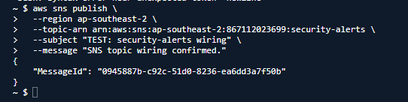
8.4 Subscribe Email to SNS Topic

aws sns subscribe \
--region <REGION> \
--topic-arn <TOPIC_ARN> \
--protocol email \
--notification-endpoint <EMAIL_ADDRESS>

Confirm the subscription via the email link.

Verify subscription:

aws sns list-subscriptions-by-topic \
--region <REGION> \
--topic-arn <TOPIC_ARN>
8.5 Attach SNS Topic to CloudWatch Alarm

Update the alarm to send notifications:

aws cloudwatch put-metric-alarm \
--region <REGION> \
--alarm-name <ALARM_NAME> \
--metric-name <METRIC_NAME> \
--namespace <METRIC_NAMESPACE> \
--statistic Sum \
--period <PERIOD_IN_SECONDS> \
--evaluation-periods <EVALUATION_PERIODS> \
--threshold <THRESHOLD> \
--comparison-operator GreaterThanOrEqualToThreshold \
--alarm-actions <TOPIC_ARN>

8.6 Validate SNS Delivery (Manual Test)

Publish a test message directly to SNS:

aws sns publish \
--region <REGION> \
--topic-arn <TOPIC_ARN> \
--subject "TEST: SNS wiring" \
--message "If you received this, SNS notification is correctly configured."

This confirms:

SNS topic works
Email subscription is confirmed
Notification path is functional

