| **Team Number** | 01 | **Section** | 02 |
| --- | --- | --- | --- |
| **Team Members** | 1. Bryson Leshkiw 2. Elmar Imanov 3. Nuha Rushad 4. Ricques Nguyen | | |
| **Software Name** | Personal Password Manager | | |

# Introduction

## Objective [5 Points]

Objective of this document is to draw out the details and showcase the new software (Personal Password Manager) to help make managing passwords a little easier on the average human. This document will further explain all the classes and components in order to show all the relationships between them to developers.

## References [5 Points]

Main reference for creating this document was Lecture 4 from the class.

## Acronyms, and Abbreviations [5 Points]

| N/A | N/A |
| --- | --- |

# Software Overview

## Problem Statement [5 Points]

As time passes, more and more websites are being created by the second with each having the user enter some sort of a password and remember it. With website security and the task of having to remember fifteen or more different passwords become more difficult for the average human, a password manager that safely stores and encrypts all of user passwords is a must in these times. Not only will it provide a more manageable environment for all of the passwords for each and every website, but it will also be risk free from developers trying to sell user information. Moreover, there is also the issue of hackers trying to get user data by cracking website security so new software is in dire need as old software becomes more susceptible to data breaches as the time passes. This manager will take a password entered by the user for a specific website, encrypt it and give the user a decryption key or a “Master key” inorder to get each and every one of their passwords back. Users will be able to add, modify and remove passwords in their personal password manager.

## Scope [5 Points]

Any person that has access to the internet and has more passwords than they can care to remember will find this product useful.

# Detailed Design

## UML Class Diagrams (for all classes/interfaces) [30 Points]

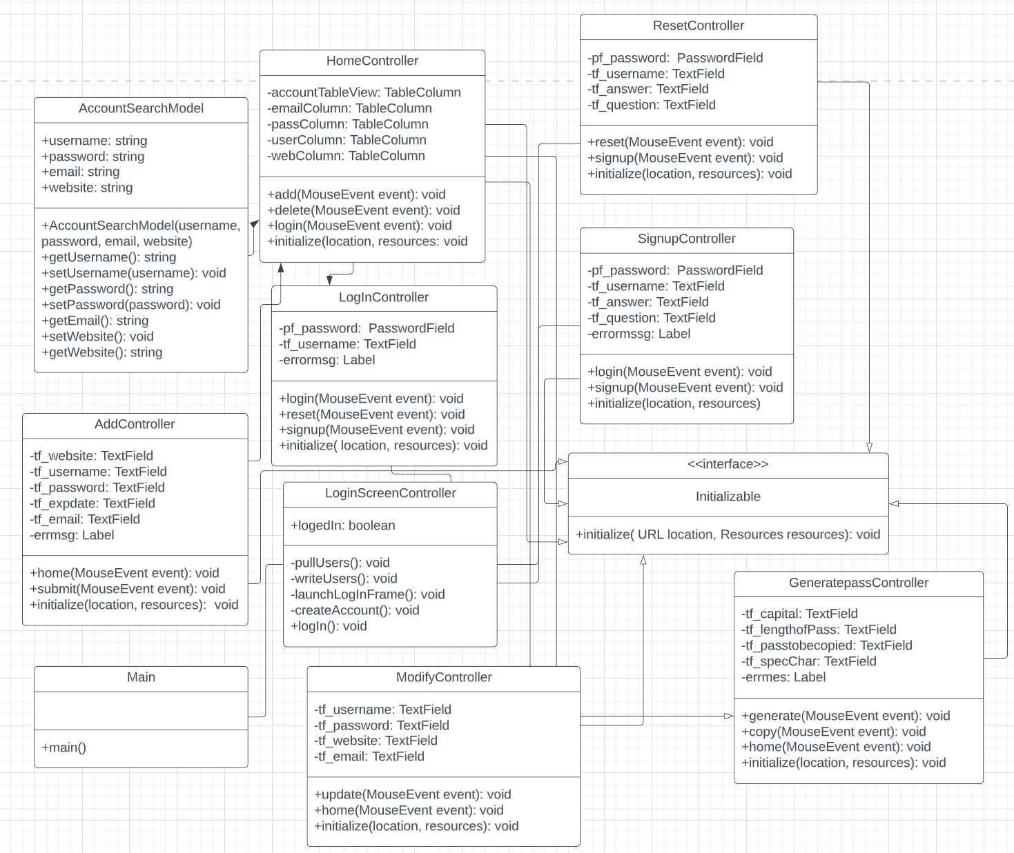

## UML Sequence and/or State Diagrams (at least two) [20 Points]

Sequence Diagram

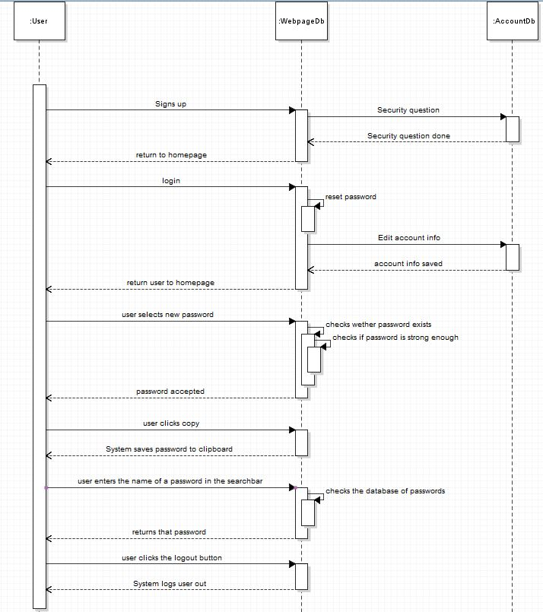

State Diagram

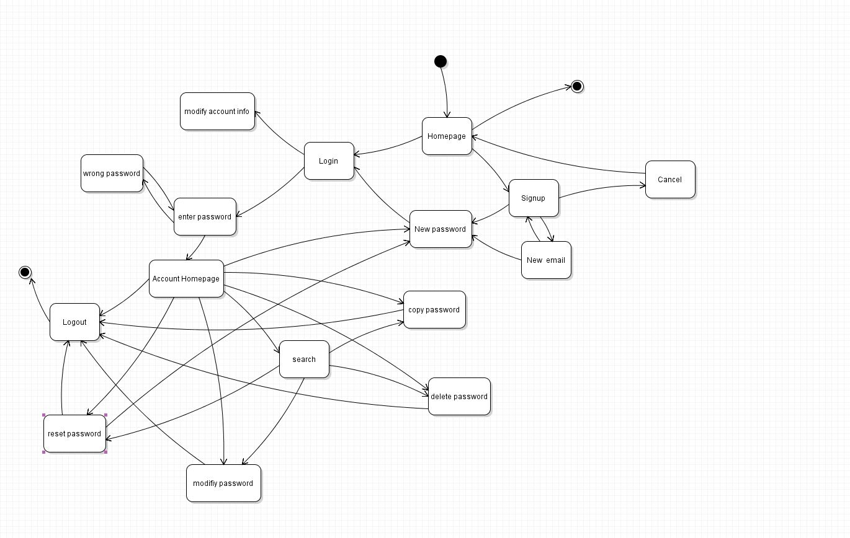

## Mockups [20 Points] (Please scroll down to view all mockups)

