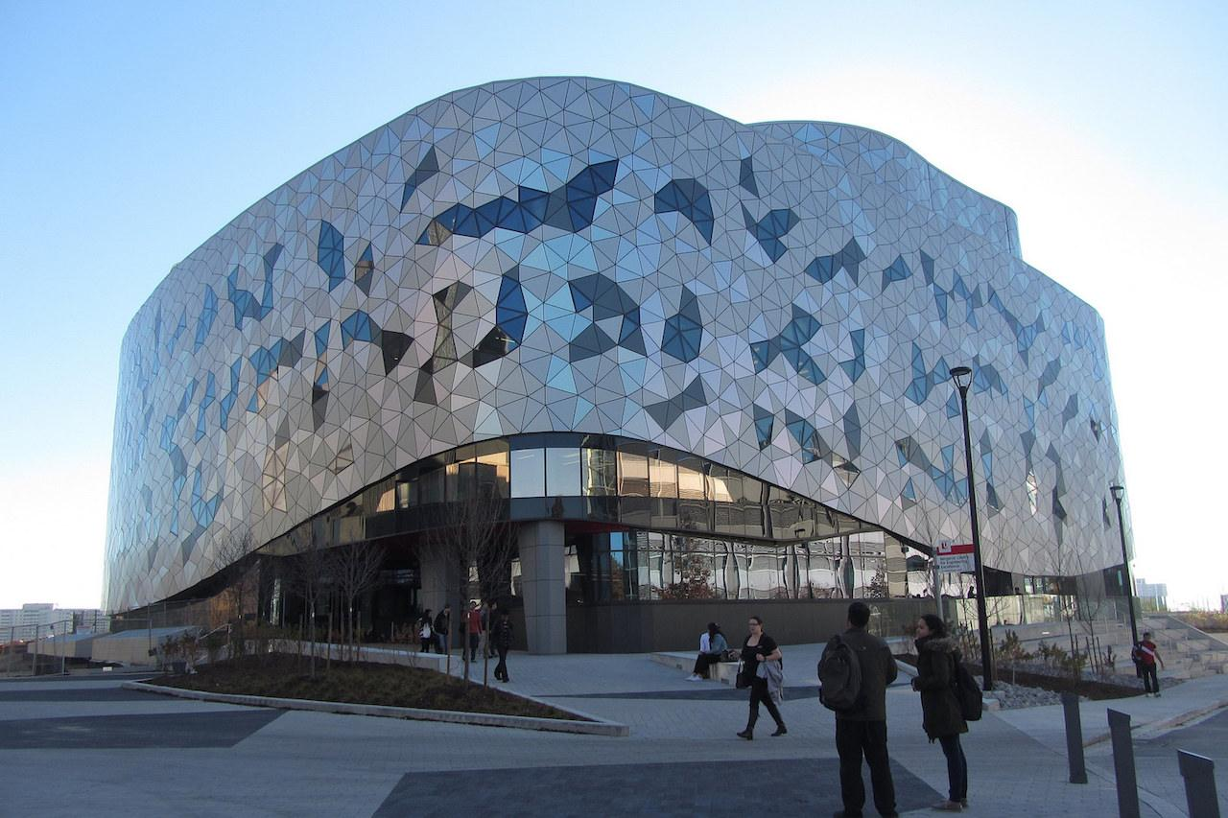

**TAB2XML**

Design Document

**Group 6**

**Elmira Onagh**

**Irsa Nasir**

**Long Lin**

**Harjap Randhawa**

**Daniel Di Giovanni**



Winter 2022

**Table of Content**

**1.** **Visualization of MusicXML** 3

1.1. Instrument: Guitar 3

1.1.1 Sequence diagram 3

1.1.2 UML Class diagram 4

1.2. Instrument: Drum 5

1.3. Instrument: Bass 5

**2.** **Playing the tablature** 5

2.1. Instrument: Guitar 5

2.2. Instrument: Drum 5

2.3. Instrument: Bass 5

**3.** **Printing the Music sheet** 5

**4.** **Go to measure** 5

# **Visualization of MusicXML**

Based on the instrument specified in the input tablature, three different objects are created: guitar, drum, and Bass. In the following section we look at different diagrams related to creation and relationships of these classes.

### Instrument: Guitar

If the instrument of the tablature is a guitar, then a guitar class is instantiated.

#### Sequence diagram

Figure1. Sequence diagram of displaying guitar tablature.

#### UML Class diagram

Figure 2. Class diagram of the Guitar class and it interactions.

### Instrument: Drum

(I think this diagram may be too cluttered, so I made a second version below)

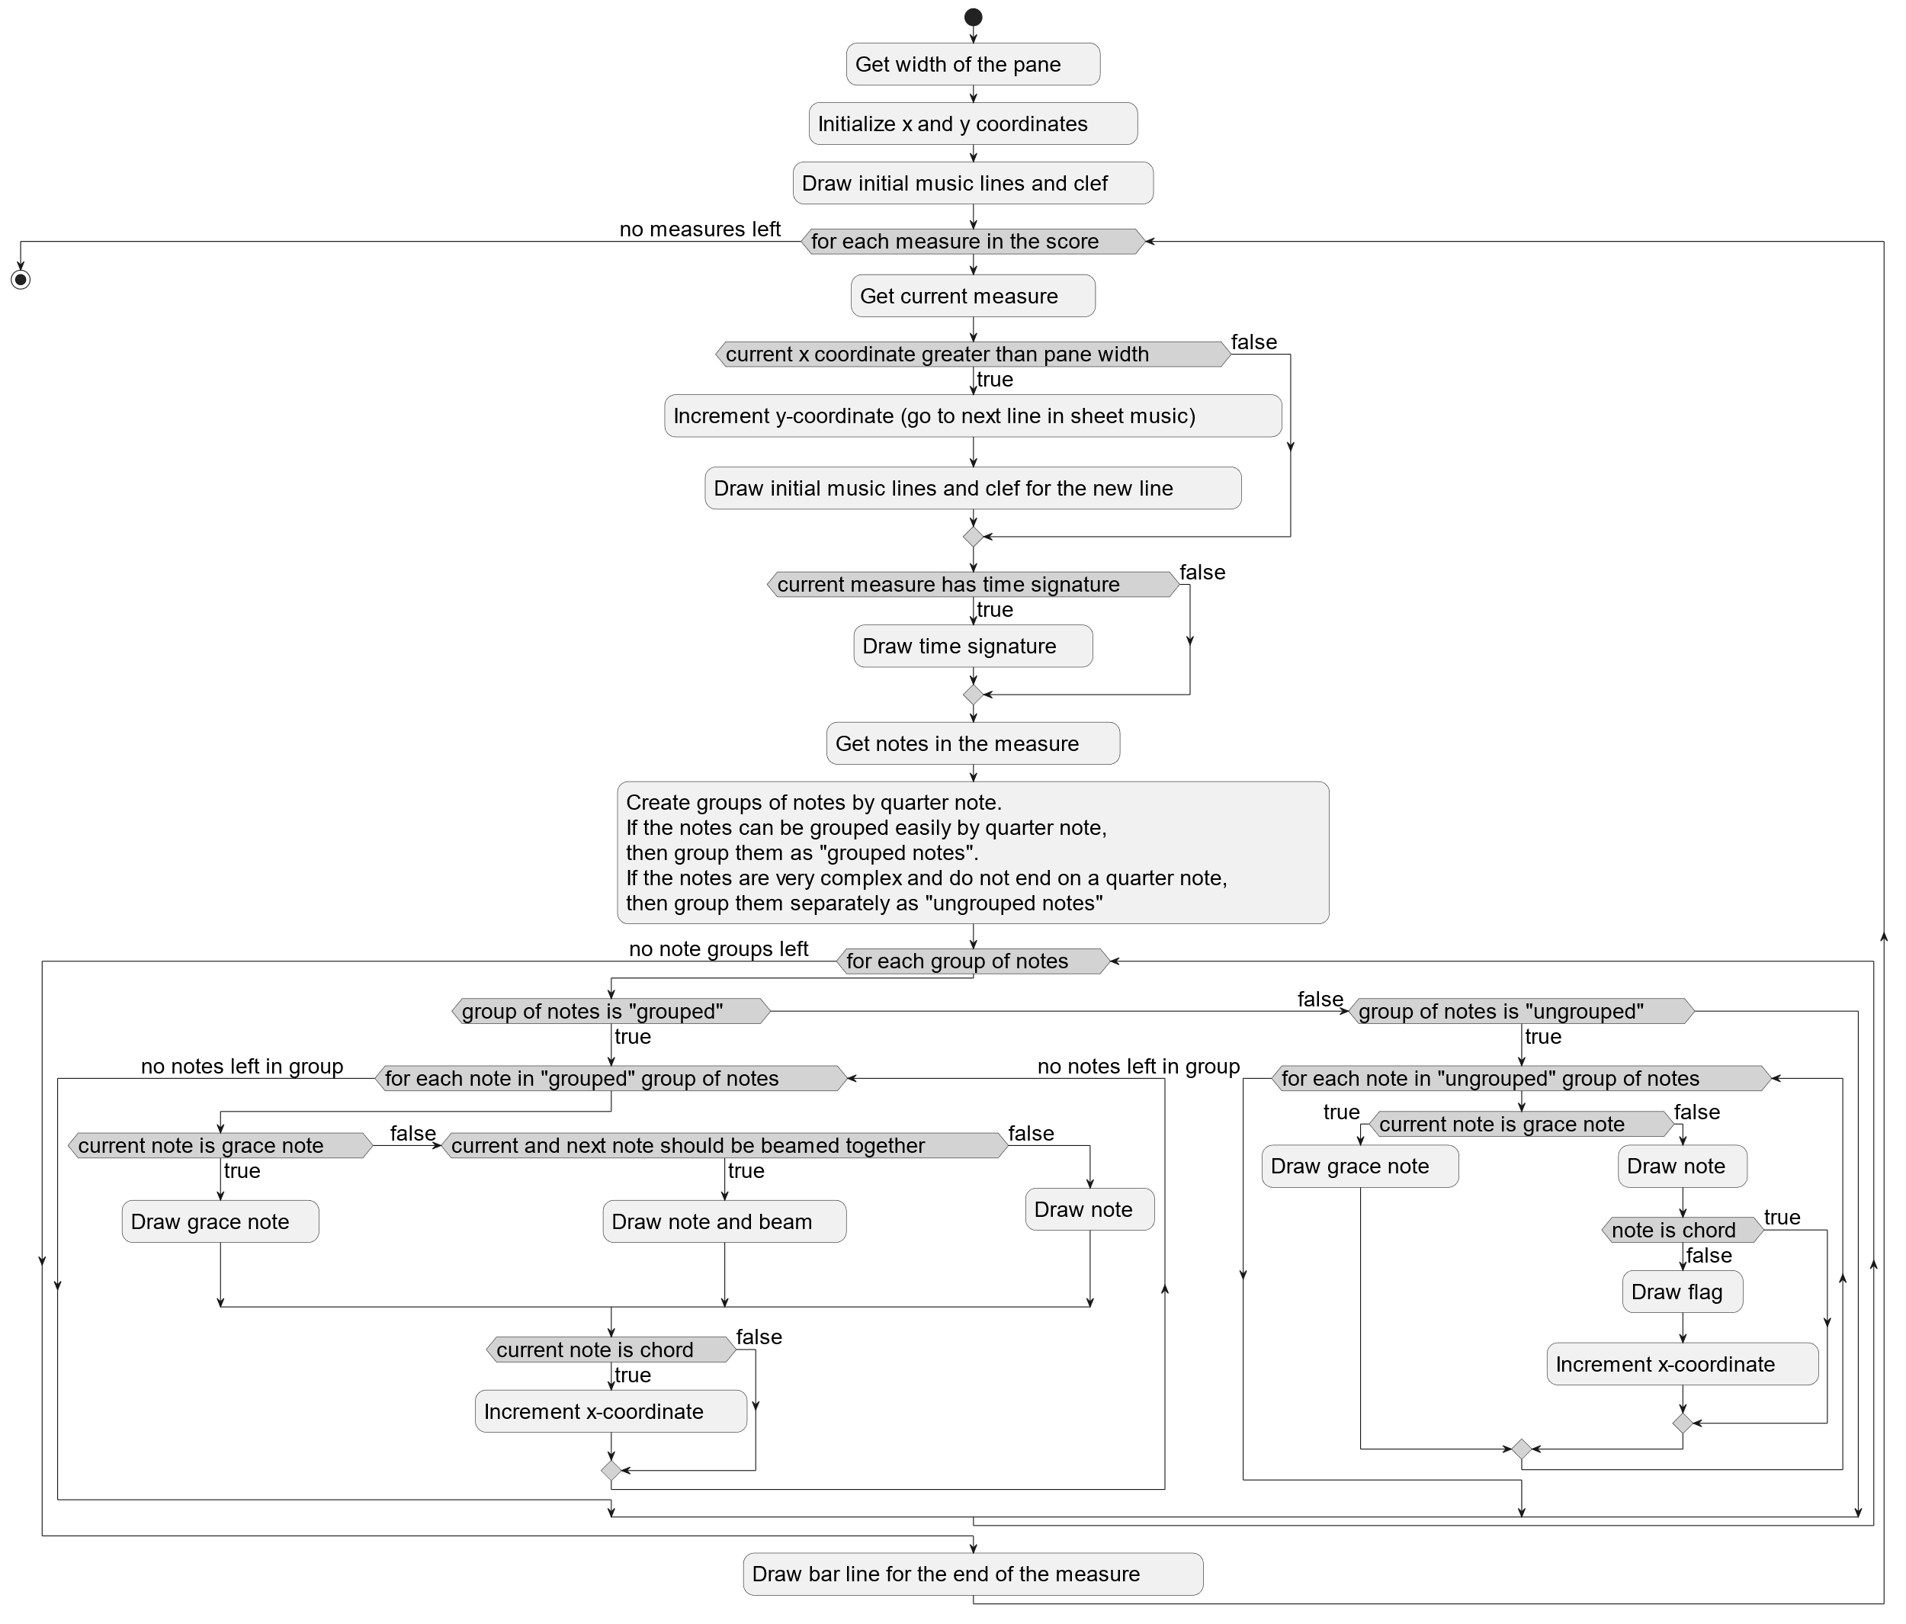

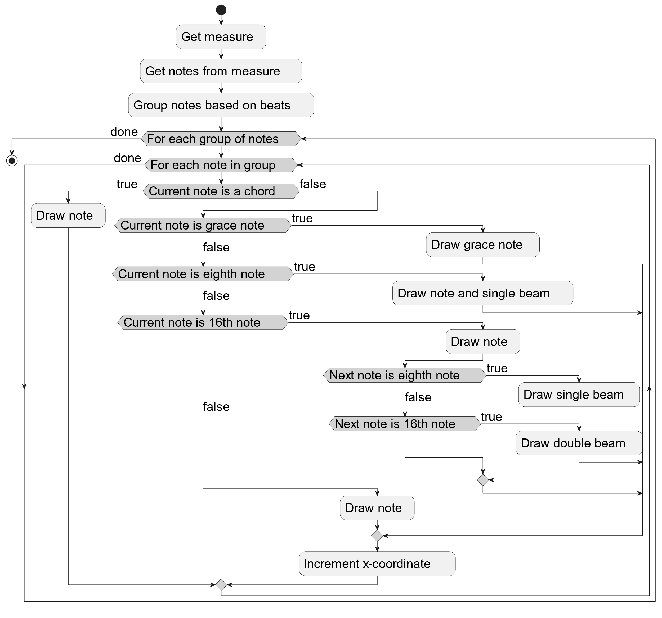

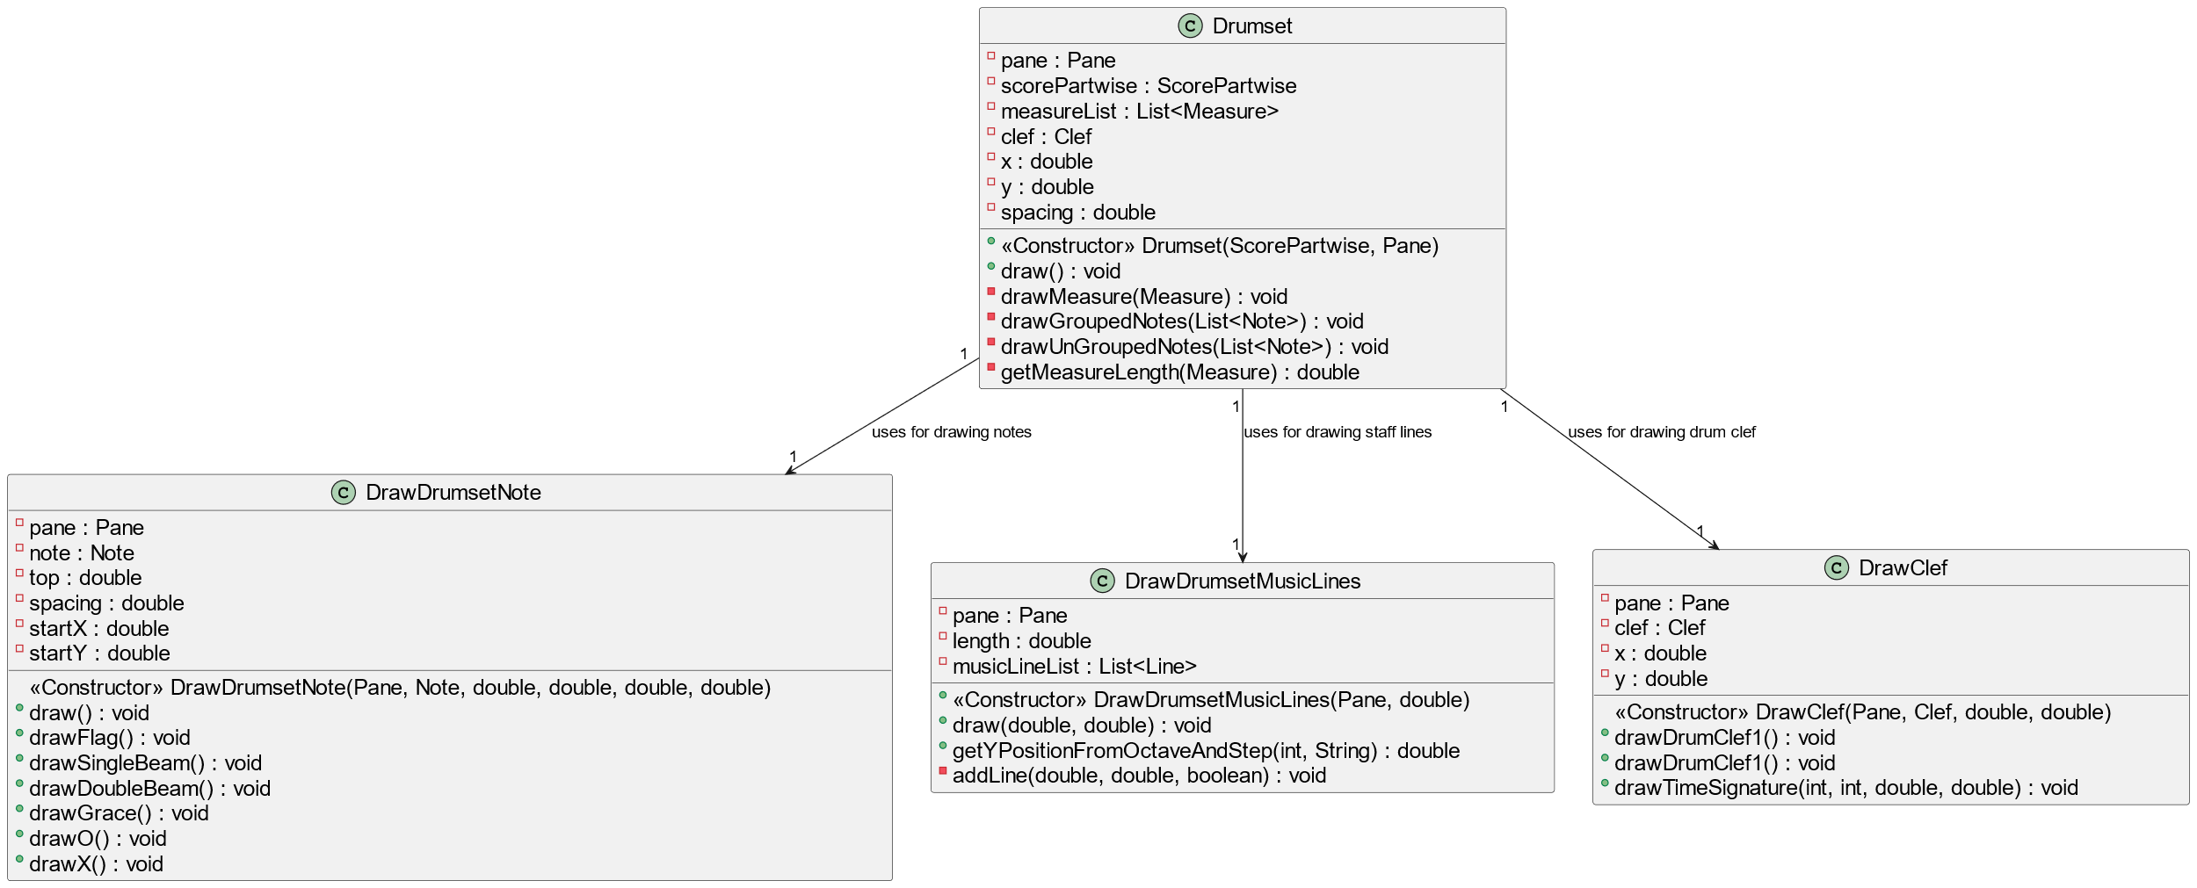

### Instrument: Bass

# **Playing the tablature**

### Instrument: Guitar

2.1.1 UML class diagram

### Instrument: Drum

2.2.1 UML class diagram

### Instrument: Bass

# **Printing the Music sheet**

Printer Sequence Diagram

Printer Activity Diagram

# **Go to measure**

**Group 6**

**Elmira Onagh**

**Irsa Nasir**

**Long Lin**

**Harjap Randhawa**

**Daniel Di Giovanni**