

**TAB2XML**

Requirements Document

**Group 6**

**Elmira Onagh**

**Irsa Nasir**

**Long Lin**

**Harjap Randhawa**

**Daniel Di Giovanni**



Winter 2022

**Table of Content**

**1.** **Functional Requirements** 2

**2.** **Non-functional Requirements** 2

**3.** **User Stories** 3

**4.** **Use Cases** 3

*Use Case 1* 3

*Use Case 2* 4

*Use Case 3* 4

*Use Case 4* 4

*Use Case 5* 4

**5.** **Use Case Diagram** 5

# **Functional Requirements**

The application must allow the users to:

* Preview the tablatures in the form of a music sheet.
* Make changes in the tablature and observe them in the music sheet.
* Print the music sheet by connecting to the printer.
* Save the music sheet in PDF form.
* Play the music notes starting from a selected measure to the end.
* Pause the playing when needed.
* Navigate to a specific Measure in the music sheet.

# **Non-functional Requirements**

The application should:

* Be available 24/7.
* Be intuitive to use.
* Be updatable.
* Perform effectively in different environments.
* Operate responsively in a timely manner.
* Operate properly with a very low rate of failures.

# **User Stories**

1. As a musician, I want to visualize a tablature; so, I can learn how to play a specific tune.
2. As a musician, I want to have the ability to make changes in the tablature and have them reflected in the music sheet immediately to see how the music sheet will evolve.
3. As a musician, I want to listen to specific Measures in the music sheet; so that I can hear how they sound.
4. As a musician, I want to print or save the music sheet; so that I can obtain a copy of it for my collection.

# **Use Cases**

#### *Use Case 1*

Title: Visualize a tablature as a music sheet

Primary actor: User (music learner)

Scenario:

1. The user inserts the tablature in the application
2. The system identifies the tablature
3. The system translates the tablature into music XML (visible image of music)
4. The system translates the music XML into a music sheet
5. User previews the music sheet

#### *Use Case 2*

Title: Print the music sheet

Primary actor: User (music learner)

Precondition: The user has already inserted and previewed the music sheet

Scenario:

1. The system prepares the music sheet for printing
2. User prints the music sheet or saves it as a PDF file.

#### *Use Case 3*

Title: Play the music sheet

Primary actor: User (music learner)

Precondition: The user has already inserted and previewed the music sheet

Scenario:

1. The system translates the music XML into a playable format
2. The user plays the music
   1. From the beginning to end
   2. Starting from a specific measure to end
   3. Replay
3. The user pauses the playing when necessary

#### *Use Case 4*

Title: Navigate to a specific measure

Primary actor: User (music learner)

Precondition: The user has already inserted and previewed the music sheet

Scenario:

1. The user navigates to a specific measure of music sheet
2. The user can navigate to the previous point

#### *Use Case 5*

Title: Update tablature

Primary actor: A human user (music learner)

Precondition: The user has already inserted and previewed the music sheet

Scenario:

1. User updates the tablature
2. The system reflects the change in the music sheet
3. User views the update in the music sheet and compares it with the previous ones.

# **Use Case Diagram**

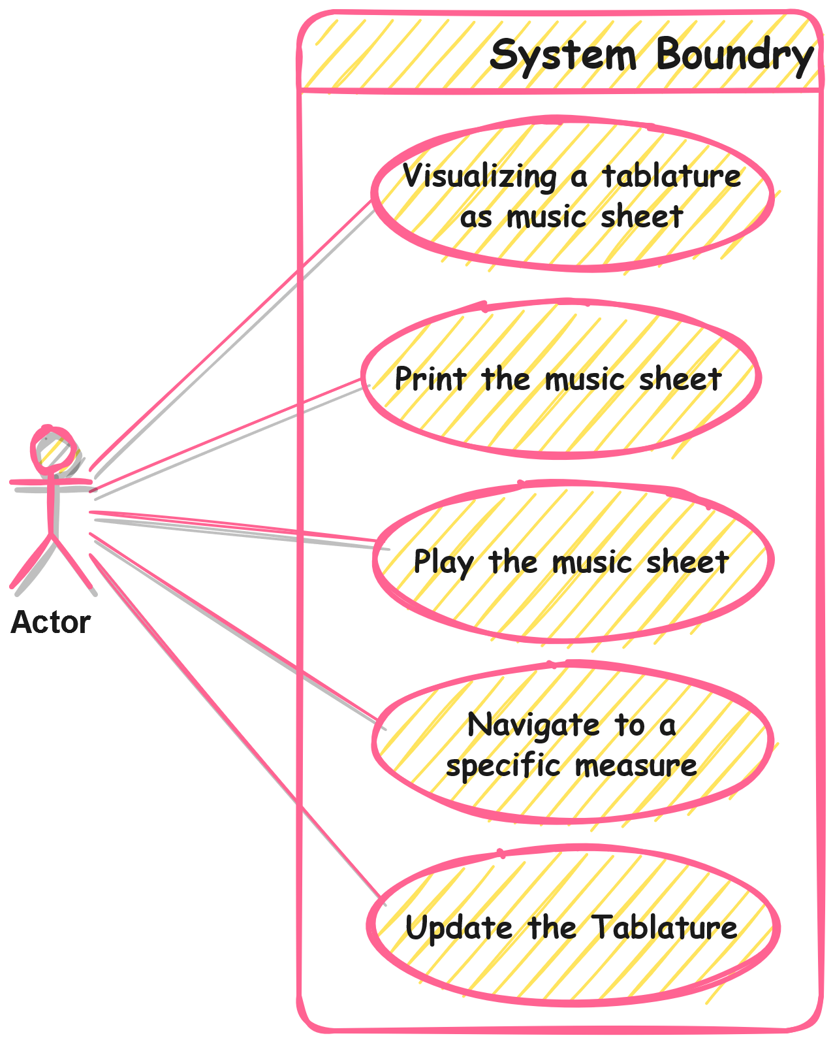

**Group 6**

**Elmira Onagh**

**Irsa Nasir**

**Long Lin**

**Harjap Randhawa**

**Daniel Di Giovanni**