

**TAB2XML**

User Manual

**Group 6**

**Elmira Onagh**

**Irsa Nasir**

**Long Lin**

**Harjap Randhawa**

**Daniel Di Giovanni**



Winter 2022

**Table of Content**

**System Overview** 2

**About TAB2XML** 2

**Intended Use** 2

**Installation Instructions** 3

**Installation on Eclipse IDE** 3

**Running the prototype** 8

**Running through Gradle Task Window** 8

**Error Handling** 9

**Using the prototype** 11

**Instrument: Guitar** 11

Previewing the music sheet 12

Playing the Notes 14

Printing and saving the music sheet 14

Navigating to a specific measure 14

Updating the Tablature 15

**Instrument: Drum** 16

Previewing the music sheet 16

Playing the Notes 18

Printing and saving the music sheet 18

Navigating to a specific measure 18

Updating the Tablature 19

# **System Overview**

## **About TAB2XML**

TAB2XML is a Java application that converts music tablature into MusicXML, a file format that represents musical notation. However, reading a MusicXML file is a tedious task. The new update introduces the ability to preview any specific MusicXML file created from a given tablature into Music Scores for a better understanding of the tablature.

Additionally, the new update includes three other features. Playing the notes, ability to print/save the music sheet as a PDF file and highlight a specific measure for navigation purposes.

Currently, only simple guitar and drum tablature are supported, but more instruments and additional support for more complicated tablature will be added in future releases.

## **Intended Use**

This application is intended to help both novice and expert music learners by allowing them to see a tablature in three different forms: tablature, music XML, and music sheet.

# **Installation Instructions**

In this section, we are going to cover the step-by-step instructions on how to install and run the TAB2XML software in eclipse IDE. For this purpose, we assume that the Java 17 and JavaFX library is already installed on the IDE and the user is able to access GitHub from their eclipse IDE. Additionally, the Gradle is installed and ready to use. The instructions are written in English, followed by reference images. You can also watch the instruction video on YouTube [here](https://youtu.be/e4EMPcAn35w).

## **Installation on Eclipse IDE**

1. Open eclipse and create/ navigate to a new workspace. Click on launch (figure 1).

Figure1. Launching eclipse workspace.

1. In the Package Explorer (usually on the left-hand side) select “Import projects” (figure 2). You can also open the import window by clicking on File → import…

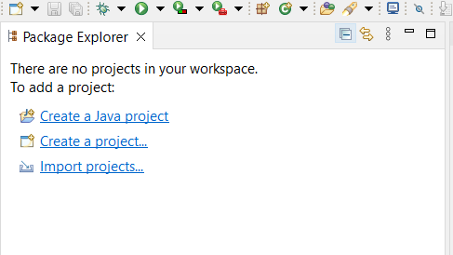

Figure 2. Package Explorer → import projects…

1. In the import window, select Git → Projects from Git. Click Next (figure 3)

Figure 3. Import window, select Projects from Git.

1. Then select “Clone URI” →Next. (Figure 4)

Figure 4. Select Clone URI.

1. In the URI enter the following link:

[**https://github.com/ElmiraOn/EECS2311_group6**](https://github.com/ElmiraOn/EECS2311_group6)

your import window should look like something like figure 5 with your username and password instead. (If your username and password are not set up check the first lecture on how to access GitHub using eclipse). After double-checking the fields, click Next.

Figure 5. Entering the URL of the repository

1. In the next window, keep default and click Next again (Figure 6)

Figure 6. Branch selection

1. Select the directory and click Next (Figure 7)

Figure 7. Setting the directory.

1. Wait for the cloning process to finish.
2. Keep the default and click next (figure 8)

Figure 8. Selecting Wizard

1. Click Finish

Figure 9. Final window for import

1. You should be able to see the application project displayed in Package Explorer.

Figure 10. The project is displayed in the package explorer.

# **Running the prototype**

## **Running through Gradle Task Window**

1. We Run this project through Gradle. To do this we need to open the “Gradle Task window” by Window →show view → others → search for the Gradle task in the search bar → open.

It will take a while for Gradle to build the project. In the end, the project folder will be displayed in the Gradle Task window

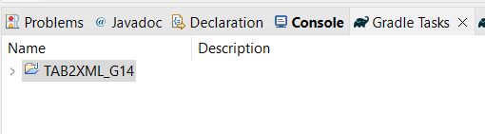

Figure 11. Project folder in the Gradle Task window.

1. To run the prototype open Tab2XML_G14 → application → Run in the Gradle task window

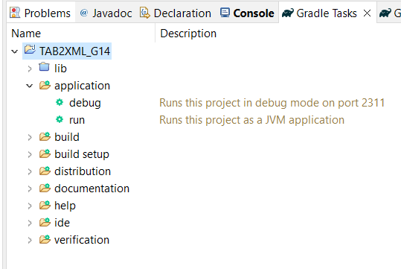

Figure 12. Navigating to “run” functionality in the Gradle task window.

## **Error Handling**

When you open the project in the Gradle task window or run it for the first time, you will likely face some errors. In this section we will discuss some methods you can try to fix these errors:

1. Under Preferences → Java→ Installed JREs make sure you have JRE 17(figure 13).

Figure 13. Installed JRE

1. Under Preferences → Gradle selects Gradle Version 7.3.3 (or 7.1.1) and under Advanced Options, point Java Home to JDK 17 by navigating to where you have stored JDK17 (figure 14).

Figure14. Gradle setting

1. In Eclipse Package Explorer, click on the three vertical dots.

Figure 15. Opening the menu in the package explorer

select Filters, and uncheck the “resources”, “Gradle build folder”, and “Gradle subprojects” so that they are visible

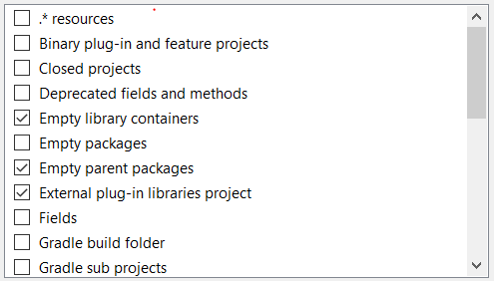

Figure 16. The “Java element filter” window

1. Right Click on the project → Gradle → Refresh Gradle Nature
2. If there are still errors when running the project, we suggest restarting the eclipse.

# **Using the prototype**

Currently, the prototype works only with the following two examples:

1. Guitar Tablature:

|-----------0-----|-0---------------|

|---------0---0---|-0---------------|

|-------1-------1-|-1---------------|

|-----2-----------|-2---------------|

|---2-------------|-2---------------|

|-0---------------|-0---------------|

1. Drum Tablature:

CC|x---------------|--------x-------|

HH|--x-x-x-x-x-x-x-|----------------|

SD|----o-------o---|oooo------------|

HT|----------------|----oo----------|

MT|----------------|------oo--------|

BD|o-------o-------|o-------o-------|

Additionally, you can use the following files under src/test/resources/system:

* bendTest1.txt (for Guitar)
* Ex38.txt (for Guitar)

## **Instrument: Guitar**

By entering the Guitar tablature from above, the system is able to:

1. Properly convert it into a music sheet.
2. print the music sheet or save it as a PDF file in the print dialogue.
3. Play the notes and chord from beginning to end
4. Vertical scrolling for long measures
5. By entering a measure number, highlight the corresponding measure on the screen
6. Allow users to return to the input window and update the tablature without the need to close the current preview window.

Unavailable functionalities: Pausing the playing capability

### Previewing the music sheet

1. Run the application as noted in the previous section (Gradle task window → application → run). This should open the main application window and you see that buttons are disabled:

Figure 17. The main application window/ input window

1. In the input area enter the guitar tablature from above by simply copy-pasting so saving the tablature file as a .txt file and use File → open and navigate to the location of the saved file:

Figure 18. Entering tablature enables the buttons

Entering the input in the correct format enables the buttons at the bottom. You can use “Show MusicXML” and “Save MusicXML” to view and save the MusicXML created using input tablature. For this documentation, we focus on the new update: “Preview Sheet Music”. Based on MuseScore Software this tablature corresponds to the following music score:

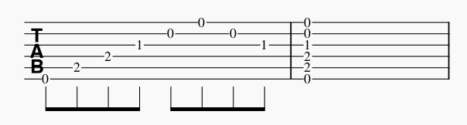

Figure 19. The Guitar tablature conversion in MuseScore app.

1. Clicking on “Preview Sheet Music” opens a new window with a Music score corresponding to the input tablature displayed on the screen. Additionally, you can see multiple buttons with different functionalities which are explained in the following sections.

Figure 20. Clicking on “Preview Music Sheet” opens the preview window.

### Playing the Notes

Clicking on the “Play Notes” button plays the notes from beginning to end. Pause and playing from the specific measure will be available in future releases. Please note that while the notes are being played, the other functionalities are not usable.

### Printing and saving the music sheet

Clicking on the “Print Music Sheet” button opens a print dialogue window where you can either select to print the music sheet using your preferred printer or save it as a PDF file.

Figure 21. Clicking on “Print Music Sheet” opens print dialogue.

**Note: if you decide to save as PDF, keep in mind that the saved .pdf file does not open automatically so make sure you take a note of the directory to which you are saving the file.

### Navigating to a specific measure

On the left bottom corner, you can enter a specific measure number and click on the “Go” button. The system will highlight the specified measure:

Figure 22. Entering a measure number and clicking on “Go” will highlight that measure

### Updating the Tablature

To Update/ change the tablature you can:

1. simply close the current preview window by clicking on either the close button or x on the top right corner. This will result in a confirmation message:

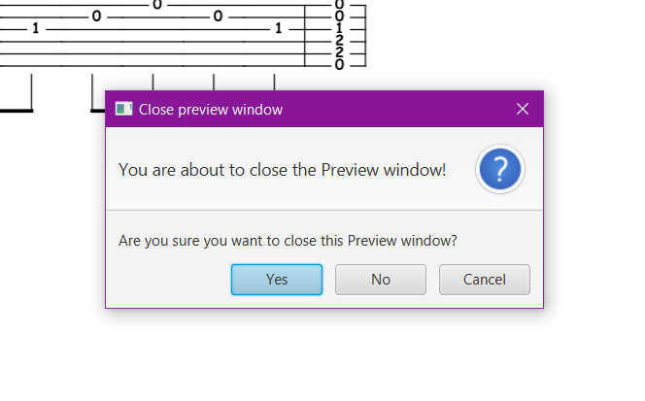

Figure 23. Confirmation message

Upon confirming the intention to close the window, you will be directed to the input window where you can make changes to the current tablature or enter a new tablature.

1. You can either minimize or move the current preview window and select the input window underneath it. Then you can make the changes you want and click on the preview button again to open a new preview window reflecting the changes you made. By using this functionality, you can compare the two preview windows to see how your changes are reflected on the music score:

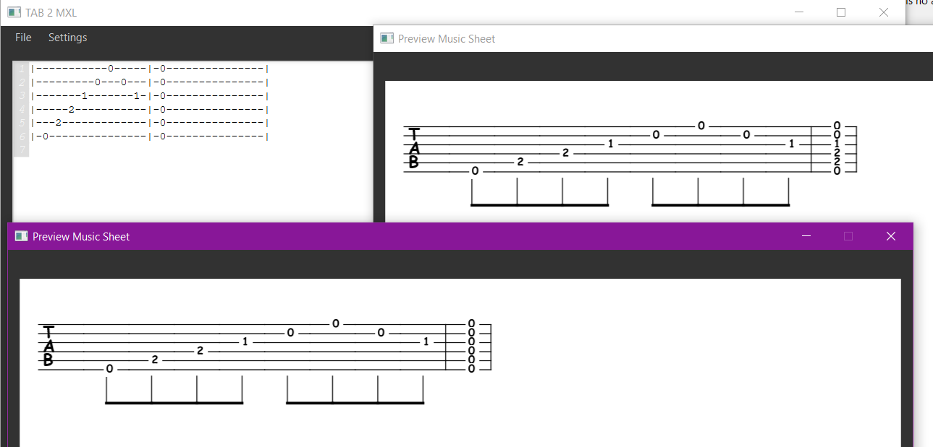

Figure 24. multiple preview windows to compare the changes made to the input tablature.

## **Instrument: Drum**

By entering the Drum tablature from above, the system is able to:

1. Properly convert it into a music sheet.
2. print the music sheet or save it as a PDF file in the print dialogue (currently only works once)
3. Play from beginning to end
4. Vertical scrolling for long measures
5. By entering a measure number, highlight the corresponding measure on the screen
6. Allow users to return to the input window and update the tablature without the need to close the current preview window

Unavailable functionalities: Pausing the playing capability

### Previewing the music sheet

The step to preview the music score for the drum tablatures is the same as the for the guitar tablature. After running the application simply enter the drum tablature into the input area by either copy-pasting or saving the tablature as a .txt file and opening it by File 🡪 open...

Figure 25. the drum tablature in the input area.

Entering the input in the correct format enables the buttons at the bottom and you can click on “Preview Sheet Music” at the bottom to open the preview window. Based on Muse Score Software this tablature corresponds to the following music score:

Figure 26. The Drum tablature conversion in Muse Score app.

Clicking on “Preview Sheet Music” opens a new window with a Music score corresponding to the input tablature displayed on the screen:

Figure 27. Clicking on “Preview Music Sheet” opens the preview window.

### Playing the Notes

Play functionality for the drum tablature is the same as for guitar tablature. Clicking on the “Play Notes” Button will play the notes of the music sheet from beginning to end. Note that other functionalities of the window will disable while the tune is being played and forcing other functionalities will result in an error and crashing of the system.

### Printing and saving the music sheet

The print function behaves as same previously and clicking on the Print button will open the print dialogue where you can either print or save the music sheet as a PDF file.

### Navigating to a specific measure

Like in the previous section, by entering a measure number in the Go-to Measure field, and clicking on the Go button, the system highlights the specified measure to differentiate it from the rest of the measures:

Figure 28. Entering a measure number and clicking on “Go” will highlight that measure

### Updating the Tablature

As in Guitar tablature, to update/change the tablature you can either close the current window, navigate to the input window, make the changes, and open a new preview window or keep the current window (move/ minimize), make the necessary changes in the input window, and open a new preview window to compare the two music scores to see how your changes affect the music score.

**Group 6**

**Elmira Onagh**

**Irsa Nasir**

**Long Lin**

**Harjap Randhawa**

**Daniel Di Giovanni**