Decentralized Academic Credential Registry
A Blockchain-Based System for Tamper-Proof Credential Issuance and Verification
Project Proposal — Bachelor's Thesis

1. Problem Statement
Academic credential fraud is one of the most pressing yet underestimated challenges facing educational institutions, employers, and governments worldwide. The global fake degree industry has grown into a staggering $22 billion USD enterprise, with estimates suggesting that an estimated 4.7 billion people globally have either acquired or been affected by fake degrees. The sophistication of modern forgery has reached alarming levels — in 2024 alone, digital diploma forgery made up 57% of all document frauds, a 244% increase from previous years, driven largely by AI-generated forgeries that are virtually indistinguishable from authentic documents.
The consequences extend far beyond individual deception. Diploma fraud can put lives at risk in industries such as healthcare and teaching, and employers who hire someone with a false degree may suffer productivity losses, quality issues, or even legal liability if that person is not truly qualified. Real-world cases make this danger concrete: in the United States, over 7,600 fake nursing degrees were sold through Florida-based schools, allowing unqualified individuals to sit national licensing exams.
Beyond outright fraud, the current verification process itself is deeply flawed. Traditional credential verification can take weeks, involves high administrative costs, and is highly vulnerable to fraudulent claims. In many countries, including Iran, the situation is compounded by the absence of a unified, reliable digital infrastructure. Employers are often forced to request physical copies of diplomas, contact universities directly, or rely on centralized web portals that are frequently unavailable or slow. Academic records remain scattered across disconnected systems, leading to data duplication, inconsistency, and a fundamental lack of trust.
The core problems can be summarized as three interconnected failures:
1. Fraud & Forgery — Paper-based and digitally-altered credentials can be manufactured by sophisticated criminal networks and are increasingly difficult to detect even by trained professionals.
2. Inefficient Verification — The current process of verifying academic credentials requires significant time, human effort, and bureaucratic coordination, often taking days or weeks.
3. Fragmented & Unreliable Systems — Academic records are duplicated across centralized databases vulnerable to downtime, manipulation, and single points of failure.
Blockchain technology presents a compelling answer: research shows that blockchain can reduce credential verification times from weeks to seconds and cut administrative costs by nearly 90%.

2. Proposed Solution & System Overview
This project proposes the design and implementation of a decentralized academic credential registry built on the Arbitrum blockchain. The system provides a transparent, tamper-proof, and universally accessible platform for issuing, storing, and verifying academic documents — without reliance on any central authority or intermediary.

Function 1 — Document Submission (Write)
An authorized Issuer (a verified institution) uploads a document to the system. To protect sensitive personal information, documents are encrypted prior to upload to IPFS (InterPlanetary File System), a decentralized peer-to-peer storage network. This ensures that even though the encrypted file exists on a public, decentralized network, its contents remain unreadable to anyone who does not hold proper decryption access — access that is granted exclusively by the Credential Owner. A cryptographic hash of the encrypted document is recorded on the Arbitrum blockchain through a smart contract, along with relevant metadata. Upon successful submission, the system returns a unique hash identifier — a permanent address representing that credential forever on the blockchain.

Function 2 — Document Retrieval & Verification (Read)
Anyone in possession of a credential's hash identifier can instantly query the smart contract to retrieve public metadata. Full document access requires explicit permission from the Owner. This verification process requires no intermediary, no phone call to a university, and no physical paperwork — it takes seconds and is available 24/7 from anywhere in the world.

Role-Based Access Control
- Admin Role — deploys the system and manages which institutions are authorized to issue credentials
- Issuer Role — granted to verified institutions permitted to upload and register documents
- Verifier Role — open to employers, government agencies, or any third party who needs to verify a credential
- Owner Role — the student or professional who owns the credential and controls access to it

Why Blockchain?
- Immutability — once recorded, a credential cannot be altered or deleted by any party, including the issuer
- Transparency — all transactions are publicly auditable, creating a complete and honest history
- Decentralization — no single point of failure
- Trustlessness — verification requires no trust in any institution or intermediary
- Speed — verification that previously took days or weeks now takes seconds

3. Actors & Use Cases

Actor 1 — Admin
The Admin is the entity that deploys the smart contracts and governs the top level of the system, controlling which institutions are granted Issuer privileges.
- Deploy and initialize the smart contract system
- Register and approve verified institutions as Issuers
- Revoke Issuer privileges from institutions if necessary

Actor 2 — Issuer (University / Institution)
The Issuer is a verified academic institution granted permission to submit credentials. It is the only entity authorized to write data to the blockchain, ensuring all credentials originate from a trusted, verified source.
- Upload a graduate's academic document (encrypted) to IPFS
- Register the document's IPFS hash and metadata on-chain
- Issue the unique hash identifier to the credential owner
- Revoke a credential if issued in error or under fraudulent circumstances
- Set expiry rules per credential: permanent or time-limited

Actor 3 — Credential Owner (Student / Graduate)
The Credential Owner is the individual to whom the credential belongs. Each credential is linked to their wallet address, making them the true owner of their academic record.
- Receive their unique hash identifier after issuance
- View all credentials associated with their wallet address
- Share their hash identifier with employers or institutions
- Grant specific wallet addresses access to their full document
- Revoke access from a previously authorized wallet

Actor 4 — Verifier (Employer / Third Party)
The Verifier is any external party who needs to confirm the authenticity of a credential. Verification requires only the hash identifier — no registration, no account, no trust in any central authority.
- Enter a hash identifier into the public verification interface
- Instantly retrieve public metadata: issuer, document type, issue date, validity status
- Request full document access from the Credential Owner

Privacy Model Summary
Data | Who Can See It
Metadata (issuer, date, type, status) | Anyone with the hash
Full document (PDF on IPFS) | Only wallets granted access by the Owner
Credential ownership (wallet address) | Public on-chain
Revocation status | Public on-chain

4. Functional Requirements

4.1 Institution Management (Admin Functions)
- FR-1: The system shall allow the Admin to register a new institution as an authorized Issuer.
- FR-2: The system shall allow the Admin to revoke an institution's Issuer privileges.
- FR-3: The system shall allow the Admin to view a list of all registered Issuers and their status.
- FR-4: The system shall restrict all Admin functions to a single authorized Admin wallet address.
- FR-5: The system shall emit an on-chain event whenever an Issuer is added or removed.

4.2 Credential Issuance (Issuer Functions)
- FR-6: The system shall allow only verified Issuers to submit new credentials.
- FR-7: The system shall require the Issuer to upload the encrypted document to IPFS and obtain its content hash (CID).
- FR-8: The system shall allow the Issuer to record metadata on-chain: recipient address, document type, field of study, institution name, issue date, expiry option (permanent/time-limited), expiry date if applicable, and IPFS hash.
- FR-9: The system shall generate and return a unique on-chain identifier for every issued credential.
- FR-10: The system shall allow the Issuer to revoke a previously issued credential.
- FR-11: The system shall automatically mark a credential as Expired once its expiry date has passed.
- FR-12: The system shall NOT allow automatic renewal of expired credentials — re-issuance requires a new submission.

4.3 Credential Ownership & Access Control (Owner Functions)
- FR-13: The system shall associate every issued credential with the recipient's wallet address as the Owner.
- FR-14: The system shall allow the Owner to view all credentials linked to their wallet.
- FR-15: The system shall allow the Owner to grant document-viewing access to a specific wallet address.
- FR-16: The system shall allow the Owner to revoke previously granted access at any time.
- FR-17: The system shall keep the full document access-restricted while metadata remains publicly queryable.

4.4 Credential Verification (Verifier Functions)
- FR-18: The system shall allow any user to query public metadata using only the hash identifier — no registration required.
- FR-19: The system shall display the credential's current status: Valid, Expired, or Revoked.
- FR-20: The system shall allow a Verifier to request document access from the Owner directly through the interface.
- FR-21: The system shall prevent modification of credential metadata after issuance, except for authorized status changes.

4.5 System-Wide Requirements
- FR-22: The system shall maintain a complete, permanent, publicly auditable history of every issuance, revocation, and expiry event.
- FR-23: The system shall be deployed on the Arbitrum network for low transaction costs and fast confirmation.
- FR-24: The system shall be designed modularly, allowing future extension to other institution types.
- FR-25: The smart contracts shall be thoroughly tested to prevent common vulnerabilities.

5. Non-Functional Requirements

5.1 Security
- NFR-1: All smart contracts shall be protected against reentrancy attacks, integer overflow/underflow, and unauthorized access.
- NFR-2: Access control shall be enforced strictly at the contract level using role-based modifiers (Admin, Issuer, Owner).
- NFR-3: All state-changing functions shall validate the caller's role before execution.
- NFR-4: The system shall undergo static analysis and thorough testing before deployment.
- NFR-5: Private document access shall be managed through cryptographic access grants — documents are encrypted (AES-256) before upload to IPFS, and the encryption key is wrapped separately for each approved wallet using its public key, so unauthorized wallets cannot read restricted content even if they know the IPFS hash.

5.2 Performance
- NFR-6: Credential verification queries shall return results in under 3 seconds under normal conditions.
- NFR-7: Credential issuance shall be confirmed within standard Arbitrum block confirmation time.
- NFR-8: The system shall be optimized for low gas consumption, storing only essential metadata and hashes on-chain.

5.3 Scalability
- NFR-9: The architecture shall support an unlimited number of Issuers without redesign.
- NFR-10: The system shall support high-volume issuance without performance degradation, leveraging Arbitrum's Layer-2 scalability.
- NFR-11: The modular contract design shall allow future integration of additional institution types.

5.4 Usability
- NFR-12: The verification interface shall require no technical blockchain knowledge from Verifiers.
- NFR-13: The Issuer dashboard shall provide a simple, guided workflow for uploading documents.
- NFR-14: Error messages shall be clear, human-readable, and informative.

5.5 Reliability & Availability
- NFR-15: The system shall have no single point of failure — both IPFS and blockchain storage are decentralized.
- NFR-16: The system shall remain fully operational even if the frontend application is offline.
- NFR-17: The system shall maintain 100% data integrity — core credential data shall never be alterable once issued.

5.6 Maintainability
- NFR-18: Smart contracts shall be documented using NatSpec comments.
- NFR-19: The codebase shall follow established Solidity style guides and best practices.
- NFR-20: Smart contracts shall be deployed as immutable, non-upgradeable contracts. This design decision reinforces the trustless and tamper-proof nature of the system, ensuring that no party — including the system Admin — can alter contract logic after deployment. Any future improvements shall be deployed as new contract versions, with historical data remaining permanently accessible under the original contract.

6. System Architecture
The system is composed of four major layers, each responsible for a distinct part of the overall functionality.

Layer 1 — Blockchain Layer (Smart Contracts on Arbitrum)
The trust and logic core of the system: a set of immutable smart contracts responsible for managing roles, recording credential metadata, enforcing access control, and emitting events for every issuance, revocation, and access grant. Deployment on Arbitrum inherits Ethereum-level security while benefiting from lower transaction costs and faster confirmation times.

Layer 2 — Decentralized Storage Layer (IPFS)
Stores the actual document files, already encrypted before upload. IPFS ensures no single server hosts the file, content-addressing (the CID is derived from the file's content), and long-term availability through pinning services. The blockchain layer never stores the document itself — only its CID.

Layer 3 — Encryption & Access Control Layer
Sits between the Owner's browser and the other two layers. It generates a random AES-256 key for each document at upload time, encrypts the document with that key before it is sent to IPFS, and encrypts the AES key itself with the recipient's public key (asymmetric key wrapping), storing that encrypted key reference on-chain. When the Owner grants access to a new Verifier, this layer re-encrypts the AES key using the Verifier's public key, entirely client-side. This layer is implemented in the frontend using standard, well-tested JavaScript cryptography libraries.

Layer 4 — Application Layer (Frontend Interface)
The interface through which all actors interact with the system: an Issuer Dashboard for uploading documents, an Owner Dashboard for managing credentials and access grants, and a Public Verification Page for instant status checks. The frontend communicates with the blockchain via Ethers.js and connects to IPFS through a gateway or pinning service.
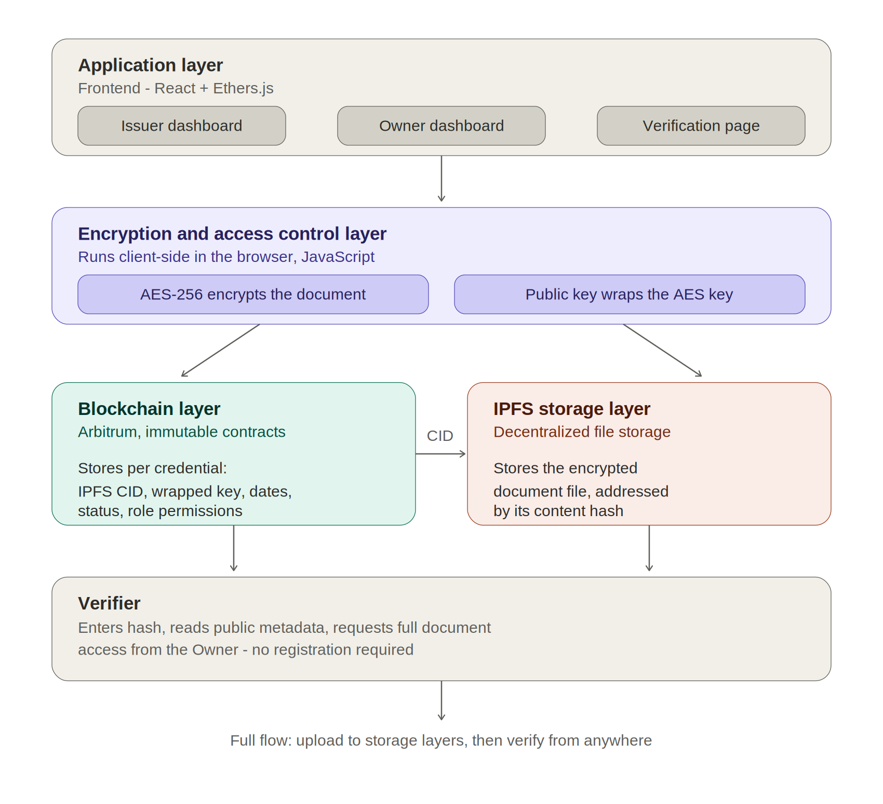
Figure 1. System architecture — application, encryption, blockchain, and storage layers.

Data Flow — Issuance
Issuer uploads document → document encrypted (AES-256) in browser → encrypted file uploaded to IPFS, returns CID → AES key encrypted with Owner's public key → smart contract stores CID, metadata, encrypted key, and expiry rules → contract returns unique credential hash → hash delivered to Owner.

Data Flow — Verification
Verifier enters credential hash → smart contract returns public metadata (issuer, type, date, status) → if full document requested, Owner grants access → Owner re-encrypts AES key for Verifier's public key → Verifier's browser decrypts key and decrypts document from IPFS.

7. Technology Stack
Layer | Tool
Smart Contracts | Solidity 0.8.x
Dev Environment | Foundry / Forge
Target Network | Arbitrum Sepolia (testnet)
Storage | IPFS
Encryption | AES-256 + public-key wrapping (eth-crypto, Web Crypto API)
Frontend | React + Ethers.js
Wallet | MetaMask

8. Roadmap
Month 1 — System design finalization, Foundry project setup, core smart contract development (UniversityRegistry, CredentialRegistry, access control).
Month 2 — Encryption/access control module, full test suite, deployment to Arbitrum Sepolia, contract verification.
Month 3 — Frontend development — Issuer dashboard, Owner dashboard, public verification page, wallet integration.
Month 4 — Security review, documentation, final testing, thesis writing and defense preparation.

