Design Decisions & Rationale
Decentralized Academic Credential Registry — Design Phase Log

1. Purpose of This Document
This document records the full design phase, following the approval of the project proposal: the reasoning behind each structural decision made for the system's data models, the two-contract architecture, and the three core interaction flows, plus the resulting class diagram, sequence diagrams, and state machine. The goal throughout is to make the design process transparent — not just presenting final diagrams, but showing why each choice was made, what alternatives were weighed, and what was rejected and why.

2. Design Process Overview
The design phase began from the four core entities identified during the proposal stage — Credential, Institution, Owner, and Access Grant — and worked through each field to decide the most appropriate data type and storage strategy, balancing three competing concerns: on-chain gas cost, extensibility across multiple institutions, and query-ability from the frontend.

3. Decision Log

3.1 Document Type — String vs Enum
Initially, document type (e.g., Bachelor's, Master's, Certificate) was modeled as a free-text string. This was reconsidered for three reasons:
- Cost — strings are significantly more expensive to store on-chain than a small integer, and this field is written once per credential, meaning the cost is paid repeatedly at scale.
- Consistency — free text allows different institutions to describe the same credential type inconsistently (e.g., "BSc" vs "Bachelor's Degree"), undermining the system's reliability as a verification source.
- Usability — a numeric enum can still be displayed as a readable label in the frontend, so no usability is lost by moving away from strings.
Decision: documentType is modeled as a fixed Solidity enum. The frontend maintains a lookup table mapping each numeric value to a human-readable label.
enum DocumentType { Bachelor, Master, Certificate, PhD, Diploma }

3.2 Major / Field of Study — Fixed Enum vs Dynamic Registry
The same reasoning that motivated moving documentType away from a string initially suggested a fixed enum for major as well. However, two options were compared before finalizing this field:
Option A — Fixed Solidity enum: Cheapest and simplest, but permanently locked at deployment. Since the system is intended to serve many institutions over time, a fixed list risks becoming a blocker whenever a new field of study needs to be added (e.g., "Data Science"), since Solidity enums cannot be extended after deployment.
Option B — Dynamic on-chain registry: A mapping (uint16 → string) maintained by the Admin, who can register new majors over time via an addMajor() function. Credentials store only the numeric majorId, keeping the same gas efficiency as an enum, while remaining extensible indefinitely.
Decision: Option B was selected. This reflects the system's stated goal of remaining adaptable to institutions beyond the initial university use case, without requiring contract redeployment every time a new field of study needs to be supported.
mapping(uint16 => string) public majors;
uint16 public majorCount;
function addMajor(string memory name) external onlyAdmin {
majors[majorCount] = name;
majorCount++;
}

3.3 Institution Name — String vs Numeric Registry
Given the pattern established above, it was worth explicitly checking whether institution names should follow the same numeric-registry approach. The conclusion was no, for a structurally different reason:
- Frequency of storage differs — documentType and major are written on every single credential (potentially thousands of times), so numeric encoding produces real, repeated gas savings. An institution's name is written once, at registration time, and referenced afterward via its wallet address, not re-written per credential.
- The wallet address already serves as the unique identifier for an institution — the name is only a display label attached to that address, not a repeated on-chain value.
- A numeric registry here would add a layer of indirection with no measurable gas benefit, since the string is only ever stored once regardless of encoding.
Decision: institution name remains a plain string field on the Institution struct. This decision illustrates that the enum/registry pattern used elsewhere is a response to per-credential repetition specifically — not a blanket rule for all text fields in the system.

3.4 Credential Status — Active, Expired, Revoked
The credential lifecycle required a clear distinction between two failure states that are easy to conflate: expiry and revocation.
 | Expired | Revoked
Trigger | Time itself, automatic | Issuer, manual action
Was the credential ever valid? | Yes — simply time-limited by design | Validity is being retracted — something is wrong
Applies to permanent credentials? | No — permanent credentials never expire | Yes — even a permanent degree can be revoked, e.g., for academic fraud discovered later

Decision: status is modeled as an enum with three values, and isTimeLimited / expiryDate remain separate fields so that expiry logic can be evaluated automatically (by comparing block.timestamp to expiryDate) without requiring any on-chain state transition to be manually triggered.
enum Status { Active, Expired, Revoked }

3.5 Access Grants — Why Not a Struct?
The other entities in the system (Credential, Institution) are each modeled as a struct, since they bundle several related fields that are read and written together as a unit. Access grants were deliberately not modeled the same way, and three approaches were compared before settling on a plain nested mapping:
Struct + array per credential: An AccessGrant struct (credentialId, grantedTo, encryptedKeyForGrantee, grantedDate, revoked) stored in a growable array. This most closely mirrors how Credential and Institution are modeled, and would let the Owner query the full access list directly from the contract. However, arrays of structs are expensive to grow on-chain, and Solidity has no native "delete" for a specific array element without either leaving a gap or manually shifting every subsequent element — both add unnecessary gas cost and code complexity for a feature that is fundamentally just a permission flag, not a rich record.
Struct + mapping (keyed, no array): mapping(bytes32 => mapping(address => AccessGrant)), storing the full struct per grantee instead of just the key. This avoids the array deletion problem, but most of the struct's fields (grantedDate, revoked) are only ever needed for display purposes, not for any on-chain logic — the contract itself never reads them to make a decision. Paying storage cost for fields the contract logic never uses is wasted gas.
Plain nested mapping, no struct: mapping(bytes32 => mapping(address => bytes)), storing only the one field the contract actually needs to enforce access: the wrapped encryption key itself. Everything else about a grant — when it happened, whether it was later revoked — is descriptive metadata, not something the contract needs to check to do its job. That metadata is emitted as event data instead, which is far cheaper to write than contract storage, and is exactly what events are designed for.
Decision: no AccessGrant struct is defined. A grant is represented purely as the presence (or emptiness) of an entry in accessGrants[credentialId][wallet]. All descriptive metadata about the grant lives in AccessGranted / AccessRevoked events instead of on-chain state, and the frontend reconstructs the Owner's full access history by indexing those events. This keeps on-chain storage limited to the single value the contract logic actually depends on.
mapping(bytes32 => mapping(address => bytes)) accessGrants;
// credentialId => granteeWallet => encryptedKeyForGrantee
// (no struct: existence/value of this entry IS the grant)

4. Finalized Data Models

4.1 Credential
Field | Type | Notes
id | bytes32 | Unique on-chain identifier
owner | address | Student's wallet
issuer | address | Institution's wallet
ipfsCID | string | Encrypted document's IPFS hash
encryptedKey | bytes | AES key wrapped for the owner
documentType | enum DocumentType | Bachelor, Master, Certificate, PhD, Diploma
majorId | uint16 | References the dynamic Major registry
issueDate | uint256 | Timestamp
isTimeLimited | bool | Whether an expiry applies
expiryDate | uint256 | 0 if permanent
status | enum Status | Active, Expired, Revoked

4.2 Institution
Field | Type | Notes
institutionAddress | address | Unique identifier
name | string | Written once at registration
isApproved | bool | Current Issuer status
approvedDate | uint256 | Timestamp of Admin approval

4.3 Major Registry
Field | Type | Notes
majors | mapping(uint16 => string) | Admin-extensible list
majorCount | uint16 | Next available ID

4.4 Access Grant
Modeled as a mapping rather than a stored struct list:
mapping(bytes32 => mapping(address => bytes)) accessGrants;
Access history reconstructed off-chain from events, not stored as queryable on-chain state.

4.5 Events
- CredentialIssued(id, owner, issuer, timestamp)
- CredentialRevoked(id, timestamp)
- AccessGranted(credentialId, grantee, timestamp)
- AccessRevoked(credentialId, grantee, timestamp)
- InstitutionApproved(institutionAddress, name)
- InstitutionRevoked(institutionAddress)
- MajorAdded(majorId, name)

6. Class Diagram
Following the data model decisions above, the system is split into two contracts rather than three. Admin and Institution management are grouped together in AccessControlRegistry, since both represent low-frequency "who is allowed to do what" logic. CredentialRegistry holds the high-frequency logic — issuance, revocation, and access grants — and depends on AccessControlRegistry only for two permission checks: confirming the caller is an approved Issuer, and confirming a submitted majorId is valid. This keeps the permission logic auditable on its own, without cluttering the core credential logic with admin bookkeeping.
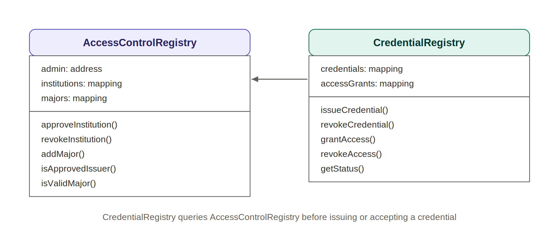
Figure 2. Class diagram — AccessControlRegistry and CredentialRegistry.

7. Sequence Diagrams

7.1 Issue Credential
An Issuer uploads a document; all encryption happens client-side in the browser before anything is sent to IPFS or the blockchain. The two self-referencing steps on Browser represent the AES encryption of the document and the wrapping of that AES key with the Owner's public key — neither step ever leaves the browser or touches a server.
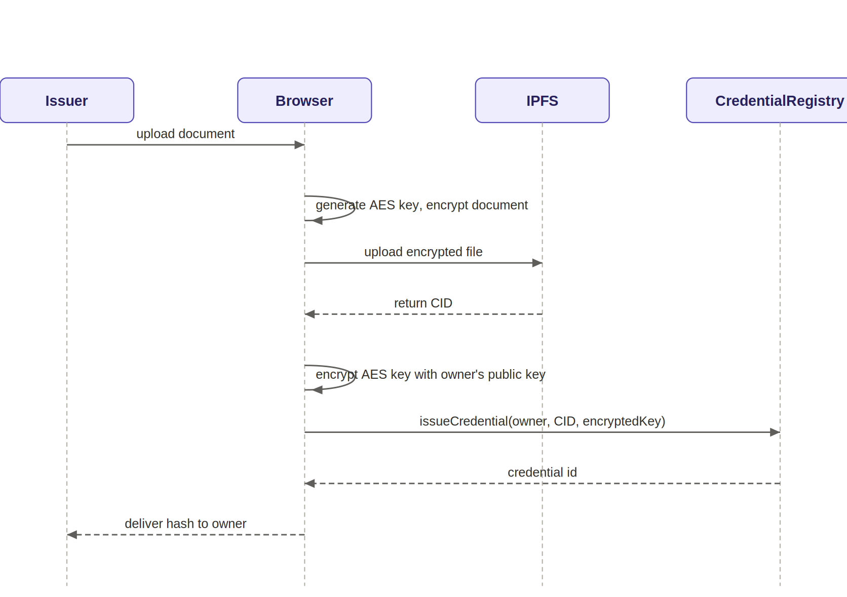
Figure 3. Sequence diagram — issuing a credential.

7.2 Grant Access
This is the flow that lets an Owner share a specific document with a Verifier, without ever exposing the raw document key. The Owner decrypts the AES key locally using their own private key, re-encrypts (wraps) it for the Verifier's public key, and submits only the wrapped version to the contract. The contract never sees the unwrapped key at any point.
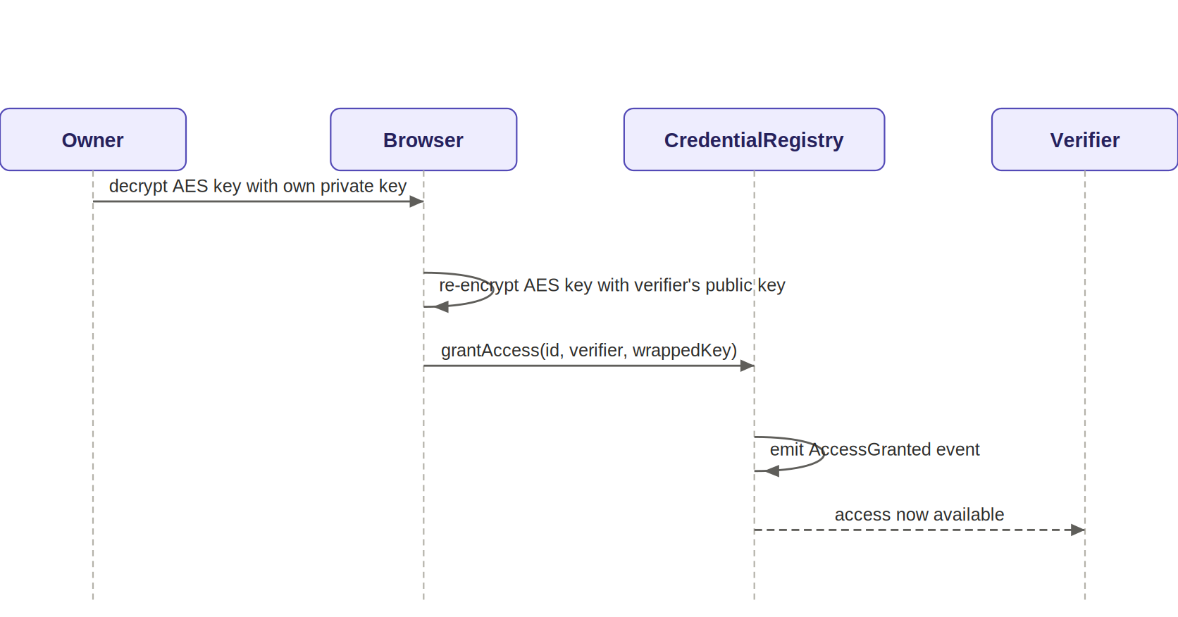
Figure 4. Sequence diagram — granting document access.

7.3 Verify Credential
Verification happens in two independent stages. The top half — reading status, issuer, type, and date — requires only the credential hash and no wallet connection at all, matching FR-18. The bottom half — viewing the full document — only proceeds if the Verifier has already received a wrapped key through the Grant Access flow; without that prior grant, the Verifier can see that a credential is valid but cannot open the document itself.
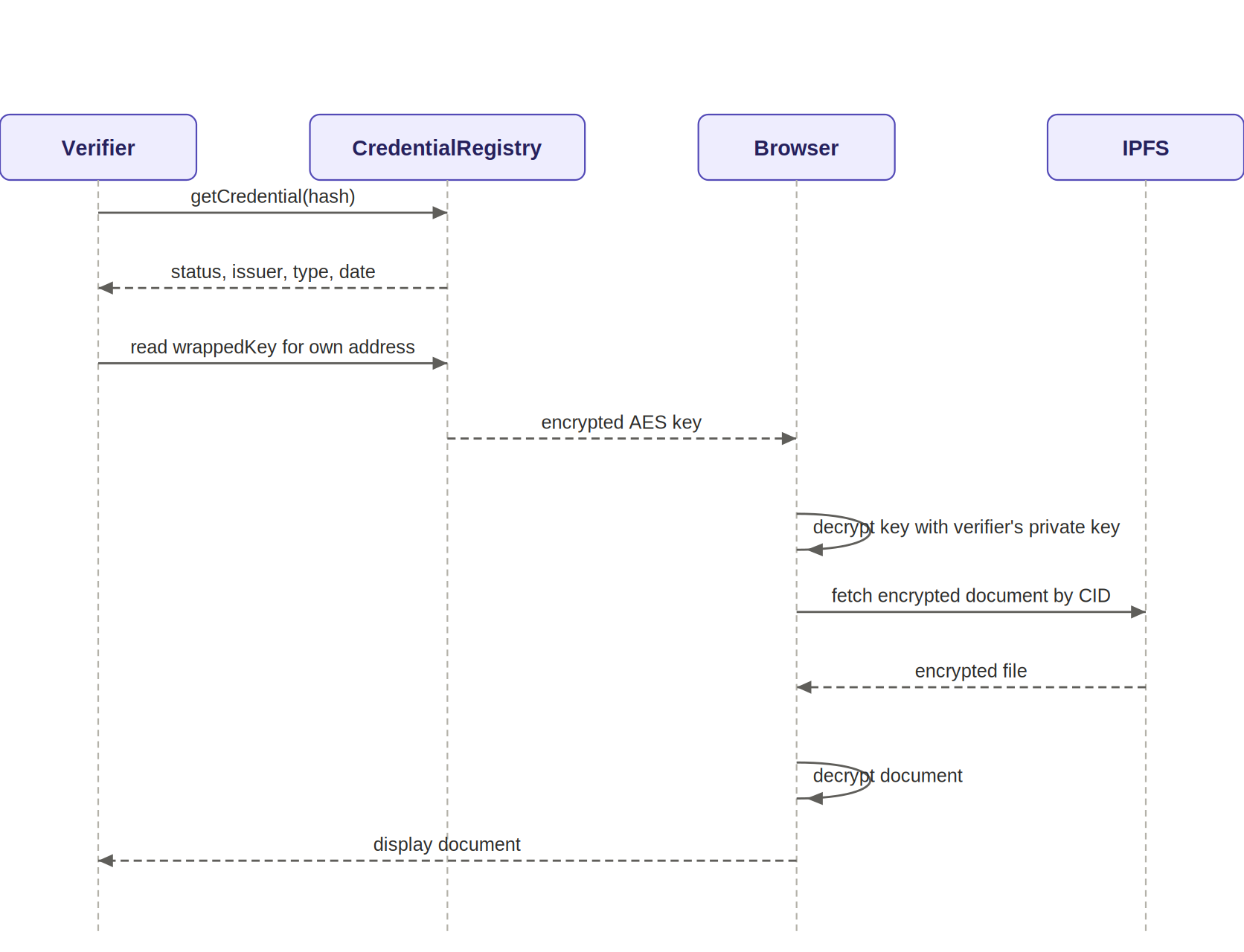
Figure 5. Sequence diagram — verifying a credential.

8. State Machine — Credential Lifecycle
The credential lifecycle has three states with two independent paths into Revoked. Active is the state every credential starts in. Active transitions to Expired only for time-limited credentials, once expiryDate has passed — this transition is evaluated automatically by comparing block.timestamp to expiryDate, not triggered by any manual action. Separately, both Active and Expired credentials can transition to Revoked at any time, since revocation reflects a problem discovered with the credential itself (fraud, error, misconduct) rather than the passage of time — this is why a permanent credential, which never reaches Expired, can still be revoked years after issuance. There is no path back to Active from either terminal state, matching FR-12: an expired or revoked credential is never automatically renewed, only reissued as a new credential.
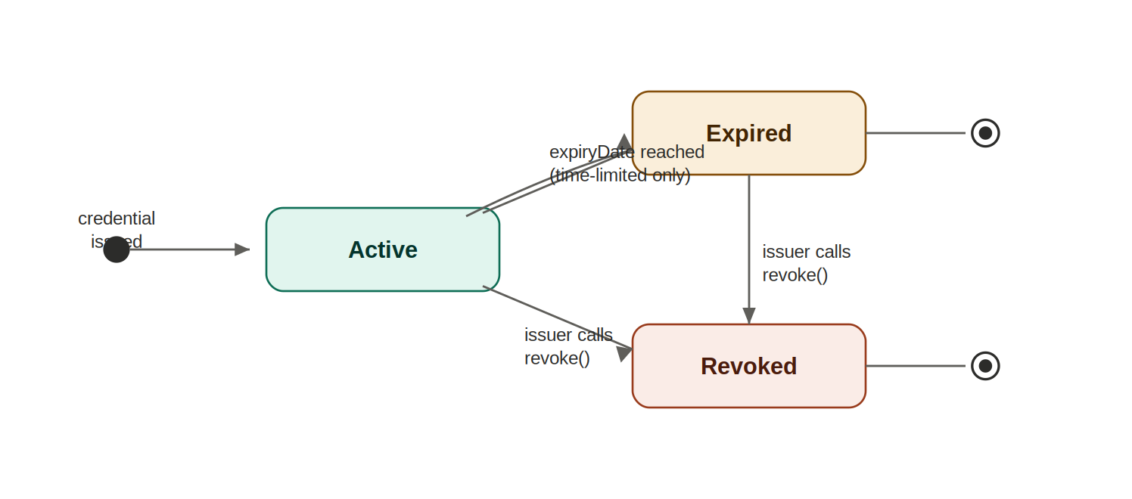
Figure 6. State machine diagram — credential status.

9. Design Phase Summary
With the data models, class diagram, sequence diagrams, and state machine now complete, the design phase covers everything needed to begin implementation with confidence: every field's type is justified, the contract boundaries are drawn along genuine responsibility lines, and every core flow — issuance, access granting, and verification — has been traced step by step. CRC cards, an activity diagram, and a CRUD matrix were considered and deliberately excluded, as the two-contract system is simple enough that the class diagram and sequence diagrams already capture that information without redundant restatement. Implementation begins next, using Foundry, targeting Arbitrum Sepolia.

