Tabriz University of Technology
Faculty of Electrical and Computer Engineering
BSc Project Report
Computer Engineering
A Decentralized System for Registering and Verifying Academic Credentials on the Blockchain
Attestera
Prepared by
Elmira Taghinasab
October 2026

Abstract
Registering, storing and verifying academic credentials still depends, in many institutions, on centralized databases and paper-based procedures. This makes forgery possible and makes verification slow and expensive. This project designs and implements a decentralized system named Attestera that issues, revokes and verifies academic credentials on a blockchain while keeping the content of the document itself confidential. The architecture rests on two immutable smart contracts deployed on the Arbitrum layer-2 network: one manages the authorization of issuing institutions, and the other stores credential metadata, credential status and access keys. Before leaving the browser, each document is encrypted with AES-256-GCM and stored on IPFS; the AES key is wrapped for each recipient with the ECIES scheme on the secp256k1 curve, so only the credential holder decides who may read the document. Sixty-four automated tests, comprising unit, fuzz, invariant and integration tests, confirm the behavior of the contracts, and the system is deployed with a web interface on the Arbitrum Sepolia test network. The results show that verification without intermediaries, and without disclosing the document content, is feasible.
Keywords: Blockchain, Smart Contract, Academic Credential, Cryptography, IPFS, Arbitrum

Contents
Abstract i
Chapter 1 Introduction 1
1.1 Problem Statement and Motivation 1
1.2 Goals and Innovation 1
1.3 Related Work 1
1.4 Scope and Limitations of the Project 2
1.5 Report Structure 2
Chapter 2 Background and Prerequisites 3
2.1 Blockchain and Smart Contracts 3
2.2 Layer-2 Networks and Arbitrum 4
2.3 Decentralized Storage with IPFS 5
2.4 Cryptography Fundamentals 5
Chapter 3 System Analysis and Design 8
3.1 Actors and Requirements 8
3.2 Threat Model 9
3.3 Architecture 9
3.4 Contract Design 10
3.5 Cryptographic Design 12
3.6 Access Granting and Verification Flows 12
Chapter 4 Implementation 14
4.1 The AccessControlRegistry Contract 14
4.2 The Credential Contract 15
4.3 The Browser Cryptography Module 16
4.4 Storage on IPFS 17
4.5 Web Interface, Storage and Deployment 18
4.6 Real Problems and Solutions 21
Chapter 5 Testing and Evaluation 22
5.1 Test Strategy 22
5.2 Fuzz Tests 22
5.3 Invariant Tests 23
5.4 Live Evaluation 24
5.5 Security Analysis 24
5.6 Known Limitations 25
Chapter 6 Summary, Conclusions and Suggestions 26
6.1 Introduction 26
6.2 Summary of the Work 26
6.3 Conclusions 26
6.4 Suggestions for Future Work 27
References 29

Chapter 1 Introduction

1.1 Problem Statement and Motivation
An academic credential is one of the most important documents of a professional life, yet verifying it still depends, in many institutions, on correspondence, manual confirmation, or the centralized database of a single university. This situation has three weaknesses: forged credentials are hard to detect, verification is slow and costly, and the credibility of a credential is tied to the survival and honesty of one institution. On the other hand, publishing the document itself is unacceptable because of the personal information it contains.
A blockchain is a shared, immutable ledger that no single party controls, and it is well suited to recording, in a provable way, who issued what and when [1]. Storing the document itself on-chain, however, is expensive and public. The problem addressed in this project is how the validity of a credential can be verified publicly and without intermediaries, while the content of the document remains readable only to those whom the holder has authorized.

1.2 Goals and Innovation
• Design and implement two smart contracts that manage issuing institutions and handle the registration, revocation and access control of credentials.
• Encrypt the document in the browser before it leaves the device and store it on IPFS, so that no central server ever sees the plaintext.
• Place access control in the hands of the holder: the document key is wrapped separately for every recipient.
• Test the contracts automatically and deploy the whole system on the Arbitrum Sepolia test network.
The practical novelty of the work is the combination of three things in one complete, runnable system: a cryptographic key pair derived from a wallet signature (so no new private key is stored), key wrapping with ECIES for each recipient, and the recording of these wrapped keys on-chain.

1.3 Related Work
EduCTX offers a blockchain-based credit and credential framework for higher education [16]. Blockcerts is an open standard for issuing credentials anchored to a blockchain, and it records only the hash of the credential [19]. Gräther and colleagues have examined a similar model [17], and the W3C standard defines the Verifiable Credentials data model [18]. Table 1.1 shows how this project differs; the comparison focuses on document confidentiality and access control.
Table 1.1. Comparison of the Attestera approach with related work
Feature | Blockcerts | EduCTX | Attestera
On-chain proof of registration | Yes | Yes | Yes
Document encryption and per-recipient access | Not a main focus | Not a main focus | Yes
Document storage | Off-chain | Off-chain | Encrypted IPFS
Institution authorization | Off-chain list | Central body | Smart contract

1.4 Scope and Limitations of the Project
This project is a functional proof of concept and not a commercial product ready for production use. The system is deployed on the Arbitrum Sepolia test network and uses tokens of no monetary value. The scope includes the smart contracts, the browser-side cryptography module, the connection to IPFS, the web interface and the automated tests. The following items were deliberately left out of scope: off-chain legal verification of issuing institutions, integration with universities' academic systems, support for contract wallets, and a professional security audit of the contracts. The known security limitations are reviewed in full in Chapter 5.

1.5 Report Structure
The rest of this document is organized into five chapters and a closing list of references.
• Chapter 2 explains the basic concepts from scratch: blockchain, smart contracts, layer-2 networks, IPFS, and cryptography, including hashing, symmetric and asymmetric encryption, digital signatures and key wrapping.
• Chapter 3 describes the requirements, actors, threat model, architecture, data model and cryptographic design of the system.
• Chapter 4 describes the implementation, with the code of the contracts, the cryptography module and the web interface, and recounts the real problems that came up.
• Chapter 5 presents the test strategy, the test results, the live deployment, the security analysis and the limitations.
• Chapter 6 contains the summary, conclusions and suggestions for future work.
• At the end comes the list of references.

Chapter 2 Background and Prerequisites

2.1 Blockchain and Smart Contracts
A blockchain is a ledger that groups transactions into blocks. Each block contains the hash of the previous block, so changing any old block changes the hash of every later block and is exposed immediately. Thousands of independent nodes keep a copy of the ledger and agree on the next block through a consensus rule, so no single party can rewrite history [1].
Ethereum made the blockchain programmable: a smart contract is a program stored at its own address on the blockchain and executed by the Ethereum Virtual Machine (EVM) [2][3]. All nodes reproduce and verify the result of the execution, and once deployed the code cannot be changed. Every transaction carries a fee, so the cost of execution matters. The layer-2 network Arbitrum executes transactions outside the first layer and records the result on Ethereum, which reduces fees considerably [4]. The term "smart contract" itself goes back to Nick Szabo in the 1990s [28].

2.1.1 Blocks, Chains and Hashes
Transactions are collected in batches into units called blocks. Besides the transactions, each block carries its timestamp, its block number and, most importantly, the hash of the previous block. A hash, explained in more detail in the cryptography section, is a unique digital fingerprint of data: if even a single bit of the data changes, the fingerprint becomes completely different. Because every block carries the fingerprint of the one before it, blocks lock together like the links of a chain, as Figure 2.1 shows.
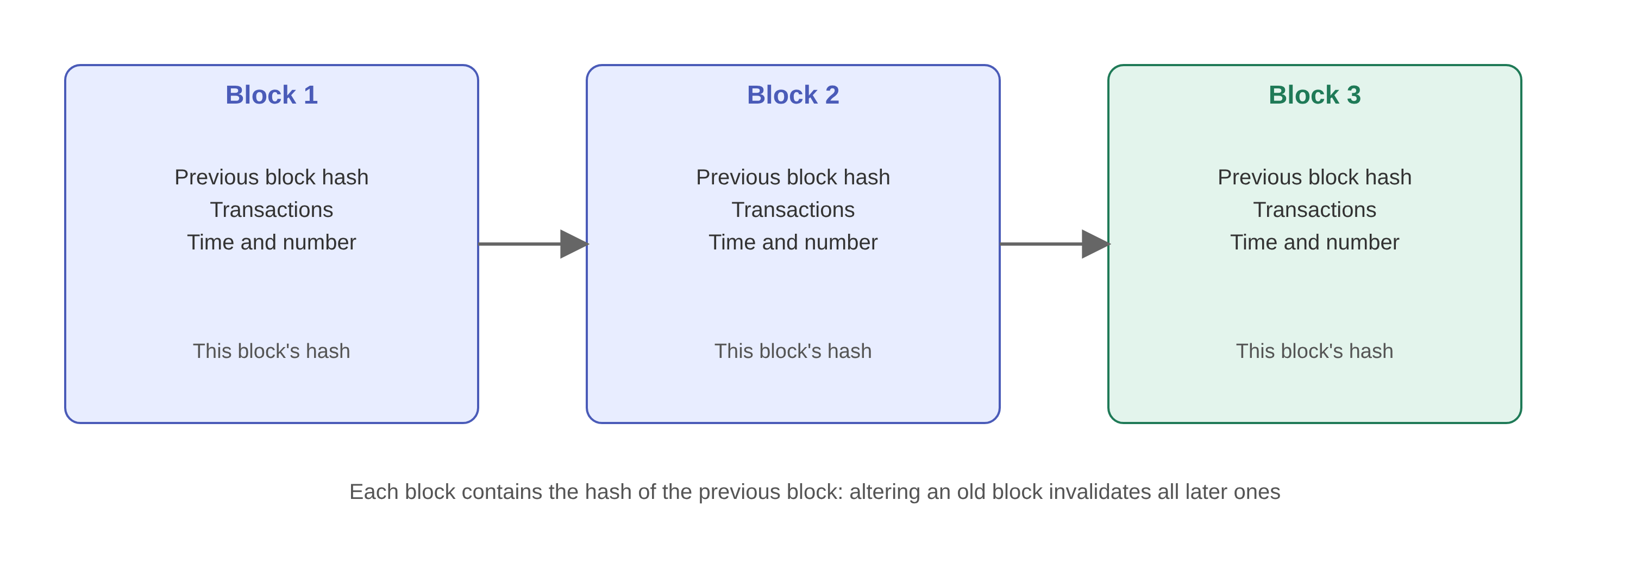
Figure 2.1. Blocks linked through the hash of the previous block
The result of this structure is immutability. Suppose someone wants to tamper with a transaction in block number 100. The hash of that block changes, so block 101, which stored the old hash, is no longer valid; to compensate, block 101 would have to change too, and so on up to the last block. In a network with thousands of independent nodes, doing this is practically impossible.

2.1.2 Accounts, Transactions and Fees
On Ethereum every participant has an account with an address, a 42-character string such as 0xaF5e…52ac, derived from the participant's public key. To do anything on the network, such as transferring currency or calling a function, the account owner must build a transaction and sign it with their private key. Anyone can check the signature and be sure that the sender really owns the address, without having access to the private key. This mechanism is explained in the digital signature section.
Executing a transaction consumes network resources, so it costs money. The unit of computational work is called gas, and the sender pays some currency for every unit of gas. Each basic operation has a fixed gas cost; for example, writing a new value into a contract's permanent storage is far more expensive than a simple addition. This has a direct effect on our design: every byte written on-chain costs money, which is why the actual document is entrusted to IPFS and only small metadata stays on-chain.

2.2 Layer-2 Networks and Arbitrum
Because of congestion, executing a transaction on the Ethereum mainnet can cost tens of dollars, which is not economical for issuing an academic credential. The common solution is layer-2 networks: networks that execute transactions outside the first layer and post only a compact summary of the results, and when needed proofs, to Ethereum.
Arbitrum belongs to the family of optimistic rollups [4]. These rollups assume that a submitted batch is correct, and only if someone claims fraud is a fraud-proof procedure run on the first layer. Figure 2.2 summarizes this flow. For a contract developer the experience is almost the same as Ethereum: the same language, the same tools and the same wallet, but with much lower fees and latency. We use the Arbitrum Sepolia test network, whose chain ID is 421614.
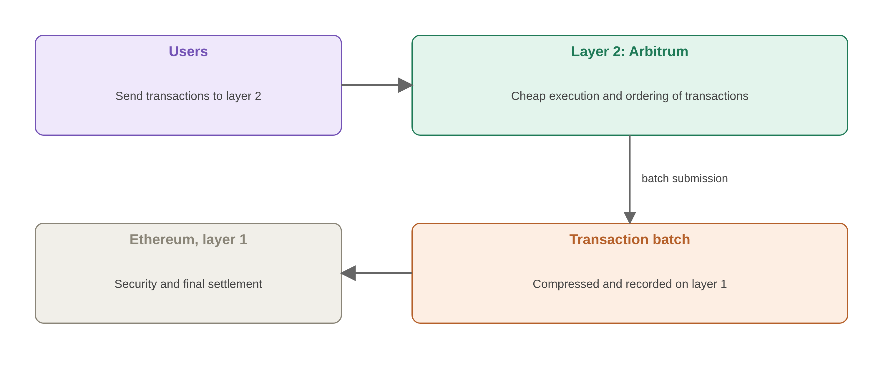
Figure 2.2. Relationship between the layer-2 network and the first layer

2.3 Decentralized Storage with IPFS
IPFS addresses files by their content: the content identifier (CID) is built from the hash of the content, so any change to the file changes the CID, and the recipient can check the integrity of the file [5]. IPFS is not private, however; anyone who knows the CID can read the file. For this reason the document must be encrypted before it is uploaded.

2.4 Cryptography Fundamentals
Cryptography covers three needs: confidentiality (only authorized parties can read), integrity (tampering becomes visible) and authenticity (the sender is identified). The tools used in this project fall into four categories.
• Hash functions such as SHA-256: map any input to a fixed 256-bit output; they are irreversible, and changing one bit of the input changes the output completely.
• Symmetric encryption such as AES-256-GCM: one key both encrypts and decrypts [6]. The GCM mode produces an integrity tag in addition to confidentiality, and tampering with the ciphertext causes an error during decryption. Each encryption needs a random 12-byte IV that must never repeat with the same key [7][30].
• Asymmetric encryption on the secp256k1 elliptic curve: each user has a private key and a public key. Through Elliptic Curve Diffie-Hellman key exchange (ECDH), two parties arrive at a shared secret without ever sending it [10][11].
• Digital signatures: the wallet signs a message with the private key, and anyone can verify the signature against the wallet address. The EIP-191 standard specifies the format of the signed message [21].
The key idea is hybrid encryption: asymmetric encryption is slow and limited to short messages, while AES is fast. So the document is encrypted with a random AES key, and only this 32-byte key is wrapped with the recipient's public key. The ECIES scheme does this: an ephemeral key pair is generated, ECDH yields a shared secret, the HKDF function derives a fresh AES key from it [12], and the document key is encrypted with that key [13]. Figure 2.3 shows this structure.
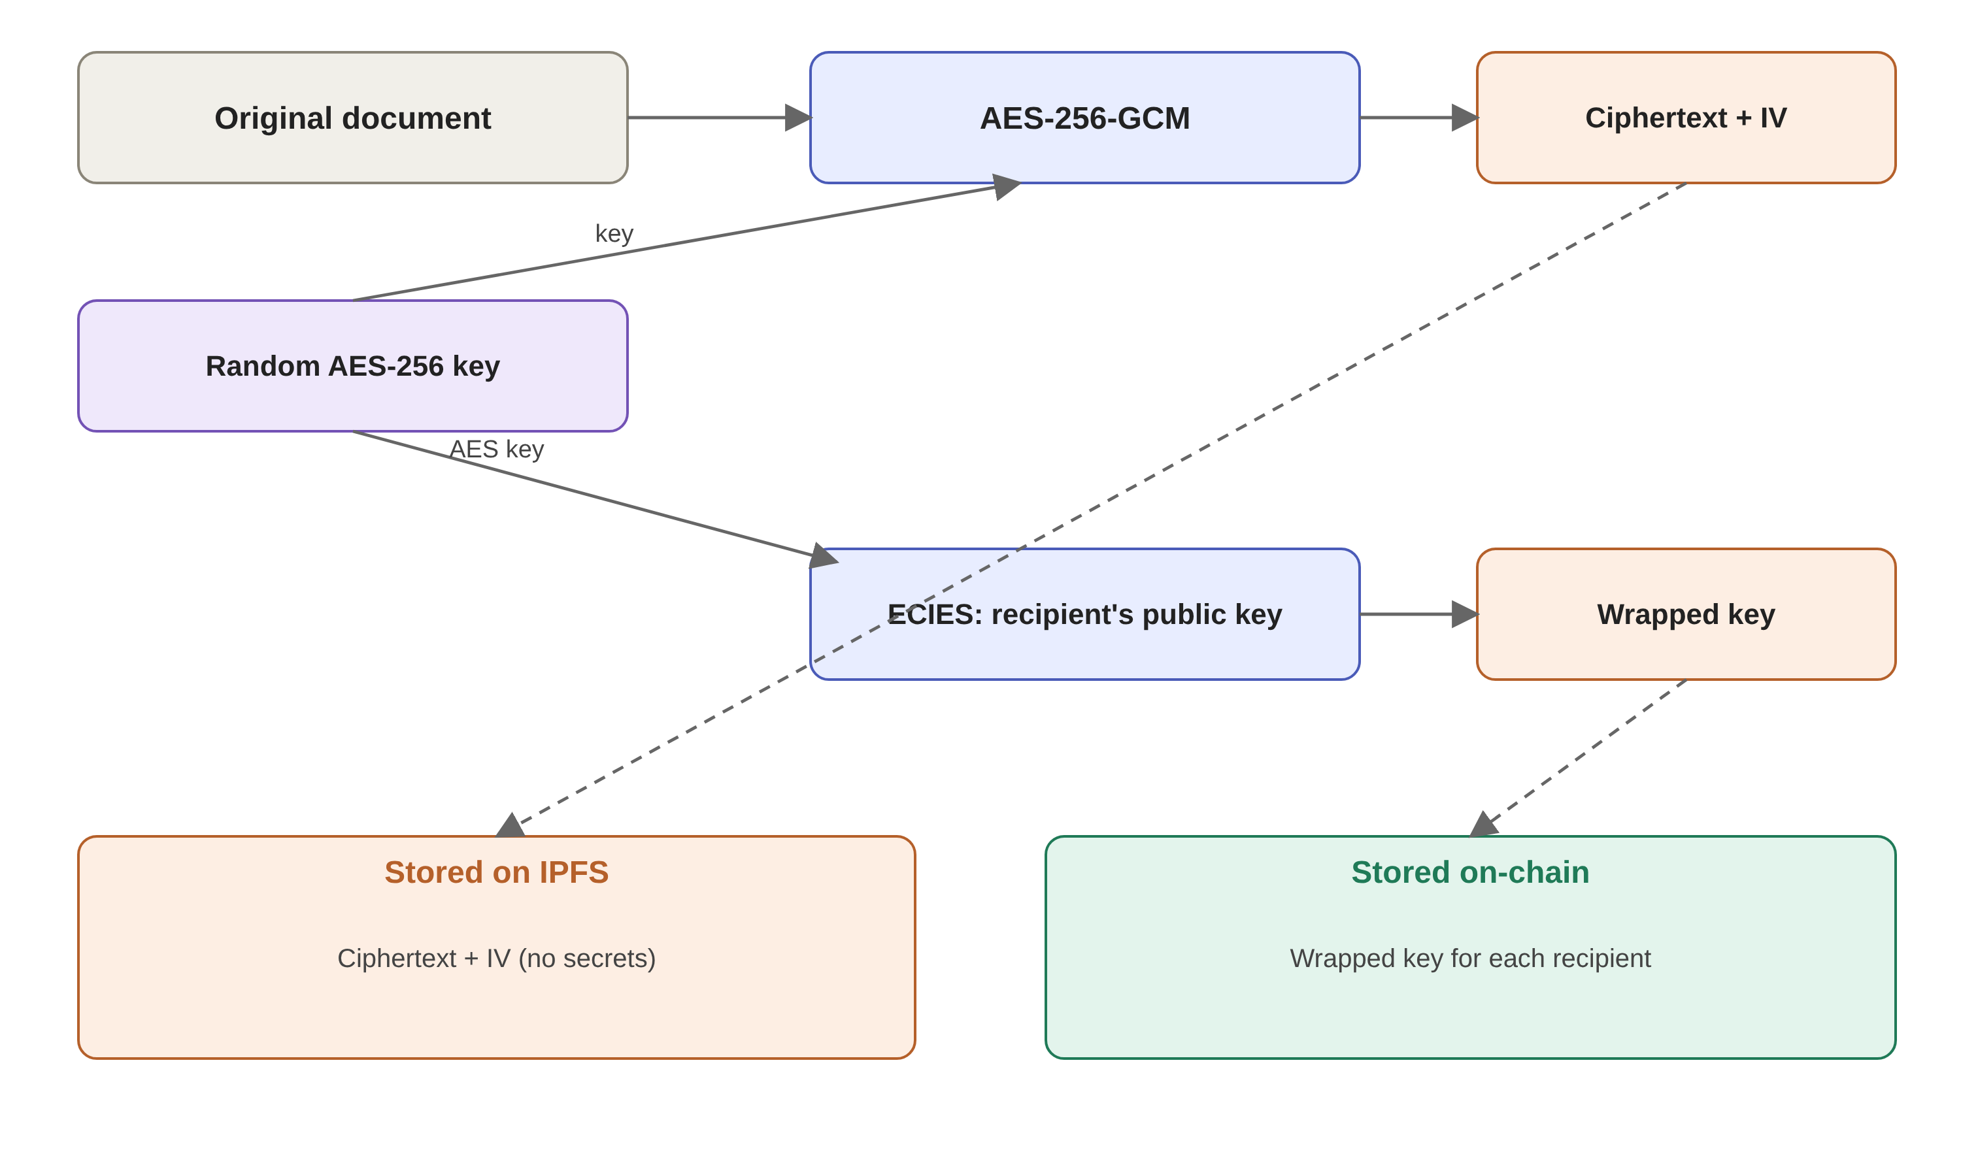
Figure 2.3. Hybrid encryption: the document with AES, and the AES key with ECIES

2.4.1 Hash Functions
A hash function converts data of arbitrary length into a string of fixed length. We call the output a digest, hash or fingerprint. A cryptographic hash function has three key properties: it is one-way (the input cannot be recovered from the hash; see also the hash-based constructions in [29]), it is collision resistant (finding two inputs with the same hash is practically impossible), and it has the avalanche effect (a small change in the input changes the hash completely).
Table 2.1 shows the SHA-256 hash [8] of three inputs. The first two inputs differ in a single letter, yet their hashes bear no resemblance.
Table 2.1. SHA-256 hashes of sample inputs
Input | SHA-256 hash (hexadecimal)
abc | ba7816bf8f01cfea414140de5dae2223 b00361a396177a9cb410ff61f20015ad
abd | a52d159f262b2c6ddb724a61840befc3 6eb30c88877a4030b65cbe86298449c9
Attestera | 5b359bc06300a20b3e959186798dfe08 dea577c1a62d6f6db3a1d9ffddee1ab8

Two hash functions are used in this project. Keccak-256 is used by Ethereum itself to build addresses, and here the credential ID [9]; the ID of each credential is the hash of its issuance details. SHA-256 is used in the browser to derive the encryption key and inside HKDF. The IPFS identifier is also built on a SHA-256 hash.

2.4.2 Diffie-Hellman Key Exchange
If two parties each hold an asymmetric key pair, they can arrive at a shared secret without any secret communication. This idea was presented by Diffie and Hellman in 1976 [10]. For an intuitive grasp, consider the small example in Table 2.2: the prime p=23 and the base g=5 are public. Alice chooses the secret number 6 and Bob the secret number 15.
Table 2.2. A small numeric example of Diffie-Hellman key exchange with p=23 and g=5
Step | Alice | Bob
Private secret | a = 6 | b = 15
Published public value | A = 5^6 mod 23 = 8 | B = 5^15 mod 23 = 19
Computing the shared secret | B^a mod 23 = 19^6 mod 23 = 2 | A^b mod 23 = 8^15 mod 23 = 2

Both arrive at the number 2, while an eavesdropper has seen only 8 and 19. The elliptic-curve version, called ECDH, is the same idea, except that exponentiation becomes scalar multiplication on the curve: if one party's private key is a and public key is a·G, and the other's are b and b·G, both compute the point (a·b)·G. In our project one side is always an ephemeral key, created only for a single wrapping.

2.4.3 Digital Signatures and Wallets
A digital signature lets the holder of a private key prove that they approved a message, without revealing the key. Ethereum uses the ECDSA algorithm on the secp256k1 curve [11][15]. The signature is built from the private key and the hash of the message, and anyone can check it using the public key (or the address). A wallet (such as MetaMask) is software that holds the private key and signs a transaction or message whenever the user approves. The web application never sees the private key; it can only request a signature.
An important point for our design: the ECDSA signatures of common wallets are generated deterministically, meaning that for a given key and message the same signature is always obtained [14]. This property lets us use the signature of a fixed message as a "reproducible source of randomness", as described in Chapter 3.

Chapter 3 System Analysis and Design

3.1 Actors and Requirements
The system has three roles. The administrator (ADMIN) approves or revokes issuing institutions and defines the fields of study. The issuing institution issues or revokes credentials. The holder views the credential and grants or revokes access for each verifier. The main requirements are: every credential is registered with a unique ID, revocation is possible only by the issuer of that credential, the document stays confidential from everyone except the holder and authorized recipients, and all rules are enforced by the contract, not by the web interface.
The threat model is simple: the chain and contracts are assumed to execute correctly, and the attacker can observe IPFS and the network and can even pose as an authorized institution. Therefore no confidential data may leave the browser unencrypted, and no sensitive function may be reachable without checking the sender.

3.1.1 Functional Requirements
The functional requirements (FR), by user role, are given in Table 3.1. The number of each requirement is also used in the descriptions of the contract code so that traceability between need and implementation is possible.
Table 3.1. Functional requirements of the system
ID | Role | Requirement
FR-1 | Admin | Approve an institution as an authorized issuer
FR-2 | Admin | Revoke an institution's authorization without affecting credentials already issued
FR-3 | Admin | View the list of all registered institutions
FR-4 | Admin | Add a new field of study to the dynamic list
FR-5 | All | Register a cryptographic public key once
FR-6 | Issuer | Issue an encrypted credential for the holder's wallet address
FR-7 | Issuer | Choose the credential type: bachelor's, master's, certificate, doctorate or diploma
FR-8 | System | Accept only registered fields of study
FR-9 | Issuer | Set an optional expiry date
FR-10 | Issuer | Revoke a credential it has issued
FR-11 | System | Expire credentials automatically, with no manual action
FR-12 | Holder | Grant access to the document to any chosen verifier
FR-13 | Holder | Revoke any verifier's access
FR-14 | Holder | View the list of all own credentials with their status
FR-15 | Holder | View the list of people with access
FR-16 | Holder | Decrypt and download own document
FR-17 | Verifier | Look up a credential by its ID
FR-18 | Verifier | See the metadata and status of a credential without connecting a wallet
FR-19 | Verifier | Decrypt the document if access has been granted
FR-20 | All | Preserve the original file name and extension after decryption

3.2 Threat Model
A security design that is not explicit about "whom and what are we protecting against" is incomplete. The assets of the system are three: the validity of the credential, the confidentiality of the document content, and the privacy of the relationship between the holder and the verifiers. The attackers considered are: a public observer who sees all on-chain and IPFS data; a malicious user who wants to issue a forged credential or revoke someone else's; a formerly authorized verifier who wants to read the document again after access was revoked; and the pinning-service provider, which holds the files.
The assumptions of the model must also be explicit: the user's wallet private key remains safe, the algorithms AES-GCM, SHA-256 and the secp256k1 curve are not broken, the majority of the network's validators are honest, and the system administrator is a trusted party for approving institutions. This last assumption is a deliberate limitation that is examined in Chapter 5. Table 3.2 summarizes the threats and the design responses.
Table 3.2. Main threats and countermeasures
Threat | Countermeasure
Credential issued by an unauthorized party | The onlyApprovedIssuer modifier, which queries the second contract
Revocation by someone other than the issuer | msg.sender == issuer check in revokeCredential
Access granted by someone other than the holder | msg.sender == owner check in grantAccess
Document read by a public observer | AES-256-GCM encryption before upload
Tampering with the document on IPFS | GCM authentication tag and the CID recorded on-chain
Exposure of the AES key on-chain | Only the ECIES-wrapped version is stored
Forgery through a duplicate ID | The ID is built from a unique nonce and an invariant test checks it
Returning a revoked credential to active | No code path leaves Revoked, and an invariant test checks it
Registering a public key on behalf of someone else | Each address writes only its own entry; the EVM guarantees this

3.3 Architecture
Figure 3.1 shows the three-layer architecture. The React web interface performs all cryptography in the browser; the encrypted document stays on IPFS; and the two contracts on Arbitrum hold only metadata, status and wrapped keys. There is no backend server.
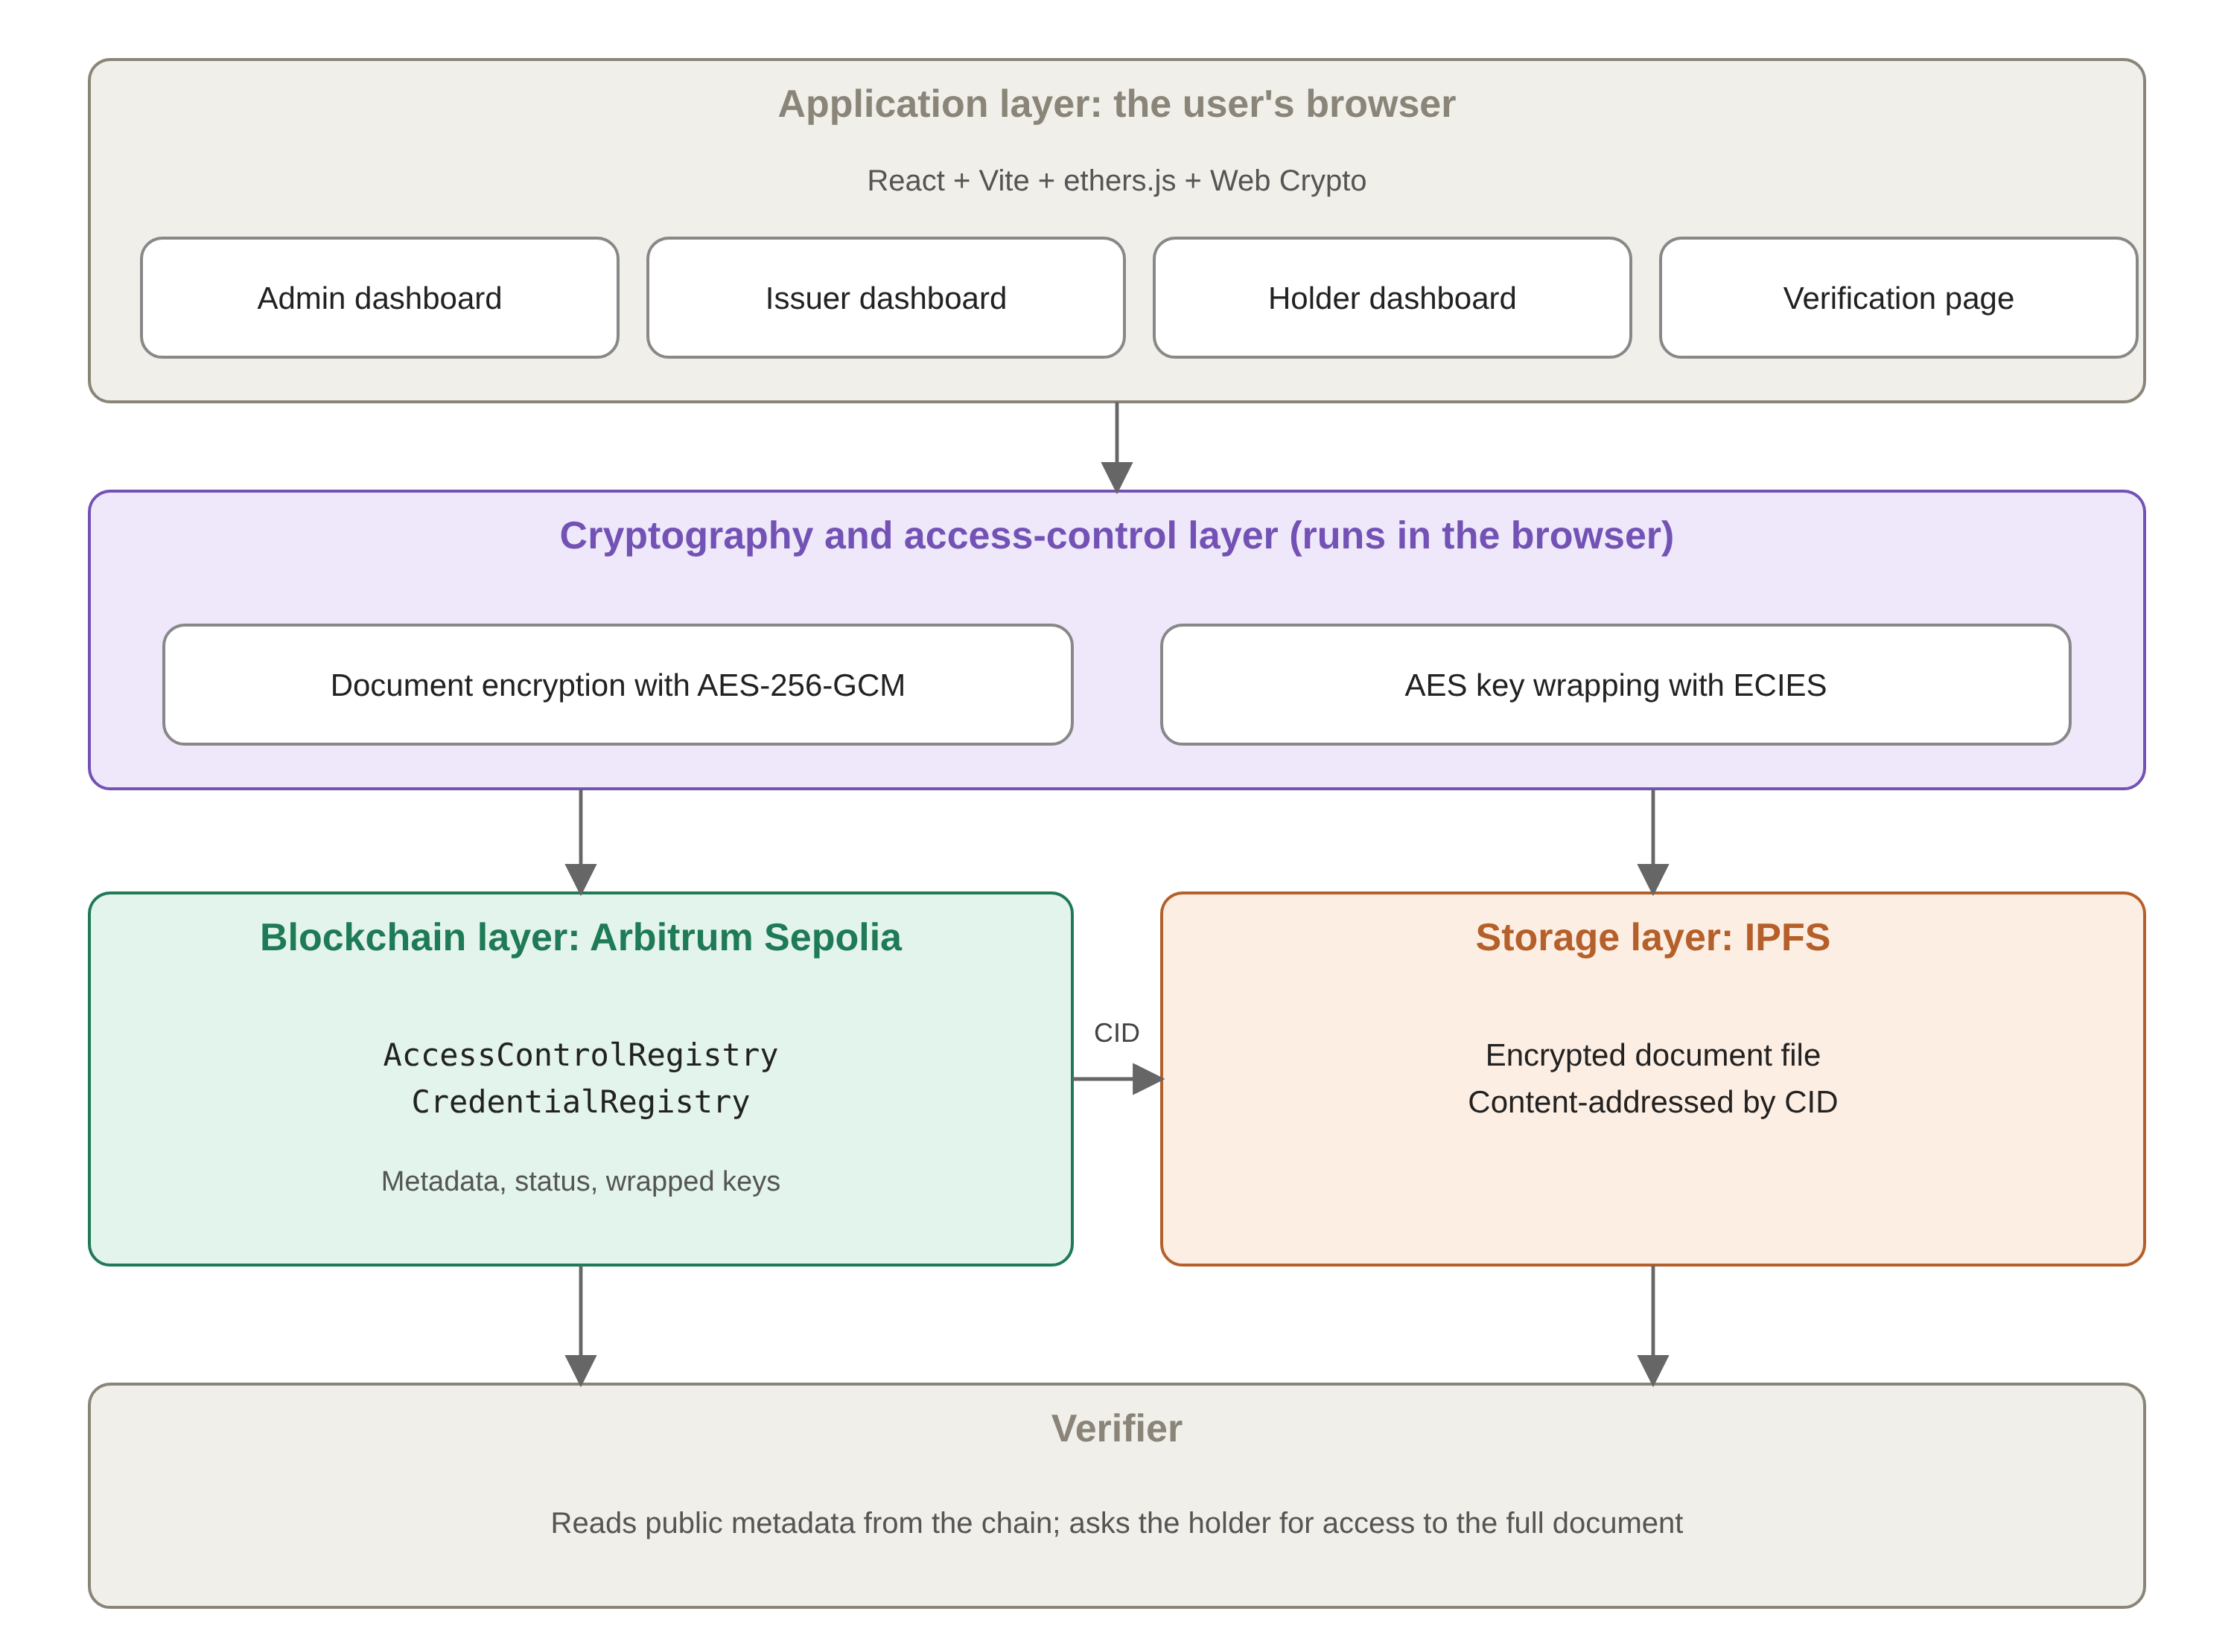
Figure 3.1. Layered architecture of the Attestera system

3.4 Contract Design
AccessControlRegistry holds the administrator (immutable), the authorized institutions, the fields of study and users' cryptographic public keys. CredentialRegistry asks it, through a narrow interface, whether the sender is an authorized institution and whether a field is valid. Both contracts are immutable after deployment and the administrator is fixed. The ID of each credential is the keccak256 of the holder, issuer, CID, timestamp and a counter. Table 3.3 summarizes the permissions.
Table 3.3. Permission matrix of the main functions
Action | Who may call it
approveInstitution, addMajor | Administrator
issueCredential | An authorized institution
revokeCredential | Only the issuer of that credential
grantAccess, revokeAccess | Only the holder
registerPublicKey | Any user, for themselves
getStatus, getCredential and other reads | Anyone

A credential has three states: active, expired and revoked (Figure 3.2). "Expired" is not stored; it is computed in getStatus from the block time, so no extra transaction is needed. Revocation is one-way, performed only by the issuer, and cannot be undone.
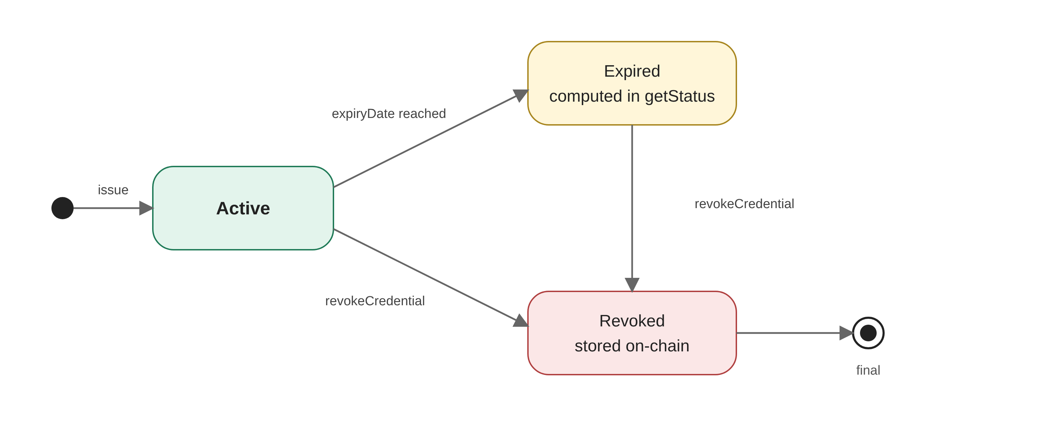
Figure 3.2. State transitions of a credential

3.4.1 Separation into Two Contracts
The logic of the system is placed in two contracts. AccessControlRegistry holds the administrator, the authorized institutions, the fields of study and the cryptographic public keys, which is state that rarely changes. CredentialRegistry manages the credentials, their status and the access keys, which is state that changes continuously. This separation has two benefits: each part is easier to review for security on its own, and the credential contract depends on only two questions to the authorization contract.
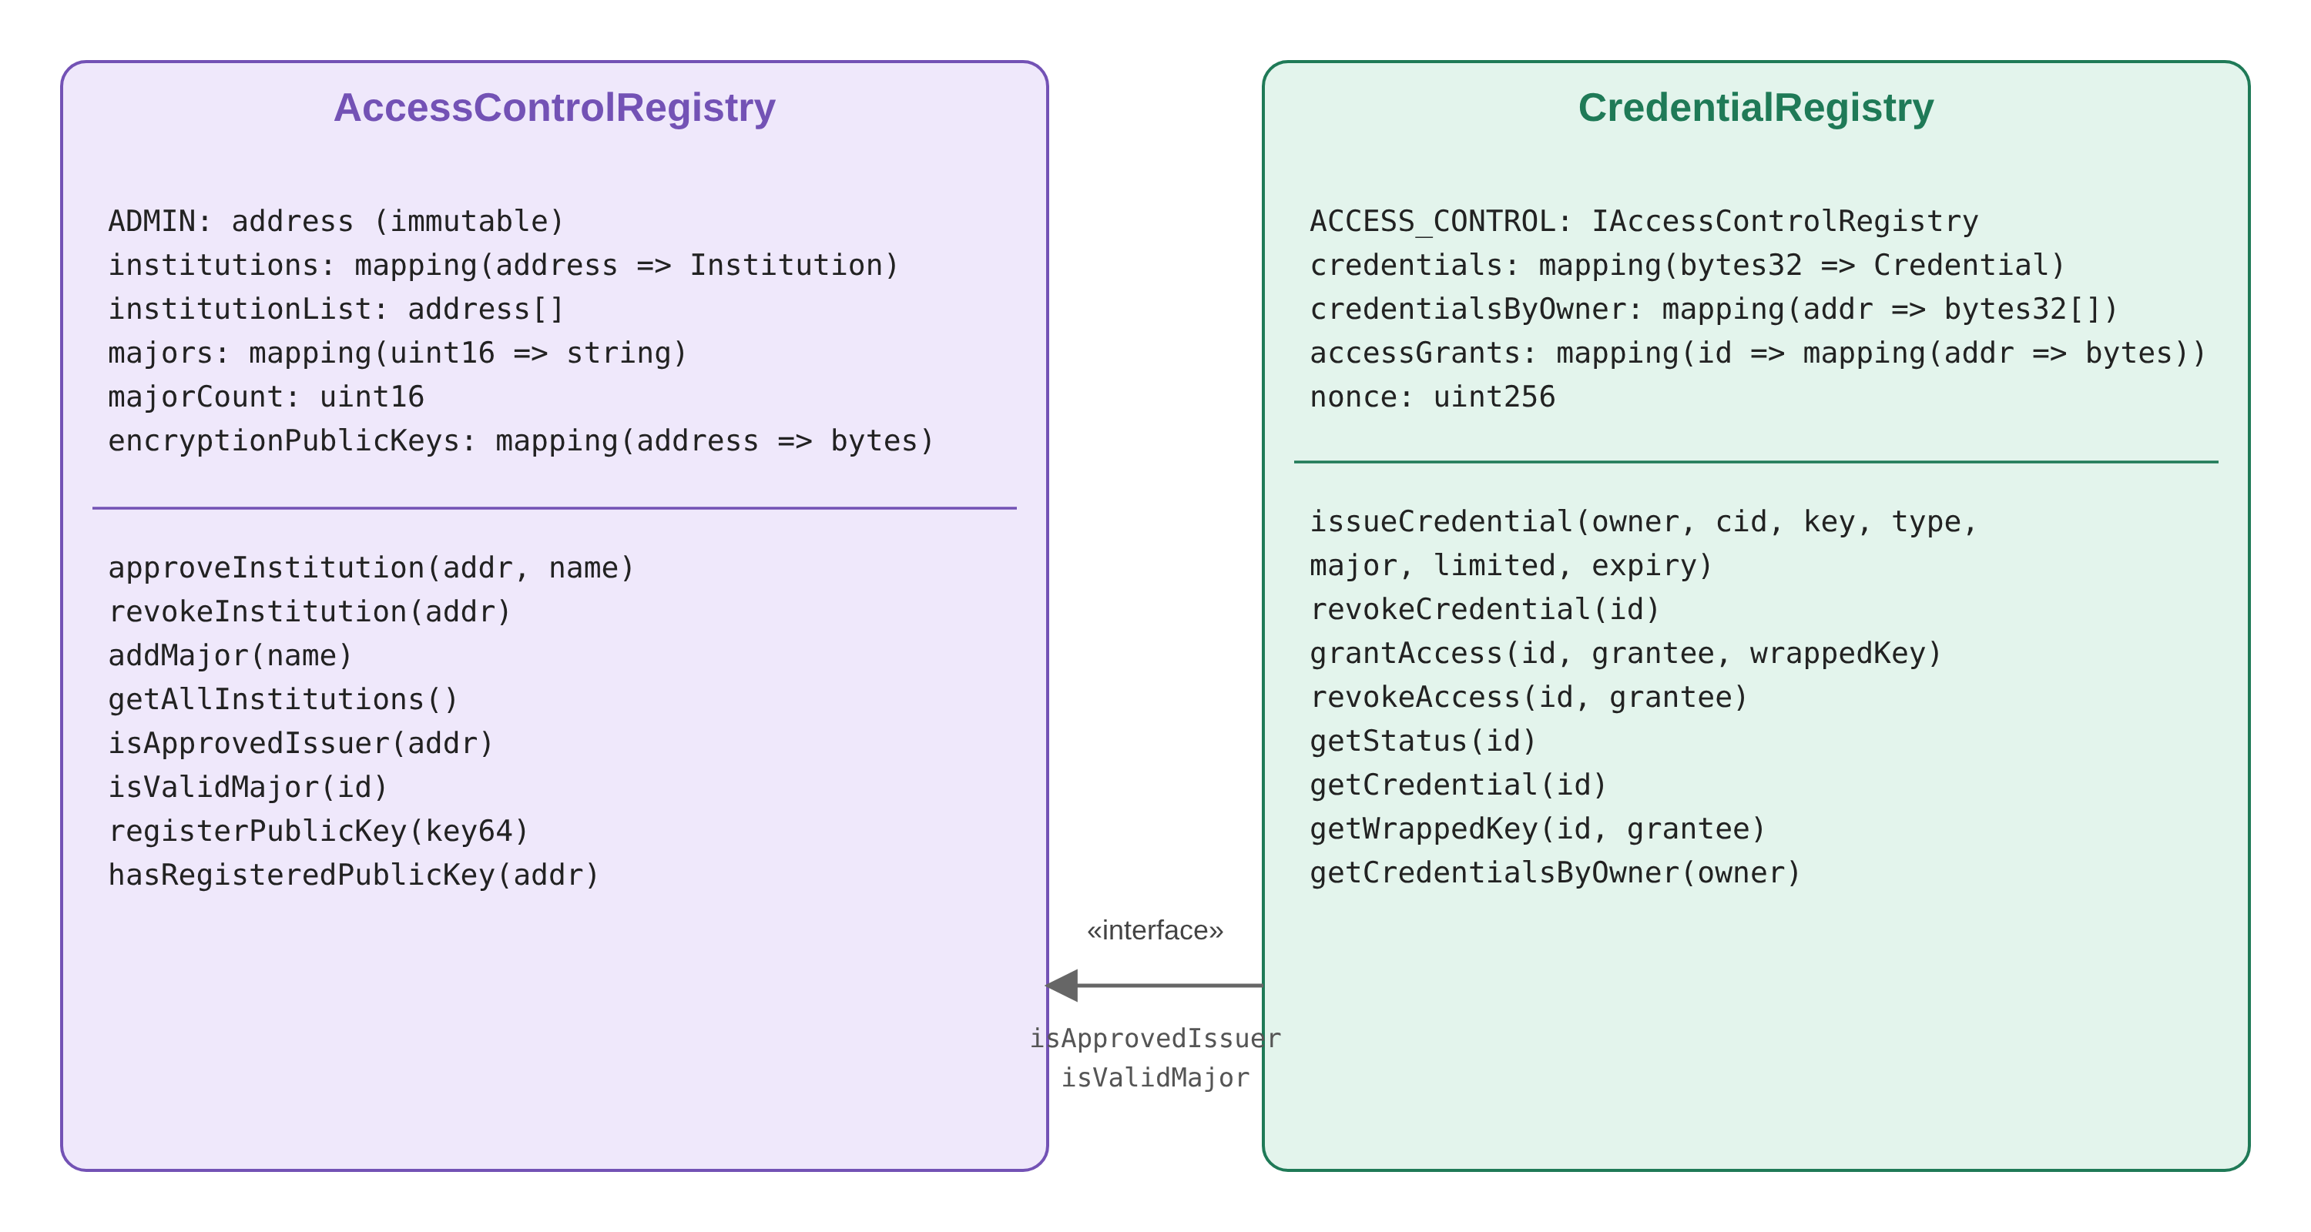
Figure 3.3. The two contracts of the system and the narrow interface between them
The dependency is established through the IAccessControlRegistry interface, which has only two functions: isApprovedIssuer and isValidMajor. As a result, testing CredentialRegistry does not require deploying the full authorization contract; a thirty-five-line mock is enough. Both contracts are immutable: the ADMIN and ACCESS_CONTROL variables are set with immutable in the constructor, and there is no upgrade path.

3.5 Cryptographic Design
Each user has a cryptographic key pair derived from their wallet: the user signs the fixed message "Enable encrypted documents on Credential Registry", the SHA-256 hash of the signature becomes a 32-byte private key, and its 64-byte public key is registered in AccessControlRegistry. This method creates no new key to look after, but it depends on the wallet's deterministic signatures.
At issuance, the browser generates a random AES-256 key, encrypts the document with AES-GCM (the 12-byte IV is placed at the start of the file) and puts the file on IPFS. It then wraps the AES key for the holder with ECIES. The wrapped key is 124 bytes: 64 bytes of ephemeral public key, 12 bytes of IV and 48 bytes of ciphertext. This value is stored on-chain in accessGrants for the holder. To give a verifier access, the holder simply re-wraps the AES key with the verifier's public key; the IPFS file stays untouched. The issuance flow appears in Figure 3.4.
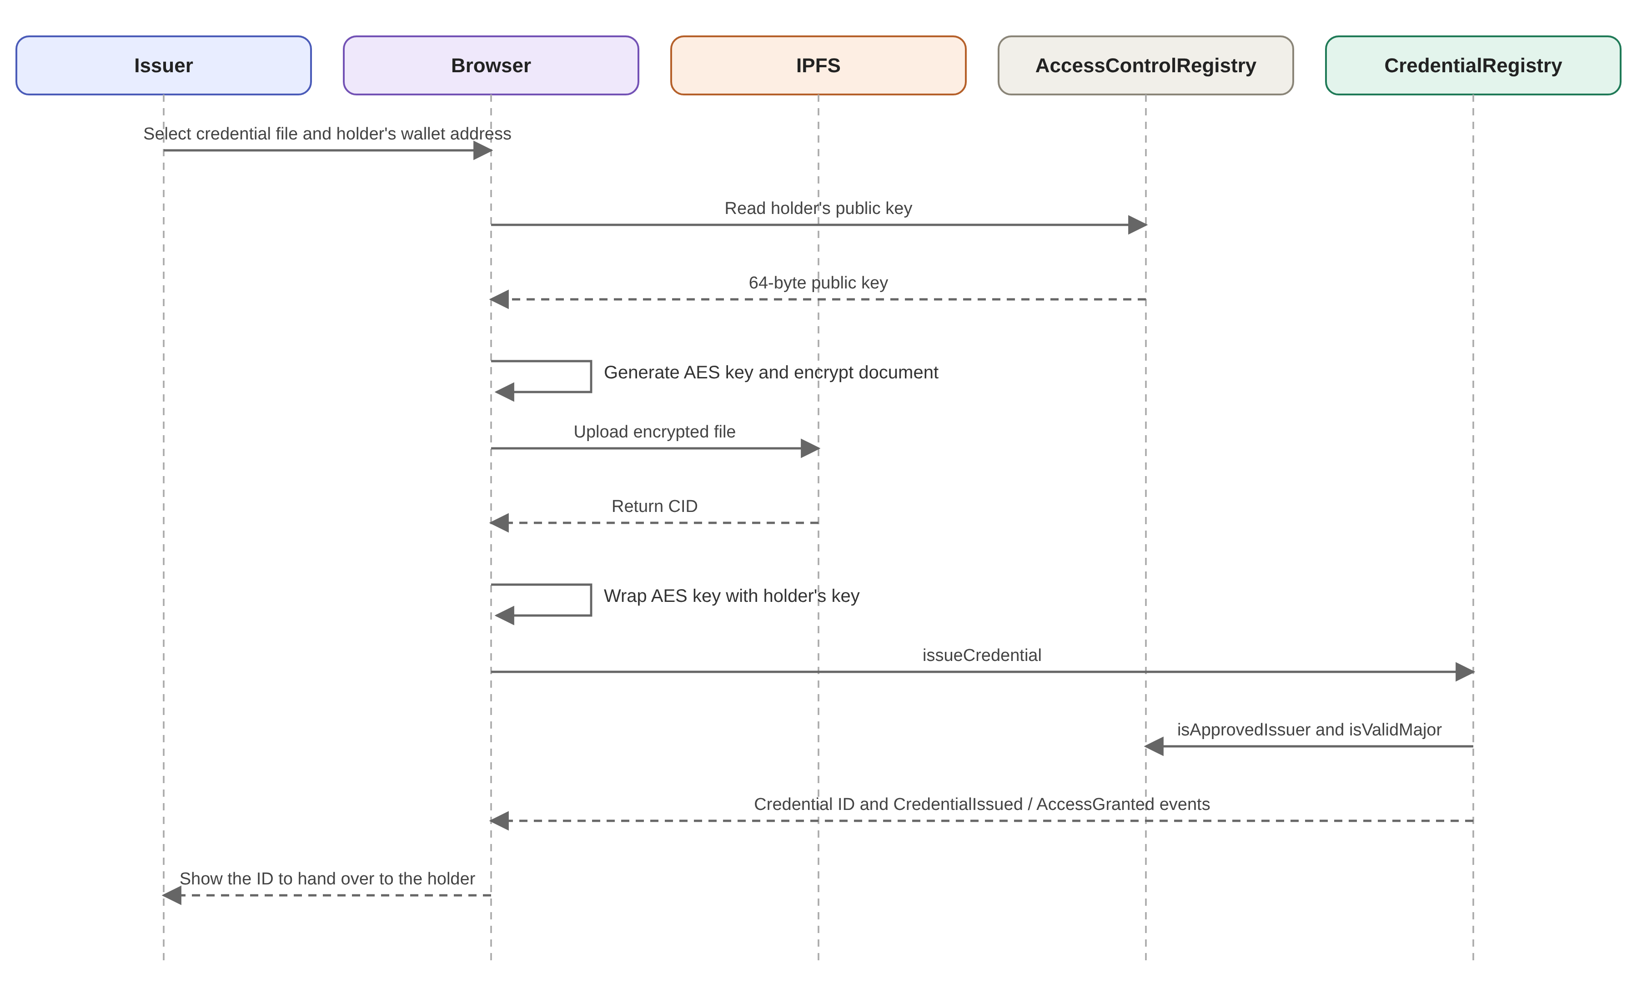
Figure 3.4. Sequence diagram of credential issuance

3.6 Access Granting and Verification Flows
The issuance flow was described in the previous section. The two other flows of the system, granting access to a verifier and verifying and viewing a document, are described next.

3.6.1 Granting Access to a Verifier
In Figure 3.5 the holder enters the verifier's address. The browser reads the verifier's public key, unwraps the AES key that had been wrapped for the holder using the holder's private key, and this time wraps it for the verifier. The document on IPFS stays untouched; only a single grantAccess transaction carrying the 124-byte package is recorded.
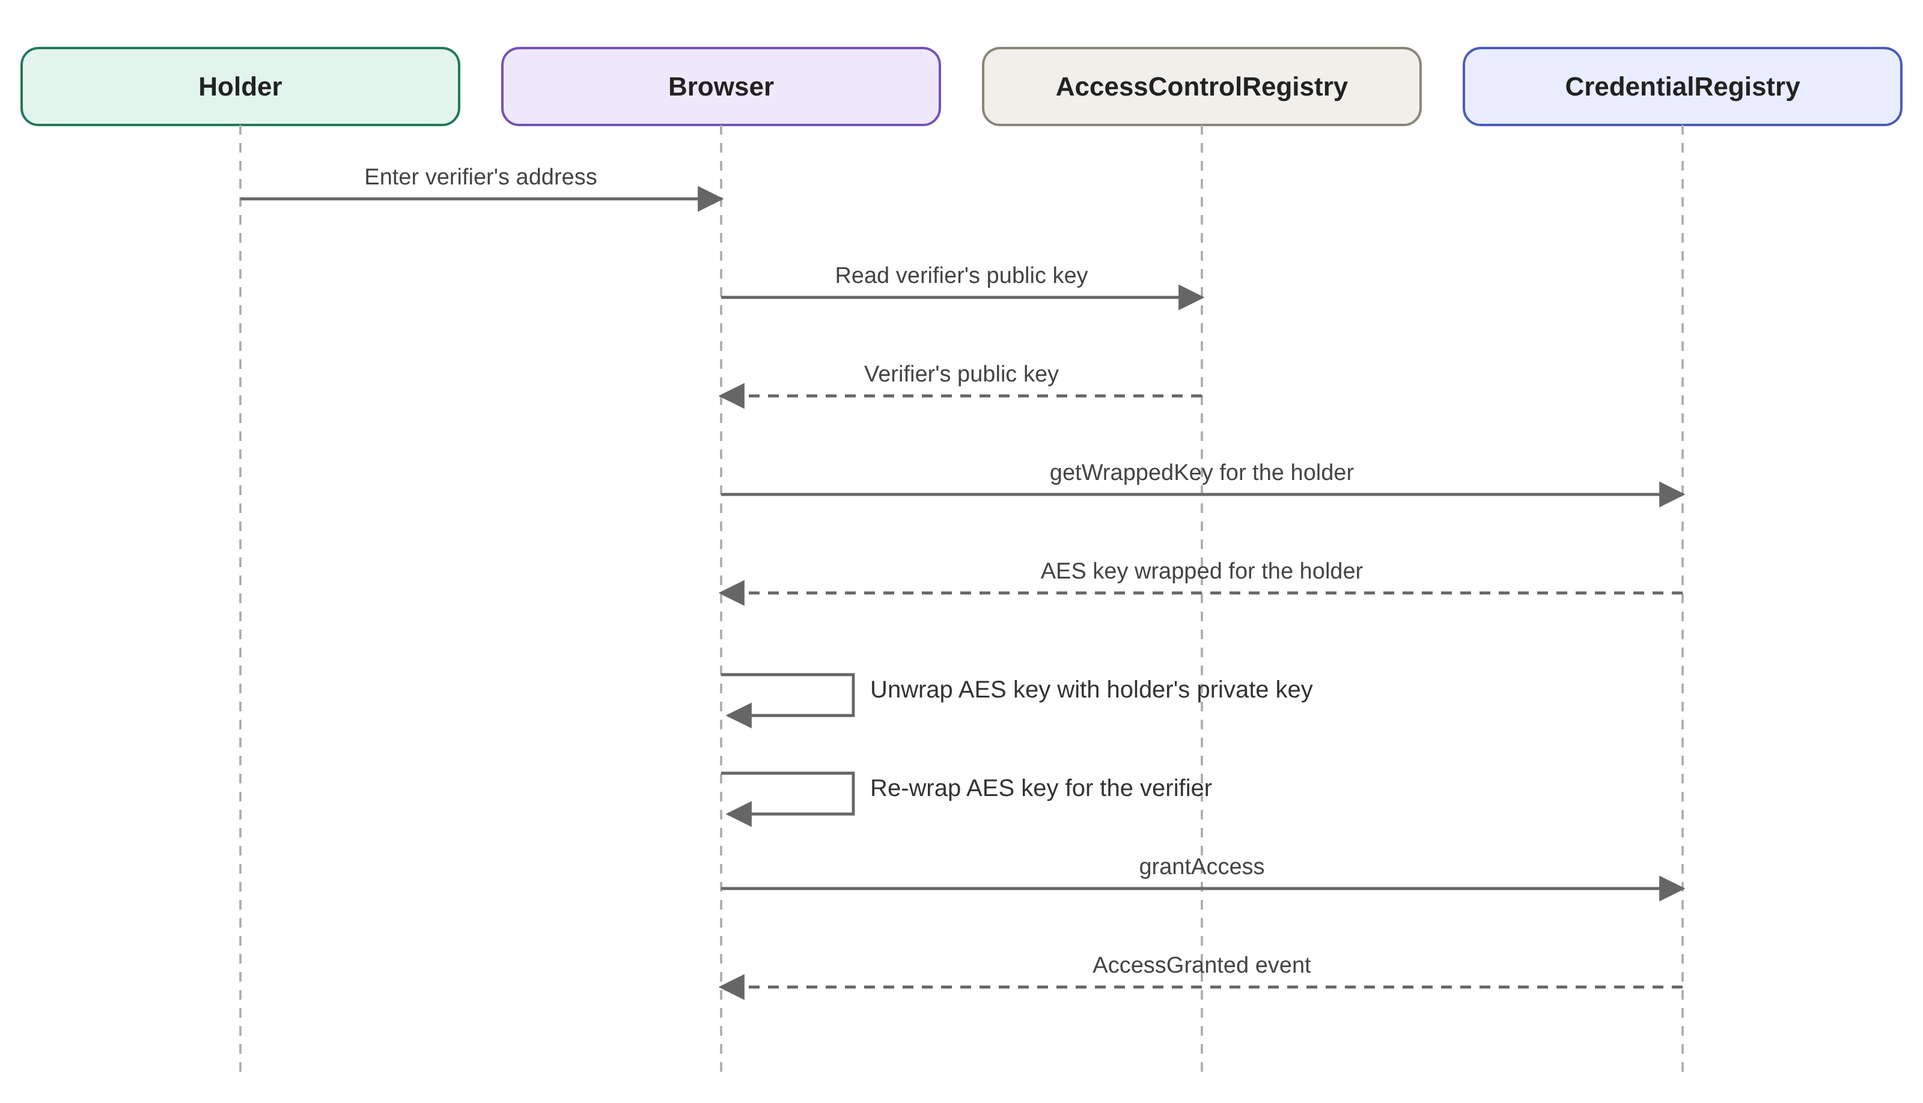
Figure 3.5. Sequence diagram of granting access to a verifier

3.6.2 Verification and Viewing the Document
Figure 3.6 shows that verification takes place in two stages. The first stage is public read-only: using the credential ID, the verifier sees the metadata and the computed status, which is possible even without connecting a wallet (FR-18). The second stage works only if access has been granted: the verifier reads their key package, unwraps it, fetches the encrypted file from IPFS and decrypts it in their own browser.
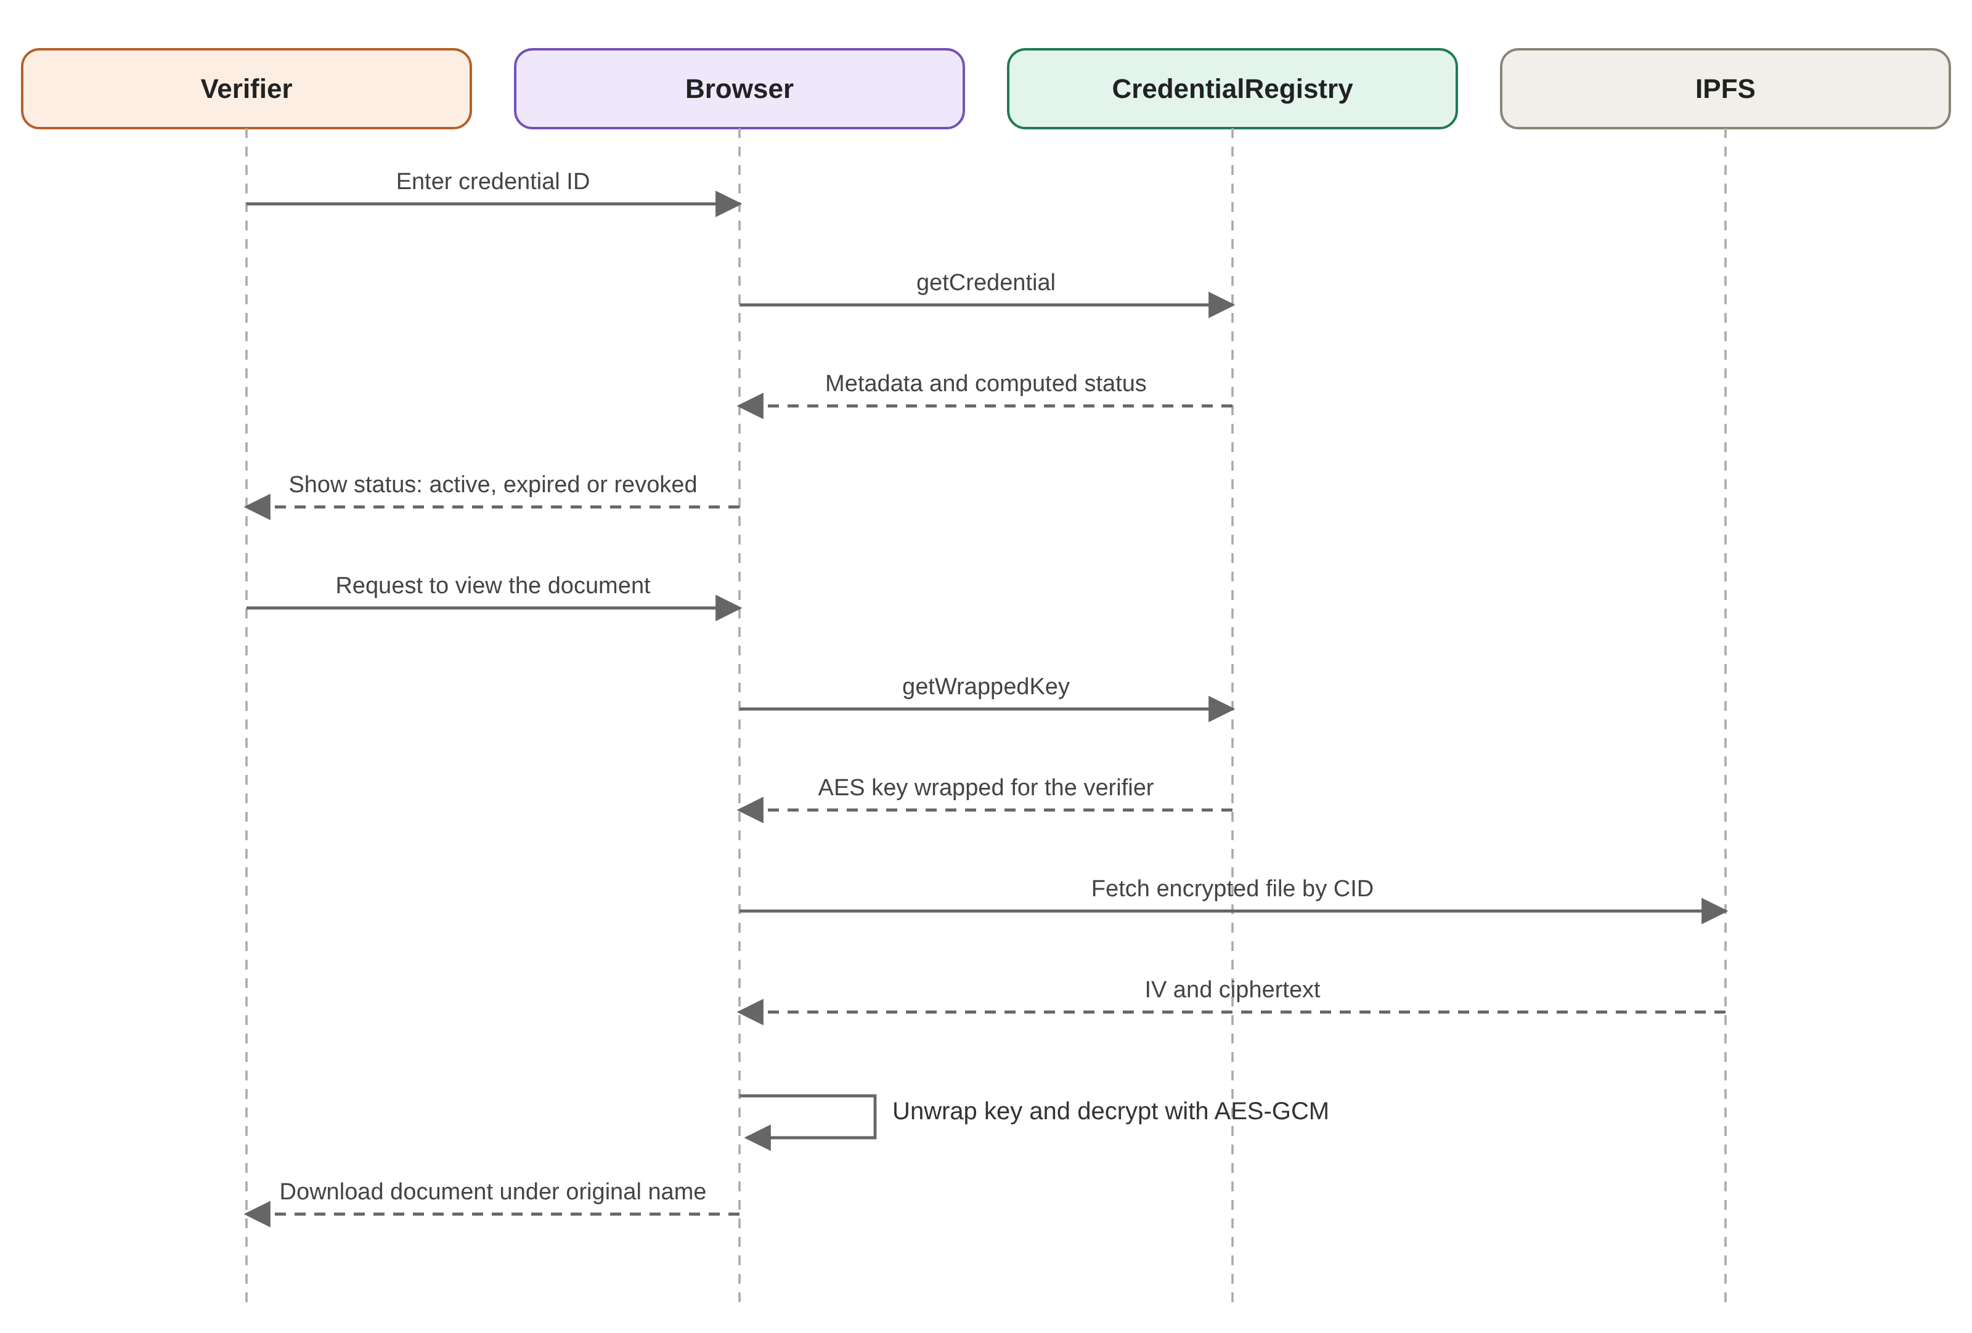
Figure 3.6. Sequence diagram of verification and viewing the document

Chapter 4 Implementation
The project has two parts: contracts (Solidity ^0.8.24 [22] with Foundry [23] and the via_ir option) and frontend-app (React with Vite and ethers version 6 [24]). The code shown below comes from the real repository, with in-code comments removed.

4.1 The AccessControlRegistry Contract
This contract has four responsibilities: holding the administrator, the authorized institutions, the fields of study and the cryptographic public keys. Listing 4.1 shows the state of the contract. The administrator's address is recorded with immutable at deployment and never changes. Institutions are kept in a mapping and, so that the administrator can list them, in an array. Fields of study are stored in a mapping with a numeric index so that a new field can be added after deployment; had an enum been used, adding a field would have required redeployment.
Listing 4.1. State of the AccessControlRegistry contract
01 contract AccessControlRegistry is IAccessControlRegistry {
02 address public immutable ADMIN;
03
04 struct Institution {
05 address institutionAddress;
06 string name;
07 bool isApproved;
08 uint256 approvedDate;
09 }
10
11 mapping(address => Institution) public institutions;
12
13 address[] public institutionList;
14
15 mapping(address => bool) private everRegistered;
16
17 mapping(uint16 => string) public majors;
18 uint16 public majorCount;
19
20 mapping(address => bytes) public encryptionPublicKeys;

Institution approval is implemented in Listing 4.2. The function first checks that the institution is not already approved. If the address is registered for the first time it is appended to the institutionList array; therefore revoking and re-approving an institution does not create a duplicate entry, a property that an independent test checks. Revoking authorization only switches off the isApproved flag, and earlier credentials remain untouched.
Listing 4.2. Approving and revoking an institution
01 modifier onlyAdmin() {
02 _onlyAdmin();
03 _;
04 }
05
06 function _onlyAdmin() internal view {
07 if (msg.sender != ADMIN) revert NotAdmin();
08 }
09
10 function approveInstitution(address institutionAddress, string calldata name)
external onlyAdmin {
11 if (institutions[institutionAddress].isApproved) revert
InstitutionAlreadyApproved();
12
13 institutions[institutionAddress] = Institution({
14 institutionAddress: institutionAddress,
15 name: name,
16 isApproved: true,
17 approvedDate: block.timestamp
18 });
19
20 if (!everRegistered[institutionAddress]) {
21 everRegistered[institutionAddress] = true;
22 institutionList.push(institutionAddress);
23 }
24
25 emit InstitutionApproved(institutionAddress, name);
26 }
27
28 function revokeInstitution(address institutionAddress) external onlyAdmin {
29 if (!institutions[institutionAddress].isApproved) revert
InstitutionNotApproved();
30
31 institutions[institutionAddress].isApproved = false;
32
33 emit InstitutionRevoked(institutionAddress);
34 }

Listing 4.3 shows the registration of the cryptographic public key. The only check is the 64-byte length of the key. The first version of the contract had another check: that the address derived from the key equals msg.sender. But since this key is deliberately separate from the wallet key, its derived address never equals the sender, and that check made the function permanently unusable. This bug was found in real testing and removed; the security of this function is simply that each address writes only its own entry, which the EVM guarantees.
Listing 4.3. Registering the cryptographic public key
01 function registerPublicKey(bytes calldata publicKey) external {
02 if (publicKey.length != 64) revert InvalidPublicKeyLength();
03
04 encryptionPublicKeys[msg.sender] = publicKey;
05
06 emit PublicKeyRegistered(msg.sender, publicKey);
07 }
08
09 function hasRegisteredPublicKey(address user) external view returns (bool) {
10 return encryptionPublicKeys[user].length > 0;
11 }

4.2 The Credential Contract
The issueCredential function runs only for an authorized institution, checks the field of study against the other contract, builds the ID, and writes the holder's wrapped key into accessGrants right there.
Listing 4.4. The issueCredential function
01 function issueCredential(address owner, string calldata ipfsCid,
02 bytes calldata ownerWrappedKey, DocumentType documentType,
03 uint16 majorId, bool isTimeLimited, uint256 expiryDate
04 ) external onlyApprovedIssuer returns (bytes32 id) {
05 if (!ACCESS_CONTROL.isValidMajor(majorId)) revert InvalidMajor();
06 id = keccak256(abi.encodePacked(owner, msg.sender, ipfsCid,
07 block.timestamp, nonce));
08 nonce++;
09 credentials[id] = Credential({ id: id, owner: owner,
10 issuer: msg.sender, ipfsCid: ipfsCid, documentType: documentType,
11 majorId: majorId, issueDate: block.timestamp,
12 isTimeLimited: isTimeLimited,
13 expiryDate: isTimeLimited ? expiryDate : 0,
14 status: Status.Active });
15 credentialsByOwner[owner].push(id);
16 accessGrants[id][owner] = ownerWrappedKey;
17 emit CredentialIssued(id, owner, msg.sender, block.timestamp);
18 }

Revocation and access use simple sender checks, and the expired status is computed at read time:
Listing 4.5. Revocation, access granting and status computation
01 function revokeCredential(bytes32 id) external {
02 Credential storage cred = credentials[id];
03 if (cred.issuer == address(0)) revert CredentialNotFound();
04 if (msg.sender != cred.issuer) revert NotIssuerOfCredential();
05 if (cred.status == Status.Revoked) revert AlreadyRevoked();
06 cred.status = Status.Revoked;
07 }
08 function grantAccess(bytes32 id, address grantee, bytes calldata wrappedKey)
09 external {
10 Credential storage cred = credentials[id];
11 if (msg.sender != cred.owner) revert NotOwnerOfCredential();
12 accessGrants[id][grantee] = wrappedKey;
13 }
14 function getStatus(bytes32 id) public view returns (Status) {
15 Credential storage cred = credentials[id];
16 if (cred.status == Status.Revoked) return Status.Revoked;
17 if (cred.isTimeLimited && block.timestamp >= cred.expiryDate)
18 return Status.Expired;
19 return Status.Active;
20 }

4.3 The Browser Cryptography Module
The encryption.js module uses Web Crypto for AES and hashing [25] and the noble-secp256k1 library [26] for the curve. If the hash of the signature is not a valid curve key, it is hashed again:
Listing 4.6. Deriving the key pair from the wallet signature
01 export async function deriveEncryptionKeypair(signatureHex) {
02 let candidate = await sha256(hexToBytes(signatureHex));
03 while (!secp.utils.isValidPrivateKey(candidate))
04 candidate = await sha256(candidate);
05 const privateKey = candidate;
06 const publicKey64 = secp.getPublicKey(privateKey, false).slice(1);
07 return { privateKey, publicKey64 };
08 }

Key wrapping is exactly ECIES: an ephemeral key, the ECDH shared secret, derivation with HKDF and encryption with AES-GCM.
Listing 4.7. Wrapping the AES key for a recipient
01 export async function wrapKeyForRecipient(aesKeyRaw, recipientPublicKey64) {
02 const ephPriv = secp.utils.randomPrivateKey();
03 const ephPub = secp.getPublicKey(ephPriv, false);
04 const recipient = concatBytes(new Uint8Array([0x04]), recipientPublicKey64);
05 const shared = secp.getSharedSecret(ephPriv, recipient, true);
06 const symKey = await deriveSymmetricKeyFromSharedPoint(shared); // HKDF
07 const iv = webcrypto.getRandomValues(new Uint8Array(12));
08 const ct = await webcrypto.subtle.encrypt(
09 { name: "AES-GCM", iv }, symKey, aesKeyRaw);
10 return { ephemeralPublicKey64: ephPub.slice(1), iv,
11 ciphertext: new Uint8Array(ct) };
12 }

4.3.1 Encrypting and Decrypting the Document
Listing 4.8. Encrypting the document with AES-256-GCM
01 export function generateAESKey() {
02 return webcrypto.getRandomValues(new Uint8Array(32));
03 }
04
05 async function importAESKey(rawKeyBytes) {
06 return webcrypto.subtle.importKey("raw", rawKeyBytes, { name: "AES-GCM" },
false, [
07 "encrypt",
08 "decrypt",
09 ]);
10 }
11
12 export async function encryptDocument(plaintextBytes, aesKeyRaw) {
13 const key = await importAESKey(aesKeyRaw);
14 const iv = webcrypto.getRandomValues(new Uint8Array(12)); // 96-bit IV,
standard for GCM
15
16 const ciphertextBuffer = await webcrypto.subtle.encrypt({ name: "AES-GCM", iv
}, key, plaintextBytes);
17
18 return { ciphertext: new Uint8Array(ciphertextBuffer), iv };
19 }
20
21 export async function decryptDocument(ciphertext, iv, aesKeyRaw) {
22 const key = await importAESKey(aesKeyRaw);
23 const plaintextBuffer = await webcrypto.subtle.decrypt({ name: "AES-GCM", iv },
key, ciphertext);
24 return new Uint8Array(plaintextBuffer);
25 }

In Listing 4.8 the 32-byte key is generated by the browser's getRandomValues, which is a cryptographically secure random generator. The importKey function imports the key with extractable set to false, meaning that after import even the browser itself does not allow the bytes to be extracted by JavaScript code. The IV is new and random for every call and is returned in the output so that it can be stored.

4.4 Storage on IPFS
The storage layer in storage.js has only two functions: uploadToStorage and fetchFromStorage. Listing 4.9 shows the upload through the Pinata service API. The encrypted bytes are placed in a FormData, sent with an Authorization header and a JWT token, and the CID is read from the response. The file name sent is deliberately a fixed, meaningless name so that no information about the content leaks to the service.
Listing 4.9. Uploading the encrypted file to IPFS
01 const PINATA_JWT = import.meta.env.VITE_PINATA_JWT;
02 const PINATA_PIN_URL = "https://api.pinata.cloud/pinning/pinFileToIPFS";
03 const PINATA_GATEWAY = "https://gateway.pinata.cloud/ipfs";
04
05 export async function uploadToStorage(encryptedBytes) {
06
07 const blob = new Blob([encryptedBytes]);
08 const formData = new FormData();
09 formData.append("file", blob, "encrypted-credential");
10
11 const response = await fetch(PINATA_PIN_URL, {
12 method: "POST",
13 headers: { Authorization: `Bearer ${PINATA_JWT}` },
14 body: formData,
15 });
16
17 if (!response.ok) {
18 const text = await response.text().catch(() => "");
19 throw new Error(`Pinata upload failed (${response.status}): ${text ||
response.statusText}`);
20 }
21
22 const result = await response.json();
23 return result.IpfsHash;
24 }
25
26 export async function fetchFromStorage(cid) {
27 const response = await fetch(`${PINATA_GATEWAY}/${cid}`);
28
29 if (!response.ok) {
30 throw new Error(`Failed to fetch document from IPFS (${response.status}).
CID: ${cid}`);
31 }
32
33 const buffer = await response.arrayBuffer();
34 return new Uint8Array(buffer);
35 }

There is one deliberate security limitation: the VITE_PINATA_JWT variable is embedded into the JavaScript bundle at build time and can therefore be extracted by any attentive visitor of the site. For a proof of concept with a free, restricted key this is acceptable, but in production the upload should go through a small intermediary server that keeps the key hidden. This item is listed among future work in Chapter 6.

4.5 Web Interface, Storage and Deployment
Uploading to IPFS goes through Pinata [27], and only the encrypted bytes are sent. The original file name is packaged together with the document itself inside the encrypted part (2 bytes of length, the name, then the content), so that the metadata on IPFS reveals nothing. The Deploy.s.sol script creates both contracts and passes the address of the first to the second. The addresses deployed on Arbitrum Sepolia are given in Table 4.1.
Table 4.1. Addresses of the contracts deployed on Arbitrum Sepolia (chain ID 421614)
Contract | Address
AccessControlRegistry | 0xf91a608c8584bBA45D771F29b3ABBe78796bEF60
CredentialRegistry | 0xDb02DC28122b841F02EF82ff624CA6afB0334CfB

4.5.1 The Issuance Flow in the Issuer Dashboard
The handleIssue function in Listing 4.10 implements the complete issuance flow. Each step shows its own status message so that the user knows what is happening during a process that lasts several seconds. The order of the steps matters: first the holder's public key is read, and if it is missing, an understandable error is shown before any costly work such as encryption or uploading the file. Then the document is packaged, encrypted and uploaded, and finally the transaction is sent. The credential ID is extracted from the CredentialIssued event inside the transaction receipt.
Listing 4.10. The credential issuance flow in the issuer interface
01 setStatus({ type: "pending", message: "Looking up the owner's encryption
public key…" });
02 const ownerPublicKeyHex = await
wallet.accessControl.encryptionPublicKeys(ownerAddress);
03 if (!ownerPublicKeyHex || ownerPublicKeyHex === "0x") {
04 throw new Error(
05 "This owner hasn't enabled encryption yet. Ask them to connect their
wallet and click 'Enable encryption' first."
06 );
07 }
08 const ownerPublicKey64 = hexToBytes(ownerPublicKeyHex);
09
10 setStatus({ type: "pending", message: "Encrypting document in your
browser…" });
11 const fileBytes = await readFileAsBytes(file);
12 const packedWithName = packWithFilename(fileBytes, file.name);
13 const aesKey = generateAESKey();
14 const { ciphertext, iv } = await encryptDocument(packedWithName, aesKey);
15 // Store IV alongside ciphertext so it can be retrieved together later.
16 const packagedFile = new Uint8Array(iv.length + ciphertext.length);
17 packagedFile.set(iv, 0);
18 packagedFile.set(ciphertext, iv.length);
19
20 setStatus({ type: "pending", message: "Uploading encrypted document…" });
21 const cid = await uploadToStorage(packagedFile);
22
23 setStatus({ type: "pending", message: "Wrapping the AES key for the owner…"
});
24 const wrapped = await wrapKeyForRecipient(aesKey, ownerPublicKey64);
25 const wrappedKeyHex = serializeWrappedKey(wrapped);
26
27 setStatus({ type: "pending", message: "Submitting transaction…" });
28 const expiryTimestamp = isTimeLimited ? Math.floor(new
Date(expiryDate).getTime() / 1000) : 0;
29 const tx = await wallet.credentialRegistry.issueCredential(
30 ownerAddress,
31 cid,
32 wrappedKeyHex,
33 documentType,
34 majorId,
35 isTimeLimited,
36 expiryTimestamp
37 );
38 const receipt = await tx.wait();
39
40 const issuedEvent = receipt.logs
41 .map((log) => {
42 try {
43 return wallet.credentialRegistry.interface.parseLog(log);
44 } catch {
45 return null;
46 }
47 })
48 .find((parsed) => parsed?.name === "CredentialIssued");
49
50 setLastIssuedId(issuedEvent?.args?.id);

4.5.2 Granting Access and Viewing the Document
Listing 4.11. Granting access by the holder
01 const verifierPublicKeyHex = await
wallet.accessControl.encryptionPublicKeys(verifierAddress);
02 if (!verifierPublicKeyHex || verifierPublicKeyHex === "0x") {
03 throw new Error("This address hasn't enabled encryption yet — ask them to
connect and enable it first.");
04 }
05
06 const wrappedForMeHex = await
wallet.credentialRegistry.getWrappedKey(cred.id, wallet.address);
07 const wrappedForMe = deserializeWrappedKey(wrappedForMeHex);
08 const aesKey = await unwrapKey(wrappedForMe, encryption.keypair.privateKey);
09
10 const wrappedForVerifier = await wrapKeyForRecipient(aesKey,
hexToBytes(verifierPublicKeyHex));
11 const tx = await wallet.credentialRegistry.grantAccess(
12 cred.id,
13 verifierAddress,
14 serializeWrappedKey(wrappedForVerifier)
15 );

In Listing 4.11 the holder unwraps the AES key from their own package and re-wraps it for the verifier. It is stressed that the document on IPFS is not touched; only this 124-byte key is recorded for the verifier. The verifier side, in Listing 4.12, is the reverse of this process: the wrapped key is read and unwrapped, the encrypted file is fetched from IPFS, the first 12 bytes are separated as the IV, and the rest is decrypted.
Listing 4.12. Viewing the document by the verifier
01 const wrappedHex = await
wallet.credentialRegistry.getWrappedKey(credentialId, wallet.address);
02 const wrapped = deserializeWrappedKey(wrappedHex);
03 const aesKey = await unwrapKey(wrapped, encryption.keypair.privateKey);
04
05 const full = await wallet.credentialRegistry.getCredential(credentialId);
06 const packagedFile = await fetchFromStorage(full.ipfsCid);
07 const iv = packagedFile.slice(0, 12);
08 const ciphertext = packagedFile.slice(12);
09 const plaintext = await decryptDocument(ciphertext, iv, aesKey);
10 const { filename, bytes: originalBytes } = unpackWithFilename(plaintext,
`credential-${credentialId.slice(0, 10)}`);
11
12 downloadBytes(originalBytes, filename);

4.6 Real Problems and Solutions
Table 4.2. Important problems during development
Problem | Solution
After issuance the holder could not decrypt their own credential | Store the holder's wrapped key in accessGrants[id][owner] at issuance
The file name and extension were lost | Pack the file name inside the encrypted part
Reading events over a long block range failed with the 10-million-block limit error | Binary search for the starting block and a public RPC as the replacement

Chapter 5 Testing and Evaluation

5.1 Test Strategy
The contracts are checked with Foundry and 64 automated tests, all of which pass. Table 5.1 shows the categories. Unit tests exercise every authorization and error branch. Fuzz tests supply random inputs (256 runs per test). Invariant tests, with 64 runs, depth 50 and the fail_on_revert option, check properties such as "a revoked credential never becomes active again" over every sequence of actions. Integration tests run the whole path of issuing, granting and revoking with both contracts.
Table 5.1. Test categories
Category | Count | Purpose
Unit: AccessControlRegistry | 24 | Authorization and key registration
Unit: CredentialRegistry | 26 | Issuance, revocation, access, status
Fuzz | 6 | Random inputs
Invariant | 4 | Properties that always hold
Integration | 4 | Full path through both contracts

5.2 Fuzz Tests
In a fuzz test, instead of one fixed input, Foundry feeds hundreds of random inputs to the test function, and the author must state a property that holds for all inputs. Table 5.2 shows the six properties tested.
Table 5.2. Fuzz tests and the property of each
Test | Property that must hold for all inputs
issueCredential with random field and type | For every valid credential type and every valid field, issuance succeeds
issueCredential to any address | For any holder address, the credential is recorded in that holder's list
Expiry boundary | Active one second before expiry and expired at the exact moment of expiry
grantAccess with any recipient and any key | The same bytes are returned unchanged
revokeAccess with any recipient | The entry is always cleared
revokeCredential with any caller | Only the real issuer succeeds

The boundary test in Listing 5.1 is a good example of the value of fuzzing. The expiry condition is written with the ≥ sign, meaning that at the exact moment of the expiry date the credential is no longer valid. A one-second difference like this is easily missed in a unit test with a fixed value, but the fuzz test, with 256 different durations on every run, probes both sides of the boundary.
Listing 5.1. Fuzz test of the expiry boundary
01 function testFuzz_getStatus_expiryBoundary(uint256 durationSeconds) public {
02 durationSeconds = bound(durationSeconds, 2, 3650 days);
03 uint256 issuedAt = block.timestamp;
04 bytes32 id = _issueTimeLimited(issuedAt + durationSeconds);
05
06 vm.warp(issuedAt + durationSeconds - 1);
07 assertEq(uint8(registry.getStatus(id)),
uint8(CredentialRegistry.Status.Active));
08
09 vm.warp(issuedAt + durationSeconds);
10 assertEq(uint8(registry.getStatus(id)),
uint8(CredentialRegistry.Status.Expired));
11 }

5.3 Invariant Tests
The invariant test is the strongest layer. Instead of writing one scenario, the fuzzer runs a random sequence of issuing, revoking, granting access and advancing time, and after every sequence all the "invariants" must still hold. Our four invariants are listed in Table 5.3.
Table 5.3. Invariant properties tested
Invariant | Meaning
Revocation is permanent | A credential that has been revoked never leaves the revoked state in any sequence of actions
Always queryable | For every issued credential, getCredential never reverts and the holder is not zero
Holder list | The ID of every credential is present in its own holder's list
ID uniqueness | No two credentials have the same ID

The design of these tests has three points. First, a helper contract called Handler sends only valid operations to the main contract. Inputs are restricted to the valid range with bound rather than by rejecting them, so that the execution budget reaches meaningful sequences and is not spent on invalid inputs. Second, the Handler keeps ghost state: the list of all issued IDs and which ones were revoked. The invariant is compared with this independent ledger, not with the contract itself. Third, the fail_on_revert setting counts every unexpected revert as a failure. Listing 5.2 shows the revocation-permanence invariant.
Listing 5.2. The revocation-permanence invariant
01 function invariant_revocationIsPermanent() public view {
02 uint256 count = handler.issuedCount();
03 for (uint256 i = 0; i < count; i++) {
04 bytes32 id = handler.issuedIds(i);
05 if (handler.wasRevoked(id)) {
06 assertEq(
07 uint8(registry.getStatus(id)),
08 uint8(CredentialRegistry.Status.Revoked),
09 "a revoked credential must never leave the Revoked state"
10 );
11 }
12 }
13 }

Listing 5.3. A part of the Handler contract
01 function revokeCredential(uint256 idSeed) public {
02 if (issuedIds.length == 0) return;
03 bytes32 id = issuedIds[idSeed % issuedIds.length];
04
05 if (registry.getStatus(id) == CredentialRegistry.Status.Revoked) return;
06
07 vm.prank(issuer);
08 registry.revokeCredential(id);
09 wasRevoked[id] = true;
10 }
11
12 function warp(uint256 secondsForward) public {
13 secondsForward = bound(secondsForward, 0, 400 days);
14 vm.warp(block.timestamp + secondsForward);
15 }

5.4 Live Evaluation
The complete scenario was run on Arbitrum Sepolia with three separate accounts: the administrator approved the issuing institution, the issuer issued an encrypted credential for the holder, the holder viewed it and gave access to a verifier, and the verifier decrypted the document. The revocation and access-revocation steps are covered by automated tests. The web interface is available at https://attestera-nu.vercel.app.

5.5 Security Analysis
Based on the threat model of Chapter 3, Table 5.4 reviews the status of each threat after implementation. The "Evidence" column points to the test or code structure that covers the threat.
Table 5.4. Evaluation of the threats after implementation
Threat | Status | Evidence
Issuance by an unauthorized party | Mitigated | The rejection test for an unapproved issuer and the revoked-institution test
Revocation or access granting by an unauthorized party | Mitigated | Unit tests and the random-caller fuzz test
Document read by the public | Mitigated | The document exists on IPFS only in encrypted form
Document tampering | Detectable | The GCM tag fails during decryption
Rollback from revocation | Mitigated | The revocation-permanence invariant
ID collision | Mitigated | The nonce and the uniqueness invariant
IV reuse | Practically impossible | A fresh AES key for every document and a random 12-byte IV
Verifier after revocation | Inherent limitation | A copy that has been read once cannot be taken back
Malicious administrator | Trust assumption | The administrator approves institutions

5.6 Known Limitations
The known limitations of the system are as follows.
• The Pinata token is in the web interface bundle and can be extracted; the solution is an intermediary server.
• Revoking a recipient's access does not undo earlier reads, because they may have kept the key or the document.
• The administrator is assumed fixed and trusted, and the contracts are not upgradeable.
• The fixed key-derivation message is exposed to phishing; an EIP-712 version [20] would be more appropriate.
• The wallet signature must be deterministic, and there is no way to recover the key.
• Credential metadata is public, and the system has not yet had an independent security audit.

Chapter 6 Summary, Conclusions and Suggestions

6.1 Introduction
This chapter summarizes the work that was done, weighs the results against the main problem, and proposes directions for improvement.

6.2 Summary of the Work
The problem of this project was how the validity of an academic credential can be verified publicly, without trusting an intermediary, while the content of the document stays confidential. Chapter 2 introduced the foundations of blockchain, smart contracts, layer-2 networks, IPFS and cryptography from the ground up. Chapter 3 defined the requirements and the threat model and designed a three-layer architecture without a server: two immutable contracts for authorization and credentials, end-to-end cryptography in the browser with AES-256-GCM and key wrapping with ECIES on secp256k1, and storage of the encrypted document on IPFS. In Chapter 4 this design was implemented with fewer than 430 lines of Solidity and about 230 lines of cryptography module, and the real development problems were solved. In Chapter 5, 64 automated tests and a live scenario on Arbitrum Sepolia evaluated the correctness of the work.

6.3 Conclusions
The results of the project can be expressed in five statements.
1. Verification without intermediaries is possible: anyone with a credential ID can read the status and metadata directly from the chain, without asking the issuing institution or even owning a wallet.
2. A balance between the transparency of the chain and the confidentiality of the document can be struck: the metadata is public, the content is encrypted, and access control is in the hands of the holder.
3. Granting access is cheap and fine-grained, because instead of encrypting the document again, only a 124-byte key is recorded for each verifier.
4. The cryptographic key can be reconstructed from the wallet's deterministic signature without being stored; this keeps the user experience simple and the attack surface small.
5. Multi-layer testing, including fuzz and invariant tests, is essential for immutable contracts and uncovers cases that scenario testing overlooks; at the same time, testing on a real network is needed to discover integration errors with the infrastructure.
Overall, Attestera shows that combining a layer-2 blockchain, decentralized storage and client-side cryptography can solve the credential verification problem without a central server. This project is a proof of concept, and real use requires the measures described in the next section.

6.4 Suggestions for Future Work
The suggestions come in two groups: first the measures that are necessary for real use, and then directions for extending the features. Each item is linked to its corresponding limitation in the limitations section of Chapter 5.

6.4.1 An Intermediary Server for the Pinata Token
The Pinata token is in the web interface configuration, and since Vite variables are embedded into the JavaScript bundle at build time, anyone who opens the site's code can see it. For a university project with a free account this is acceptable, but in a real environment an intermediary (proxy) server should hold the token and forward only valid upload requests to Pinata. Because the submitted content is already encrypted, this server sees no confidential data and is responsible only for protecting the quota and the cost.

6.4.2 Multisig Administration
The credibility of the whole system depends on the administrator: the administrator decides which institutions may issue. If the administrator is not trustworthy, the whole system is called into question. In a real version, the administrator's address can be handed to a multi-signature wallet (multisig) so that approving or revoking an institution depends on the agreement of several people. Because the contract is immutable, this decision has to be made before deployment.

6.4.3 Integration with University Systems and Automatic Issuance
Today issuance is done by manually uploading a file in the web interface. In real use, the university's academic system can be connected to the contract so that a credential is issued automatically once graduation is confirmed, reducing human error and repetitive work.

6.4.4 Student Identity Verification
The contract binds the credential to the holder's wallet address, but it gives no guarantee that the wallet belongs to that student. In practice the issuer checks this link off-chain. Verifying the student's identity and securely recording the link between the student and the wallet, for example when handing over the credential, completes the missing link of this chain.

6.4.5 Mobile Interface
Most end users, especially students and employers, use mobile phones. A mobile interface that works with mobile wallets would make the system easier to reach.

6.4.6 Other Suggestions
Table 6.1. Other suggested improvements and their priority
Suggestion | Motivation | Priority
Structured activation message with EIP-712 | Prevent abuse by a fake website | High
Professional security audit | Assurance before deployment on the mainnet | High
Support for contract wallets | Wider adoption, for example with the ERC-1271 standard | Medium
Pagination of the credential list and an event indexer | Scalability and read speed | Medium
Publishing the credential as a W3C verifiable credential | Compatibility with the identity ecosystem [18] | Medium
Zero-knowledge proofs for selective disclosure | Prove, for instance, "holds a bachelor's degree" without showing the document | Low
Social recovery of the key | Reduce the risk of losing the wallet | Low

References
The references used in this report are listed below. The web addresses were checked in October 2026.
[1] Nakamoto, S.; Bitcoin: A Peer-to-Peer Electronic Cash System; 2008.
[2] Buterin, V.; A Next-Generation Smart Contract and Decentralized Application Platform (Ethereum White Paper); 2014.
[3] Wood, G.; Ethereum: A Secure Decentralised Generalised Transaction Ledger (Yellow Paper); 2014.
[4] Kalodner, H.; Goldfeder, S.; Chen, X.; Weinberg, S. M.; Felten, E. W.; Arbitrum: Scalable, Private Smart Contracts; Proceedings of the 27th USENIX Security Symposium; 2018.
[5] Benet, J.; IPFS - Content Addressed, Versioned, P2P File System; arXiv:1407.3561; 2014.
[6] National Institute of Standards and Technology; Advanced Encryption Standard (AES); FIPS PUB 197; 2001.
[7] Dworkin, M.; Recommendation for Block Cipher Modes of Operation: Galois/Counter Mode (GCM) and GMAC; NIST Special Publication 800-38D; 2007.
[8] National Institute of Standards and Technology; Secure Hash Standard (SHS); FIPS PUB 180-4; 2015.
[9] Bertoni, G.; Daemen, J.; Peeters, M.; Van Assche, G.; The Keccak Reference, Version 3.0; 2011.
[10] Diffie, W.; Hellman, M.; New Directions in Cryptography; IEEE Transactions on Information Theory, 22(6), 644-654; 1976.
[11] Certicom Research; SEC 2: Recommended Elliptic Curve Domain Parameters, Version 2.0; 2010.
[12] Krawczyk, H.; Eronen, P.; HMAC-based Extract-and-Expand Key Derivation Function (HKDF); RFC 5869; 2010.
[13] Shoup, V.; A Proposal for an ISO Standard for Public Key Encryption, Version 2.1; 2001.
[14] Pornin, T.; Deterministic Usage of the Digital Signature Algorithm (DSA) and Elliptic Curve Digital Signature Algorithm (ECDSA); RFC 6979; 2013.
[15] Johnson, D.; Menezes, A.; Vanstone, S.; The Elliptic Curve Digital Signature Algorithm (ECDSA); International Journal of Information Security, 1(1), 36-63; 2001.
[16] Turkanovic, M.; Holbl, M.; Kosic, K.; Hericko, M.; Kamisalic, A.; EduCTX: A Blockchain-Based Higher Education Credit Platform; IEEE Access, 6, 5112-5127; 2018.
[17] Grather, W.; Kolvenbach, S.; Ruland, R.; Schutte, J.; Torres, C.; Wendland, F.; Blockchain for Education: Lifelong Learning Passport; Proceedings of the 1st ERCIM Blockchain Workshop; 2018.
[18] World Wide Web Consortium; Verifiable Credentials Data Model 1.0; W3C Recommendation; 2019.
[19] Learning Machine; MIT Media Lab; Blockcerts: The Open Standard for Blockchain Credentials; https://www.blockcerts.org.
[20] Bloemen, R.; Logvinov, L.; Evans, J.; EIP-712: Typed Structured Data Hashing and Signing; Ethereum Improvement Proposals; 2017.
[21] Ethereum Improvement Proposals; EIP-191: Signed Data Standard; 2016.
[22] Solidity Documentation; https://docs.soliditylang.org.
[23] Foundry Book; https://book.getfoundry.sh.
[24] ethers.js Documentation, Version 6; https://docs.ethers.org/v6.
[25] World Wide Web Consortium; Web Cryptography API; W3C Recommendation; 2017.
[26] Paul Miller; noble-secp256k1: Fastest JS implementation of secp256k1; https://github.com/paulmillr/noble-secp256k1.
[27] Pinata Documentation; https://docs.pinata.cloud.
[28] Szabo, N.; Smart Contracts: Building Blocks for Digital Markets; 1996.
[29] Merkle, R. C.; A Digital Signature Based on a Conventional Encryption Function; Advances in Cryptology - CRYPTO '87, 369-378; 1987.
[30] Joux, A.; Authentication Failures in NIST Version of GCM; comments submitted to NIST; 2006.

