|  |  |  |
| --- | --- | --- |
| Project Report | **Student Book Pro** | |
| Student Book Pro is a software application for education establishments to manage students’ data. | | Abdalla Elerian 2158  Anwar Mohamed 2491 |

**Manual Guide**

* **Add a new Student**

To add new student you have two ways:

* By pressing on the button in the tool bar.
* By pressing Records 🡪 Add New.

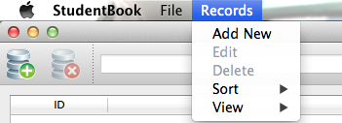

Both ways will lead you to the window of adding a new student

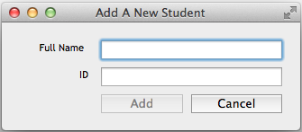

* **Delete a student**

To add new student you have two ways:

* By pressing on the button in the tool bar.
* By pressing Records 🡪 Delete.

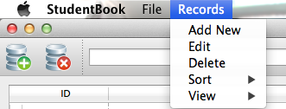

* **Search for a student**

You two types of search:

1. Search by Id.
2. Search by Name.

Choose between searching by id or by name then press or press “Enter”.

* **Edit a student’s data**

To edit the id or the name you have two choices:

1. By double clicking the data you want to modify.



1. By pressing the data you want to change then go to Records 🡪 Edit.

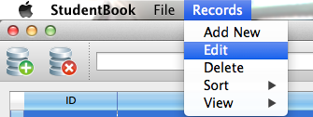

* **Sort the list**

To sort the list you can sort by id or by names

Go to Records 🡪 Sort.

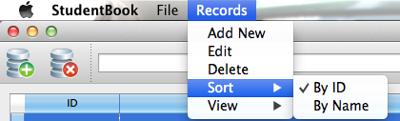

* **View List (Inorder/Preorder/Postorder)**

You have the choice to change the view to inorder or preorder or postorder. Go to Records 🡪 View.

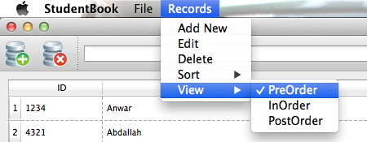

* **Open and Save a file**

To open or to save a file, go to File 🡪 Open or File 🡪 Save.

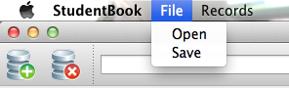

**Technical Specifications**

* Student Book Pro Graphical User Interface is based on Qt, a cross-platform application and UI framework for developers using C++ or QML, a CSS & JavaScript like language.
* 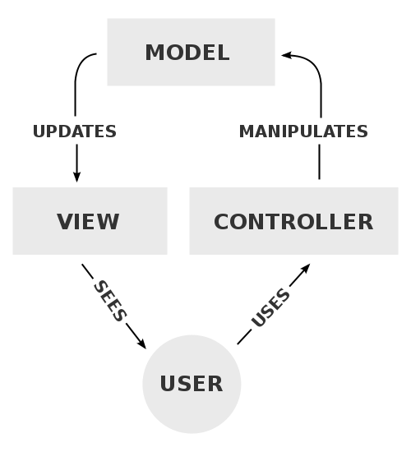It is based on MVC architectural pattern, Model–view–controller (MVC) is a software architectural pattern for implementing user interfaces. It divides a given software application into three interconnected parts, so as to separate internal representations of information from the ways that information is presented to or accepted from the user.
* Students’ data are represented inside a Binary Search Tree where Insertion, Edition, Deletion and Searching occur through it. The data is stored inside a structure per student where the pointer of this structure is saved inside a new node in 2 binary search trees, one sorted by ID & the other sorted by Name. By this technique we have eliminated the memory usage since we have avoided the duplication of data inside each tree.
* The deletion technique implemented in this software is intelligent enough to delete both nodes from each binary search tree in a complexity of O(1). This was achieved by saving the pointer of each node inside each binary search tree in the structure for data per student.
* During opening a data store, students’ data are imported and balanced inside the internal binary search tree.
* The Model is interconnected with the View through a double linked list implemented with an iterator control that helps iterating on the whole linked list.