Instructions

Allowed tools: Paper, pen and dictionary.

Write name and personal number here:

……………………………………………….
Write the secret number given to you on EVERY page including here:

……………………………………………….
If you want your result sent to you by email, write your email address here:

………………………………………………

Maximum number of points on the exam is 80. An additional 20 points are given for the programming and bioinformatics labs, i.e. the final grade is based 80% on this exam and 10% for the programming labs and 10% for the bioinformatics labs. To pass the course you need to pass all labs, have at least 50% grade in total and have at least 32 points on this exam.

Grades are then accordingly to the following (as specified by Stockholm University)
- A 92-100%
- B 80-91%
- C 68-79%
- D 56-67%
- E 50-55%
- Fx 45-49%
- F 0-44%

Each question should be answered within the provided space, if you need more space, write on the back of the paper.

You can answer in either English or Swedish

Arne can be reached at 070-6951045 for questions, and will pass by a few times during the exam.

Short questions (8 p per question):

- Describe how ClustalW (and other progressive multiple sequence alignment methods) works?

- What is the “power law–like distributions of paralogous family size in a genome”? Explain how this describes the different protein family sizes (4p). Which fundamental evolutionary principle might have caused this distribution (4p)?
- Describe and draw the TMHMM method that is used for membrane protein topology predictions (4p). How is the length of the helices modeled (2p)? What is the “positive inside rule” and how is it taken into account in the model (2p)?.

- Use (A) How many degrees of freedom (e.g., angles) do you need to describe the backbone conformation of a protein chain of length N residues? (4p)

(B) What amino acids does this Ramachandran plots represent (4p)?
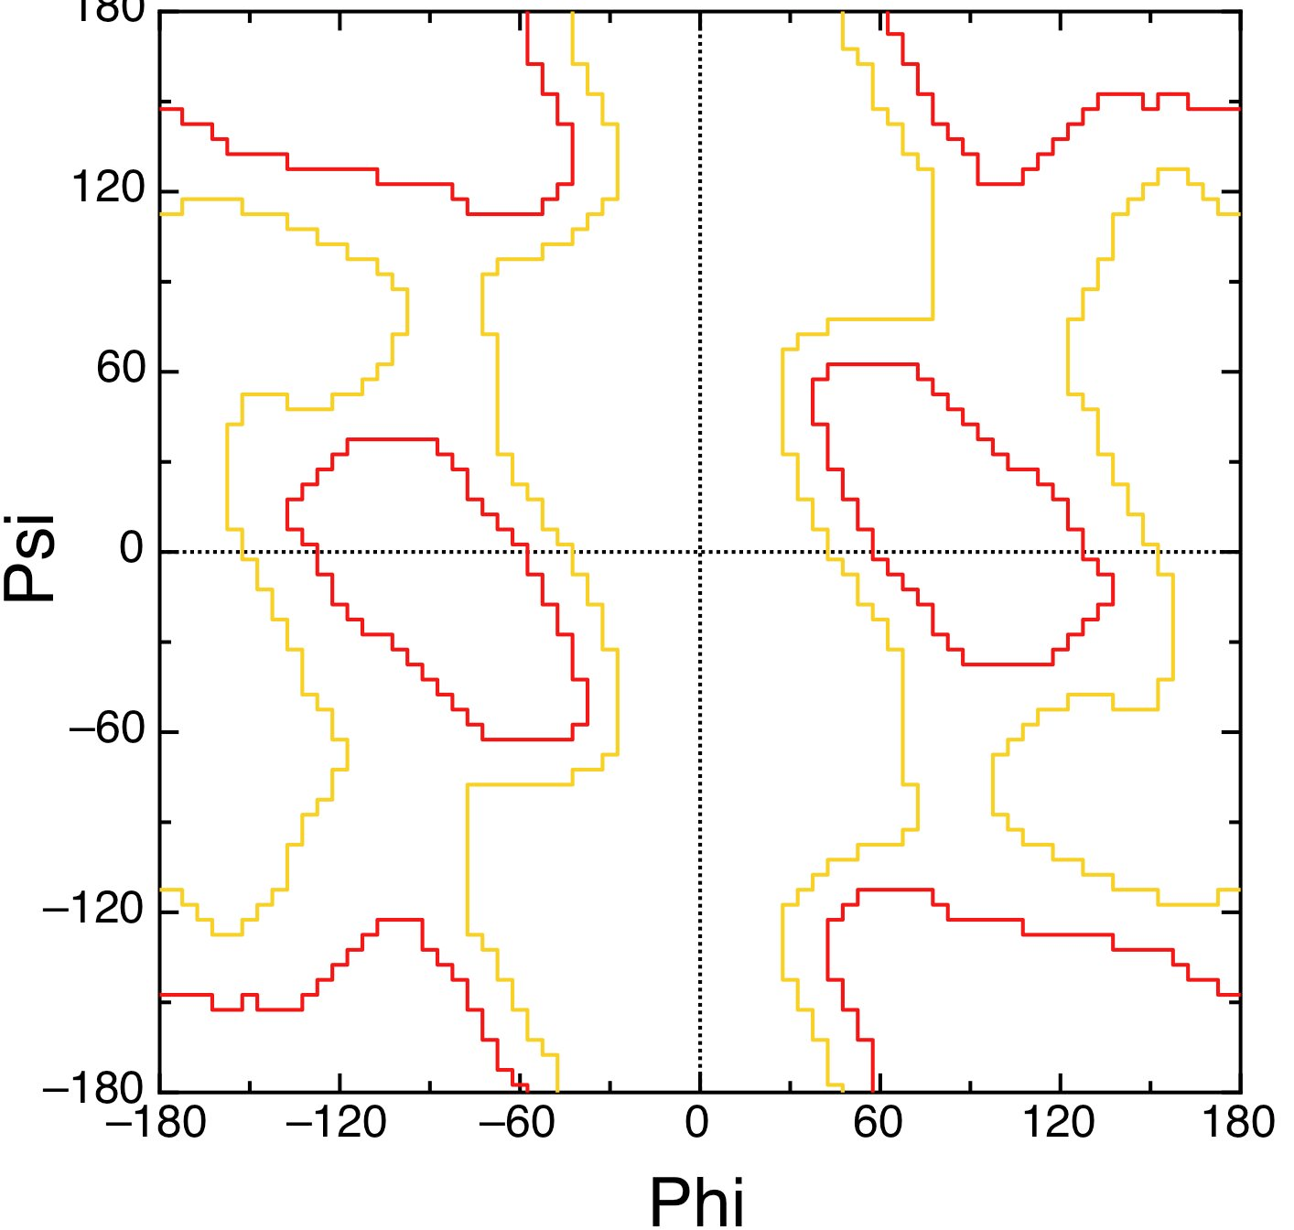

- Given an identity matrix (score of 1 for matches and 0 for mismatches) and a gap penalty of -1 per gap what is the optimal local alignment and score of the following sequence pairs (4p per pair):

IKLALL / IKAL

WYIKLLLL / WIKLLLK

- (a) Describe how a supervised machine learning method works (4p)? Describe some factors that are important to obtain the best result. (b) In particular what is overtraining (2p) and (c) how can it be avoided (2p)??

- What is the difference between a parsimonious and a neighbor joining method in phylogeny ?
- How is the E-value in sequence alignment dependent on the score and the database size?

Long question (16p).
9. Describe how you would develop a predictor that is able to identify the interaction areas between two proteins. What methods would you use? What are the important data you can use? How would you develop the pipeline? Describe potential problems. What proteins are easier to predict?

