Final Report

Capstone Project - The Battle of Neighborhoods

Author Eloisa Moreira de Lira
April, 08 of 2020

Introduction

The global pharmaceutical market is expected to overcome $1.5 trillion by 2023, from the $1.2 trillion of 2018, at an annual growth rate of 3-6%. This increase should be paralleled by the increase in the number of launched products, that might reach 54 in 2023.

Competition in biosimilars is also expected to increase by three times, while specialty share of total medicine spending will reach 50% by 2023 in most developed markets.

These scenarios are illustrated by the recent IQVIA Institute of Human Data Science “The Global Use of Medicine in 2019 and Outlook to 2023”.

Pharmacies today not only dealing medicine, it’s a source of many kind hygiene and food products. This stores open 24/7 turned a kind of convenience point spread everywhere.

For those reasons this study shows how some Data Science tools can be useful in some bussiness stratregies. This report makes part of the final evaluation to Professional Certificate in Data Science in partnership with Coursera and IBM.

Explaining the task

A foreign group would like to install some pharmacies in LA in order to gain customers in not foreseen areas. This task was performed aiming to execute an areal study of new places and then expand pharmacies in Los Angeles. Today Los Angeles count with three main pharmacies spreaded such as Wallgreens, CVS and Wallmart pharmacy. However some place are covered by little few sorted pharmaceutical establishments making this fact a window to relevant success.

Some places the number of pharmacies are fewer or almost inexistent.Due this It was performed a areal studies and suggested some conclusions using Machine Learning tools.

The term "k-means" was first used by James MacQueen in 1967, [1] though the idea goes back to Hugo Steinhaus in 1956.[2] The standard algorithm was first proposed by Stuart Lloyd of Bell Labs in 1957 as a technique for pulse-code modulation.

k-means clustering is a method of vector quantization, originally from signal processing, that aims to partition n observations into k clusters in which each observation belongs to the cluster with the nearest mean (cluster centers or cluster centroid), serving as a prototype of the cluster. This results in a partitioning of the data space into Voronoi cells.

k-means clustering has been used as a feature learning (or dictionary learning) step, in either (semi-)supervised learning or unsupervised learning. Reference

For this case was necessary to download the dataframe of neighborhood and their respective coordinates. Then the search was complemented by the venues rank by the FourSquare API.
Describing the dataset

Before to perform the code. It’s necessary to find some prior information. Even more, it’s mister to ensure where to grab data in reliable sources. For sake to know, data conditioning or data wrangling the most time of cases spend the major part of time. The quality of data are linked with the clean data, absolutely yes. Informally some authors affirm be more than 70% of time spent used during the wrangling and it’s not guarantee be yielded a perfect data at once. As seen in Data Science Methology course, data cleaning it’s a interative task. We perform the condiction as we go forward in analysis and are realized some editions or data increment.

In this report, to perform the analysis we took the Neighborhood data from Los Angeles State as a CSV file (comma separated by values) from NDSC Coachella Valley platform (see the complete address please the Bibliography section). Through this data will be performed a radial searching getting the main stores using the Foursquare API. Using the Foursquare, the set are accomplish with coordinates, store category , address etc. This data produce us a rank of neighborhood pharmacies venues according the local user. All the present stores are gathered like clusters provided by the Clustering algorithm from machine Learning approach. Finally the conclusions of each potential location will be presented in this report.

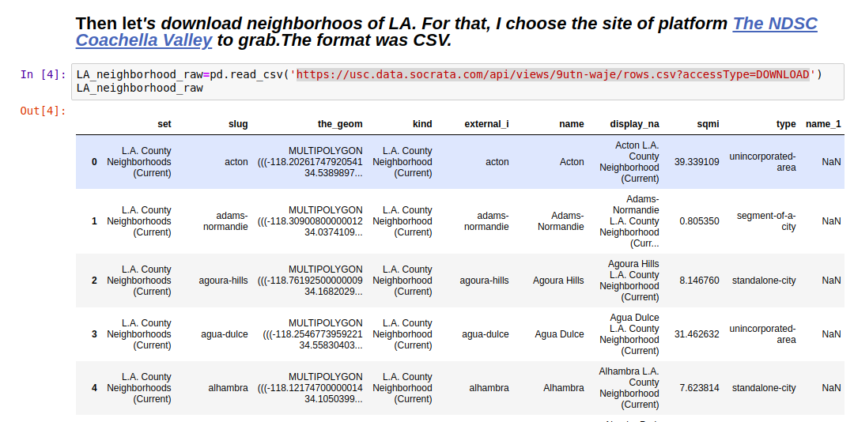
Picture: Raw data of Neighborhood of Los Angeles, CA.

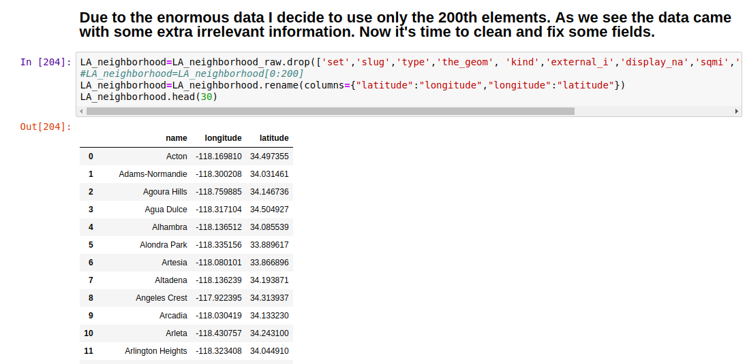
Picture: Dataset Neighborhood cleaned

Using FourSquare API

The Foursquare Places API provides location based experiences with diverse information about venues, users, photos, and check-ins. The API supports real time access to places, Snap-to-Place that assigns users to specific locations, and Geo-tag. Additionally, Foursquare allows developers to build audience segments for analysis and measurement. JavaScript Serialized Object Notation (JSON) is the preferred response format.

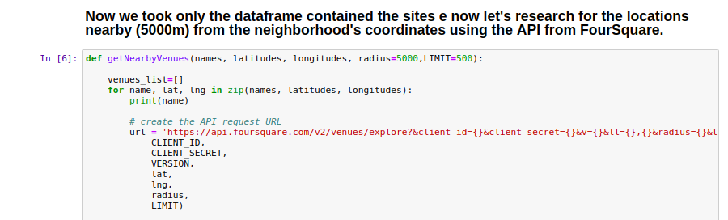
Picture: Requesting the data through the Foursqaure credencials at the block of code above.
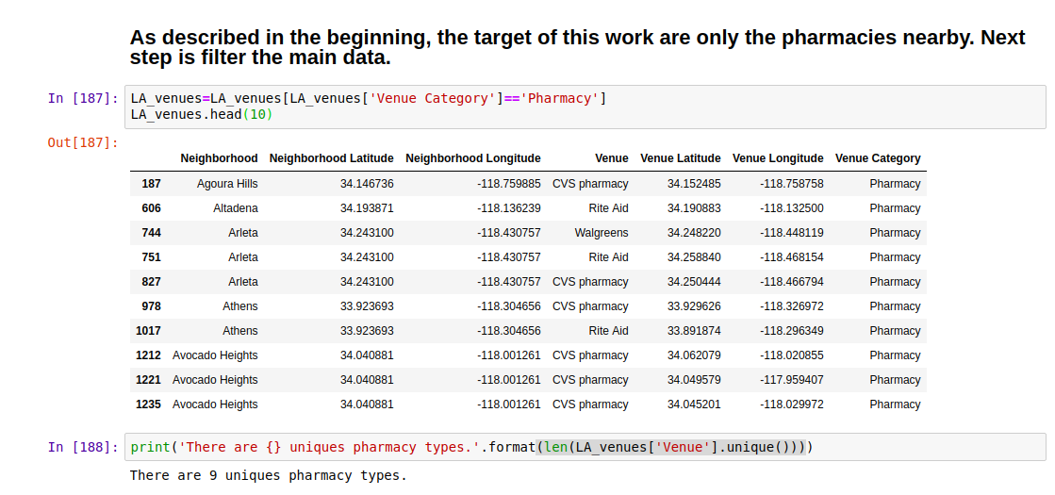
Picture: Venue, Venue Latitude,Venue Logitude and Venue Category columns are provided by API Foursquare. Here is the dataframe merged with columns neighborhood.

One-hot Encoding Method

One hot encoding is a process by which categorical variables are converted into a form that could be provided to ML algorithms to do a better job in prediction. The categorical value represents the numerical value of the entry in the dataset.

Advantages
Determining the state has a low and constant cost of accessing one flip-flop
Changing the state has the constant cost of accessing two flip-flops
Easy to design and modify
Easy to detect illegal states
Takes advantage of an FPGA's abundant flip-flops
Using a one-hot implementation typically allows a state machine to run at a faster clock rate than any other encoding of that state machine.[9]

Disadvantages
Requires more flip-flops than other encodings, making it impractical for PAL devices
Many of the states are illegal [10]

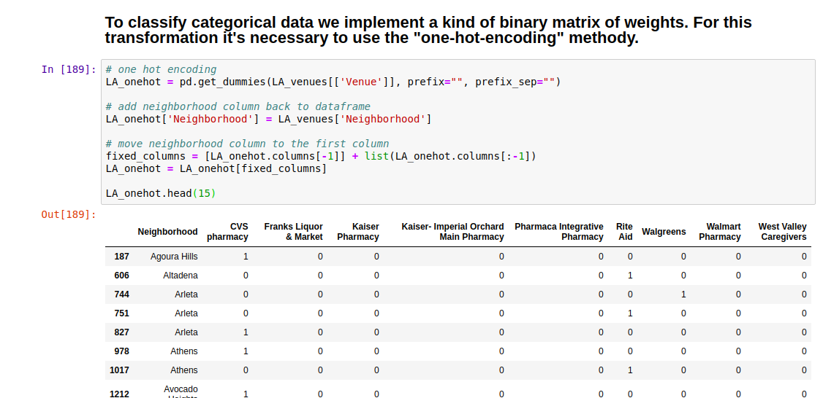

Picture : the methology applied in the code and some outputs. In our case it was necessary to count how many pharmacies occured in each Neighborhood.
The Method of Machine Learning

Machine learning (ML) is the scientific study of algorithms and statistical models that computer systems use to carry out tasks without explicit instructions, such as by using pattern recognition and inference.

Machine learning algorithms build a mathematical model based on sample data, known as "training data", in order to make predictions or decisions without being explicitly programmed to do so Machine learning algorithms are used in a wide variety of applications, such as email filtering and computer vision, where it is difficult or infeasible to develop conventional algorithms to perform the needed tasks.

Early classifications for machine learning approaches sometimes divided them into three broad categories, depending on the nature of the "signal" or "feedback" available to the learning system.

Supervised machine learning

Supervised machine learning uses sample data that is well classified and labeled. It’s supervised because it involves a set of feedback data that indicates whether the predictions based on the sample data are correct or incorrect.

Unsupervised learning

No labels are given to the learning algorithm, leaving it on its own to find structure in its input. Unsupervised learning can be a goal in itself (discovering hidden patterns in data) or a means towards an end (feature learning).

Clustering algorithms

Clustering focuses on identifying groups of similar records and labeling the records according to the group to which they belong. This is done without prior knowledge about the groups and their characteristics. Types of clustering algorithms include the K-means, TwoStep and Kohonen clustering.

- means Clustering

The k-means method has been shown to be effective in producing good clustering results for many practical applications. However, a direct algorithm of k-means method requires time proportional to the product of number of patterns and number of clusters per iteration. This is computationally very expensive especially for large datasets.

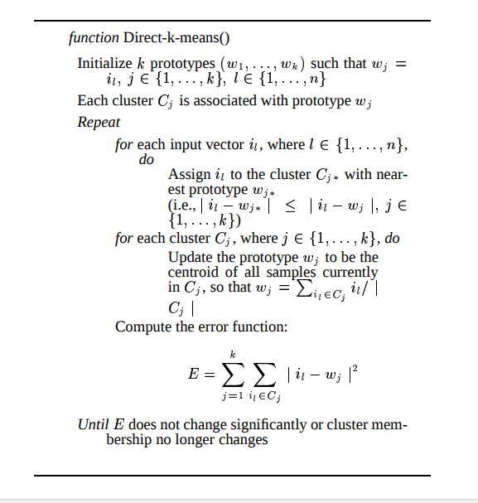

Picture : the algorithm of K means Clustering(8)

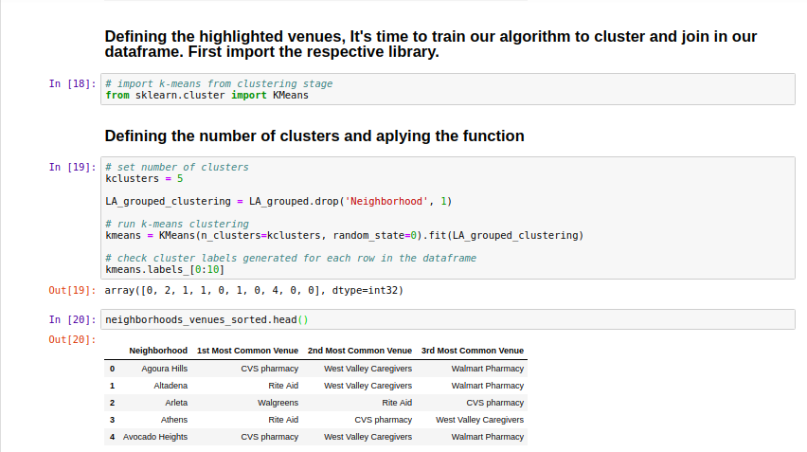

Picture: After set the number of clusters equals five. The algorithm separates in way of array all the clusters label to be merged with data frame lately.

After merge all the favorite venues with respective Neighborhood names and coordinates It was insert the cluster label as well. Bellow the result:

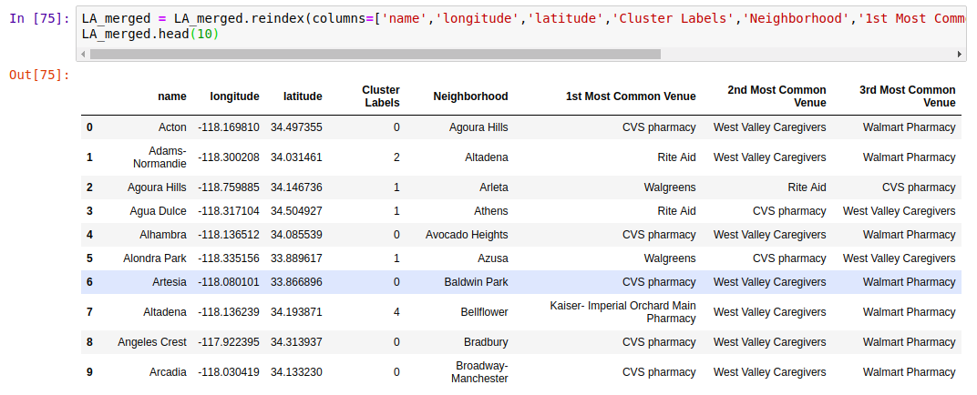

Now let’s seen in the map plotting using the Folium library.

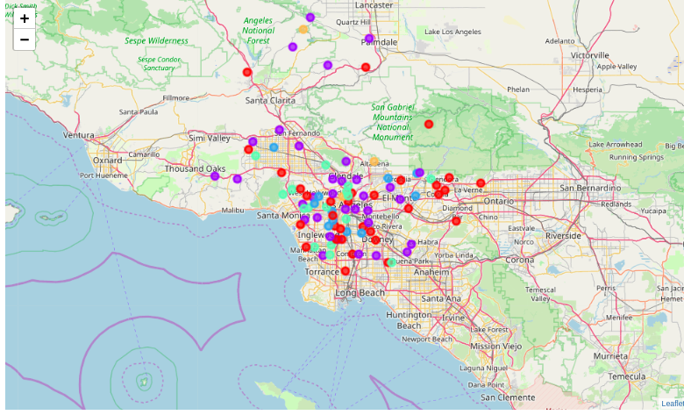

Picture : each color represent an individual cluster. Naming by color: red-cluster0, violeta-cluster1, blue-cluster2, green-cluster3, orange-cluster4.

Let’s see the results coded in Jupyter Notebook. In order crescent of clusters:
Cluster 00
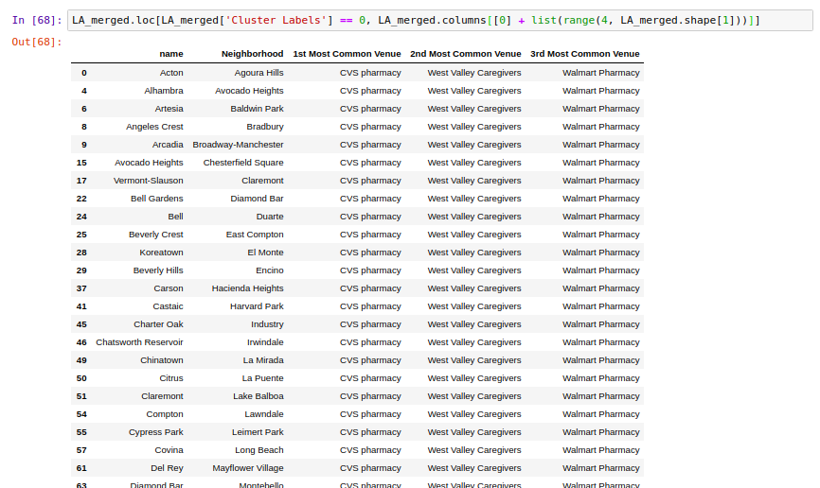

Cluster 01

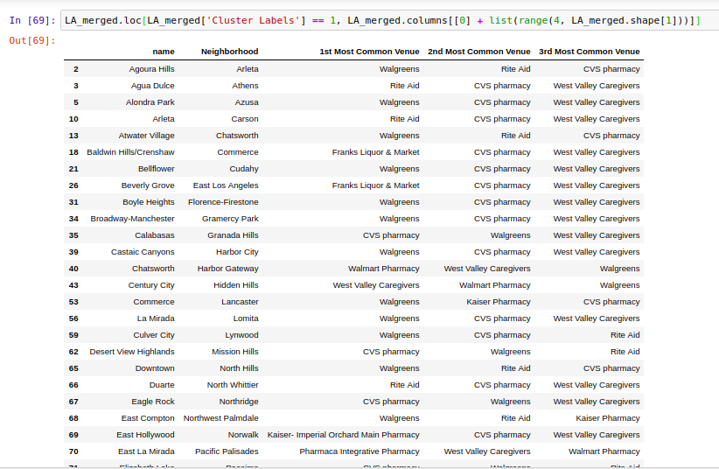

Cluster 02
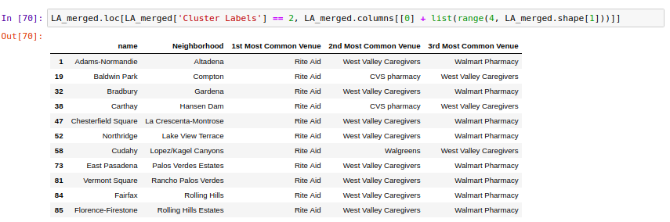

Cluster 03

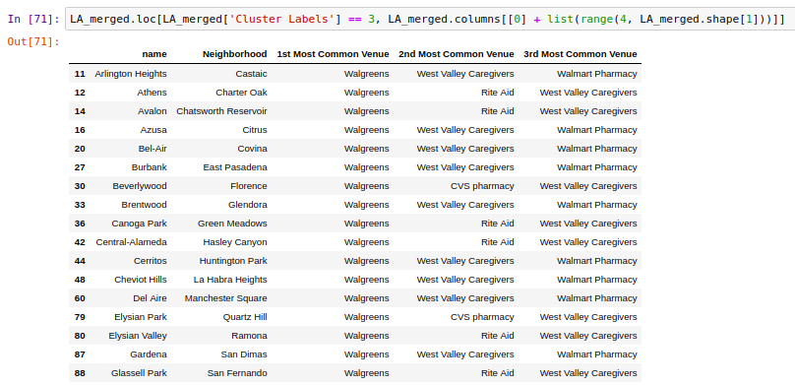

Cluster 04
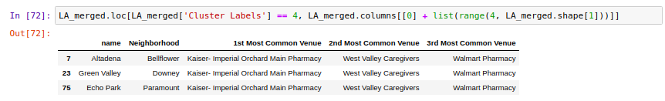

Conclusions

As seen in the map it's clear that some areas are dominated by big pharmacies. But despite this fact it's possible see another areas lacking the of them thus is a opportunity to new comes.

1. Region of Palmdale are predominancy of Wallgreeens pharmacies but the low density of dots turns a good area to enter in.

2. Santa Clarita,Malibu, Glendale and West Hollywood regions does not enterend in the clusters or have fewer dots. May be there was many others little pharmacies not relevant to be weighted. Here area potencial area to install a store too.

3. Ranchos Palos Verdes until Long Beach seacost side area hot areas to new opportunities.

4.In overwall LA is dominatad buy to main pharmacies groups: Wallgreen and CVS as 1st Venues preferences. Despite this the city offer some opportunities to receiver a newer since that glimpse the statements above.

Complementary References

[1]( MacQueen, J. B. (1967). Some Methods for classification and Analysis of Multivariate Observations. Proceedings of 5th Berkeley Symposium on Mathematical Statistics and Probability. 1. University of California Press. pp. 281–297. MR 0214227. Zbl 0214.46201. Retrieved 2009-04-07.)

(Steinhaus, Hugo (1957). "Sur la division des corps matériels en parties". Bull. Acad. Polon. Sci. (in French). 4 (12): 801–804. MR 0090073. Zbl 0079.16403.)

- “The Global Use of Medicine in 2019 and Outlook to 2023” https://www.iqvia.com/insights/the-iqvia-institute/reports/the-global-use-of-medicine-in-2019-and-outlook-to-2023 (visited in April 7, 2020)
- https://en.wikipedia.org/wiki/K-means_clustering (visited in April 7, 2020)
https://www.programmableweb.com/api/foursquare

https://www.programmableweb.com/api/foursquare (visited in April 8, 2020)

https://en.wikipedia.org/wiki/Machine_learning (visited in April 6, 2020)

Machine Learning for Dummies https://www.ibm.com/downloads/cas/GB8ZMQZ3 (visited in April 6, 2020)

Alsabti, Khaled; Ranka, Sanjay; and Singh, Vineet, "An efficient k-means clustering algorithm" (1997). Electrical Engineering and Computer Science. 43.
https://surface.syr.edu/eecs/43

[9]Xilinx. "HDL Synthesis for FPGAs Design Guide". section 3.13: "Encoding State Machines". Appendix A: "Accelerate FPGA Macros with One-Hot Approach". 1995.

[10] Cohen, Ben (2002). Real Chip Design and Verification Using Verilog and VHDL. Palos Verdes Peninsula, CA, US: VhdlCohen Publishing. p. 48. ISBN 0-9705394-2-8.

[11]https://hackernoon.com/what-is-one-hot-encoding-why-and-when-do-you-have-to-use-it-e3c6186d008f (visited in April 8, 2020)

All this work was performed inspired by the exercises done which comprehend the Module "Applied Data Science Capstone"from Coursera (Data Science Professional Specialization)

