高三冲刺作文精写训练-第 1 篇
题目 1：（传统文化+校园活动+说明描述+议论）（难度 7）
随着中国传统文化的复兴，汉服(Hanfu)作为一种独特的服饰文化，逐渐受到人们的关注和喜爱。假如你是明启中学
的学生李华，你校正在向学生们征集新社团的创建意向。作为汉服爱好者，你准备成立汉服社，请给校委会写一封
邮件表达你的想法。你的邮件需包含：
1. 成立该社团的目的；
2. 社团拟开展的活动及原因。
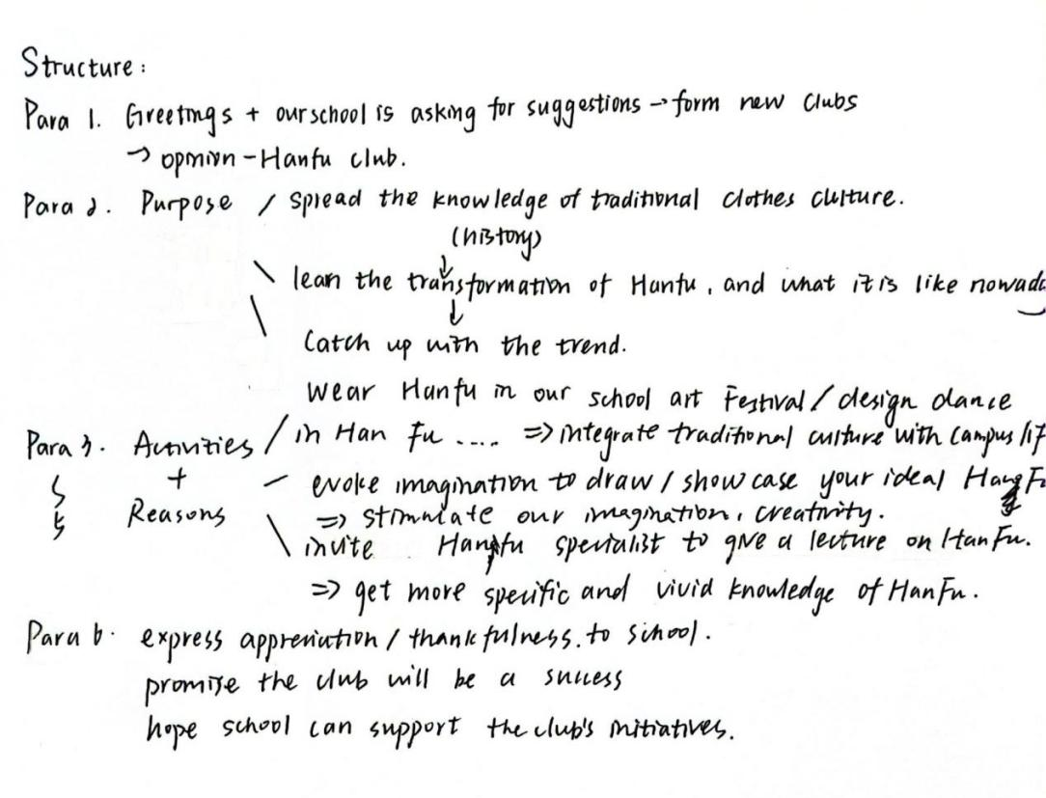
Dear school committee,
Greetings! With the revival of traditional Chinese culture, Hanfu is getting increasing attention from the masses. Seeing that our school is resembling new-club proposals, I’m going to establish the Hanfu club as I’m definitely a ‘Hanfu-goer’.
The purposes of this foundation lie in two points. Above all, I think it’s of great importance to spread the knowledge of traditional clothes culture in such a digital era, cementing our bond with the past ancestors and our ever-lasting Chinese culture. Specifically, armed students with the transformation of Hanfu throughout history can prompt them better understand the present Hanfu trend, pacing with the current headlines.
To get better prepared for the club, I have envisioned several activities initially.
First and for most, we can invite Hanfu expert to give a lecture on Hanfu. He or she may vividly depict considerable types of Hanfu style, making our eyes fixed with excitement and surprise especially girls. This activity also allows us to get a deeper understanding of the national merge in Chinese history from a refreshed lens, clothes.
Moreover, initiating activity which allows students to draw and showcase their ideal Hanfu styles is also an appealing activity . By using different texture of papers and different color, students can fully evoke their imagination and creativity and accomplish some , mind-blowing works of art.
Last but not least, students can wear Hanfu in our school Art Festival. We may design some ‘Hanfu Show’, prompting students who want to show themselves in a unique style rather than monotonous uniform.
Putting Hanfu choreography on stage, demonstrating the enchanting performance of students can undoubtedly impress the whole school. It’ such an imposing way of integrating traditional culture with campus life.

In a nutshell, I promise the Hanfu club will provide teachers and students with full engagement and vitality. I’ll appreciate it so much if you can take my proposal into consideration. Thank you.
档次 | 内容 | 语言 | 组织结构
A |  | 9-10 | 4-5
B | 7-8 | 7-8
C | 5-6 |  | 2
D | 3-4 | 3-4 | 1
E | 0-2 | 0-2 | 0

Yours, LiHua

