高三冲刺作文精写训练-第 1 篇
题目 1：（传统文化+校园活动+说明描述+议论）（难度 7）
随着中国传统文化的复兴，汉服(Hanfu)作为一种独特的服饰文化，逐渐受到人们的关注和喜爱。假如你是明启中学
的学生李华，你校正在向学生们征集新社团的创建意向。作为汉服爱好者，你准备成立汉服社，请给校委会写一封
邮件表达你的想法。你的邮件需包含：
1. 成立该社团的目的；
2. 社团拟开展的活动及原因。
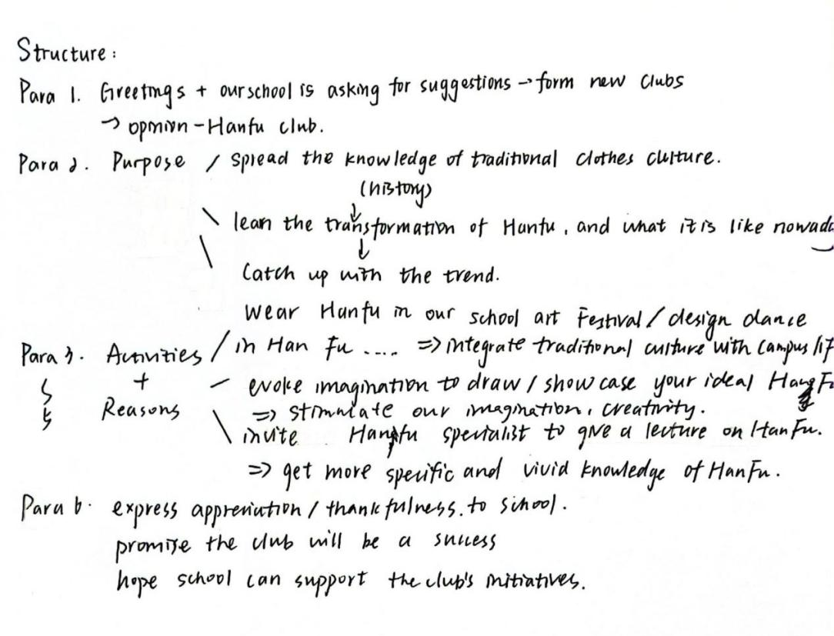
Structure的想法很好，且符合题目要求。但信息量较大，可以斟酌要点并删减
审题情况：本文完整回应了题目的要求，文章分为两个板块，一个是目的，另一个是开展活动的提议，内容充实，但需要删减优化。
Dear school committee,
Greetings! With the revival of traditional Chinese culture, Hanfu is getting gaining increasing attention from the masses. Seeing that our school is resembling new-club proposals, I’m going to establish the Hanfu club as I’m definitely a ‘Hanfu-goer’.
段落点评：第一段开门见山地表达了写信的目的，即申请成立汉服社。但语言需要再润色。
语言提升：1.积累表达：“gain/ receive attention” 更地道。2. 注意词意“resemble”：像、类似；这里应该换为“considering”或“accepting”3.“I’m going to establish” 太口语化，改为 “I would like to propose the establishment of...” 更正式且有礼貌。 4.“Hanfu-goer” 不是标准表达，可以理解但会比较奇怪。可以用 “Hanfu enthusiast” 或者 “Hanfu lover”.
问题建议：1.建议多阅读外刊，去积累native的表达方式。2.部分搭配虽没有语法错误但比较生硬。
The purposes of this foundation lie in two points. Above all, I think it’s of great importance to spread the knowledge of traditional clothes culture in such a digital era, as a way of cementing our bond with the past ancestors and our ever-lasting Chinese culture. Specifically, armed students with the transformation of Hanfu throughout history can prompt them to better understand the present Hanfu trend, pacing with the current headlines.
段落点评：详细阐述了成立汉服社的目的，强调了汉服的文化价值和意义
语言提升：1.“foundation”一般指基金会，这里还是改回“club”比较好。2.“lie in two points” 虽不算错，但可以更自然地表达为 “can be summarized in two main aspects” 3.“traditional clothes culture” 不准确，改为“traditional clothing culture” 或 “traditional dress culture” 4.“past ancestors” 属于重复表达，ancestor 本身就表示“祖先”，去掉“past”即可语法结构混乱，主语不清晰。5.“armed students” 开头像是主语，但主语后接的是动词“can prompt them”，语义不清。应该改为：If students are equipped with knowledge... then they can better understand... 6.“pacing with the current headlines” 的表达不清晰，可能想表达“跟上时代潮流” pace 一般用作名词，用作动词时表示因烦恼来回的踱步。
修改参考：
More specifically, by learning about the evolution of Hanfu throughout history, students will be better equipped to understand current Hanfu trends and appreciate their relevance in today’s cultural landscape.
问题建议：1.需要加强对词汇的深入学习。比如prompt sb. to do sth.；pace的用法等等。2.语言流畅度欠佳，部分表达比较生硬。3.句式可以优化的更简洁。
To get better prepared for the club, I have envisioned several activities initially.
过渡句：策划活动
First and for most, we can invite a Hanfu expert to give a lecture on Hanfu.（第二个“Hanfu”有点废话文学可以加些具体内容） He or she may vividly depict considerable types of Hanfu style, making our eyes fixed with excitement and surprise especially girls. This activity also allows us to get gain a deeper understanding of the national merge in Chinese history from a refreshed lens, clothes. throught the lens of clothing.
语言提升：1. 注意冠词First and foremost, we could invite a Hanfu expert to deliver a lecture on the history and aesthetics of Hanfu；give a lecture 可以换成“deliver a lecture” 2.“considerable types” 不合适，considerable 一般形容“数量”或“重要性”，应改为 “a wide range of”。3.“Hanfu style” 应为复数形式：“Hanfu styles”。4.“making our eyes fixed” 是字面直译，英语中不常这么说。5. “especially girls” 放句末有歧义，整句话需要简化和提升语言流畅度。
修改建议：The speaker could vividly present a wide range of Hanfu styles, which would undoubtedly captivate the audience—particularly those with a keen interest in traditional fashion.
Moreover, initiating an activity which allows students to draw design and showcase their ideal Hanfu styles is also an appealing activitycan be engaging. By using different textures of papers and different colors, students can fully evoke their imagination and creativity and accomplish some ,producing truly mind-blowing works of art.
有语法错误+语言需要精简
Last but not least, students can wear Hanfu in during our school Art Festival. We may design some ‘Hanfu Shows’, prompting students who want to show themselves in a unique style rather than monotonous uniform.
(这句有语法错误 定语从句使用多余，主干：prompt students 这对吗？？）Putting Hanfu choreography on stage, demonstrating the enchanting performance of students can undoubtedly impress the whole school. It’ such an imposing impressive way of integrating traditional culture with campus life.
“活动”段综评：要点很充实，但是语言比较繁琐导致篇幅太长。建议文章整体采用四段式。中间body段，一段写purpose，另一段写activity，现文章结构有些松散。一个过渡句+三个activity需要合成一段来写。
语言提升建议：1.冠词。注意可数名词要么加冠词，要么加复数，不可单独出现。2. imposing形容物一般指规模宏大、雄伟；形容人一般指其威严或气场强大。这里建议换成impressive；3.需要强化语法训练，尤其是复合句。

示例参考(建议积累自己的表达习惯，示例仅是提供主体段的结构参考）：To better prepare for the club, I also have envisioned several activities initially. One engaging way to promote traditional culture on campus is through Hanfu-themed creative activities. For example, students can design their ideal Hanfu styles using various textures and colors, giving full play to their imagination and artistic skills.Additionally, we could organize a Hanfu show to encourage students to express themselves through unique styles, as a refreshing alternative to the monotonous school uniform.Performances featuring Hanfu choreography would not only showcase the beauty of tradition but also make cultural heritage a vivid part of school life.
In a nutshell, I promise the Hanfu club will provide teachers and students with full engagement and vitality. I’ll appreciate it so much if you can take my proposal into consideration. Thank you.
段落点评：总结了邮件的内容，并表达了对社团设立的强烈愿望。
问题建议：划线句没什么语法问题但是很生硬有些chinglish，需要日常多阅读外刊积累地道表达。
修改示例：In a nutshell, I believe the Hanfu Club will offer a dynamic and enriching experience for both teachers and students. Your kind consideration of my proposal would be sincerely appreciated. Thank you.
本篇总体评价和提升建议：本文内容很充实，较好的回应题目。但是语言上，有较多基本语法错误，以及部分表达过于生硬，需要加强练习。同时建议简化某些句子，使语言更加贴近英语的表达习惯。结构有些松散，文章尽量采取四段式。加油！
本篇文章打分估计为：17-18分
档次 | 内容 | 语言 | 组织结构
A | 9-10 | 9-10 | 4-5
B | 7-8 | 7-8 | 3
C | 5-6 | 5-6 | 2
D | 3-4 | 3-4 | 1
E | 0-2 | 0-2 | 0

Yours, LiHua

