UNIVERSITY OF MAINE

Group and Individual Reflection and Collaboration

Principal Investigator: Dr. Gregory L. Nelson, Assistant Professor, Department of Computer Science, College of Liberal Arts and Sciences (CLAS), University of Maine

Application Narrative:

1. Funding

N/A.

2. Summary

This study investigates how social reflection (reflecting together in small groups), individual reflection, and combinations of the two support people's learning, professional skills, self-efficacy, professional identity, and improvement over time, in settings outside of and independent of any single course or semester. Prior research has shown that metacognitive and reflective strategies and peer support can improve learning outcomes (Chan & Lee, 2021; Lim et al., 2022), and reflection groups are effective and common in teacher and medical professional education, but there is little research on scalable, sustainable, peer-based reflection practices in computing and how to design them for adoption beyond a single course.

The research team offers reflection groups outside of any course, integrating working professionals as peers. Positive results in this setting will also inform future adoption pathways, such as a standalone one-credit reflection-groups course.

Two terms are used throughout this application, including its appendices. Members are the people who take part in the reflection groups and the other reflection activities the research team offers. Those activities are a service that would be offered regardless of this research; they are not themselves research, and their design is not part of this application. Participants are the people who take part in the research: those whose reflection-group materials are used as research data, those who respond to a research survey, and those who take part in a research interview. Most participants are also members, but the two roles are separate, and the comparison population described below are participants who are not members.

This study covers reflection and collaboration activities outside of courses: ongoing reflection groups for current students (outside their coursework), recent graduates and alumni, working professionals participating as peers, and community members in informal or online reflection communities; the matching and behavior-change tools that support these groups; and comparative evaluation including professional comparison samples. The reflection groups and reflection activities are offered as an ongoing service to members and would be offered regardless of this research; this protocol governs the research use of data generated by that service, plus research-specific activities (surveys, interviews, and comparison groups).

For the purposes of the research "outcomes" below refers to: professional skills & dispositions, learning, career, and other personal and social outcomes. For example, professional skills (such as iterative improvement, lifelong learning, psychological safety, and communication), self-efficacy, professional identity, and other personal, professional, and group outcomes.

Research Questions:

1. What are the effects of and outcomes from reflection activities, such as reflection groups?

2. Which design features of reflection activities, such as reflection groups, most support members and outcomes?

3. What barriers and enablers shape whether people adopt and sustain reflection practices within and after participating in reflection groups, including maintaining and transferring skills and other outcomes from their prior experiences?

4. What reflection group designs, such as mixing and not mixing members with different prior experience levels, lead to more positive effects from reflection groups?

5. For reflection groups, what balance of scaffolding (such as regular reflection questions) and agency/adaptability (such as groups determining and changing reflection questions) leads to better long-term outcomes?

Methods:

This research is expected to run over multiple years. Neither membership in a reflection group nor research participation is tied to a course or semester. Reflection groups run in participation cycles of approximately 12 weeks; new cycles may begin at any time of year, and activities recur at general intervals rather than on an academic calendar. Groups that wish to continue meeting after a cycle ends may do so. All group meetings, information sessions, and whole-cohort activities are held online (analogous to an online class). Recruitment for each part of the research is in Section 4 and consent for each part is in Section 5; neither is repeated here.

Reflection-group materials collected as part of normal reflection-group activities:

None of the reflection-group materials used as research data is sensitive in nature. They concern learning, professional skills, and taking part in a small group. The intake survey includes standard demographic items, one of which asks about disability or accommodations and may be left unanswered; no other category of sensitive information is collected anywhere in this study. These activities are the service, not the research, so no instrument appendix is included for them. Each item below states what the research would use and how it is collected. Group meetings are not recorded — no audio and no video is captured — and no researcher attends a meeting, apart from a member of the research team reading the verbal script in Appendix F at the start of a group's first session.

1. Intake survey, completed online in Qualtrics when a member joins, which the service uses to form compatible groups. It collects availability, background, prior programming experience, demographics, baseline outcome measures, and the member's email address.

2. Icebreaker responses, written by members online in their group's shared workspace before or during their first meeting.

3. Group meeting agenda notes, written by members themselves online in their group's shared workspace during each meeting, including the notes from the longer retrospective meeting at the end of a participation cycle.

4. Individual written reflections, completed online in Qualtrics after each meeting and visible only to the research team.

5. Notes and materials from the optional whole-cohort activity held about halfway through a cycle, and from the co-design sessions in which members suggest improvements to the reflection-group designs, both held online.

6. Usage data from the online tool that supports the groups — for example responses to its reminders and which of its features are used — exported from the tool.

Research data collected outside of normal reflection group activities:

7.
Longitudinal follow-up surveys. Members are

invited to confidential follow-up surveys, taken online in Qualtrics, each taking approximately 10–15 minutes. The surveys are confidential rather than anonymous: each response carries the participant's email address as an identifier, handled as described in Section 6. Invitations
are

sent at

approximately 3 months and 6 months after a member's group begins, and then approximately every 6 months, for up to four years (up to nine follow-up surveys in total); each is a separate invitation and a participant may respond to some and not others. The survey questions are in Appendix C.

8. Interviews. A purposeful subset of members is invited to confidential individual interviews about their experiences, professional-skill behaviors, and changes over time. Interviews are one-to-one; there are no group interviews. Each takes approximately 30–60 minutes and is conducted online on Zoom or in person, according to the participant's preference and researcher availability. Interviews are audio-recorded and transcribed; no video is recorded. Online interviews are recorded using Zoom's audio-only recording; in-person interviews are recorded on a password-protected handheld audio recorder. Agreeing to be recorded is not required in order to take part: a participant who prefers not to be recorded is interviewed with the researcher taking written notes instead. Recordings are transcribed by the named investigators. The interview guide is in Appendix E.

Interviews are scheduled where a member's experience is likely to be informative rather than on a fixed calendar. For example: shortly before or after a member joins a group; at the midpoint of a participation cycle; at the end of a cycle, following the group's retrospective meeting; after a member leaves a group, or after their group stops meeting; and after a follow-up survey response indicates something worth understanding in more depth, such as a large change in a self-efficacy or professional-identity measure, or a written answer describing a barrier to sustaining a reflection practice. Members may also ask to be interviewed. A participant may be interviewed more than once — for example once after each participation cycle.

9. Comparison group. For comparative evaluation, the team will separately recruit a comparison group of working professionals for surveys and optional interviews. A modification will be submitted for control group details at a later date to the IRB for review and approval prior to any recruitment for this group beginning. That modification will state the timing, mode, length, and confidentiality of the comparison-group surveys and interviews, and will include the survey and interview instruments as appendices. The compensation offered to this group is stated in Section 9.

Data collected:

1.1 Reflection-group intake survey responses: availability, background, demographics, baseline outcome measures, and contact email.

1.2 Reflection group materials: icebreaker responses, meeting agenda notes including the end-of-cycle retrospective, individual written reflections, and notes and materials from whole-cohort activities
and co-design sessions.

1.3
Tool-usage data (for example, reminder responses and feature use), linked by the same participant identifier; no separate instrument.

1.4 Longitudinal follow-up survey responses: email address and outcome measures (Appendix C).

1.5

Interview audio recordings and transcripts, and, where a participant declines recording, interview notes (interview guide in Appendix E).

1.6 Comparison-group survey and interview data, to be specified in the modification described above.

References:

Chan, C. K. Y., & Lee, K. K. W. (2021). Reflection literacy: A multilevel perspective on the challenges of using reflections in higher education through a comprehensive literature review. Educational Research Review, 32, 100376.

Edmondson, A. (1999). Psychological safety and learning behavior in work teams. Administrative Science Quarterly, 44(2), 350–383.

Grant, A. M., Franklin, J., & Langford, P. (2002). The Self-Reflection and Insight Scale: A new measure of private self-consciousness. Social Behavior and Personality, 30(8), 821–835.

Kember, D., Leung, D. Y. P., Jones, A., Loke, A. Y., McKay, J., Sinclair, K., Tse, H., Webb, C., Wong, F. K. Y., Wong, M., & Yeung, E. (2000). Development of a questionnaire to measure the level of reflective thinking. Assessment & Evaluation in Higher Education, 25(4), 381–395.

Lim, R. B. T., Hoe, K. W. B., & Zheng, H. (2022). A systematic review of the outcomes, level, facilitators, and barriers to deep self-reflection in public health higher education: Meta-analysis and meta-synthesis. Frontiers in Education, 7, 938224.

3. Personnel

PI: Dr. Gregory L. Nelson, Assistant Professor, Department of Computer Science, CLAS, University of Maine (gregory.nelson@maine.edu).

Roles: Principal Investigator, study design, reflection group and tool design, data analysis, recruiting, interviewing.

Experience: 5+ years of human-computer interaction and computing education research with human participants.

Cyril Agbewali-Koku, PhD Student, Department of Computer Science, CLAS, University of Maine (cyril.agbewalikoku@maine.edu).

Roles: Research assistant; study and design contributions, data analysis, recruiting, survey administration, interviewing.

Experience: ~1 year research experience with human participants.

Troy Schotter, Lecturer and PhD Student, Department of Computer Science, CLAS, University of Maine (troy.schotter@maine.edu).

Roles: design, data analysis, recruiting.

Experience: ~2 years research experience with human participants.

4. Participant recruitment

Participant Population:

Participants are adults age 18 or older. Because this protocol is not tied to a specific course, the population includes current university students (participating outside their coursework), recent graduates and alumni, working professionals, and community members in informal or online reflection communities. Individuals younger than 18 are excluded.

Reflection groups are normally formed in sizes of 3–5 members (typically 5). Given we will openly recruit people online to be a part of the study, over 5 years we may have up to 1,000 participants, including members who take part in reflection activities and comparison-group participants who do not.

Participant Identification and Recruitment Procedures:

How members come to join a reflection group is not part of this application, because the groups themselves are not research. What follows is the recruitment for each part of the research. All recruitment texts are in Appendix F.

(1) Recruitment for research use of reflection-group materials.

At the first session of each reflection group, a member of the research team reads the verbal script in Appendix F. It states that this is a University of Maine research study, names the researcher speaking and gives contact information, explains that the team is asking to use the materials the group's activities generate as research data, lists those materials, states that meetings are not recorded, and explains how to decline. The opt-out form in Appendix A is emailed to every member of the group on the same day, so that members who were not at the first session receive it too.

(2) Recruitment of members for the longitudinal follow-up surveys.

Members are invited by the email in Appendix F, sent at each survey point. It states that this is research in its opening lines, names a researcher and gives contact information, gives the length of the survey and the raffle entry offered, and links to the survey, whose first page is the consent form in Appendix B.

(3) Recruitment of members for interviews.

Members are invited by the email in Appendix F, at the points described in Section 2. It states that this is research in its opening lines, names a researcher and gives contact information, states the length and format of the interview, states that the interview is audio-recorded and that a member who prefers not to be recorded may take part with written notes instead, states the raffle entry offered, and carries a scheduling link. The interview consent form (Appendix D) is sent with the invitation.

(4) and (5) Recruitment of the comparison population for surveys and interviews.
Comparison-group professionals will be recruited through the research team's newsletters, email invitations to alumni networks, and social media announcements. No professional recruiting company or agency is used. The evaluation plan anticipates that later-year comparative studies will involve intervention populations of roughly 60–100 participants and comparison groups of roughly 200 professionals. A modification will be submitted for control group recruitment details at a later date to the IRB for review and approval prior to any recruitment for this group beginning.

5. Informed consent

Consent is handled separately for each part of the research, and all of it is electronic. Consistent with exempt review, no consent form is signed and no signature is collected. Everyone must be at least 18 years of age.

(1) Research use of reflection-group materials

Members do not need to do anything in order for their reflection-group materials to be used as research data. The opt-out form in Appendix A is emailed to every member on the day of their group's first session, after the verbal script in Appendix F has been read at that session. A member who does not wish their materials to be used for research emails any member of the research team with the subject line “Opt out of reflection research”; the form gives the addresses and the wording, and no reason has to be given. We ask for a decision within two weeks of the first session, so that a member's materials are not archived for research before they have decided, but a member may opt out at any later time and their materials are then deleted from the research data, for as long as we are still able to locate them (Section 6). A member who opts out stays in their reflection group on exactly the same terms.

(2) Longitudinal follow-up surveys.

The consent form in Appendix B appears as the first page of every follow-up survey. Submitting the survey indicates consent. The participant may print or save the consent page for their records.

(3) Interviews.

The interview consent form in Appendix D is emailed with the interview invitation and the scheduling link. The researcher goes through it with the participant at the start of the interview and answers any questions before any recording begins. Taking part in the interview indicates consent.

(4) and (5) Comparison-population surveys and interviews.
A modification will be submitted for control group consent details at a later date to the IRB for review and approval prior to any recruitment for this group beginning. The comparison-group survey and interview consent forms will be submitted with it.

6. Confidentiality

Initially, all data will be stored on a secure cloud storage platform that encrypts all data at rest and in transit with AES-256 bit encryption and is password protected. Identifiable data are accessible only to the research personnel named in Section 3.

(1) Research use of reflection-group materials.
Reflection-group materials are collected in Qualtrics, in each group's shared online workspace, or by export from the supporting tool, and are copied to the secure cloud storage platform. Members' gender and disability status, reported on the intake survey and used for group matching, are never disclosed to other members. The materials of members who opt out are removed before archiving, as described below.
(2) Longitudinal follow-up surveys.
Survey data is collected and stored in a secured cloud platform (Qualtrics). Survey responses are exported to the secure cloud storage platform and deleted from Qualtrics within 14 days of collection. Surveys are confidential rather than anonymous, and IP addresses are not collected.
(3) Interviews.
Interviews are conducted online (Zoom) or in person. Recordings of online interviews are removed from Zoom within 72 hours and stored on the secure cloud storage platform; recordings made on a handheld recorder for in-person interviews are removed from the device within 72 hours and stored in the same place. For example, the recording of an interview held in March 2027 is removed from Zoom or from the recorder in March 2027.
Original audio recordings are kept only until the transcript has been checked against them. Each recording is deleted within 12 months of the interview; for example, the recording of an interview held in March 2027 is deleted by March 2028. Because the last interviews under this protocol are expected by December 2035, no recording will be kept after December 2036. Transcripts, and interview notes where a participant declined recording, are de-identified and archived as described below.
(4) and (5) Comparison-population surveys and interviews.
A modification will be submitted for control group confidentiality details at a later date to the IRB for review and approval prior to any recruitment for this group beginning.

Archiving, key file, and withdrawal (all research data).
Within 14 days after the end of a participant's participation in an activity cycle, or for data collected on an ongoing basis, within 14 days of collection, all data will be archived to a separate cloud data platform, with all participant identifiers (such as email addresses) replaced with a randomly generated encrypted key. During this archiving, the data of members who have opted out of research use are filtered out and deleted, by looking up their email addresses and removing the records associated with them.

The key file that maps to participants' email addresses and participant demographic data will be stored in a separate folder; it is stored electronically and is encrypted. Five years after a participant's participation ends, their email address will be deleted from the key file; for example, for a participant whose participation ends in Fall 2026, the key entry will be deleted by the end of December 2031. This is to allow participants to withdraw their consent later if they wish. We can only delete participant data while the key exists.
The archived, de-identified data will be retained indefinitely.

7. Risks to participants

There are risks of time and inconvenience to participants. There is a minimal risk of a data breach; we expect a potential risk of embarrassment in that event. To minimize this risk, participant emails are replaced with a randomized unique identifier that cannot be traced back to the email address within the timelines described in Section 6; this identifier is stored separately along with demographic and any other personally identifiable information.

The consent page at the start of each survey makes clear that any question can be skipped if the participant does not feel comfortable answering, and participants are told the same at the start of an interview.

8. Benefits

There are no direct benefits to participants.

The research may improve understanding of scalable, adoptable, and effective reflection-based practices for supporting learning, professional skills, and lifelong learning across educational and professional settings. Findings may inform pedagogical practice, may support adoption across institutions, and may contribute to understanding how to sustain professional growth after graduation. These are potential benefits to others rather than promised outcomes.

9. Compensation
For each longitudinal follow-up survey a participant submits (Appendix C), the participant will be entered into a raffle to win a $10 electronic VISA gift card, sent by email within 48 hours of the raffle draw. Participants must reach the end of the survey to be entered into the raffle, though they may skip individual questions.

Participants who complete an interview will be entered into a raffle to win a $25 electronic VISA gift card, sent by email within 48 hours of the raffle draw. Entry is per interview.

Comparison-group participants are offered the same raffle entries as members: entry into a raffle to win a $10 electronic VISA gift card for each follow-up survey submitted, and entry into a raffle to win a $25 electronic VISA gift card for each interview completed.
Raffle draws are held [quarterly, at the end of March, June, September, and December]. In each draw, one $10 gift card is awarded for every [10] survey entries received since the previous draw, and one $25 gift card for every [5] interview entries, rounded up, so each survey entry has at least a [1 in 10] chance of winning and each interview entry at least a [1 in 5] chance. Winners are chosen with a random number generator and notified by email.

Where the cumulative compensation one participant receives exceeds $75, the tax-reporting information collected through Appendix G is provided to the appropriate University office.
University policy does not permit gift cards to be used to compensate University of Maine faculty and staff, so they take part without compensation; student employees may receive gift cards (Appendix G).

Gift cards are sent within 48 hours of each raffle draw. Final distribution dates, by type: gift cards for member follow-up surveys will be distributed no later than December 2035; gift cards for member interviews no later than December 2035; and gift cards for comparison-group surveys and interviews no later than December 2035, or an earlier date stated in the comparison-group modification. December 2035 is the end of the four-year follow-up window for the last participation cycle this protocol anticipates.

There is no compensation for other activities.

Appendix A: Opt-out form for research use of reflection group materials

UNIVERSITY OF MAINE — RESEARCH OPT-OUT FORM

Group and Individual Reflection and Collaboration

Researchers:

• Gregory L. Nelson, Assistant Professor, Computer Science Department, University of Maine (gregory.nelson@maine.edu) (Principal Investigator, Main Contact)
• Cyril Agbewali-Koku, Computer Science Department, University of Maine (cyril.agbewalikoku@maine.edu)
• Troy Schotter, Lecturer and PhD Student, Computer Science Department, University of Maine (troy.schotter@maine.edu)

We are asking to use your reflection-group materials as data in a research project led by Dr. Gregory L. Nelson, a faculty member in the Department of Computer Science at the University of Maine. The purpose of the research is to study how reflecting — on your own and together with others in small groups — affects learning, professional skills, self-efficacy, professional identity, and improvement over time. You must be at least 18 years of age to be part of the research.

What Will You Be Asked to Do?

You will not be asked to do anything beyond what you already do as a member of your reflection group. Unless you opt out, the research team will use the following materials, which your group's activities produce anyway, as research data:

• Your intake survey responses, including the availability, background, and demographic information used to form groups;
• Your icebreaker responses and the agenda notes your group writes in its shared online workspace;
• The individual written reflections you complete after each meeting;
• Notes and materials from whole-cohort activities and from sessions in which members suggest improvements to the reflection groups;
• Records of how you use the online tool that supports your group, such as your responses to its reminders.
Group meetings are not recorded, and no researcher attends them apart from reading this information at your group's first session.

Risks

• No additional time or effort is required of you;
• Loss of confidentiality of your data, although we will protect your data as described in the Confidentiality section.

Benefits

• There are no direct benefits to you;
• This research may improve understanding of effective ways to support learning and professional skills, which may benefit future students, professionals, and the broader community.

Confidentiality

Your data will be stored in password-protected systems accessible only to the research team, using software that provides additional security (encryption). Your email address will be used as an identifier so we can connect your information across activities and remove your data if you ask us to.

Your gender and disability status, which you may have given on the intake survey and which we use to match you into a group, are never shown to other members.

Within 14 days after your participation in a cycle ends, or within 14 days of collection for ongoing data, your identifiers will be replaced with a randomly generated key. The key file mapping your email and your demographic data will be stored separately, and it is encrypted. Five years after your participation ends, your email will be deleted from the key file; for example, if your participation ends in Fall 2026, by the end of December 2031. After that, we can no longer locate your data to delete it. The de-identified archived data will be retained indefinitely.

Compensation

There is no compensation for the research use of your reflection-group materials.

Voluntary

Being part of the research is voluntary, and it is separate from the reflection group. Whether or not your materials are used for research makes no difference to your place in your group, to how your group is run, or to anything else we offer you.

If you do not want your reflection group materials used as research data, email any of the researchers listed above with the subject line “Opt out of reflection research”. Please do this within two weeks of your group's first session if you can, so that we do not archive your materials for research before you have decided. You may also opt out later at any time, and we will delete your materials from the research data for as long as we are still able to locate them — that is, until your email address is removed from the key file five years after your participation ends. You do not have to give a reason.

If you are willing for your materials to be used as research data, you do not need to do anything.

Contact Information

If you have any questions about this study, please contact any of the researchers listed above, including the Principal Investigator, Dr. Gregory L. Nelson (gregory.nelson@maine.edu). If you have any questions about your rights as a research participant, please contact the Office of Research Compliance, University of Maine, 207-581-2657 (or e-mail umric@maine.edu).

You do not need to sign or return this form. Please keep it for your records.

Appendix B:

Longitudinal follow-up survey

consent form

(submission indicates consent)

UNIVERSITY OF MAINE — CONSENT FORM (Surveys)

Group and Individual Reflection and Collaboration

Researchers:

• Gregory L. Nelson, Assistant Professor, Computer Science Department, University of Maine (gregory.nelson@maine.edu) (Principal Investigator, Main Contact)
• Cyril Agbewali-Koku, Computer Science Department, University of Maine (cyril.agbewalikoku@maine.edu)
• Troy Schotter, Lecturer and PhD Student, Computer Science Department, University of Maine (troy.schotter@maine.edu)

You are invited to participate in a research project led by Dr. Gregory L. Nelson, a faculty member in the Department of Computer Science at the University of Maine. The purpose of the research is to study how individual and group reflection affect learning, professional skills, self-efficacy, professional identity, and improvement over time. You must be at least 18 years of age to participate.

What Will You Be Asked to Do?

Take a confidential, online follow-up survey that will take 10–15 minutes. You may be invited to take further follow-up surveys over time — at approximately 3 months and 6 months after your reflection group begins, and then about every 6 months, for up to four years. Each one is a separate invitation, and you may respond to some and not others.

Risks

Time and inconvenience; loss of confidentiality of your data, although we will protect your data as described below.

Benefits

There are no direct benefits to you, but your responses help improve understanding of effective ways to support learning and professional skills.

Confidentiality

Your responses are confidential, not anonymous. Your responses will be stored in a password-protected system using software that provides additional security (encryption). Your email address is used as an identifier so we can connect your responses across activities and remove your data if you ask us to. Your responses are exported from the survey platform and deleted from it within 14 days of collection. We do not collect IP addresses. Within 14 days of collection, your identifiers are replaced with a randomly generated key; the key file and your demographic data are stored separately, and your email is deleted from the key file five years after your participation ends — for example, if your participation ends in Fall 2026, by the end of December 2031 — after which your data can no longer be located for deletion. De-identified archived data are retained indefinitely.

Compensation

For each longitudinal follow-up survey you submit, you will be entered into a raffle to win a $10 electronic VISA gift card. You must reach the end of the survey to be entered, though you may skip the occasional question. After the raffle draw, the winner will receive the gift card by email within 48 hours. Draws are held [quarterly], and each entry has at least a [1 in 10] chance of winning. Under University policy, University of Maine faculty and staff are not offered gift cards.

Voluntary

Participation is voluntary. Submission of this survey indicates consent to participate. You may skip any questions and stop at any time. You may revoke consent at any time until your email is removed from the key file (five years after your participation ends; for example, if your participation ends in Fall 2026, by the end of December 2031) by emailing any member of the research team with the subject line “Withdraw from reflection research.”

Contact Information

Questions about this study: Dr. Gregory L. Nelson (gregory.nelson@maine.edu). Questions about your rights as a research participant: Office of Research Compliance, University of Maine, 207-581-2657 (or e-mail umric@maine.edu).

Submitting this survey indicates that you have read the above information and agree to participate.

You do not need to sign this form. You may print or save this page for your records.
Appendix C: Longitudinal follow-up survey

Your Email:

Majors, Career

How confident do you feel in your programming abilities? (Scale: 1-7, where 1 is "Not confident at all" and 7 is "Very confident")

How comfortable are you reading, writing, speaking, and listening in English? (Scale: 1-7, where 1 is "Not comfortable at all" and 7 is "Extremely comfortable")

How many hours do you work for pay or at a job, each week, on average?

What jobs and/or careers do you currently have, if any? (Open-ended question)

Part A: If you are still in university or other education/training programs (if not, skip to Part B below):

What are some future careers you are considering after college? (Open-ended question)

What is your intended major(s) and/or minor(s)? (Open-ended question)

What year of university are you in? (Select one: Freshman (First Year), Sophomore (Second Year), Junior (Third Year), Senior (Fourth Year), Graduate Student, Other - please specify)

Part B: If you are no longer taking courses, please answer the following (if not, skip and click the Next button below):

What are some future jobs or careers you are considering after or in addition to your current ones? (Open-ended question)

What major(s) and/or minor(s) did you graduate with and when? (Open-ended question)

Self-efficacy

Self-efficacy is a measurement about your confidence in your ability to perform a task. In the following sections, we ask you to evaluate your self-efficacy with regards to programming.

This survey was designed to be broadly applicable. Nevertheless, it uses a number of technical terms, which may or may not be familiar to you depending on the languages or paradigms you might have experienced. In this sense, interpret the phrase "function or method" as "function" or "method" depending on your background. If you do not recognize a term, please select "no answer" for that item.

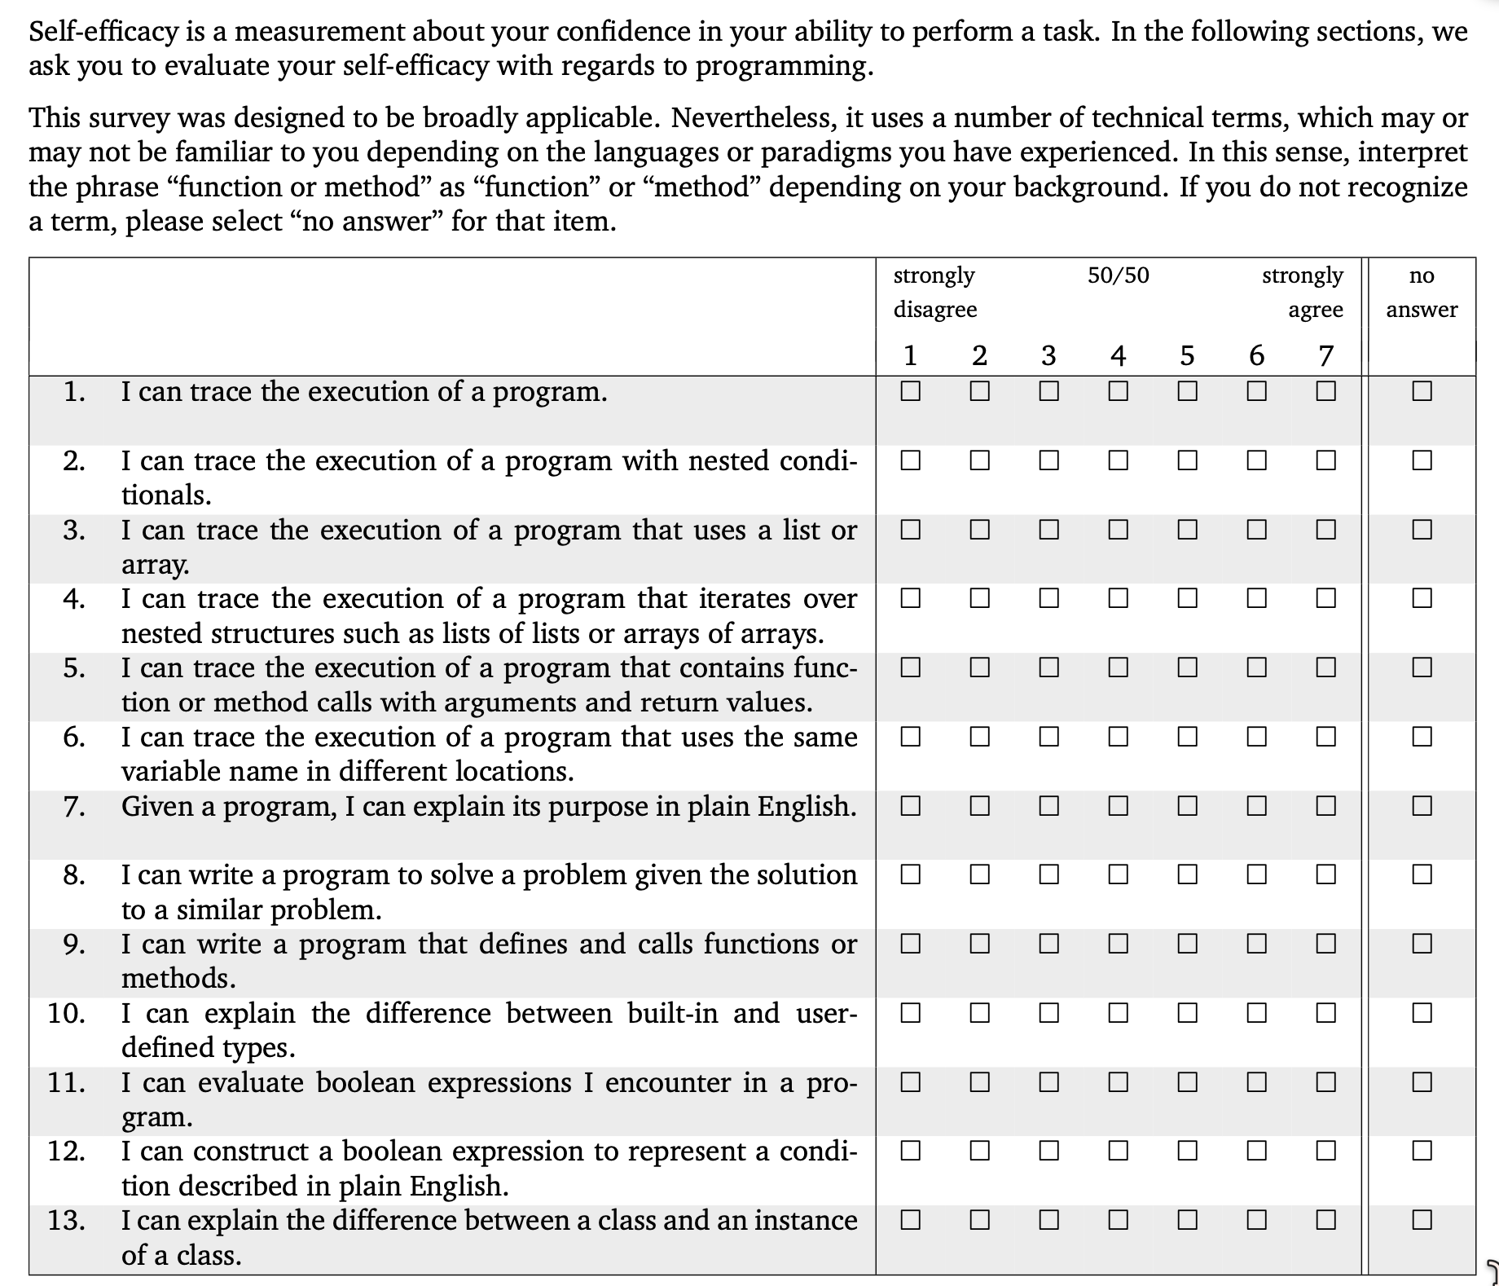

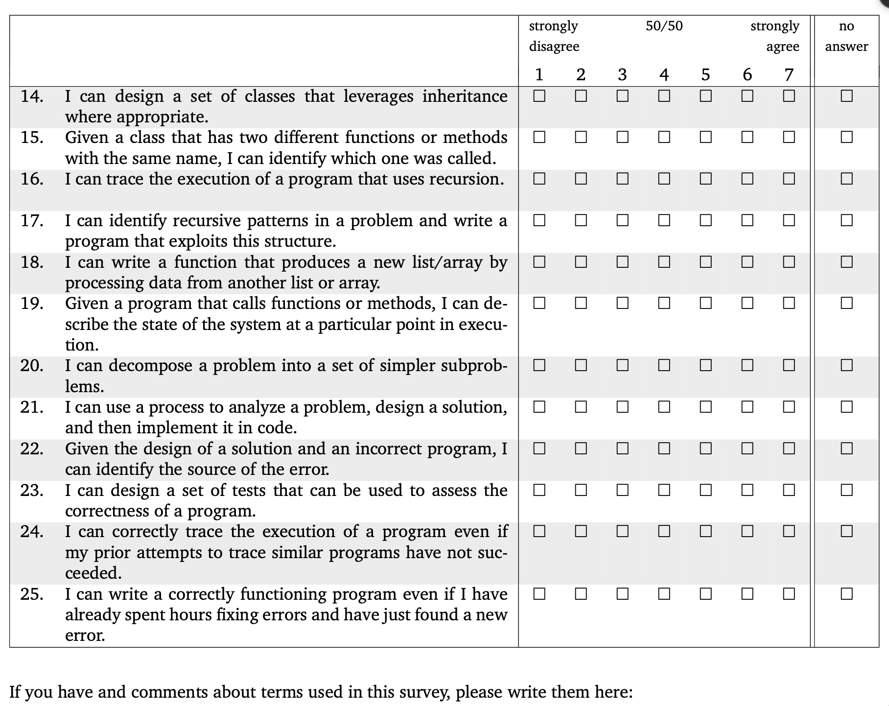

(free response textbox for the question above)

Professional and STEM identity

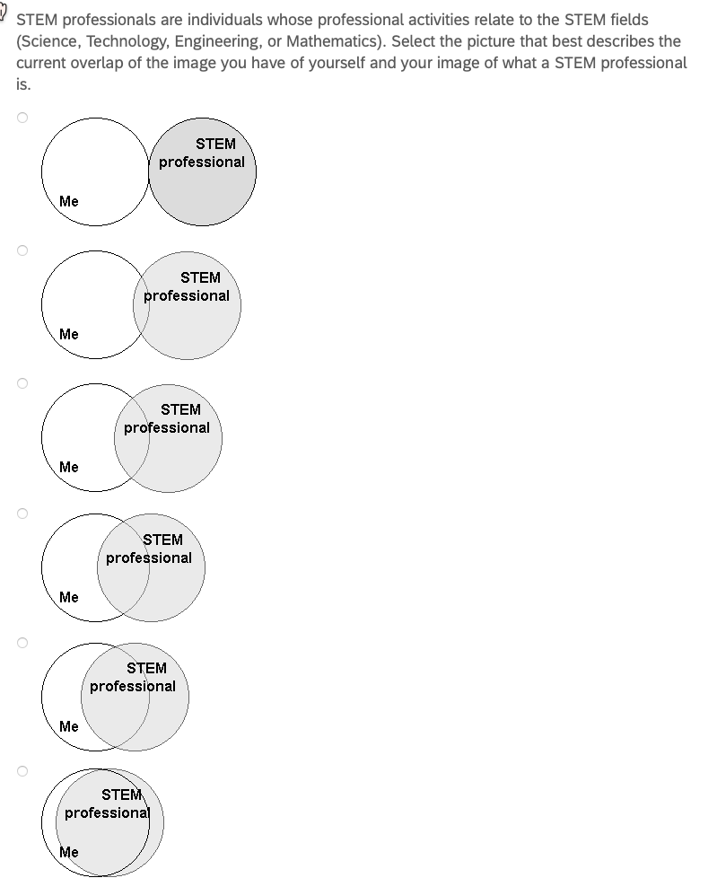

Sense of belonging

1. I feel like I "belong" in computer science.

2. I consider myself as a scientist, technologist, engineer, or mathematician.

3. I take pride in my computing abilities.

on a 5-point Likert scale ranging from 1 = strongly disagree to 5 = strongly agree, with a 3 = neutral.

Professional and reflection skills

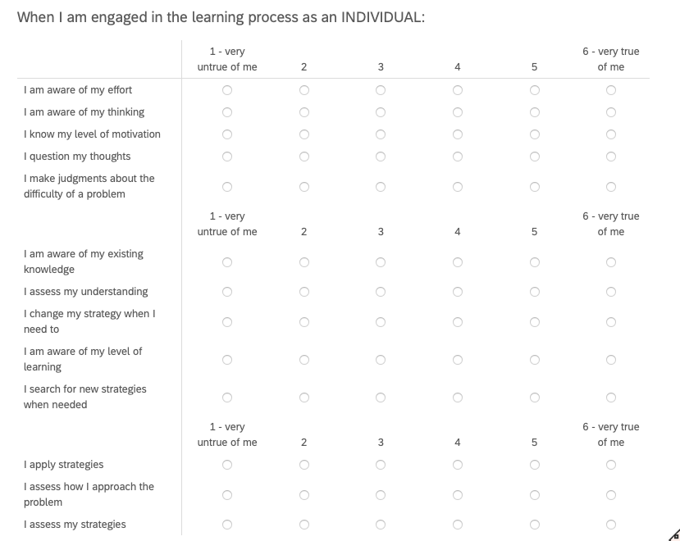

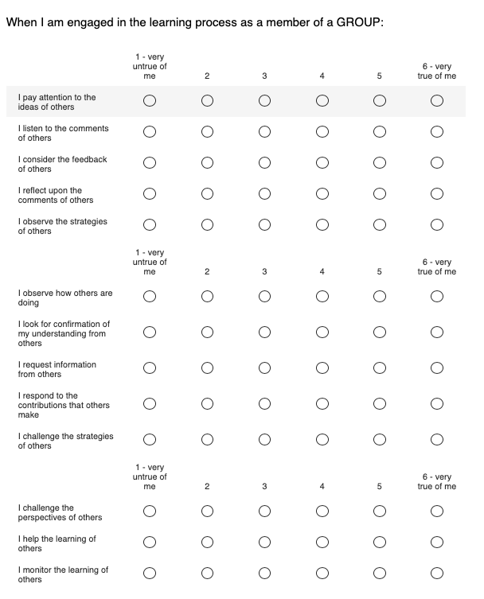

I feel a sense of belonging in computer science.

Strongly disagree, Somewhat disagree, Neither agree nor disagree, Somewhat agree, Strongly agree

Please describe your answer:

Please describe the long-term effects on yourself, if any, from the reflection groups and/or your individual reflections?

What practices, if any, have you continued or partly continued from the reflection groups and/or your individual reflections?

If so, around how often do you do each of those practices?

Please share potential improvements for the reflection groups:

If there is anything else you would like to add that might be relevant, please do so here.

We value and appreciate your sharing and responses to these questions.

Appendix D: Interview consent form

UNIVERSITY OF MAINE — CONSENT FORM (Interview)

Group and Individual Reflection and Collaboration

Researchers:

• Gregory L. Nelson, Assistant Professor, Computer Science Department, University of Maine (gregory.nelson@maine.edu) (Principal Investigator, Main Contact)
• Cyril Agbewali-Koku, Computer Science Department, University of Maine (cyril.agbewalikoku@maine.edu)
• Troy Schotter, Lecturer and PhD Student, Computer Science Department, University of Maine (troy.schotter@maine.edu)

You are invited to take part in a confidential interview as part of this research, led by Dr. Gregory L. Nelson, a faculty member in the Department of Computer Science at the University of Maine. You must be at least 18 years of age to participate.

What Will You Be Asked to Do?

• Take part in a one-to-one interview about your experiences in the reflection activities, your professional-skill behaviors, and changes over time. The interview will be 30–60 minutes. It is conducted online (Zoom) or in person, based on your preference and researcher availability, and is audio-recorded; no video is recorded. If you would rather not be recorded, we will take written notes instead, and you can still take part.

You may be invited to more than one interview over time — for example, one after each participation cycle. Each invitation is separate, and you may accept some and not others. The total time depends on how many you take part in: three interviews would be about 1.5–3 hours in total. You will be emailed a scheduling link to sign up.

Risks

• Time and inconvenience;
• Loss of confidentiality of your data, although we will protect your data as described in the Confidentiality section.

Benefits

• There are no direct benefits to you;
• This research should help us learn more about how to design reflection groups that support learning and professional skills (or why particular designs do not work), which may benefit future members of reflection groups.

Confidentiality

All interview data (recordings, transcripts, and notes) will be stored in password-protected computer systems accessible only to the research team, using software that provides additional security (encryption). Your email address will be used as an identifier so that we can link your interview to your other data in this study and remove any data if you decide later that you want any of your data deleted.

If the interview is online, the recording is taken with the meeting platform's audio-only recording (Zoom) and removed from that platform within 72 hours. If the interview is in person, the recording is made on a password-protected handheld recorder and removed from that device within 72 hours. Either way it is then stored on the secure cloud platform described above. Recordings are transcribed by the researchers named above; we do not use an outside transcription service. For example, the recording of an interview held in March 2027 is removed from Zoom or from the recorder in March 2027.

Within 14 days of collection, all data will be archived to a cloud data platform, with any of your identifiers (such as email address) replaced with a randomly generated key stored on a password-protected computer with software that provides additional security (encryption). The key file that maps to your email address and demographic data will be stored in a separate Cloud data platform. Five years after your participation ends, your email address will be deleted from the key file; for example, if your participation ends in Fall 2026, the key entry will be deleted by the end of December 2031. This is to allow you to withdraw your consent to participating in the research later if you wish. We can only delete your data until the key file is deleted.

Notes and transcripts from the interviews will be copied onto a cloud data platform, with any of your identifiers replaced with your key. The archived data will be retained indefinitely, except for the original audio recordings, which are kept only until the transcript has been checked and are deleted within 12 months of your interview. For example, the recording of an interview held in March 2027 will be deleted by March 2028.

Your privacy and right to withdraw from the study at any point (even after an interview) will be respected, so we will delete any of your data upon your request as long as it is within five years of the end of your participation, as otherwise your email address will have been deleted from the key file.

Compensation

For each interview, you will be entered into a raffle to win a $25 electronic VISA gift card. You must reach the end of the interview to be entered, though you may skip the occasional question. After the raffle draw, the winner will receive the gift card by email within 48 hours. Draws are held [quarterly], and each entry has at least a [1 in 5] chance of winning. Under University policy, University of Maine faculty and staff are not offered gift cards. For example, if you take part in an interview after one participation cycle and then another after the next cycle, that would be two separate raffle entries.

Voluntary

Participation is voluntary. You may skip any interview questions and stop at any time. You may revoke consent for any portion of this research study at any time until your email address is removed from the key file (five years after your participation ends; for example, if your participation ends in Fall 2026, by the end of December 2031). If you wish to revoke consent, contact one of the researchers by email and we will update your status in our records; you would need to agree again to this consent form before any further information is gathered.

Contact Information

If you have any questions about this study, please contact any of the researchers that are a part of the study: gregory.nelson@maine.edu (Principal Investigator, Main Contact), cyril.agbewalikoku@maine.edu, troy.schotter@maine.edu. If you have any questions about your rights as a research participant, please contact the Office of Research Compliance, University of Maine, 207-581-2657 (or e-mail umric@maine.edu).

Taking part in the interview indicates that you have read the above information and agree to participate. You will receive a copy of this form.

Appendix E: Interview guide

Interviews are semi-structured and one-to-one. The interviewer follows up on what the participant raises, and not every topic is covered in every interview.

Opening, before any recording begins: "Thank you for making the time. Before we start I will go through the consent form with you and answer any questions. With your agreement I will record the audio of this conversation so that I can have it transcribed; no video is recorded. If you would rather I did not record, I will take written notes instead, and we can go ahead either way. You can skip any question and stop at any time."

Topics:

1. Background and current situation: what you are studying or working on now, and what brought you to a reflection group.

2. Your experience of the group: what a typical meeting was like for you, what your group chose to spend its time on, and how that changed over the cycle.

3. What, if anything, has changed for you — in your learning, in your confidence, in how you see yourself professionally, and in the professional skills your group discussed. Examples of specific occasions are welcome.

4. Reflection practices: what you do now, if anything, that you did not do before; how often; and what makes it easy or hard to keep up.

5. Design features: which parts of the group's design helped and which got in the way — for example the guided agenda, your group's freedom to set its own agenda, the individual written reflections, the short skill videos, and group size.

6. Group composition: your experience of a group that did or did not mix people with different levels of prior experience, and of groups that did or did not include working professionals.

7. Barriers and enablers to keeping a reflection practice going after a group ends, or after leaving a group.

8. The whole-cohort activities and any sessions where members suggested improvements to the reflection groups: what you took from them.

9. What you would change about the reflection groups.

10. Anything else you would like to add that we have not asked about.

Appendix F: Recruitment texts

Verbal script — research use of reflection group materials

Read aloud by a member of the research team at the first session of each reflection group, and emailed to every member of that group the same day together with the opt-out form in Appendix A.

Before we start, I want to tell you about a research study, because it is separate from this group. I am [name], [role] in the Department of Computer Science at the University of Maine, and you can reach me at [email]. Dr. Gregory L. Nelson leads the study, at gregory.nelson@maine.edu.

This reflection group is something we offer regardless of the research, and nothing about it changes based on what you decide here. What we are asking is whether we may also use the materials this group produces as research data: the intake survey you filled out when you joined, your icebreaker answers, the agenda notes your group writes during meetings, the short individual reflection you write after each meeting, notes and materials from the whole-cohort and improvement sessions, and how you use the tool that supports the group. Your meetings are not recorded — no audio and no video — and after today no researcher sits in on them. There is no compensation for this part.

You do not have to do anything. If you are willing, there is nothing to fill in. If you would rather your materials were not used for research, email any of us with the subject line “Opt out of reflection research”. It helps if you decide within two weeks, but you can change your mind later at any time, and it makes no difference to your place in this group either way.

I will email everyone the form with all of this written down, including who to write to, right after this session. Are there any questions?

Email — longitudinal follow-up survey invitation

Subject: Follow-up survey — University of Maine reflection research

Hello, I hope this message finds you well. I am reaching out regarding the University of Maine research study on reflection that runs alongside the reflection groups. Here is the link to a confidential online follow-up survey about your learning, professional skills, and reflection practices, which takes about 10–15 minutes: ____. The first page is the consent form, and submitting the survey indicates your consent. Taking part is voluntary and you may skip any question. For this survey, you will be entered into a raffle to win a $10 electronic VISA gift card — if you win, the gift card will be sent within 48 hours of the draw (University policy does not permit gift cards for University of Maine faculty and staff, who take part without compensation). If you have any questions, contact Greg Nelson, Assistant Professor, University of Maine (gregory.nelson@maine.edu) or Cyril Agbewali-Koku, PhD Student (cyril.agbewalikoku@maine.edu). Thank you again for your time and contribution,

Email — interview invitation

Subject: Interview invitation — University of Maine reflection research

Hello, we are inviting you to take part in a research interview about your experience of the reflection activities, your professional-skill behaviors, and what has changed for you over time, as part of a University of Maine research study. The interview is one-to-one, takes about 30–60 minutes, and is held on Zoom or in person, based on your preference. With your agreement the interview is audio-recorded (no video is recorded); if you would rather not be recorded, the researcher will take written notes instead. If you would like to participate, here is a scheduling link: ____. Before the interview you will see our consent form. If you take part in an interview, you will be entered into a raffle to win a $25 electronic VISA gift card — if you win, the gift card will be sent within 48 hours of the draw (University policy does not permit gift cards for University of Maine faculty and staff, who take part without compensation). If you have any questions, contact Greg Nelson, Assistant Professor, University of Maine (gregory.nelson@maine.edu) or Cyril Agbewali-Koku, PhD Student (cyril.agbewalikoku@maine.edu). Thank you,

Sending compensation

Greetings, congratulations — you have won the raffle draw for the (survey / interview) you completed for the reflection research project. Here is your $__ electronic VISA gift card: ____. We appreciate your time and your contribution.

Appendix G: Compensation information form

Administered through Qualtrics as a standalone form, separately from every research instrument, to participants who have won a raffle draw and wish to receive a gift card. It is linked from the notification email sent to raffle winners. Responses are stored apart from research data and are never joined to a participant's survey responses, interview, or written reflections.

Introduction: You have won a raffle draw for an activity you completed in this research project. To issue and record the payment, the University requires some information from you. This form is separate from the study. What you enter here is not connected to your answers, and no one analyzing the research data sees it. Completing this form is optional: if you would rather not, you remain in the research on exactly the same terms and we simply cannot send you a gift card.

Because University policy does not permit gift cards to be used to compensate University employees, a participant employed by the University of Maine is not offered a gift card. Student employees of the University may receive one, and where their total compensation from University research exceeds the reporting threshold, the University's tax-reporting process applies, and we will ask for the additional information it requires.

1. Full name (as it should appear on University payment records):

2. Mailing address:

3. Email address to which the electronic gift card should be sent:

4. Are you currently employed by the University of Maine, including as a student employee? (Yes / No)

5. Confirmation of receipt: I acknowledge that I will receive an electronic gift card of the value stated in the raffle notification for this activity. (Checkbox)

Completed by the research team, not by the participant: the activity compensated, the date, the value of the gift card, and the name of the researcher issuing it. These are recorded in the study's disbursement log, which is held with the University's required gift card documentation rather than with the research data. Where a participant's cumulative compensation exceeds the reporting threshold, the information described in the consent forms is forwarded to the appropriate University office, and a W-9 is collected where the University requires one.

