UNIVERSITY OF MAINE
Group and Individual Reflection and Collaboration
Principal Investigator: Dr. Gregory L. Nelson, Assistant Professor, Department of Computer Science, College of Liberal Arts and Sciences (CLAS), University of Maine
Application Narrative:

1. Funding
N/A.

2. Summary
This study investigates how social reflection (reflecting together in small groups), individual reflection, and combinations of the two support people’s learning, professional skills, self-efficacy, professional identity, and improvement over time, in settings outside of and independent of any single course or semester. Prior research has shown that metacognitive and reflective strategies and peer support can improve learning outcomes (Chan & Lee, 2021; Lim et al., 2022), and reflection groups are effective and common in teacher and medical professional education, but there is little research on scalable, sustainable, peer-based reflection practices in computing and how to design them for adoption beyond a single course.
This study offers reflection groups outside of any course and integrating working professionals as peers. Positive results in this setting will also inform future adoption pathways, such as a standalone one-credit reflection-groups course.
This study covers reflection and collaboration activities outside of courses: ongoing reflection groups for current students (outside their coursework), recent graduates and alumni, working professionals participating as peers, community members in informal or online reflection communities; the matching and behavior-change tools that support these groups; and comparative evaluation including professional comparison samples. The reflection groups and reflection activities are offered as an ongoing service to participants and would be offered regardless of this research; this protocol governs the research use of data generated by that service, plus research-specific activities (surveys, interviews, and comparison groups).
For the purposes of the research “outcomes” below refers to: professional skills & dispositions, learning, career, and other personal and social outcomes. For example, professional skills (such as iterative improvement, lifelong learning, psychological safety, and communication), self-efficacy, professional identity, and other personal, professional, and group outcomes.

Research Questions:
1. What are the effects of and outcomes from reflection groups?
2. Which design features of these reflection groups most support participants and outcomes?
3. What barriers and enablers shape whether people adopt and sustain reflection practices within and after participating in reflection groups, including maintaining and transferring skills and other outcomes from their prior experiences?
4. What reflection group designs, such mixing and not mixing participants with different prior experience levels, lead to more positive effects from reflection groups?
5. For reflection groups, what balance of scaffolding (such as regular reflection questions) and agency/adaptability (such as groups determining and changing reflection questions) leads to better long-term outcomes?

Methods:
This research is expected to run over multiple years. Participation is not tied to a course or semester. Reflection groups run in participation cycles of approximately 12 weeks; new cycles may begin at any time of year, and activities recur at general intervals rather than on an academic calendar. Groups that wish to continue meeting after a cycle ends may do so. All group meetings, information sessions, and whole-cohort activities are held online (analogous to an online class).

1. Individuals will be recruited via email outreach to registered organizations at the University of Maine, and faculty recruiting announcements, professional networks and alumni networks. Recruitment emails will be sent to organization leaders and listservs with a request to share the study opportunity with members. The research team will hold information sessions online during the recruitment period, and optionally invite prior reflection groups participants to share their experiences at those sessions (like a brief personal testimonial or statement). Interested participants will be directed to a study information webpage containing details about the study purpose, procedures, time commitment, and a link to the consent form.
2. Consent. All interested participants review and electronically sign an informed consent form (Appendix A) before beginning study participation. The consent form indicates whether their service data (group agenda notes, individual reflections, intake information, and tool-usage data) may be analyzed for research.
For the reflection-group service (offered regardless of research):
3. Intake and matching. People who opt in take an initiation survey to assess baseline programming knowledge, other outcomes such as self-efficacy, professional identity, and professional skills, and to gather demographics (Appendix B). They are matched into small groups, normally of 3–5 members (typically 5), based on shared gender, shared disability status, and overlapping availability. Group numbers and meeting times are shared with participants; gender and disability status are never disclosed to other participants. Matching may later be supported by the research team’s constraint-solver matching tool, which uses only the same intake information.
4. First meeting icebreaker. Before or during a group’s first meeting, members complete an icebreaker activity. Members are told they may pass on any question.
5. Group meetings and individual reflections. Each group holds a roughly 30-minute online meeting at a regular interval (for example, weekly), where:
  - Participants discuss what's going well in their learning and what is supporting their learning.
  - Participants give updates on their weekly goal from the previous week (if applicable).
  - Participants identify areas for potential improvement in their learning.
  - Each participant chooses one thing to improve for the next week.

6. After meetings, members complete brief individual written reflections, viewable only by the research team. Each week, participants may also be offered a brief (5–10 minute) video on a relevant professional skill (for example, help-seeking or problem solving strategies). About halfway through a cycle, all groups are invited by email to an optional whole-cohort online activity presenting trends, challenges, and successful strategies across groups, with an opportunity to give feedback on improving the reflection groups. At the end of a participation cycle (approximately 12 weeks), each group holds a longer (about 45–60 minute) retrospective meeting in which members identify what they individually improved, how other members helped, and how the group can improve together.
7. Groups integrating professionals. Some groups integrate working professionals as peer members (not mentors). Students and other participants are never required to have professionals in their group; they opt in after reviewing the professional’s profile. Professional-only groups may be formed. Alumni may be matched with students from their university.
8. Group remedies. Members of a group that stops functioning well may join a more functional group (which opts in to adding a new member) or form a new group with others.

For the research:
9. Surveys. Consenting participants complete a survey at group initiation, approximately 3 months and 6 months later, and then approximately every 6 months, for up to four years after group initiation (up to 9 follow-up surveys total). Surveys are administered through Qualtrics and take approximately 10–15 minutes. Each survey begins with a consent statement; submission indicates consent (Appendix F); distribution email templates are in Appendix E.
10. Interviews. A purposeful subset of participants is invited to confidential interviews before, during, and/or after participation, about their experiences, professional-skill behaviors, and changes over time (Appendix G). Interviews are audio-recorded (no video) and transcribed.
11. Comparison participants. For comparative evaluation, the team will separately recruit a comparison group of working professionals for surveys and optional interviews. The evaluation plan anticipates that later-year comparative studies will involve intervention populations of roughly 60–100 participants and comparison groups of roughly 200 professionals recruited through an outreach using social media announcements and also alumni networks.
12. Participant co-design sessions. Participants are periodically invited to co-design sessions to shape reflection-group designs, identify challenges and barriers, and propose improvements; session notes and artifacts are analyzed qualitatively.
Data collected:
1.1 Intake and initiation survey responses: availability, background, demographics, outcome measures, and contact email (Appendix B).
1.2 Reflection group materials: meeting agenda notes and individual written reflections.
1.3 Longitudinal follow-up survey responses: email address and outcome measures (Appendix C).
1.4 Interview recordings and transcripts (consent form and protocol outline in Appendix G).
1.5 Tool-usage data (for example, reminder responses and feature use), linked by the same participant identifier; no separate instrument.
1.6 Participant co-design session notes and artifacts.

References:
Chan, C. K. Y., & Lee, K. K. W. (2021). Reflection literacy: A multilevel perspective on the challenges of using reflections in higher education through a comprehensive literature review. Educational Research Review, 32, 100376.
Edmondson, A. (1999). Psychological safety and learning behavior in work teams. Administrative Science Quarterly, 44(2), 350–383.
Grant, A. M., Franklin, J., & Langford, P. (2002). The Self-Reflection and Insight Scale: A new measure of private self-consciousness. Social Behavior and Personality, 30(8), 821–835.
Kember, D., Leung, D. Y. P., Jones, A., Loke, A. Y., McKay, J., Sinclair, K., Tse, H., Webb, C., Wong, F. K. Y., Wong, M., & Yeung, E. (2000). Development of a questionnaire to measure the level of reflective thinking. Assessment & Evaluation in Higher Education, 25(4), 381–395.
Lim, R. B. T., Hoe, K. W. B., & Zheng, H. (2022). A systematic review of the outcomes, level, facilitators, and barriers to deep self-reflection in public health higher education: Meta-analysis and meta-synthesis. Frontiers in Education, 7, 938224.

3. Personnel
PI: Dr. Gregory L. Nelson, Assistant Professor, Department of Computer Science, CLAS, University of Maine (gregory.nelson@maine.edu).
Roles: Principal Investigator, study design, reflection group and tool design, data analysis, recruiting, interviewing.
Experience: 5+ years of human-computer interaction and computing education research with human participants.
Cyril Agbewali-Koku, PhD Student, Department of Computer Science, CLAS, University of Maine (cyril.agbewalikoku@maine.edu).
Roles: Research assistant; study and design contributions, data analysis, recruiting, survey administration, interviewing.
Troy Schotter, Lecturer and PhD Student, Department of Computer Science, CLAS, University of Maine (troy.schotter@maine.edu).
Roles: design, data analysis, recruiting.
Experience: education research with human participants.

4. Participant recruitment
Participant Population:
Participants are adults age 18 or older. Because this protocol is not tied to a specific course, the population includes current university students (participating outside their coursework), recent graduates and alumni, working professionals, and community members in informal or online reflection communities. Individuals younger than 18 are excluded. High-school students who visit reflection-group sessions as part of the research team’s outreach activities are not research participants, and no data about them are collected under this protocol.
Reflection groups are normally formed in sizes of 3–5 (typically 5). For comparative evaluation in later years, the evaluation plan anticipates intervention populations of roughly 60–100 participants and comparison groups of roughly 200 professionals, consistent with the Methods above.
Participant Identification and Recruitment Procedures:
Recruitment occurs independently of course enrollment: through the research team’s online collaboration platform, newsletters, email invitations and mailing lists, word of mouth, email outreach to registered student organizations at the University of Maine, faculty recruiting announcements, presentations at academic conferences and email invitations to alumni of the team’s prior courses — limited to former participants who have completed those courses and are no longer enrolled in them. No professional recruiting company or agency is used; comparison-group professionals are recruited through the same channels — the team’s newsletters, email invitations to alumni networks, and social media announcements. Recruitment scripts are provided in Appendix D. During recruitment periods, the research team holds online information sessions, optionally inviting prior reflection group participants to share their experiences. Interested individuals are directed to a study information webpage containing details about the study purpose, procedures, time commitment, and a link to the consent form. Participation is voluntary.
If any participants are recruited from courses currently taught by a member of the research team, the protections of the approved course-based protocol also apply: participation has no effect on grades.

5. Informed consent
Informed consent is obtained electronically. All interested participants review and electronically sign the consent form for research use of reflection-group activities (Appendix A) before beginning study participation, and indicate consent before their data are used for research; they may opt out at any time by emailing a member of the research team. For surveys, a consent statement appears at the beginning of each survey and submission indicates consent (Appendix F). For interviews, participants complete a separate interview consent form before the interview begins (Appendix G).

6. Confidentiality
Participants in reflection groups will be asked to respect the confidentiality of their peers and not share personal information discussed in the groups. However, we cannot guarantee complete confidentiality in the reflection group meeting setting. Participants will be informed of this limitation in the consent process.
All data for the study will be stored in a cloud data platform that encrypts all data at rest and in transit with AES-256 bit encryption and is password protected. The initiation and follow-up surveys will be stored in Qualtrics. Interview recordings, transcripts and tool-usage data exports are stored on the secure cloud data platform.
Within 14 days after the end of a participant’s participation in an activity cycle, or for data collected on an ongoing basis, within 14 days of collection, all data (including Qualtrics data) will be archived to a separate cloud data platform, with all participant identifiers (such as email addresses) replaced with a randomly generated encrypted key.
The key file that maps to participants’ email addresses and participant demographic data will be stored in a separate folder. Five years after a participant’s participation ends, their email address will be deleted from the key file; for example, for a participant whose participation ends in Fall 2026, the key entry will be deleted by the end of December 2031. This is to allow participants to withdraw their consent later if they wish. We can only delete participant data while the key exists.
The archived, de-identified data will be retained indefinitely.
In summary, the following data from participants who take part in the research will be retained indefinitely in de-identified form: intake and initiation survey responses (1.1), reflection group materials (1.2), longitudinal follow-up survey responses (1.3), interview recordings and transcripts (1.4), tool-usage data (1.5), and co-design session notes and artifacts (1.6).
Participants’ privacy and right to withdraw from the study will be respected, so we will delete any of their data upon request as long as the request is within 5 years of the end of their participation, as otherwise their email address will have been deleted from the key file.

7. Risks to participants
There are risks of time and inconvenience to participants. There is a minimal risk of a data breach; we expect a potential risk of embarrassment in that event. To minimize this risk, participant emails are replaced with a randomized unique identifier that cannot be traced back to the email address no later than 14 days after participation ends; this identifier is stored separately along with demographic and any other personally identifiable information.
Because reflection groups involve sharing among peers, there is a risk that personal information shared in a group could be disclosed by another member; participants are asked to respect confidentiality and are informed that it cannot be guaranteed.
The surveys make clear in the introduction that any question can be skipped if the participant does not feel comfortable answering.

8. Benefits
There are no direct benefits to participants, but participants may learn and reflect critically about their learning, professional skills, self-efficacy, and professional identity over time, which may help them develop skills useful in their education and careers, and they may benefit from community, peer support, and professional networks formed through the groups.
The overall benefits of the research include improving understanding of scalable, adoptable, and effective reflection-based practices for supporting learning, professional skills, and lifelong learning across educational and professional settings. Findings may inform pedagogical practice, support adoption across institutions, and contribute to understanding how to sustain professional growth after graduation.

9. Compensation
No payments or extra credit are made for participating in reflection groups. For each longitudinal follow-up survey a participant submits (Appendix C), the participant will be offered a $10 electronic VISA gift card, sent by email within 48 hours of survey submission. Participants must reach the end of the survey to receive compensation, though they may skip individual questions. Participants who complete an interview will be offered a $25 electronic VISA gift card, sent by email within 48 hours of the interview. Comparison-group participants receive the same compensation as other participants: a $10 electronic VISA gift card for each submitted follow-up survey (the initiation survey is not compensated). There is no compensation for other activities.

Appendix A: Consent form for participation
UNIVERSITY OF MAINE — CONSENT FORM
Group and Individual Reflection and Collaboration
Researchers:
• Gregory L. Nelson, Assistant Professor, Computer Science Department, University of Maine (gregory.nelson@maine.edu) (Principal Investigator, Main Contact)
• Cyril Agbewali-Koku, Computer Science Department, University of Maine (cyril.agbewalikoku@maine.edu)
• Troy Schotter, Lecturer and PhD Student, Computer Science Department, University of Maine (troy.schotter@maine.edu)

You are invited to participate in a research project led by Dr. Gregory L. Nelson, a faculty member in the Department of Computer Science at the University of Maine. The purpose of the research is to study how reflecting — on your own and together with others in small groups — affects your learning, professional skills, self-efficacy, professional identity, and improvement over time. You must be at least 18 years of age to participate.
What Will You Be Asked to Do?
If you decide to participate in the research, you may be asked to:
• Provide your availability and a small amount of background information so you can be matched into a small reflection group (normally 3–5 people);
• Participate in regular (for example, weekly) online reflection group meetings of about 30 minutes during a participation cycle of approximately 12 weeks (your group may continue meeting after the cycle ends if it wishes);
• After each group session, complete a brief individual reflection survey, about 5-10 minutes;
• Optionally participate in intermittent broader activities with other research participants in other groups (held online). For example, halfway through the research participation cycle, an activity to discuss trends, challenges, and successful strategies, and to provide feedback on how to improve the reflection groups.

• Have your reflection group materials, individual reflections, and use of the supporting tool analyzed by the research team;
• Complete a survey when you begin, and confidential follow-up surveys of about 10–15 minutes each at approximately 3 months, 6 months, and then about every 6 months, for up to four years (up to 9 follow-up surveys total);
• Optionally take part in a confidential interview about your experiences;
• Optionally take part in co-design sessions to help improve the reflection-group designs, with session notes and materials analyzed by the research team.
You may optionally give consent for the research team to link your data from this study with data from prior or related reflection-group research studies led by this research team in which you participated and consented to research use of your data (for example, reflection groups in a prior course), to help understand your experience and outcomes over time.
Risks
• Time and inconvenience;
• Loss of confidentiality of your data, although we will protect your data as described in the Confidentiality section;
• Information you share in group discussions could be disclosed by other members; group members are asked to respect confidentiality, but it cannot be guaranteed.
Benefits
• There are no direct benefits to you, but you may reflect more often and more critically about your learning and professional skills, which may help your education and career, and you may benefit from peer support and community;
• This research should improve understanding of effective ways to support learning and professional skills, which may benefit future students, professionals, and the broader community.
Confidentiality
Participants in reflection groups are asked to respect the confidentiality of their peers and not share personal information discussed in the groups. We cannot guarantee complete confidentiality in the group setting.
If you previously participated in related reflection-group research led by this research team and consented to the research use of your data in that study, we may link that data with your data from this study to help understand your experience in these reflection groups. Your data will be stored in password-protected systems accessible only to the research team, using software that provides additional security (encryption). Your email address will be used as an identifier so we can connect your information across activities and remove your data if you ask us to.
Within 14 days after your participation in a cycle ends, or within 14 days of collection for ongoing data, your identifiers will be replaced with a randomly generated key. The key file mapping your email and your demographic data will be stored separately. Five years after your participation ends, your email will be deleted from the key file; after that, we can no longer locate your data to delete it. The de-identified archived data will be retained indefinitely.
Compensation
For each longitudinal follow-up survey you submit, you will be compensated with a $10 electronic VISA gift card. You must reach the end of the survey to receive this compensation, though you may skip the occasional question. Compensation is sent by email within 48 hours of survey submission. If you opt to take part in an interview, you will be compensated with a $25 electronic VISA gift card, sent by email within 48 hours of your interview. There is no compensation for other activities.
Voluntary
Participation in the research is voluntary. You may skip any question and stop at any time. You may opt out, or revoke consent for any portion of this research, at any time until your email is removed from the key file (five years after your participation ends; for example, if your participation ends in Fall 2026, by the end of December 2031), by emailing any member of the research team with the subject line “Opt out of reflection research.”
Contact Information
If you have any questions about this study, please contact any of the researchers listed above, including the Principal Investigator, Dr. Gregory L. Nelson (gregory.nelson@maine.edu). If you have any questions about your rights as a research participant, please contact the Office of Research Compliance, University of Maine, 207-581-2657 (or e-mail umric@maine.edu).

Appendix B: Intake / initiation survey
The purpose of this survey is to understand your background, interests, and current outcomes as you begin participating. Your answers are confidential. There are no right or wrong answers. You may skip any questions you are uncomfortable answering.

Your Email:
Majors, Career, Prior Learning
What are some future careers you are considering after college? (Open-ended question)

What is your intended major(s) and/or minor(s)? (Open-ended question)

What year of university are you in? (Select one: Freshman (First Year), Sophomore (Second Year), Junior (Third Year), Senior (Fourth Year), Graduate Student, Other - please specify)

Please share a little bit about yourself, such as some hobbies or other parts of your life important to you. (Open-ended question)

How many hours do you work for pay or at a job, each week, on average? (Open-ended question)

Do you have any prior programming experience? (Yes/No)

If applicable, which programming languages have you worked with? (Open-ended question)

How confident do you feel in your programming abilities? (Scale: 1-7, where 1 is "Not confident at all" and 7 is "Very confident")

Demographics
What is your age?
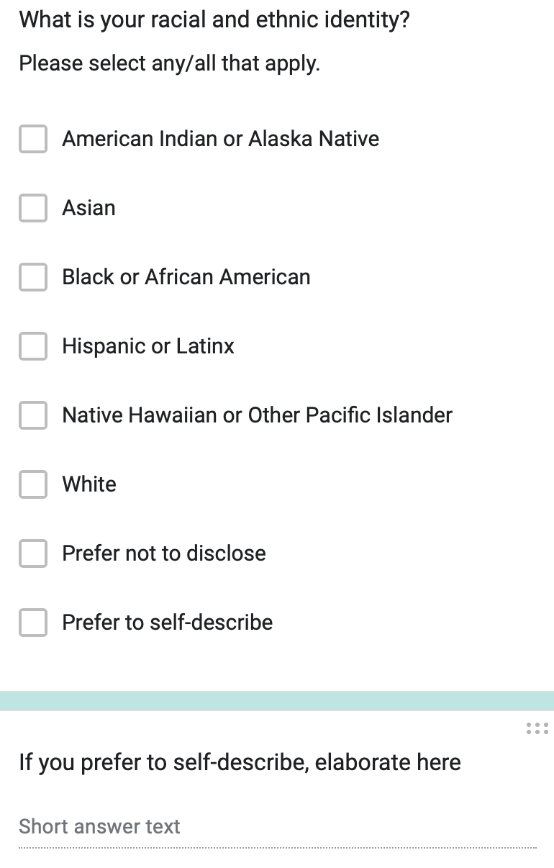
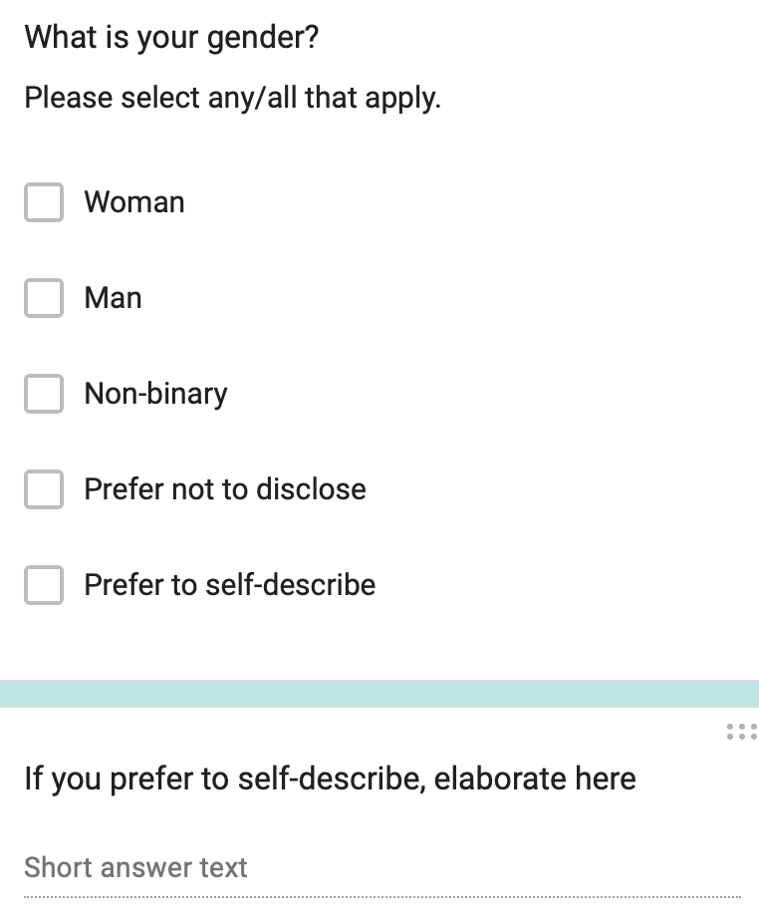
Did you grow up in a household where at least one adult caretaker (mother, father, other caregiver) had a bachelor’s degree or higher (or international equivalent)? Yes / No / Not Sure
Do you have any disabilities or accommodations? (Yes/No/Prefer not to answer)
If applicable, do you have any of the following disabilities or chronic conditions? (Please check all that apply.)
Attention deficit
Autism
Blind or visually impaired
Deaf or hard of hearing
Health-related disability
Learning disability
Mental health condition
Mobility-related disability
Speech-related disability
Prefer not to answer
Other (please specify, optional)

Are you an international student? (Yes/No)

What country did you attend high school in?

What was your high school GPA? Please answer as a number out of the maximum, for example 2.2 out of 4.

Are you a native English speaker? (Yes/No)

How comfortable are you reading, writing, speaking, and listening in English? (Scale: 1-7, where 1 is "Not comfortable at all" and 7 is "Extremely comfortable")

Self-efficacy
Self-efficacy is a measurement about your confidence in your ability to perform a task. In the following sections, we ask you to evaluate your self-efficacy with regards to programming.
This survey was designed to be broadly applicable. Nevertheless, it uses a number of technical terms, which may or may not be familiar to you depending on the languages or paradigms you might have experienced. In this sense, interpret the phrase “function or method” as “function” or “method” depending on your background. If you do not recognize a term, please select “no answer” for that item.
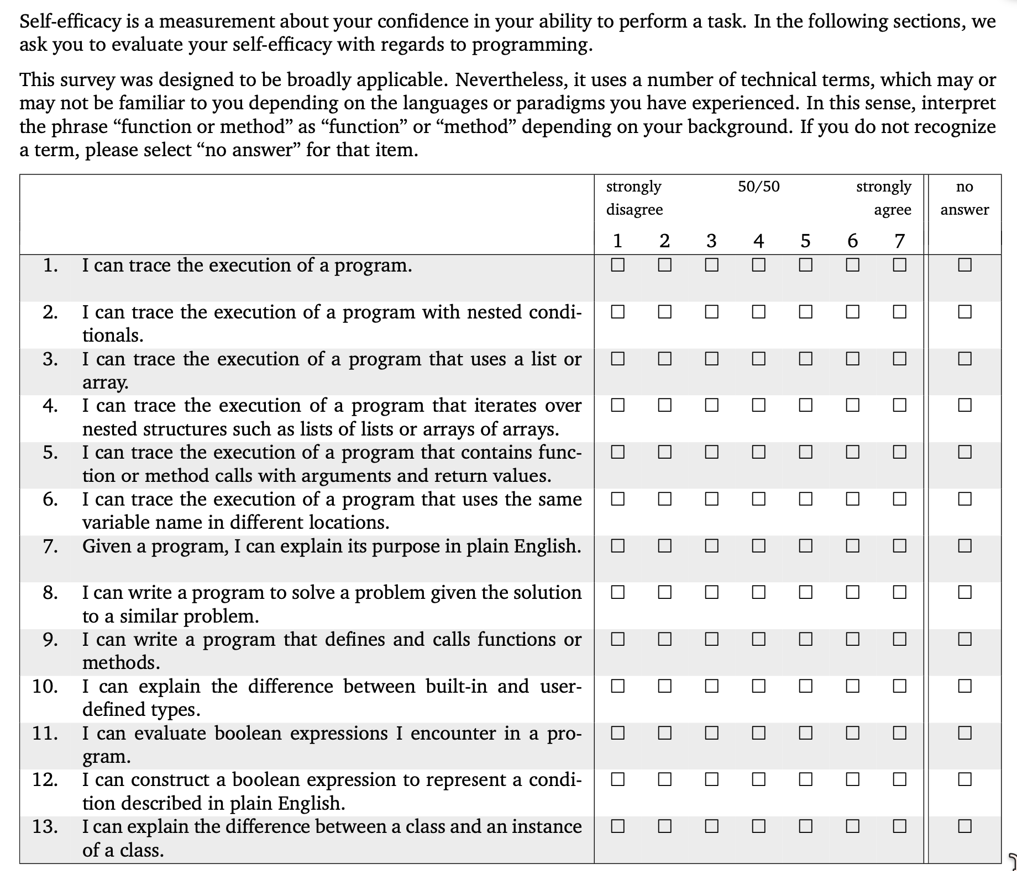
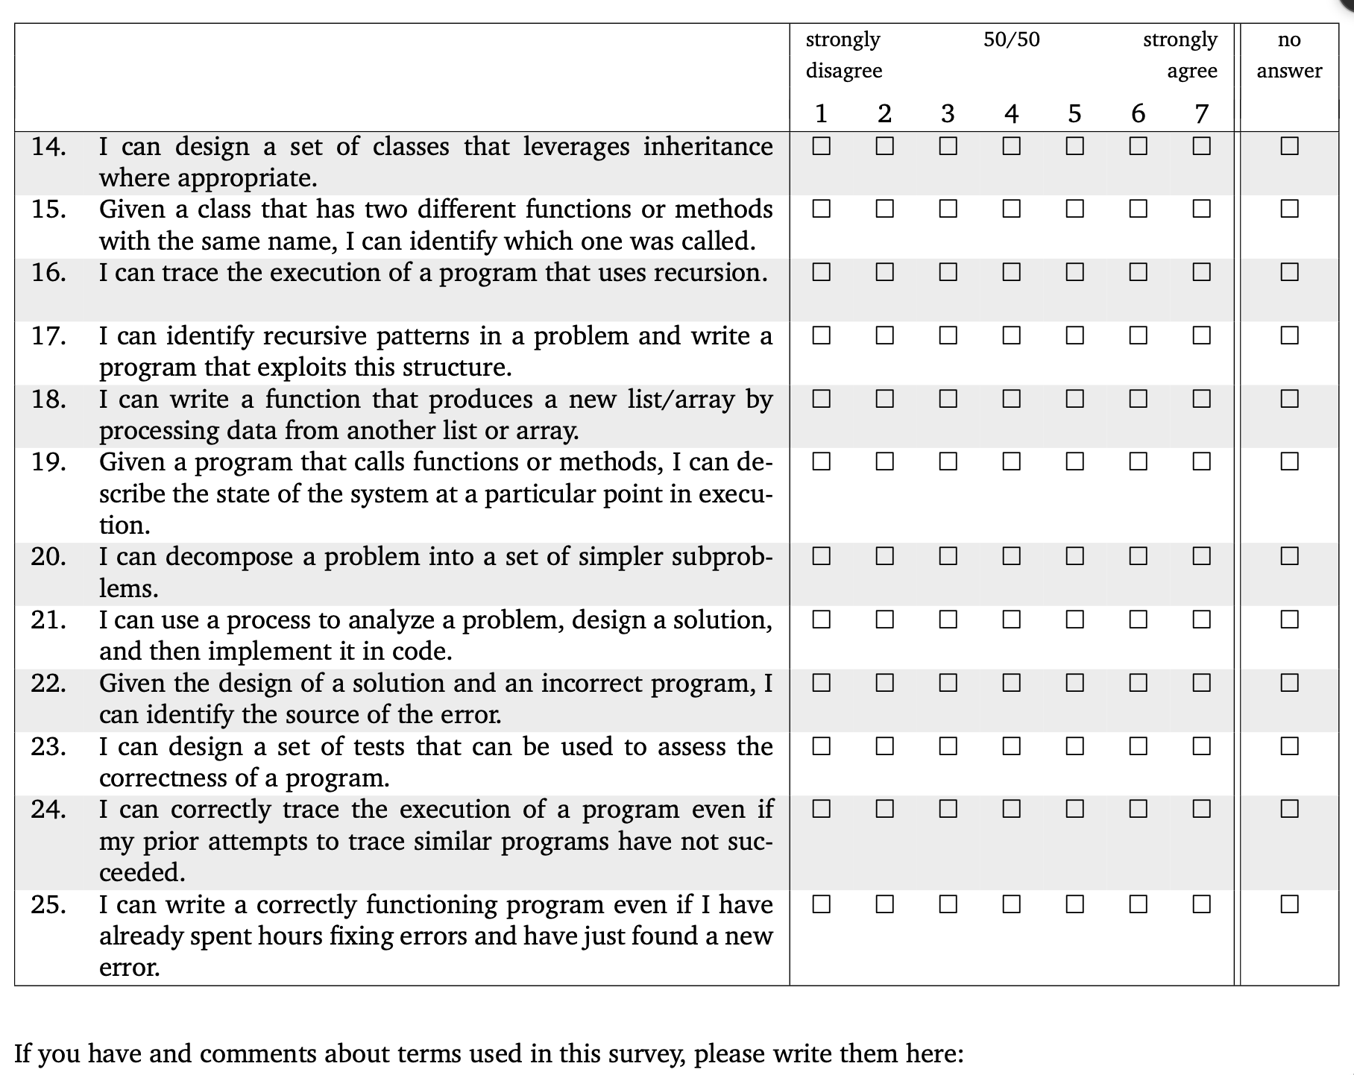
(free response textbox for the question above)
Professional and STEM identity
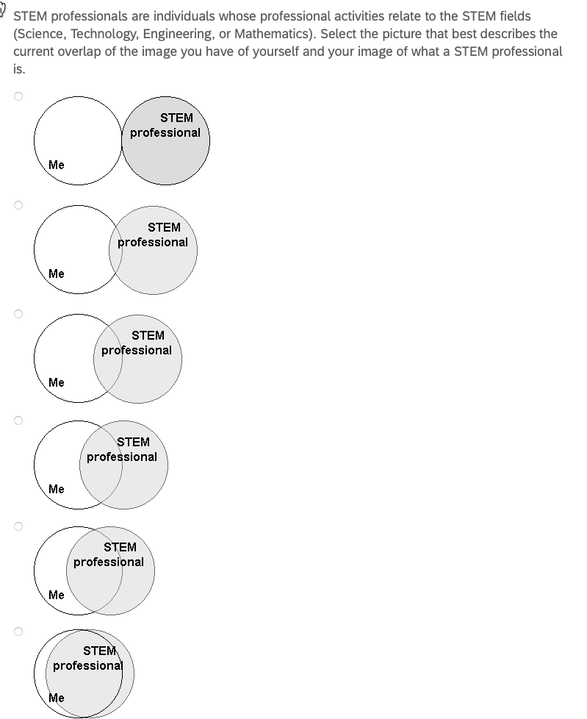

Sense of belonging

1. I feel like I “belong” in computer science.
2. I consider myself as a scientist, technologist, engineer, or mathematician.
3. I take pride in my computing abilities.
on a 5-point Likert scale ranging from 1 = strongly disagree to 5 = strongly agree, with a 3 = neutral.
Professional and reflection skills

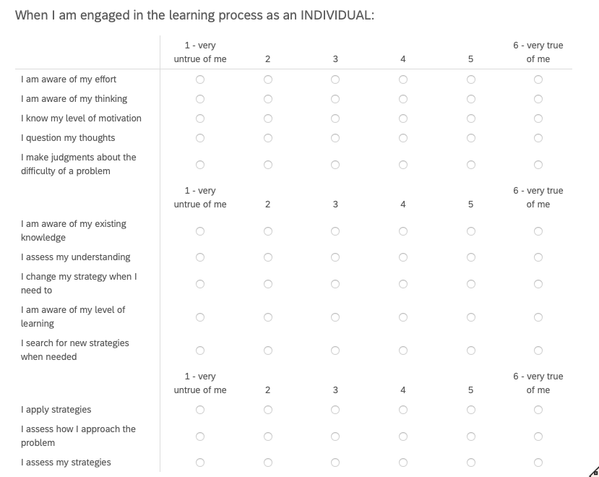

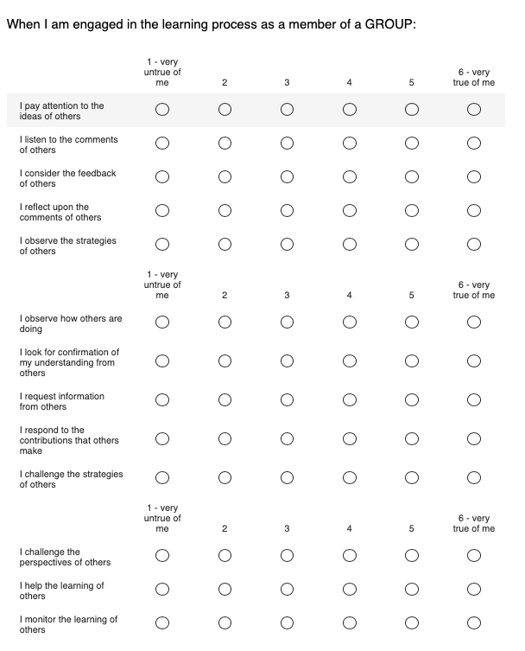

I feel a sense of belonging in this class.
Strongly disagree, Somewhat disagree, Neither agree nor disagree, Somewhat agree, Strongly agree

Please describe your answer:

Appendix C: Longitudinal follow-up survey
Please help us understand your experiences over time. Your answers are confidential. There are no right or wrong answers. You may skip any questions you are uncomfortable answering. For each follow-up survey you complete, you will receive a $10 electronic VISA gift card.
Your Email:
Majors, Career
How confident do you feel in your programming abilities? (Scale: 1-7, where 1 is "Not confident at all" and 7 is "Very confident")

How comfortable are you reading, writing, speaking, and listening in English? (Scale: 1-7, where 1 is "Not comfortable at all" and 7 is "Extremely comfortable")
How many hours do you work for pay or at a job, each week, on average?
What jobs and/or careers do you currently have, if any? (Open-ended question)
Part A: If you are still in university or other education/training programs (if not, skip to Part B below):
What are some future careers you are considering after college? (Open-ended question)
What is your intended major(s) and/or minor(s)? (Open-ended question)
What year of university are you in? (Select one: Freshman (First Year), Sophomore (Second Year), Junior (Third Year), Senior (Fourth Year), Graduate Student, Other - please specify)

Part B: If you are no longer taking courses, please answer the following (if not, skip and click the Next button below):
What are some future jobs or careers you are considering after or in addition to your current ones? (Open-ended question)

What major(s) and/or minor(s) did you graduate with and when? (Open-ended question)

Self-efficacy
Self-efficacy is a measurement about your confidence in your ability to perform a task. In the following sections, we ask you to evaluate your self-efficacy with regards to programming.
This survey was designed to be broadly applicable. Nevertheless, it uses a number of technical terms, which may or may not be familiar to you depending on the languages or paradigms you might have experienced. In this sense, interpret the phrase “function or method” as “function” or “method” depending on your background. If you do not recognize a term, please select “no answer” for that item.


(free response textbox for the question above)
Professional and STEM identity


Sense of belonging

1. I feel like I “belong” in computer science.
2. I consider myself as a scientist, technologist, engineer, or mathematician.
3. I take pride in my computing abilities.
on a 5-point Likert scale ranging from 1 = strongly disagree to 5 = strongly agree, with a 3 = neutral.
Professional and reflection skills





I feel a sense of belonging in computer science.
Strongly disagree, Somewhat disagree, Neither agree nor disagree, Somewhat agree, Strongly agree

Please describe your answer:
Please describe the long-term effects on yourself, if any, from the reflection groups and/or weekly reflections from the course?
What practices, if any, have you continued or partly continued from the reflection groups and/or weekly reflections?
If so, around how often do you do each of those practices?
Please share potential improvements for the weekly reflection groups or the course in general:
If there is anything else you would like to add that might be relevant, please do so here.
We value and appreciate your sharing and responses to these questions.

Appendix D: Recruitment / invitation scripts
General invitation (collaboration platform, mailing lists, networks, conferences):
You are invited to take part in research on how reflecting — on your own and together in small groups — affects learning, professional skills, and improvement over time. We run small online reflection groups (normally 3–5 people) that meet for about 30 minutes at a regular interval, with a guided agenda and brief individual reflections. Participation is voluntary; for students, participating will not affect grades in any way. You must be at least 18 years old. More details are in the consent form. If you have questions, contact a member of the research team listed on the consent form.
Alumni invitation (email to former participants of the team’s courses):
Greetings! You previously took part in reflection groups in one of our courses. We are now running ongoing reflection groups outside of courses — for recent graduates, professionals, and students — and would love to have you join. Groups meet online for about 30 minutes at a regular interval with a guided agenda. Joining is voluntary and separate from any course; you may participate in the groups whether or not you choose to take part in the associated research. Details are in the consent form: . Questions? Reply to this email.
Organization / listserv invitation (email to leaders of registered student organizations, professional groups, and mailing lists, with a request to share with members):
Hello! We are inviting members of your organization to take part in ongoing online reflection groups, part of a University of Maine research project on how reflecting — individually and together in small groups — supports learning and professional skills. Groups of 3–5 meet online for about 30 minutes at a regular interval over a cycle of approximately 12 weeks, with a guided agenda and brief individual reflections. Participation is voluntary and open to students, recent graduates, and working professionals (age 18+); members may join the groups whether or not they take part in the research. We would be grateful if you could share this opportunity with your members. We are also holding short online information sessions where prospective members can learn more and hear from prior participants. Details, the information session schedule, and the consent form are at: . Questions? Contact the research team listed on the consent form.

Appendix E: Other scripts (email templates)
Sending out a survey:
Greetings, here is the link to the (initiation or follow-up) survey for the reflection and collaboration research project: . It takes about 10–15 minutes. Thank you,
Sending out a longitudinal follow-up survey:
Greetings, I hope this message finds you well. I’m reaching out regarding the reflection research project you took part in. Here is the link to a confidential follow-up survey, which takes about 10–15 minutes: . For each follow-up survey you complete, you will receive a $10 electronic VISA gift card within 48 hours of submission. Thank you again for your time and contribution,
Sending compensation:
Greetings, thank you for completing the follow-up survey for the reflection research project. Here is your $10 electronic VISA gift card: . We appreciate your continued participation.

Appendix F: Survey consent (submission indicates consent)
UNIVERSITY OF MAINE — CONSENT FORM (Surveys)
Group and Individual Reflection and Collaboration
You are invited to participate in a research project led by Dr. Gregory L. Nelson, a faculty member in the Department of Computer Science at the University of Maine. The purpose of the research is to study how individual and group reflection affect learning, professional skills, self-efficacy, professional identity, and improvement over time. You must be at least 18 years of age to participate.
What Will You Be Asked to Do?
Take a confidential survey of about 10–15 minutes about your background, experiences, and outcomes. You may be invited to take follow-up surveys over time — at approximately 3 months and 6 months, and then about every 6 months, for up to four years (up to 9 follow-up surveys total).
Risks
Time and inconvenience; loss of confidentiality of your data, although we will protect your data as described below.
Benefits
There are no direct benefits to you, but your responses help improve understanding of effective ways to support learning and professional skills.
Confidentiality
Your responses will be stored in a password-protected system using software that provides additional security (encryption). Your email address is used as an identifier so we can connect your responses across activities and remove your data if you ask us to. Within 14 days of collection, your identifiers are replaced with a randomly generated key; the key file and your demographic data are stored separately, and your email is deleted from the key file five years after your participation ends, after which your data can no longer be located for deletion. De-identified archived data are retained indefinitely. If you previously participated in related reflection-group research led by this research team and consented to the research use of your data in that study, we may link that data with your responses here to help understand your experience over time.
Compensation
For each longitudinal follow-up survey you submit, you will be compensated with a $10 electronic VISA gift card, sent by email within 48 hours of submission. You must reach the end of the survey to receive this compensation, though you may skip the occasional question. The initiation survey is not compensated.
Voluntary
Participation is voluntary. Submission of this survey indicates consent to participate. You may skip any questions and stop at any time. You may revoke consent at any time until your email is removed from the key file (five years after your participation ends; for example, if your participation ends in Fall 2026, by the end of December 2031) by emailing any member of the research team with the subject line “Opt out of reflection research.”
Contact Information
Questions about this study: Dr. Gregory L. Nelson (gregory.nelson@maine.edu). Questions about your rights as a research participant: Office of Research Compliance, University of Maine, 207-581-2657 (or e-mail umric@maine.edu).
Comparison-participant adaptation (professionals recruited for comparison surveys only): the same consent statement is used, with the purpose sentence reading “The purpose of the research is to understand professionals’ skills, learning, and reflection practices over time, as a comparison for evaluating reflection-group programs,” and the Voluntary section omitting the reflection-activities clause.

Appendix G: Interview consent form and protocol outline
UNIVERSITY OF MAINE — CONSENT FORM (Interview)
Group and Individual Reflection and Collaboration
Researchers:
• Gregory L. Nelson, Assistant Professor, Computer Science Department, University of Maine (gregory.nelson@maine.edu) (Principal Investigator, Main Contact)
• Cyril Agbewali-Koku, Computer Science Department, University of Maine (cyril.agbewalikoku@maine.edu)
• Troy Schotter, Lecturer and PhD Student, Computer Science Department, University of Maine (troy.schotter@maine.edu)
You are invited to take part in a confidential interview as part of this research, led by Dr. Gregory L. Nelson, a faculty member in the Department of Computer Science at the University of Maine. You must be at least 18 years of age to participate.
What Will You Be Asked to Do?
If you decide to participate, you will be asked to:
• Participate in interviews about your experiences in the reflection groups, your professional-skill behaviors, and changes over time. Each interview will be 30–60 minutes. Interviews are conducted online (for example, Zoom) or in person, based on your preference and researcher availability, and are audio-recorded (no video is recorded). If you do not wish to be recorded, we will take written notes instead.
The total time commitment is variable based on the interviews you sign up for. For example, if you participate in an interview now and one after each of the next two participation cycles, that would be a total of 1.5–3 hours, but you can sign up for fewer interviews. You will be emailed a scheduling link to sign up for interviews.
Risks
• Time and inconvenience;
• Loss of confidentiality of your data, although we will protect your data as described in the Confidentiality section.
Benefits
• There are no direct benefits to you, but you may reflect more on your learning and professional skills, which may help you develop skills useful in your education and career;
• This research should help us learn more about how to design reflection groups that support learning and professional skills (or why particular designs do not work), which will benefit future participants;

Confidentiality
All data (interview recordings and transcripts, and interview notes) will be stored in password-protected computer systems accessible only to the research team, using software that provides additional security (encryption). Your email address will be used as an identifier so that we may relate answers from one method of information gathering to the others, as well as give us the ability to remove any data if you decide later that you want any of your data deleted.
Within 14 days of collection, all data will be archived to a cloud data platform, with any of your identifiers (such as email address) replaced with a randomly generated key stored on a password-protected computer with software that provides additional security (encryption). The key file that maps to your email address and demographic data will be stored in a separate Cloud data platform. Five years after your participation ends, your email address will be deleted from the key file; for example, if your participation ends in Fall 2026, the key entry will be deleted by the end of December 2031. This is to allow you to withdraw your consent to participating in the research later if you wish. We can only delete your data until the key file is deleted.
Notes and transcripts from the interviews will be copied onto a cloud data platform, with any of your identifiers replaced with your key. The archived data will be retained indefinitely, except for the original audio recordings, which will be deleted at the same time as when your email address is deleted from the key file, five years after your participation ends. For example, if your participation ends in Fall 2026, the audio recordings will be deleted by the end of December 2031.
Your privacy and right to withdraw from the study at any point (even after an interview) will be respected, so we will delete any of your data upon your request as long as it is within five years of the end of your participation, as otherwise your email address will have been deleted from the key file.
Compensation
For each interview, you will be compensated with a $25 electronic VISA gift card. You must reach the end of the interview in order to receive this compensation, though you may skip the occasional question. You will receive your compensation by email within 48 hours of the interview. For example, if you participate in an interview after one participation cycle and then another after the next cycle, that would be two interviews and $50 in total.
Voluntary
Participation is voluntary. You may skip any interview questions and stop at any time. You may revoke consent for any portion of this research study at any time until your email address is removed from the key file (five years after your participation ends; for example, if your participation ends in Fall 2026, by the end of December 2031). If you wish to revoke consent, contact one of the researchers by email and we will update your status in our records; you would need to agree again to this consent form before any further information is gathered.
Contact Information
If you have any questions about this study, please contact any of the researchers that are a part of the study: gregory.nelson@maine.edu (Principal Investigator, Main Contact), cyril.agbewalikoku@maine.edu, troy.schotter@maine.edu. If you have any questions about your rights as a research participant, please contact the Office of Research Compliance, University of Maine, 207-581-2657 (or e-mail umric@maine.edu).
Your choice below indicates that you have read the above information and agree to participate. You will receive a copy of this form.
☐ I consent to being part of this study
_____________________________________
Email

