Disclosure of Invention

1. Product, Project, and Legal Owner

Invention Title: A Vehicle Trajectory Generation Method Based on Velocity-Adaptive Pole Placement Control and Bicycle Kinematic Model
Engineering Department: BCSC-EPA1.2
Related product / project: Entrytrim-MPC4
Project MCR ID code: BM-00098757_008
Inventor: WANG Evan (wun7wx) - 100%

2.1 Prior Art

In autonomous driving systems, predicting the future trajectories of surrounding vehicles is a fundamental capability for safe motion planning and decision-making. Once a vehicle's lane selection intention has been identified (e.g., lane keeping, lane changing to the left or right), the system must generate a complete, physically feasible trajectory that describes the vehicle's future motion in both spatial and temporal dimensions. This trajectory serves as the direct input to downstream planning modules for collision avoidance and path planning.
Current trajectory generation methods in the prediction domain can be broadly categorized into three approaches:
Kinematic Extrapolation Methods: These methods, such as Constant Turn Rate and Acceleration (CTRA) or Constant Yaw Constant Velocity (CYCV), propagate the vehicle's current kinematic state forward in time using simplified motion equations. While computationally efficient, they fundamentally ignore the road geometry and lane structure, leading to trajectories that drift out of lanes on curved roads and fail to capture the natural lane-following behavior of human drivers.
Polynomial Fitting Methods: These methods fit polynomial curves (typically 3rd to 5th order) to connect the vehicle's current state to a predicted future state. While they can produce smooth curves, they lack a closed-loop control mechanism to ensure stable convergence to the target path. The resulting trajectories may exhibit unrealistic curvature profiles, excessive lateral acceleration, or physically infeasible steering inputs, particularly in scenarios involving large lateral offsets or high curvature roads.
Neural Network-Based Methods: Deep learning models can generate trajectories by learning from large-scale driving datasets. However, these models often produce trajectories that violate vehicle kinematic constraints (e.g., impossible curvature changes or discontinuous heading angles), especially for low-speed or edge-case scenarios not well-represented in training data. Post-processing is typically required to make such trajectories physically plausible.
Therefore, there is a need for a trajectory generation method that simultaneously satisfies three requirements: (1) generating trajectories that naturally follow road geometry, (2) guaranteeing strict compliance with vehicle kinematic constraints, and (3) providing mathematically provable convergence properties through formal control theory.

2.2 Technical Problem Solved

Current trajectory generation methods for vehicle prediction primarily suffer from the following defects:
Lack of Road Geometry Awareness: Kinematic extrapolation methods (CTRA, CYCV) propagate motion states without considering road curvature, lane width, or boundary constraints. On curved roads, the predicted trajectory inevitably deviates from the actual lane, leading to false collision warnings or missed detections. The trajectory has no mechanism to "steer back" toward the lane center.
Absence of Convergence Guarantees: Polynomial fitting methods generate open-loop trajectories that connect two states without any feedback mechanism. If the initial lateral offset is large (e.g., a vehicle at the edge of a lane), the fitted polynomial may produce trajectories with unrealistic oscillations, overshooting, or divergence. There is no formal guarantee that the trajectory will converge to the target lane center smoothly and stably.
Violation of Vehicle Physical Constraints: Existing methods often generate trajectories that are geometrically smooth but physically infeasible. Common violations include: instantaneous changes in steering angle (ignoring steering inertia), curvature values exceeding the mechanical steering limit, lateral acceleration exceeding passenger comfort thresholds, and speed profiles that imply physically impossible braking or acceleration.
Coupling of Path Shape and Speed Profile: Many methods generate trajectories in which the spatial path shape is entangled with the vehicle's speed. This means that the same lane-following intention produces vastly different path geometries at different speeds — a slowly moving vehicle may have a very short trajectory that fails to provide sufficient look-ahead for downstream planning, while a fast-moving vehicle may have overly sparse reference points leading to poor tracking accuracy.
Inability to Handle Heterogeneous Vehicle Types: Prediction systems must generate trajectories for diverse road users including passenger cars, trucks, buses, motorcycles, and bicycles. These vehicle types have fundamentally different kinematic parameters (wheelbase, maximum steering angle), yet existing methods typically use a one-size-fits-all approach or require separate models for each vehicle type.

2.3 Core of the Invention

Velocity-Adaptive Pole Placement Feedback Controller: This invention introduces a discrete-time pole placement feedback controller whose pole positions are dynamically adapted to the vehicle's longitudinal velocity through a calibrated piecewise linear mapping function. At low speeds, the poles are placed close to the origin for gentle, smooth convergence; at high speeds, the poles are moved away from the origin for rapid error correction. This velocity-adaptive design provides mathematically guaranteed convergence (via eigenvalue assignment) while ensuring natural driving behavior across all speed ranges, which is fundamentally superior to open-loop polynomial methods that lack convergence guarantees.
Dual-Mode Feedforward Control with Curvature Lookahead: The controller employs a feedforward-plus-feedback architecture. The feedforward component supports two modes: curvature-based feedforward for lane-following path generation (anticipating road geometry) and heading-difference-based feedforward for tracking existing trajectories (e.g., post-processing neural network outputs). This dual-mode design enables the same controller framework to serve both trajectory generation and trajectory refinement tasks.
Quantitative Path-Speed Decoupling via Nominal Virtual Speed: The method introduces a formal decoupling between spatial path geometry and the vehicle's actual longitudinal speed. Path shape is generated under a nominal virtual speed v_nom = PLF_path(v_actual), which is bounded to a well-conditioned operating range. Section 4.5 provides a quantitative proof that, within each constant segment of PLF_path, the generated spatial path is invariant to actual speed — eliminating the path-shape distortion that plagues coupled methods at extreme speeds.

Systematic Pole Mapping Calibration: The velocity-to-pole mapping PLF(v) is obtained through a multi-objective optimization framework that jointly minimizes lateral tracking error, heading error rate, and a comfort metric (e.g., peak lateral jerk or steering rate). The calibration produces speed-segmented pole assignments with provable stability margins at each operating point (Section 4.6).
Universal Vehicle Parameter Estimation: The method estimates the kinematic parameters (wheelbase and maximum steering angle) of any detected vehicle from its perception bounding box length using calibrated lookup tables. This enables a single unified model to generate physically accurate trajectories for all vehicle types — from bicycles (1.0m) to large buses (10.5m) — without requiring type-specific models.
Closed-Loop Neural Network Trajectory Fusion: For neural-network-based predictors, the same pole placement controller operates in heading-difference feedforward mode as a closed-loop kinematic refiner. The fusion mechanism computes explicit kinematic deviation metrics between the NN raw output and the refined trajectory, and adjusts the NN mode probability through a confidence interaction function — yielding a unique confidence-aware hybrid prediction pipeline (Section 4.7).

2.4 Drawings (System Block Diagram, Flowchart etc.)
a. System Block Diagram

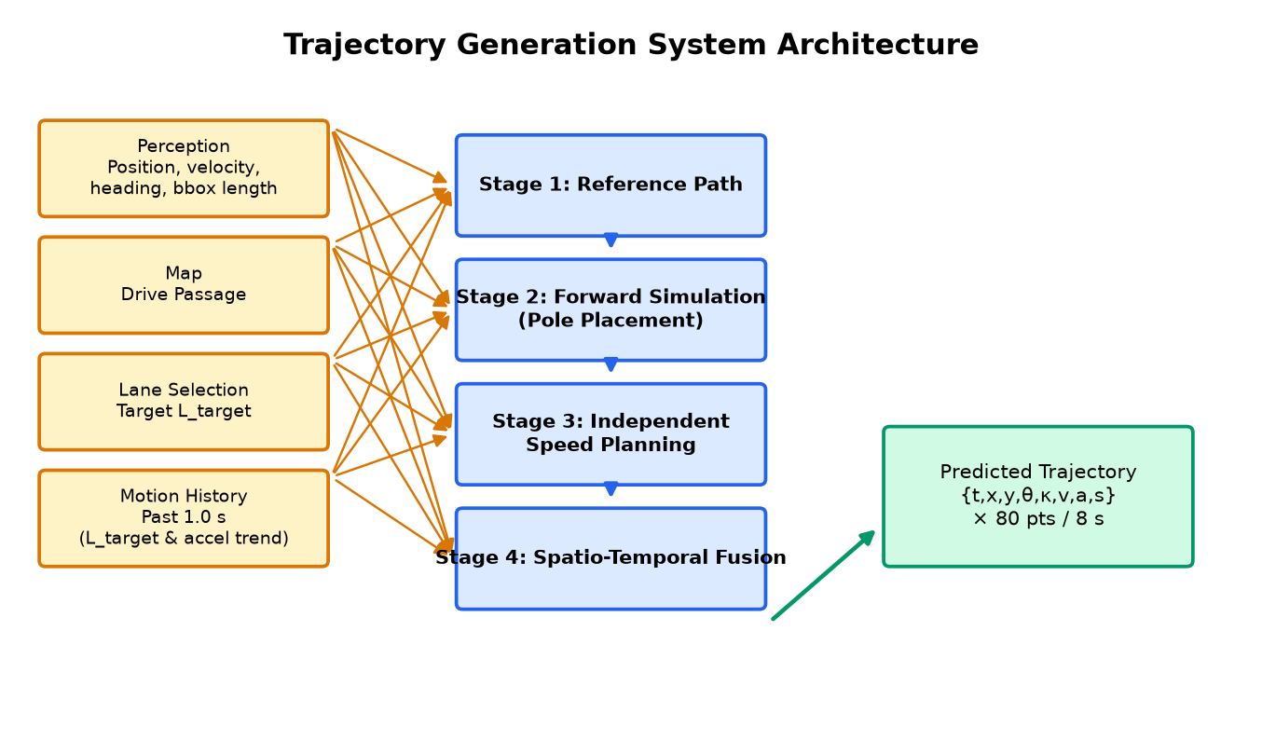
Figure 1: Trajectory Generation System Architecture — showing four input sources (Perception, Map, Lane Selection, Motion History), four processing stages, and the output trajectory format.

b. Flowcharts

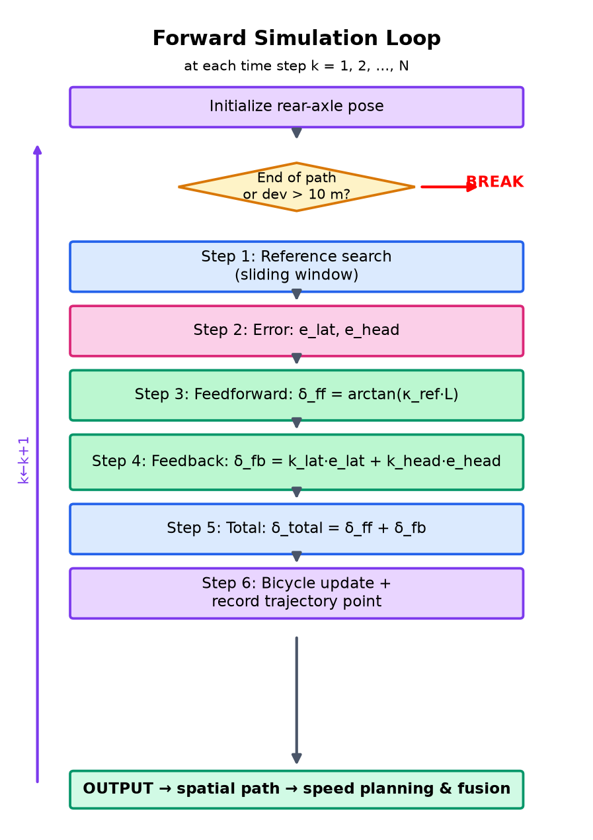
Figure 5: Forward Simulation Loop — detailed flowchart showing the six core steps executed at each time step k, including reference point search, feedforward/feedback computation, bicycle model update, and trajectory recording.
Forward Simulation Loop — the following six core steps are executed at each time step k (illustrated in Figure 5):
1. Reference point search: locate the closest reference point via sliding-window search.
2. Error computation: compute lateral error e_lat and heading error e_head.
3. Feedforward steering: compute δ_ff from curvature or heading difference (Section 4.4).
4. Feedback steering: compute δ_fb using the velocity-adaptive pole-placement gains (Section 4.3.2).
5. Total steering: δ_total = δ_ff + δ_fb.
6. Bicycle model update and trajectory recording: advance the vehicle state and store the output trajectory point (Section 4.2).

c. Additional Visualizations [OPTIONAL], e.g., data structure diagrams, state transition diagrams, or sequence diagrams for complex interactions

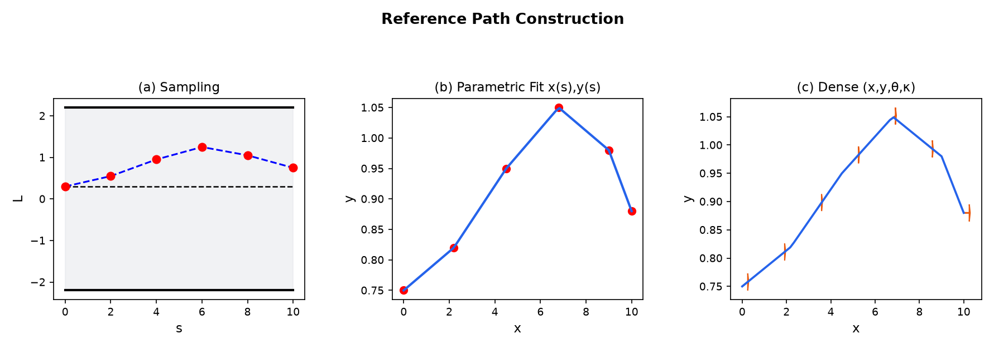
Figure 2: Reference Path Construction — (a) sampling waypoints from the Drive Passage with target lateral offset L_target, (b) smooth parametric curve fitting x(s), y(s), (c) dense reference points with position, heading angle (arrows), and curvature.
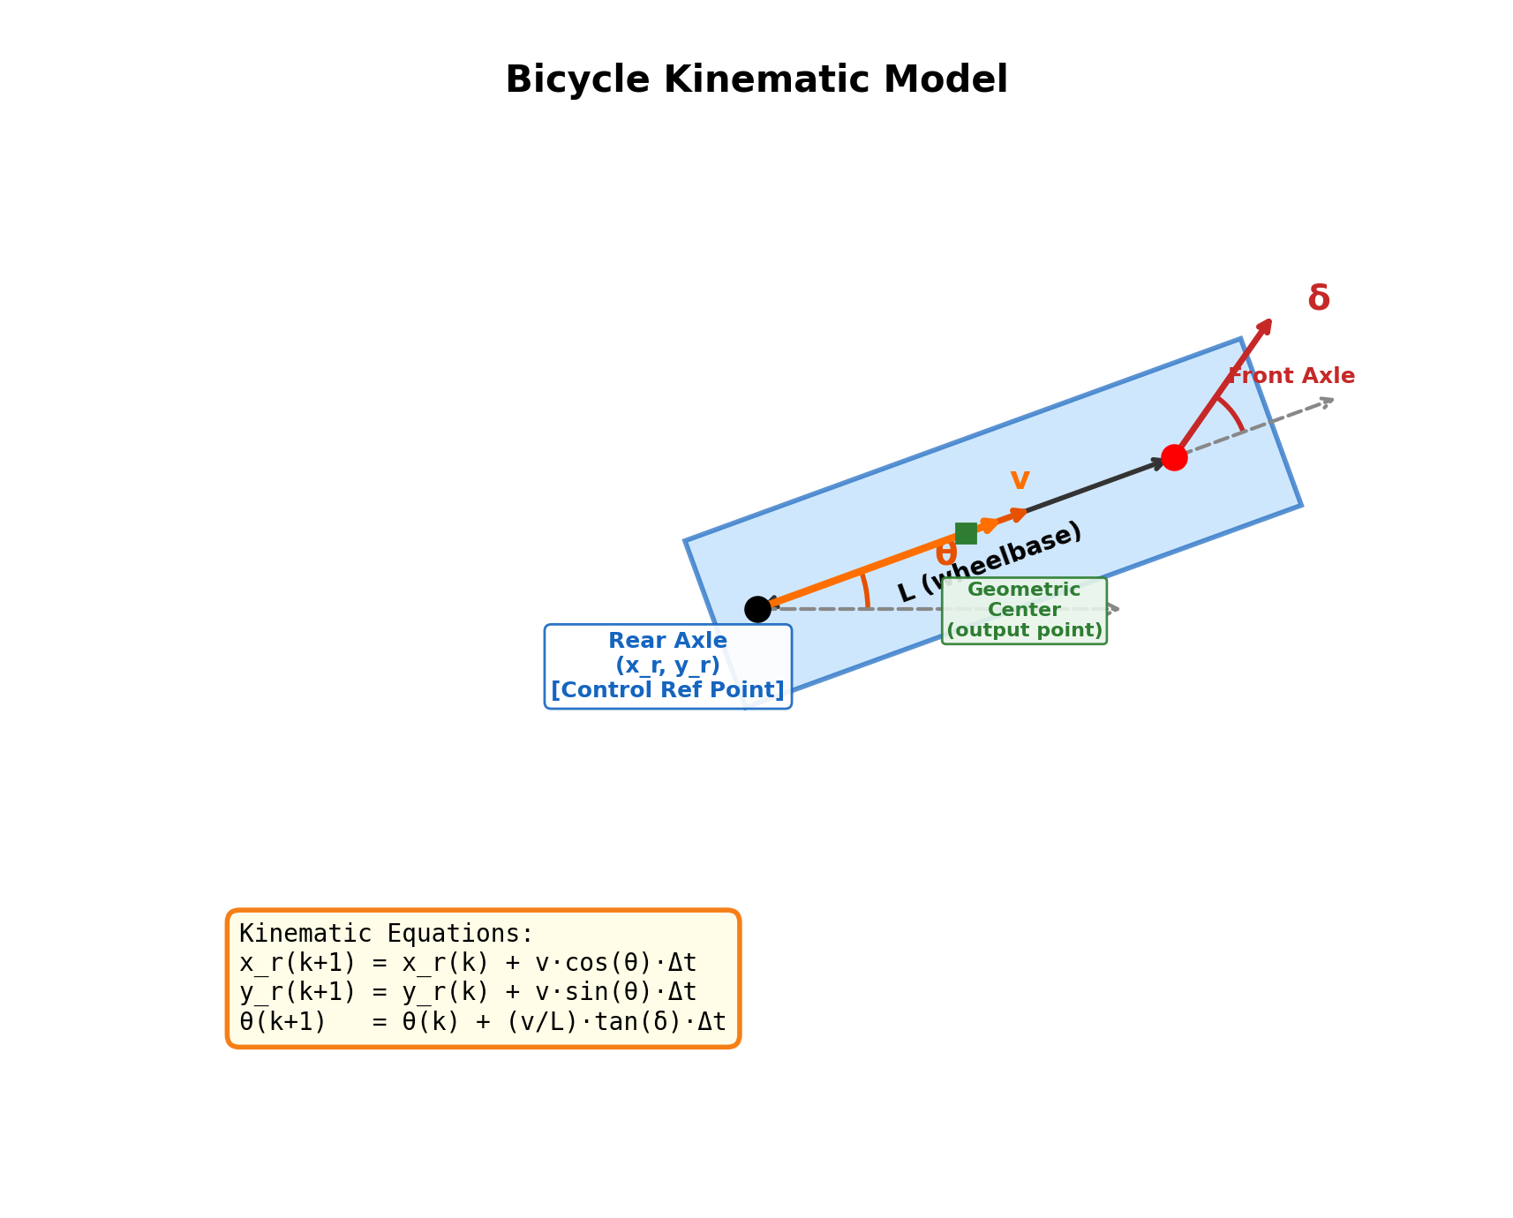
Figure 3: Bicycle Kinematic Model — showing the rear axle (control reference point, black dot), front axle with steering angle δ (red), wheelbase L, heading angle θ (orange), velocity vector v, and geometric center (green square, output point). The kinematic equations at the bottom describe the rear-axle motion update at each time step.
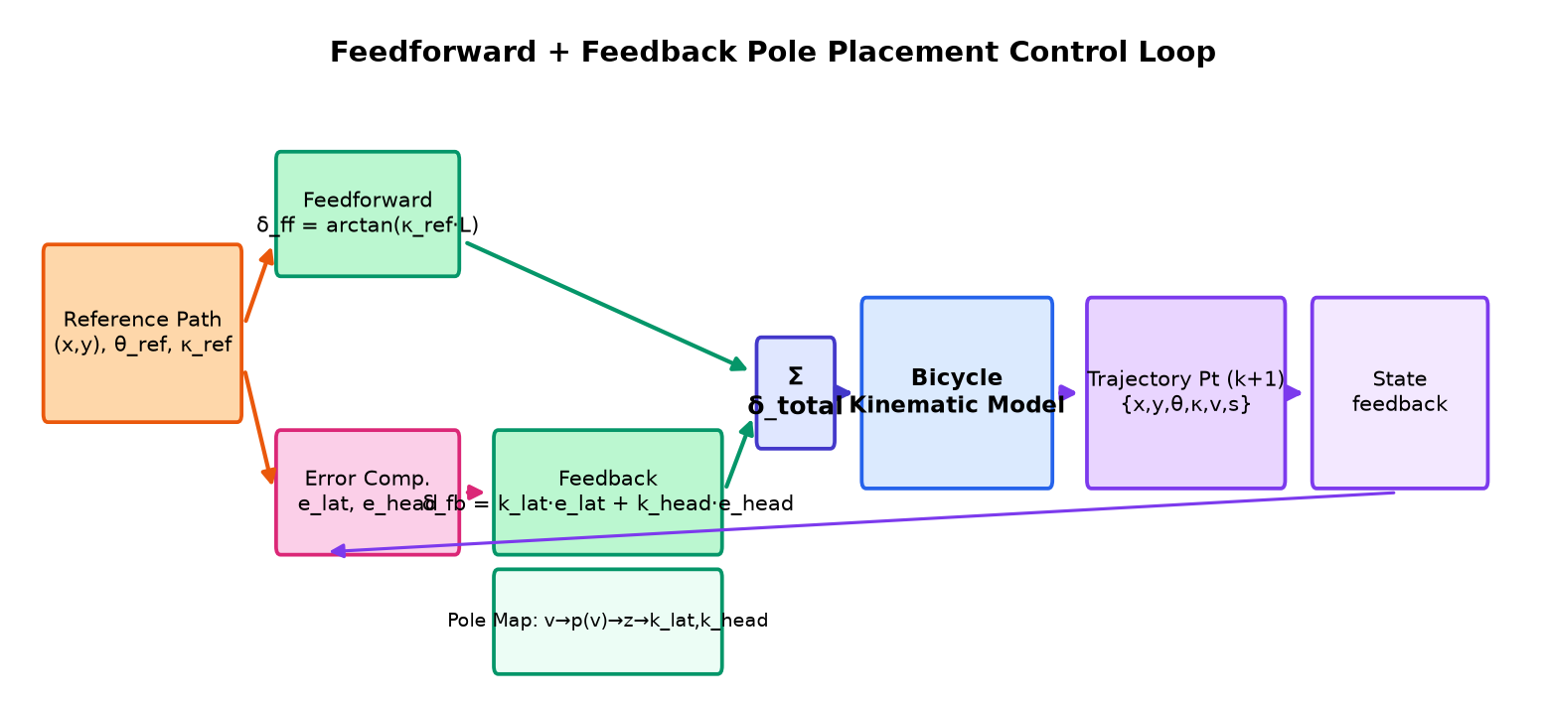
Figure 4: Feedforward + Feedback Pole Placement Control Loop — the reference path provides curvature (κ) to the feedforward controller and position/heading to the error computation block. The feedback controller uses velocity-adaptive pole placement gains. The bicycle model state feeds back for the next iteration.
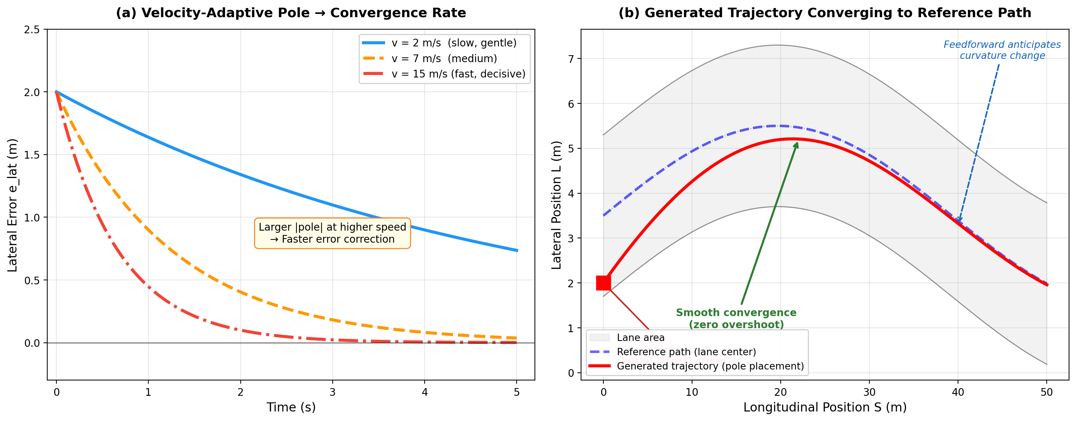
Figure 6: Pole Placement Convergence Behavior — (a) lateral error decay at different speeds: low speed (gentle), medium speed (moderate), high speed (fast, decisive), all with zero overshoot; (b) a generated trajectory (red) smoothly converging to the reference path (blue dashed) on a curved road, with feedforward anticipating curvature changes.

2.5 Detailed Description of Structure and Function

The trajectory generation method requires the following inputs from upstream modules:
Input Source | Data | Description
Perception System | Position (x, y) | Vehicle center position in world coordinates
Perception System | Velocity (vx, vy)  Heading angle θ  Bounding box length | Current motion state; bbox length is used to estimate wheelbase and max steering angle
Map System | Drive Passage | Lane geometric representation containing centerline, boundaries, curvature, and lane type
Lane Selection Module  (e.g., APF method) | Target lateral offset  L_target | The desired lateral position relative to lane centerline, determined by the upstream lane probability model
Motion History Buffer | Past 1.0 s trajectory states | Historical positions, velocities, and timestamps used to estimate target lateral offset L_target and longitudinal acceleration trend for independent speed planning
The method outputs a complete predicted trajectory consisting of a sequence of trajectory points at a fixed time interval of 0.1 seconds over a prediction horizon of 8-10 seconds (typically 80-100 points). Each trajectory point contains 8 state quantities:
Symbol | Quantity | Unit
t | Time | seconds
x | X position (world frame) | meters
y | Y position (world frame) | meters
θ | Heading angle | radians
κ | Curvature | m⁻¹
v | Longitudinal speed | m/s
a | Longitudinal acceleration | m/s²
s | Arc length from start | meters
The overall system architecture is divided into three stages: Reference Path Construction, Forward Simulation with Pole Placement Control, and Spatio-Temporal Fusion. Standard kinematic constraint enforcement (steering limits, acceleration bounds) is applied within the simulation loop as necessary implementation details and is not claimed as the inventive core. The detailed description of each stage follows.

4.1 Reference Path Construction in Frenet Coordinate System
The first stage constructs a smooth reference path that the controller will track, representing the ideal driving line incorporating road geometry and the desired lateral offset L_target from upstream lane selection.

4.1.1 Drive Passage Sampling
The lane geometric representation (Drive Passage) is sampled at regular longitudinal intervals, beginning from a point behind the vehicle (up to 10 m backward) and extending forward to cover the prediction horizon. The sampling distance is:
D_sample = T_horizon × (v_nom + v_offset)
where T_horizon is the prediction time horizon, v_nom is the nominal virtual speed (Section 4.5), and v_offset is a constant offset (typically 5.0 m/s) ensuring sufficient look-ahead. At each sampling point along the longitudinal coordinate s, the system queries the Cartesian position at the Frenet coordinate (s, L_target).
N = max(D_sample / D_interval + 1, N_min)
where D_interval is the desired sampling interval (8.0 m) and N_min is the minimum number of sampling points (5).

4.1.2 Curve Fitting and Reference Point Generation
The sampled waypoints are fitted to produce a smooth parametric curve x(s), y(s). At each dense re-sampling point, the system computes position (x, y), heading angle θ, and curvature κ. The output is an ordered sequence of reference triplets (position, heading, curvature) serving as the tracking target for the pole placement controller.

4.2 Bicycle Kinematic Model
The vehicle's motion is described by a bicycle kinematic model, which simplifies the vehicle as a rigid body with two axles (front and rear). The state variables are: rear-axle position (x_r, y_r), heading angle θ, longitudinal velocity v, and front wheel steering angle δ. The discrete-time kinematic equations are:

x_r(k+1) = x_r(k) + v(k) · cos(θ(k)) · T_s
y_r(k+1) = y_r(k) + v(k) · sin(θ(k)) · T_s
θ(k+1) = θ(k) + [v(k) / L] · tan(δ(k)) · T_s
where L is the wheelbase (front-to-rear axle distance) and T_s is the simulation time step.

4.2.1 Control Reference Point
The bicycle kinematic model uses the rear-axle center as the control reference point and reports trajectory points at the vehicle geometric center for downstream modules. The conversion follows the standard half-wheelbase offset along the heading direction.

4.2.2 Vehicle Parameter Estimation from Perception Data
Since the prediction module operates on other vehicles detected by the perception system, the exact kinematic parameters (wheelbase, maximum steering angle) are unknown. The system estimates these parameters from the perceived bounding box length using calibrated piecewise linear lookup tables. The calibration covers the full spectrum of road users:
Vehicle Type | Body Length (m) | Est. Wheelbase (m) | Max Steer Angle (rad)
Pedestrian | 1.0 | 0.6 | 1.047 (π/3)
Bicycle | 1.57 | 1.22 | 0.49
Tricycle | 2.95 | 2.1 | 0.496
Passenger Car | 4.786 | 2.92 | 0.546
Minibus | 5.995 | 3.85 | 0.583
Large Bus | 10.48 | 5.89 | 0.67

Intermediate values are obtained through linear interpolation, ensuring smooth parameter variation with body length.

4.3 Velocity-Adaptive Pole Placement Feedback Controller
The core of the trajectory generation is a discrete-time feedback controller based on pole placement theory. The controller computes the steering angle command at each simulation step to drive the vehicle toward the reference path, ensuring stable and smooth convergence.

4.3.1 Velocity-Dependent Pole Assignment
The closed-loop system's poles are assigned as a function of the vehicle's current longitudinal velocity using a calibrated piecewise linear mapping function. The continuous-domain pole p(v) determines the convergence rate of the tracking error:
p(v) = -PLF(|v|)
where PLF is a piecewise linear function with the following mapping:
Speed v (m/s) | 0.0 | 0.5 | 1.8 | 6.6 | 10.5 | 11.5 | 35.0
Pole |p(v)| | 0.01 | 0.2 | 0.5 | 0.8 | 1.0 | 1.3 | 3.0

Design rationale: At low speeds (v < 2 m/s), small pole values produce gentle, non-oscillatory convergence. At high speeds (v > 10 m/s), large pole values produce rapid error correction critical for safety. The specific speed value used to query PLF(v) depends on the operating mode (Section 4.5): in decoupled path generation mode, a nominal virtual speed is substituted; in direct trajectory mode, the actual vehicle speed is used.

4.3.2 Discrete-Time Feedback Gain Computation
The feedback gains are derived rigorously from the bicycle kinematic model through linearization, exact discretization, and pole assignment. The complete derivation follows.
Step 1: Continuous-Time Lateral Error Dynamics
Starting from the bicycle kinematic model, we linearize the lateral error dynamics around a reference path under the small-angle approximation (sin(e) ≈ e, tan(δ) ≈ δ). Define the state vector x = [e_lat, e_head]ᵀ where e_lat is the signed lateral distance from the rear axle to the reference path, and e_head = θ_ref − θ is the heading angle error. The control input u = δ_fb is the feedback steering angle (the feedforward component is omitted here as it compensates for the reference path curvature and does not affect the error dynamics).
The continuous-time error dynamics are:
ė_lat = +v · e_head
ė_head = −(v / L) · δ_fb
Physical interpretation: The first equation states that heading misalignment causes lateral drift — when the vehicle heading deviates from the reference, the vehicle drifts sideways at a rate proportional to the heading error. The second equation states that steering reduces the heading error (the negative sign): applying positive δ_fb increases the vehicle's heading angle θ, which decreases e_head = θ_ref − θ. This negative sign is the physical basis for stable feedback control.
In state-space form ẋ = A_c · x + B_c · u :
A_c = [ [0, v], [0, 0] ]
B_c = [ [0], [−v/L] ]
Note: The minus sign in B_c is essential. It reflects the physical fact that steering acts as negative feedback on the heading error. This sign must be carried consistently through discretization and gain derivation.
Step 2: Exact Discretization (Zero-Order Hold)
The continuous-time system is converted to discrete-time using the Zero-Order Hold (ZOH) method, which assumes the steering angle is held constant during each time step T_s. Since A_c is nilpotent (A_c² = 0), the matrix exponential simplifies to:
exp(A_c · τ) = I + A_c · τ
The discrete-time state matrix is:
A_d = exp(A_c · T_s) = I + A_c · T_s = [ [1, v·T_s], [0, 1] ]
The discrete-time input matrix requires the ZOH integral:
B_d = ∫₀ᵀˢ exp(A_c · τ) · B_c dτ = B_c · T_s + A_c · B_c · T_s² / 2
Computing A_c · B_c = [ [−v²/L], [0] ], we obtain:
B_d = [ [−v²·T_s² / (2L)], [−v·T_s / L] ]
Key insight: Both elements of B_d carry the minus sign inherited from B_c. The non-zero first element (−v²T_s²/2L) captures the intra-step coupling: when a steering angle is applied, it first changes the heading (via the second element), and the heading change then causes a lateral position shift within the same time step (via the first element). This coupling term is absent in a naive forward Euler discretization and is essential for the correct gain derivation.
Step 3: Pole Placement Gain Derivation
The state feedback law, matching the code implementation, uses positive gains:
δ_fb = k_lat · e_lat + k_head · e_head (i.e., u = +K · x, where K = [k_lat, k_head])
Since B_d already contains the minus signs from the physics, the closed-loop dynamics use the standard form:
x(k+1) = (A_d + B_d · K) · x(k)
Sign consistency check: Expanding the (2,2) element of A_d + B_d·K gives 1 + (−v·T_s/L)·k_head = 1 − v·T_s·k_head/L. Since k_head > 0 and v·T_s·k_head/L > 0, this diagonal element is less than 1, confirming the feedback is stabilizing. If B_d had the wrong sign (positive), this element would be 1 + v·T_s·k_head/L > 1, making the system unstable.

We assign both closed-loop eigenvalues to z = exp(p · T_s), where p < 0 is the desired continuous-domain pole. A repeated eigenvalue produces critically damped convergence with zero overshoot. The desired characteristic polynomial is:
det(λI − A_d − B_d · K) = (λ − z)² = λ² − 2z·λ + z²
Expanding the left-hand side and matching the coefficients of λ¹ and λ⁰ with the right-hand side yields two linear equations in two unknowns. Solving:
k_lat = (1 − 2z + z²) · L / (v² · T_s²) = (1 − z)² · L / (v² · T_s²)
k_head = (3 − 2z − z²) · L / (2·v · T_s) = (1 − z)(3 + z) · L / (2·v · T_s)
where z = exp(p · T_s) and p = −PLF(|v|) < 0. These formulas have been verified by symbolic computation (SymPy) to exactly match the code implementation.
Step 4: Stability Proof
Since the desired continuous-domain pole p is strictly negative (p < 0), the discrete-domain pole satisfies 0 < z = exp(p · T_s) < 1. Both eigenvalues of the closed-loop matrix (A_d + B_d · K) equal z, so their magnitudes are strictly less than 1.
At any fixed velocity v, the closed-loop matrix (A_d + B_d·K) has both eigenvalues equal to z = exp(p(v)·T_s) with |z| < 1. By the discrete-time Lyapunov stability theorem, the frozen-time system is asymptotically stable for every constant v > 0.
In practice, the vehicle velocity changes over time, making the pole p(v) and the closed-loop matrix time-varying — the controller is effectively a gain-scheduled (or linear parameter-varying, LPV) system. Under the slowly-varying assumption (the scheduling rate of v is small relative to the error convergence rate |p|), the frozen-time eigenvalues remain strictly inside the unit circle at every time step, ensuring practical input-to-state stability of the velocity-scheduled closed loop.
The repeated eigenvalue z guarantees critically damped, non-oscillatory convergence (no repeated zero-crossings of the error signal). For the canonical lateral-step response (initial heading error e_head(0) = 0), the lateral error decays monotonically with zero overshoot. For general initial conditions where both e_lat(0) and e_head(0) are nonzero, the discrete Jordan form x(k) = zᵏ·x(0) + k·zᵏ⁻¹·N·x(0) (where N is the nilpotent part) admits at most a single zero-crossing of e_lat before final convergence, but no sustained oscillation. This critically damped character produces natural, human-like lane-following behavior. □
The complete feedback steering command at each simulation step is:
δ_fb = k_lat(v) · e_lat + k_head(v) · e_head

4.3.3 Lateral Error Computation
At each simulation step, the system identifies the closest reference point to the vehicle's current rear-axle position using a sliding-window search (window size: 20 reference points ahead of the previous closest index). The lateral position error is computed as the signed cross-product distance from the rear-axle to the reference tangent line:
e_lat = -[(x_e - x_b)(y_r - y_b) - (y_e - y_b)(x_r - x_b)] / ||(x_e - x_b, y_e - y_b)||
where (x_b, y_b) is the closest reference point, (x_e, y_e) is a point one unit along the reference heading direction, and (x_r, y_r) is the rear-axle position. The heading angle error is simply:
e_head = normalize(θ_ref - θ_vehicle)

4.4 Feedforward Control
The feedforward component anticipates the required steering input based on the reference path geometry, reducing the burden on the feedback controller and improving tracking accuracy. Two feedforward modes are supported:

4.4.1 Curvature-Based Feedforward (for Lane-Following Path Generation)
The feedforward steering angle is computed from the reference path curvature:
δ_ff = arctan(κ_ref · L)
where κ_ref is the curvature of the reference path at the closest reference point. This formulation is derived from the steady-state steering angle required for the bicycle model to follow a circular arc of curvature κ_ref.

4.4.2 Heading-Difference Feedforward (for Trajectory Tracking)
When tracking an existing trajectory (e.g., post-processing neural network outputs), the curvature information may be noisy or unavailable. In this case, the feedforward is computed from the heading angle rate of change along the reference:
δ_ff = arctan[Δθ_ref · L / (T_s · max(v, 0.5))]
where Δθ_ref is the heading angle change between consecutive reference points.

4.4.3 Total Steering Command
The total steering command is the sum of feedforward and feedback:

δ_total = δ_ff + δ_fb

4.5 Decoupled Path Generation with Nominal Virtual Speed and Quantitative Independence Proof
4.5.1 Nominal Speed Substitution Mechanism
In decoupled path generation mode (main vehicle lane-follow predictor), the spatial path is generated by substituting the actual speed v_actual with a nominal virtual speed:
v_nom = PLF_path(v_actual)
where PLF_path maps actual speed to a bounded range [v_min_nom, v_max_nom] (typically [5.0, 15.0] m/s). All pole-placement gain computations and forward simulations during path generation use v_nom exclusively; v_actual enters only in the subsequent independent speed planning stage.
4.5.2 Quantitative Proof of Path-Shape Invariance to Actual Speed
Define the spatial path generation operator as a discrete-time mapping:
P = Φ(x₀, R, v_control, δ_ff, K(v_control))
where x₀ is the initial bicycle state; R(v_nom) = {(p_i, θ_i, κ_i)} is the reference path constructed from Drive Passage geometry, target lateral offset L_target, and sampling horizon D_sample = T_horizon × (v_nom + v_offset); v_control is the speed input to the controller; δ_ff is the curvature feedforward; and K(v) = [k_lat(v), k_head(v)] are the pole-placement feedback gains.
Proposition (Segment-wise Path-Shape Invariance): In decoupled Mode A, v_control = v_nom = PLF_path(v_actual). For any two actual speeds v₁, v₂ such that PLF_path(v₁) = PLF_path(v₂) = v̄, the generated spatial paths are identical: Φ(x₀, R(v̄), v̄) is independent of whether the vehicle's actual speed is v₁ or v₂.
Proof sketch: (1) The reference path R(v_nom) depends on v_actual only through v_nom via D_sample = T_horizon × (v_nom + v_offset). Since v_nom = PLF_path(v_actual) is piecewise constant (e.g., v_actual ∈ [0, 10] m/s ⇒ v_nom = 5.0 m/s), R(v_nom) is identical for all v_actual within that segment. (2) The feedback gains K(v_nom) depend exclusively on v_nom. (3) The feedforward δ_ff = arctan(κ·L) depends only on reference curvature. (4) The forward simulation uses a constant speed profile ref_v[k] = v_nom at every step, so each discrete state transition is identical when v_nom is fixed. Therefore P = Φ(R(v_nom), v_nom), and v_actual influences P only through the piecewise-constant mapping PLF_path, never directly. □
Corollary (Bounded Cross-Segment Distortion): Across PLF_path segments where v_nom changes, spatial path distortion is bounded by the ratio v_max_nom / v_min_nom (typically 3:1 for [5, 15] m/s), whereas coupled methods can exhibit unbounded distortion (e.g., a 30× speed ratio produces ~30× change in reference-point density and pole magnitude).

4.5.3 Two Operating Modes
Mode A — Decoupled Path Generation: v_control = v_nom. Output is a pure spatial path (DiscretizedPath). Used by the main vehicle lane-follow predictor.
Mode B — Direct Trajectory Generation: v_control = v_actual. Output is a complete spatio-temporal trajectory. Used by L2 lane-follow, bicycle lane-follow, and neural network trajectory refinement.
Both modes share the same controller code; only the speed input and output format differ. Mode A exploits the invariance property above; Mode B exploits the full velocity-adaptive pole range for scenarios where actual speed dynamics matter (e.g., near-stationary cyclists).

4.6 Systematic Pole Mapping Calibration via Multi-Objective Optimization
The velocity-to-pole mapping PLF(v) is systematically calibrated from recorded driving or high-fidelity simulation data. Calibration is performed offline and deployed as a piecewise-linear lookup table at runtime.
4.6.1 Calibration Dataset and Metrics
Actual speed (m/s) | 0–10 | 10–15 | 15–30 | >30
Nominal speed (m/s) | 5.0 | 5.0–8.0 | 8.0–15.0 | 15.0
Effective |p| | ≈0.72 | 0.72–0.85 | 0.85–1.32 | ≈1.32

For each candidate pole assignment p(v) at speed v, the controller is evaluated on a dataset of lane-following scenarios with known reference paths. Three metrics are computed:
J_track = Σ_k [w_lat · e_lat(k)² + w_head · e_head(k)²] — lateral and heading tracking error over the prediction horizon
J_comfort = max_k |d²e_lat/dt²| — peak lateral jerk (comfort proxy)
J_stability = max_v |z(v)| where z(v) = exp(p(v)·T_s) — worst-case discrete pole magnitude (must satisfy |z| < 1)

4.6.2 Multi-Objective Optimization Formulation

The calibration solves a constrained multi-objective problem at each speed knot v_i:
Actual Speed | 0-10 | 10-15 | 15-30 | >30
Nominal Speed | 5.0 | 5.0-8.0 | 8.0-15.0 | 15.0
Unit | m/s | m/s | m/s | m/s
minimize J(p) = α · J_track(p) + β · J_comfort(p)
subject to |z(v_i)| ≤ 1 − ε (stability margin ε > 0)
p_min ≤ p(v_i) ≤ p_max (physical bounds)
where α, β are weighting coefficients reflecting the safety-comfort trade-off. The Pareto-optimal solutions are evaluated, and the knee point (best compromise) is selected for each speed segment. The resulting piecewise linear function PLF(v) is verified to maintain |z(v)| < 1 across the entire speed range, providing a stability certificate for the gain-scheduled controller.

4.6.3 Validation and Deployment
The calibrated PLF(v) is cross-validated on held-out scenarios (lane changes, curved roads, low-speed urban driving). Deployment criteria require simultaneous satisfaction of: (i) mean tracking error J_track below a preset threshold at each speed knot, (ii) comfort bound J_comfort below a passenger-comfort limit, and (iii) stability certificate |z(v)| ≤ 1 − ε for all v in the operating envelope.

4.7 Closed-Loop Neural Network Trajectory Fusion
Neural network predictors (e.g., ActNet) capture complex driving intentions but may produce kinematically inconsistent trajectories at low speeds (discontinuous heading, excessive curvature). This invention closes the loop: the NN output serves as a spatial intent reference, and the pole placement controller re-simulates a physically feasible trajectory from the measured initial state — while quantifying the kinematic gap and adjusting prediction confidence accordingly.

4.7.1 Trigger Condition: Slow-Moving Trajectory Detection
Fusion is activated when the NN output is classified as slow-moving: any trajectory point with speed below 2.0 m/s, or total arc length below 16.0 m. Fast-moving trajectories bypass closed-loop refinement because NN outputs at highway speeds are typically kinematically consistent.

4.7.2 Closed-Loop Refinement Pipeline
When triggered, the pipeline executes four stages: (1) Pre-processing — clamp curvature to a feasible range and limit step-to-step heading changes to remove NN artifacts; (2) Reference construction — convert NN polyline points to a reference sequence; map center points to rear-axle references when speed is low; (3) Closed-loop re-simulation — TrackTrajectoryByPolePlacement with heading-difference feedforward (Section 4.4.2), starting from the measured bicycle state; (4) Acceptance — replace the raw NN trajectory with the refined output if the refined trajectory contains sufficient valid points and does not terminate prematurely.

4.7.3 Kinematic Deviation Metrics
After refinement, explicit deviation metrics quantify the kinematic gap between the raw NN trajectory T_NN and the refined trajectory T_ref:
D_lat = max_k |e_lat(T_NN(k), T_ref)| — maximum lateral deviation (m)
D_head = max_k |e_head(T_NN(k), T_ref)| — maximum heading deviation (rad)
D_κ = max_k |κ_NN(k) − κ_ref(k)| — maximum curvature deviation (m⁻¹)
D_composite = w_lat·D_lat + w_head·D_head + w_κ·D_κ — weighted composite deviation
Decision logic: if D_composite > τ_high, the NN output is deemed kinematically inconsistent and the refined trajectory fully replaces it; if τ_low < D_composite ≤ τ_high, the refined trajectory is accepted with reduced confidence; if D_composite ≤ τ_low, the refined trajectory is accepted as a minor correction with confidence near the original NN probability. This metric-driven gating is unique to the closed-loop architecture — open-loop post-processing (e.g., curvature clamping alone) cannot quantify kinematic fidelity.

4.7.4 Confidence Interaction with NN Mode Probability
Each NN trajectory mode carries a softmax probability p_mode. The fusion adjusts the effective prediction confidence:
p_effective = p_mode · σ(−γ · D_composite)
where σ is a sigmoid function and γ is a sensitivity parameter. Large D_composite drives p_effective toward zero, preventing downstream planners from over-trusting NN modes that required substantial kinematic correction. When D_composite ≈ 0, p_effective ≈ p_mode, indicating the NN output was already kinematically plausible. In multi-modal outputs, probabilities are re-normalized after adjustment: p̃_i = p_effective,i / Σ_j p_effective,j.

4.7.5 Speed Profile Rectification (Decoupled Fusion)
When speed rectification is enabled, the refined spatial path is combined with an independently planned speed profile (longitudinal acceleration trend + curvature-limited safe speed), mirroring the decoupled architecture of Section 4.5. Spatial refinement and temporal speed assignment are thus separated, ensuring consistent treatment of rule-based and NN-based predictions.

4.8 Spatio-Temporal Fusion
In decoupled Mode A, spatial path (Section 4.5) and speed profile are fused by numerical integration. The speed profile is planned independently: longitudinal acceleration is estimated from motion history, then corrected by curvature-limited safe speed v_safe = √(a_lat_plan / κ_max) over a look-ahead window, and finally clamped to speed-dependent acceleration bounds. At each time step t_i, the speed profile provides s(t_i) and v(t_i); the spatial path is queried at s(t_i) to obtain (x, y, θ, κ). The complete point {t_i, x, y, θ, κ, v, a, s} is assembled. If s(t_i) exceeds path length before the horizon ends, Section 4.9 extension is activated.

4.9 Trajectory Extension Along Lane Tangent
When the fused trajectory does not cover the full prediction horizon (common in low-speed scenarios), extension proceeds along the lane tangent at the last point, maintaining the last known speed and heading until the horizon is fully covered.

4.10 Alternative Embodiments
Alternative Embodiment 1: Road-Type-Adaptive Pole Mapping. The calibrated PLF(v) from Section 4.6 can be specialized by road type (highway vs. urban), selecting different Pareto-optimal solutions from the calibration Pareto front.
Alternative Embodiment 2: Model Predictive Control (MPC) Extension. The single-step pole placement controller can be extended to a receding-horizon MPC formulation for explicit handling of future constraints (e.g., upcoming lane narrowing).
Alternative Embodiment 3: Nonlinear Bicycle Model. The kinematic bicycle model can be replaced with a dynamic bicycle model including tire slip angles for improved high-speed accuracy.

Alternative Embodiment 4: Multi-Modal NN Fusion. When the NN outputs multiple trajectory modes, each mode is independently refined; p_effective is computed per mode via Section 4.7.4, and probabilities are re-normalized for confidence-aware multi-hypothesis prediction.

2.6 Proving the Invention on Competitor Products [OPTIONAL]

2.7 Disclosure Timeline (Third Parties or Public)

2.8 Supporting Evidence and Test Results [OPTIONAL]

