**Tendències**

**Tecnològiques**

**Vinicius Nascimento**

**(v.freires.2016)**

**Eloy Lopez**

**(Eloy.lopez.2016)**

**Salle Social Network**

Introducion

**This project is about the development of a social network. The objectives of this project are to use all the knowledge acquired in the classroom, both in the structural part and in the design part. We divide the tasks into several parts and use tools like Trello and Github to follow better the progress of the project. As an aid to researching and performing some tasks we used stackoverflow.**

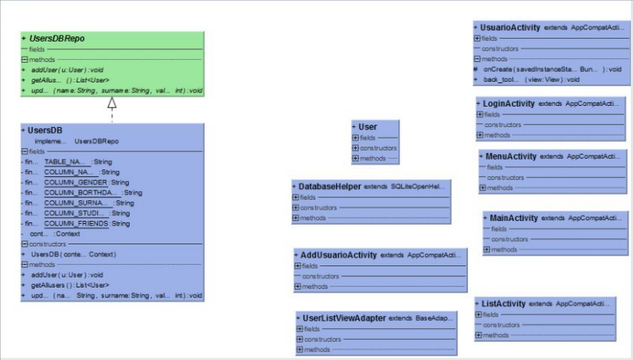Class Diagram

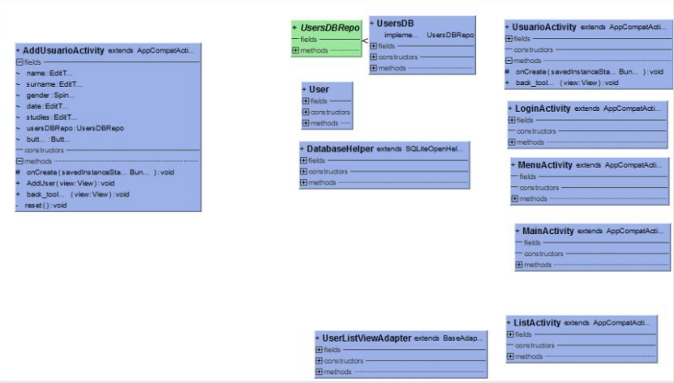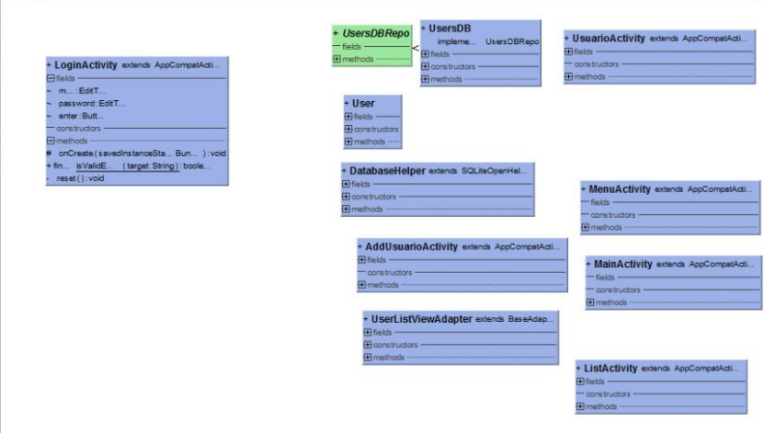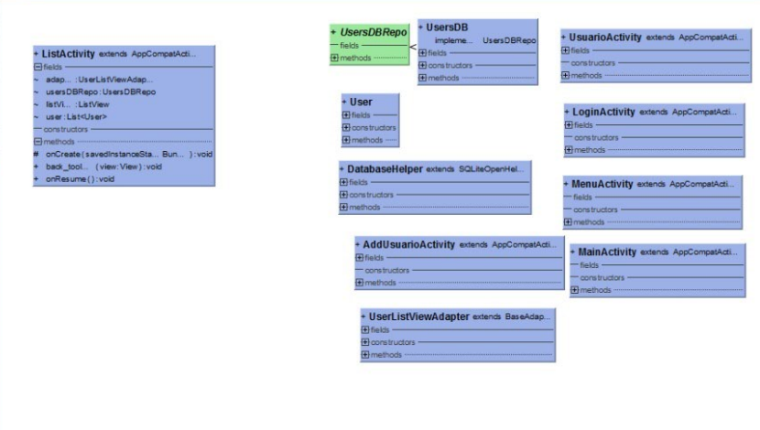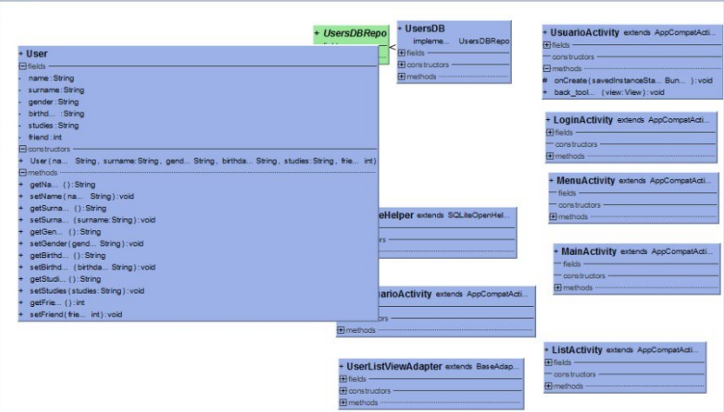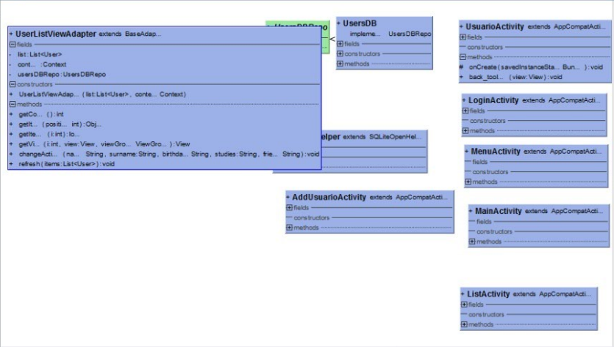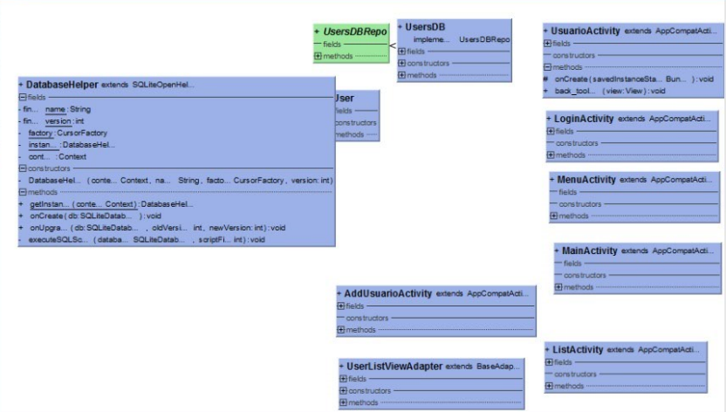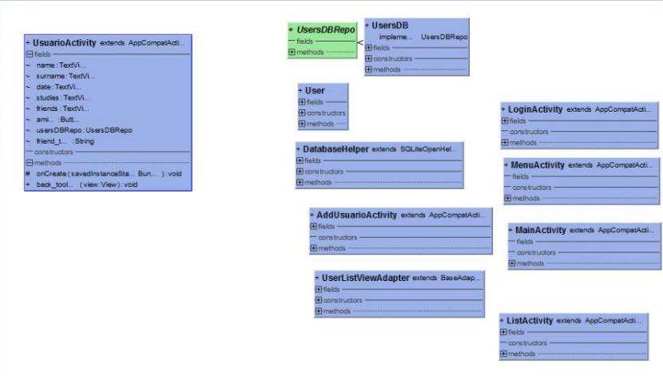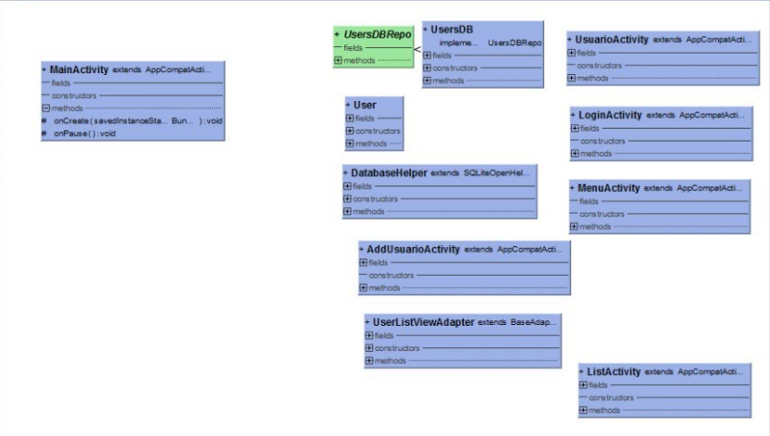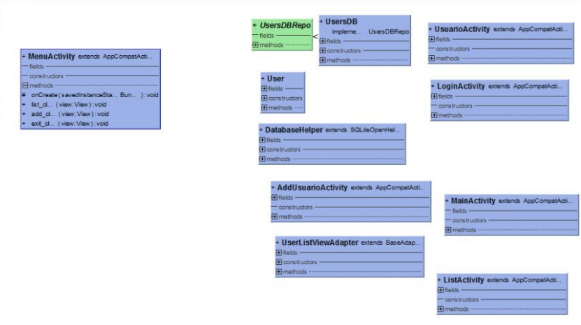

Conclusion

**At the beginning of development, it has become easy and we have divided the tasks properly until we perceive the problems arising. We had some problems in the middle of development when we try to generate a file that saves inside the device, but we solve it with an internal database.**

**We also learned to work as a team and to use better storage systems such as GitHub**