

**Network Project  
add reliability to UDP sending-Receiving**

|  |  |
| --- | --- |
| **id** | **Names** |
| **13T5040** | **Mohammad Mahmoud Hafez Alberry** |
| **1301628** | **Yasser Alaa Alden Kamal** |

**About UDP:**

**The UDP protocol provides a connectionless service to its applications. This is a no-frills service that provides no  
reliability, no flow control, and no congestion control.**

**Reliability:  
 reliability means guarantee delivery of application-layer messages to the destination.**

**How can we guarantee that:  
we have make sure of two things.  
 1- We should break the message to smaller packets.  
 2- All packets must deliver to the destination.  
 3- All packet must deliver correctly without corruption**

**So, assuming this is the message**



**We will break this message to fixed size packets as shown below for ex 50 Byte per packet.**

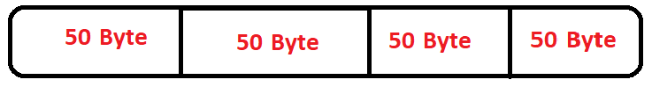

**We can make the sender send packets again and again until gets ack message from the reciever**

**And to ensure that every packet will deliver without corruption we add header that carries the key of the packet and number of the packet.**

**There are so many types of keys that describe the packet the simplest one of them is to count ones of the binary packet so, assuming we will send 'A', the ascii of('A') = 65 and the binary code ='0b1000001' so the number of ones= 2 and so on**

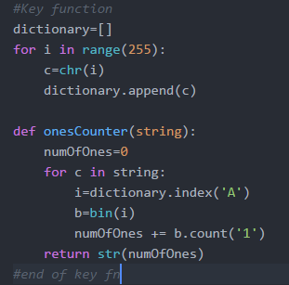

**We stored all characters in one list (dictionary) and then we search for the characters in the dictionary and convert its index to binary and then count the ones.**

**As mentioned before the packet size =50 byte   
Every byte consists of 8 binary zeros and ones   
if accidently all the 50 bytes ='0b11111111' then the number of ones will be = 8 * 50 = 400**

**Then now we are sure of that the max number of characters we need to reserve in the header of the packet to the key will=3 characters.**

**Now we need to determine the max size of message or file that will be sent, so that we can reserve correct size for packet number in the packet header**

**if we choose the max size = 1 K Byte then, max number of packets = 1 K/50 = 21   
so we need to reserve 2 characters for packet number.**

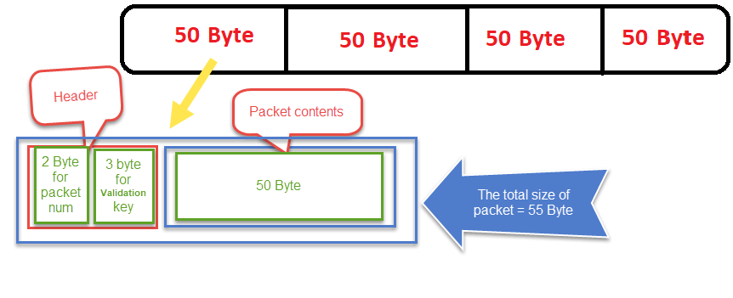

**The code for sender**

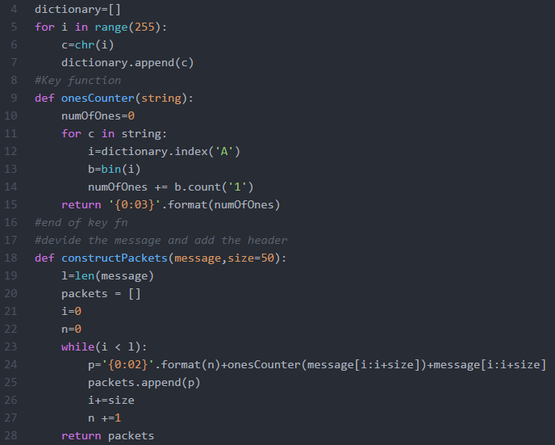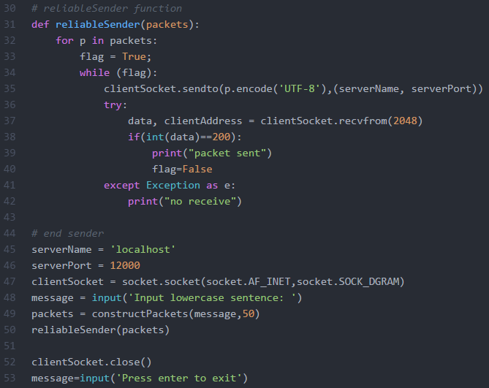

**Code of receiver**

