

**BCM**

Kareem Magdy Albolaqi

SPRINT   
10

Table of Contents

LAYERED ARCHTICTURE 2

PROJECT FLOWCHART 5

DRIVERS 7

MCAL 7

DIO DRIVER 7

USART DRIVER 10

HAL 13

LED DRIVER 13

SERVICE 14

BCM 14

# LAYERED ARCHTICTURE

**LED SEQUENCE V1.0 PAGE 2**

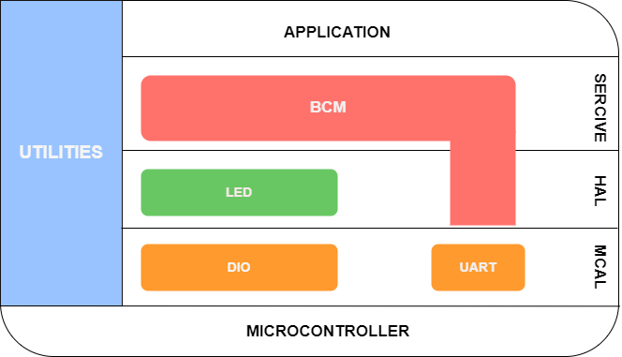

# PROJECT FLOWCHART

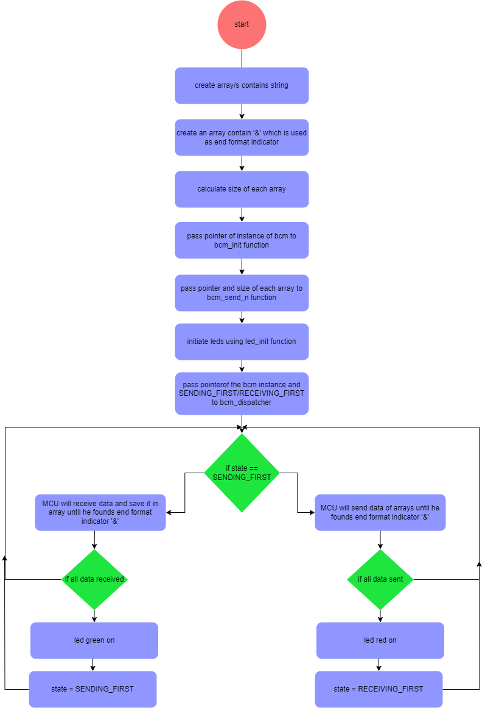



# DRIVERS

## MCAL

### DIO DRIVER

Dio_ErrorStatus Dio_init(void);

Dio_ErrorStatus Dio_WriteChannel(Dio_Channel channel , Dio_status state);

Dio_ErrorStatus Dio_ReadChannel(Dio_Channel channel);

|  |  |  |
| --- | --- | --- |
| **DIO_init** | **DIO_write** | **DIO_read** |
|  |  |  |

Configurations :

|  |  |
| --- | --- |
|  |  |

|  |
| --- |
|  |

|  |
| --- |
|  |

### USART DRIVER

uart_error_state USART_init(void);

uart_error_state USART_transmit(uint8_t data);

uart_error_state USART_receive(uint8_t *data);

|  |  |  |
| --- | --- | --- |
|  |  |  |

Configurations :

|  |  |
| --- | --- |
|  |  |

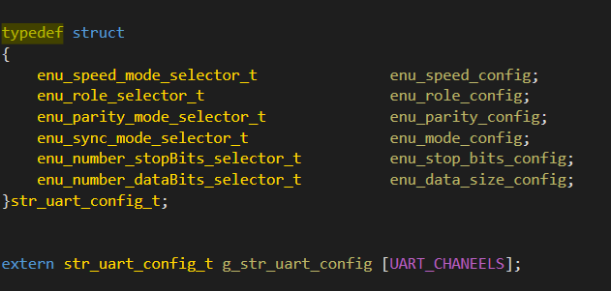

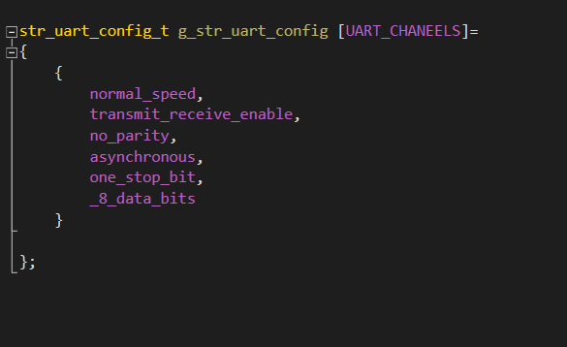

## 

## HAL

### LED DRIVER

Dio_ErrorStatus LED_init(PORT_NUM portNum , PIN_NUM pinNum); Dio_ErrorStatus LED_on (PORT_NUM portNum , PIN_NUM pinNum); Dio_ErrorStatus LED_off(PORT_NUM portNum , PIN_NUM pinNum);

|  |  |  |
| --- | --- | --- |
| **LED_init** | **LED_on** | **LED_off** |
|  |  |  |

## SERVICE

### BCM

enu_sysem_status_t bcm_init(str_bcm_instance_t *ptr_bcm_instance_t);

enu_sysem_status_t bcm_denit(str_bcm_instance_t *ptr_bcm_instance_t);

enu_bcm_send_state_t bcm_send( str_bcm_instance_t *ptr_bcm_instance_t ,uint8_t * ptr_buffer);

enu_bcm_send_state_t bcm_send_n( str_bcm_instance_t *ptr_bcm_instance_t , uint8_t * ptr_buffer,uint8_t a_buffer_length);

enu_bcm_send_state_t bcm_disbatcher(str_bcm_instance_t *ptr_bcm_instance_t , enu_bcm_first_use a_first_use);

|  |
| --- |
| bcm_init |
|  |

|  |
| --- |
| bcm_send_n |
|  |

Configurations :

