{name} {amount}: {#inline} Inline Var: {ivar} {/inline}

{#teste}

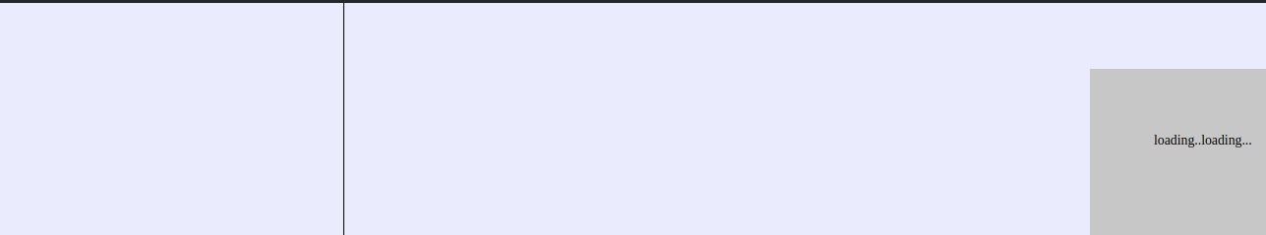

{hope}

{/teste}

{#outer}

Outer text with a variable {outerval}

{#inner}

inner text with another variable {innerval}

{/inner}

{/outer}

***NO LOOPS HERE***

***testing*** {a} ***more testing***

***inlineloop*** *{#inlineloop}* ***var {var}*** *{/inlineloop}*

|  |  |  |
| --- | --- | --- |
|  |  |  |
|  |  |  |

4324324