JPA Sprawozdanie
1. Basics

Kod mapowanej klasy:

@Entity(name = "Products")
public class Product {
@Id
@GeneratedValue(strategy = GenerationType.AUTO)
private int id;
private String productName;
private int unitsOnStock;
private double price;
public Product() {
}
public Product(String productName, int unitsOnStock, double price) {
this.productName = productName;
this.unitsOnStock = unitsOnStock;
this.price = price;
}
@Override
public String toString() {
return String.format("ID: %d, Name: %s, Units: %d, Price: %.2f",
id, productName, unitsOnStock, price);
}
}
Przykładowe polecenie dodanie do bazy:
public class AddProduct implements Command {
private Session session;
public AddProduct(Session session) {
this.session = session;
}
@Override
public void execute() {
System.out.print("Name: ");
String productName = scanner.nextLine();
System.out.print("Price: ");
double price = Float.parseFloat(scanner.nextLine());
System.out.print("UnitsOnStock: ");
int onStock = Integer.parseInt(scanner.nextLine());
Transaction tx = session.beginTransaction();
session.save(new Product(productName, onStock, price));
tx.commit();
}
}
SELECT * FROM PRODUCTS

2. Wprowadzenie modelu dostawcy.

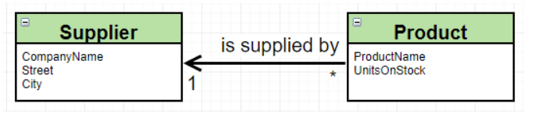

@Entity
public class Supplier {
@Id
@GeneratedValue(strategy = GenerationType.AUTO)
private int id;
private String companyName;
private String street;
private String city;
public Supplier() {
}
public Supplier(String companyName, String street, String city) {
this.companyName = companyName;
this.street = street;
this.city = city;
}
@Override
public String toString() {
return String.format("ID: %d, CompanyName: %s, Street: %s, City: %s",
id, companyName, street, city);
}
}
Zmiana w modelu Produktu:
@ManyToOne
private Supplier supplier;
Dodanie dostawcy do produktu:

public void execute() {
System.out.print("Product id: ");
int id = Integer.parseInt(scanner.nextLine());
System.out.print("Supplier id: ");
int c_id = Integer.parseInt(scanner.nextLine());
Transaction tx = session.beginTransaction();
Product product = session.get(Product.class, id);
Supplier supplier = session.get(Supplier.class, c_id);
if (product != null && supplier != null) product.setSupplier(supplier);
tx.commit();
}

Logi:
Hibernate: select product0_.id as id1_0_0_, product0_.price as price2_0_0_, product0_.productName as productN3_0_0_, product0_.supplier_id as supplier5_0_0_, product0_.unitsOnStock as unitsOnS4_0_0_, supplier1_.id as id1_1_1_, supplier1_.city as city2_1_1_, supplier1_.companyName as companyN3_1_1_, supplier1_.street as street4_1_1_ from Products product0_ left outer join Supplier supplier1_ on product0_.supplier_id=supplier1_.id where product0_.id=?

Hibernate: select supplier0_.id as id1_1_0_, supplier0_.city as city2_1_0_, supplier0_.companyName as companyN3_1_0_, supplier0_.street as street4_1_0_ from Supplier supplier0_ where supplier0_.id=?

Hibernate: update Products set price=?, productName=?, supplier_id=?, unitsOnStock=? where id=?

SELECT * FROM PRODUCTS;
SELECT * FROM SUPPLIER;
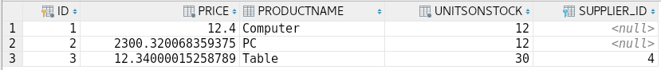

4. Odwrócenie relacji

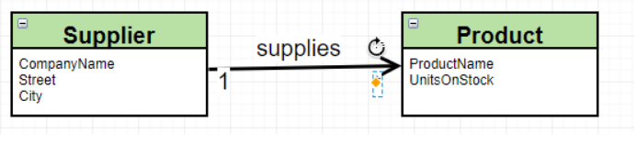
Zmiana w modelu Supplier:

@OneToMany
private Set<Product> supplies;
Po zaaktualizowaniu bazy (bez ponownego tworzenia):
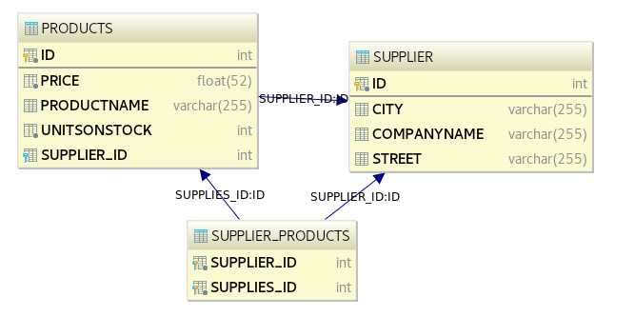

Jak widać, jest to przykład z tabelą łącznikową. Zmieńmy teraz model:

W modelu Supplier:

@OneToMany
@JoinColumn(name = "SUPPLIER_ID")
private Set<Product> supplies;

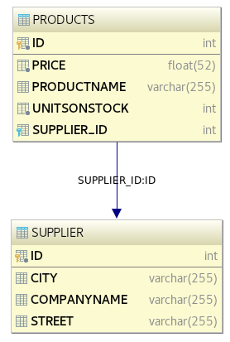

Jak widać, mamy relację bez tabeli łącznikowej.

6. Relacja dwustronna:
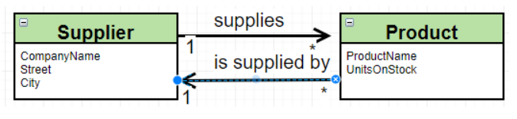
W modelu Supplier:
@OneToMany
@JoinColumn(name = "SUPPLIER_ID")
private Set<Product> supplies;
W modelu Product:
@ManyToOne
@JoinColumn(name = "SUPPLIER_ID")
private Supplier supplier;
Prowadzi to jednak to podwójnych updatów w bazie:
Hibernate: select product0_.id as id1_0_0_, product0_.price as price2_0_0_, product0_.productName as productN3_0_0_, product0_.SUPPLIER_ID as SUPPLIER5_0_0_, product0_.unitsOnStock as unitsOnS4_0_0_, supplier1_.id as id1_1_1_, supplier1_.city as city2_1_1_, supplier1_.companyName as companyN3_1_1_, supplier1_.street as street4_1_1_ from Products product0_ left outer join Supplier supplier1_ on product0_.SUPPLIER_ID=supplier1_.id where product0_.id=?
Hibernate: select supplier0_.id as id1_1_0_, supplier0_.city as city2_1_0_, supplier0_.companyName as companyN3_1_0_, supplier0_.street as street4_1_0_ from Supplier supplier0_ where supplier0_.id=?
Hibernate: select supplies0_.SUPPLIER_ID as SUPPLIER5_0_0_, supplies0_.id as id1_0_0_, supplies0_.id as id1_0_1_, supplies0_.price as price2_0_1_, supplies0_.productName as productN3_0_1_, supplies0_.SUPPLIER_ID as SUPPLIER5_0_1_, supplies0_.unitsOnStock as unitsOnS4_0_1_ from Products supplies0_ where supplies0_.SUPPLIER_ID=?
Hibernate: update Products set price=?, productName=?, SUPPLIER_ID=?, unitsOnStock=? where id=?
Hibernate: update Products set SUPPLIER_ID=? where id=?
Dlatego podmieniamy adnotacje w modelu Supplier na:
@OneToMany(mappedBy = "supplier")
private Set<Product> supplies;
W resultacie otrzymujemy:
Hibernate: select product0_.id as id1_0_0_, product0_.price as price2_0_0_, product0_.productName as productN3_0_0_, product0_.SUPPLIER_ID as SUPPLIER5_0_0_, product0_.unitsOnStock as unitsOnS4_0_0_, supplier1_.id as id1_1_1_, supplier1_.city as city2_1_1_, supplier1_.companyName as companyN3_1_1_, supplier1_.street as street4_1_1_ from Products product0_ left outer join Supplier supplier1_ on product0_.SUPPLIER_ID=supplier1_.id where product0_.id=?
Hibernate: select supplier0_.id as id1_1_0_, supplier0_.city as city2_1_0_, supplier0_.companyName as companyN3_1_0_, supplier0_.street as street4_1_0_ from Supplier supplier0_ where supplier0_.id=?
Hibernate: select supplies0_.SUPPLIER_ID as SUPPLIER5_0_0_, supplies0_.id as id1_0_0_, supplies0_.id as id1_0_1_, supplies0_.price as price2_0_1_, supplies0_.productName as productN3_0_1_, supplies0_.SUPPLIER_ID as SUPPLIER5_0_1_, supplies0_.unitsOnStock as unitsOnS4_0_1_ from Products supplies0_ where supplies0_.SUPPLIER_ID=?
Hibernate: update Products set price=?, productName=?, SUPPLIER_ID=?, unitsOnStock=? where id=?

7. Dodanie modelu Category
@Entity
public class Category {
@Id
@GeneratedValue(strategy = GenerationType.AUTO)
private int categoryId;
private String name;
@OneToMany
@JoinColumn(name = "CATEGORY_ID")
private List<Product> products;
public Category() {
}
public Category(String name) {
this.name = name;
products = new LinkedList<>();
}
@Override
public String toString() {
return String.format("ID: %d, Name: %s", categoryId, name);
}
public void addProduct(Product product){
products.add(product);
}
}
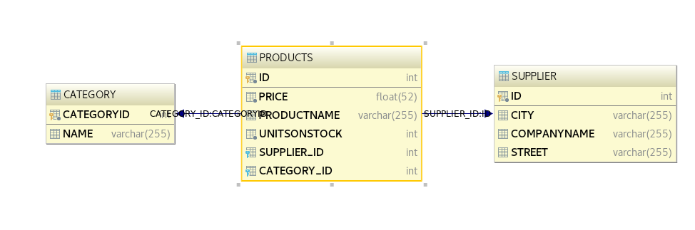
Dodawanie dostawców, produktów i pobieranie danych:
public static void main(final String[] args) throws Exception {
final Session session = getSession();
Transaction tx = session.beginTransaction();
Supplier supplier = new Supplier("XKOM", "Chopina", "Krak?w");
session.save(supplier);
Product product = new Product("Notebook", 20, 3.500);
Product product1 = new Product("Macbook", 20, 3.500);
Product product2 = new Product("Smartphone", 20, 3.500);
session.save(product);
session.save(product1);
session.save(product2);
supplier.addSupplied(product);
supplier.addSupplied(product1);
supplier.addSupplied(product2);
Supplier s = session.get(Supplier.class, supplier.getId());
s.getSupplies().forEach(System.out::println);
Product p = session.get(Product.class, product.getId());
System.out.println(p.getSupplier());
tx.commit();
session.close();
}
Logi:

Hibernate: values next value for hibernate_sequence
Hibernate: values next value for hibernate_sequence
Hibernate: values next value for hibernate_sequence
Hibernate: values next value for hibernate_sequence
ID: 26, Name: Notebook, Units: 20, Price: 3,50
ID: 27, Name: Macbook, Units: 20, Price: 3,50
ID: 28, Name: Smartphone, Units: 20, Price: 3,50
ID: 25, CompanyName: XKOM, Street: Chopina, City: Kraków
Hibernate: insert into Supplier (city, companyName, street, id) values (?, ?, ?, ?)
Hibernate: insert into Products (price, productName, SUPPLIER_ID, unitsOnStock, id) values (?, ?, ?, ?, ?)
Hibernate: insert into Products (price, productName, SUPPLIER_ID, unitsOnStock, id) values (?, ?, ?, ?, ?)
Hibernate: insert into Products (price, productName, SUPPLIER_ID, unitsOnStock, id) values (?, ?, ?, ?, ?)
Hibernate: update Products set price=?, productName=?, SUPPLIER_ID=?, unitsOnStock=? where id=?
Hibernate: update Products set price=?, productName=?, SUPPLIER_ID=?, unitsOnStock=? where id=?
Hibernate: update Products set price=?, productName=?, SUPPLIER_ID=?, unitsOnStock=? where id=?

SELECT * FROM PRODUCTS;
SELECT * FROM SUPPLIER;
SELECT * FROM CATEGORY;
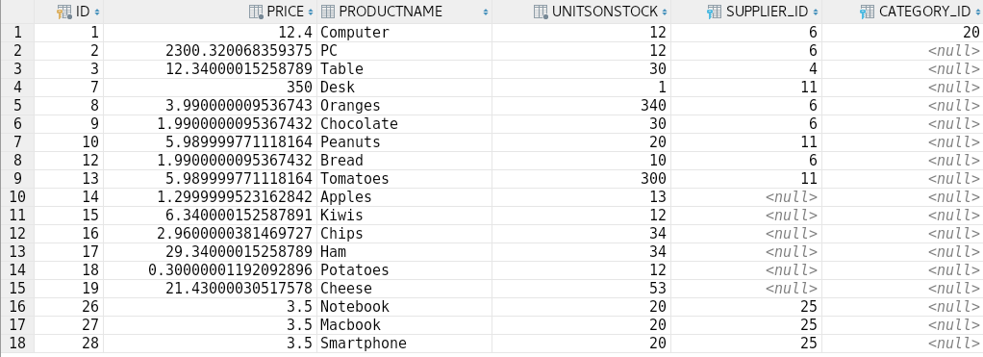
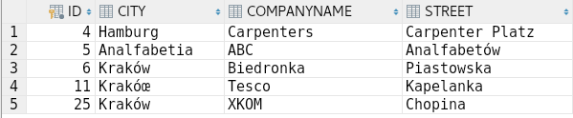
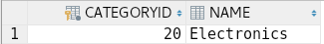

8. Relacje wiele do wielu
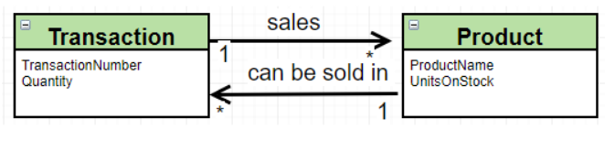

Stworzyłem model Transaction:
@Entity(name = "Transactions")
public class Transaction {
@Id
@GeneratedValue(strategy = GenerationType.AUTO)
private int id;
private int quantity;
@ManyToMany
private Set<Product> products;
public Transaction() {
}
public Transaction(int quantity) {
this.quantity = quantity;
this.products = new HashSet<>();
}
public void addProduct(Product product) {
products.add(product);
product.getTransactions().add(this);
}
public Set<Product> getProducts() {
return products;
}
@Override
public String toString() {
return String.format("Transation number: %d, Quantity: %d", id, quantity);
}
public int getId() {
return id;
}
}
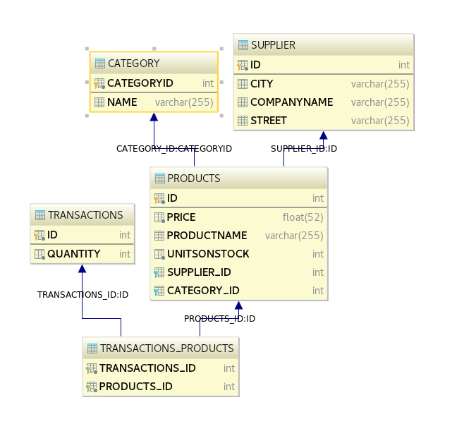

Dodanie produktów do transakcji i pobranie danych:
public static void main(final String[] args) throws Exception {
final Session session = getSession();
Transaction tx = session.beginTransaction();
domain.Transaction transaction = new domain.Transaction(3);
domain.Transaction transaction1 = new domain.Transaction(1);
session.save(transaction);
session.save(transaction1);
List<Product> productList = session
.createQuery("from Products", Product.class)
.getResultStream().limit(6).collect(Collectors.toList());
productList.forEach(product -> {
transaction.addProduct(product);
transaction1.addProduct(product);
});
Product p = session.get(Product.class, productList.get(0).getId());
p.getTransactions().forEach(System.out::println);
System.out.println();
domain.Transaction t = session.get(domain.Transaction.class, transaction.getId());
t.getProducts().forEach(System.out::println);
tx.commit();
session.close();
}
Logi:
Hibernate: create table Transactions (id integer not null, quantity integer not null, primary key (id))
Hibernate: create table Transactions_Products (transactions_id integer not null, products_id integer not null, primary key (transactions_id, products_id))
Hibernate: alter table Transactions_Products add constraint FKnm9r0f3h9sbrx6jbbv263y2t6 foreign key (products_id) references Products
Hibernate: alter table Transactions_Products add constraint FKa2t7pp8h5r02op4tcj7pwfupv foreign key (transactions_id) references Transactions
Hibernate: values next value for hibernate_sequence
Hibernate: values next value for hibernate_sequence
Hibernate: select product0_.id as id1_1_, product0_.price as price2_1_, product0_.productName as productN3_1_, product0_.SUPPLIER_ID as SUPPLIER5_1_, product0_.unitsOnStock as unitsOnS4_1_ from Products product0_
Hibernate: select supplier0_.id as id1_2_0_, supplier0_.city as city2_2_0_, supplier0_.companyName as companyN3_2_0_, supplier0_.street as street4_2_0_ from Supplier supplier0_ where supplier0_.id=?
[...]
Hibernate: select transactio0_.products_id as products2_4_0_, transactio0_.transactions_id as transact1_4_0_, transactio1_.id as id1_3_1_, transactio1_.quantity as quantity2_3_1_ from Transactions_Products transactio0_ inner join Transactions transactio1_ on transactio0_.transactions_id=transactio1_.id where transactio0_.products_id=?
Hibernate: select transactio0_.products_id as products2_4_0_, transactio0_.transactions_id as transact1_4_0_, transactio1_.id as id1_3_1_, transactio1_.quantity as quantity2_3_1_ from Transactions_Products transactio0_ inner join Transactions transactio1_ on transactio0_.transactions_id=transactio1_.id where transactio0_.products_id=?
Transation number: 33, Quantity: 3
Transation number: 34, Quantity: 1

ID: 1, Name: Computer, Units: 12, Price: 12,40
ID: 3, Name: Table, Units: 30, Price: 12,34
ID: 8, Name: Oranges, Units: 340, Price: 3,99
ID: 2, Name: PC, Units: 12, Price: 2300,32
ID: 9, Name: Chocolate, Units: 30, Price: 1,99
ID: 7, Name: Desk, Units: 1, Price: 350,00
Hibernate: insert into Transactions (quantity, id) values (?, ?)
Hibernate: insert into Transactions (quantity, id) values (?, ?)
Hibernate: insert into Transactions_Products (transactions_id, products_id) values (?, ?)
Hibernate: insert into Transactions_Products (transactions_id, products_id) values (?, ?)
[...]
Hibernate: insert into Transactions_Products (transactions_id, products_id) values (?, ?)

SELECT * FROM PRODUCTS as p
JOIN TRANSACTIONS_PRODUCTS PRODUCT ON p.ID = PRODUCT.PRODUCTS_ID
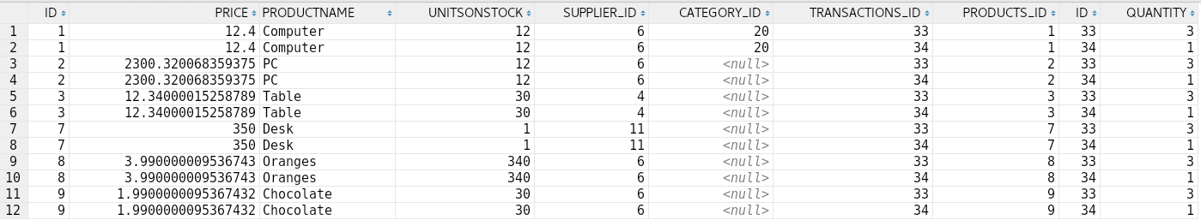
JOIN TRANSACTIONS T ON PRODUCT.TRANSACTIONS_ID = T.ID;
9. Przejście na JPA

public static void main(final String[] args) throws Exception {
EntityManagerFactory emf = Persistence
.createEntityManagerFactory("WStanekJPAPractice");
EntityManager em = emf.createEntityManager();
EntityTransaction etx = em.getTransaction();
etx.begin();
Supplier supplier = new Supplier("Komputronik", "Nie wiem", "Krak?w");
em.persist(supplier);
Product product = new Product("Notebook", 20, 3.500);
Product product1 = new Product("Macbook", 20, 3.500);
Product product2 = new Product("Smartphone", 20, 3.500);
em.persist(product);
em.persist(product1);
em.persist(product2);
supplier.addSupplied(product);
supplier.addSupplied(product1);
supplier.addSupplied(product2);
Supplier s = em.find(Supplier.class, supplier.getId());
s.getSupplies().forEach(System.out::println);
Product p = em.find(Product.class, product.getId());
System.out.println(p.getSupplier());
etx.commit();
em.close();
}
10. Kaskady:

W modelu Product:
@ManyToMany(mappedBy = "products", cascade = CascadeType.PERSIST)
private Set<Transaction> transactions;
W modelu Transaction:
@ManyToMany(cascade = CascadeType.PERSIST)
private Set<Product> products;
public static void main(final String[] args) throws Exception {
final Session session = getSession();
Transaction tx = session.beginTransaction();
domain.Transaction t = new domain.Transaction(3);
domain.Transaction t1 = new domain.Transaction(1);
Product p = new Product("Scisors", 12, 2.5);
Product p1 = new Product("Sofa", 1, 1400);
t.addProduct(p);
t.addProduct(p1);
t1.addProduct(p);
t1.addProduct(p1);
session.persist(p);
tx.commit();
session.close();
}

Logs:
Hibernate: values next value for hibernate_sequence
Hibernate: values next value for hibernate_sequence
Hibernate: values next value for hibernate_sequence
Hibernate: values next value for hibernate_sequence
Hibernate: insert into Products (price, productName, SUPPLIER_ID, unitsOnStock, id) values (?, ?, ?, ?, ?)
Hibernate: insert into Transactions (quantity, id) values (?, ?)
Hibernate: insert into Products (price, productName, SUPPLIER_ID, unitsOnStock, id) values (?, ?, ?, ?, ?)
Hibernate: insert into Transactions (quantity, id) values (?, ?)
Hibernate: insert into Transactions_Products (transactions_id, products_id) values (?, ?)
Hibernate: insert into Transactions_Products (transactions_id, products_id) values (?, ?)
Hibernate: insert into Transactions_Products (transactions_id, products_id) values (?, ?)
Hibernate: insert into Transactions_Products (transactions_id, products_id) values (?, ?)

11. Embedded i embeddable:

@Embeddable
public class Address {
private String street;
private String city;
public Address() {
}
public Address(String street, String city) {
this.street = street;
this.city = city;
}
public void setStreet(String street) {
this.street = street;
}
public void setCity(String city) {
this.city = city;
}
public String getStreet() {
return street;
}
public String getCity() {
return city;
}
}
W modelu Supplier:
@Embedded
private Address address;
public static void main(final String[] args) throws Exception {
final Session session = getSession();
Transaction tx = session.beginTransaction();
Supplier p = new Supplier("Lewiatan", "Budryka", "Krak?w");
session.persist(p);
tx.commit();
session.close();
}
Hibernate: insert into Supplier (city, street, companyName, id) values (?, ?, ?, ?)
SELECT * FROM SUPPLIER;
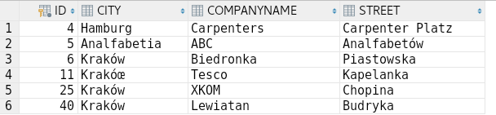
Teraz w drugą stronę:

@Entity
@SecondaryTable(name = "Address")
public class Supplier {
@Id
@GeneratedValue(strategy = GenerationType.AUTO)
private int id;
private String companyName;
@Column(table = "Address")
private String street;
@Column(table = "Address")
private String city;
@OneToMany(mappedBy = "supplier")
private Set<Product> supplies;
public Supplier() {
}
}

public static void main(final String[] args) throws Exception {
final Session session = getSession();
Transaction tx = session.beginTransaction();
Supplier p = new Supplier("?abka", "Kawiory", "Krak?w");
session.persist(p);
tx.commit();
session.close();
}
Logs:
Hibernate: create table Address (city varchar(255), street varchar(255), id integer not null, primary key (id))
Hibernate: alter table Address add constraint FKj91l3o9613sfn00sb8yj237f2 foreign key (id) references Supplier
Hibernate: values next value for hibernate_sequence
Hibernate: insert into Supplier (companyName, id) values (?, ?)
Hibernate: insert into Address (city, street, id) values (?, ?, ?)

SELECT * FROM SUPPLIER JOIN ADDRESS A ON SUPPLIER.ID = A.ID;
SELECT * FROM ADDRESS;
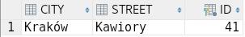
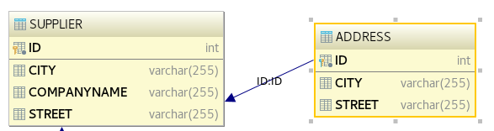

Pola CITY i STREET w tabeli Supplier pozostały z powodu wcześniejszych rekordów.

12. Dziedziczenie
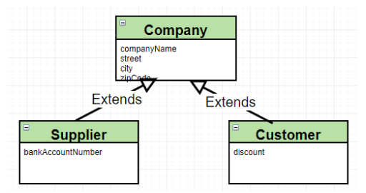
a)
@Entity
@Inheritance(strategy = InheritanceType.SINGLE_TABLE)
public class Company {
@Id
@GeneratedValue(strategy = GenerationType.AUTO)
private int id;
private String companyName;
private String street;
private String city;
private String zipCode;
public Company() {
}
public Company(String companyName, String street, String city, String zipCode) {
this.companyName = companyName;
this.street = street;
this.city = city;
this.zipCode = zipCode;
}
@Override
public String toString() {
return String.format("ID: %d, CompanyName: %s, Street: %s, City: %s, ZipCode: %s",
id, companyName, street, city, zipCode);
}
}
public static void main(final String[] args) throws Exception {
final Session session = getSession();
Transaction tx = session.beginTransaction();
Supplier s = new Supplier("B&D", "Pionowa", "Rozentown", "12-123");
Customer c = new Customer("U Krysi", "Pozioma", "Blacktown", "32-123", 23.5);
session.save(s);
session.save(c);
tx.commit();
session.close();
}
Hibernate: insert into Company (city, companyName, street, zipCode, DTYPE, id) values (?, ?, ?, ?, 'Supplier', ?)
Hibernate: insert into Company (city, companyName, street, zipCode, discount, DTYPE, id) values (?, ?, ?, ?, ?, 'Customer', ?)
SELECT * FROM COMPANY;
b)

@Entity
@Inheritance(strategy = InheritanceType.SINGLE_TABLE)
public class Company

Funkcja main zostaje taka sama

Hibernate: insert into Company (city, companyName, street, zipCode, id) values (?, ?, ?, ?, ?)
Hibernate: insert into Supplier (id) values (?)
Hibernate: insert into Company (city, companyName, street, zipCode, id) values (?, ?, ?, ?, ?)
Hibernate: insert into Customer (discount, id) values (?, ?)

SELECT * FROM COMPANY;
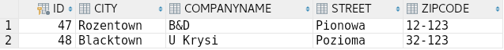
c)
@Entity
@Inheritance(strategy = InheritanceType.TABLE_PER_CLASS)
public class Company
Hibernate: create table Company (id integer not null, city varchar(255), companyName varchar(255), street varchar(255), zipCode varchar(255), primary key (id))
Hibernate: create table Customer (id integer not null, city varchar(255), companyName varchar(255), street varchar(255), zipCode varchar(255), discount double not null, primary key (id))
Hibernate: alter table APP.SUPPLIER add column zipCode varchar(255)
Hibernate: values next value for hibernate_sequence
Hibernate: values next value for hibernate_sequence
Hibernate: insert into Supplier (city, companyName, street, zipCode, id) values (?, ?, ?, ?, ?)
Hibernate: insert into Customer (city, companyName, street, zipCode, discount, id) values (?, ?, ?, ?, ?, ?)

SELECT * FROM CUSTOMER;
SELECT * FROM SUPPLIER;

