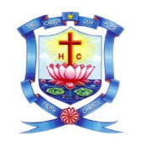
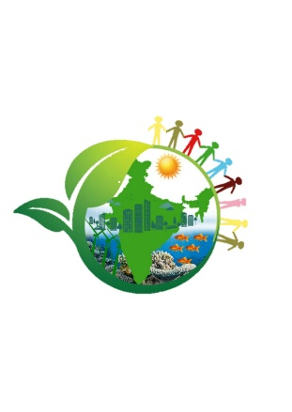

HOLY CROSS COLLEGE (AUTONOMOUS)

Affiliated to Bharathidasan University
Nationally Accredited (4thCycle) with A⁺⁺Grade
(CGPA 3.75/4) by NAAC
College with Potential for Excellence.
Tiruchirapalli - 620002

Crossian Institute for Collaborative Research on Sustainable Development
AIdeathon: Innovating for a Cleaner, Sustainable Campus

The Crossian Institute for Collaborative Research on Sustainable Development (CICRSD) organised an interdepartmental Ideation Hackathon titled “AIdeathon: Innovating for a Cleaner, Sustainable Campus” on 4th August 2025. The event provided a platform for students to present innovative ideas and prototypes focusing on sustainability and campus cleanliness through creative and technology-driven approaches. Students from various departments actively participated and showcased their problem-solving skills and interdisciplinary thinking. The programme was held in Room No. L16 and was judged by Dr. Emima Jeronsia.
Based on the creativity and feasibility of the ideas presented, prizes were awarded to the top three teams. The I Prize was secured by the II M.Sc Biotechnology team comprising Preethi C., Ramya B., and Harsini Poornima. The II Prize was awarded to the Artificial Intelligence and Machine Learning team consisting of A. Janathul Rifaya, T. Kavipriya, P. Harini, and A. Arockiya Niranjan. The III Prize was won by the III B.Sc Biotechnology team with Pavithra Babiyana Sahai R., Jaya Preethi M., and Gopikaa R. The hackathon successfully encouraged innovation, collaboration, and awareness towards sustainable development among the student community.



