Reversing and Patching Internet Download Manager

1. Objective of the Assignment
The objective of this assignment was to reverse engineer a downloader(IDM) application and modify its behavior(bypass the registration ) so that it can register and accept user through the method binary patching. The investigation will cover initial executable reconnaissance, Dynamic analysis, dynamic patching, Verification and Testing. I will investigate the target application's registration mechanism and analyze the program logic responsible for registration-related decisions. Using dynamic analysis and debugging, I will examine the relevant control flow and demonstrate the patching process required by the assignment.
Tools used
Application: IDM version 6.24, the software analized
Detector: Detect It Easy (DIE) to check the executable file
Debugger: x32dbg to observe how the program behaves during execution
Utility software: Hex editor to view the executable’s raw bytes

2. Initial Reconnaissance
I began by launching Internet download manager (IDM) version 6.42 and familiarizing myself with its primary interface. I also made visible the Registration menu so I could get acquainted with the application's registration interface.
After that, I was ready to check the IDM executable with Detect It Easy (DIE), allowing me to identify the fileformat, processor architecture, and other information of the executable.
Identifying the architecture is useful since it allows me to use the next stage's debugger accordingly. After getting the details of the executable, I can proceed with the analysis using the right x32dbg/x64dbg.

3. Dynamic Analysis
Executable Analysis Using Detect It Easy (DIE)
Step 1: First of all, I opened the IDM installation folder and found idman.exe file.
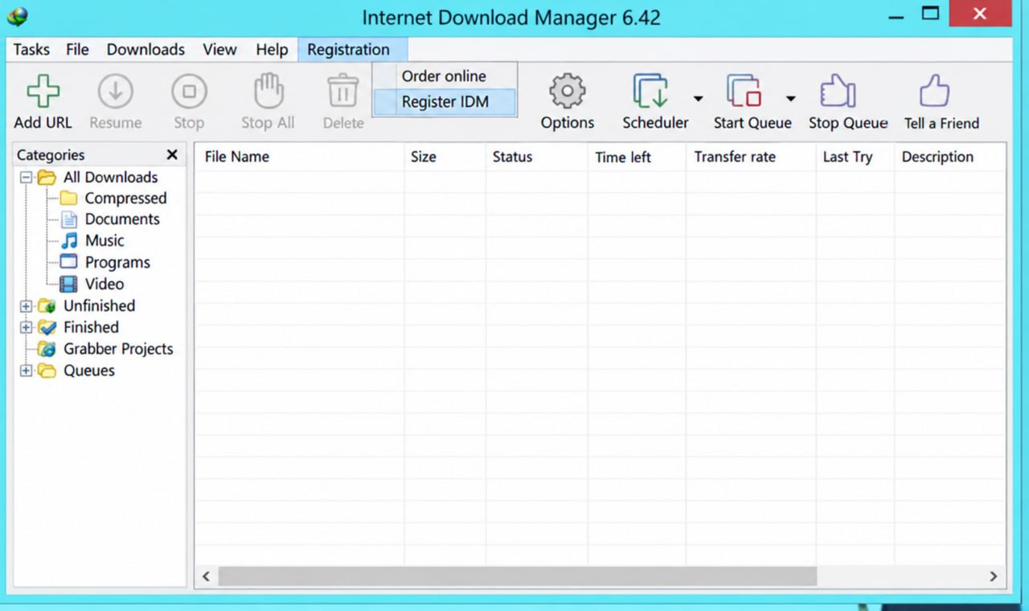
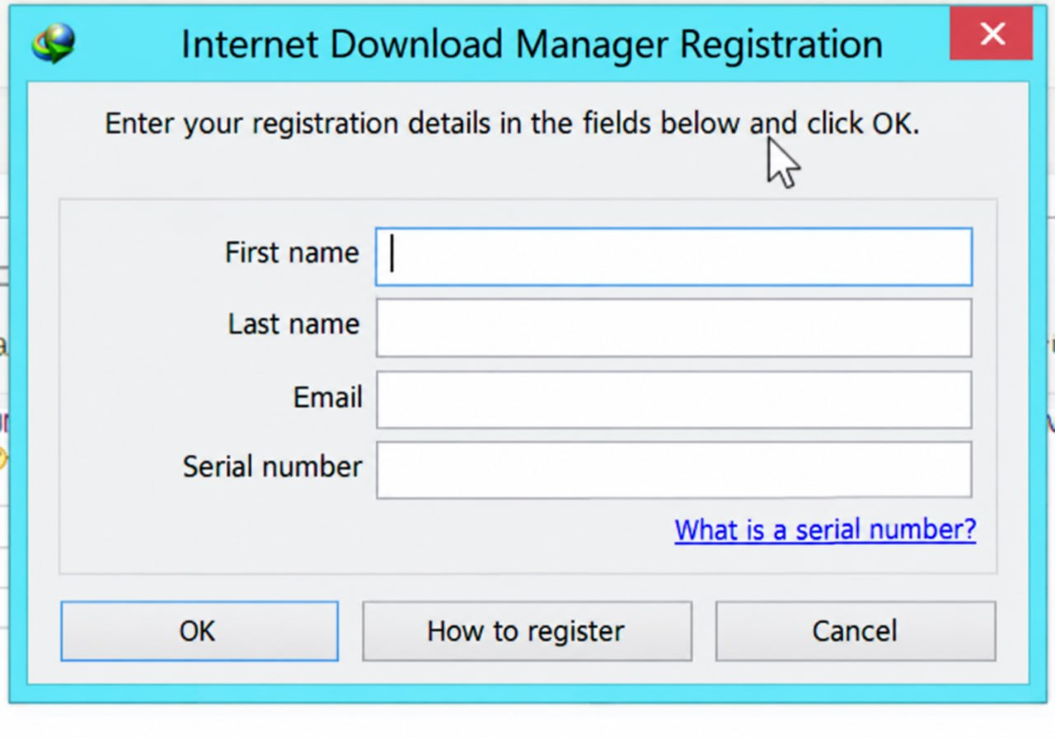

Step 2: After that, I opened the Detect It Easy(DIE), selected the file, and saw its details.
Step 3 : I looked at the information displayed by DIE such as the file format, architecture, etc. in order to know more details about the executable.
Step 4: Finally, I take a screen-shot of the result and put that as a part of my report. Thereafter I was in a position to proceed with the next step and to start analyzing the program with a debugger.
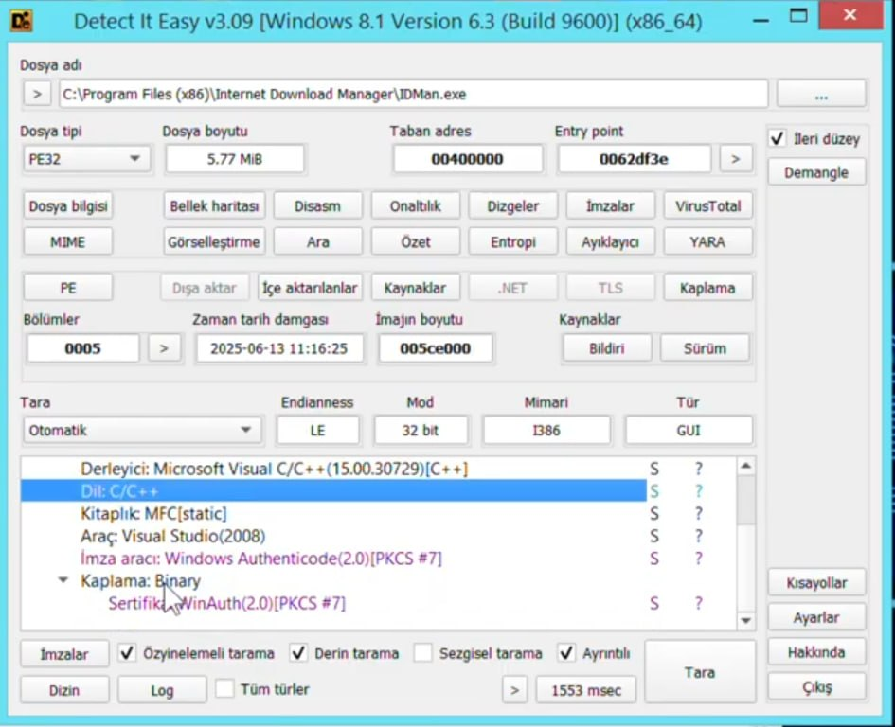

4. Dynamic Patching
Step 1: Attach the debugger
- opened x32dbg with the appropriate structure
- Attach it to the running application
- Observe the program's state when the registration dialog is displayed.
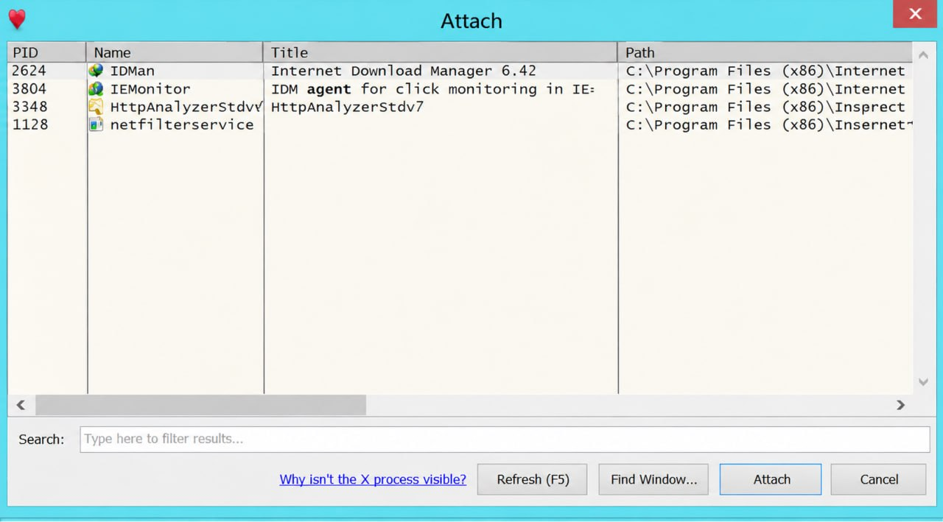

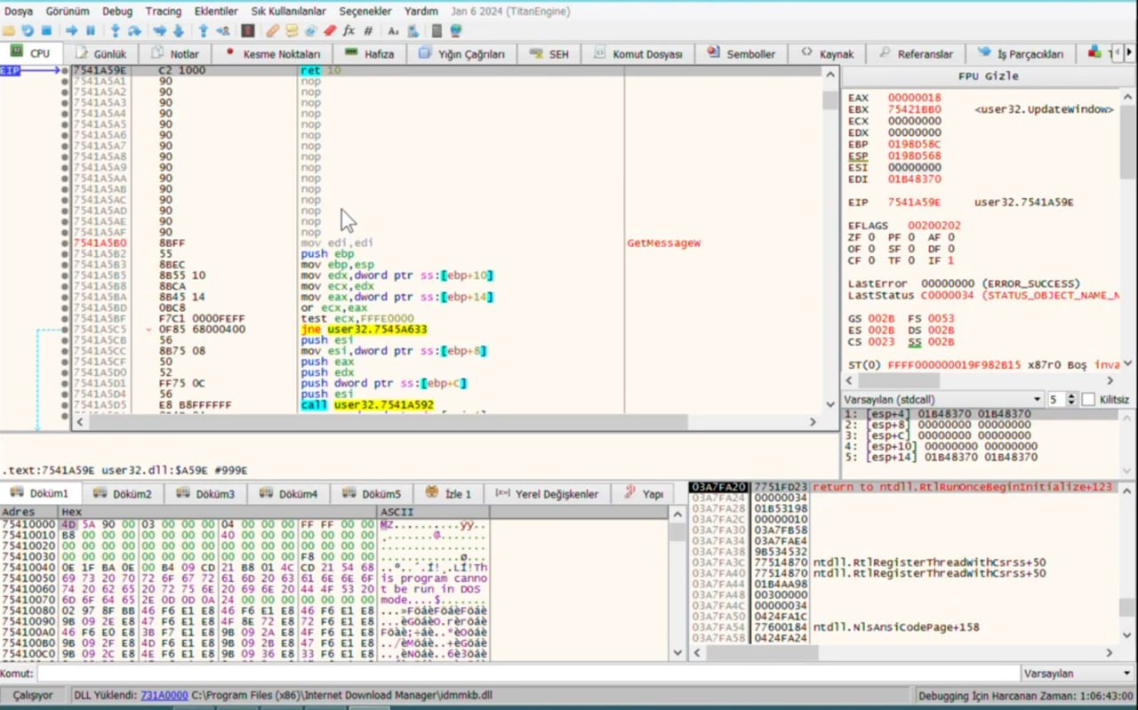
Step 2: Examine the call stack
- Open the Call Stack view.
- Examine the sequence of function calls associated with the current execution.
- Identify which modules appear in the call stack.
- Record relevant addresses and symbols for further analysis.

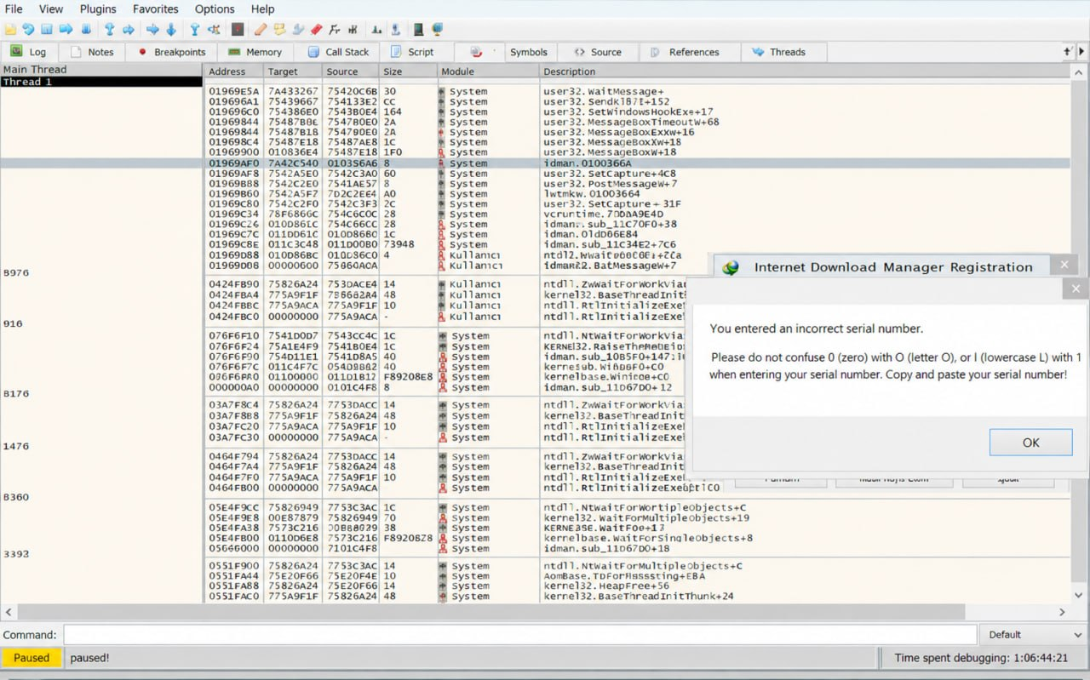

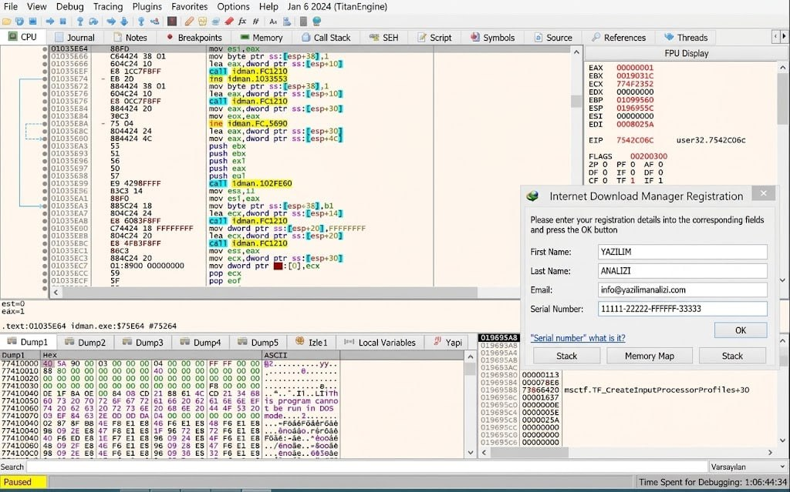
Step 4: Returning Execution to the Main Application Module
Go to debug → Run until return (Ctrl + F9)
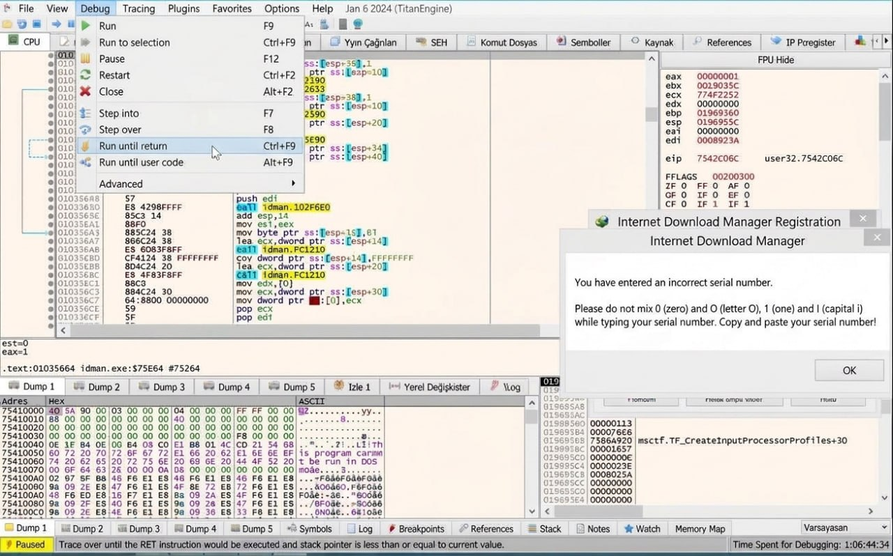
Then go back to Debug → Run until user code (Alt + F9)
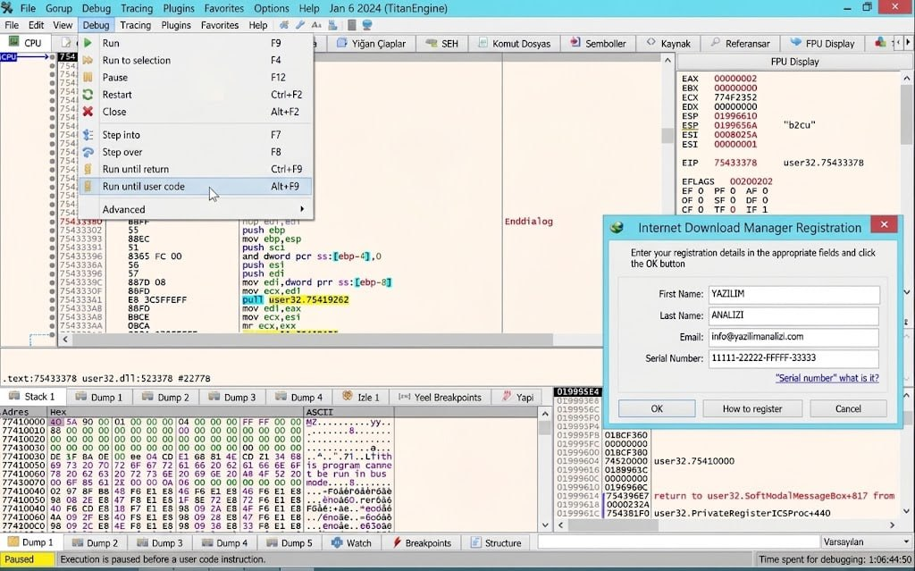

Step 5: Locate and Analyze the Registration Validation Logic in User Code
After executing Run until user code (Alt + F9), the debugger halted execution at the function prologue (push ebp at 010E3C30) inside the main executable module (idman.exe
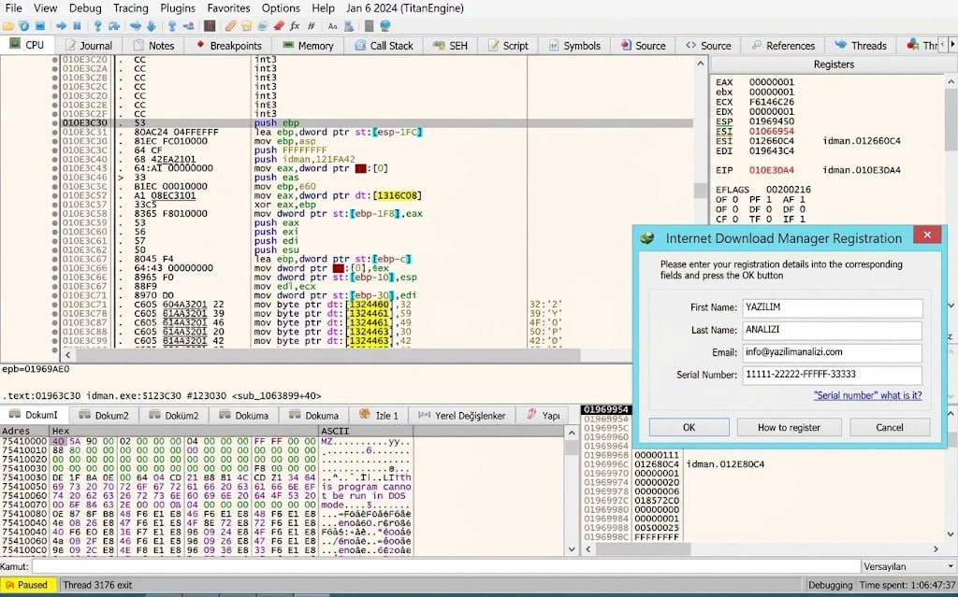
step 6: Setting Breakpoint
First I opened IDM in x32dbg, and examined the assembly instructions in the CPU panel.Then I set a breakpoint in an instruction of my choice to pause the program while running. when the program halted I examined the instructions, register values, and memory information presented in the debugger. I also observed the registration window and the error message that is displayed when the entered serial number is not correct. I got to learn about how the breakpoints work and how x32dbg can be utilized to observe a program while it is being executed, by doing so.
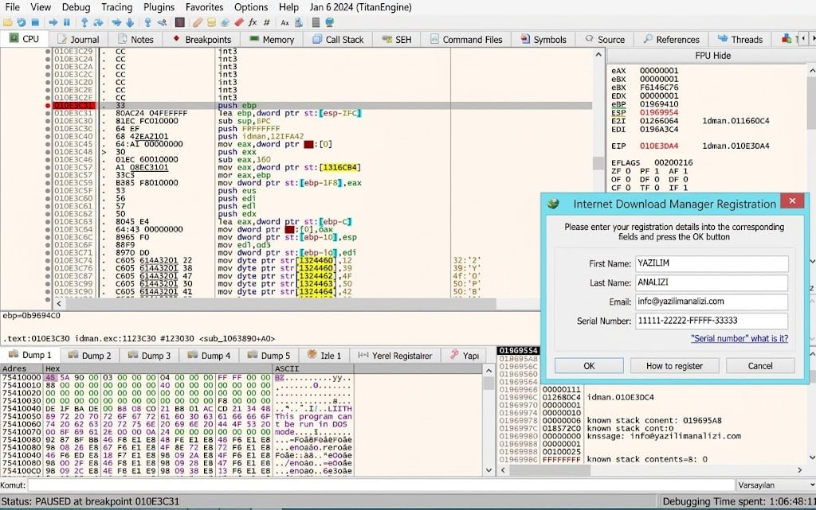
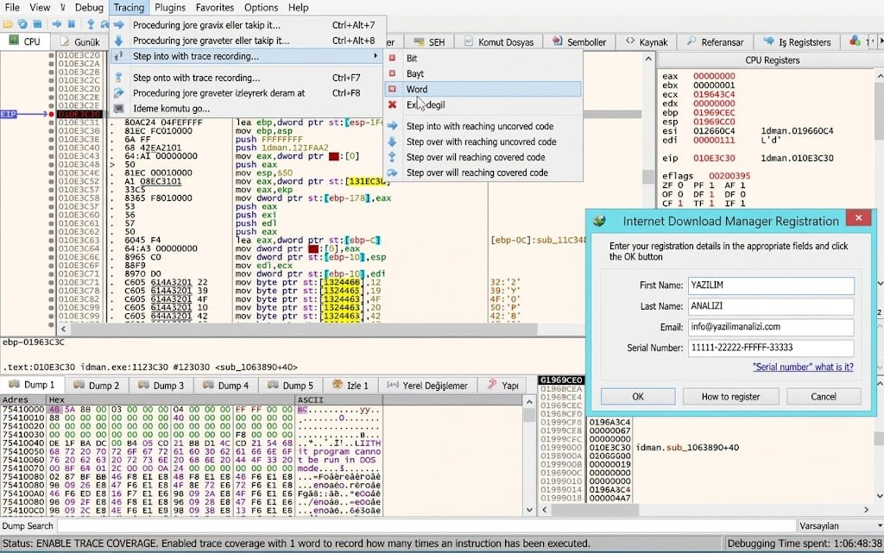
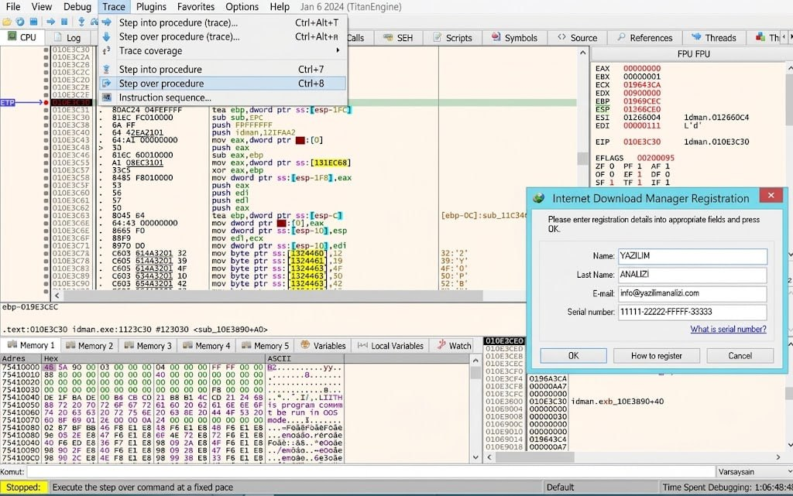

step 7:Patching the Conditional Jump (Changing jnz/jne to je)

In this step, you modified the assembly code by changing the conditional jump instruction (jnz or jne) to its opposite condition (je).
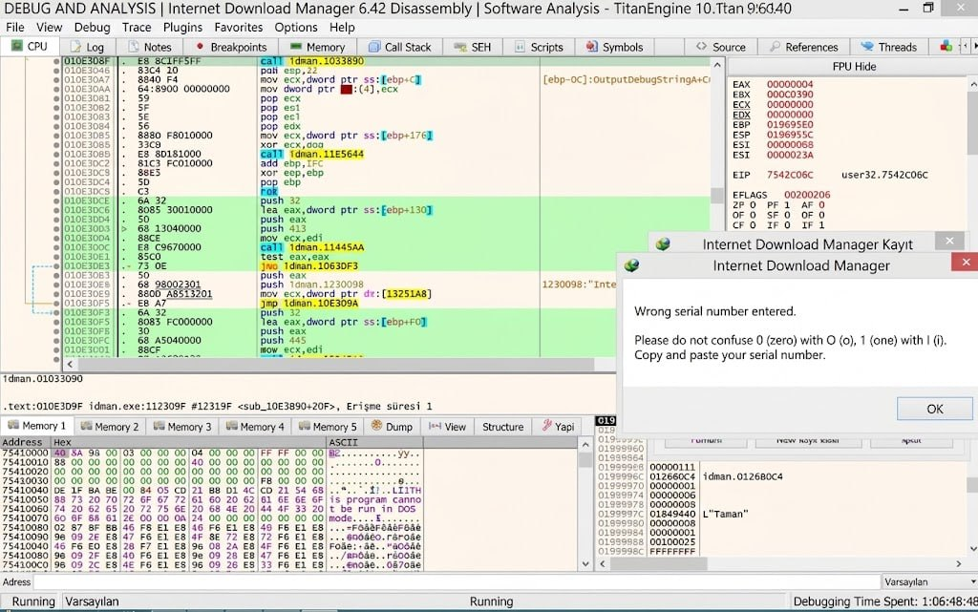
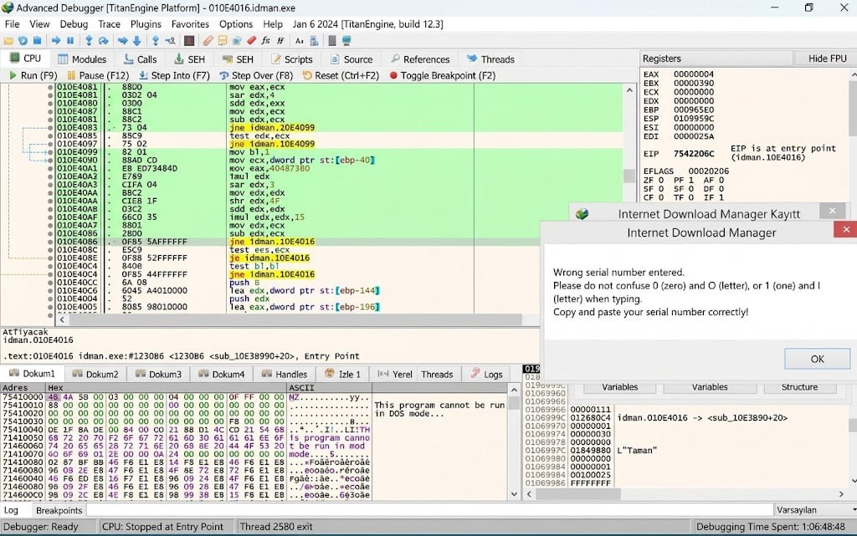
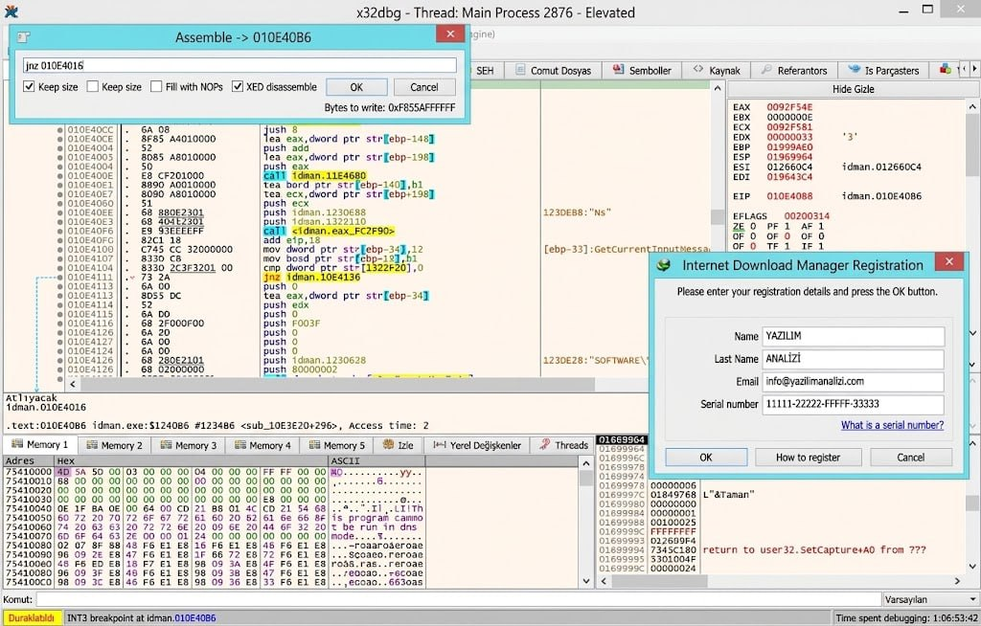
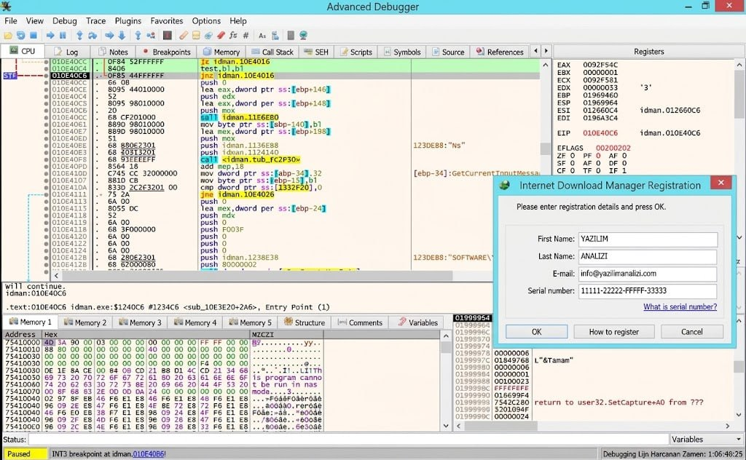

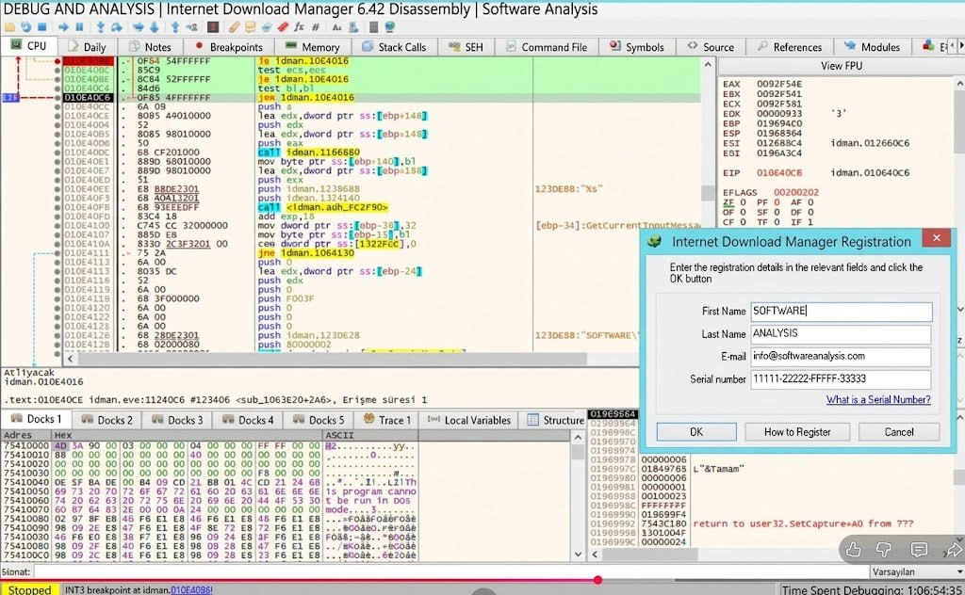
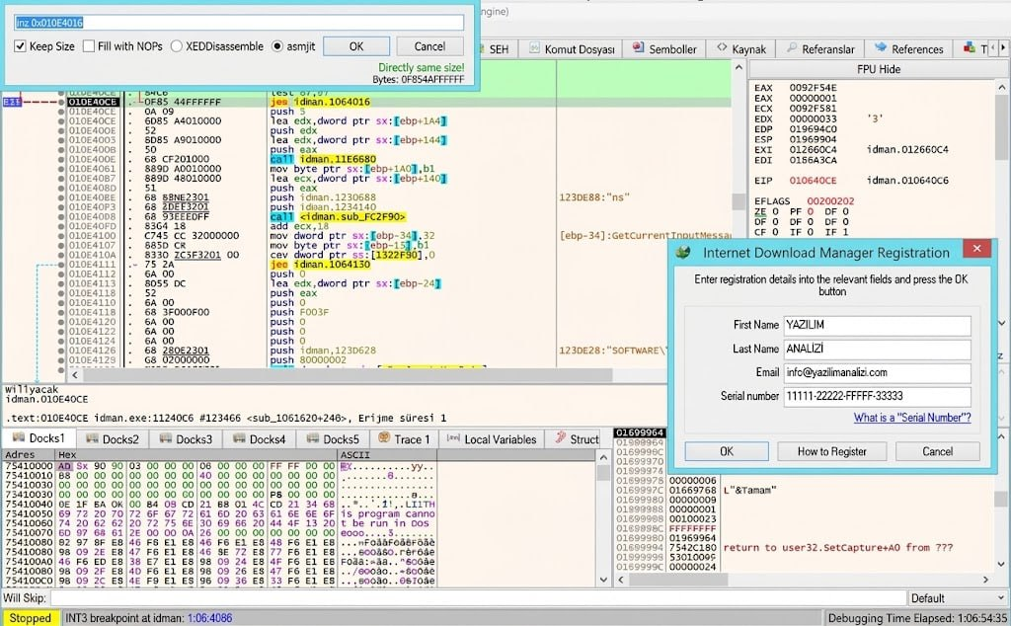

Step 8: Patching the File
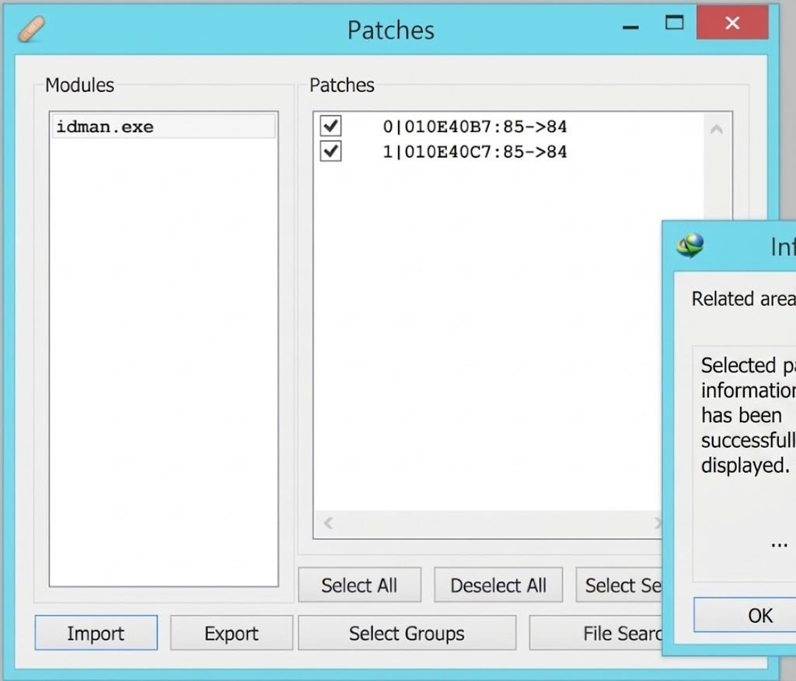
Step 9: Verification and Testing

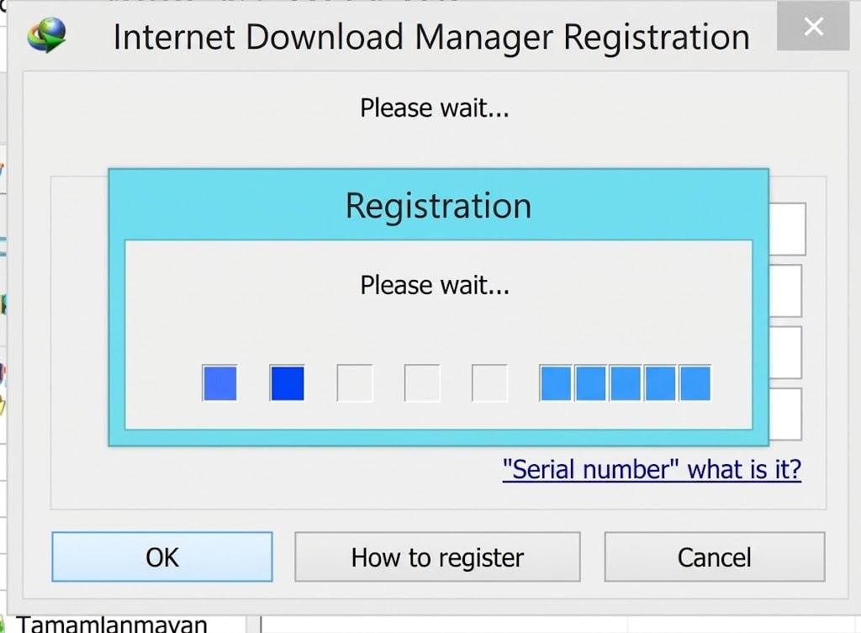
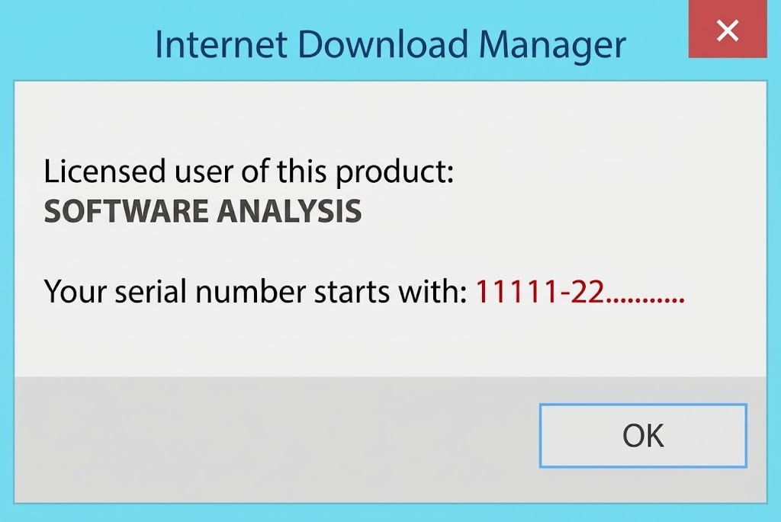
5 Conclusion
This assignment delved into the reverse engineering of Internet Download Manager (IDM) using Detect It Easy (DIE) and x32dbg. Static and dynamic analysis was used to analyze the executable, registration trace controlflow, and discover validation routines. Conditional branch modification was implemented in memory and persisted using the debugger's patching functionality, and testing using sample registration details showed the application's registration behaviour had been changed, showing the main steps of reverse engineering, dynamic patching and verification.

