Sequence diagrams for Order tracking system.

1.Track an Order

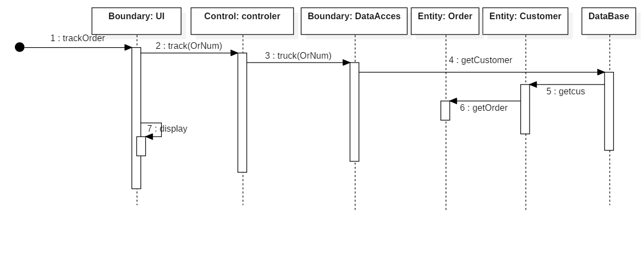

2.Generate Bill for Corporate customer

