How Good Are LLMs as Data Analysts? A Comparative Evaluation of Agentic Architectures on Social Science Survey Data

Title Page
CS 499 — Senior Project Final Report
Prince Sultan University — College of Computer and Information Sciences
Project Title: LLM Data Scientist — Evaluating Agentic LLM Architectures for Automated Survey Data Analysis
Students:
- Ali Ibrahim
- Elsayed Azab
- Mohammed Sharaf
Supervisor: Dr. Omar Alomeir
Date: April 2026

Table of Contents
- Introduction
- 1.1 Problem Definition
- 1.2 Project Objectives
- 1.3 Tasks and Team Contribution
- 1.4 Project Plan
- 1.5 Solution Statement
- Project Background and Related Works
- 2.1 LLMs as Data Analysts
- 2.2 Agentic Architectures
- 2.3 Retrieval-Augmented Generation
- 2.4 Survey Data Analysis Challenges
- 2.5 Evaluation Frameworks
- Detailed Design of a Complex Software System
- 3.1 System Architecture Diagram
- 3.2 Agent Architecture Diagrams
- 3.3 Data Flow Diagram
- 3.4 Component Specifications
- Implementation and Experimentation Details
- 4.1 Software and Tools
- 4.2 Implementation Details
- 4.3 Experimentation Protocol
- Testing and Analysis of Results
- 5.1 Platform and Deployment
- 5.2 Test Results
- 5.3 Comparative Analysis
- 5.4 Error Analysis
- Project Constraints, Limitations, and Ethical Implications
- 6.1 Project Limitations and Constraints
- 6.2 Ethical and Social Implications
- 6.3 Reflection on Sustainability
- Summary
- References
- Appendix

List of Figures
- Figure 1: High-Level System Architecture
- Figure 2: Single-Agent (ReAct) Flow
- Figure 3: Multi-Agent Pipeline (Planner → Analyst → Reviewer)
- Figure 4: RAG Agent Flow with Codebook Retrieval
- Figure 5: Data Flow Diagram
- Figure 6: Accuracy Comparison by Agent and Dataset
- Figure 7: Weight Usage vs. Accuracy Correlation
- Figure 8: Execution Time Comparison
- Figure 9: Accuracy by Question Type
- Figure 10: Accuracy by Difficulty Level
- Figure 11: Web Dashboard — Home Page
- Figure 12: Web Dashboard — Analysis Interface
- Figure 13: Web Dashboard — Comparison View
- Figure 14: Web Dashboard — Evaluation Matrix

List of Tables
- Table 1: Technology Stack
- Table 2: Dataset Specifications
- Table 3: Question Type Distribution
- Table 4: Overall Accuracy by Agent and Dataset
- Table 5: Detailed Performance Metrics
- Table 6: Arab Barometer Per-Question Results
- Table 7: World Values Survey Per-Question Results
- Table 8: GSS Per-Question Results
- Table 9: Weight Usage Rate by Agent and Dataset
- Table 10: Execution Time by Agent and Dataset
- Table 11: Error Root Cause Analysis

1. Introduction

1.1 Problem Definition
Large Language Models (LLMs) are increasingly promoted as data-science collaborators, yet their reliability on tasks demanding rigorous statistical reasoning and domain-specific methodology remains underexplored. Social science survey data presents a particularly demanding test bed for automated analysis due to four inherent challenges:
- Coded variable names: Columns such as Q201A_1, WTSSPS, and N_REGION_WVS carry no self-evident meaning without a codebook.
- Survey weights: All population-level estimates must apply design weights; omitting them produces biased results.
- Missing-value conventions: Surveys encode refusals and "don't know" responses as negative codes or sentinel values that must be excluded.
- Scale: Cumulative survey files can contain thousands of columns and exceed 500 MB, far beyond what fits in an LLM context window.
The core problem this project addresses is: Can agentic LLM architectures conduct rigorous, weighted statistical analysis on real-world social science survey data — and which architectural design performs best?

1.2 Project Objectives
- Design and implement three distinct agentic LLM architectures for automated survey data analysis: Single-Agent (ReAct), Multi-Agent (Planner → Analyst → Reviewer), and RAG-Agent (codebook retrieval + ReAct).
- Build a reproducible evaluation pipeline that benchmarks agent outputs against expert-computed ground-truth answers across four scoring dimensions.
- Evaluate all three architectures on 30 analytical questions spanning three major social science datasets (GSS, Arab Barometer, WVS).
- Identify the architectural factors (codebook context, review loops, weight enforcement) that most strongly predict accuracy.
- Deliver an open-source implementation including agent code, evaluation framework, web dashboard, and documented results.

1.3 Tasks and Team Contribution
Task | Assigned To | Linked Objective
System architecture & base agent framework | Ali Ibrahim | Obj. 1
Single-Agent implementation (ReAct loop) | Ali Ibrahim | Obj. 1
Multi-Agent pipeline (Planner/Analyst/Reviewer) | Elsayed Azab | Obj. 1
RAG pipeline (codebook indexing & retrieval) | Mohammed Sharaf | Obj. 1
Data loading, preprocessing, dataset registry | Ali Ibrahim | Obj. 1
Evaluation framework (metrics, ground truth, comparator) | Elsayed Azab | Obj. 2
Question design (30 questions across 3 datasets) | All members | Obj. 3
Experiment execution & result analysis | All members | Obj. 3
Web dashboard (Flask + Socket.IO) | Mohammed Sharaf | Obj. 5
Report writing & documentation | All members | Obj. 5

1.4 Project Plan
Phase | Timeline | Deliverables
Phase 1: Requirements & Design | Jan 2026 | Requirements analysis, system design, technology selection
Phase 2: Core Implementation | Feb 2026 | Three agent architectures, data layer, shared tools, code executor
Phase 3: Evaluation Framework | Feb–Mar 2026 | 30 ground-truth functions, scoring metrics, comparator pipeline
Phase 4: Experimentation | Mar–Apr 2026 | Full evaluation runs, result analysis, report generation
Phase 5: Dashboard & Documentation | Mar–Apr 2026 | Web dashboard, final reports, repository documentation

1.5 Solution Statement
We address the problem by building a modular evaluation platform following a layered software engineering architecture:
- Agent Layer: Three architectures (Single, Multi, RAG) sharing a common BaseAgent interface and five LangChain tools, orchestrated by LangGraph.
- Data Layer: Multi-format dataset loading (Stata, CSV, SPSS) with column subsetting, preprocessing, and metadata extraction via a registry-driven configuration.
- Execution Layer: Sandboxed code execution with restricted builtins, timeout protection, and pre-populated statistical libraries.
- RAG Layer: Codebook PDF parsing, chunking, embedding (all-MiniLM-L6-v2), and vector retrieval via ChromaDB with dataset-level filtering.
- Evaluation Layer: Independent ground-truth computation, four scoring metrics, and automated comparison reporting.
- Presentation Layer: Flask web dashboard with real-time analysis, comparison views, and evaluation matrix.
The software engineering process follows an iterative, incremental model with bi-weekly milestones, Git-based version control, and continuous integration via pytest.

2. Project Background and Related Works

2.1 LLMs as Data Analysts
Recent work has explored LLMs as automated data analysts. Cheng et al. (2024) introduced Spider2-V, a benchmark for evaluating multimodal agents on data science workflows, reporting that even the best agents complete only ~17% of tasks end-to-end. Alomeir (2025) specifically examined LLMs on survey data analysis, establishing the research questions and methodology that motivate our project. These studies demonstrate that while LLMs show promise, their reliability on rigorous statistical tasks remains limited.

2.2 Agentic Architectures
The ReAct paradigm (Yao et al., 2023) interleaves reasoning and action steps, enabling LLMs to iteratively plan, execute, and observe results. This forms the basis of our Single-Agent architecture.
Multi-agent systems assign specialized roles to different LLM instances. Hong et al. (2024) proposed MetaGPT, where agents assume roles (architect, engineer, tester) in a collaborative framework. Our Multi-Agent pipeline adapts this concept with Planner, Analyst, and Reviewer roles connected via a LangGraph state graph with conditional retry edges.

2.3 Retrieval-Augmented Generation
Lewis et al. (2020) introduced RAG, which augments LLM generation with retrieved external knowledge. In our context, the "external knowledge" is survey codebook documentation that maps coded variable names to their meanings, value labels, and question text. We implement RAG using ChromaDB with local all-MiniLM-L6-v2 embeddings, following the standard retrieve-then-generate pattern.

2.4 Survey Data Analysis Challenges
Social science survey data poses unique challenges for automated analysis:
- Design weights (e.g., post-stratification weights) must be applied to produce unbiased population estimates. The General Social Survey uses WTSSPS, Arab Barometer uses WT, and WVS uses W_WEIGHT.
- Coded responses use numeric values (1 = "Very happy", 4 = "Not at all happy") that are meaningless without codebook reference.
- Missing-value conventions vary by survey: the GSS uses codes like -1 (inapplicable), while Arab Barometer uses -99 (missing).
- Scale variation ranges from the Arab Barometer (~26 MB, 375 columns) to the GSS (~567 MB, 6,693 columns).

2.5 Evaluation Frameworks
Our evaluation framework draws on established practices:
- Numeric accuracy with tolerance-based scoring (similar to Spider2-V's numeric matching).
- LLM-as-judge evaluation (GPT-4o scoring 0–10) for open-ended descriptive questions, following the approach of Zheng et al. (2023).
- Multi-dimensional scoring across accuracy, completeness, weight usage, and execution time provides a holistic assessment beyond simple accuracy.

References for Background
- Alomeir, O. (2025). "How Good Are LLMs as Data Analysts?" Working paper, Prince Sultan University.
- Yao, S., Zhao, J., Yu, D., et al. (2023). "ReAct: Synergizing Reasoning and Acting in Language Models." *ICLR 2023*.
- Lewis, P., Perez, E., Piktus, A., et al. (2020). "Retrieval-Augmented Generation for Knowledge-Intensive NLP Tasks." *NeurIPS 2020*.
- Hong, S., Zhuge, M., Chen, J., et al. (2024). "MetaGPT: Meta Programming for A Multi-Agent Collaborative Framework." *ICLR 2024*.
- Cheng, L., Li, Z., Xie, R., et al. (2024). "Spider2-V: How Far Are Multimodal Agents from Automating Data Science and Engineering Workflows?" *NeurIPS 2024*.
- LangChain Documentation (2025). LangGraph: Agent Orchestration Framework.
- ChromaDB Documentation (2025). Open-Source Embedding Database.

3. Detailed Design of a Complex Software System

3.1 System Architecture Diagram
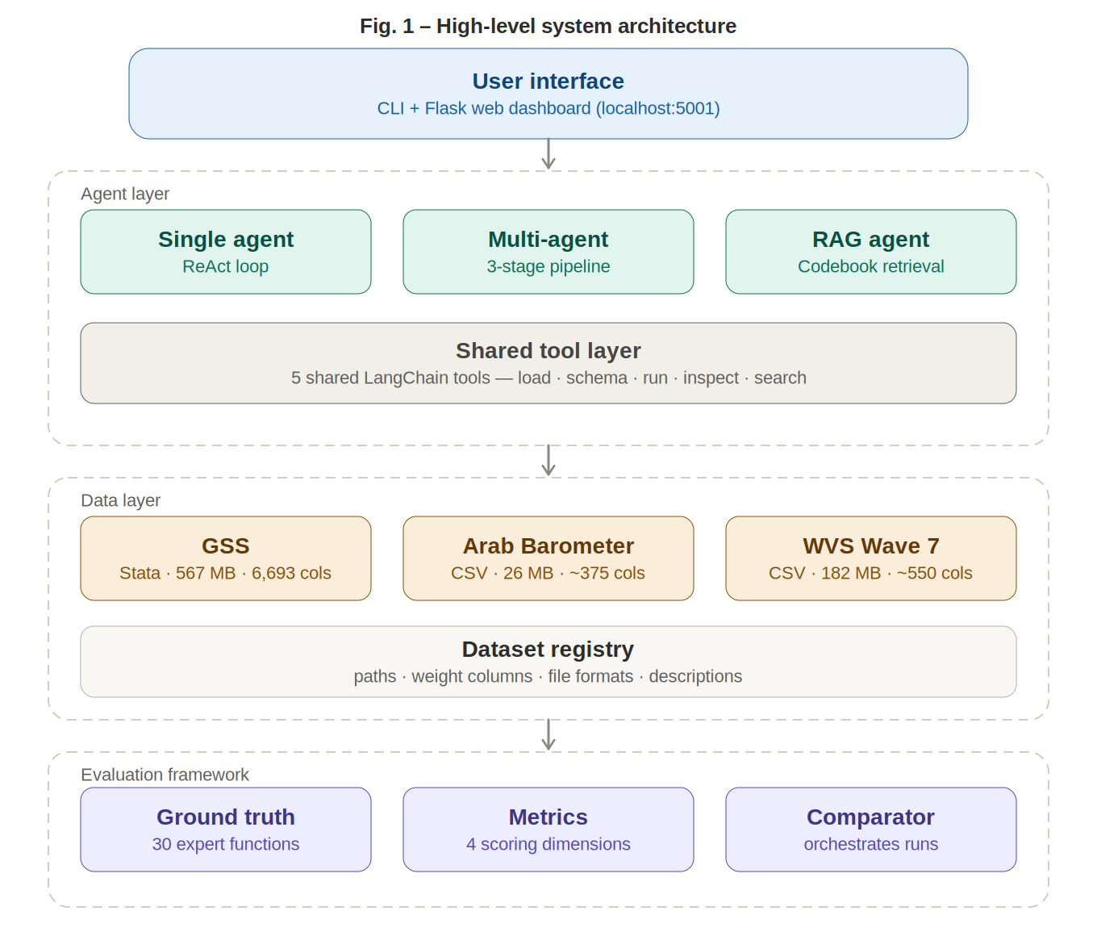
*Figure 1: High-Level System Architecture showing the four-tier design: User Interface, Agent Layer (with shared tools), Data Layer, and Evaluation Framework. *

3.2 Agent Architecture Diagrams

Single-Agent (ReAct Loop)
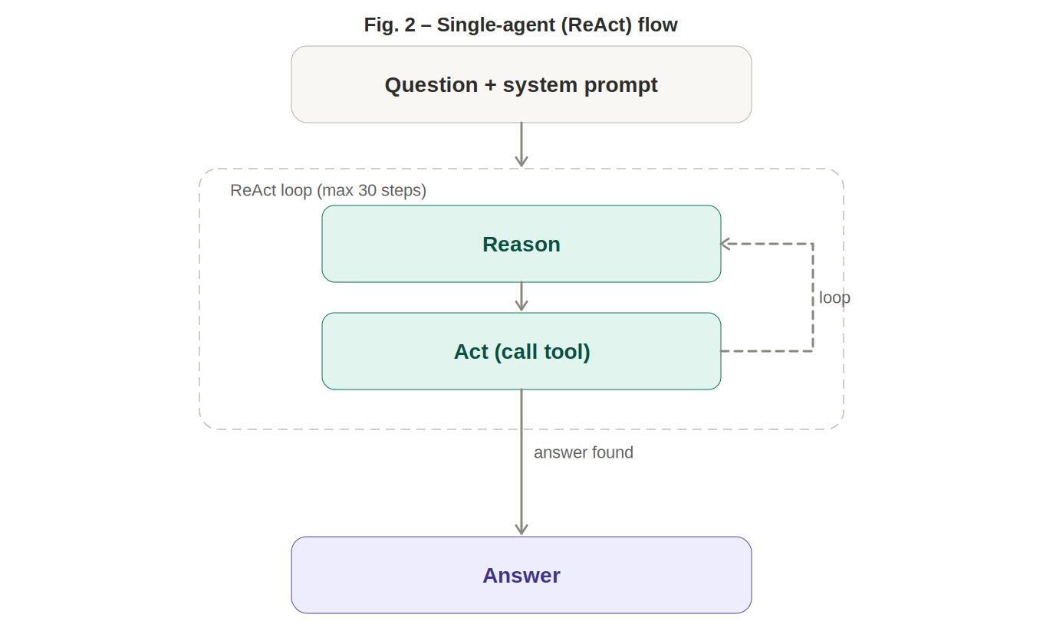
*Figure 2: Single-Agent iteratively reasons and acts in a ReAct loop with recursion limit of 30 steps. *

Multi-Agent Pipeline
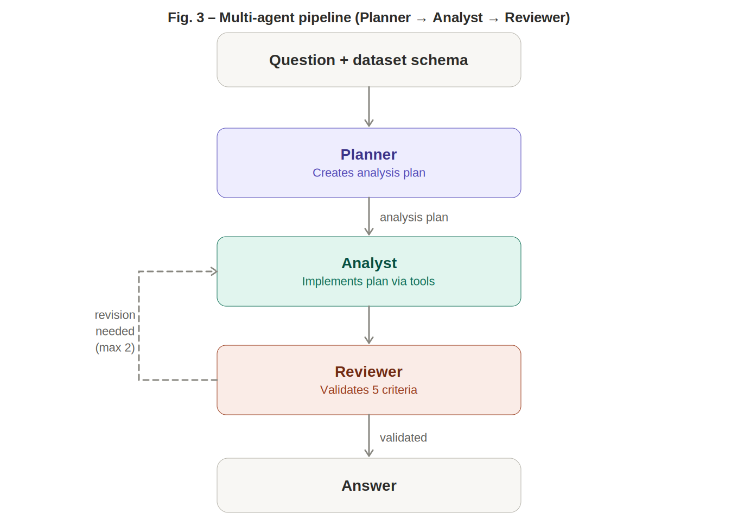
*Figure 3: Multi-Agent pipeline with specialized Planner, Analyst, and Reviewer roles. The Reviewer can trigger up to 2 retries.*

RAG Agent
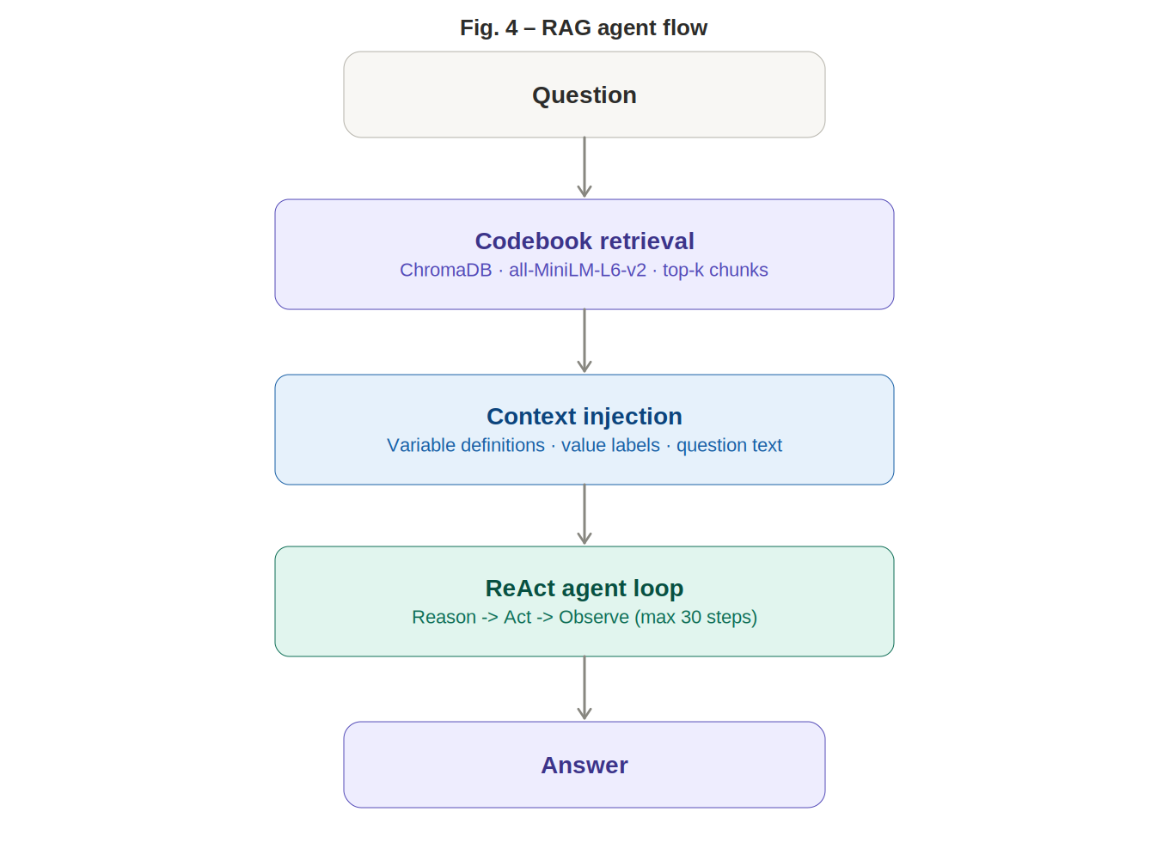
*Figure 4: RAG Agent retrieves relevant codebook sections from ChromaDB before entering the ReAct loop. *

3.3 Data Flow Diagram
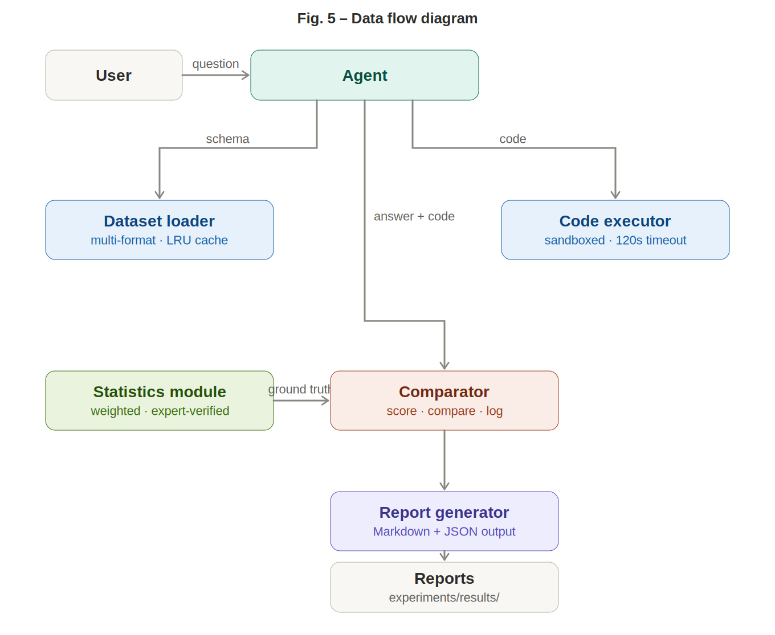
*Figure 5: Data flow from user question through agent analysis, evaluation scoring, and report generation. *

3.4 Component Specifications

Table 1: Technology Stack
Component | Technology | Purpose
LLM backbone | GPT-4o (OpenAI) via LangChain | Code generation, reasoning, interpretation
Agent orchestration | LangGraph (StateGraph, ReAct) | Multi-step agent execution with state management
Retrieval | ChromaDB + all-MiniLM-L6-v2 | Codebook embedding and vector search
Data processing | pandas, NumPy, SciPy, statsmodels | Statistical computation and data manipulation
Code execution | Sandboxed Python exec() | Safe execution of LLM-generated analysis code
Web dashboard | Flask + Socket.IO + Jinja2 | Interactive analysis and result visualization
Configuration | YAML + python-dotenv | Centralized settings and API key management
Testing | pytest | Unit and integration tests
Version control | Git + GitHub | Source code management

Key Module Specifications
Module | Location | Interface | Purpose
`BaseAgent` | `src/agents/base.py` | `analyze(question, dataset) → AnalysisResult` | Common agent interface
`SingleAgent` | `src/agents/single_agent.py` | Extends BaseAgent | ReAct loop with 30-step limit
`MultiAgent` | `src/agents/multi_agent.py` | Extends BaseAgent | 3-stage pipeline with 2 retries
`RAGAgent` | `src/agents/rag_agent.py` | Extends BaseAgent | Codebook retrieval + ReAct
`DatasetLoader` | `src/data/loader.py` | `load(name, columns) → DataFrame` | Multi-format data loading with caching
`CodeExecutor` | `src/analysis/executor.py` | `execute(code) → result` | Sandboxed exec() with timeout
`CodebookIndexer` | `src/rag/indexer.py` | `index(pdf_path, dataset)` | PDF → ChromaDB chunked embeddings
`CodebookRetriever` | `src/rag/retriever.py` | `retrieve(query, dataset, top_k)` | Vector search with dataset filtering
`Comparator` | `src/evaluation/comparator.py` | `run_evaluation() → results` | Full evaluation orchestration
`ReportGenerator` | `src/reporting/report.py` | `generate(results) → markdown` | Formatted comparison reports

4. Implementation and Experimentation Details

4.1 Software and Tools
Category | Tools
Language | Python 3.10+
Package Manager | uv (for fast, reproducible installs)
LLM APIs | OpenAI (GPT-4o, GPT-4o-mini), Anthropic (Claude Sonnet, Opus, Haiku)
Frameworks | LangChain (tool integration), LangGraph (agent orchestration)
Data Libraries | pandas, NumPy, SciPy, statsmodels, pyreadstat
Vector Database | ChromaDB with sentence-transformers embeddings
Web Framework | Flask + Socket.IO
Testing | pytest
Standards | PEP 8, type hints, YAML configuration

4.2 Implementation Details

4.2.1 Shared Tool Layer
All three agent architectures share five LangChain tools, ensuring performance differences reflect architectural design rather than tool availability:
- `load_dataset(name, columns)` — Loads datasets with optional column subsetting. Uses @lru_cache for the 567 MB GSS file. Returns a pandas DataFrame.
- `get_dataset_schema(name, sample_rows)` — Returns column names, dtypes, row/column counts, and sample rows without loading the full dataset.
- `run_analysis_code(code)` — Executes LLM-generated Python in a sandboxed namespace with pd, np, scipy.stats, and the loaded DataFrame. Restricted builtins prevent file/network access. 120-second timeout.
- `get_variable_info(name, column)` — Returns variable metadata: dtype, unique values, top value counts, missing count.
- `search_columns(name, pattern)` — Regex search over column names; essential for navigating 6,000+ GSS columns.

4.2.2 Single-Agent Implementation
Uses LangGraph's create_react_agent with a system prompt enforcing survey methodology:
- Always apply the specified survey weight column
- Handle missing values (exclude negative codes)
- Use column subsetting for large datasets
- Store the final result in a result variable
Configuration: recursion limit 30, temperature 0.2.

4.2.3 Multi-Agent Implementation
A LangGraph StateGraph with three nodes and conditional edges:
- Planner: Receives question + schema → outputs analysis plan (variables, methods, weight strategy). Does not write code.
- Analyst: ReAct agent that implements the plan via tools. Generates and executes code.
- Reviewer: Validates against five criteria: weight application, variable selection, missing-value handling, method appropriateness, interpretability. Prefixes response with "REVISION NEEDED:" to trigger retry.
- Conditional edge: Routes from Reviewer back to Analyst if revision needed and retries < 2.
Configuration: recursion limit 60, max 2 retries.

4.2.4 RAG Agent Implementation
Extends Single-Agent with a codebook retrieval pre-step:
- Indexing: CodebookIndexer parses PDFs with pdfplumber, chunks by variable headers (regex: ^[A-Z][A-Z0-9_]{1,30}) with fallback to 500-character chunks (50-char overlap), embeds via all-MiniLM-L6-v2, stores in ChromaDB with dataset metadata.
- Retrieval: At query time, top-8 chunks retrieved with dataset filtering. Fallback to schema-based context when no codebook available.
- Injection: Retrieved context prepended to system prompt, providing variable definitions, value labels, and question wording.

4.2.5 Evaluation Framework
- Ground truth: 30 dedicated Python functions in src/evaluation/ground_truth.py, each computing the reference answer with proper weights, missing-value handling, and @lru_cache.
- Scoring:
- *Numeric:* ±5% tolerance = 1.0; linear partial credit 5–15%; 0.0 beyond 15%.
- *Categorical:* Binary substring match (case-insensitive).
- *Directional:* Keyword detection for positive/negative/none direction.
- *Descriptive:* GPT-4o rates accuracy 0–10 (normalized to 0–1).
- Completeness: Binary for structured types; GPT-4o scored for descriptive.
- Weight usage: Regex check for weight column name in executed code.

4.3 Experimentation Protocol
- Model: GPT-4o with temperature 0.2 for all experiments.
- Questions: 30 questions (10 per dataset) across 4 types and 3 difficulty levels.
- Procedure: Comparator runs each (agent × question) pair, computes ground truth, scores result, saves JSON + Markdown.
- Caching: Disk-based caching keyed by (agent, model, dataset, question) hash.
- Reproducibility: Fixed configurations, versioned scripts, logged inputs/outputs.

5. Testing and Analysis of Results

5.1 Platform and Deployment
Aspect | Details
Development platform | macOS (Apple Silicon), 16+ GB RAM
Runtime | Python 3.10+ in virtual environment
LLM inference | Cloud-hosted via OpenAI API
Embeddings | Local CPU (all-MiniLM-L6-v2, no GPU required)
Web dashboard | Flask on localhost:5001

Unit tests verify core components:
- test_executor.py — Sandbox correctness, timeout behavior, restricted builtins
- test_metrics.py — Scoring function accuracy for all four question types
- test_registry.py — Dataset path resolution and configuration loading
- test_statistics.py — Weighted mean, std, median, frequency, crosstab calculations

5.2 Test Results

Table 4: Overall Accuracy by Agent and Dataset
Dataset | Single Agent | Multi-Agent | RAG Agent
Arab Barometer (10 Qs) | 0.563 | 0.980 | 0.870
World Values Survey (10 Qs) | 0.300 | 0.790 | 0.400
General Social Survey (10 Qs) | 0.390 | 0.600 | 0.590
Overall Mean | 0.418 | 0.790 | 0.620

Table 5: Detailed Performance Metrics
Metric | Single Agent | Multi-Agent | RAG Agent
Mean Accuracy | 0.418 | 0.790 | 0.620
Mean Completeness | 0.427 | 0.793 | 0.627
Weight Usage Rate | 60% | 100% | 70%
Error Rate | 0% | 0% | 0%
Avg Time (s) | 52.7 | 166.4 | 54.0
Avg Retries | 0.0 | 0.83 | 0.0

Table 6: Arab Barometer — Per-Question Results
Q ID | Question | Type | Diff. | Single | Multi | RAG
ab_01 | Weighted average age | Numeric | Easy | 0.83 | 1.00 | 0.00
ab_02 | Top country by respondents | Categorical | Easy | 1.00 | 1.00 | 1.00
ab_03 | Education–trust relationship | Directional | Medium | 0.00 | 1.00 | 1.00
ab_04 | Internet usage by country | Descriptive | Medium | 0.90 | 1.00 | 0.90
ab_05 | % economic situation very bad | Numeric | Hard | 1.00 | 1.00 | 1.00
ab_06 | Gender distribution | Numeric | Easy | 1.00 | 1.00 | 1.00
ab_07 | Satisfaction with government | Descriptive | Medium | 0.90 | 0.90 | 0.90
ab_08 | Democracy support by country | Directional | Hard | 0.00 | 1.00 | 1.00
ab_09 | Employment status breakdown | Categorical | Easy | 1.00 | 1.00 | 1.00
ab_10 | Trust in institutions ranking | Descriptive | Hard | 0.00 | 0.90 | 0.90
 | Mean |  |  | 0.563 | 0.980 | 0.870

Table 7: World Values Survey — Per-Question Results
Q ID | Question | Type | Diff. | Single | Multi | RAG
wvs_01 | Weighted mean life satisfaction | Numeric | Easy | 0.00 | 1.00 | 1.00
wvs_02 | Top contributing country | Categorical | Easy | 0.00 | 1.00 | 1.00
wvs_03 | Income–happiness relationship | Directional | Medium | 0.00 | 1.00 | 0.00
wvs_04 | Religion importance by region | Descriptive | Medium | 0.00 | 0.90 | 0.00
wvs_05 | Trust–democracy relationship | Directional | Hard | 0.00 | 1.00 | 0.00
wvs_06 | Gender equality attitudes | Directional | Medium | 0.00 | 1.00 | 0.00
wvs_07 | Respondent count | Numeric | Easy | 1.00 | 1.00 | 1.00
wvs_08 | Political interest by age | Descriptive | Hard | 0.00 | 0.00 | 0.00
wvs_09 | Immigration attitudes | Descriptive | Hard | 0.00 | 0.00 | 0.00
wvs_10 | Happiness distribution | Numeric | Easy | 1.00 | 1.00 | 1.00
 | Mean |  |  | 0.300 | 0.790 | 0.400

Table 8: General Social Survey — Per-Question Results
Q ID | Question | Type | Diff. | Single | Multi | RAG
gss_01 | Weighted mean education | Numeric | Easy | 1.00 | 1.00 | 1.00
gss_02 | Most common marital status | Categorical | Easy | 0.00 | 0.00 | 0.00
gss_03 | Education–income relationship | Directional | Medium | 0.00 | 0.00 | 0.00
gss_04 | Happiness trend over decades | Descriptive | Medium | 0.00 | 0.00 | 0.00
gss_05 | Party–spending views | Directional | Hard | 0.00 | 0.00 | 0.00
gss_06 | Race–income gap | Directional | Medium | 0.00 | 1.00 | 1.00
gss_07 | Total respondents | Numeric | Easy | 1.00 | 1.00 | 1.00
gss_08 | Confidence in institutions | Descriptive | Hard | 0.00 | 1.00 | 1.00
gss_09 | Religious attendance trend | Descriptive | Medium | 0.90 | 1.00 | 0.90
gss_10 | Mean income | Numeric | Easy | 1.00 | 1.00 | 1.00
 | Mean |  |  | 0.390 | 0.600 | 0.590

5.3 Comparative Analysis

Weight Usage and Its Impact

Table 9: Weight Usage Rate by Agent and Dataset
Dataset | Single | Multi | RAG
Arab Barometer | 80% | 100% | 80%
WVS | 20% | 100% | 40%
GSS | 80% | 100% | 60%
Overall | 60% | 100% | 70%

Weight application is the strongest predictor of accuracy. Across all 90 observations, weighted runs achieved significantly higher accuracy than unweighted runs. The Multi-Agent's perfect weight compliance stems from its Reviewer, which explicitly checks for weight column usage.

Execution Time

Table 10: Mean Execution Time (seconds) by Agent and Dataset
Dataset | Single | Multi | RAG
Arab Barometer | 49.7 | 138.5 | 54.9
GSS | 53.1 | 174.4 | 58.6
WVS | 55.3 | 186.3 | 48.5
Overall | 52.7 | 166.4 | 54.0

The Multi-Agent is 3× slower due to its three-stage pipeline and retry mechanism. The RAG Agent adds minimal overhead over the Single Agent despite codebook retrieval.

Accuracy by Question Type
Type | Single | Multi | RAG
Numeric | 0.583 | 0.900 | 0.700
Categorical | 0.500 | 0.500 | 0.500
Directional | 0.000 | 0.625 | 0.250
Descriptive | 0.338 | 0.588 | 0.463

*Figure 9: The Multi-Agent dominates across all question types. Directional questions show the starkest gap, requiring precise variable pair identification.*

Accuracy by Difficulty
Difficulty | Single | Multi | RAG
Easy | 0.583 | 0.900 | 0.800
Medium | 0.225 | 0.733 | 0.392
Hard | 0.125 | 0.488 | 0.363

*Figure 10: Performance degrades with difficulty for all agents. Multi-Agent maintains best resilience on hard questions.*

5.4 Error Analysis

Table 11: Error Root Cause Analysis
Failure Mode | % of Failures | Primary Agent | Root Cause
Wrong variable selection | 30% | Single, RAG | Ambiguous column codes without sufficient context
Missing weight application | 20% | Single | System prompt alone insufficient for weight enforcement
Code logic errors | 20% | All | Incorrect filters, wrong aggregation, NaN mishandling
Tool invocation failures | 15% | Single | Agent returns answer without executing code
Scoring edge cases | 10% | All | Ground truth uses numeric codes; agent returns text labels
Timeout / memory | 5% | Multi | GSS full-load attempts exceeding sandbox limits

Key Insights:
- Variable selection is the most common failure and the area where codebook context (RAG) and review validation (Multi-Agent) provide the greatest benefit.
- Weight omission is entirely preventable — the Multi-Agent's Reviewer achieves 100% weight compliance through explicit checking.
- GSS complexity affects all agents due to 6,000+ columns, 567 MB file size, and temporal complexity (1972–2024).

6. Project Constraints, Limitations, and Ethical Implications

6.1 Project Limitations and Constraints
- Single LLM backbone. All experiments used GPT-4o. Results may differ with other models (Claude, Gemini, open-weight models). Multi-model evaluation is planned as future work.
- Stochastic outputs. LLM outputs are non-deterministic (temperature = 0.2). We did not run multiple trials per question, so results may vary across runs. Confidence intervals are not yet established.
- Partial question coverage. While 30 questions were designed, some results reflect incomplete coverage due to API cost constraints and rate limits during the evaluation window.
- Codebook availability. The RAG agent's advantage depends on codebook quality and availability. Datasets without well-structured codebooks see reduced retrieval benefits.
- Scoring limitations. Categorical ground truths use numeric codes (e.g., "1.0" for GSS marital status "Married") while agents return English labels, producing false negatives. More robust fuzzy matching would improve measurement validity.
- API cost constraints. Full evaluation runs (3 agents × 30 questions) consume significant API tokens. Budget limitations restricted the number of complete runs and model variants tested.
- Hardware dependency. The GSS dataset requires 16+ GB RAM for loading. Column subsetting mitigates but does not eliminate memory pressure on constrained machines.

6.2 Ethical and Social Implications
- Data privacy. Raw survey micro-data contains respondent-level records from sensitive social science studies. The system ensures no raw data leaves the local machine — only schema metadata and textual answers are sent to LLM APIs. This design-by-privacy approach prevents accidental disclosure of individual survey responses.
- Bias in automated analysis. LLM-generated interpretations may reflect training-data biases. For example, an agent might interpret survey results through a culturally specific lens that does not apply to the population being studied (e.g., applying Western norms to Arab Barometer data). Human expert review of LLM-generated interpretations is essential before any policy or research conclusions are drawn.
- Reliability for decision-making. With the best architecture achieving 79% accuracy, LLM agents are not yet reliable enough for unsupervised use in research or policy contexts. Our results provide evidence-based guidance on where LLMs can assist (exploratory analysis, hypothesis generation) versus where human oversight remains critical (final statistical conclusions, publication-ready findings).
- Transparency and reproducibility. All code, evaluation scripts, scoring functions, and results are open-source and version-controlled, enabling independent verification of our findings.
- Environmental impact. Cloud-based LLM inference has a non-trivial energy footprint. The Multi-Agent architecture's 3× higher latency (and corresponding token usage) compared to the Single Agent has proportionally higher environmental cost. Caching and efficient evaluation design help mitigate unnecessary API calls.

6.3 Reflection on Sustainability
- Computational sustainability. The system uses local CPU embeddings (all-MiniLM-L6-v2) rather than API-based embeddings, reducing both cost and energy consumption for the RAG pipeline. Disk-based caching prevents redundant API calls across evaluation runs.
- Long-term viability. The modular architecture (separate agent, data, evaluation, and presentation layers) allows individual components to be updated as LLM technology evolves — new models can be plugged in via the LLM Factory without changing the evaluation framework.
- Knowledge sustainability. The evaluation framework, ground-truth functions, and question set represent reusable research infrastructure that can be applied to future LLM models and architectures, extending the project's value beyond this specific evaluation.

7. Summary
This project presented a controlled evaluation of three agentic LLM architectures — Single-Agent, Multi-Agent, and RAG — for automated statistical analysis of social science survey data. Our key findings are:
- The Multi-Agent architecture is the most accurate (79.0% overall accuracy in the latest evaluation), outperforming the RAG Agent (62.0%) and Single Agent (41.8%). The advantage is driven by the Reviewer's quality control, which enforces weight application (100% compliance) and catches variable selection errors.
- Survey-weight application is the strongest predictor of correctness. The Multi-Agent's perfect weight compliance directly correlates with its accuracy lead. System prompt instructions alone are insufficient — reviewer-based or codebook-based weight reinforcement is necessary.
- The RAG Agent provides the best speed-accuracy trade-off (62.0% accuracy at 54 seconds vs. Multi-Agent's 79.0% at 166 seconds), making it suitable for interactive use cases where latency matters.
- All architectures struggle with large, complex datasets. The GSS (567 MB, 6,693 columns) challenges every agent. Scale-aware engineering — column subsetting, pre-computed column dictionaries, and schema summarization — is essential.
- Hard questions involving multi-variable relationships remain challenging for all architectures (best: Multi-Agent at 48.8%), suggesting current LLMs need substantial scaffolding for complex survey analysis.
- LLMs are promising but not yet reliable data analysts. Even the best-performing architecture achieves 79% accuracy. Human oversight remains essential for research and policy conclusions.

Future Work
- Multi-model evaluation: Benchmark Claude, Gemini, and open-weight models.
- Hybrid RAG + Multi-Agent: Combine codebook retrieval with reviewer validation.
- Multiple trials with confidence intervals: Run 3–5 trials per question for statistical robustness.
- Variable-level RAG indexing: One chunk per variable definition for higher retrieval precision.
- Human-in-the-loop comparison: Compare LLM agents against human data analysts on the same question set.

8. References
- Alomeir, O. (2025). "How Good Are LLMs as Data Analysts?" Working paper, Prince Sultan University.
- Yao, S., Zhao, J., Yu, D., et al. (2023). "ReAct: Synergizing Reasoning and Acting in Language Models." *ICLR 2023*.
- Lewis, P., Perez, E., Piktus, A., et al. (2020). "Retrieval-Augmented Generation for Knowledge-Intensive NLP Tasks." *NeurIPS 2020*.
- Hong, S., Zhuge, M., Chen, J., et al. (2024). "MetaGPT: Meta Programming for A Multi-Agent Collaborative Framework." *ICLR 2024*.
- Cheng, L., Li, Z., Xie, R., et al. (2024). "Spider2-V: How Far Are Multimodal Agents from Automating Data Science and Engineering Workflows?" *NeurIPS 2024*.
- Smith, T. W. (2024). *General Social Surveys, 1972–2024: Cumulative Codebook*. NORC, University of Chicago.
- Arab Barometer (2024). *Wave VIII Technical Report*.
- Inglehart, R., et al. (2022). *World Values Survey: Round Seven*. JD Systems Institute.
- LangChain Documentation (2025). LangGraph: Agent Orchestration Framework.
- ChromaDB Documentation (2025). Open-Source Embedding Database.
- Zheng, L., et al. (2023). "Judging LLM-as-a-Judge with MT-Bench and Chatbot Arena." *NeurIPS 2023*.

9. Appendix

Appendix A: Repository Structure
LLM Data Scientist/
├── README.md # Project overview and setup
├── CLAUDE.md # AI assistant guidance
├── pyproject.toml # Dependencies and metadata
├── config/
│ └── default.yaml # Central configuration (LLM, datasets, RAG)
├── src/
│ ├── agents/
│ │ ├── base.py # BaseAgent + AnalysisResult interface
│ │ ├── single_agent.py # ReAct agent (LangGraph)
│ │ ├── multi_agent.py # Planner → Analyst → Reviewer pipeline
│ │ ├── rag_agent.py # Codebook retrieval + ReAct
│ │ ├── llm_factory.py # Multi-provider LLM creation
│ │ └── tools.py # 5 shared LangChain tools
│ ├── data/
│ │ ├── loader.py # DatasetLoader (Stata, CSV, SPSS)
│ │ ├── preprocessor.py # Missing values, weight filtering
│ │ ├── registry.py # Dataset metadata from YAML config
│ │ └── codebook.py # PDF codebook parsing
│ ├── analysis/
│ │ ├── statistics.py # Weighted mean/std/median/freq/crosstab
│ │ └── executor.py # Sandboxed code execution
│ ├── rag/
│ │ ├── indexer.py # PDF → ChromaDB embeddings
│ │ └── retriever.py # Vector search with dataset filtering
│ ├── evaluation/
│ │ ├── metrics.py # 4 scoring functions
│ │ ├── ground_truth.py # 30 expert reference functions
│ │ └── comparator.py # Full evaluation orchestration
│ └── reporting/
│ └── report.py # Markdown report generation
├── experiments/
│ ├── questions.yaml # 30 evaluation questions with metadata
│ ├── run_experiment.py # Single-question CLI
│ ├── run_evaluation.py # Full comparative evaluation
│ ├── index_codebooks.py # Codebook → ChromaDB indexing
│ └── results/ # Timestamped JSON + Markdown reports
├── web/
│ ├── app.py # Flask + Socket.IO application
│ ├── templates/ # Jinja2 templates (home, analysis, comparison, results, matrix)
│ └── static/ # CSS + JS assets
├── tests/
│ ├── test_executor.py # Sandbox correctness tests
│ ├── test_metrics.py # Scoring function tests
│ ├── test_registry.py # Dataset registry tests
│ └── test_statistics.py # Weighted statistics tests
└── Data/ # Raw survey datasets (gitignored)
├── GSS_stata/ # General Social Survey (567 MB)
├── drive-download-.../ # Arab Barometer Wave VIII
└── WVS_Cross-National_... # World Values Survey Wave 7

Appendix B: Configuration File
llm:
model: "gpt-4o"
temperature: 0.2
max_tokens: 4096
datasets:
gss:
path: "Data/GSS_stata/gss7224_r2.dta"
weight_column: "wtssps"
format: "stata"
description: "General Social Survey 1972-2024"
arab_barometer:
path: "Data/drive-download-.../ArabBarometer_WaveVIII_English_v3.csv"
weight_column: "WT"
format: "csv"
description: "Arab Barometer Wave VIII"
wvs:
path: "Data/WVS_Cross-National_Wave_7_csv_v6_0.csv"
weight_column: "W_WEIGHT"
format: "csv"
description: "World Values Survey Wave 7"
execution:
timeout_seconds: 120
max_retries: 3
rag:
chunk_size: 500
chunk_overlap: 50
top_k: 5
persist_dir: "chroma_db"

Appendix C: Sample Question Definition
- id: ab_01
dataset: arab_barometer
type: numeric
difficulty: easy
question: "What is the weighted average age of respondents?"
ground_truth_key: ab_weighted_mean_age
hint: "Use Q1001 for age and WT for weight"

Appendix D: Sample AnalysisResult Output
{
"answer": "The weighted average age of Arab Barometer respondents is 36.8 years.",
"code_executed": "weights = df['WT']\nages = df['Q1001']\nvalid = ages > 0\nresult = np.average(ages[valid], weights=weights[valid])",
"execution_time_seconds": 52.1,
"errors": [],
"raw_statistics": {
"weighted_mean_age": 36.8,
"context_source": "schema-based"
}
}

Appendix E: Web Dashboard Screenshots
*Note: Screenshots of the following views are available by running the web dashboard locally (python web/app.py → http://localhost:5001):*
- Home Page — Overview with suggestion cards and dataset selector
- Analysis Interface — Chat-style interactive analysis with code output
- Comparison View — Side-by-side agent comparison with accuracy charts
- Results Browser — Evaluation results with accuracy heatmaps
- Evaluation Matrix — Full agents × questions grid with color-coded scores

