Installing and opening MobiQ project in Eclipse

1. To open project in eclipse (Luna), go to File> import

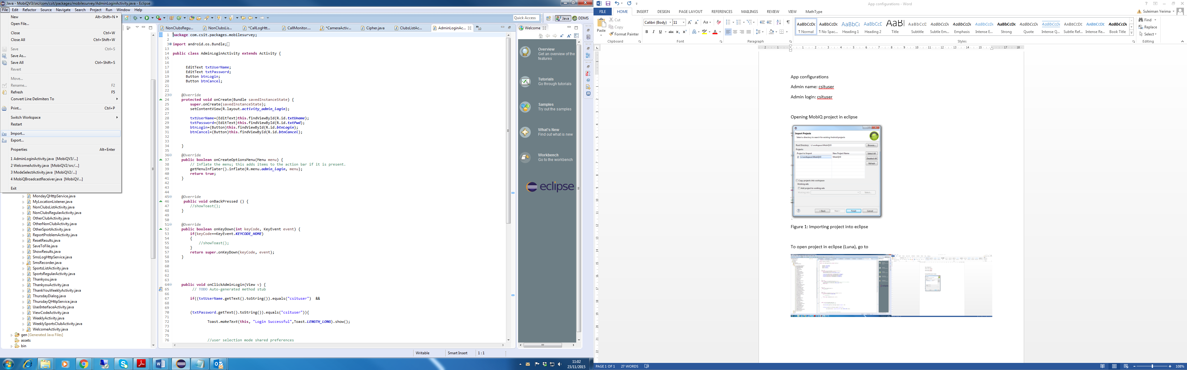

Fig 1: Go to File> import

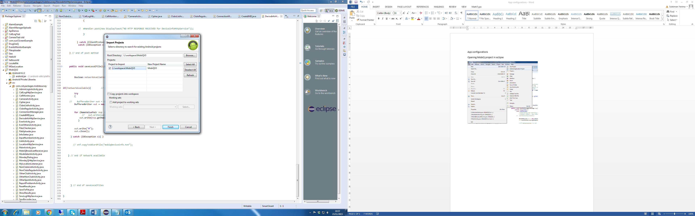

Figure 2: Importing project into eclipse

2. Browse to the root directory and select MobiQV3

3. You can change the project name to one of your choice.

4. Select finish

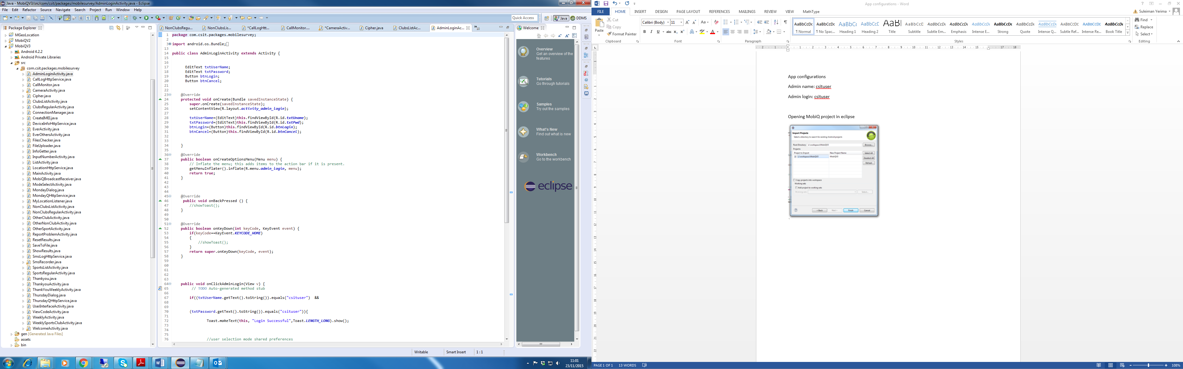

Fig 3: MobiQ project opened in Eclipse