Distributing Applications as Executable (*.exe) Files

This feature is required to
- Get High performance (No compiling time)
- Protect your source code
- Distribute an easy to use software

Practical Steps:-

  - Run the application (YourFileName.nova) to get a generated object file (YourFileName.nova.star)
  - Create new folder (Myapp as example)
  - Copy the generated object file YourFileName.nova.Star to this new folder (Myapp)
  - Copy nova.exe to this new folder (Myapp)
  - Rename YourFileName.nova.Star file to YourApplicationName.Star
  - Rename nova.exe file to YourApplicationName.exe
  - Distribute this new folder (Myapp) to your Customers/Friends
  - What they need is to Run YourApplicationName.exe
  - That is all, Have Fun!!

The idea is simple and clear, when you run Supernova Interpreter (nova.exe)
After renaming it to (YourApplicationName.exe) the interpreter will try to find a file
Carry the name YourApplicationName.star to load and execute.

Example:-

- Run Samples\DateAndTime\Flash.nova

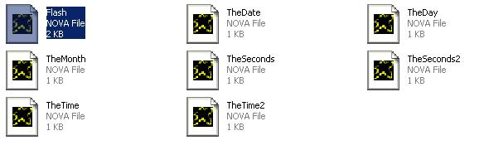
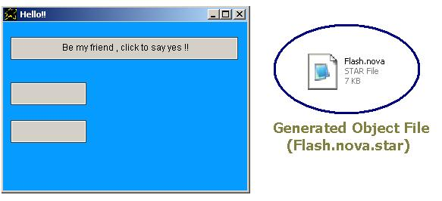
- Create new folder then copy Flash.nova.star & Nova.exe to this folder

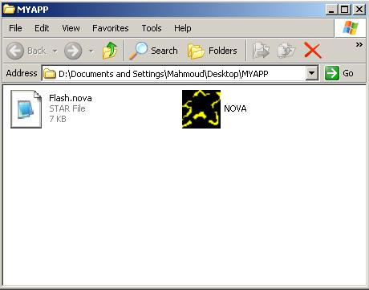
- Rename Flash.nova.star to Flash.star
- Rename NOVA.exe to Flash.exe
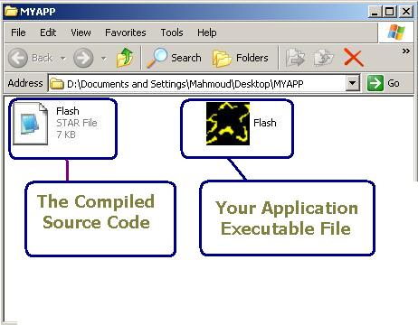
- Run Flash.exe (No Loading… Message appears, Have Fun!!)

