How to use the language interpreter?

The First method:-

1 - Run Nova.exe
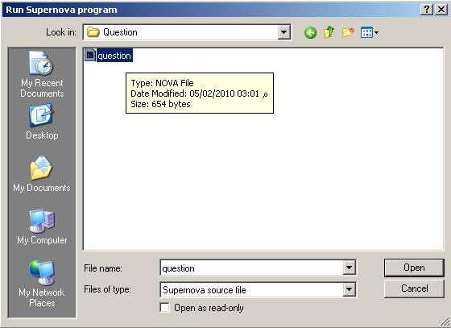

2 - Select any filename.nova to RUN!!!

The Second method:-

1 - Select any "filename.nova"
2 - Right click using the mouse.
3 - Select "Open With".
4 - Select "Choose program".
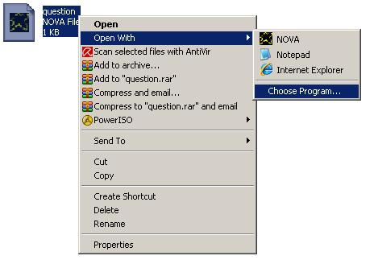
5 - Click Browse.
6 - Select the file "Nova.exe"
7 - Click Ok.
8 - Enable "Always use the selected program to open
This kind of files"
9 - Click ok.
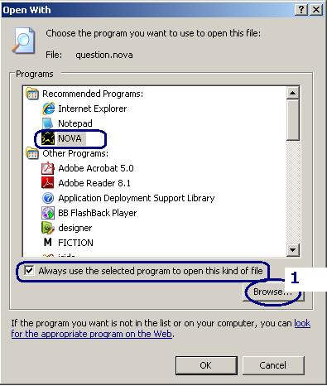
10- At any time Double Click filename.nova to RUN !!

