PWCT & ADO (ActiveX Data Object) - Lesson [3]
This lesson include :-
- Design a search form
- Connect to access database using ADO
- Search for records
- Show search results

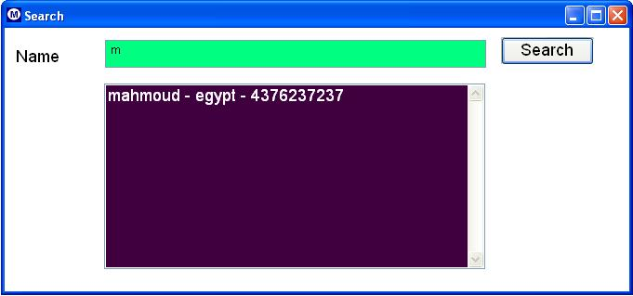

Final Steps Tree

The First Step
Define Window ( win1 )
Window Events
Window Properties
Window Controls
Define Label ( lbl1 )
Label Events
Label Properties
Define TextBox ( textName )
TextBox EVENTS
TextBox Properties
Define New Button ( btn1 )
Button Events
Event: ON CLICK
Button Properties
Define New ListBox ( list1 )
ListBox Event
ListBox Properties
End Of Window
Activate window
Procedure
Define Procedure search
Code Block
cName = win1.textName.Value
oCon = Create New ADODB Connection
Open ADODB Connection oCon , Connection String : Initial Catalog=data.mdb'
oRS = Create New ADODB RecordSet Object
Open Recordset oRS , Connection oCon , CursorType 1 , SQL Statement "Select * from tel where name like '" + cName + "%'"
mymax := ADODB RecordSet (oRS) , Get Records Count
win1.list1.DeleteAllItems ( )
IF ( mymax > 0 )
Code Block
FOR LOOP ( From x = 1 To mymax Step 1)
Code Block
vname = ADODB RecordSet (oRS) Get Field ("name") Value
vaddress = ADODB RecordSet (oRS) Get Field ("address") Value
vphone = ADODB RecordSet (oRS) Get Field ("phone") Value
win1.list1.AddItem ( vName + " - " + vAddress + " - " + vPhone )
ADODB RecordSet oRS - Goto Next Record
End of For Loop
ELSE
Code Block
Show Message "Record not found" Title "Sorry" Type: Message Box
END OF IF STATEMENT
End of Procedure

Implementation Steps

