**JBlock2D Guide – Version 1.0**

This is a short how-to on how to use version 1.0 of the JBlock2D custom pattern drafting software.

**Step 1** – Navigate to the download location found on Github, [link here](https://github.com/aharwood2/JBlock2D/releases).

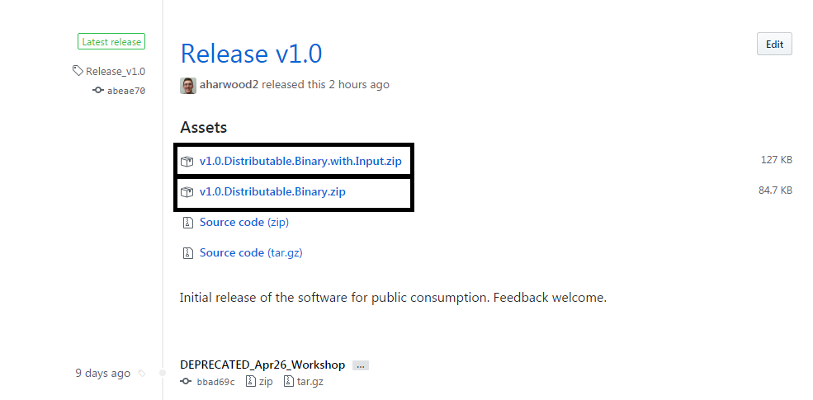**Step 2** – There are 2 version of the program as shown and highlighted below, one with input files, and one without. If you don’t have access to the custom measurements used in the JBlock2D software then download the .zip file entitled ‘v1.0.Distributable.Binary.with.Input.zip.

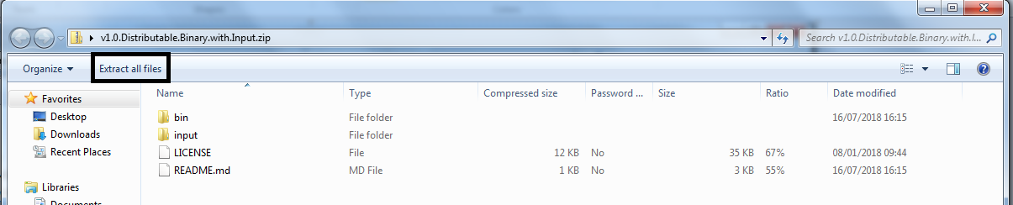**Step 3** – After download the .zip file and opening it, you’ll be faced with the four files as seen below. Click the ‘Extract all files’ button highlighted and choose your save destination to extract the software and it’s components.

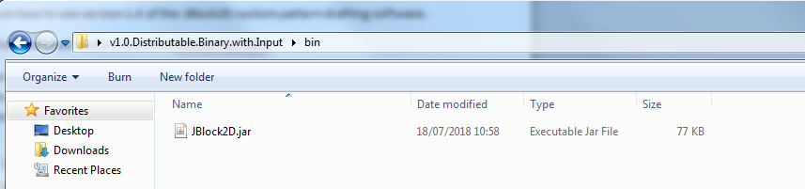**Step 4** – Now open the folder call ‘bin’, inside will be a file called ‘JBlock2D.jar’. This is our program. Having java installed on your computer is necessary to run this file. Your computer will most likely already have this installed but if not navigate [here](https://java.com/en/download/) to download it.

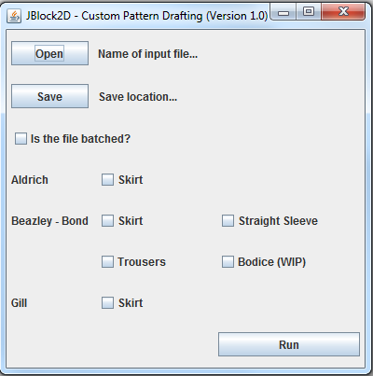**Step 5** – Open the ‘JBlock2D.jar’ file and you should see the image on the right. This is a simple, functional version of the user interface but will become more intuitive and easy to use in subsequent releases. To use the software there are five things you need to do.

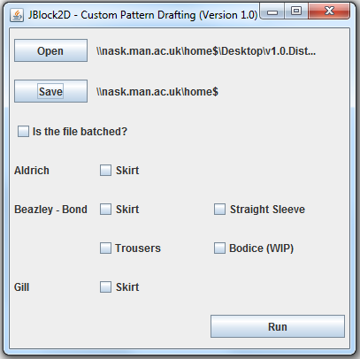**Step 5.1** – Firstly you need to select the input file you want to use. Clicking the ‘Open’ button will open a traditional file navigator. In the folder you downloaded at the beginning there was another folder below ‘Bin’ called ‘Input’. Here you will find a number of input files. Files with spreadsheet in their title are batched (multiple data sets), files with an ID in their title are singular data sets (one person). Later versions will have more input files to use but there is a small selection to use.

**Step 5.2** – Secondly you need to choose a save location, this is where the custom pattern blocks will be exported to. The program will automatically separate patterns into type so there is no need to do this. After choosing the save location the software should look similar to this.

**Step 5.3** – Thirdly you need to identify if the file is batched or not and check/uncheck the box accordingly. Check the box if the input file you are using has more than one set of data in, leave it blank if there is just one.

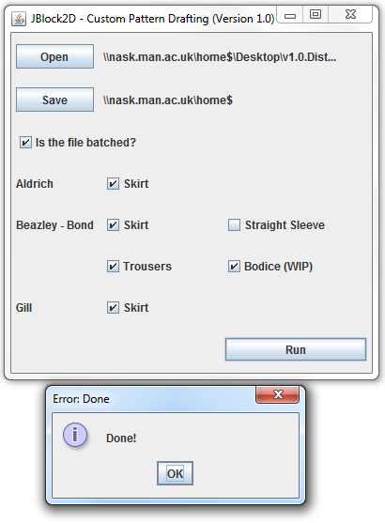**Step 5.4** – Fourthly you need to choose which patterns you want to draft. If you are using one of the input files included in the package you downloaded you won’t be able to output the sleeve, as it needed new custom measurements that aren’t present in the older data files. In later versions everyone will have access to all patterns. It should also be notes that the Bodice pattern is not correct, currently we lack the ability to get the measurement for the armhole. This should be resolved soon and will be fixed as and when.

**Step 5.5** – Fifthly, and lastly, you need to run the software. Once you have selected the patterns you want to create, click run. Once the process is completed you’ll see a dialogue box pop up saying ‘Done!’ If you aren’t seeing this then check to make sure you followed the steps correctly. If the problem still persists, send me an email at [james.gill-6@student.manchester.ac.uk](mailto:james.gill-6@student.manchester.ac.uk) and I will fix the issue as soon as I can.

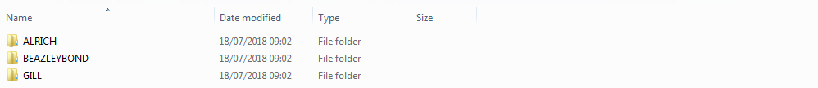**Step 6** – Once you have run the program, navigate to the folder you chose and you should see something similar to the image below. The top level of folders is the pattern drafting method (Aldrich, Gill etc), then inside each folder will be the pattern type (Bodice, Skirt etc). Only the folders for the patterns you chose will be created.

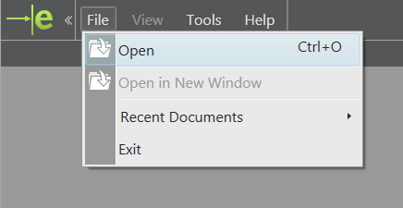**Step 7** – In order to open the patterns you will need to install a .dxf file reader, the one we recommend is eDrawings, part of the SOLIDWORKS package. If you only wish to view the .dxf files, you can download the free reader from [this link](http://www.edrawingsviewer.com/ed/download.htm). Scroll down to ‘eDrawings Viewer’ and follow the instructions.

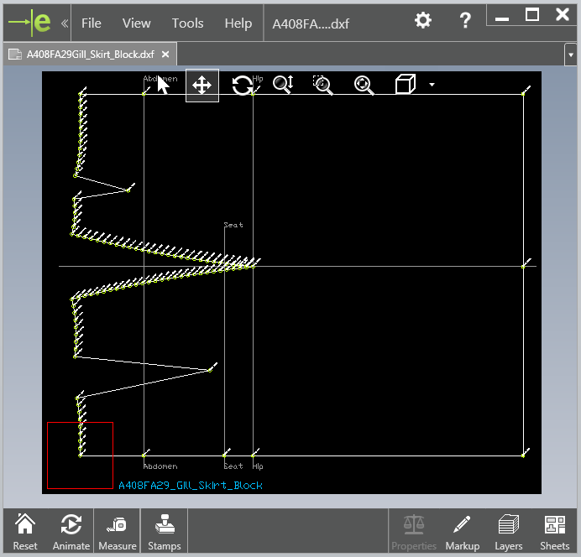**Step 8** – Once you have the software installed open it and go to ‘File’ then ‘Open’. A file explorer will open, find where you chose to export the custom pattern outputs and select one of them.

**Step 9** – On the right is an example of one of the output files (Gill Skirt). You will be able to see additional layers on the drawing (coordinates, keypoints, construction lines, scan ID number etc), these can be disabled by clicking on the layers button on the bottom right. Later versions will have the ability to select which layers you want to have.

That’s it! If you have any issues, questions, or ideas for changes/enhancements, send me an email at [james.gill-6@student.manchester.ac.uk](mailto:james.gill-6@student.manchester.ac.uk) and I’ll get back to you.