# Transects in EwE

Author: Jeroen Steenbeek (EII)  
Version 1.1, 21 September 2017

# Scope

Transects, like regions, are a mechanism to extract results for selected map cells from Ecospace. Where regions provide area averages for a cluster of cells, transects retain the actual cell values that can be plotted to the screen, and can be written to file.

# Requirements

The EwETransectExtractionPlugin is needed to use the transect logic.

# Usage

## Creating, editing and deleting transects

Transects are defined in the Ecospace input form (Navigator > Ecospace > Input > Transects; Figure 1). A transect is created by clicking on the map which sets the start location of a new transect, and moving the mouse while keeping the left mouse button down to draw the end location of the transect. The transect is defined when the left mouse button is released.

Transect end points can be clicked and dragged, and the entire transect line can be clicked and dragged as well by clicking on transect in between the ends.

The selected transect is drawn using the EwE system colour ‘highlight’ (orange by default), and the cells that the transect crosses are drawn as well. Non-selected transects are drawn using the EwE system colour ‘readonly’ (bluish-grey by default). EwE system colours be changed via Menu > Tools > Options > Display > Colours.

A selected transect can be deleted by pressing the [Delete transect] button.

Only one transect can be selected at the time.

When double-clicking a transect in the transects list, the edit transect form opens up where the transect can be renamed, and its start and end point can be edited numerically (Figure 2).

## Gathering transect summaries

Transect summary data is collected when Ecospace runs. Summary data for a transect is discarded once a transect is repositioned.

## Viewing transect summaries

Transect summary data is viewed in the transect summary form (Navigator > Ecospace > Output > Transect summary; see Figure 3). The following plots are shown for the selected transect:

* Depth profile of the transect (in meters);
* MPA overlap;
* Ecospace biomass estimates (in t/km2), per group, at a given time step;
* Ecospace catch estimates (in t/km2), per group, at a given time step.

The depth profile and MPA overlap plots will always show data, as these plots are based on Ecospace input data. The Ecospace estimate plots require Ecospace to have ran.

Once Ecospace has ran two additional options become available (Figure 3):

* Play and Stop controls can be used to view changing transect summaries over time;
* Transect summaries over time can be saved to CSV files, where transects are written to individual files.

## Auto-saving transect summaries

Transect summary CSV files can be automatically saved when Ecospace runs. This can be configured in the Ecospace parameters form (Navigator > Ecospace > Input > Ecospace parameters), see Figure 4). A message in the EwE status panel will tell you that transect information has been saved to file, and clicking that message will open the folder of the file location.

# Known issues

* The transect logic is implemented as a plug-in, and plug-ins do not have integrated access to the EwE model database. Transect data is currently stored in XML files specific to the EwE model file name and the Ecospace scenario, placed in the same directory as the EwE model database. Using separate files for storing model configuration data is a potential source for error when transferring models to other computers. In a future version, transect data must be stored within the EwE model database
* The map where transects are entered misses important context. The Ecospace MPA, habitat, and environmental driver layers are not shown here, but may be needed to position a transect. In a future extension the transect input map will have to become part of the main Ecospace maps input interface, addressing all of these issues at once.Foreseen improvements

The transect functionality is a prototype to which many features could be added, such as:

## Transects

* The end points of a transect are expressed in map units (longitude and latitude). The actual cells used by a transect are calculated from the centroids (row, col) of the cells that contain the transect end points. The transect may thus use cells that do not visually overlap with the transect line. This can be addressed by 1) using the end point locations instead of cell centroids to determine the intersecting cells; or 2) snapping the transect end points to the centroid of cells.

## Transect summaries

* Transect animation play at a fixed speed of 100ms per tick. This speed could become user configurable;
* It is not possible to view the transect summary for a specific time step other than waiting for the animation to show that time step. The ability to select which time step to display can be added;
* The content of the summary view is fixed to the four variables listed earlier. More variables could be shown, and the option to show/hide specific variables can be added;
* The summaries plot form is transect-oriented, showing all available variables, in separate plots, for a selected transect. The summaries form could become variable-oriented, showing how a selected variable compares across different transects in separate plots;
* It may be useful to be able to show/hide data for functional groups in the Ecospace estimates plots.

### CSV file format

Transect summary files contain biomass and catch Ecospace estimates for all time steps, and all groups, for all cells in the transect. Such CVS files can get large.

* It might be useful to add a CSV file format with annual averages per transect;
* It might be useful to add a CSV file format with average values for the entire transect per time step.

## Acknowledgements

Transects logic for EwE is funded through COSM / INSITE funding from CEFAS.

# Figures

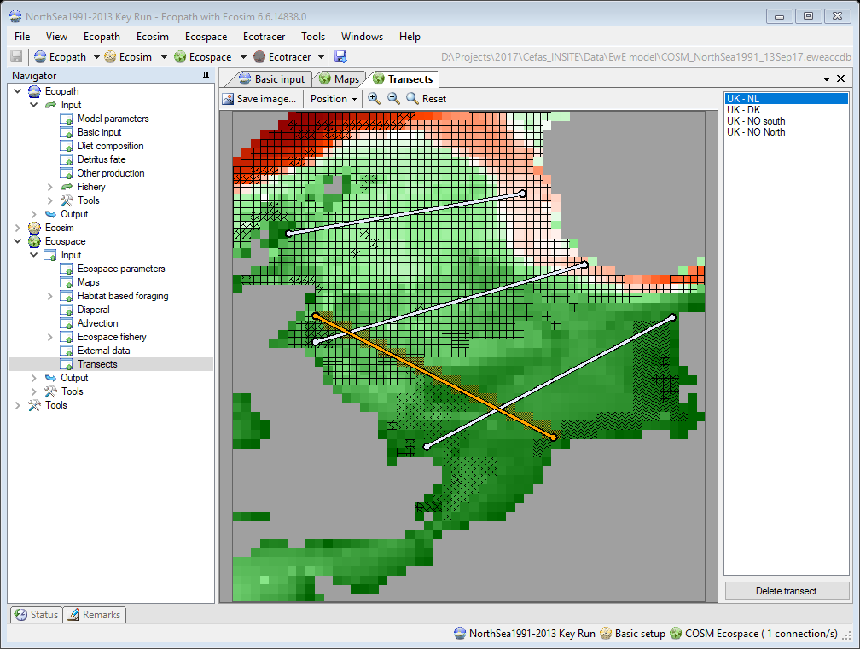

Figure 1 – Transects input screen, where transects are defined through simple sketching. The map shows transect lines superimposed on the depth and MPA map layers. The grid cells for the selected transect (orange line) are rendered.

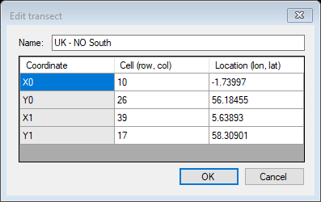

Figure 2 - The Edit transect form, where a transect can be renamed and its coordinates can be set by entering the cell index (row, col) or coordinates (in map units)

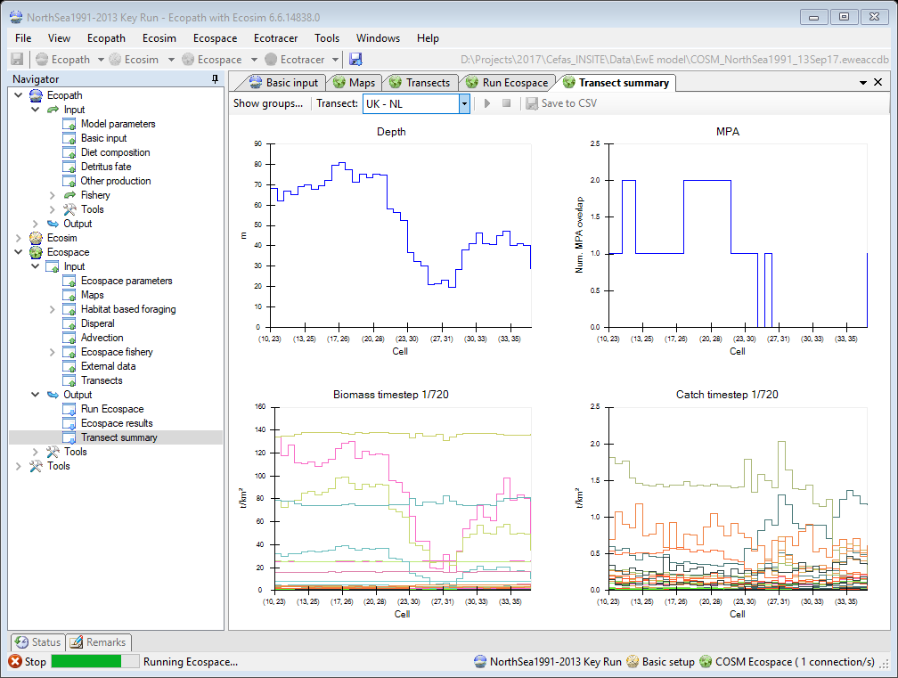

Figure 3 - Transect summary screen after running Ecospace. Transect 2 crosses a land cells and a MPA. The plots show that Biomass and Catch are unavailable for land cells, and that catches are absent within the MPA. Animation of results has progressed to time step 66 of 600. The Save to CSV option is enabled because Ecospace has executed.

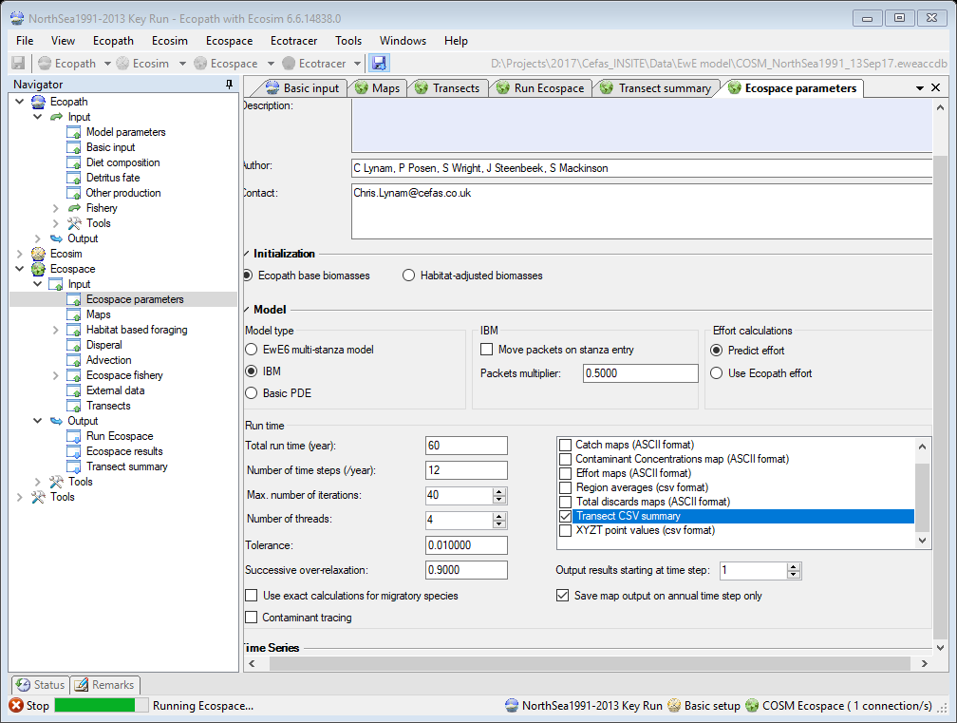

Figure 4 – Configuring Ecospace to automatically save transect summary CSV files.