**X-Ray Calc**

v. 2.4

**FITTING TUTORIAL**

1. **Preparation**

This document practically introduces the procedure of “Manual Fitting.” The term “fitting” here means that the parameters of a model are varied until the best match between the simulated and experimental reflectivity curves is achieved. Parameters of a multilayer model are thickness, density, and roughness of individual layers.

Before Fitting, the initial model is needed to be created, and the experimental reflectivity data have to be loaded to the program. The creation of a model is described in ***Structure_Manual.pdf****,* so details of this step are omitted here. The project file ***mo-b_demo.xrcx*** is located in the ***examples*** folder.

1. Create an initial model. The parameters of the model should be based on some preliminary information, such as materials used for deposition and their sequence, thickness of layers based on deposition rates and times. Cross-sectional TEM might help with the initial step.   
   In this particular case, a thick Mo sublayer was deposit first on Si wafer. Then, 250 pairs of Mo and B were deposited. A thick B layer was deposited on the top.

1. To load the experimental XRR curve, click ***Load*** on the ***Data*** pane and select file   
   ***mo-b_demo.tet***.
2. Press ***F5*** to compute the theoretical XRR curve. After finishing the computation, the Calculation tab will be activated. There you can see both experimental and calculated curves. The curves did not match because the initial model did not well represent the real structure.
3. Press ***F6*** or click the ***Fitting*** button. The ***Fitting*** window will appear. Here you can quickly adjust the parameters of the model to match the curves.
4. 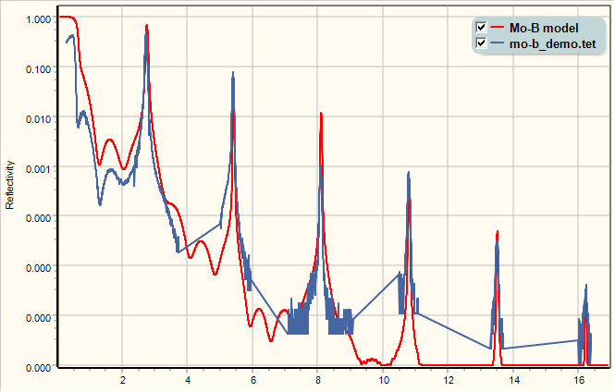**Fitting**
5. Roughly adjust the period of the structure. Use the spin button to quickly change the thickness of the second B layer until the position of main diffraction peaks matches. Also, reduce the roughness of the B layer to increase the intencity of the last peak.
6. Roughly adjust the ratio of B and Mo thickness. This ratio affects the relative intensity of the diffraction peaks. For instance, now, the second peak is too high, and the third peak is too low. Because Mo and B layers are inside the main stack, and the total thickness of the main stack defines their angular position (see Bragg’s equation), the adjustment of the ratio should not change the stack.   
     
     
   To keep the total thickness of the stack fixed, check B and Mo layers as shown here:  
   A screenshot of a cell phone

   Description automatically generated  
     
   Now, increasing B thickness will cause a simultaneous reduction of B thickness.
7. Adjust the roughness of the layers to further match the intensity of peaks.

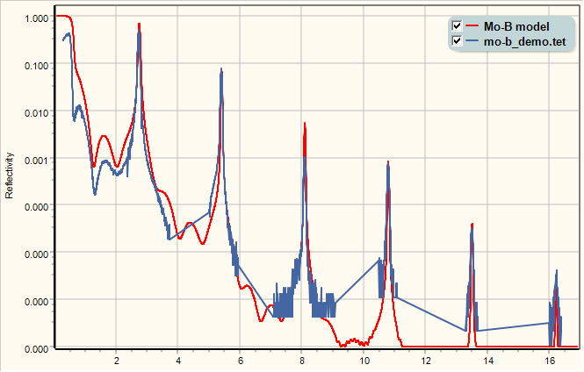

1. Modify the model to approach the real structure and to get a better ***Fitting***. For instance, interlayers between B and Mo might be introduced. Some low-density carbon contained layer could be on the surface, etc.