**X-Ray Calc**

v. 2.4

**USER MANUAL**

Contents

1. General notes 3

2. Interface overview 3

3. Toolbars 4

3.1 Project toolbar 4

3.2 Computation toolbar 5

3.3 Help toolbar 6

4. Project tree 6

5. Model structure 6

5.1 Stacks 6

5.2 Layers 6

6. Plot 7

7. Manual fitting 7

8. Extensions 8

8.1 Gradient extension 8

9. Background 9

# General notes

Functions marked *experimental* in this document are under development now. They content bugs or may not work at all.

# Interface overview

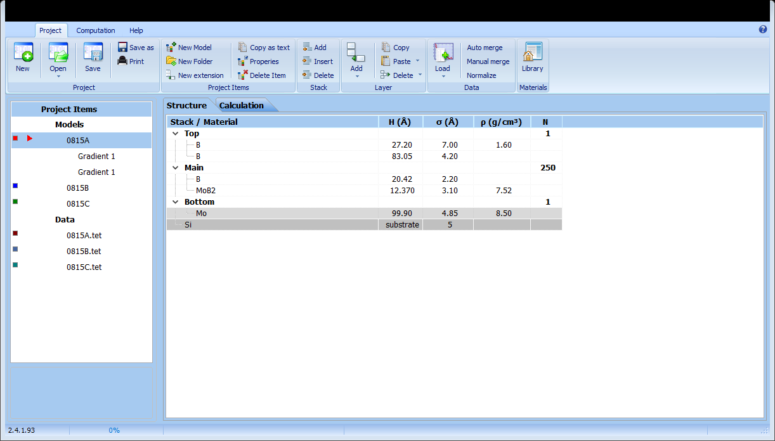

The Main window contents the Ribbon toolbar, the Project tree, Structure, and Computation tabs. Additional tabs could appear if different model extensions are used, e.g., Gradients.

The Ribbon toolbar has three tabs – **Project**, **Computation**, and **Help**. Each tab contents various commands and controls grouped in Panels.

Project tree displays various project items, such as models, data files, model’s extensions etc. Structure tab displays an active model. Computation tab shows results of calculation in the Plot.

# Toolbars

## Project toolbar

The **Project** toolbar contents project-related commands grouped on panels:

* Panel **Project**:
  + New creates a new empty project contained a single empty model.
  + Open call “Open project” dialog to open a project form file. Drop-down menu contents list of ten previously opened projects.
  + Save saves the project to a file having a *current file name*.
  + Save as shows “Save as” dialog to select the new file name and location of the project.
  + Print – prints the current project (*experimental*).
* Panel **Project items** allows to manage the structure and content of the project:
  + New model adds new empty model to the project.
  + New folder (*experimental*) creates a new folder in **Models** or **Data** sections.
  + New extension adds an extension to the selected model.
  + Copy as text (*experimental*) copies the selected project item as text.
  + Properties displays **Properties** dialog for the selected project item. The content of the dialog depends on the type of project item.
  + Delete item deletes the selected project item.

* Panels **Stacks** and **Layers** contents commands for manipulation of the structure of a model:
  + Add (Stack) adds a new empty stack to the model. If no stacks were selected, the new stack would be added before the substrate. Otherwise, it would be added after the *selected* stack.
  + Insert (Stack) inserts a new stack before the selected one.
  + Delete (Stack) deletes the selected stack with all the layers inside it.
  + Add (Layer) adds a new layer into the selected stack. The drop-down menu contents Insert Layer command.
  + Copy copies the selected layer(s) to the clipboard.
  + Paste pastes layers from the clipboard after the selected layer or into the selected stack.
  + Delete deletes the selected layer(s). The drop-down menu contents Cut layers command.

* **Data** panel allows manipulations with experimental data.
  + Load loads measured XRR curve from an ASCII file (*\*.dat, *.tet, *.txt*). The drop-down menu contents Paste from clipboard command.
  + Normalize normalizes all points of the selected experimental data curve by a real factor *z*.
  + Auto Merge and Manual Merge perform some special manipulations on data measured by *DRON-3M* diffractometer and *Counter* acquisition software.
* **Materials** panel contents Library command. This command opened the **Materials Library** window.

## Computation toolbar

This toolbar contents computation-related commands and controls grouped on panels:

* **Compute**
  + Run runs computation for the active model. The drop-down menu contents Run all command, which computes all the models in the project one-by-one.
  + Stop immediately terminates current computations
  + Fitting shows the **Manual Fitting** dialog
* **Options** panel allows setting up the computation. Reflectivity could be calculated as a function of grazing angle or wavelength. Depending on the selected Mode, one of the panels **By angle** or **By wavelength** would be activated. These panes allow changing the parameters of calculation.
  + Polarization – should be both types of polarization used in the calculation. Using of s polarization is preferable when the calculation is performed at hard x-rays and low grazing angles (below 20°). In this case, the calculation speed would be significantly faster. In the cases of larger angles and softer irradiation, ***sp*** mode should be used.
  + Number of points defines the precision of calculation. The time of calculation linearly increased with the rising of the number.
  + Θ1 and Θ2 define the range of angles for calculation.
  + 2Θ checkbox enables calculation for Θ-2Θ geometry. ΔΘ implements the instrumental divergence of the incident beam.
  + The similar settings for adjustment of the wavelength range are used in the **Wavelength mode**.
* **Result** panel
  + Export button on the allowed to export the calculated curve to an ASCII file or copy it to the clipboard (trough the drop-down menu).
  + Save button on the Plot pane saves the graph as a graphical file (*.bmp). The drop-down menu contents command for **copying of the Plot** to clipboard as an image.

## Help toolbar

The Help toolbar contents links to various internal and external help recourses.

* **Online Help** panel provides links to the X-Ray Calc home page, wiki, and bug-tracker.
* **Tutorials** panel allows opening basic tutorials distributed within the X-Ray Calc package.
* **Help** panel shows this document and **About** window.

# Project tree

The Project tree hierarchically displays project items. The colored rectangle on the left shows the color used for the specific element on the Plot.

The project Items are:

* Models – formal descriptions of the layered structure. The *Active model* is marked by the red rectangle left to the model’s name.
* Data – experimental XRR curves loaded to the project.
* Folders (*experimental*) – models and data could be organized to folders.
* Model extensions (*experimental*) – additional modifiers for models, such as Gradients

# Model structure

## Stacks

The model represents a layered structure, which also could be periodical. The model consists of a substrate and at least one **Stack**. The **Stack** is the group of layers. Use Stack panel to add or delete stacks to the model. To change properties of any stack, double-click, or select the stack and press Enter, or right-click and select Edit from the pop-up menu, or press *Ctrl+E*. See *Model Tutorial* for details.

## Layers

Commands on Layer panels could be used to manipulate elements of the structure. Some commands could be called from the right-click menu. To change properties of any layer, double-click, or select the layer and press Enter, or right-click and select Edit from the pop-up menu, or press *Ctrl+E*. See *Model Tutorial* for details.

# Plot

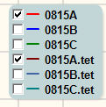These controls allow switching between the Linear/Log scale of the reflectivity plot and set the background level.

The Legend on the Plot could be used to control the visibility of curves.

# Manual fitting

The term “fitting” here means that the parameters of a model are varied ***manually*** until the best match between the simulated and experimental reflectivity curves is achieved. Parameters of the multilayer model are thickness, density, and roughness of individual layers.

Before Fitting, the initial model is needed to be created, and the experimental reflectivity data have to be loaded to the program.

To perform the fitting, do the following steps:

1. To load the experimental XRR curve, click ***Load*** on the ***Data*** pane and select file.
2. Create the initial model.
3. Press ***F5*** to compute the initial theoretical XRR curve. After finishing the computation, the ***Computation Result*** tab will be activated. There you can see both experimental and calculated curves. The curves do not match because the initial model did not represent the real structure well.
4. Press ***F6*** or click the ***Fitting*** button. The ***Fitting*** window will appear. Here you can quickly adjust the parameters of the model and match both curves.

See *Fitting Tutorial* for further details.

# Extensions

X-Ray Calc allows to use additional modifiers for models, called Extensions. The selected extension could be deactivated by pressing F3 or trough right-click menu. The name deactivated extension will be shadowed in the Project tree.

## Gradient extension

This extension allows to imply gradual changing of parameters of the model, for instance thickness. It could be used to model some physical effects like drifting of the deposition rate during the manufacturing of a coating or increasing of the interface roughness due to columnar growth. To add the Gradient, select the model in the ***Project Tree*** and call New Extension command. New extension called *“Gradient 1”* will be added. Please note, that many different gradients could be used at the same time.

To change parameters of the gradient, double-click on its name.

* Name defines the displayed name of the gradient
* Stack drop-down list allows to select the stack which will be modified.
* Layer specify the layer to modify
* Gradient could be applied to thickness, roughness, or density
* Rate defines how fast the perimeter will increase from layer to layer. For example, 0.2 means that the thickness of the next layer will be multiplied by 1.2.

Gradient is applied from the bottom of the stack (from the substrate). To implement reduction of the parameter, the Rate should be negative.

If the model contents active gradients, new **Gradients** tab will be displayed after the computation to demonstrate gradients graphically.

# Background

X-Ray Calc is based on the recursive method of computation of LAXRD diffraction patterns [5, 6]. In this method, the following equation is used for the calculation of the refraction index for a multilayer structure having n layers:

$$r\left(z_{j}\right)=\frac{r_{j}^{F}+r(z_{j+1})∙e^{2iχ_{j+1}l_{j+1}}}{1+r_{j}^{F}∙r(z_{j+1})∙e^{2iχ_{j+1}l_{j+1}}}$$

$χ_{j}=k∙\sqrt{ε_{j}-\sin^{2}(ϕ)}$, j = 0, 1, … n (1)

In Equation 1, rF is an amplitude refraction index for the j-th interface, given by Fresnel’s equation:

$r_{j}^{F}=\frac{{χ_{j}}/{η_{j}} - {χ_{j+1}}/{η_{j+1}}}{{χ_{j}}/{η_{j}} + {χ_{j+1}}/{η_{j+1}}}=\frac{η_{j}^{-1}\sqrt{ε_{j}-\sin^{2}\left(ϕ\right)} - η_{j+1}^{-1}\sqrt{ε_{j+1}-\sin^{2}(ϕ)}}{η_{j}^{-1}\sqrt{ε_{j}-\sin^{2}(ϕ)} + η_{j+1}^{-1}\sqrt{ε_{j+1}-\sin^{2}(ϕ)}}$ (2)

Where ηj=1 for s-polarization; ηj = εj for p-polarization; εj = 1-δ+i∙γ is complex dielectric constant given by the following equation:

$\left({δ \atop γ}\right)=0.54∙{10}^{-5}∙\frac{ρ}{μ}λ^{2}\left({f_{1} \atop f_{2}}\right)$ (3)

Where λ is the wavelength of X-Ray irradiation (in Angstroms), ρ is a density of a material, µ is atomic weight, f1, and f2 are real and complex parts of atomic scattering factor [5]. X-Ray Calc has an embedded database of the scattering factors based on [7].

The recursive calculation starts from the substrate (j=n). Values of r(zj) are consequentially calculated on each interlayer interface. The refraction index of the whole structure is calculated as R=|r(z0)|2. Thus, equations 1-3 allow to numerically solve the problem of refraction of x-rays for arbitrary layered structure for any wavelength and incident angle. This method entirely takes into account the effects of dynamic scattering and absorption.

Various structural imperfections such as interface roughness affect the diffraction pattern, but Equation (1) describes refraction of an ideal structure. To implement the effects of interface roughness in the model, the rough interface with a sudden change of dialectical constant is replaced by a single layer having thickness 2σ [4, 8]. Inside this layer, dialectical constant gradually changes according to a particular law. If the roughness distribution is described by Gaussian function, the variation of dielectrically constant inside the thin interlayer is described by Error function (so-called Debye-Waller factor [9]):

$R\left(θ\right)=R_{0}(θ)∙\exp\left(-\frac{16π^{2}σ^{2}\sin^{2}\left(θ\right)}{λ^{2}}\right)$ (4)

Besides, linear-gradient function, step function, or sinus also could be used [4, 8]. It should be noted that this mathematical model cannot distinguish interface roughness and a concentration gradient. The blur of dielectric constant on rough interfaces causes reducing refraction on each interface and the overall refraction. The role of roughens increased with rising the incident angle.

The precision of the simulation by X-RayCalc was validated by comparison with the IMD software package [4]. LAXRD patterns were simulated by both software packages for several identical structures. In both cases, the same database of X-Ray scattering factors was used. A point-by-point comparison of results revealed the minimal divergence (below 0.5%). The observed difference might be attributed to accumulation of rounding errors.

**References**