Practical 1

1.

The process id of the child & parent processes

2. 166118

3. 165985

4.

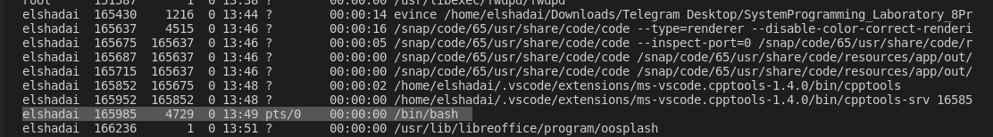

Practical 2

1.

