|  |
| --- |
| c4-bg |
| Addis Ababa Institute of Technology center for Information Technology and Scientific computing |
| **Fundamentals of web Design and Development** |
|  |
|  |
|  |

|  |
| --- |
|  |

Name: Elshaday Abebe

Section: Software 2

ID: ATR/6947/11

Instructor: Mr Fitsum A.

Table of Contents

Part 1: History of Internet [The evolution] 2

Part2: What are the guidelines for evaluating the value of a Web site? 7

Part 3: Evaluating website base on the above guidelines 9

Part 4: 12 most popular types of websites 12

Part 5: Web ARCHIVE (Way back machine) on popular websites 19

# Part 1: History of Internet [The evolution]

The internet is one of the most important tools in recent history, giving us access to countless amounts of information. The internet actually got it started over 50 years ago and computers back then filled up the entire room. Scientists and researchers used it for a year to communicate during the cold war. It was useful because if one computer went down the other would not follow.

In 1962 the scientist J.C.R. LICKLIDER proposed the idea of a network of computers that could talk to one another.

In 1969 the first ever message was sent from one computer to another over the ARPANET the government network at that time.

ARPANET stands for the Advanced Research Projects Agency Network.

It all started with ARPANET on October 29, 1969 when the first successful message was sent from a computer in UCLA to another computer (also called node) at the Stanford Research Institute (SRI). These computers were called Interface Message Processors (IMP).

It was located in a research lab in UCLA and STANFORD all the message said was ‘LOGIN’. Stanford only receives the first two letters of the message ‘LI’. By the end of the year only 4 computers were connected to this network.

In 1971 Ray Tomlinson was developing the first system to send mail back and forth between users of ARPANET. This would eventually be called electronic mail or Email for short and the ‘@’ symbol was used to tell a person’s name and a host name apart. In that year computer scientist Vinton Cerf came in, he invented a way to introduce a computer across the globe to each other in a virtual space. This invention was called Transmission control protocol (TCP) which was followed by Internet protocol (Ip).

The system slowly evolved so it was not immediately adopted for commercial use. Instead in the early 1980’s it was adopted by universities and research institutes through an initiative by the NSF (National Science Foundation). It was called the NSFNET Project and its aim was to promote research and education. The best way to do this was to use an interconnected network of computers that can provide a way to collaborate and share information. This provided a backbone that included the Computer Science Network (CSNET) that linked computer science research among academics. Eventually ARPANET and NSFNET would be decommissioned, thus paving the way for the commercialization of the Internet. It was also called the “Internet” as a sort of portmanteau of “interconnected” and “network” and has been called the Internet since. This would involve the development of standards maintained by the IETF (Internet Engineering Task Force) with contributions from among many organizations like the IEEE (Institute of Electrical and Electronics Engineers), IESG (Internet Engineering Steering Group) and the ISO (International Organization for Standardization).

In the 1980s scientists used Cerf’s protocol to send data back and forth but in 1990s where it really all began.

In 1991 computer programmer named Tim Berners - Lee invented the World Wide Web this was just data sharing for scientists anymore. This was an entire network of information that was accessible to anyone with an internet connection.

In 1992 ERWISE was created. It was an internet browser and the first to have a graphical interface. A few Browsers came before and after but 1993 MOSAIC was created and it was popularized surfing the web. MOSAIC influences many of the browsers to follow including NETSCAPE NAVIGATOR. In 1994 NETSCAPE NAVIGATOR became the most popular web browser at the time accounting for 90% of web usage in 1995. In the early 90s some companies starting to provide dial-up internet access. It is a method of connecting to the internet the telephone line. The telephone line was plugged in to the modem and the other end was plugged in to the phone jack. To access the Internet, all users needed to do was known the telephone number of the connected computer. From this computer, the user can establish connections to other computers. This computer was called a server and provided basic or specific services for users. This is known as a client/server architecture. There was a period in history where we could not use the telephone and the internet at the same time.

Many early Internet users accessed what are called Bulletin Board Services (BBS) which are servers that host an electronic version of a bulletin board. It was a place to look for information regarding certain interest groups. Eventually bigger services like USENET opened up and these services provided more information through discussion forums or newsgroups. Users also used a service called FTP, which allowed them to upload or download files. This was important among researchers who needed to exchange data files that may be too large to attach with e-mail but It was an inconvenient process having to dial-up to a different computer every time when you needed to. This is where Internet Service Providers (ISP) entered the picture. This was the period of the Internet called Web 1.0. This was a time when the Internet was mainly web pages and hyperlink content. By providing the Internet as a service to users, they can make using the Internet more convenient. Thus began the commercialization of the Internet. Companies like AOL began this push as an ISP. Microsoft then bundled IE with the Windows OS starting with Windows 95. By embracing and extending the Internet to Windows users, Microsoft effectively killed off the competition. Netscape closed shop while other browsers like Mozilla were marginalized. Offering IE for free was the starting point for most users since the majority of them had a PC running Windows. Now that they had the software to access the Internet, it would be much easier. All they needed to do next was subscribe to an Internet service. While some critics predicted the Internet was a fad and would eventually fall along with the dotcom bubble toward the late 1990’s, instead it thrived thanks in part to its commercialization. You can call it a network effect in which more users who joined created more connections, allowing more information to be shared and accessed. Even the mainstream news giants took notice and soon they too established an online presence. The Internet was now a competitor to news media outlets as a source of information. Meanwhile, AOL would face stiffer competition in the 2000’s, this time from broadband Internet providers who offer bundled services, not just the Internet. The big players offered Internet with telephone and cable service at good starting rates to get more customers. This affected smaller ISP’s who can only offer Internet and so they had to close shop. Gone are the days when you can access the Internet loosely. It now requires an ISP for the majority of users. As commercial interests grew along with Internet use, many platforms emerged that became known as social media. This would bring Web 2.0, when user generated content and interoperability of web pages would become more dynamic and work with newer devices. It was also the emergence of cloud computing in which access to servers are obscured by the Internet. The cloud was a virtual collection of servers that provided services to users. The giants in this game were Facebook, Google, Twitter and more recently Snapchat and Instagram. Facebook began to use its clout to buy up smaller companies and use their features. It attempted to buy out Snapchat, but instead acquired Instagram and started incorporating Snapchat features. It became clear that Facebook, with 2.2 billion+ users (as of this writing), is far ahead. Facebook was not exactly an open system since they can control what users can see and this is already becoming an issue. Twitter, another platform, can also censor certain users, either due to violation of their policy or even for other reasons. There have been complaints that Twitter is not fair when blocking users from using the platform. Another platform like YouTube allow users to upload videos. It is also content controlled by YouTube in order to weed out harmful content which is a good practice. The only issue is that sometimes the content is not really harmful but YouTube will ban it due to some sort of violation of its policy. So policy is always something that social media platforms impose on users. These maybe apps, but they are the reason many people are using the Internet. Without these platforms, there would be less ways to share or convey information. Perhaps the biggest issue with social media platforms is that they collect user data and sell it to an interested third party. This is all legal since the Terms of Service (TOS) agreement allows the platform to share your information and use it for their own purposes. The data collected from social media is used more for targeting users by brands. The third party would most likely be ad agencies, marketing firms and research groups. They use analytics on the cold data they get from social media and harvest useful information from them. What they get are insights that is information that provides data about the users of these platforms.

The information is then sold, as a product, to brands in order to allow them to target the users for ads and services. Information is not really free, it has become a commodity that has a price people are willing to pay for. While a centralized platform controls all your data and information you feed it, a decentralized platform would not. There is also more privacy on decentralized platforms as none of your data or activity is being monitored and collected. A related topic to the centralized Internet is Net Neutrality in the US. A deregulated Internet may be good for the ISP’s involved, but perhaps not for the users. The repeal of Net Neutrality has given more control to ISP’s to do whatever they like. They can throttle speed, control media content access and even increase rates without any intervention from the Federal Communications Commission (FCC). Instead another government agency, the Federal Trade Commission (FTC), will be tasked with monitoring ISP’s.

It still doesn’t give users the assurance that ISP’s will not abuse their power. In the interest of business, repeal does mean that ISP’s are more incentivized to innovate and improve their networks and service. Once again centralized power given to the ISP’s leaves the consumers with little choice. There are concepts for decentralized ISP projects. One such project is called Open Internet Socialization Project (OISP). Their goal is for members of a community to own the means for delivering Internet to each other with incentives for that delivery. It’s just a question of how effective these projects will be implemented.

There are pros and cons to a centralized Internet. In terms of pros, it has allowed the Internet to expand due to the services provided by the ISP’s and also the popularity of social media platforms. The cons is that since it is centralized, there is not much choice for users. A user’s access to the Internet is at the mercy of their provider and the platform. This is a single point of failure, not something the original Internet was designed for. Most places don’t have many options for the Internet either since an ISP may have cornered the market in that area. Security is also be a concern here, since a centralized location for data makes it an easy target for hackers. Users have experienced hacks where their personal information was compromised because they were stored by a single company. Often the information ends up in the wrong hands.

Centralized systems are also easy targets for disruptive activities like DDOS attacks, service outages and malware virus infections. I won’t go into further detail on decentralized solutions for the Internet, but I am just pointing out the cons of having too much centralization of the Internet. For this reason, some are worried about the centralized Internet. The balance of power tilts toward the ISP and platforms who have big business interests. As these giants grew however, they are stifling innovation that makes it harder for others to compete in the same space. Decentralization offers its solutions to these problems so it is worth exploring for the future development of the Internet.

# Part2: What are the guidelines for evaluating the value of a Web site?

There is a lot of useful information on the internet However, since anyone can publish to the internet it is crucial to evaluate website before relying on the information many of us use the internet to gather information for all sort of things we might use that information to make decision about health, politics, finances or social issues. But some of the information you fine on the internet is not going to be trustworthy.

1. Accuracy of Web Documents(Reliability)

* Does the website list its source of information?
* Are there grammatical errors?
* Is the information provided correct?
* Who wrote the page and can you contact him or her?
* What is the purpose of the document and why was it produced?
* Is this person qualified to write this document?
* Make sure author provides e-mail or a contact address/phone number.
* Know the distinction between author and Webmaster.

1. Authority of Web Documents(Credibility)

* Does the person who is producing the information have a professional background in the subject?
* Who published the document and is it separate from the "Webmaster?"
* Check the domain of the document, what institution publishes this document?
* Does the publisher list his or her qualifications?
* What credentials are listed for the authors)?
* Where is the document published? Check URL domain.

1. Objectivity of Web Documents(Bias)

* Is the information presented from an unbiased, factual, non-perspective?
* What goals/objectives does this page meet?
* How detailed is the information?
* What opinions (if any) are expressed by the author?
* Determine if page is a mask for advertising; if so information might be biased.
* View any Web page as you would an infomercial on television. Ask yourself why was this written and for whom?

1. Currency of Web Documents(Timeliness)

* When was the information posted to the internet?
* When was the website last updated?
* Does the website show current change in relation to advances made in the subject matter?
* When was it produced?
* When was it updated
* How up-to-date are the links (if any)?
* How many dead links are on the page?
* Are the links current or updated regularly?
* Is the information on the page outdated?

1. Coverage of the Web Documents(Quality)

* How well rounded is the information?
* Does the website discuss information within the context of larger issues and form different perspectives?
* Are the links (if any) evaluated and do they complement the documents' theme?
* Is it all images or a balance of text and images?
* Is the information presented cited correctly?
* If page requires special software to view the information, how much are you missing if you don't have the software?
* Is it free or is there a fee, to obtain the information?
* Is there an option for text only, or frames, or a suggested browser for better viewing?
* Domains in relation to evaluating websites

In addition to using the previously mentioned concepts, we can also begin to think about how trustworthy a website is paying attention to its domain.

Domains are parts of a web address that can tell us a little about the kind if institution or organization the information originate from. Like .edu, .com, .gov, .net, .org

* Websites ending in .com or .net are considered as commercial websites whose main objectives is to gain financial income from the information provided. Not all website that end in .com or .net are untrustworthy, but we should be more caution of these websites than others

# Part 3: Evaluating website base on the above guidelines

**Zehabesha :** [**https://www.zehabesha.com/**](https://www.zehabesha.com/)

This website is an extensive Ethiopian news source which provides balanced news, perspectives, and issues across the political spectrum to its visitors and claims its committed to separating news and views while covering broad areas of health, education, politics and so on.

The navigation bar includes Home, News, Opinion & Analysis, Scholarly Articles, Economy, History, Health, Sport, Video, Amharic. Although this site does bring up-to-date information to its users, it lacks attractiveness. The look and feel of the site while passing through the links is not of the highest caliber.

Accuracy of Web Documents

In terms of accuracy the website doesn’t clearly states by who most of the articles are written. But some articles are published by zehab, which isn’t clearly identified and its contact information isn’t listed. And also the qualification of this publisher isn’t described clearly.

The author of the site does provide their phone numbers and email addresses in the Contact us heading.

Other than the above problems the website does provide its main purpose which is providing information on a regular basis.

Authority of Web Document

In the case of authority Zehabesha is published by the founder and executive editor Alyou Tebeje, though it’s not clear whether this person is the webmaster or not. Other than the name and the titles there aren’t any credentials of the person provided. The website doesn’t state from where its being published.

Objectivity of Web Documents

The goal of the website is to provide information and news. The information published appear to be accurate and precise. But the website does contain advertisement, so it might seem the information is biased.

Currency of web documents

The articles in the website do provide publishing dates and the webpage is updated regularly. I haven’t found any dead links on the page The links are updated regularly and the information being published by the site appears to be up-to-date.

Coverage of web documents

Any visitor can view the information published on this site without any limitations what so ever. It doesn’t require fees, or any types of additional software.

It tries to incorporate images to the articles and them appears to be balance between images and texts.

The information provided are cited accordingly.

**Healthy Water:** [**https://www.cdc.gov/healthywater/index.html**](https://www.cdc.gov/healthywater/index.html)

* “.gov” is a governmental site so that the information is more reliable. This page is sponsored by centers for disease and prevention.
* CDC is a federal agency under the department of health and human service and is an organization with along research history.
* On this website if we scroll down to the bottom of the page we can see the date of review, it says “page last reviewed: October 4, 2016”. There is also an option to receive emails when the content is updated, that’s an attempt to make sure visitors of this have the timeliest information. These will help to determine the current of the information on the site.
* On this site there are a lot of clickable button, which leads to a page with detailed information on the purpose and intended audiences of this website. Though there are image found throughout the website, there are all relevant to the topic of water.
* The font and colors being used are all professional in a nature as well. There is multiple healthy water topic area we can explore. If we click on any topic area, we can find various publications, data and statistics on the topic.
* The corresponding author is clearly listed along with their credentials. And we can use the contact information to perform even more research to field make sure they are an expert in this field.
* This site provides high quality information. Though out the pages on this website, including the home page, I have noticed there’s no advertising any claims putting forth a biased agenda.
* The site’s purpose is to provide research based information on all aspects of healthy water using statistic and in depth research. That suggests the information is an objective as possible and free of biased.
* So generally this site is current, its information is relevant, the information we found way written objectively, we can easily identify the author and creator of research and the information has been reviewed and maintained to ensure the highest quality,
* Nonprofit websites have different business purposes. But still, they need to follow the [best-practices of web design](https://www.webalive.com.au/good-website-design-principles/) to provide the necessary information to their target groups and supporters. Maintaining a good brand image is also another critical factor. Good looking websites help nonprofits to reach more people and motivate visitors to advance their causes.

**World wild life:** [**https://www.worldwildlife.org/**](https://www.worldwildlife.org/)

* WWF has a very informative website that aims to educate visitors about the current status of wildlife across the planet. The navigation bar includes Our work, Species that you should know and care about, Places that are important for wilderness preservation, about us and How to help. Hovering mouse pointers on these headings brings out drop-down menus with well-organized sections.
* The Donate and Adopt call-to-action buttons at the top right corner take the visitor to a page with multiple donation options and information. This is a great way to convert potential participators.
* The rest of the homepage presents informative content from WWF. It blends images, text and social media content using a grid of rectangular boxes. The site looks great on a small screen. Overall the design is visually appealing.
* The site’s purpose is to provide research based information on all aspects of World Wild life using depth research in order to conserve nature and reduce the most pressing threats to the diversity of life on Earth. That suggests the information is an objective as possible and free of biased.
* There is also an option to get the latest conservation news with WWF email when the content is updated, that’s an attempt to make sure visitors of this have the timeliest information and determine the current of the information on the site.
* On this site there are a lot of clickable button, which leads to a page with detailed information on the purpose and intended audiences of this website. Though there are image found throughout the website, there are all relevant to the topic of World wild life.
* This website is more reliable because it is nonprofit website.
* This website provides high quality information. Though out the pages on this website, including the home page, I have noticed there’s no advertising.
* The font and colors being used are all professional in a nature as well. There is multiple world wild life topic area we can explore. If we click on any topic area, we can find various publications, data and statistics on the topic.
* It is public participating website in different aspect.

# **Part 4: 12 most popular types of websites**

* **Blog** Typically managed by an individual or a small group, a blog can cover any topic – whether it’s travel tips, financial advice, or doughnut reviews. While they’re often written in an informal or conversational style, professional blogging has gone on to become an extremely popular method of [making money online](https://www.expertmarket.co.uk/website-builders/how-bloggers-make-money).

Example: -

Boing Boing([**https://boingboing.net/**](https://boingboing.net/))

Mr. Money Mustache([**https://www.mrmoneymustache.com/**](https://www.mrmoneymustache.com/))

Gizmodo([**https://gizmodo.com/**](https://gizmodo.com/))  is an online magazine that provides information and articles related to technology, design, and social trends.

Slashdot([**https://slashdot.org/**](https://slashdot.org/)) It features news stories on science, technology, and politics that are submitted and evaluated by site users and editors.

Mashable([**https://mashable.com/**](https://mashable.com/)) is a global, multi-platform media and entertainment company. Powered by its own proprietary technology, Mashable is the go-to source for tech, digital culture and entertainment content for its dedicated and influential audience around the globe.

* **Social Network** we all know Facebook and Twitter, but social media sites can take many other forms. These sites are usually created to let people share thoughts, images or ideas, or simply connect with other people in relation to a certain topic. Social media sites are also increasingly becoming the go-to destination for people to read up on the news.

Example: -

Snapchat([**https://www.snapchat.com/**](https://www.snapchat.com/)) t is a popular messaging app that lets users exchange pictures and videos (called snaps) that are meant to disappear after they're viewed.

Pinterest([**https://www.pinterest.com/**](https://www.pinterest.com/))  is social media network that allows users to share images associated with project, goods, and services, and to visually discover new interests by browsing images others have posted.

LinkedIn([**https://www.linkedin.com/**](https://www.linkedin.com/))  is a social media platform geared to professionals. It enables you to network and to build your professional portfolio, but you can also go out into the world and look for a new job.

Twitter([**https://twitter.com/**](https://twitter.com/))  is a social media site, and its primary purpose is to connect people and allow people to share their thoughts with a big audience.

WeChat([**https://www.wechat.com/en**](https://www.wechat.com/en)) Previously it was only used for sending instant messages, but now it forms the basis of your daily digital life. It's the ecosystem for media, developers, online shops, and it includes instant messaging, your official account, mini-programs, mini-games, and corporate WeChat.

* **Educational Website** The websites of educational institutions and those offering online courses fall into the category of educational websites. These websites have the primary goal of either providing educational materials to visitors, or providing information on an educational institution to them.

Example: -

edx([**https://www.edx.org/school/edx**](https://www.edx.org/school/edx))  is an online learning destination and MOOC provider, offering high-quality courses from the world's best universities and institutions to learners everywhere.

AcademicEarth([**https://academicearth.org/**](https://academicearth.org/)) offers free online video courses and academic lectures from the world's top universities such as UC Berkeley, UCLA, University of Michigan, University of Oxford Harvard, MIT, Princeton, Stanford ...

Big Think([**https://bigthink.com/**](https://bigthink.com/))  a collection of interviews, presentations, and roundtable discussions with experts from a wide range of fields.

Brightstorm([**https://brightstorm.com./**](https://brightstorm.com./)) It features thousands of study videos as well as other study tools and resources such as Math Genie and College Counseling.

CosmoLearnig([**https://cosmolearning.org/**](https://cosmolearning.org/))  is a non-profit educational website committed to improving the quality of homeschooling, teaching and student excellence.

* **Wiki or community forum** A wiki website allows people to collaborate online and write content together. The most popular example is Wikipedia itself, which allows anyone to amend, add to, and assess the content of each article.

Example: -

Quora([**https://www.quora.com/**](https://www.quora.com/))  is an American question-and-answer website where questions are asked, answered, and edited by Internet users, either factually or in the form of opinions.

Stackoverflow([**https://stackoverflow.com/**](https://stackoverflow.com/))  is a platform where students and professionals post queries and answer questions about programming.

Nexipia([**https://forums.nexopia.com/**](https://forums.nexopia.com/))  is a Canadian social networking website.  It was designed for ages 14 and up, which was later lowered to 13. Users are able to create and design profiles, a friends list, blogs, galleries, compose articles and forums.

Reddit([**https://www.reddit.com/**](https://www.reddit.com/)) is an American social news aggregation, web content rating, and discussion website.

Github([**https://github.com/**](https://github.com/)) is a web-based platform used for version control. Git simplifies the process of working with other people and makes it easy to collaborate on projects.

* **Nonprofit(Advocacy) websites** don’t aim to sell products or services to their visitors, but they still need to convince people to support their cause. Websites are one of the primary ways the charity organizations connect with their potential patrons.

Example: -

Charity:water(<https://www.charitywater.org/>)  is a nonprofit organization bringing clean and safe drinking water to people in developing countries.

RedCrossAustralia(<https://www.redcross.org.au/>) Australian Red Cross is building a better society based on people helping people. Working towards the vision of human dignity, peace, safety and wellbeing for all.

WorldWildlifeFund(<https://www.worldwildlife.org/>) working in the field of wilderness preservation, and the reduction of human impact on the environment.

OneDrop(<https://www.onedrop.org/en/>) Providing access to safe Water, Sanitation, and Hygiene

FordFoundation(<https://www.fordfoundation.org/>)an American private foundation with the mission of advancing human welfare.

* **Business Website** A website that is used to officially represent a brand on the Internet, and which is often used as the landing page for advertising content.

Example: -

DMN(<https://www.dmnews.com/>) is a resource for [marketing and sales professionals](https://www.marketingeye.com.au/) that explores all realms of digital and data driver marketing in an unbiased and incisive manner.

Event Marketer(<https://www.eventmarketer.com/>) provides the information needed for strategic brand-side event [marketers and agency executives](https://www.marketingeye.com.au/about-us/marketing-team.html) ranging from face-to-face to corporate events.

Chief Marketer(<https://www.chiefmarketer.com/>) serves [marketing professionals](https://www.marketingeye.com.au/about-us/marketing-team.html) of consumer and business-to-business brands with rich and thorough information on measurable marketing strategies, tactics, and technique.

Fortune(<https://www.fortune.com/>) is one of the world’s leading business media brands which is accompanied by a multinational monthly magazine, daily website and conference series.

ClickZ(<https://www.clickz.com/>) is the largest resource in the world for interactive marketing news, information, commentary, advice, opinion, research, and reference. Through these resources, ClickZ aspires to assist digital marketers in doing their jobs better.

* **Personal Website** is a group of web pages that someone creates about themselves. It basically contains things that are personal.

Example: -

[Ellen Skye Riley](http://ellensriley.com/)(<http://ellensriley.com/>)

[Jim Ramsdem](http://jimramsden.com/)([https://jimramsden.com/#](https://jimramsden.com/))

[Anthony Wiktor](http://www.anthonydesigner.com/)(<https://www.anthonydesigner.com/>)

[Red Russak](http://redrussak.com/)(<http://redrussak.com/>)

[Sarah Chang](http://www.sarahlichang.com/)(<http://www.sarahlichang.com/>)

* **Entertainment Website** A social entertainment service is an online service, platform or website which links back to social networking websites to help connect users and has begun to facilitate audience acquisition.

Example: -

YouTube(<https://www.youtube.com/>)  is used to watch music videos, comedy shows, how to guides, recipes, hacks and more.

Netflix(<https://www.netflix.com/et/>)  is a streaming service that allows our members to watch a wide variety of award-winning TV shows, movies, documentaries, and more on thousands of internet-connected devices.

Thirty mile Zone(<https://www.tmz.com/>) altered the entertainment news landscape by changing the way the public gets its news.

Internet Movie Database(<https://www.imdb.com/>)  is an online database of information related to films, television programs, home videos, video games, and streaming content online.

Fandango(<https://www.fandango.com/>) is the ultimate digital network for all things movies, serving more than 67 million unique visitors per month globally with best-in-class movie information, ticketing to more than 45,000 screens, trailers and original video, home entertainment and fan merchandise.

* **Content aggregator** site collects information from all over the web and posts it in one location for visitors to access.

Example: -

Feedly(<https://feedly.com/i/welcome>) It has to be on top because it is easily one of the best news aggregator websites on the web. With a clean, simple design, Feedly is an excellent way to follow news.

Panda(<https://usepanda.com/app/#/>)  is a great tool for anyone working as a web designer, developer, or who has the entrepreneurial spirit. It is unique among aggregator sites because it follows Dribble, Balance, Product Hunt, GitHub.

Techmeme(<https://www.techmeme.com/>) A brilliant technology-themed aggregator site that pulls in tech stories from all over the spectrum. It includes sites like Reddit alongside breaking business news.

Metacritic(<https://www.metacritic.com/>) is one of my favorite news aggregator websites and easily one of the top such sites of all time. It is a review aggregator, like Rotten Tomatoes, but it also includes games and music.

The Morning News(<https://themorningnews.org/>)  The Morning News is unique in that it only has a single column with news covering a wide variety of topics. The topics are not the usual topics you find on news aggregators with more obscure stories finding their way to the front page.

* **Portal**  is a specially designed [website](https://en.wikipedia.org/wiki/Website) that brings information from diverse sources, like [emails](https://en.wikipedia.org/wiki/Email), [online forums](https://en.wikipedia.org/wiki/Internet_forum) and [search engines](https://en.wikipedia.org/wiki/Web_search_engine), together in a uniform way.

Example: -

https://portal.aait.edu.et/

<https://bvoip.hawaiiantel.com/Login/>

[http://portal.du.edu.et/](http://portal.du.edu.et/?AspxAutoDetectCookieSupport=1)

[https://portal.hawaiipacifichealth.org/](https://portal.hawaiipacifichealth.org/logon/LogonPoint/tmindex.html)

<http://portal.kmu.edu.et/>

* **Informational Website** are those sites which are created in order to provide a customized and branded resource for potential and active customers, members, investors and so forth.

Example: -

Roadfood(<https://roadfood.com/>) This website helps you get your favorite food while on the road. It’s like street food at a click. It’s available in many states across the United States.

Mentalfloss(<https://www.mentalfloss.com/>) delivers smart, fun and shareable content in an upbeat and witty environment. An encyclopedia of everything,

Mashable(<https://mashable.com/>)is a global, multi-platform media and entertainment

company.

Web Monkey(<https://webmonkey.net.au/>) was an online tutorial website composed of various articles on building webpages from backend to frontend.

Trip Advisor(<https://www.tripadvisor.com/>) This one is like a city guide search engine that helps you find the city’s best restaurants and “things to do” while you are away from home.

* **News or Magazine Websites** The primary purpose of a news website is to keep its readers up to date on current affairs, whereas online magazines will focus more on entertainment.

Example: -

The new York Times(<https://www.nytimes.com/>)  is an American newspaper based in New York City with worldwide influence and readership.

Futurism(<https://futurism.com/>) Discover the latest science and technology news and videos on breakthroughs that are shaping the world of tomorrow.

Variety(<https://variety.com/>) Entertainment news, film reviews, awards, film festivals, box office, entertainment industry conferences.

Reuters(<https://www.reuters.com/>) brings you the latest news from around the world, covering breaking news in markets, business, politics, entertainment, technology and video.

Inquisitr(<https://www.inquisitr.com/>) Part of these amazing newspaper website design collection, Inquisitr pledge to deliver quality news and entertainment stories worldwide.

# Part 5: Web ARCHIVE (Way back machine) on popular websites

Instagram(<https://www.instagram.com/?hl=en>)

* In April 14, 2015 Instagram was created.
* The icon was different but the font and colors being used are all professional.
* We can take a picture or videos, we can even add filter and make our photo or video look better.
* On the first page we can see an Instagram app opened on a phone which is nice for the user to see.
* There is a contact provided below the page.
* Almost all the year it is almost the same UI

Facebook(<https://www.facebook.com/>)

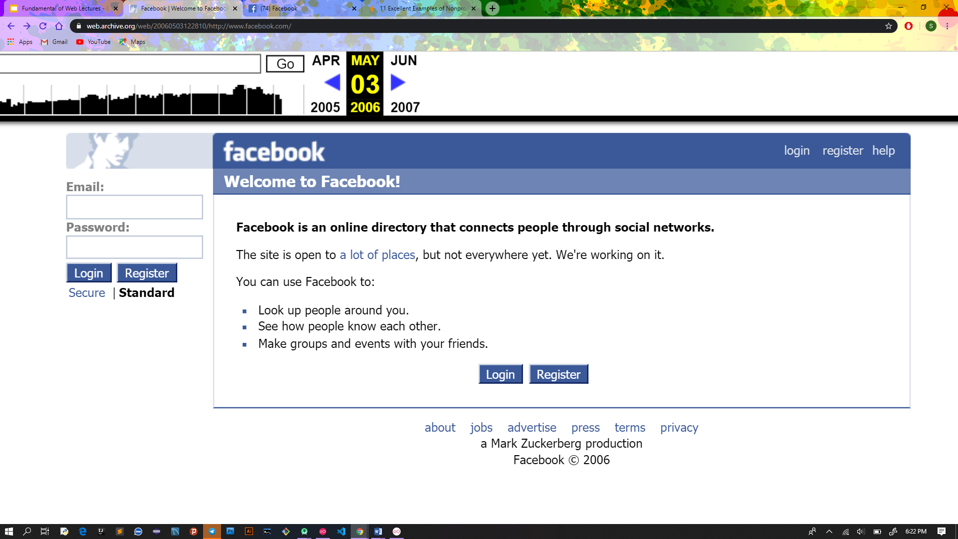

* In May 03, 2006 Facebook was open site but not everywhere.
* Used to look up people around us
* Used to make group and evets with our friends
* The UI looked like the on this
* We have contact information on the bottom which is good
* It was all text based

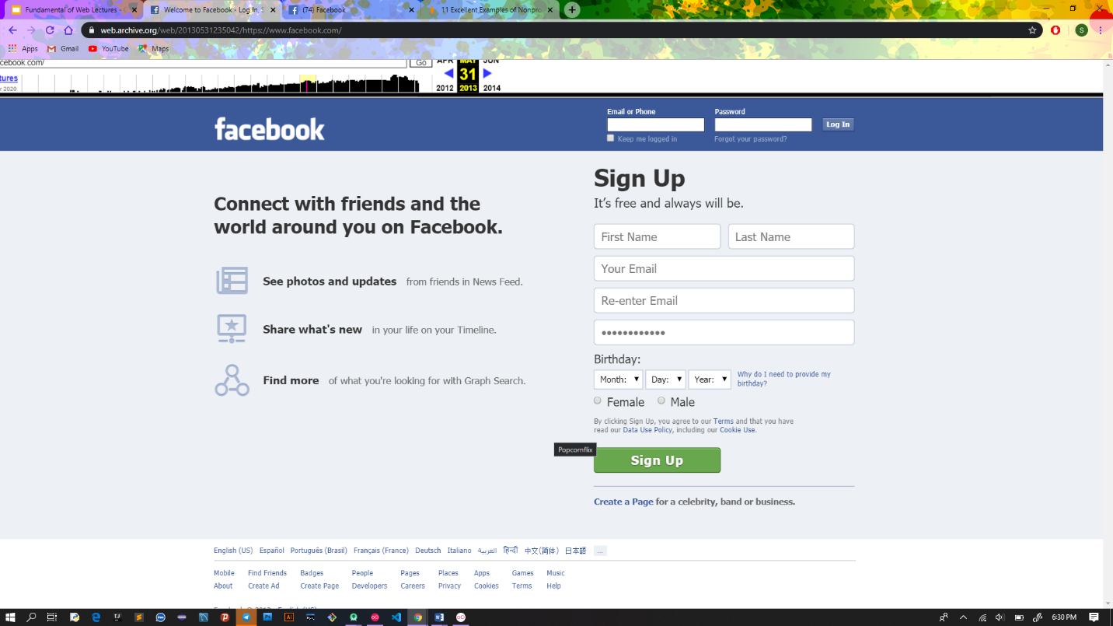

* In May 31, 2013 the UI of face book become more classic.
* The login form was located at the top of the sites page and the signup form covers wide space.
* It required more information to fill up by the user
* It has many languages we can change
* There is an option to keep us logged in
* If we forgot the password, we can say it forgot password and manage it
* The font and color is more professional

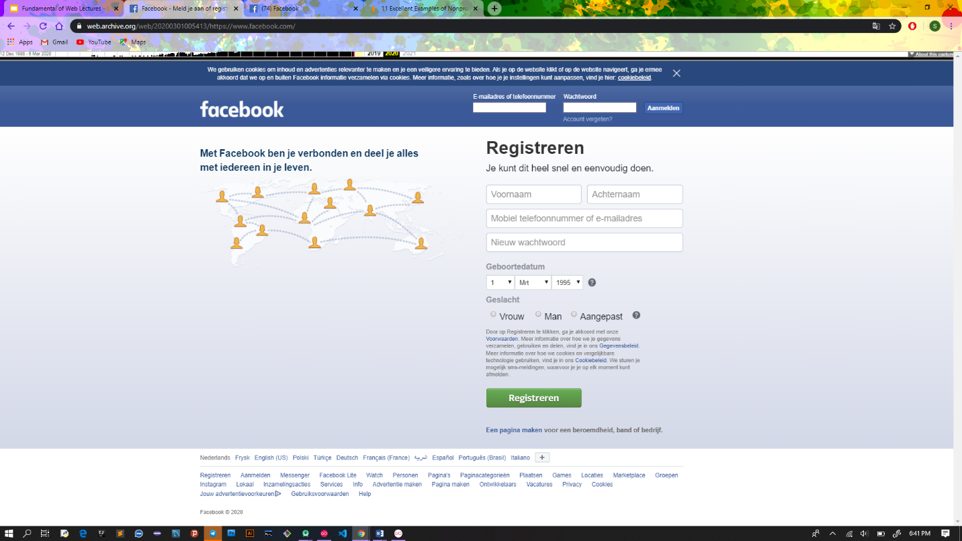

* In March 01, 2020 it looks like this
* This version is more color added
* It is almost same with 2013 but some features are added

**Reference**

<https://www.expertmarket.co.uk/web-design/different-types-of-websites>

<https://hackernoon.com/the-evolution-of-the-internet-from-decentralized-to-centralized-3e2fa65898f5>