Introduction
The director of marketing at Cyclistic, a bike-share company in Chicago, believes the company’s future success depends on maximizing the number of annual memberships. Therefore, the marketing analyst team at Cyclistic wants to understand how casual riders and annual members use Cyclistic bikes differently. From these insights, the team will design a new marketing strategy to convert casual riders into annual members.

About the company:
In 2016, Cyclistic launched a successful bike-share offering. Since then, the program has grown to a fleet of 5,824 bicycles that are geotracked and locked into a network of 692 stations across Chicago. The bikes can be unlocked from one station and returned to any other station in the system anytime.
Until now, Cyclistic’s marketing strategy relied on building general awareness and appealing to broad consumer segments. One approach that helped make these things possible was the flexibility of its pricing plans: single-ride passes, full-day passes, and annual memberships. Customers who purchase single-ride or full-day passes are referred to as casual riders. Customers who purchase annual memberships are Cyclistic members.

Business Task Statement

Problem:
How to convert casual riders into annual members to maximize profit?

Business Task:
Maximizing the number of annual memberships through converting casual riders into annual members. Therefore, understand how casual riders and annual members use Cyclistic bikes differently to design a new marketing strategy focusing on casual riders.
This question will guide the future marketing program:
1.How do annual members and casual riders use Cyclistic bikes differently?

Key Stakeholders:
Lily Moreno (The director of marketing): Responsible for the development of campaigns and initiatives to promote the bike-share program.
Cyclistic marketing analytics team: A team of data analysts who are responsible for collecting, analyzing, and reporting data that helps guide Cyclistic marketing strategy.
Cyclistic executive team: Will decide whether to approve the recommended marketing program.

Data Description

Data source:
The data for analysis can be obtained from the "divvy-tripdata" bucket, which includes multiple CSV files. These files are available for download in a range of zip files, from 202206-divvy-tripdata.zip to 202305-divvy-tripdata.zip.

Data Details:
Data Format: The data is provided in 12 CSV files, each containing structured data in comma-separated values (CSV) format.
Covered Period: The data covers the period from June 2022 to May 2023, capturing ride information for this one-year duration.
Information Included:
- Ride ID
- Ride Type (Classic - Docked - Electric)
- Start of Ride (Date - Time)
- End of Ride (Date - Time)
- Start Station Name
- Start Station ID
- End Station Name
- End Station ID
- Start Latitude
- Start Longitude
- End Latitude
- End Longitude
- Customer Type (Member - Casual)

Data Processing

Data Cleaning and Manipulation Process Documentation:
- Files Import
The CSV files are imported into SQL as tables within the "cyclistic" database.
- Merging Tables
A new table called "combined_trips" is created using the following schema:
CREATE TABLE cyclistic.dbo.combined_trips (
ride_id NVARCHAR(50),
rideable_type NVARCHAR(50),
started_at DATETIME2,
ended_at DATETIME2,
start_station_name NVARCHAR(100),
start_station_id NVARCHAR(50),
end_station_name NVARCHAR(100),
end_station_id NVARCHAR(50),
start_lat FLOAT,
start_lng FLOAT,
end_lat FLOAT,
end_lng FLOAT,
member_casual NVARCHAR(50)
);

The data from all the CSV files is inserted into the new "combined_trips" table using the UNION ALL operator.

- NULLS
Checking for NULL values across all columns in the "combined_trips" table is done using the following query:

SELECT *
FROM cyclistic.dbo.combined_trips
WHERE ride_id IS NULL
OR rideable_type IS NULL
OR started_at IS NULL
OR ended_at IS NULL
OR start_station_name IS NULL
OR start_station_id IS NULL
OR end_station_name IS NULL
OR end_station_id IS NULL
OR start_lat IS NULL
OR start_lng IS NULL
OR end_lat IS NULL
OR end_lng IS NULL
OR member_casual IS NULL

Total_num_of_rows | num_of_null_rows | Percentage
5,829,030 | 1,334,349 | 22.91%
The total number of rows with NULL values in any of these columns is 1,334,349, accounting for 22.91% of the total rows in the table. The columns with NULL values are "start_station_name," "start_station_id," "end_station_name," and "end_station_id." Since the Station ID columns are not used in the analysis and Station Name columns will be partly used, these NULL values will be disregarded for now.
- Duplicates
Identifying duplicate rows is done by checking the "ride_id" column for duplicate values using the following query:

SELECT ride_id
FROM cyclistic.dbo.combined_trips
GROUP BY ride_id
HAVING COUNT(*) > 1;

Only one row is identified as a duplicate based on the "ride_id" column. However, the data within this row differs, suggesting an error in the "ride_id" column rather than a duplicate ride. This row will not be removed as it will not impact the analysis.

- inconsistencies
Checking the length of the "ride_id" column is done using the following query:

SELECT LEN(ride_id)
FROM cyclistic.dbo.combined_trips

To identify inconsistencies in the length of the "ride_id" values, the following query is executed:

SELECT ride_id
FROM cyclistic.dbo.combined_trips
WHERE LEN(ride_id) < 16 OR LEN(ride_id) > 16
The query reveals that there are 512 rows with a length less than 16, indicating discrepancies in the IDs. For example, values like "2.93492E+15" appear, whereas a normal ID should follow the format "C10099D850C7FC17".
- New Table Version
A new version of the table, called "combined_trips_v2," is created using the following query:

SELECT ride_id, rideable_type,started_at, ended_at, start_station_name, end_station_name, member_casual,
DATEDIFF(MINUTE, started_at, ended_at) AS ride_duration,
CONCAT(start_station_name, ' to ', end_station_name) AS ride_route,
FORMAT(started_at, 'dddd') AS day_of_week
INTO cyclistic.dbo.combined_trips_v2
FROM cyclistic.dbo.combined_trips

The new table, "combined_trips_v2," includes additional columns such as "ride_duration" (calculated as the difference in minutes between "started_at" and "ended_at"), "ride_route" (a concatenation of the start and end station names), and "day_of_week" (the day of the week extracted from the "started_at" timestamp).

Analysis

Descriptive analysis:
1. Calculation of the mean of “ride_duration”
Calculating the average duration of rides, separated by member and casual riders:
SELECT
AVG(ride_duration) AS average_duration,
AVG(CASE WHEN member_casual = 'member' THEN ride_duration END) AS member_average_duration,
AVG(CASE WHEN member_casual = 'casual' THEN ride_duration END) AS casual_average_duration
FROM [cyclistic].[dbo].[combined_trips_v2]

average_duration | member_average_duration | casual_average_duration
18 | 12 | 28
The average duration for all rides is 18 minutes. The average duration for member riders is 12 minutes, while the average duration for casual riders is 28 minutes. This suggests that casual riders tend to have longer ride durations compared to members, indicating a potential difference in usage patterns between the two groups.
2. Calculating the maximum “ride_duration”
Determining the maximum ride duration observed, with separate values for members and casual riders:
SELECT
MAX(ride_duration) AS max_duration,
MAX(CASE WHEN member_casual = 'member' THEN ride_duration END) AS member_max_duration,
MAX(CASE WHEN member_casual = 'casual' THEN ride_duration END) AS casual_max_duration
FROM [cyclistic].[dbo].[combined_trips_v2]

max_duration | member_max_duration | casual_max_duration
32035 | 1498 | 32035
The maximum ride duration observed is 32,035 minutes, which is equivalent to approximately 22 days. For member riders, the maximum ride duration is 1,498 minutes, while for casual riders, it is also 32,035 minutes. It is worth investigating why there are such long ride durations, especially for casual riders, as it could be due to issues like bike theft or failure to properly dock the bike.
After further investigation, it was discovered that ride durations exceeding 1,440 minutes (24 hours) are considered outliers and may indicate issues with bike return or potential bike theft. Therefore, these trips with durations greater than 1,440 minutes should be removed from the analysis.

3. Calculating the minimum “ride_duration”
Finding the minimum ride duration observed, both overall and for member and casual riders:
SELECT
MIN(ride_duration) AS min_duration,
MIN(CASE WHEN member_casual = 'member' THEN ride_duration END) AS member_min_duration,
MIN(CASE WHEN member_casual = 'casual' THEN ride_duration END) AS casual_min_duration
FROM [cyclistic].[dbo].[combined_trips_v2]

min_duration | member_min_duration | casual_min_duration
-169 | -169 | -127
The minimum ride duration observed is -169 minutes. It is unrealistic to have negative ride durations, and further investigation is needed to understand the cause. It is recommended to remove these negative duration rides from the analysis and investigate the underlying reasons for this inconsistency.
4. The mean after removing outliers
Recalculating the average ride duration after removing outlier rides with excessively long or negative durations:
SELECT
AVG(ride_duration) AS average_duration,
AVG(CASE WHEN member_casual = 'member' THEN ride_duration END) AS member_average_duration,
AVG(CASE WHEN member_casual = 'casual' THEN ride_duration END) AS casual_average_duration
FROM [cyclistic].[dbo].[combined_trips_v2]
WHERE ride_duration <= 1440 AND ride_duration >= 0

average_duration | member_average_duration | casual_average_duration
15 | 12 | 20
After removing the outlier ride durations exceeding 1,440 minutes and in negative, the average duration for all rides is recalculated as 15 minutes. The average duration for member riders remains at 12 minutes, while the average duration for casual riders decreases to 20 minutes. Removing the outliers provides a more accurate representation of the typical ride durations.
5. New Table Version
Creating a new table with filtered data from the original table:
SELECT *
INTO cyclistic.dbo.combined_trips_v3
FROM cyclistic.dbo.combined_trips_v2
WHERE ride_duration <= 1440 AND ride_duration >= 0

The new table called "combined_trips_v3" was created. This table contains the filtered data from "combined_trips_v2" where the ride durations are between 0 and 1,440 minutes (inclusive).

6. Calculation of the mode of “day_of_week”
To determine which day of the week has the highest frequency of rides, we calculate the mode of the “day_of_week” column:

SELECT day_of_week,
COUNT(day_of_week) AS total_day_rides,
COUNT(CASE WHEN member_casual = 'member' THEN day_of_week END) AS member_day_rides,
COUNT(CASE WHEN member_casual = 'casual' THEN day_of_week END) AS casual_day_rides
FROM cyclistic.dbo.combined_trips_v3
GROUP BY day_of_week
ORDER BY CASE
WHEN day_of_week = 'Monday' THEN 1
WHEN day_of_week = 'Tuesday' THEN 2
WHEN day_of_week = 'Wednesday' THEN 3
WHEN day_of_week = 'Thursday' THEN 4
WHEN day_of_week = 'Friday' THEN 5
WHEN day_of_week = 'Saturday' THEN 6
WHEN day_of_week = 'Sunday' THEN 7
END


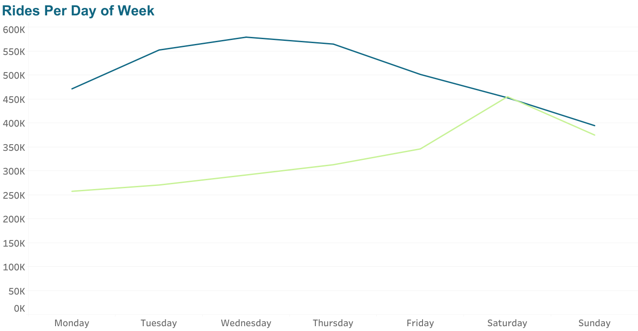



Saturday has the highest number of rides, with a total of 907,523 rides recorded throughout the year. Among these rides, 452,625 were by member riders, while 454,898 were by casual riders.
Sunday follows closely behind with 769,210 rides. Member riders accounted for 394,439 rides, while casual riders contributed 374,771 rides.
Weekdays also show substantial ride activity, with the highest number of rides occurring on Wednesday (870,628 rides). Out of these rides, 579,226 were by members, and 291,402 were by casual users.
The distribution of rides across weekdays indicates that members tend to have higher ride counts during weekdays, particularly from Monday to Wednesday. After Wednesday, the number of member rides gradually declines until Sunday. This pattern suggests that members primarily use the bikes for commuting or regular activities during weekdays.
Casual users, on the other hand, have a different pattern. They have relatively fewer rides on weekdays, particularly on Monday, and their ride counts increase gradually from Tuesday to Saturday. Saturday shows the highest number of rides for casual riders, indicating a preference for leisure activities on weekends.

- Calculation of the average “ride_duration” of “day_of_week”

The following query calculates the average ride duration for each day of the week:

SELECT
day_of_week,
AVG(ride_duration) AS avg_day_duration,
AVG(CASE WHEN member_casual = 'member' THEN ride_duration END) AS member_avg_day_duration,
AVG(CASE WHEN member_casual = 'casual' THEN ride_duration END) AS casual_avg_day_duration
FROM cyclistic.dbo.combined_trips_v3
GROUP BY day_of_week
ORDER BY CASE
WHEN day_of_week = 'Monday' THEN 1
WHEN day_of_week = 'Tuesday' THEN 2
WHEN day_of_week = 'Wednesday' THEN 3
WHEN day_of_week = 'Thursday' THEN 4
WHEN day_of_week = 'Friday' THEN 5
WHEN day_of_week = 'Saturday' THEN 6
WHEN day_of_week = 'Sunday' THEN 7
END
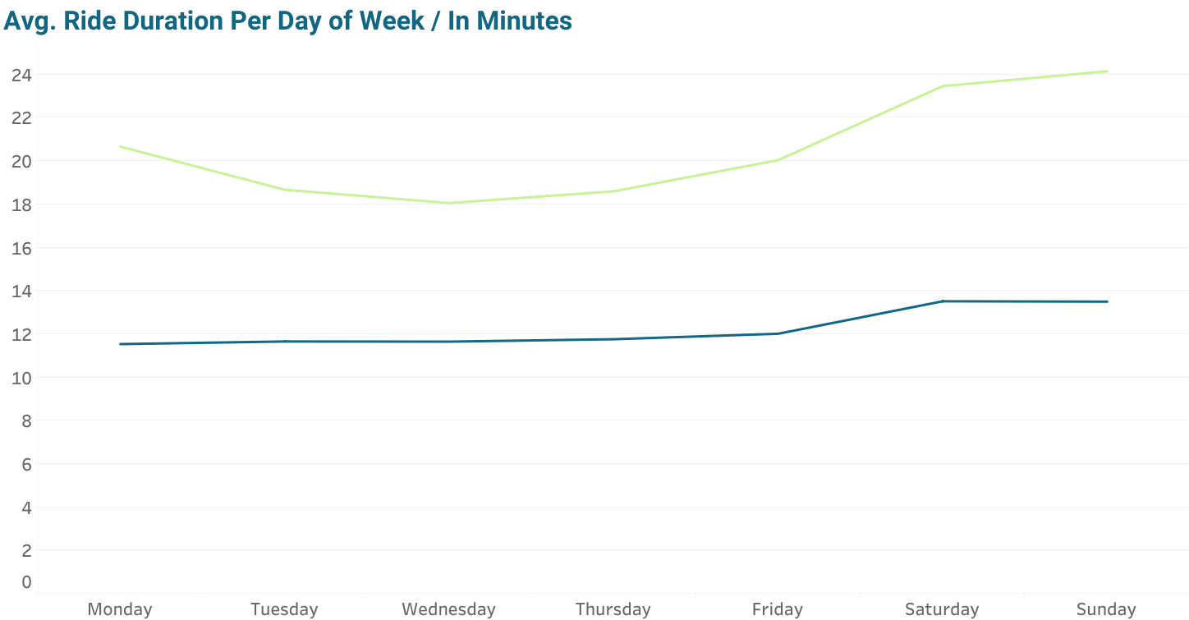

The total average duration starts at 14 minutes on Monday and decreases to 13 minutes on Tuesday and Wednesday. However, it begins to increase again from Thursday, reaching 18 minutes on Saturday and Sunday.
When considering the average duration for member riders, it consistently stays at 11 minutes throughout the weekdays. As the weekend approaches, there is a slight increase in duration, reaching 13 minutes on both Saturday and Sunday. In contrast, casual riders exhibit a distinct trend. The weekdays show an average duration of 18 minutes, but as we move towards the weekend, the duration significantly increases, peaking at 24 minutes on Sunday. On Monday, the average duration for casual riders decreases to 20 minutes.
These findings indicate that members and casual riders have different usage patterns. Members tend to use the bikes consistently throughout the week, possibly for commuting or regular activities. Casual riders, on the other hand, show a preference for leisurely rides, as evidenced by their longer durations on weekdays and weekends.
8. Exploring different seasons
A. The query explores the different seasons by analyzing the number of rides taken in each month, distinguishing between member riders and casual riders.
SELECT
YEAR(started_at) AS year,
MONTH(started_at) AS month,
COUNT(*) AS num_of_trips,
SUM(CASE WHEN member_casual = 'member' THEN 1 ELSE 0 END) AS num_member_trips,
SUM(CASE WHEN member_casual = 'casual' THEN 1 ELSE 0 END) AS num_casual_trips
FROM [cyclistic].[dbo].[combined_trips_v3]
GROUP BY YEAR(started_at), MONTH(started_at)
ORDER BY YEAR(started_at), MONTH(started_at)

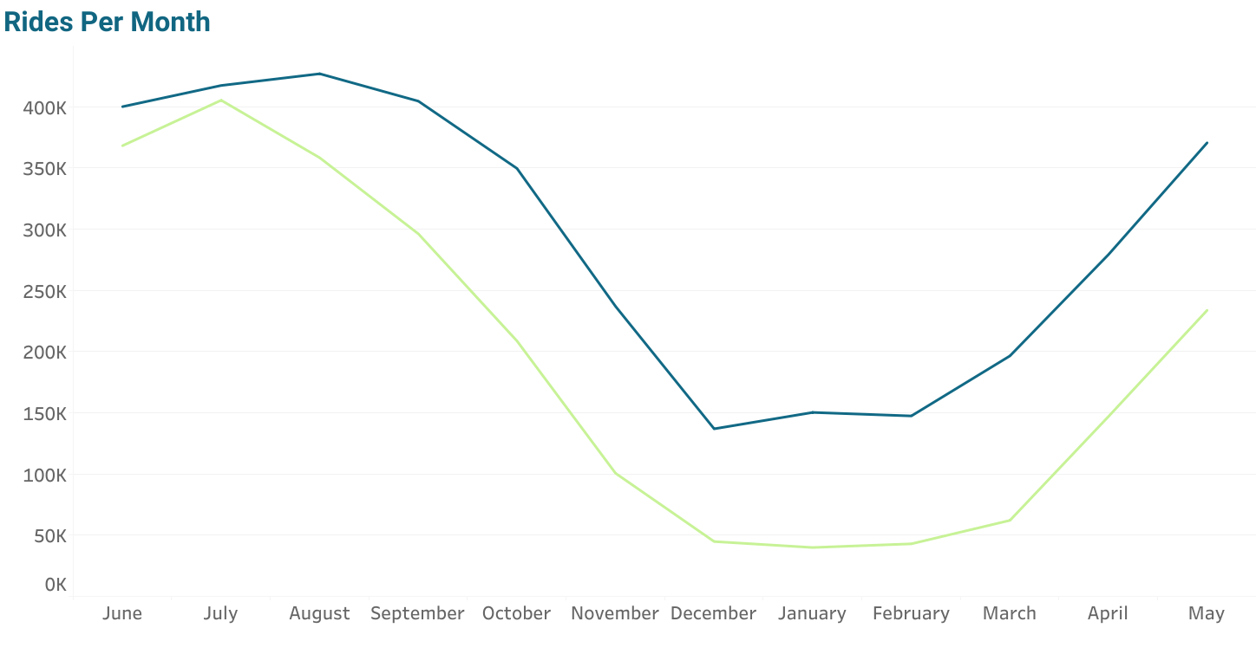

Both members and casual riders follow a similar pattern in terms of the number of rides taken during different seasons. The number of rides tends to increase during the summer months, reaching its peak in July. During this period, both member and casual riders show a relatively high number of rides, with members slightly outnumbering casual riders.
As the summer season transitions into the winter months, the number of rides decreases for both members and casual riders. However, it is interesting to note that the decrease in rides is more significant for casual riders, with a decline of 88%, compared to a decrease of 65% for members. This indicates that casual riders may be more influenced by seasonal factors, such as weather conditions or specific activities associated with summer, resulting in a larger decrease in their ride numbers.
With the arrival of spring, the number of rides starts to rise again for both member and casual riders, signaling a shift towards increased bike usage as the weather improves and outdoor activities become more appealing. This upward trend continues into the following months, with both rider segments gradually increasing their ride numbers.

B. The query calculates the average ride duration for each month:

SELECT
YEAR(started_at) AS YEAR,
MONTH(started_at) AS month,
AVG(ride_duration) AS average_duration,
AVG(CASE WHEN member_casual = 'member' THEN ride_duration END) AS member_average_duration,
AVG(CASE WHEN member_casual = 'casual' THEN ride_duration END) AS casual_average_duration
FROM cyclistic.dbo.combined_trips_v3
GROUP BY YEAR(started_at), MONTH(started_at)
ORDER BY YEAR(started_at), MONTH(started_at)

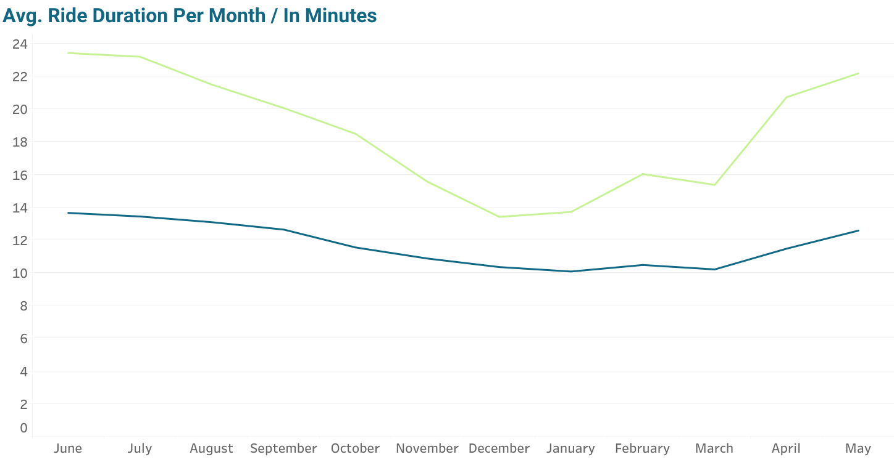

The average ride duration remains relatively consistent throughout the year, ranging from 10 to 18 minutes. Members tend to have shorter ride durations compared to casual customers in most months. The average ride duration is highest in the summer months (June, July, and August) and gradually decreases towards the end of the year.
There is a noticeable dip in average ride duration during the winter months (December, January, and February), which could be also influenced by factors such as weather conditions or decreased outdoor activities. The ride durations start to increase again in the spring months (March, April, and May), potentially indicating a shift towards more favourable weather conditions and increased outdoor activities.
Overall, these findings suggest that ride durations are influenced by seasonal variations, with longer rides during the summer and shorter rides during the winter. Members and casual customers exhibit similar patterns, but members tend to have shorter durations on average.
9. TOP 10 Popular_ride_routes
The following SQL query retrieves the top 10 popular ride routes, along with the total number of rides, the number of rides by members, and the number of rides by casual customers:
SELECT TOP 10
ride_route,
COUNT(*) AS total_rides,
SUM(CASE WHEN member_casual = 'member' THEN 1 ELSE 0 END) AS num_member_rides,
SUM(CASE WHEN member_casual = 'casual' THEN 1 ELSE 0 END) AS num_casual_rides
FROM [cyclistic].[dbo].[combined_trips_v3]
WHERE NOT(start_station_name IS NULL OR end_station_name IS NULL)
GROUP BY ride_route
ORDER BY total_rides DESC

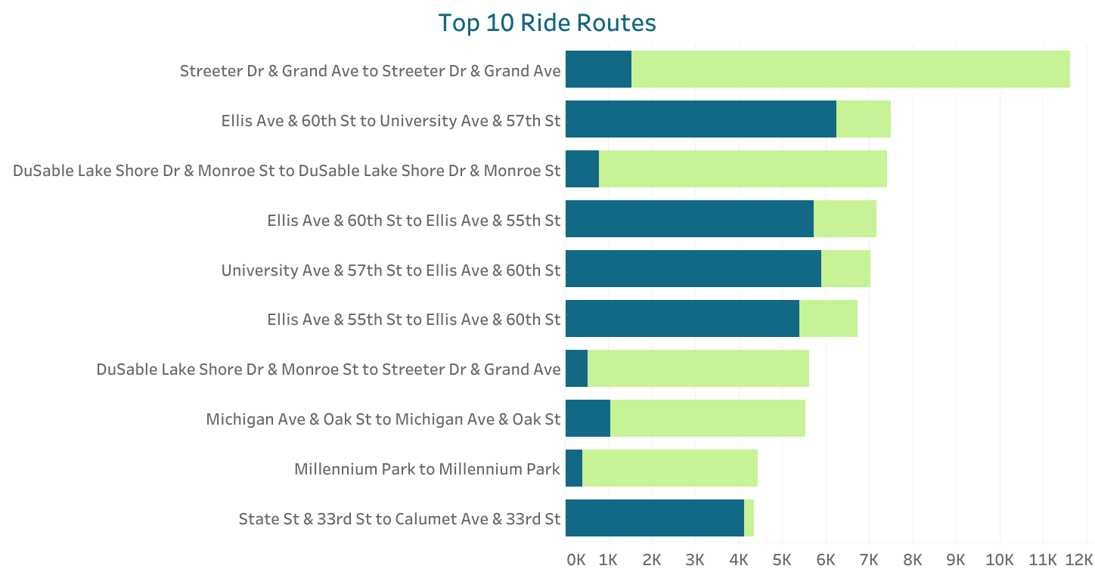

Members and casual customers have distinct preferences when it comes to popular ride routes. The top route with 11,619 rides is favored by casual customers, with 10,091 rides compared to 1,528 rides by members. Similarly, the second most popular route with 7,497 rides is primarily preferred by members, with 6,245 member rides compared to 1,252 casual rides.

This trend is consistent across all the top routes, indicating that there are specific routes that appeal more to either members or casual customers. Further investigation reveals that popular routes among members tend to revolve around universities and central city areas, whereas casual customers are more drawn to routes near parks and waterfronts. This observation further supports the previous analysis, emphasizing the differing usage patterns and preferences of these two customer segments.
10. Ride by Hour of the Day
The following query examines the distribution of rides throughout the day, broken down by hour, to gain insights into the patterns and preferences of members and casual customers:

SELECT
DATEPART(HOUR, started_at) AS hour,
COUNT(*) AS total_rides,
SUM(CASE WHEN member_casual = 'member' THEN 1 ELSE 0 END) AS member_rides,
SUM(CASE WHEN member_casual = 'casual' THEN 1 ELSE 0 END) AS casual_rides
FROM [cyclistic].[dbo].[combined_trips_v3]
GROUP BY DATEPART(HOUR, started_at)
ORDER BY hour
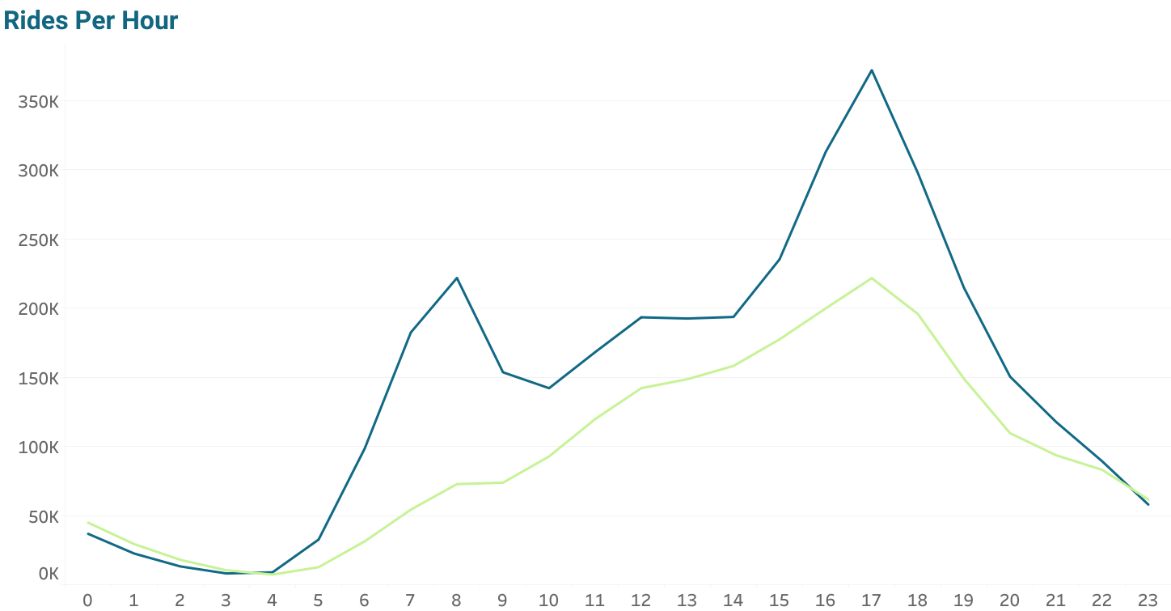

There is a notable peak in rides during the afternoon hours, specifically from 16 to 18. During this time, both members and casual customers contribute to a higher number of rides, suggesting that it is a popular period for bike usage.
Both members and casual customers exhibit a similar pattern of riding hours throughout the day, with some notable differences. Most rides for both segments occur during the daytime hours, from around 6 to 21. However, there are a few distinct trends to highlight.
For members, there is a significant increase in rides during the early morning hours, particularly from 6 am to 9 am. This suggests that members may use the bikes for commuting to work or other morning activities. Additionally, members tend to have a higher percentage of rides during these morning hours compared to casual customers.
On the other hand, casual customers have a higher proportion of rides during the late evening and early morning hours, specifically from 23 to 3. This indicates that casual customers may use the bikes for leisure or late-night activities.
Overall, both members and casual customers contribute to the rides throughout the day, but there are noticeable differences in their riding patterns during specific hours.

11. Ride by Hour of “day_of_week”

The query provides a breakdown of total rides, member rides, and casual rides based on the day of the week and hour of the day:

SELECT
day_of_week,
DATEPART(HOUR, started_at) AS hour,
COUNT(*) AS total_rides,
SUM(CASE WHEN member_casual = 'member' THEN 1 ELSE 0 END) AS member_rides,
SUM(CASE WHEN member_casual = 'casual' THEN 1 ELSE 0 END) AS casual_rides
FROM [cyclistic].[dbo].[combined_trips_v3]
GROUP BY day_of_week, DATEPART(HOUR, started_at)
ORDER BY day_of_week, hour
Tuesday
Wednesday
Monday
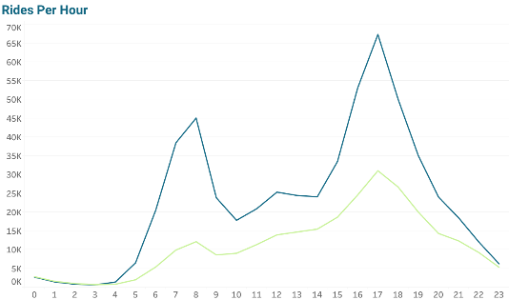
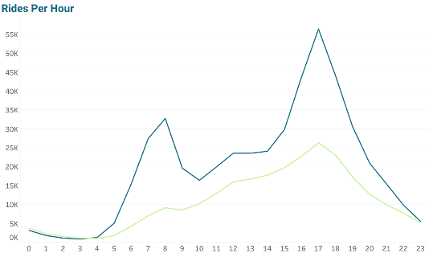
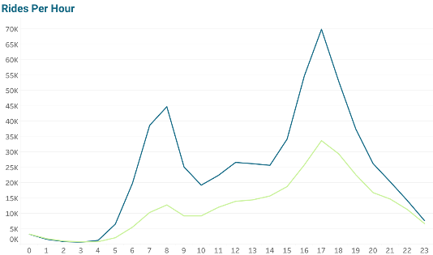

Saturday
Friday
Thursday
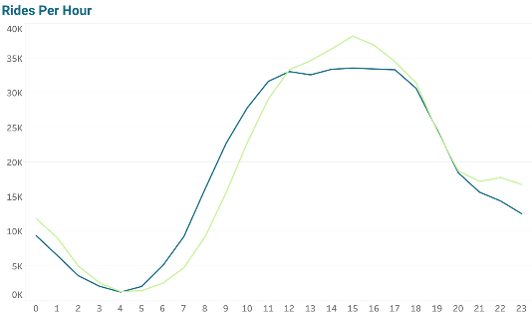
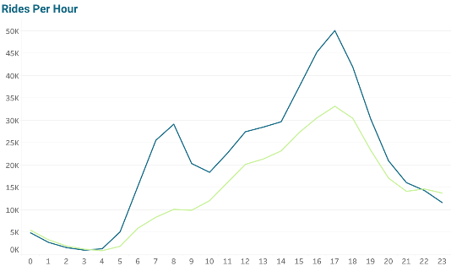
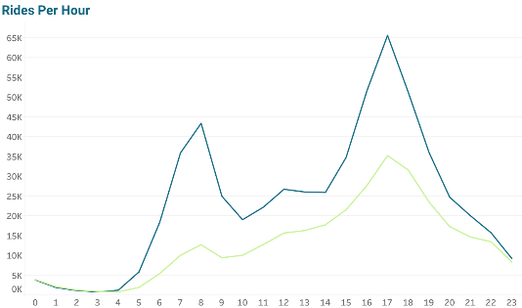

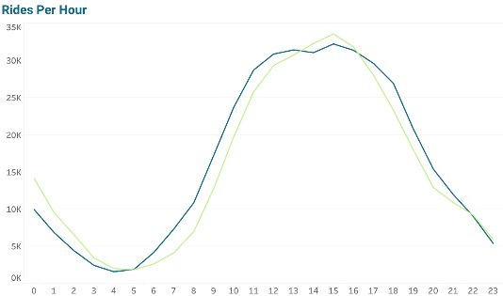
Sunday

On weekdays, in the morning period, there are significantly more rides by members compared to casual customers. However, as the day progresses, the gap between the number of rides by members and casual customers narrows, but there are still more member rides. The number of rides for both members and casual customers increases again around 16:00, but the percentage increase for members is almost double that of casual customers, suggesting that more members use the bikes for commuting to and from work or school. On weekends, the pattern is different, with both customers showing a gradual increase in rides starting from the morning and peaking around 16:00, followed by a decrease. This implies that weekends are more popular for recreational bike rides for both members and casual customers.
12. Average Ride Duration by Hour of “day_of_week”

The query computes the average ride duration for members and casual customers across different days of the week and hours of the day:

SELECT day_of_week,
DATEPART(HOUR, started_at) AS hour,
AVG(ride_duration) AS avg_ride_duration,
AVG(CASE WHEN member_casual = 'member' THEN ride_duration END) AS avg_member_ride_duration,
AVG(CASE WHEN member_casual = 'casual' THEN ride_duration END) AS avg_casual_ride_duration
FROM [cyclistic].[dbo].[combined_trips_v3]
GROUP BY day_of_week, DATEPART(HOUR, started_at)
ORDER BY day_of_week, hour
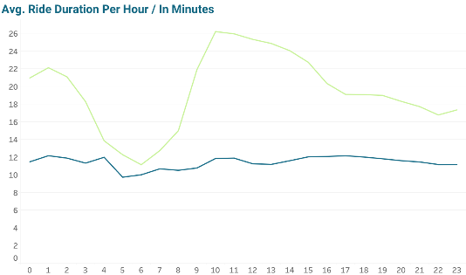
Wednesday
Tuesday
Monday
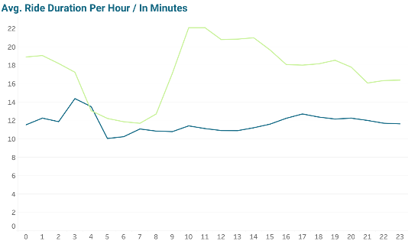
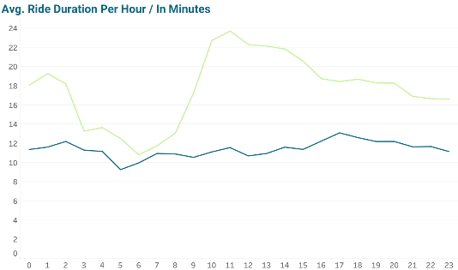

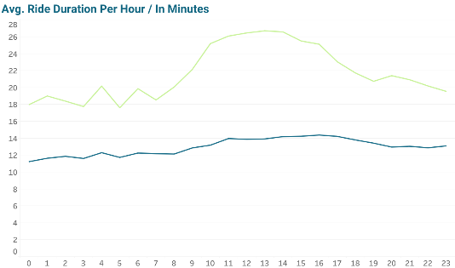
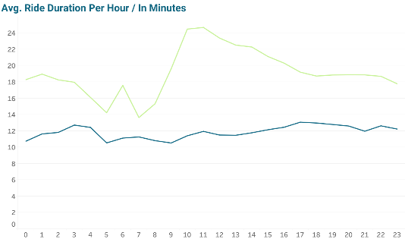
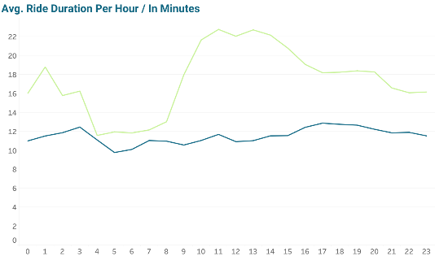
Saturday
Friday
Thursday

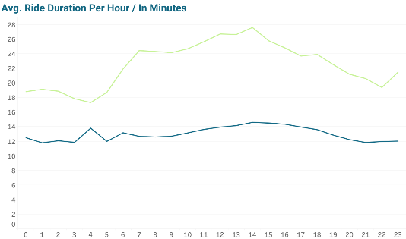
Sunday

Across all weekdays, casual customers tend to have longer average ride durations compared to members, while the morning period casual customers ride duration decrease almost to the same level as members indicating that casual customers use the bikes mostly for going to work or other daily activities during that time. On weekends, the average ride durations for both members and casual customers are higher than on weekdays. The highest average ride durations for both customer types are observed in the afternoon and evening hours, peaking around 17:00 to 20:00. This suggests that the late afternoon and early evening are the most popular times for bike rides. The data reveals that casual customers have a greater increase in average ride duration during weekends compared to members as their ride duration is almost constant.
13. Ride by bike type
The query shows rides based on different types of bikes, namely classic bikes, docked bikes, and electric bikes:

SELECT
rideable_type,
COUNT(*) AS total_rides,
SUM(CASE WHEN member_casual = 'member' THEN 1 ELSE 0 END) AS member_rides,
SUM(CASE WHEN member_casual = 'casual' THEN 1 ELSE 0 END) AS casual_rides
FROM [cyclistic].[dbo].[combined_trips_v3]
GROUP BY rideable_type
ORDER BY rideable_type

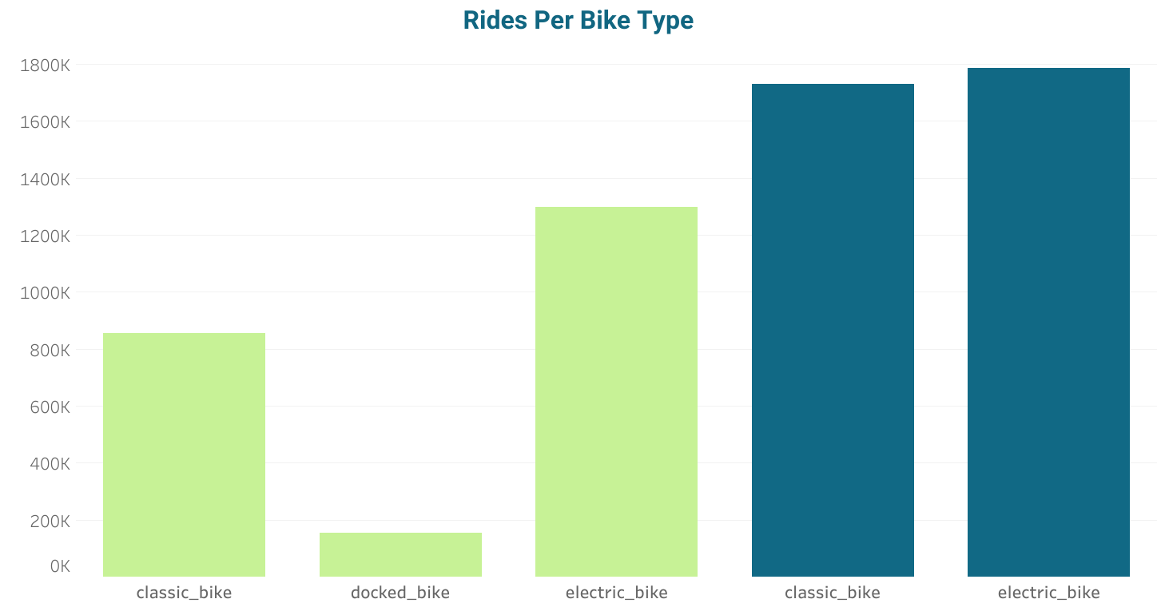
The results indicate that electric bikes are the most frequently used by both members and casual customers, with a total of 3,083,334 rides. Classic bikes follow closely behind with 2,585,092 rides. Interestingly, docked bikes have a significantly lower total ride count with 155,235 rides, and it appears that only casual riders have utilized this bike type.
The distinction between docked bikes and the other types warrants further investigation to understand why docked bikes seem to be exclusively used by casual customers and not by members.

14. Rides Per Year
SELECT COUNT(*) AS total_rides,
SUM(CASE WHEN member_casual = 'member' THEN 1 ELSE 0 END) AS member_rides,
SUM(CASE WHEN member_casual = 'casual' THEN 1 ELSE 0 END) AS casual_rides
FROM cyclistic.dbo.combined_trips_v3

total_rides | member_rides | casual_rides
5823661 | 3516131 | 2307530

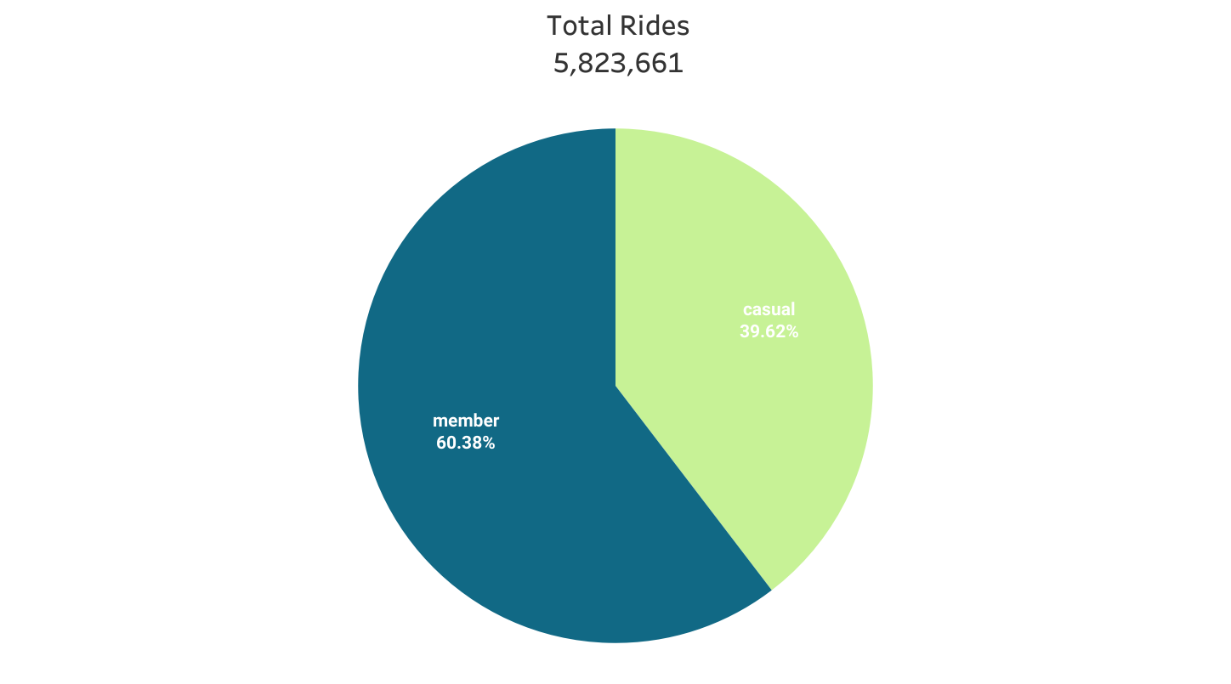

Analysis Summery
- Casual customers have higher ride durations compared to member customers.

- Casual customers show an increase in rides during weekends and a decrease on weekdays, while member customers exhibit the opposite trend with more rides on weekdays and fewer on weekends. Interestingly, both customer segments have a similar number of rides during the weekends.

- Both casual customers and member customers experience peak ride volumes during the summer season, while the number of rides decreases during the winter months. Additionally, member customers have shorter ride durations compared to casual customers in both winter and summer.

- Members and casual customers have distinct preferences for favourite routes. Members tend to prefer areas around universities and inner-city locations, while casual customers favour routes near parks and shores.
- There is a consistent pattern in riding hours for both members and casual customers, with a peak occurring around 18:00. However, members have an additional peak in the morning hours, while there are more casual riders than members during late night and early morning hours.

- Both member customers and casual customers show a preference for electric bikes, although the difference in usage between electric bikes and other bike types is not substantial.

Recommendations
- Implement targeted marketing campaigns ahead of the summer season.
- Counteract the winter decrease in ride numbers through promotions and adjustments to bikes and stations, considering weather conditions.
- Direct marketing efforts towards weekends and popular areas among casual riders.
- Encourage casual riders to become members by offering promotions for long ride durations.

Visualiation

Dashboard: Cyclistic Bike-Share | Tableau Public

Presentation: Cyclistic Case Study Presentation.pptx

