**Yin-Hsia Yen**

**Routing Protocols;**

**RIP & OSPF Simulation using Riverbed Modeller (OPNET)**

**EE450**

**Session 2**

**Abstract**

This lab is consisted of two separate mini labs, the first one is **Routing Information Protocol** and the second one is **Open Shortest Path First**. Both lab examines the behavior of network under different events.

The first lab examines the change of route table and network behavior after a link failure in a small network that consists of four interconnected routers and each connected with two subnetworks.

The second lab examines the effects of link failure, network area, and mode of network on the network routing behavior in a small network that consists of eight interconnected routers.

**Lab RIP: Routing Information Protocol**

Simulation Model

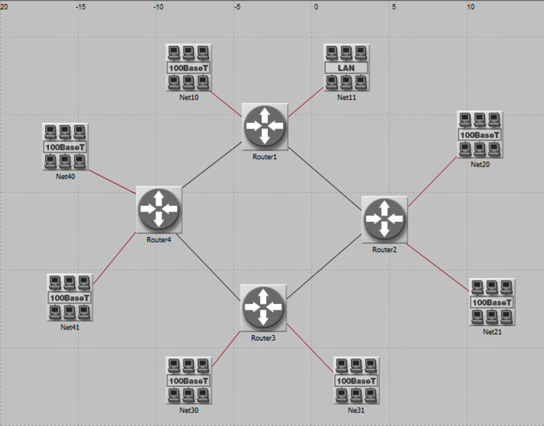 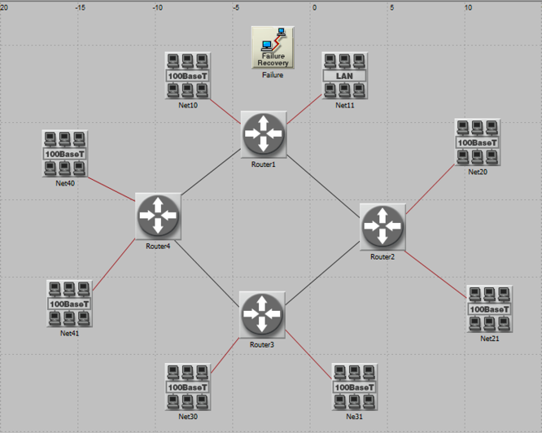

Print out the layout of the network you implemented in this lab. On this layout, from the information included in the **gdf** file, write down the IP addresses associated with **Router1** as well as the addresses assigned to each sub network

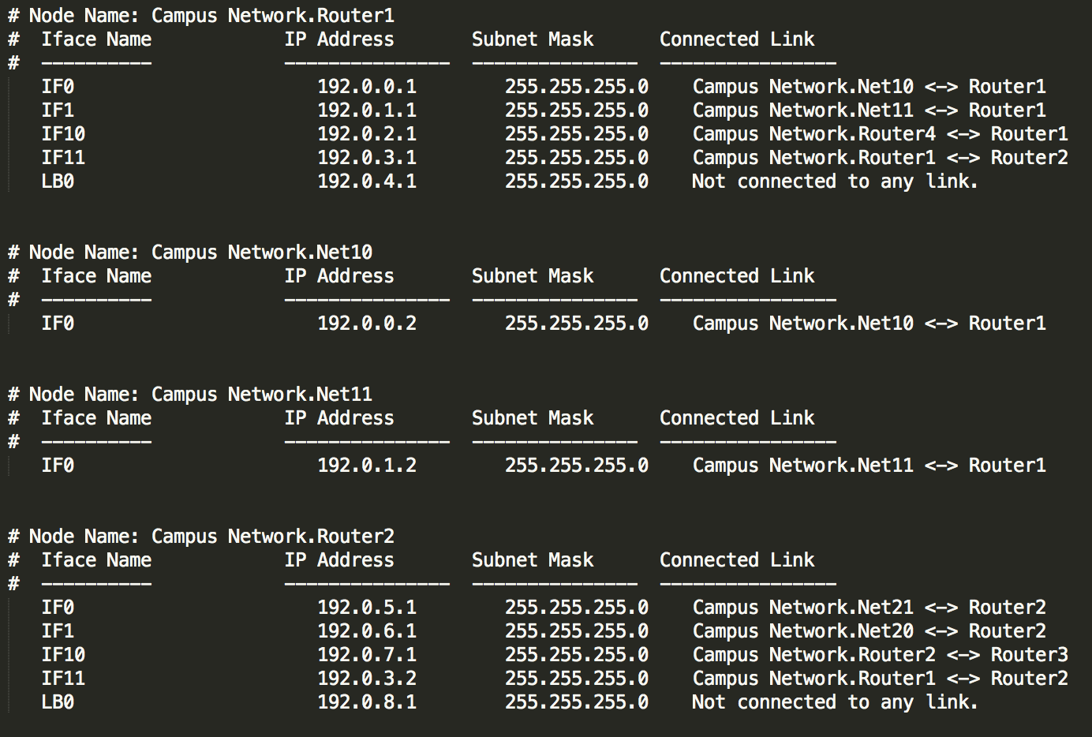

IP addresses associated to Router 1

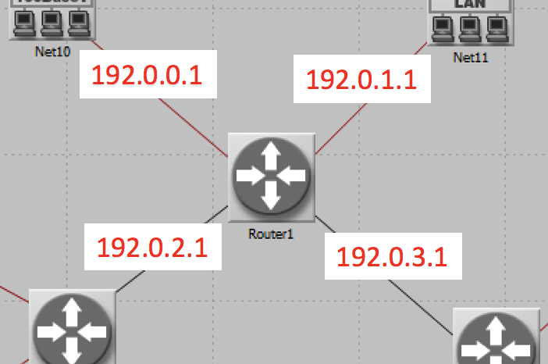

IP address for each sub network

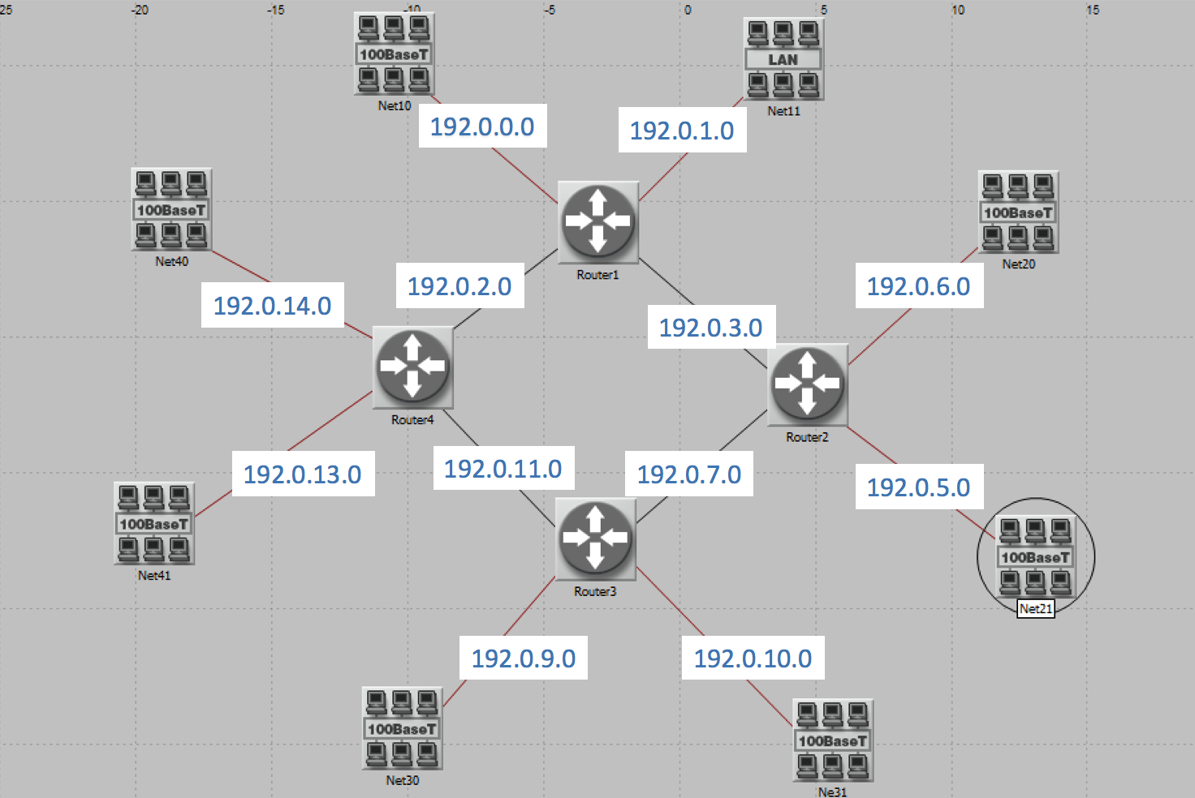

Q1. Obtain and analyze the graphs that compare the sent RIP traffic for both scenarios. Make sure to change the draw style for the graphs to **Bar Chart.**

The traffic sent in the No Failure scenario is smoother than the Failure scenario. The nodes repeated sending packets in the failure scenario in order to learn that there is a failure in the network and adjust routing table to avoid the failed link.

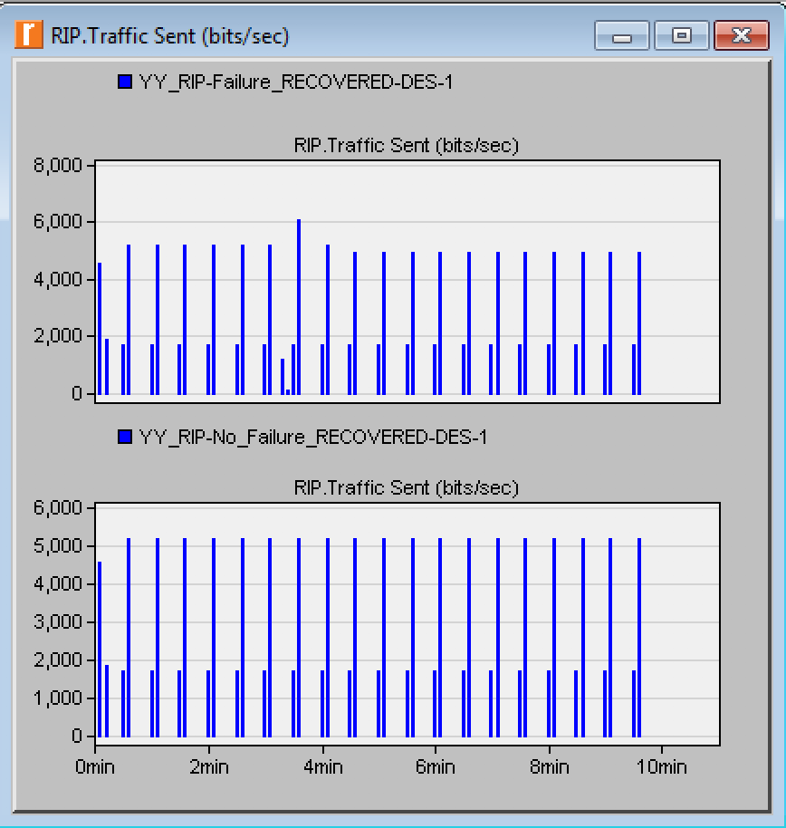

Q2. Describe and explain the effect of the failure of the link connecting Router1to Router2 on the routing tables.

After the failure of the link detected, the routing table update the path. As a result, Router4 is the next hop and the corresponding next hop addresses changed on the routing table.

(No Failure)

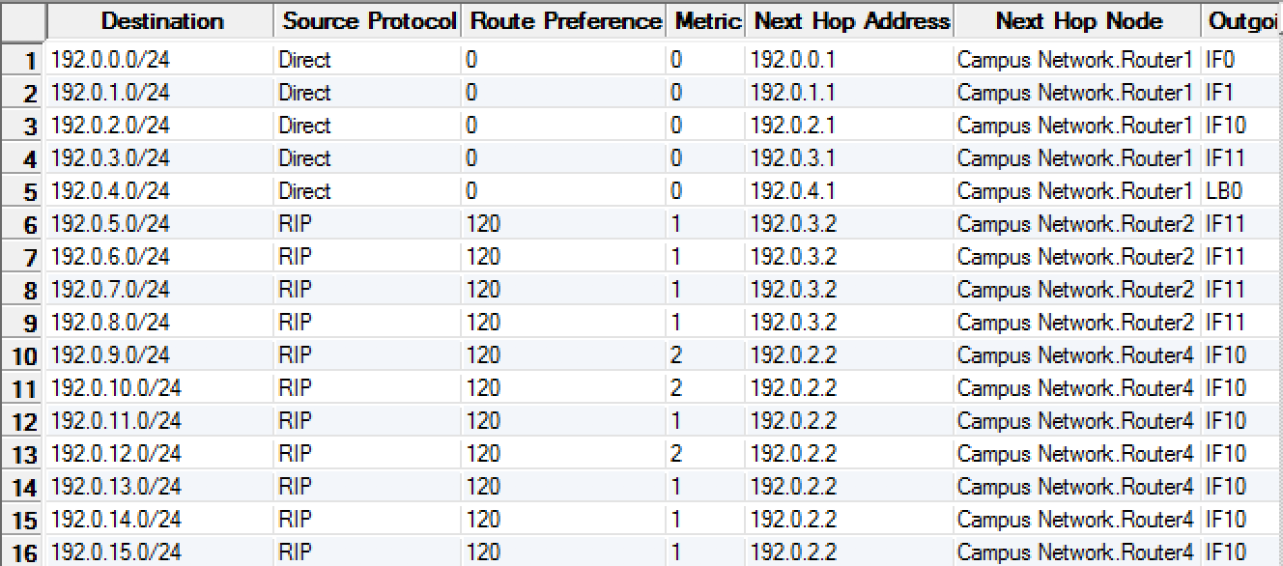

(Failure)

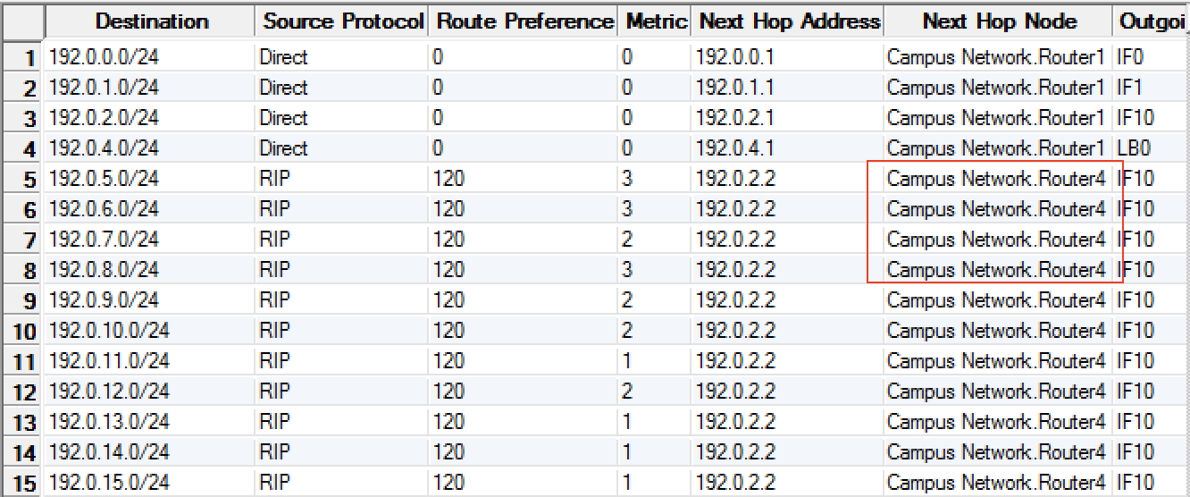

Q3. Create another scenario which has the link connecting **Router1** to **Router2** recover after 400 seconds. Generate and analyze the graph that shows the effect of this recovery on the **Total Number of Updates** in the routing table of **Router1**. Check the contents of **Router1**‘s routing table. Compare this table with the corresponding routing tables generated in the **NO Failure** and **Failure** scenarios.

The number of updates happened at 200s and 400s when the link failed and recovered. The routing table is updated at 200s when the failure happened, and the routing table is updated again at 400s when the link connection is recovered which is the same as No Failure.

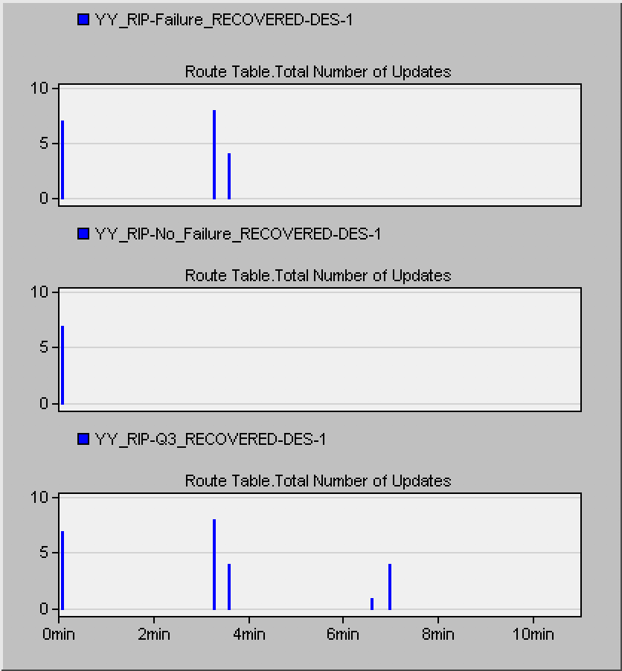

(Q3_RECOVERED)

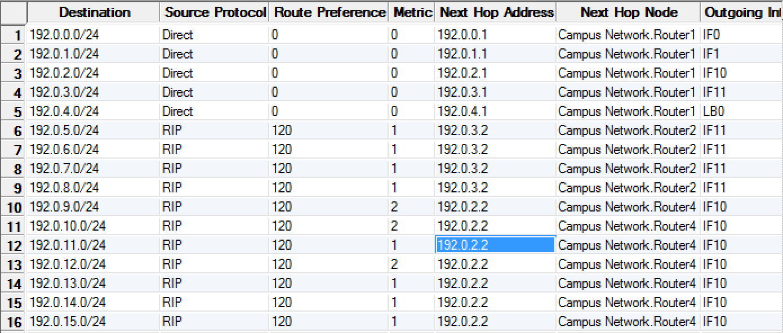

**Lab OSPF: Open Shortest Path First**

Simulation Model

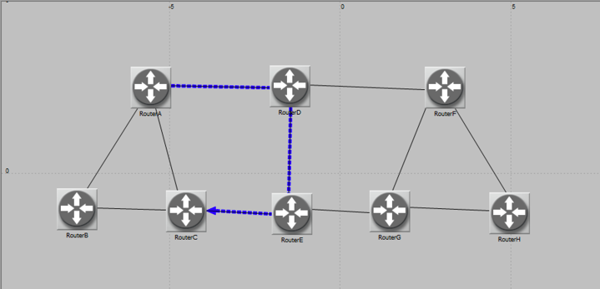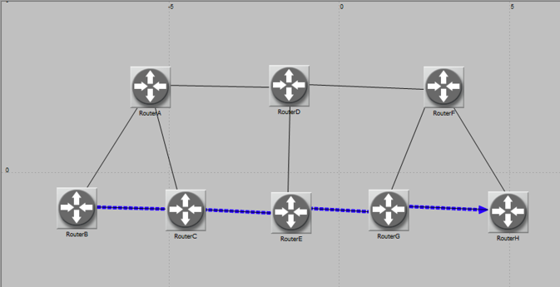

Fig. No_Areas (A-C) Fig. No_Areas (B-H)

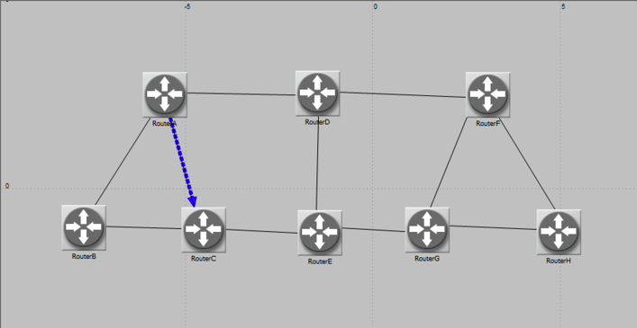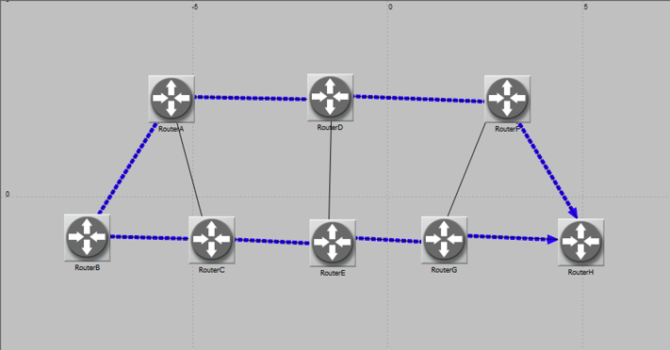

Fig Areas (A-C) Fig. Balanced (B-H)

Q1. Explain why the Areas and Balanced scenarios result in different routes than those observed in the No_Areas scenario, for the same pair of routers.

In **No_Areas** scenario, the path from Router A to Router C is A - D - E - C where the total cost is 15. The path from Router B to Router H is B - C - E - G - H where the total cost is 40 which is the minimum cost. In **Areas** scenario, the router first considers the network area before the cost for each link. Therefore, Router A directly goes to Router C even though the cost is higher than the minimum cost. In **Balance** scenario, the router will select all the best paths and the traffic is balanced between the path. Therefore, Router B to Router H is B - C - E - G – H, as well as B - A - D - F - H.

Q2. Using the simulation log, examine the generated routing table in RouterA for each of the three scenarios. Explain the values assigned to the Metric column of each route.

The metric column shows the cost through the corresponding link. In the No-Areas case, the cost going through Router A, D, E, and to C is 15. In the Areas case, the cost going from Router A to B and then to C which is 40. Since Router A, B and C are all in the same area, Router A will connect to B and C before considering connection with other nodes even the other connection cost is lower. In the Balanced case, the cost is the same as in No-Areas case, because it is the best route going from Router A to C in terms of cost.

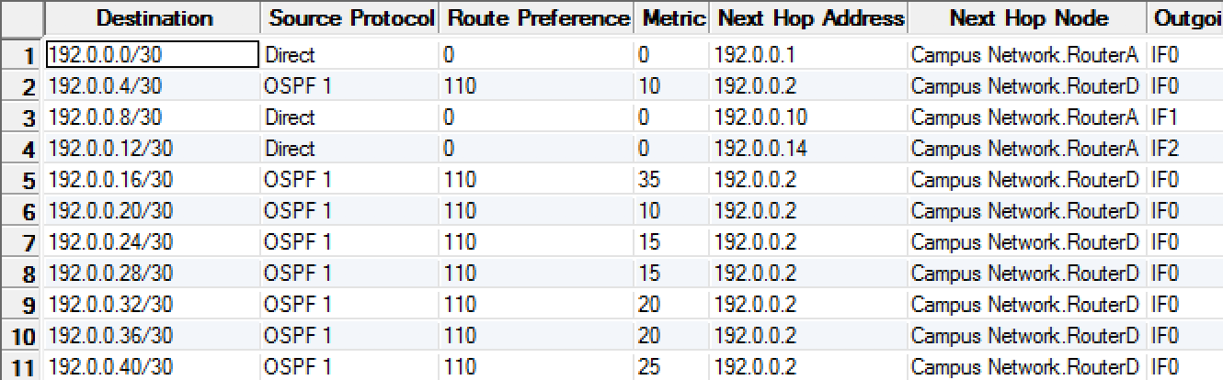

Fig. No Areas

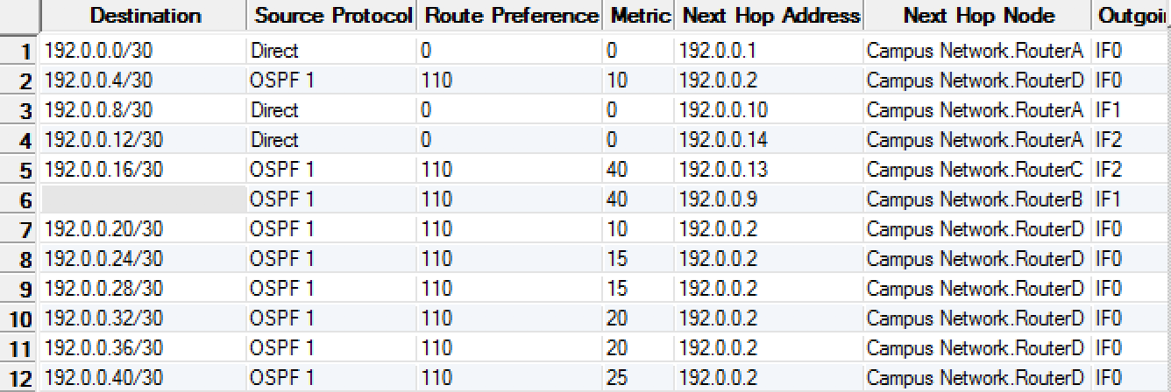

Fig. Areas

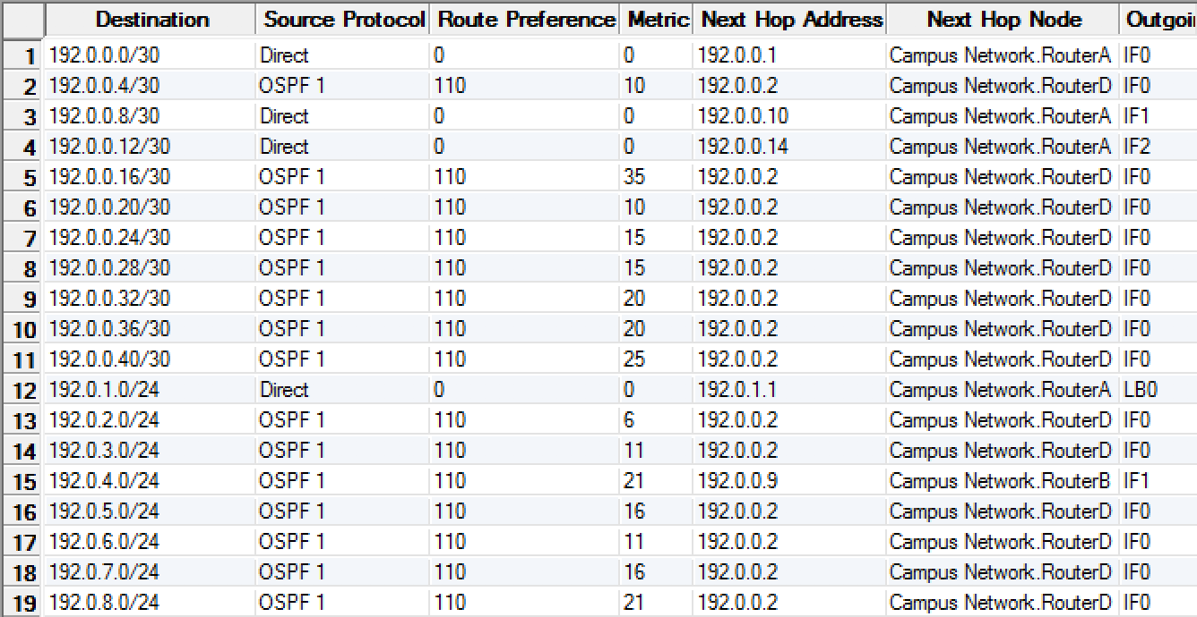

Fig. Balanced

Q3. Modeler allows you to examine the link-state database that is used by each router to build the directed graph of the network. Examine this database for RouterA in the No_Areas scenario. Show how RouterA utilizes this database to create a map for the topology of the network and draw this map (This is the map that will be used later by the router to create its routing table.)

Corresponding IP address around Router A

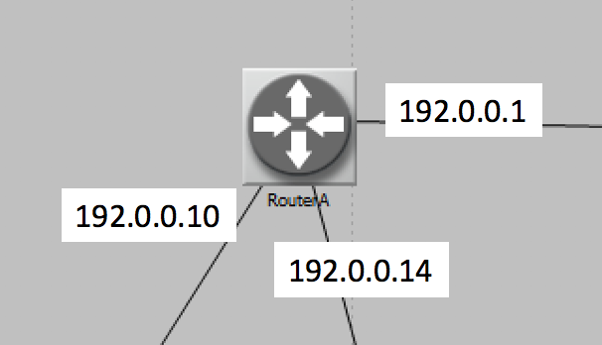

Sub-network

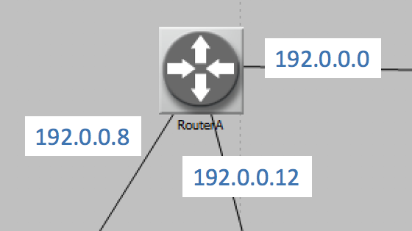

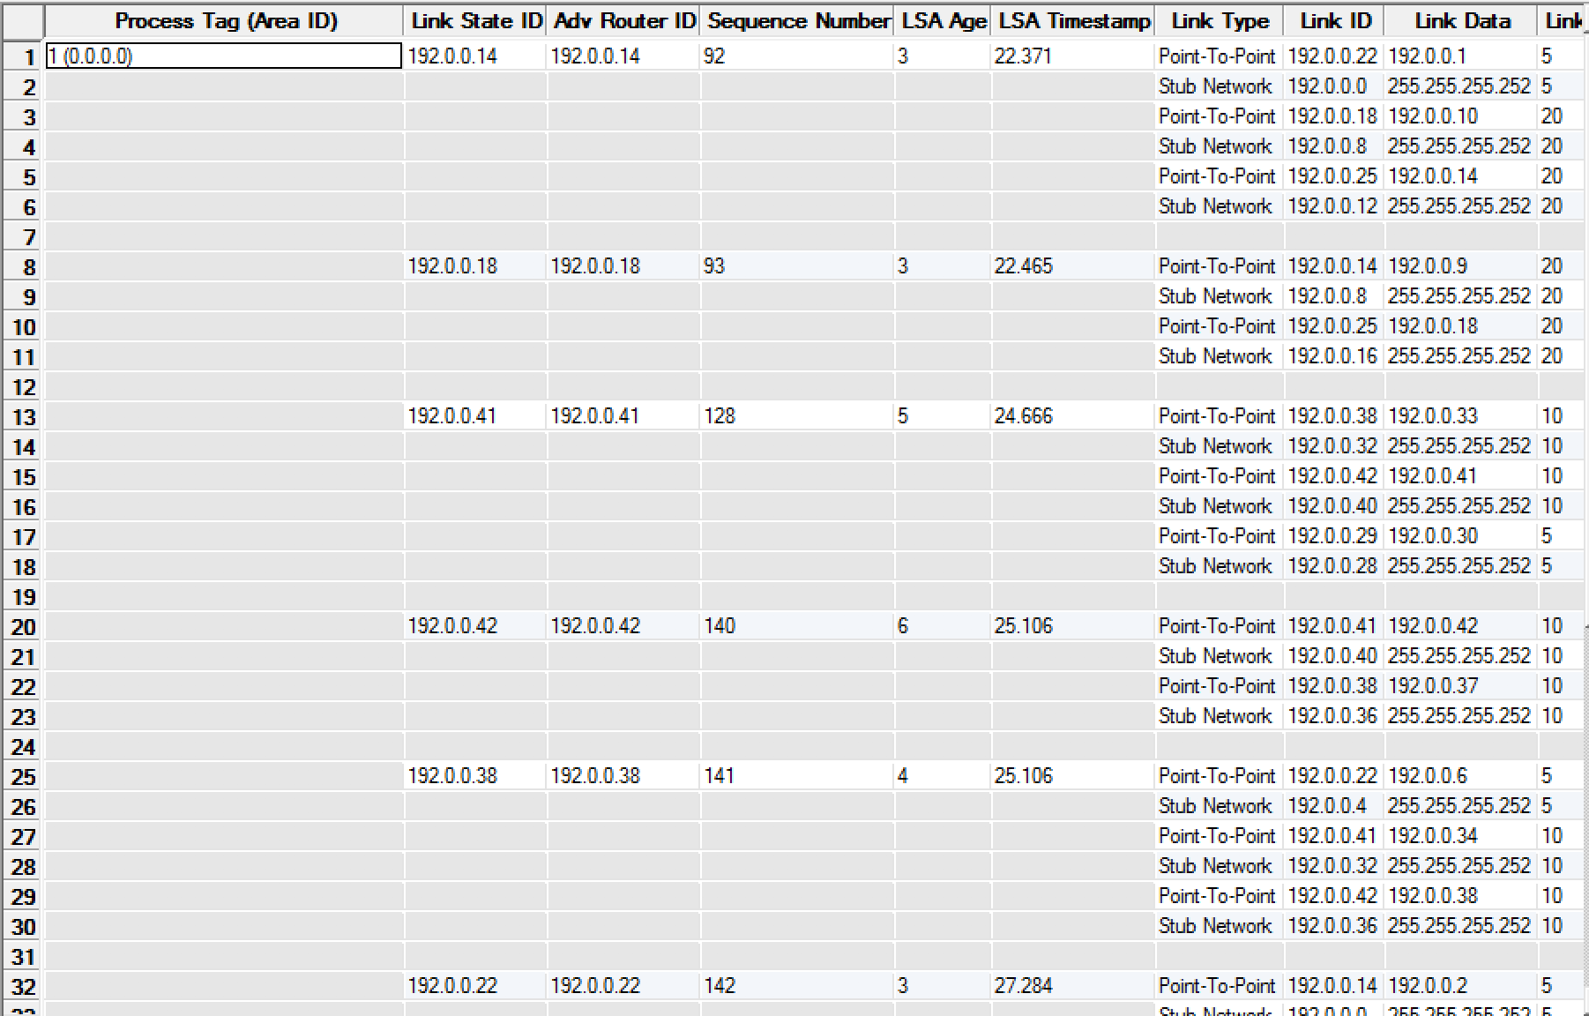

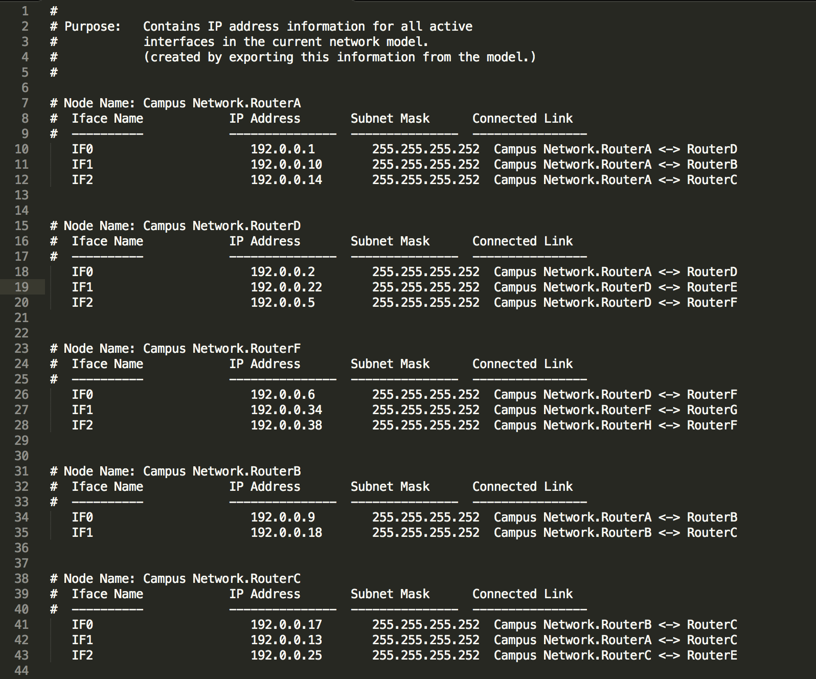

Q4. Create another scenario as a duplicate of the No_Areas scenario. Name the new scenario Q4_No_Areas_Failure. In this new scenario simulate a failure of the link connecting RouterD and RotuerE. Have this failure start after 100 seconds. Rerun the simulation. Show how that link failure affects the content of the link- state database and routing table of RouterA. (You will need to disable the global attribute OSPF Sim Efficiency. This will allow OSPF to update the routing table if there is any change in the network.)

The costs of the network that needs to go between router D and router E increase because the link D to E is not available. The router need to use another path to forward the data.

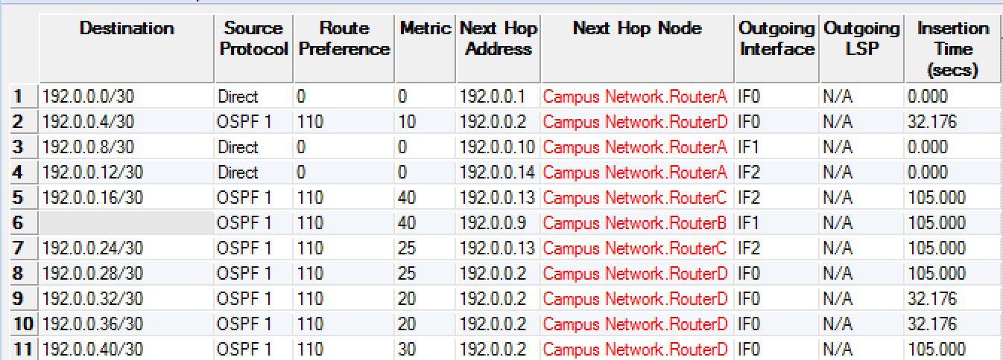

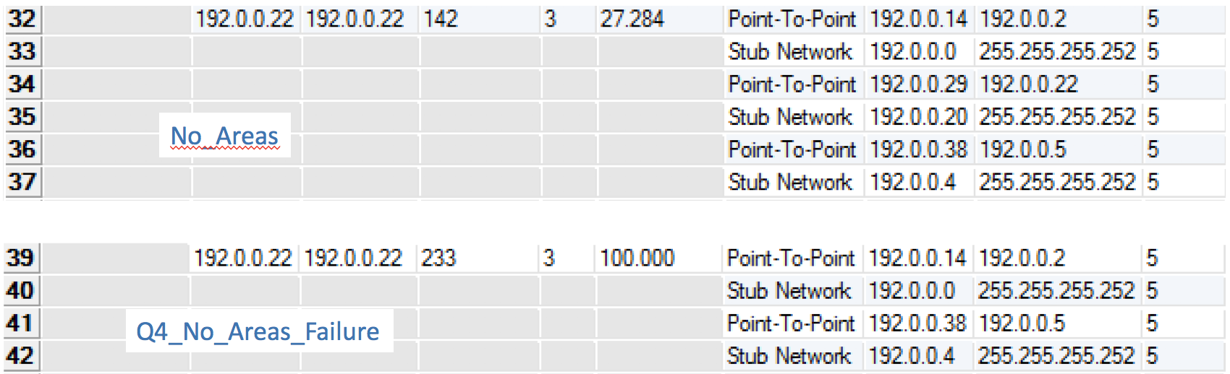

Q5. For both No_Areas and Q4_No_Areas_Failure scenario, collect the Traffic Sent (bits/sec) statistic (one of the Global Statistics under OSPF). Rerun the simulation for those two scenarios and obtain the graph that compares the OSPF’s Traffic Sent (bits/sec) in both scenarios. Comment on the obtained graph.

In the Q4_No_Areas_Failure scenario, there is a peak of traffic sent around 100s. However, in No_Areas scenario, traffic sent is smoother around 100s. It is because the routing table repeatedly sent packets in the Q4_No_Areas_Failure scenario.

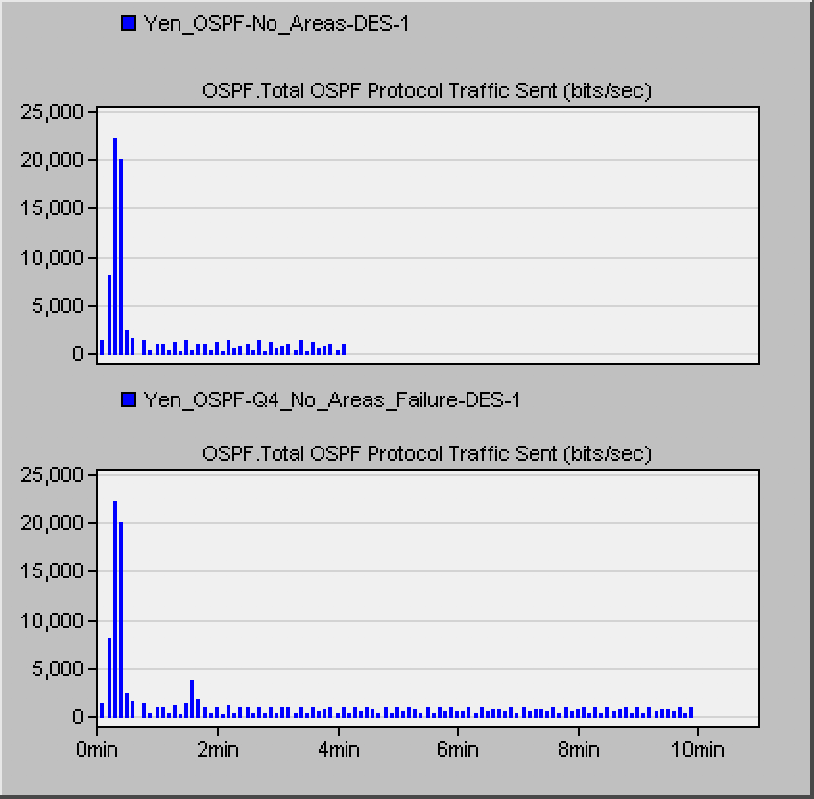

**Discussion and Conclusion**

From the first lab, when the link failure, the traffic sent will increase in the network because the routing table will be updated after a failure is recovered. In addition, from the second lab, no area scenario will take the minimum cost path. However, OSPF also has assigning area and load balancing setting. Apparently, OSPF is more complicated than RIP.