CS585
Database Systems
Fall 2009
Midterm Exam

Name: _____________________
Student ID: _________________

 | Maximum | Received
Problem 1 | 15
Problem 2 | 20
Problem 3 | 20
Problem 4 | 20
Problem 5 | 15
Problem 6 | 10

2 hr exam. A one sided 8.5 X 11 cheat sheet allowed
- 15 pts
Indicate whether each of the following statements is true or false (T/F):

______ Ternary relationships are not supported in ER.

______In EER, a subclass inherits the attributes of only the super-class that is one level above it in the hierarchy.

______When two relations are related to each other, a referencing relation has a foreign key.

______ Not every attribute has a domain

______ A weak entity can be identified uniquely only by considering the primary key of another (owner) entity

______ Some constraints (notably, functional dependencies) cannot be expressed in the ER model.

______ A weak entity can be identified uniquely only by considering the primary key of another (owner) entity

______ Views can be used to present necessary information, while hiding details in underlying relation(s).

______ The Oracle spatial database is an example of an OODBMS.

______ Regardless of how a kd-tree is constructed one can never be certain that the tree is balanced.

______ Rose algebra defines the rules of 3-valued logic.

______ SQLJ is more similar to embedded SQL than to JDBC

______ Stored procedures have the disadvantage that if the application works with multiple databases, the stored procedure has to be duplicated on all instances of the database.

______ Spatial databases provide efficient algorithms for joining of spatial data.

______ Although an R-tree is guaranteed to be balanced, one cannot be guaranteed to complete a search in this tree in O(logn) time.

- 20 pts
Consider the schema design below:

TEAM (TName, Location, Manager, Rank)
[STR] [STR] [STR] [NUM]
PLAYER (PName, Age, Salary, PNO, Team)
[STR] [NUM] [NUM] [NUM] [STR]

Primary keys are underlined above. There is the following referential integrity constraint:
From PLAYER.Team to TEAM.TName

Write the SQL queries for the following:

a) Find the PNO and Team of each player who is over Age 30 and who plays on a team ranked 10 or below.

b) Find the name of each team where all the players are younger than Age 25.

c) Find the PName, Age, Team and Manager for each player whose salary is more than 100,000.

d) Change the salary of each player over Age 30 to be 5% higher (give then a 5% salary raise).

- 20 pts
Reduce the following 2 EER diagram to relations using the pure relational model. (i.e., no object oriented or object relational). Make sure to identify all primary and foreign keys. (You do not have to write SQL statements.)
a-
A
B
C
D
E
U
b1
a1
F
G
c1
c2
g1
e1
d1
a2
d2
H
U

b-
A
B
C
a1
a2
o
E
F
d
f1
D
d
d1
R
e1
c1
b1
e1
r1

- 20 pts

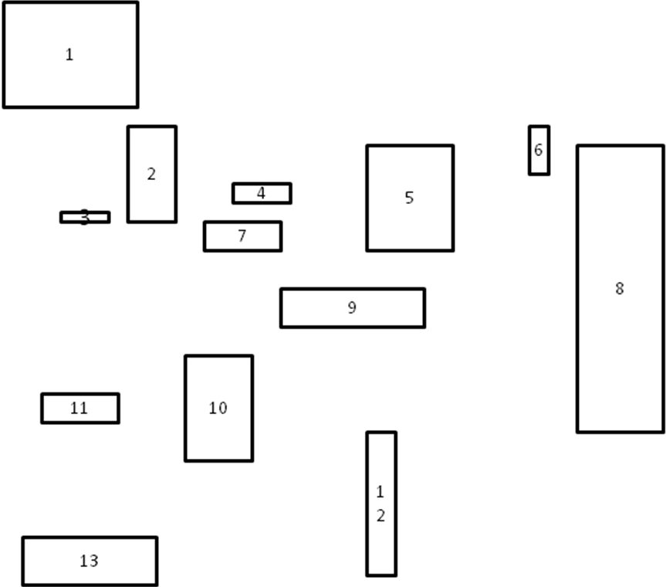

- Build a R-tree with M = 4, m = 2 from the above spatial data (every leaf nodes contains index records between m and M, unless it is the root). Building a R-tree, use linear cost splitting (linear cost splitting chooses far apart nodes as ends. Randomly choose nodes and assign them so that they require the smallest MBR enlargement). And show each step.

- 15 pts

Briefly describe function of following resultSet.

ResultSet rs=pstmt.executeQuery(sql);
While (rs.next()) {
// process the data
}
- rs.next()

- rs.absolute(3):

- rs.Relative(2)

- rs.last()

- 10 pts

Determine the spatial relationship between the following pairs of regions based on the information give about their interior and boundaries. Draw an example demonstrating each relationship.

I1 is the interior of region1
B1 is the boundary of region 1
I2 is the interior of region 2
B2 is the boundary of region 2

- I1∩I2 = 1 I1∩B2 = 1 B1∩I2= 0 B1∩B2=1

- I1∩I2=0 I1∩B2 = 1 B1∩I2= 1 B1∩B2=0

- I1∩I2=1 I1∩B2 = 0 B1∩I2= 0 B1∩B2=1

