**KOLEGJI UNIVERSUM**



Programi Shkenca Kompjuterike / Viti I / Semestri 2

Lënda: Hyrje ne Struktura te te Dhenave

Chapter 7 – Fundamentals of Computer Programming with C#

Studentja: Prof.Dr:

Elsira Kabashi Muzafer Shala

Asistenti: Laberion Zebica

Prishtinë 2021

1. Write a program, which creates an array of **20 elements of type integer** and initializes each of the elements with a value equals to the index of the element multiplied by 5. Print the elements to the console.

using System;

namespace Detyra1

{

class Program

{

static void Main(string[] args)

{

int[] arr = new int[20];

for (int i = 0; i < arr.Length; i++)

{

arr[i] = i * 5;

Console.WriteLine(arr[i]);

}

}

}

}

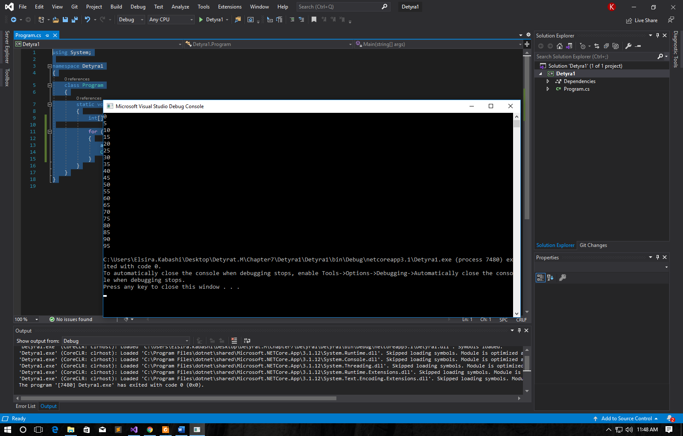

1. Write a program, which **reads two arrays** from the console and **checks whether they are equal** (two arrays are equal when they are of equal length and all of their elements, which have the same index, are equal).

using System;

namespace Detyra2

{

class Program

{

static void Main(string[] args)

{

bool arraysEqual = true;

Console.Write("Enter lenght of first array: ");

int length = Int32.Parse(Console.ReadLine());

int[] arrA = new int[length];

for (int i = 0; i < arrA.Length; i++)

{

Console.Write("Enter element {0}: ", i);

arrA[i] = Int32.Parse(Console.ReadLine());

}

Console.Write("\nEnter lenght of second array: ");

if (length != Int32.Parse(Console.ReadLine())) Console.WriteLine("\nArrays have different lengths.");

else

{

int[] arrB = new int[length];

for (int i = 0; i < arrB.Length; i++)

{

Console.Write("Enter element {0}: ", i);

arrB[i] = Int32.Parse(Console.ReadLine());

}

for (int i = 0; i < arrA.Length; i++)

{

if (arrA[i] != arrB[i])

{

Console.WriteLine("\nArrays are different.");

arraysEqual = false;

break;

}

}

if (arraysEqual) Console.WriteLine("\nArrays are the same.");

}

}

}

}

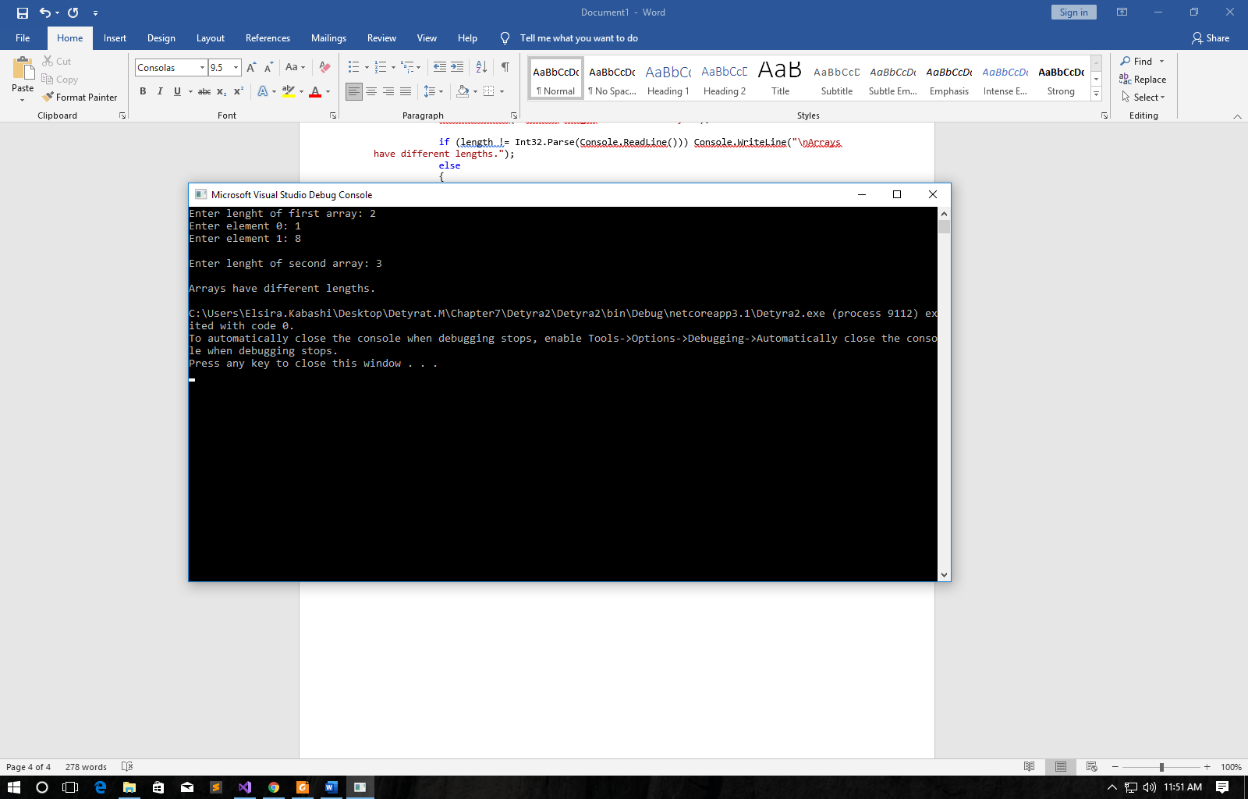

3. Write a program, which **compares two arrays of type char lexicographically** (character by character) and checks, which one is first in the lexicographical order.

using System;

namespace Detyra3

{

class Program

{

static void Main(string[] args)

{

bool arrayEqual = true;

char[] arrA = new char[5] { 'a', 'b', 'c', 'd', 'e' };

char[] arrB = new char[5] { 'a', 'b', 'c', 'd', 'e' };

if (arrA.Length > arrB.Length) Console.WriteLine("Second array is lexicographicaly first.");

else if (arrA.Length < arrB.Length) Console.WriteLine("First array is lexicographicaly first.");

else

{

for (int i = 0; i < arrA.Length; i++)

{

if (arrA[i] < arrB[i])

{

Console.WriteLine("First array is lexicographicaly first.");

arrayEqual = false;

break;

}

if (arrA[i] > arrB[i])

{

Console.WriteLine("Second array is lexicographicaly first.");

arrayEqual = false;

break;

}

}

if (arrayEqual) Console.WriteLine("Arrays are lexicographicaly equal.");

}

}

}

}

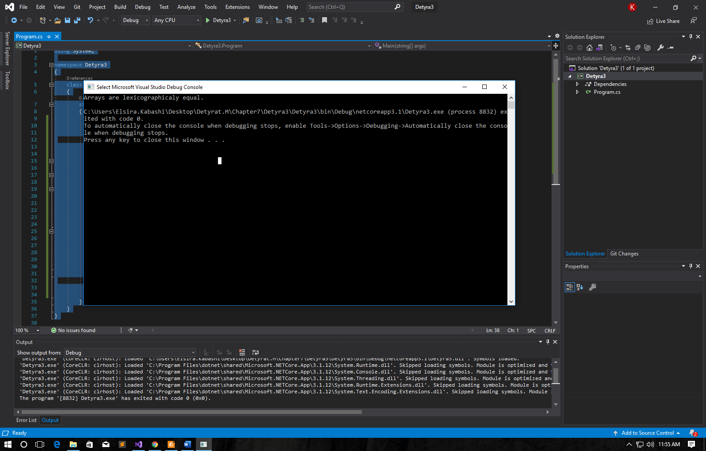

4. Write a program, which finds the maximal sequence of consecutive equal elements in an array.  
E.g.: {2, 1, 1, 2, 3, 3, **2, 2, 2**, 1} à {2, 2, 2}.  
à {2, 2, 2}.

using System;

namespace Detyra4

{

class Program

{

static void Main(string[] args)

{

int count = 1, tempCount = 1, number = 0;

Console.Write("Enter array length: ");

int length = Int32.Parse(Console.ReadLine());

int[] arr = new int[length];

for (int i = 0; i < arr.Length; i++)

{

Console.Write("Enter {0} element: ", i);

arr[i] = Int32.Parse(Console.ReadLine());

}

for (int i = 0; i < arr.Length - 1; i++)

{

if (arr[i] == arr[i + 1]) tempCount++;

else tempCount = 1;

if (tempCount > count)

{

count = tempCount;

number = arr[i];

}

}

for (int i = 0; i < count; i++) Console.Write("{0}, ", number);

}

}

}

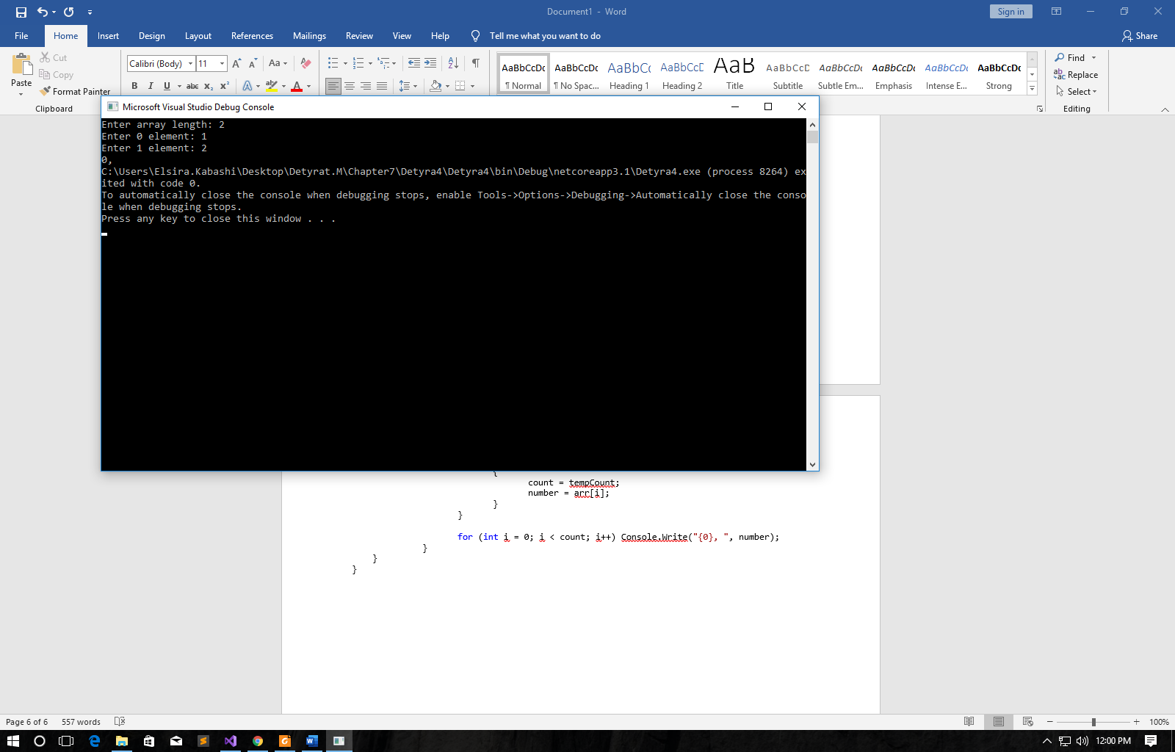

5. Write a program, which finds the **maximal sequence** of consecutively placed **increasing integers**.  
Example: {3, **2, 3, 4**, 2, 2, 4} à {2, 3, 4}.

using System;

namespace Detyra5

{

class Program

{

static void Main(string[] args)

{

Console.Write("Enter array length: ");

int length = Int32.Parse(Console.ReadLine());

int[] arr = new int[length];

int sames = 1, bestSames = 1, bestStart = 0, lastElement = 0;

for (int i = 0; i < arr.Length; i++)

{

Console.Write("Enter {0} element: ", i);

arr[i] = Int32.Parse(Console.ReadLine());

}

for (int i = 0; i < arr.Length - 1; i++)

{

if (arr[i] + 1 == arr[i + 1])

{

sames++;

if (sames > bestSames)

{

bestSames = sames;

lastElement = i + 1;

bestStart = lastElement - bestSames + 1;

}

}

else sames = 1;

}

for (int i = bestStart; i < bestSames + bestStart; i++) Console.Write("{0}, ", arr[i]);

}

}

}

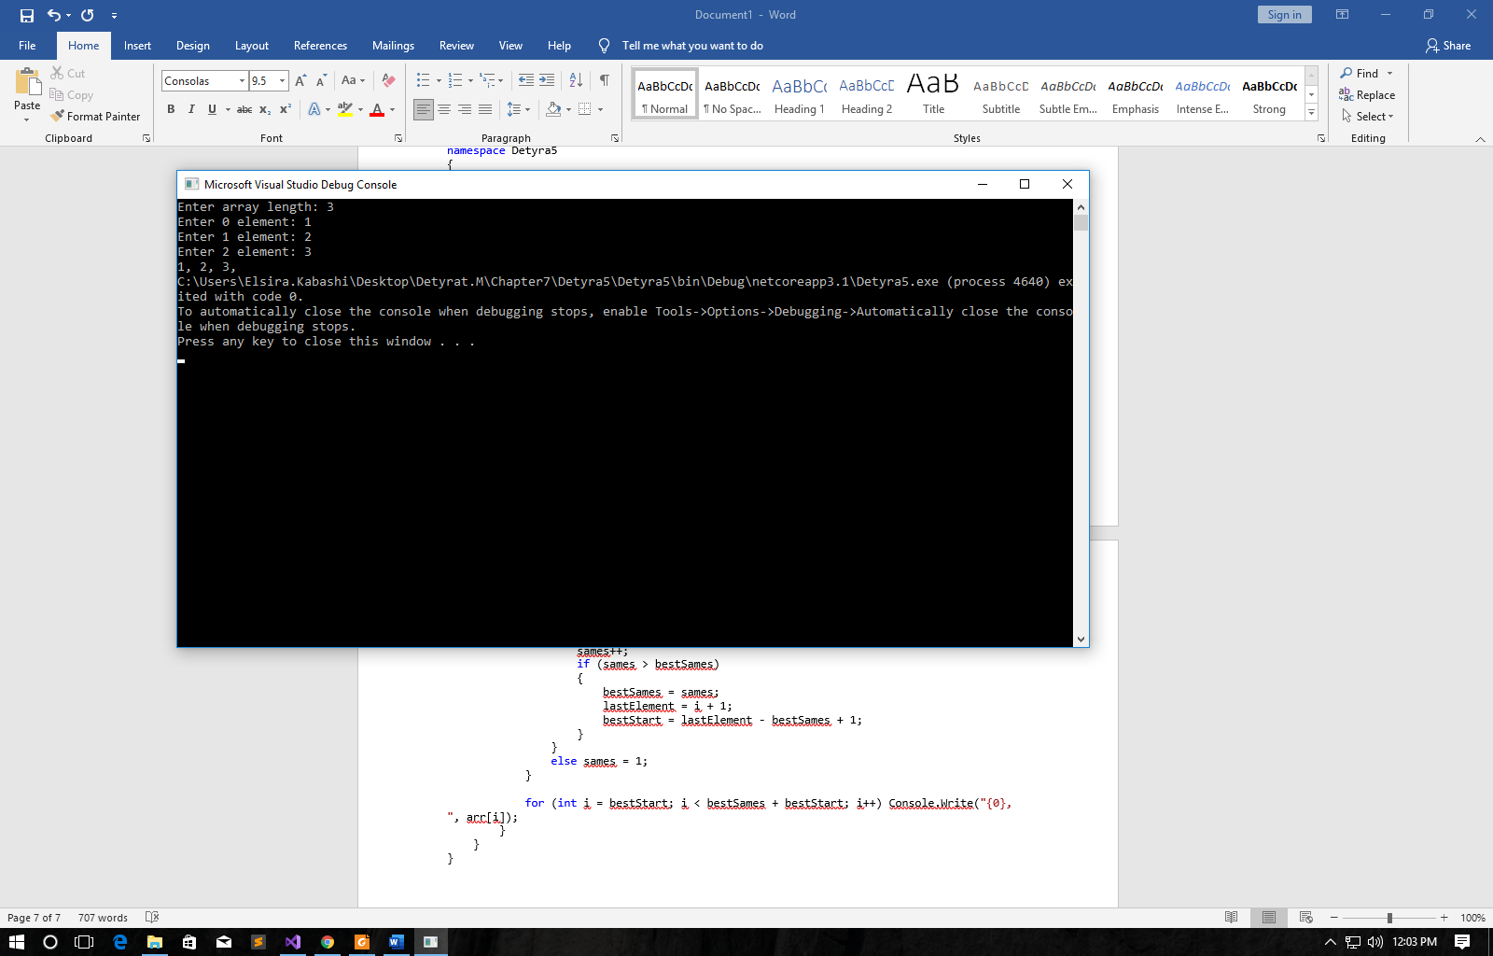

6. Write a program, which finds the **maximal sequence of increasing elements** in an array arr[n]. It is not necessary the elements to be consecutively placed.  
Example: {9, 6, **2**, 7, **4**, 7, **6**, 5, **8**, 4} à {2, 4, 6, 8}.

using System;

namespace Detyra6

{

class Program

{

static void Main(string[] args)

{

int counter = 0, tempIndex, tempCounter;

Console.Write("Enter array length: ");

int length = Int32.Parse(Console.ReadLine());

int[] arr = new int[length];

int[] result = new int[length];

for (int i = 0; i < length; i++)

{

Console.Write("Enter {0} element: ", i);

arr[i] = Int32.Parse(Console.ReadLine());

}

for (int i = 0; i < length; i++)

{

int[] tempResult = new int[length];

tempIndex = tempCounter = 1;

tempResult[0] = arr[i];

for (int j = i + 1; j < length; j++)

{

if (arr[j] > tempResult[tempIndex - 1])

{

tempResult[tempIndex] = arr[j];

tempIndex++;

tempCounter++;

}

else if (tempIndex > 1 && arr[j] > tempResult[tempIndex - 2] && arr[j] < tempResult[tempIndex - 1]) tempResult[tempIndex - 1] = arr[j];

}

if (counter < tempCounter)

{

counter = tempCounter;

result = tempResult;

}

}

for (int i = 0; i < counter; i++) Console.Write("{0},", result[i]);

}

}

}

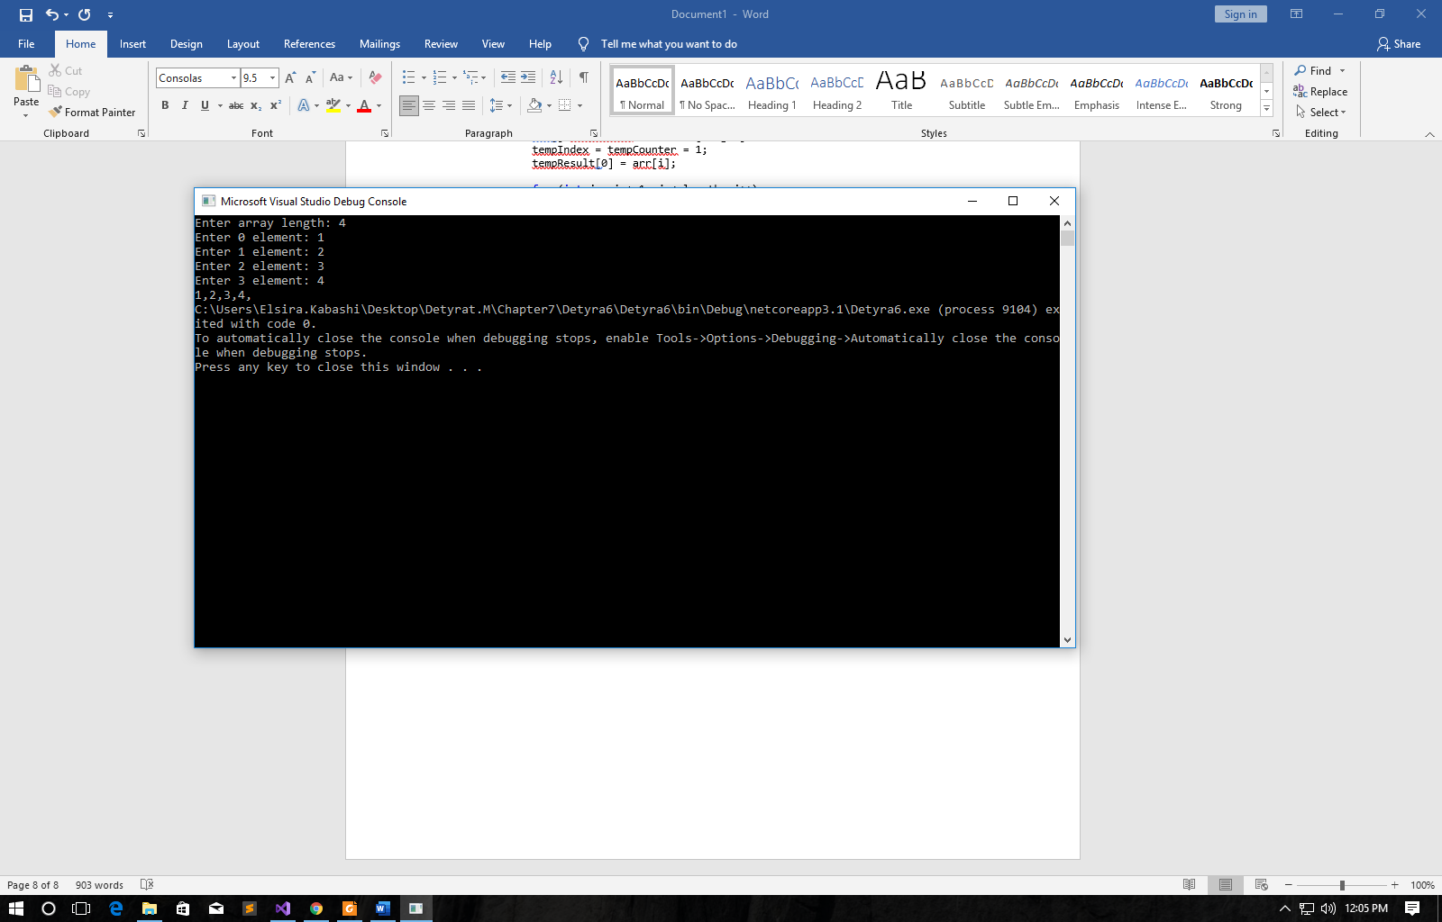

7. Write a program, which reads from the console two integer numbers **N** and **K** (K < N) and array of N integers. Find those **K consecutive elements** in the array, which have **maximal sum**.

using System;

namespace Detyra7

{

class Program

{

static void Main(string[] args)

{

int sum = 0;

Console.Write("Enter N: ");

int n = Int32.Parse(Console.ReadLine());

Console.Write("Enter K (K < N): ");

int k = Int32.Parse(Console.ReadLine());

int[] arr = new int[n];

for (int i = 0; i < n; i++)

{

Console.Write("Enter {0} element: ", i);

arr[i] = Int32.Parse(Console.ReadLine());

}

Array.Sort(arr, (a, b) => b.CompareTo(a));

for (int i = 0; i < k; i++) sum += arr[i];

Console.WriteLine("\nBiggest sum is {0}", sum);

}

}

}

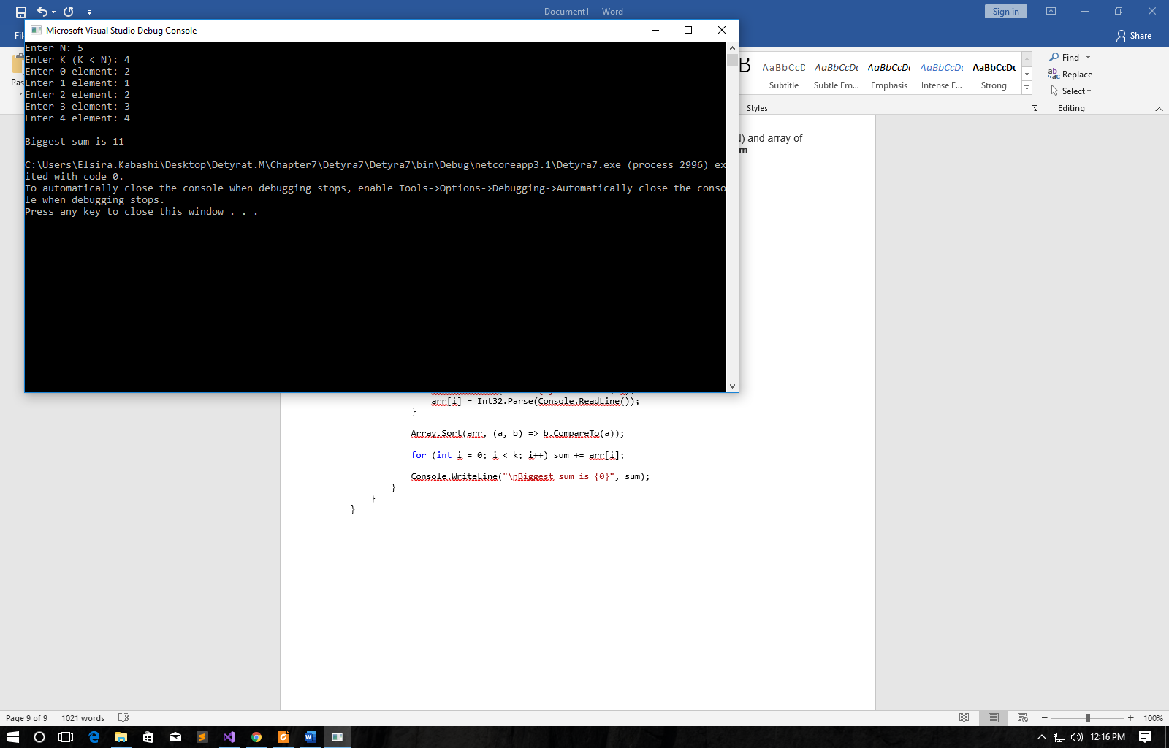

8. **Sorting an array** means to arrange its elements in an increasing (or decreasing) order. Write a program, which sorts an array using the algorithm "selection sort".

using System;

namespace Detyra8

{

class Program

{

static void Main(string[] args)

{

int i, j, iMin, temp;

Console.Write("Enter array length: ");

int length = Int32.Parse(Console.ReadLine());

int[] arr = new int[length];

for (i = 0; i < length; i++)

{

Console.Write("Enter {0} element: ", i);

arr[i] = Int32.Parse(Console.ReadLine());

}

for (j = 0; j < length - 1; j++)

{

iMin = j;

for (i = j + 1; i < length; i++) if (arr[i] < arr[iMin]) iMin = i;

if (iMin != j)

{

temp = arr[j];

arr[j] = arr[iMin];

arr[iMin] = temp;

}

}

for (i = 0; i < length; i++) Console.Write("{0} ", arr[i]);

}

}

}

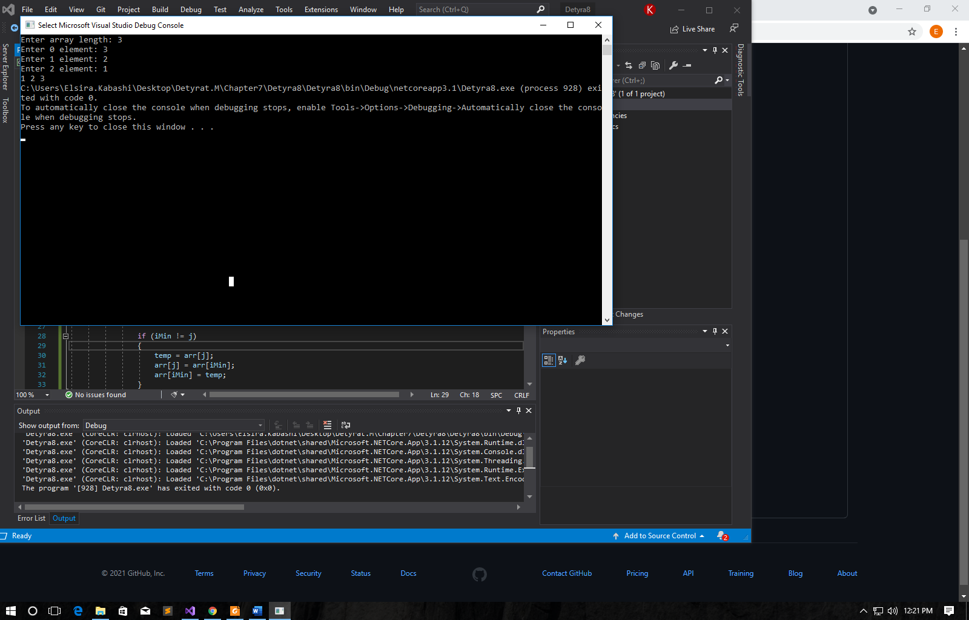

9. Write a program, which finds a subsequence of numbers with maximal sum. E.g.: {2, 3, -6, -1, **2, -1, 6, 4**, -8, 8} à **11**

using System;

namespace Detyra9

{

class Program

{

static void Main(string[] args)

{

int sum = 0, tempSum;

Console.Write("Enter array length: ");

int length = Int32.Parse(Console.ReadLine());

int[] arr = new int[length];

for (int i = 0; i < length; i++)

{

Console.Write("Enter {0} element: ", i);

arr[i] = Int32.Parse(Console.ReadLine());

}

for (int i = 0; i < length - 1; i++)

{

tempSum = arr[i];

for (int j = i + 1; j < length; j++)

{

tempSum += arr[j];

if (tempSum > sum) sum = tempSum;

}

}

Console.WriteLine("Result is {0}. ", sum);

}

}

}

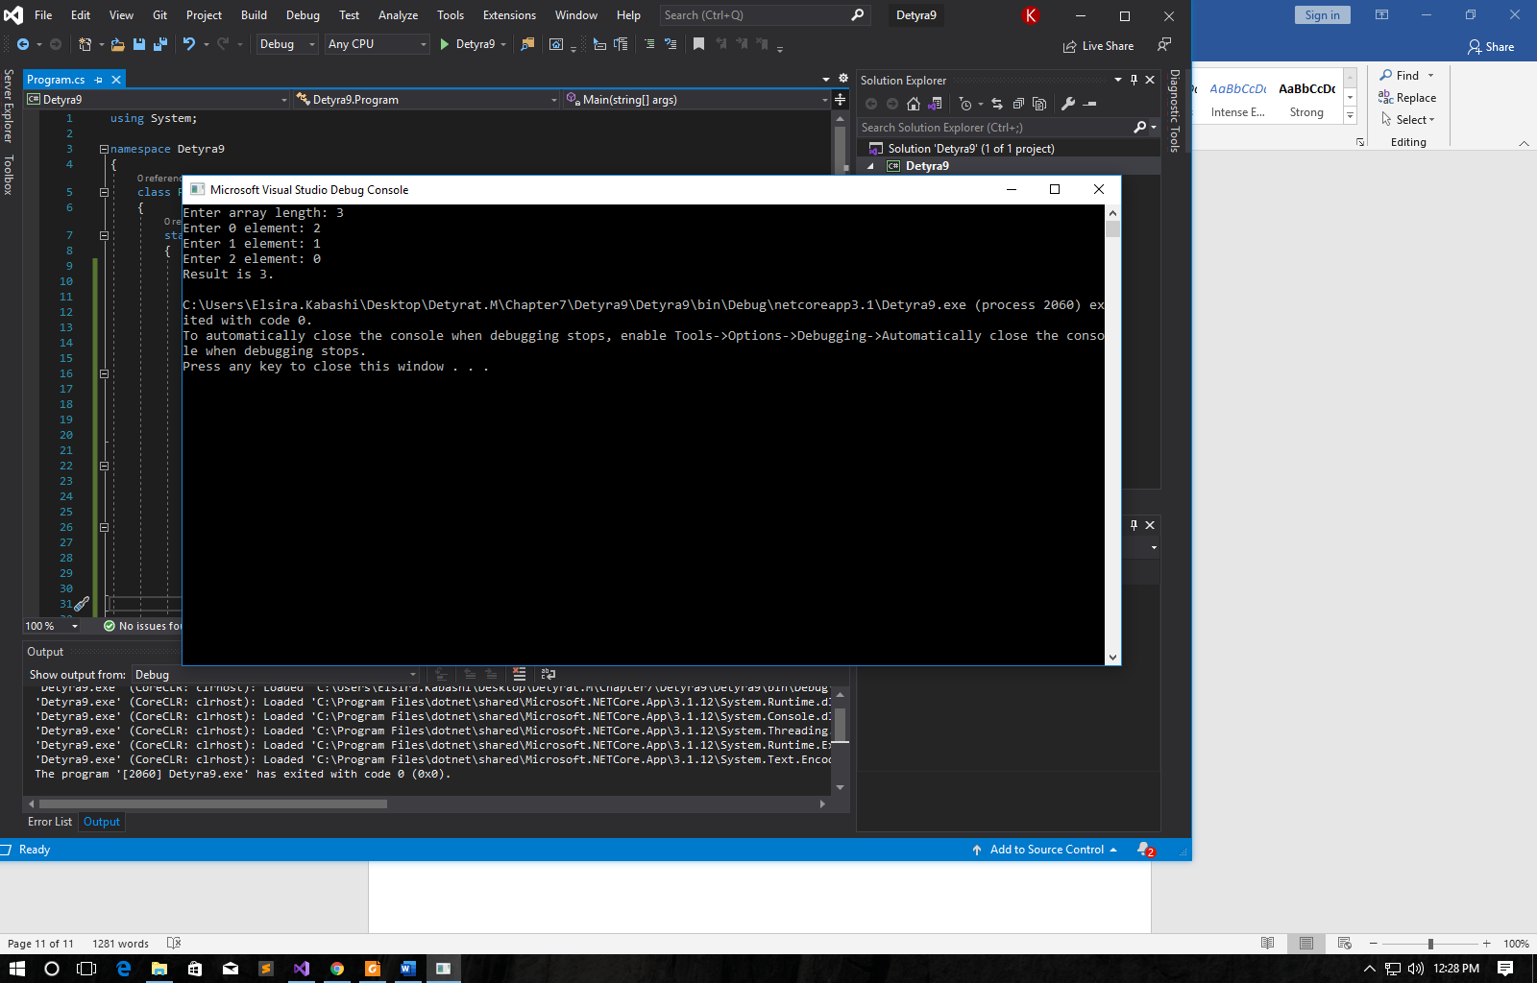

10. Write a program, which finds the **most frequently occurring** element in an array. Example: {**4**, 1, 1, **4**, 2, 3, **4**, **4**, 1, 2, **4**, 9, 3} à 4 (5 times).

using System;

namespace Detyra10

{

class Program

{

static void Main(string[] args)

{

int counter = 0, tempCounter = 1, foundNumber = 0;

Console.Write("Enter array length: ");

int length = Int32.Parse(Console.ReadLine());

int[] arr = new int[length];

for (int i = 0; i < length; i++)

{

Console.Write("Enter {0} element: ", i);

arr[i] = Int32.Parse(Console.ReadLine());

}

Array.Sort(arr);

for (int i = 0; i < length - 1; i++)

{

if (arr[i] == arr[i + 1]) tempCounter++;

else tempCounter = 1;

if (tempCounter > counter)

{

counter = tempCounter;

foundNumber = arr[i];

}

}

Console.WriteLine("{0} was found {1} times.", foundNumber, counter);

}

}

}

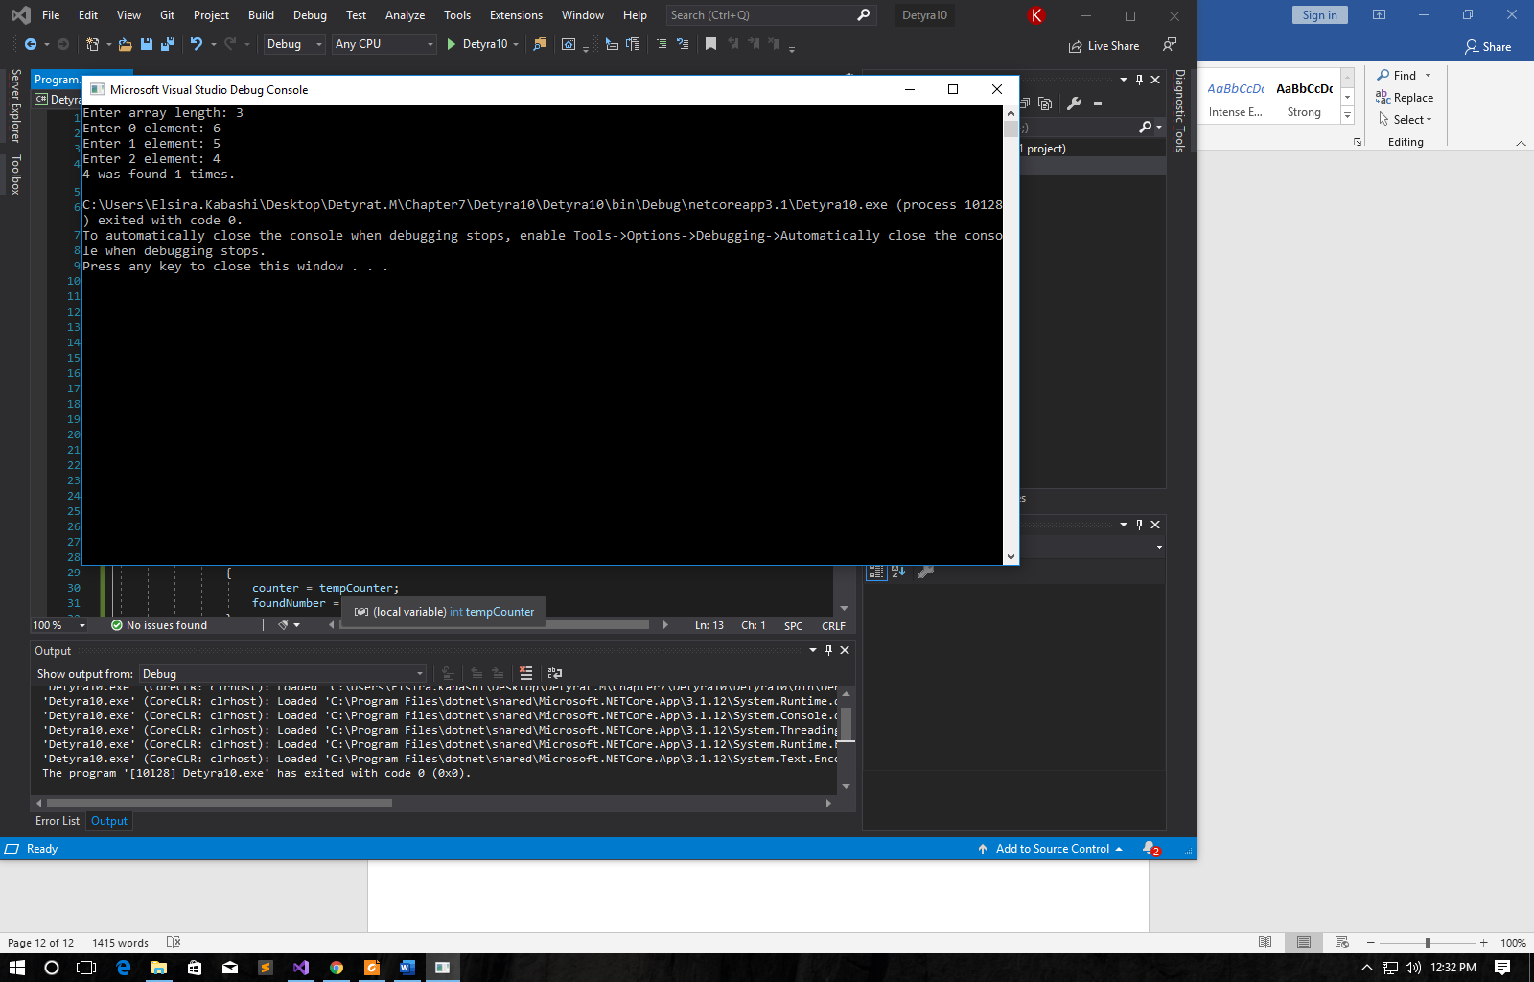

11. Write a program to find a sequence of neighbor numbers in an array, which has a **sum of certain number S**. Example: {4, 3, 1, **4**, **2**, **5**, 8}, S=11 à {4, 2, 5}.

using System;

namespace Detyra11

{

class Program

{

static void Main(string[] args)

{

int sum = 0, start = 0, end = 0;

bool sumFound = false;

Console.Write("Enter S: ");

int s = Int32.Parse(Console.ReadLine());

Console.Write("Enter array length: ");

int length = Int32.Parse(Console.ReadLine());

int[] arr = new int[length];

for (int i = 0; i < length; i++)

{

Console.Write("Enter {0} element: ", i);

arr[i] = Int32.Parse(Console.ReadLine());

}

for (int i = 0; i < length - 1; i++)

{

sum = arr[i];

for (int j = i + 1; j < length; j++)

{

sum += arr[j];

if (sum == s)

{

start = i;

end = j;

sumFound = true;

break;

}

}

if (sumFound) break;

}

if (sumFound) for (int i = start; i <= end; i++) Console.Write("{0},", arr[i]);

else Console.WriteLine("No sum found.");

}

}

}

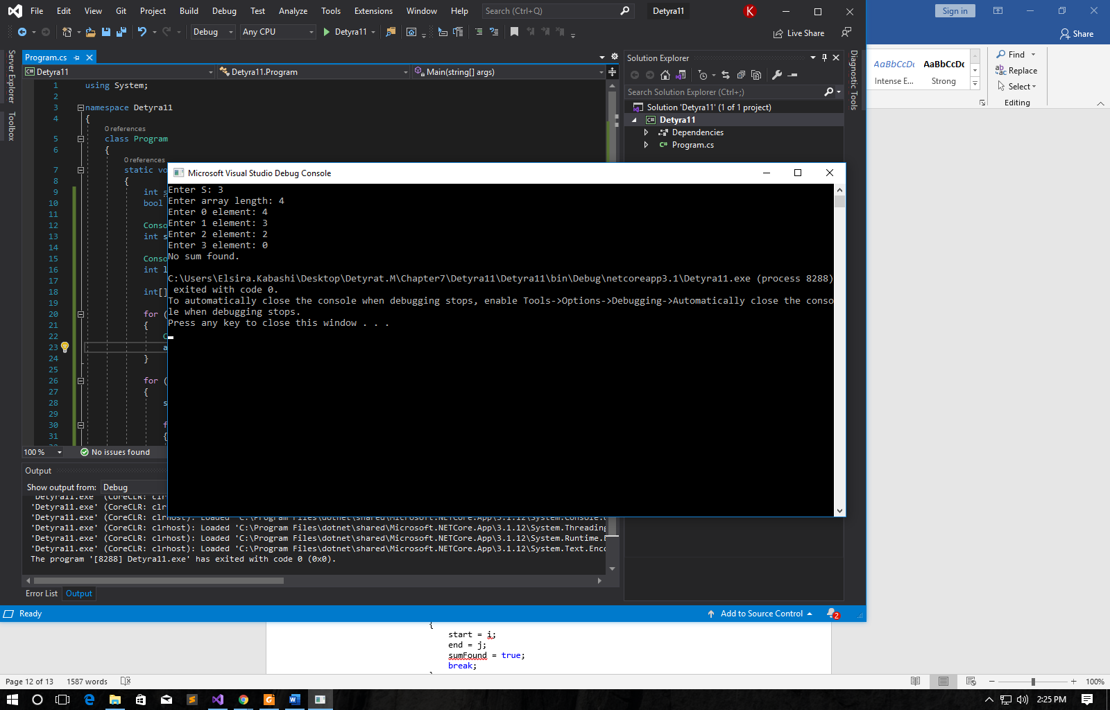

12. Write a program, which creates square matrices like those in the  
figures below and prints them formatted to the console. The size of the  
matrices will be read from the console. See the examples for matrices  
with size of 4 x 4 and make the other sizes in a similar fashion:

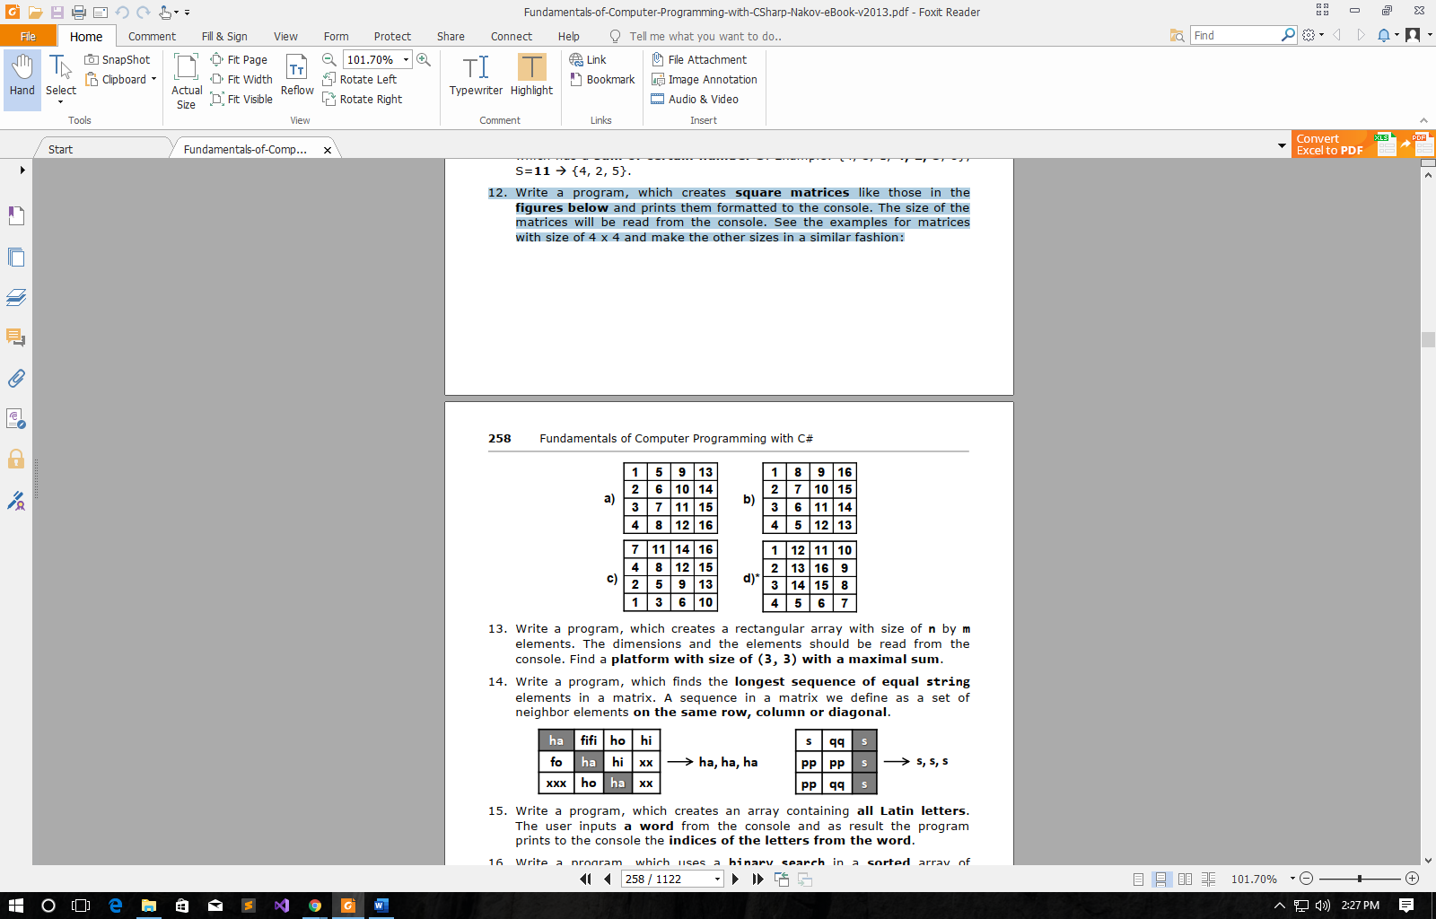

using System;

namespace Detyra12

{

class Program

{

static void Main(string[] args)

{

Console.Write("Enter height: ");

int y = Int32.Parse(Console.ReadLine());

Console.Write("Enter width: ");

int x = Int32.Parse(Console.ReadLine());

int a = 0;

for (int i = 1; i <= y; i++)

{

Console.Write("{0} ", i);

a += i;

for (int j = 1; j < x; j++)

{

a += y;

Console.Write("{0} ", a);

}

a = 0;

Console.WriteLine();

}

}

}

}

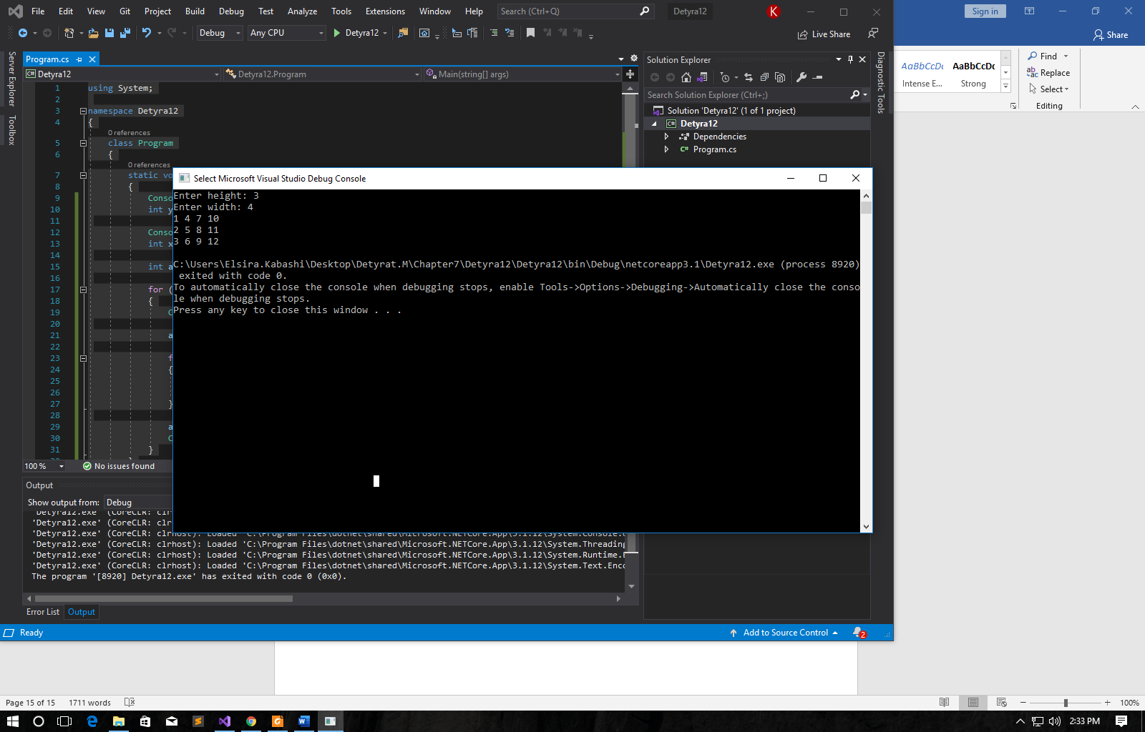

13. Write a program, which creates a rectangular array with size of n by m elements. The dimensions and the elements should be read from the console. Find a **platform with size of (3, 3) with a maximal sum**.

using System;

namespace Detyra13

{

class Program

{

static void Main(string[] args)

{

int row = 0, col = 0, sum = -1000;

Console.Write("Enter N: ");

int n = Int32.Parse(Console.ReadLine());

Console.Write("Enter M: ");

int m = Int32.Parse(Console.ReadLine());

int[,] arr = new int[n, m];

for (int i = 0; i < n; i++)

for (int j = 0; j < m; j++)

{

Console.Write("Arr [{0}][{1}] = ", i, j);

arr[i, j] = Int32.Parse(Console.ReadLine());

}

for (int tempRow = 0; tempRow < arr.Length - 2; tempRow++)

for (int tempCol = 0; tempCol < arr.GetLength(0) - 2; tempCol++)

{

int tempSum = arr[row, col] + arr[row, col + 1] + arr[row, col + 2] +

arr[row + 1, col] + arr[row + 1, col + 1] + arr[row + 1, col + 2] +

arr[row + 2, col] + arr[row + 2, col + 1] + arr[row + 2, col + 2];

if (tempSum > sum)

{

row = tempRow;

col = tempCol;

sum = tempSum;

}

}

Console.WriteLine("Result");

Console.WriteLine("{0} {1} {2}", arr[row, col], arr[row, col + 1], arr[row, col + 2]);

Console.WriteLine("{0} {1} {2}", arr[row + 1, col], arr[row + 1, col + 1], arr[row + 1, col

+ 2]);

Console.WriteLine("{0} {1} {2}", arr[row + 2, col], arr[row + 2, col + 2], arr[row + 2, col

+ 2]);

Console.WriteLine("The maximum sum is {0}.", sum);

}

}

}

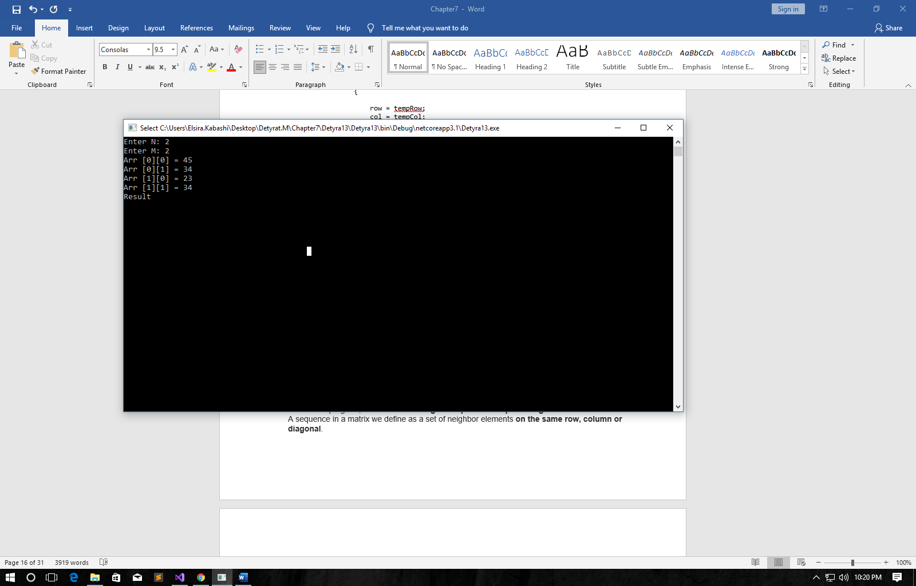

14. Write a program, which finds the **longest sequence of equal string elements in a matrix**. A sequence in a matrix we define as a set of neighbor elements **on the same row, column or diagonal**.

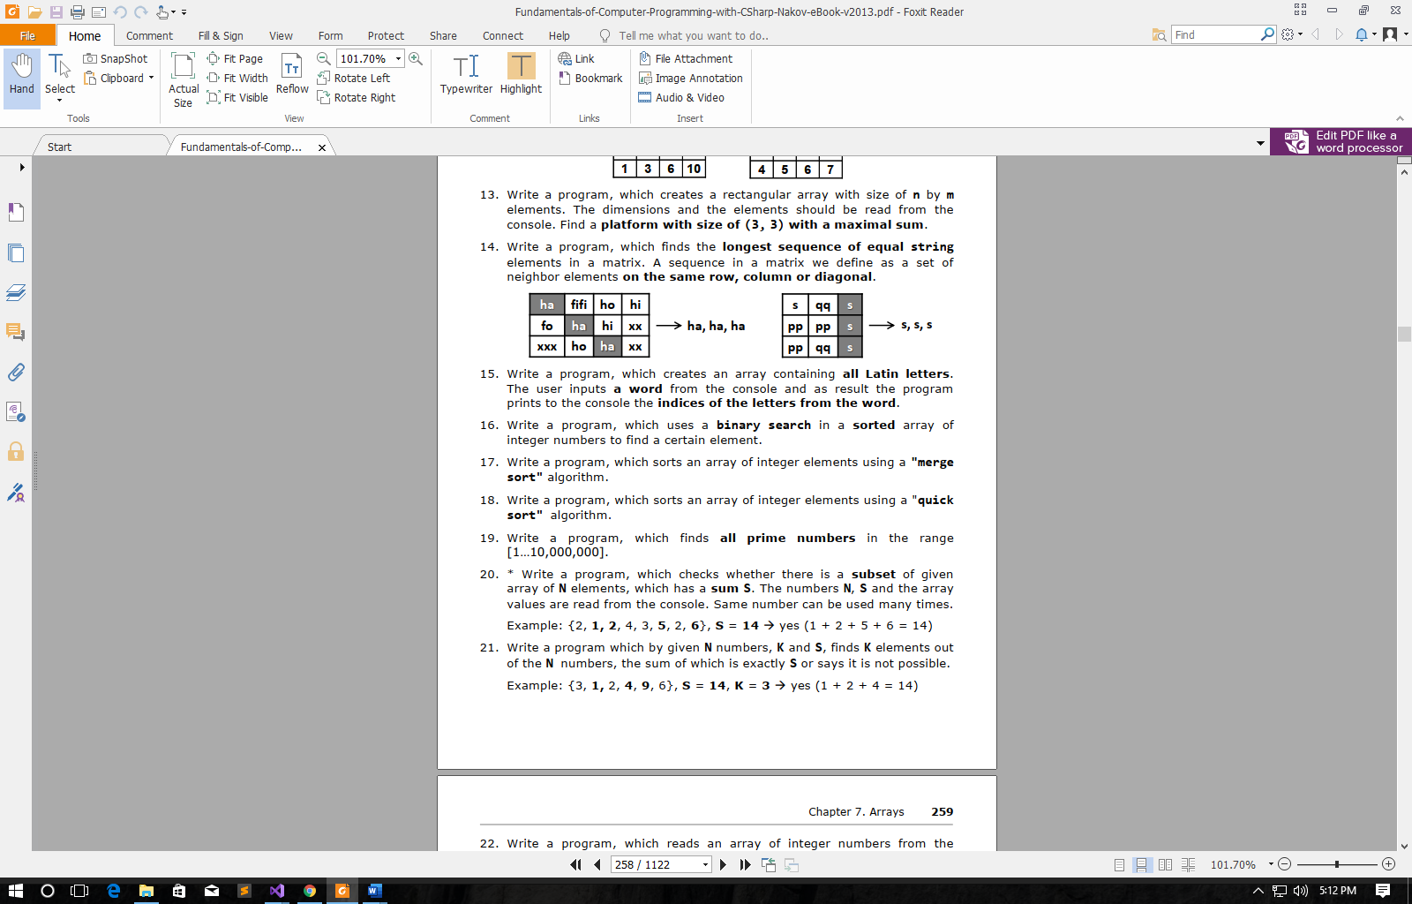

using System;

namespace Detyra14

{

class Program

{

static void Main(string[] args)

{

int tempSeq = 1, seq = 1;

string element = "e";

Console.Write("Enter N: ");

int n = Int32.Parse(Console.ReadLine());

Console.Write("Enter M: ");

int m = Int32.Parse(Console.ReadLine());

string[,] arr = new string[n, m];

for (int i = 0; i < n; i++)

for (int j = 0; j < m; j++)

{

Console.Write("Arr [{0}][{1}] = ", i, j);

arr[i, j] = Console.ReadLine();

}

for (int rows = 0; rows < arr.GetLength(0); rows++)

{

for (int cols = 0; cols < arr.GetLength(1) - 1; cols++)

{

if (arr[rows, cols] == arr[rows, cols + 1]) tempSeq++;

else tempSeq = 1;

if (seq < tempSeq)

{

seq = tempSeq;

element = arr[rows, cols];

}

}

tempSeq = 1;

}

for (int cols = 0; cols < arr.GetLength(1); cols++)

{

for (int rows = 0; rows < arr.GetLength(0) - 1; rows++)

{

if (arr[rows, cols] == arr[rows + 1, cols]) tempSeq++;

else tempSeq = 1;

if (seq < tempSeq)

{

seq = tempSeq;

element = arr[rows, cols];

}

}

tempSeq = 1;

}

for (int i = 0; i < arr.GetLength(0) - 1; i++)

for (int j = 0; j < arr.GetLength(1) - 1; j++)

{

for (int rows = i, cols = j; rows < arr.GetLength(0) - 1 && cols < arr.GetLength(1) - 1; rows++, cols++)

{

if (arr[rows, cols] == arr[rows + 1, cols + 1]) tempSeq++;

else tempSeq = 1;

if (seq < tempSeq)

{

seq = tempSeq;

element = arr[rows, cols];

}

}

tempSeq = 1;

}

for (int i = 0; i < arr.GetLength(0) - 1; i++)

for (int j = 1; j < arr.GetLength(1); j++)

{

for (int rows = i, cols = j; rows < arr.GetLength(0) - 1 && cols > 0; rows++, cols--)

{

if (arr[rows, cols] == arr[rows + 1, cols - 1]) tempSeq++;

else tempSeq = 1;

if (seq < tempSeq)

{

seq = tempSeq;

element = arr[rows, cols];

}

}

tempSeq = 1;

}

for (int i = 0; i < seq; i++) Console.Write("{0}, ", element);

}

}

}

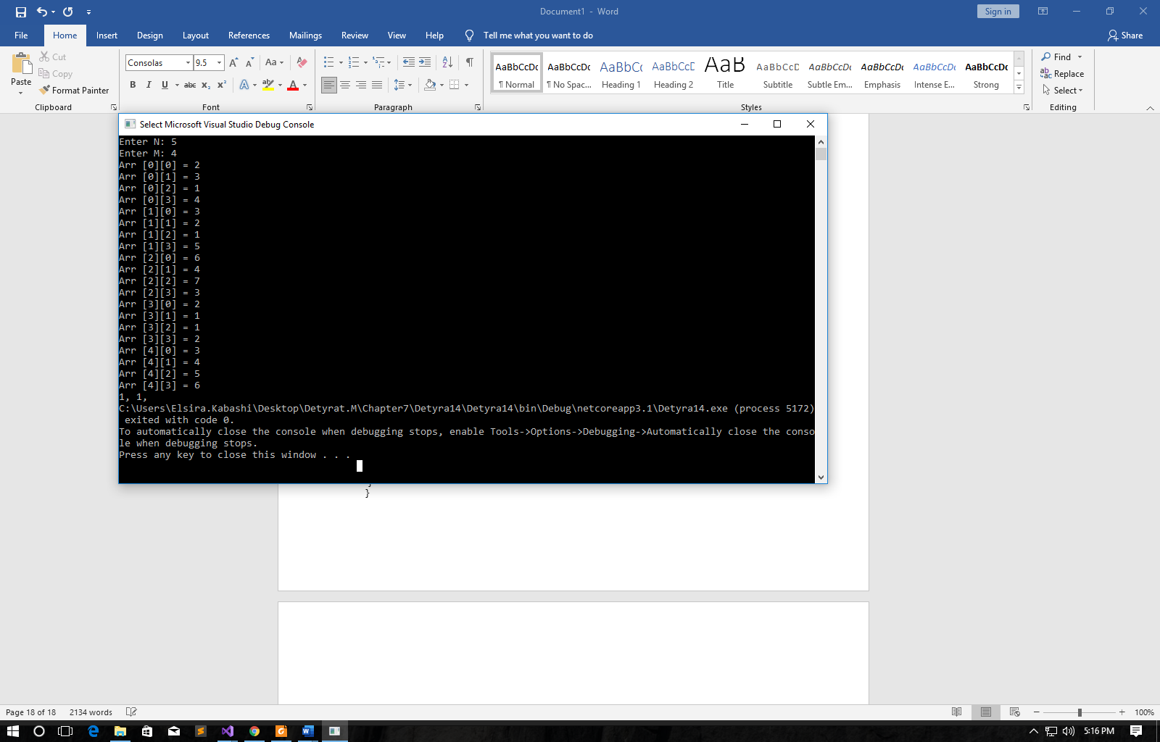

15. Write a program, which creates an array containing **all Latin letters**. The user inputs **a word** from the console and as result the program prints to the console the **indices of the letters from the word**.

using System;

namespace Detyra15

{

class Program

{

static void Main(string[] args)

{

char[] alphabet = { 'a', 'b', 'c', 'd', 'e', 'f', 'g', 'h', 'i', 'j', 'k', 'l', 'm', 'n', 'o', 'p', 'q', 'r', 's', 't', 'u', 'v', 'w', 'x', 'y', 'z' };

Console.Write("Enter a word: ");

char[] word = (Console.ReadLine()).ToCharArray();

for (int i = 0; i < word.Length; i++)

for (int j = 0; j < alphabet.Length; j++)

if (word[i] == alphabet[j]) Console.Write("{0} ", j);

}

}

}

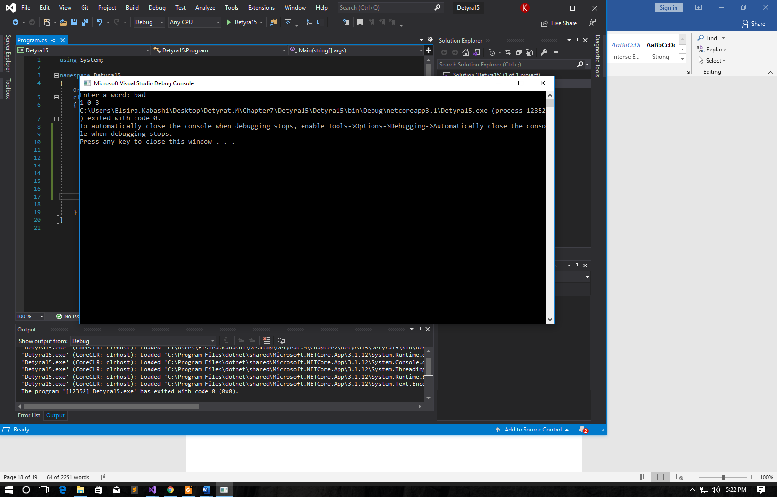

16. Write a program, which uses a **binary search** in a **sorted** array of integer numbers to find a certain element.

using System;

namespace Detyra16

{

class Program

{

static void Main(string[] args)

{

Console.Write("Enter array length: ");

int length = Int32.Parse(Console.ReadLine());

int[] arr = new int[length];

for (int i = 0; i < length; i++)

{

Console.Write("Enter {0} element: ", i);

arr[i] = Int32.Parse(Console.ReadLine());

}

Console.Write("Enter searched number: ");

int number = Int32.Parse(Console.ReadLine());

int index = Array.BinarySearch(arr, number);

if (index >= 0) Console.Write("Number is on {0} index.", index);

else Console.Write("Number wasn't found.");

}

}

}

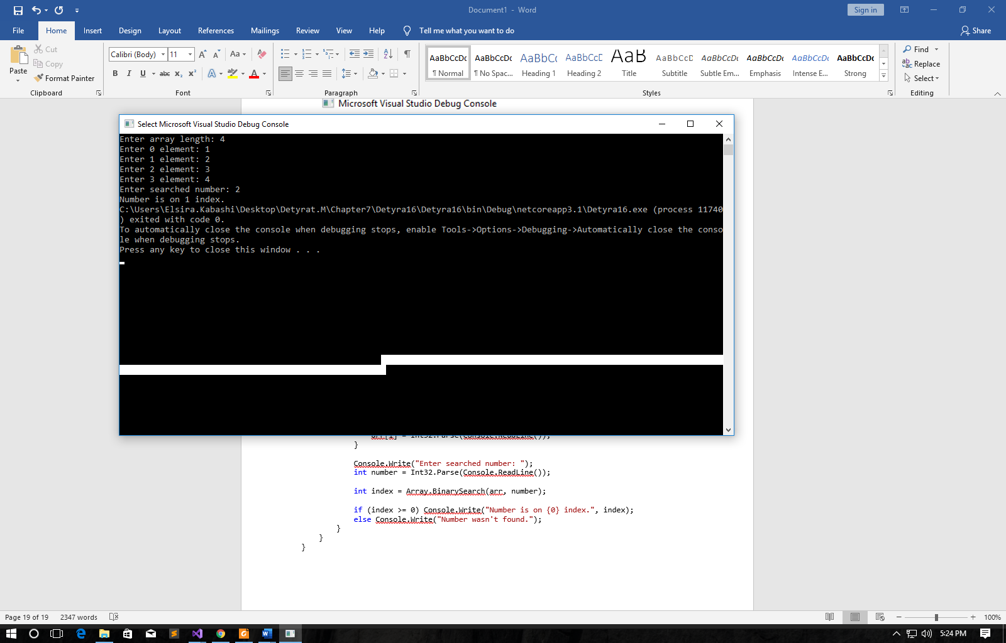

17. Write a program, which sorts an array of integer elements using a "**merge sort**" algorithm.

using System;

namespace Detyra17

{

class Program

{

static public void DoMerge(int[] numbers, int left, int mid, int right)

{

int[] temp = new int[25];

int i, left_end, num_elements, tmp_pos;

left_end = (mid - 1);

tmp_pos = left;

num_elements = (right - left + 1);

while ((left <= left_end) && (mid <= right))

{

if (numbers[left] <= numbers[mid]) temp[tmp_pos++] = numbers[left++];

else temp[tmp_pos++] = numbers[mid++];

}

while (left <= left_end) temp[tmp_pos++] = numbers[left++];

while (mid <= right) temp[tmp_pos++] = numbers[mid++];

for (i = 0; i < num_elements; i++)

{

numbers[right] = temp[right];

right--;

}

}

static public void MergeSort_Recursive(int[] numbers, int left, int right)

{

int mid;

if (right > left)

{

mid = (right + left) / 2;

MergeSort_Recursive(numbers, left, mid);

MergeSort_Recursive(numbers, (mid + 1), right);

DoMerge(numbers, left, (mid + 1), right);

}

}

static void Main(string[] args)

{

Console.Write("Enter array length: ");

int length = Int32.Parse(Console.ReadLine());

int[] arr = new int[length];

for (int i = 0; i < length; i++)

{

Console.Write("Enter {0} element: ", i);

arr[i] = Int32.Parse(Console.ReadLine());

}

MergeSort_Recursive(arr, 0, arr.Length - 1);

for (int i = 0; i < arr.Length; i++) Console.WriteLine(arr[i]);

}

}

}

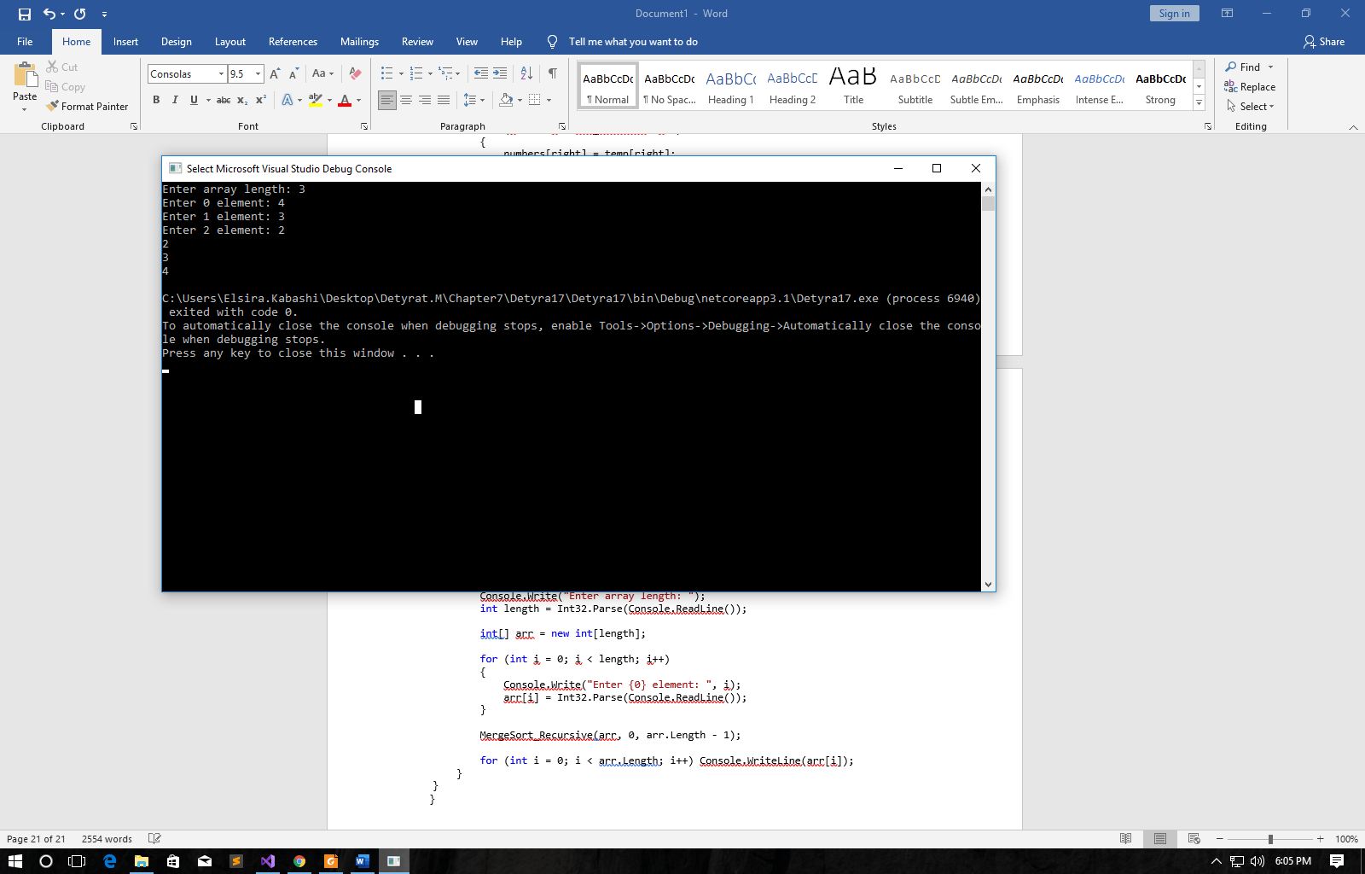

18. Write a program, which sorts an array of integer elements using a "**quick sort**" algorithm.

using System;

namespace Detyra18

{

class Program

{

public static void Quicksort(int[] elements, int left, int right)

{

int i = left, j = right;

IComparable pivot = elements[(left + right) / 2];

while (i <= j)

{

while (elements[i].CompareTo(pivot) < 0) i++;

while (elements[j].CompareTo(pivot) > 0) j--;

if (i <= j)

{

int tmp = elements[i];

elements[i] = elements[j];

elements[j] = tmp;

i++;

j--;

}

}

if (left < j) Quicksort(elements, left, j);

if (i < right) Quicksort(elements, i, right);

}

static void Main(string[] args)

{

Console.Write("Enter array length: ");

int length = Int32.Parse(Console.ReadLine());

int[] arr = new int[length];

for (int i = 0; i < length; i++)

{

Console.Write("Enter {0} element: ", i);

arr[i] = Int32.Parse(Console.ReadLine());

}

Quicksort(arr, 0, arr.Length - 1);

for (int i = 0; i < arr.Length; i++) Console.WriteLine(arr[i]);

}

}

}

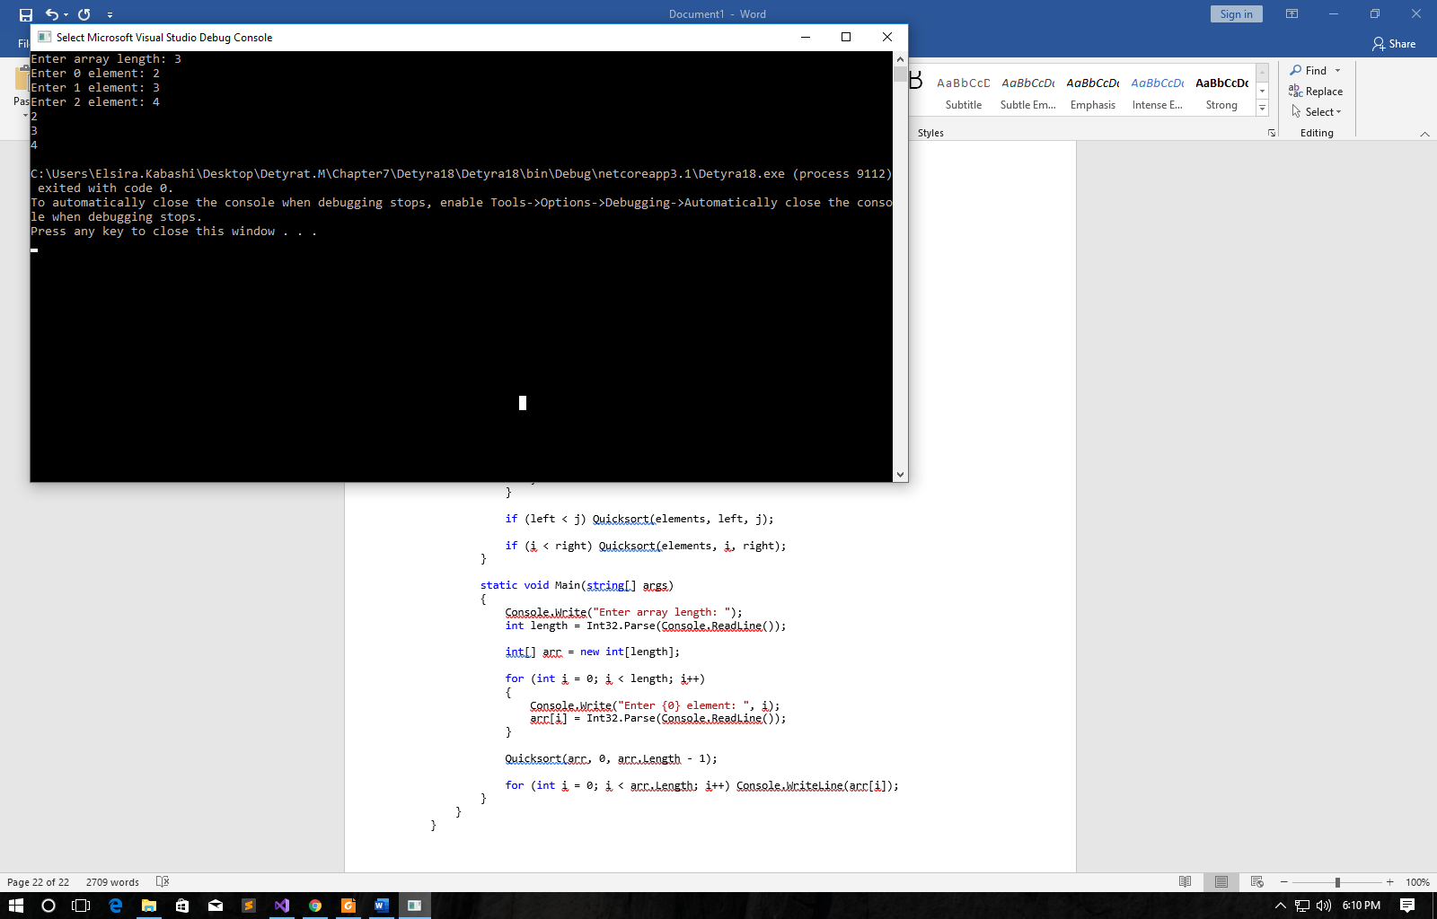

19. Write a program, which finds **all prime numbers** in the range [1…10,000,000].

using System;

namespace Detyra19

{

class Program

{

public static void Main()

{

int num, i, ctr, stno, enno;

Console.Write("\n\n");

Console.Write("Find the prime numbers within a range of numbers:\n");

Console.Write("---------------------------------------------------");

Console.Write("\n\n");

Console.Write("Input starting number of range: ");

stno = Convert.ToInt32(Console.ReadLine());

Console.Write("Input ending number of range : ");

enno = Convert.ToInt32(Console.ReadLine());

Console.Write("The prime numbers between {0} and {1} are : \n", stno, enno);

for (num = stno; num <= enno; num++)

{

ctr = 0;

for (i = 2; i <= num / 2; i++)

{

if (num % i == 0)

{

ctr++;

break;

}

}

if (ctr == 0 && num != 1)

Console.Write("{0} ", num);

}

Console.Write("\n");

}

}

}

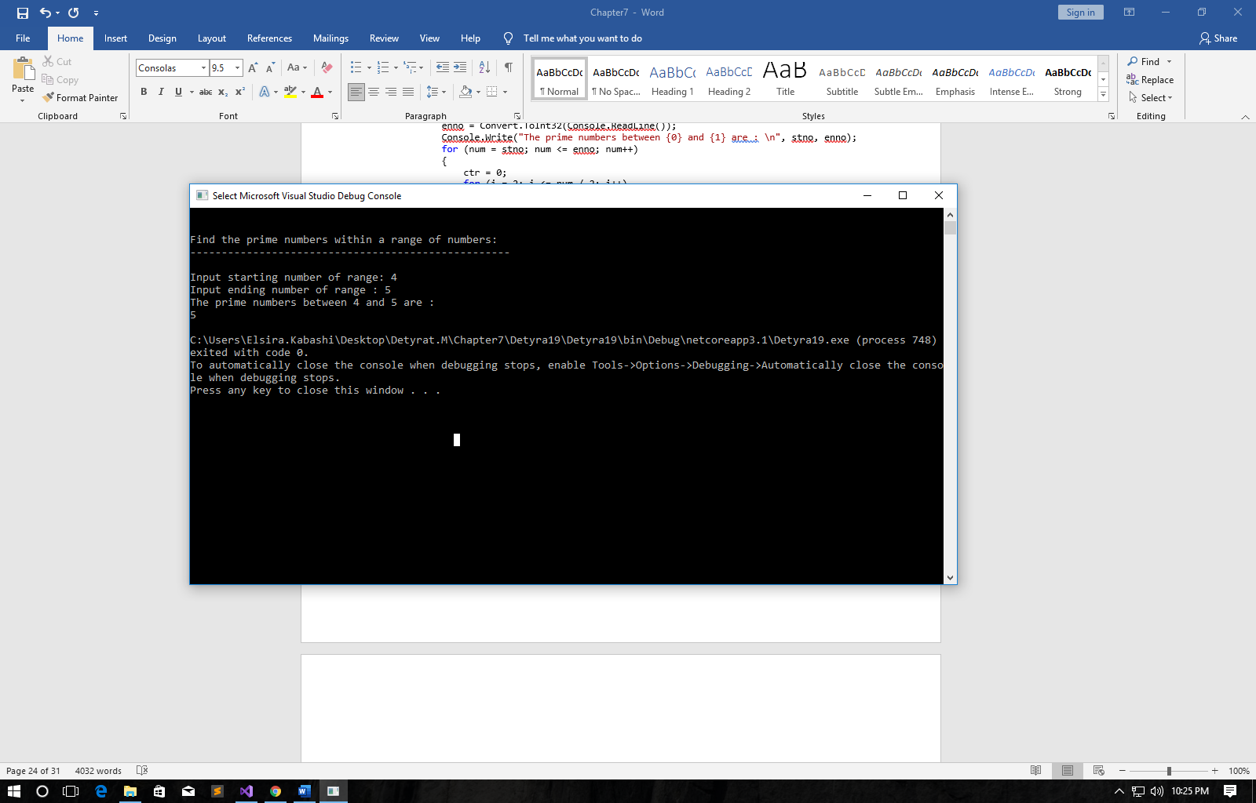

20. Write a program, which checks whether there is a **subset** of given array of **N** elements, which has a **sum S**. The numbers N, S and the array values are read from the console. Same number can be used many times.  
Example: {2, 1, 2, 4, 3, 5, 2, 6}, S = 14 à yes (1 + 2 + 5 + 6 = 14)

using System;

namespace Detyra20

{

class Program

{

static int wantedSum;

static bool solution = false;

static void GenerateSubset(int[] arr, int[] subset, int index, int current, int elementsInSubset)

{

if (index == elementsInSubset)

{

CheckSubsets(subset, elementsInSubset);

return;

}

for (int i = current; i < arr.Length; i++)

{

subset[index] = arr[i];

GenerateSubset(arr, subset, index + 1, i + 1, elementsInSubset);

}

}

static void CheckSubsets(int[] subset, int elementsInSubset)

{

int sum = 0;

for (int i = 0; i < elementsInSubset; i++) sum += subset[i];

if (sum == wantedSum)

{

for (int i = 0; i < elementsInSubset; i++) Console.Write("{0} ", subset[i]);

Console.WriteLine();

solution = true;

}

}

static void Main()

{

Console.Write("Enter array length: ");

int length = int.Parse(Console.ReadLine());

int[] arr = new int[length];

for (int i = 0; i < length; i++)

{

Console.Write("Enter {0} element: ", i);

arr[i] = int.Parse(Console.ReadLine());

}

Console.Write("Enter S: ");

wantedSum = int.Parse(Console.ReadLine());

int[] subset = new int[length];

for (int i = 1; i <= length; i++) GenerateSubset(arr, subset, 0, 0, i);

if (!solution) Console.WriteLine("No subset with sum {0} found.", wantedSum);

}

}

}

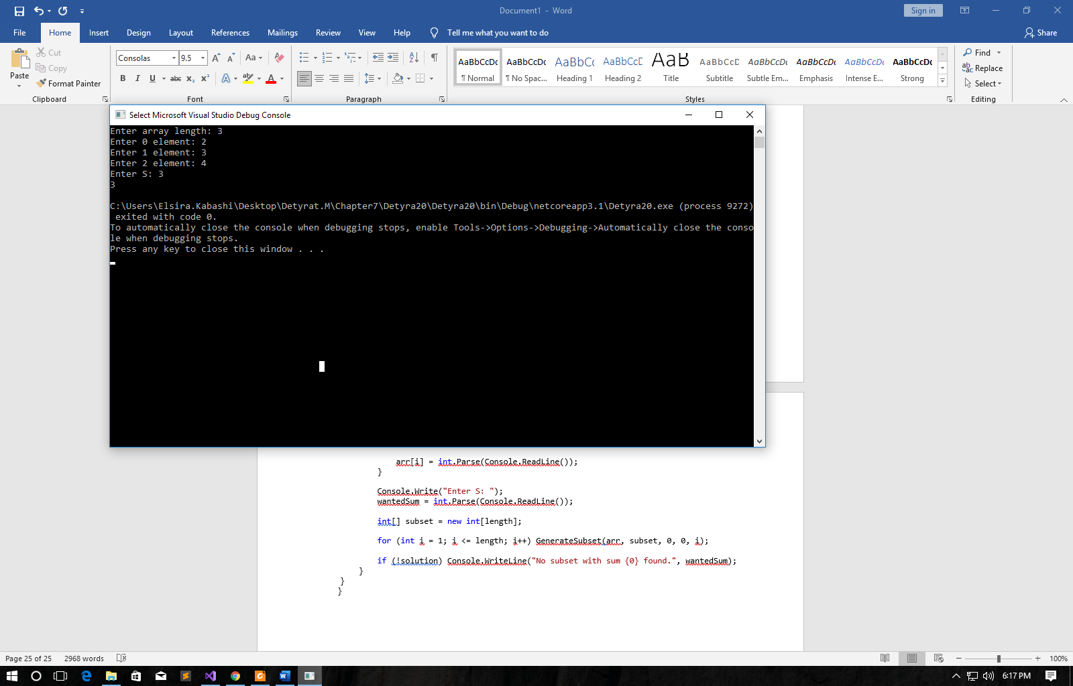

21. Write a program which by given **N** numbers, **K** and **S**, finds **K** elements out of the **N** numbers, the sum of which is exactly **S** or says it is not possible.  
Example: {3, **1**, 2, **4**, **9**, 6}, **S = 14**,**K = 3** à yes (1 + 2 + 4 = 14)

using System;

namespace Detyra21

{

class Program

{

public static int[] findSolution(int[] a, bool[] filter, int index, int s, int size)

{

if (index < a.Length)

{

filter[index] = true;

int[] x = findSolution(a, filter, index + 1, s, size);

if (x.Length > 0) return x;

else

{

filter[index] = false;

return findSolution(a, filter, index + 1, s, size);

}

}

else

{

int sum = 0, count = 0;

for (int i = 0; i < a.Length; i++)

{

if (filter[i])

{

sum += a[i];

count++;

}

}

int[] solution = new int[0];

if (sum == s && count == size)

{

solution = new int[count];

count = 0;

for (int i = 0; i < a.Length; i++) if (filter[i]) solution[count++] = a[i];

}

return solution;

}

}

static void Main(string[] args)

{

Console.Write("Enter N = ");

int n = int.Parse(Console.ReadLine());

Console.Write("Enter K = ");

int size = int.Parse(Console.ReadLine());

int[] arr = new int[n];

for (int i = 0; i < n; i++)

{

Console.Write("{0}: ", i);

arr[i] = int.Parse(Console.ReadLine());

}

Console.Write("Sum of elements, s = ");

int s = int.Parse(Console.ReadLine());

int[] solution = findSolution(arr, new bool[arr.Length], 0, s, size);

Console.WriteLine("Your solution:");

for (int i = 0; i < solution.Length; i++) Console.Write(solution[i] + "; ");

Console.ReadLine();

}

}

}

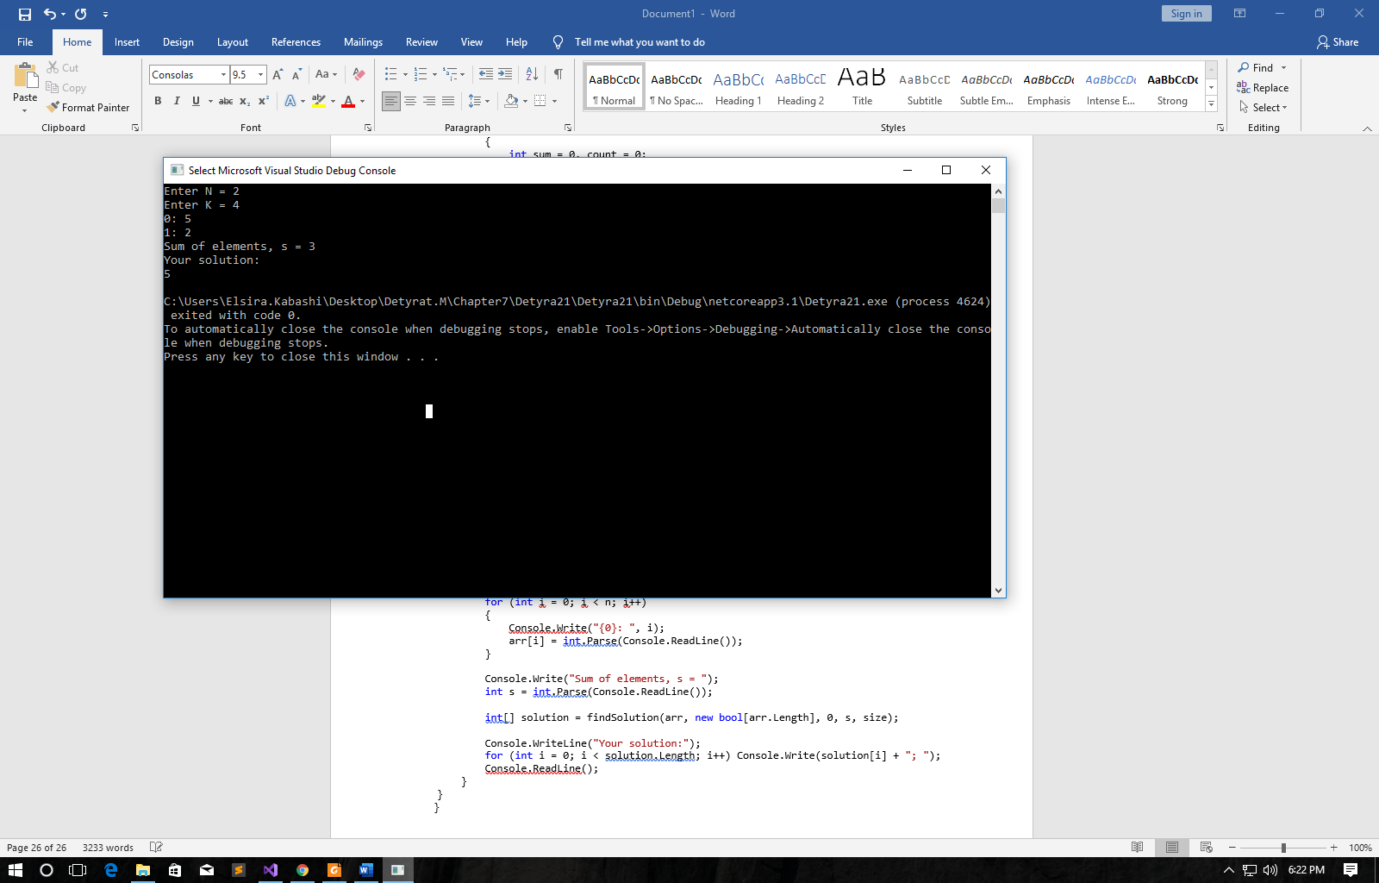

22. Write a program, which reads an array of integer numbers from the console and **removes a minimal number of elements** in such a way that **the remaining array is sorted** in an increasing order.  
Example: {6, **1**, 4, **3**, 0, **3**, 6, **4**, **5**} à {1, 3, 3, 4, 5}  
Guidelines: Use **dynamic programming** to find the **longest increasing sub-sequence** in the input sequence arr[]. The elements not included in the maximal increasing sequence should be removed in order the array to become sorted.

using System;

namespace Detyra22

{

class Program

{

static void Main(string[] args)

{

int subset = 0, longestLength = 0;

Console.Write("Enter arr length: ");

int length = Int32.Parse(Console.ReadLine());

int[] arr = new int[length];

for (int i = 0; i < length; i++)

{

Console.Write("Enter {0} element: ", i);

arr[i] = Int32.Parse(Console.ReadLine());

}

int m = (1 << length);

int[,] subsets = new int[m, length];

for (int i = 0; i < m; i++)

for (int j = 0; j < length; j++) subsets[i, j] = i / (m / 2 / (1 << j)) % 2;

for (int i = 0; i < m; i++)

{

int max = -1000, count = 0;

for (int j = 0; j < length; j++)

{

if (subsets[i, j] > 0)

{

if (arr[j] >= max)

{

count++;

max = arr[j];

}

else

{

count = 0;

break;

}

}

}

if (longestLength < count)

{

longestLength = count;

subset = i;

}

}

Console.WriteLine("Result:");

for (int i = 0; i < length; i++) if (subsets[subset, i] > 0) Console.Write(arr[i] + "; ");

}

}

}

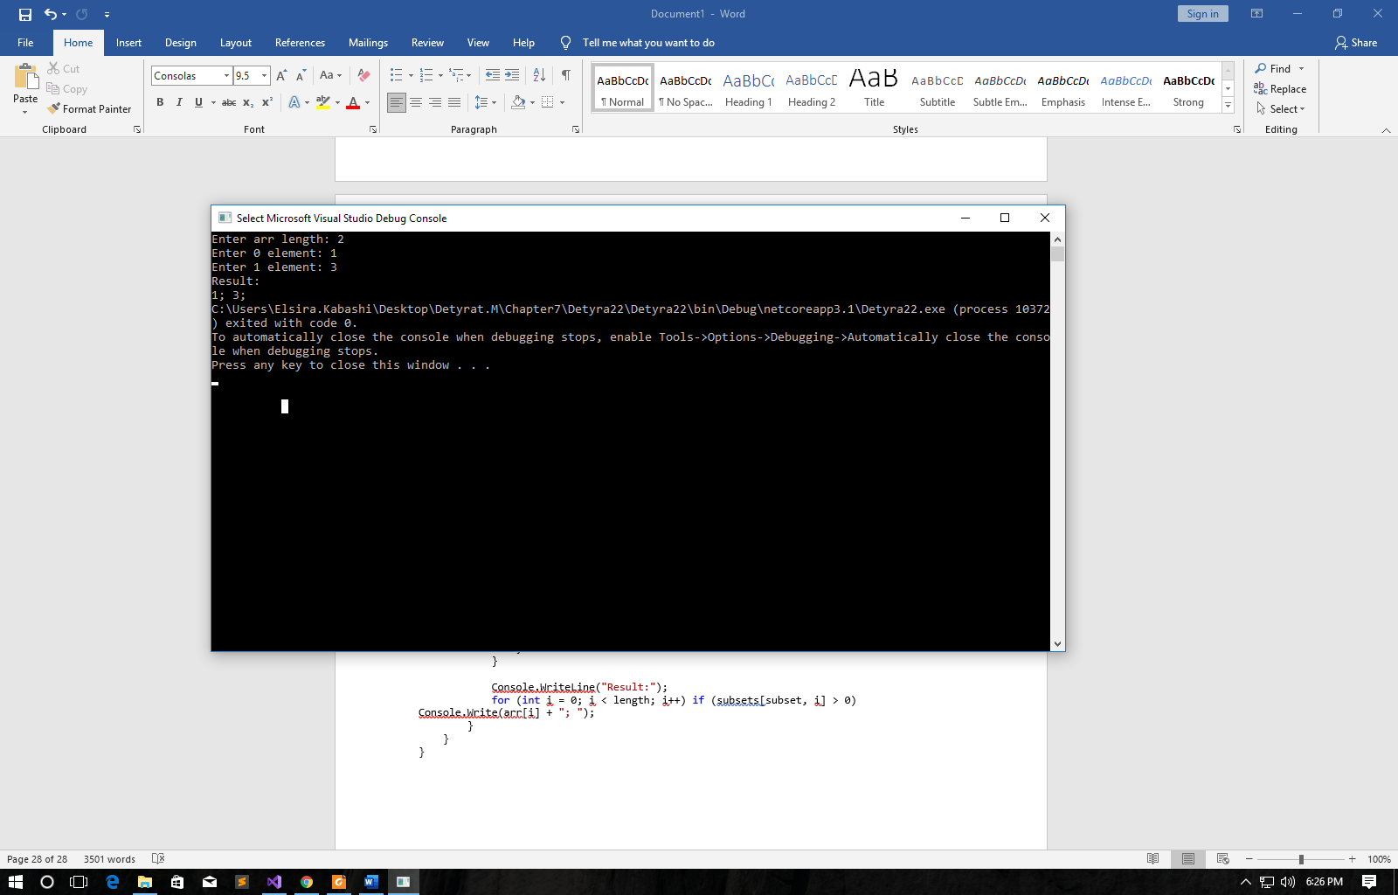

23. Write a program, which reads the integer numbers N and K from the console and prints **all variations of K elements of the numbers in the interval [1…N]**.  
Example: N = 3 à {1, 2, 3}, {1, 3, 2}, {2, 1, 3}, {2, 3, 1}, {3, 1, 2}, {3, 2, 1}

using System;

namespace Detyra23

{

class Program

{

public static int n;

static void Main(string[] args)

{

Console.Write("Enter N: ");

n = Int32.Parse(Console.ReadLine());

Console.Write("Enter K: ");

int k = Int32.Parse(Console.ReadLine());

int[] arr = new int[k];

recSolution(arr, 0);

}

static void recSolution(int[] array, int index)

{

if (index != array.Length)

for (int i = 1; i <= n; i++)

{

array[index] = i;

recSolution(array, index + 1);

}

else

{

for (int i = 0; i < array.Length; i++) Console.Write(array[i] + " ");

Console.WriteLine();

}

}

}

}

