**KOLEGJI UNIVERSUM**



Programi Shkenca Kompjuterike / Viti I / Semestri 2

Lënda: Hyrje ne Struktura te te Dhenave

Chapter 8 – Fundamentals of Computer Programming with C#

Studentja: Prof.Dr:

Elsira Kabashi Muzafer Shala

Asistenti: Laberion Zebica

Prishtinë 2021

1. Convert the numbers 151, 35, 43, 251, 1023 and 1024 to the **binary numeral system**.

using System;

namespace Detyra1

{

class Program

{

static void Main(string[] args)

{

Console.WriteLine("150 to binary {0}.", Convert.ToString(150, 2));

Console.WriteLine("35 to binary {0}.", Convert.ToString(35, 2));

Console.WriteLine("43 to binary {0}.", Convert.ToString(43, 2));

Console.WriteLine("251 to binary {0}.", Convert.ToString(251, 2));

}

}

}

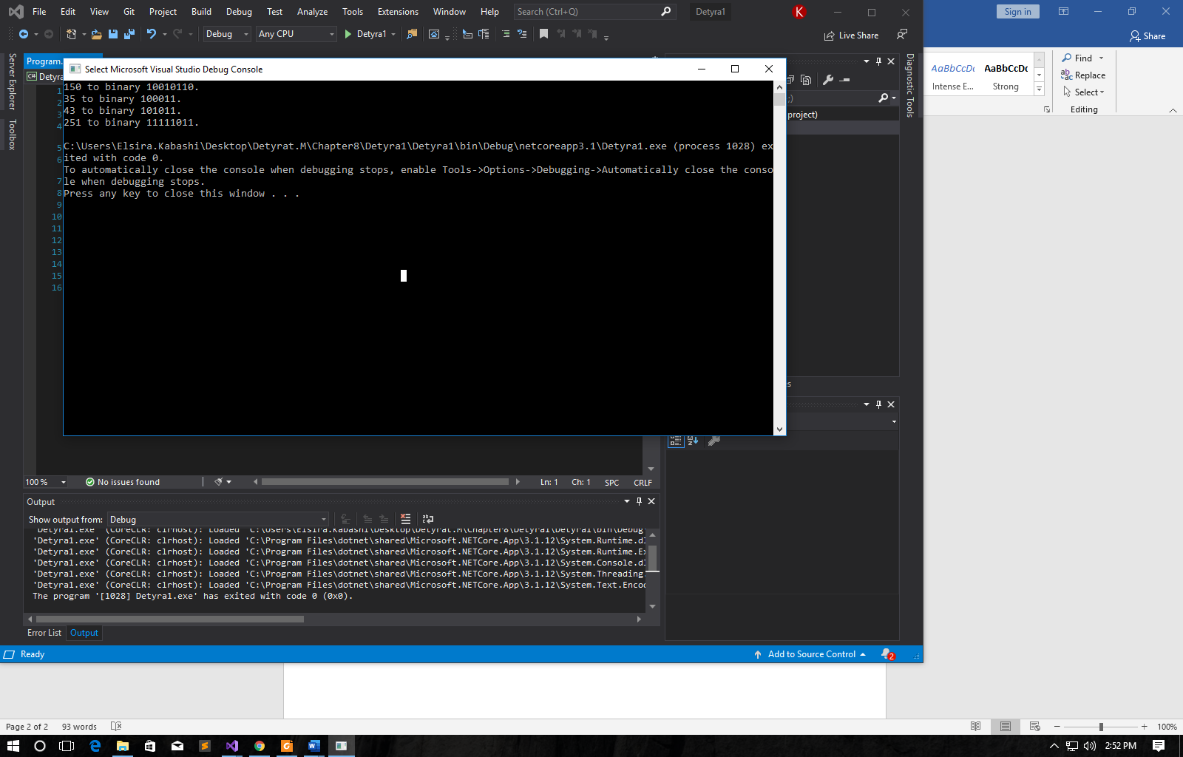

1. Convert the number 1111010110011110(2) to **hexadecimal** and **decimal** numeral systems.

using System;

namespace Detyra2

{

class Program

{

static void Main(string[] args)

{

Console.WriteLine("1111010110011110 to decimal is {0}.",

Convert.ToInt64("1111010110011110", 2));

Console.WriteLine("1111010110011110 to hexadecimal is {0}.",

Convert.ToInt64("1111010110011110", 2).ToString("X"));

}

}

}

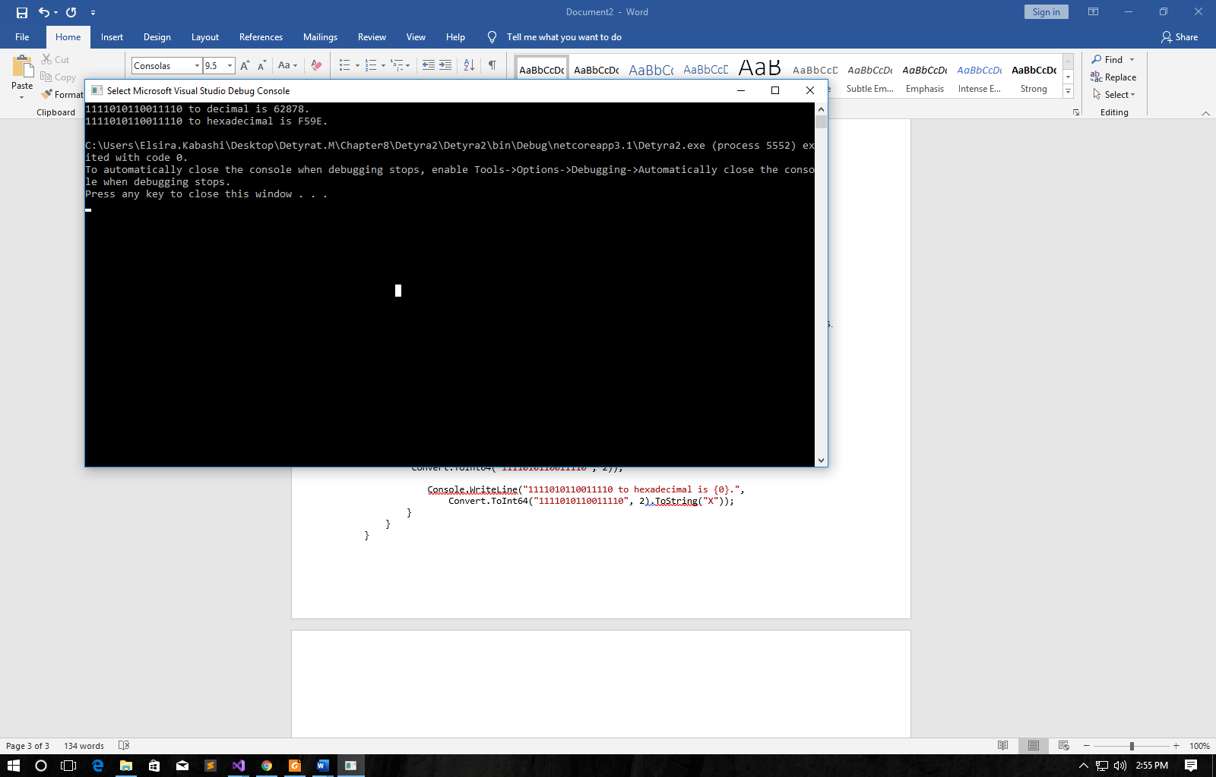

1. Convert the hexadecimal numbers FA, 2A3E, FFFF, 5A0E9 to **binary** and **decimal** numeral systems.

using System;

namespace Detyra3

{

class Program

{

static void conversion(string value)

{

Console.WriteLine("{0} to decimal is {1}.",

value, Convert.ToInt32(value, 16));

Console.WriteLine("{0} to decimal is {1}.\n", value,

Convert.ToString(Convert.ToInt32(value, 16), 2));

}

static void Main(string[] args)

{

conversion("2A3E");

conversion("FA");

conversion("FFFF");

conversion("5A0E9");

}

}

}

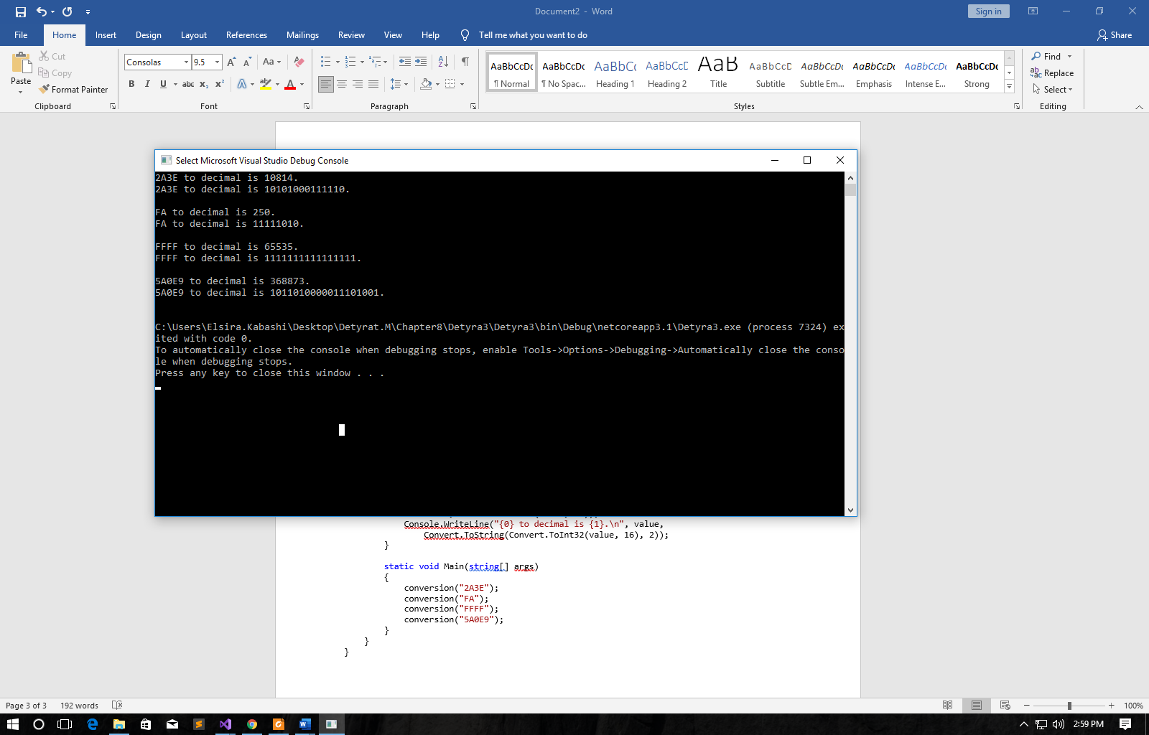

1. Write a program that converts a **decimal number to binary one**.

using System;

namespace Detyra4

{

class Program

{

static void Main(string[] args)

{

Console.Write("Enter decimal number: ");

int deci = Int32.Parse(Console.ReadLine());

Console.WriteLine("{0} to binary is {1}.",

deci, Convert.ToString(deci, 2));

}

}

}

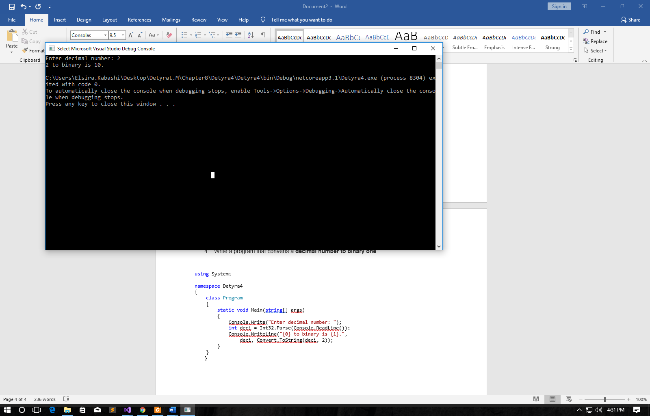

1. Write a program that converts a **binary number to decimal one**

using System;

namespace Detyra5

{

class Program

{

static void Main(string[] args)

{

Console.Write("Enter binary number: ");

string binary = Console.ReadLine();

Console.WriteLine("{0} to decimal is {1}.",

binary, Convert.ToInt64(binary, 2));

}

}

}

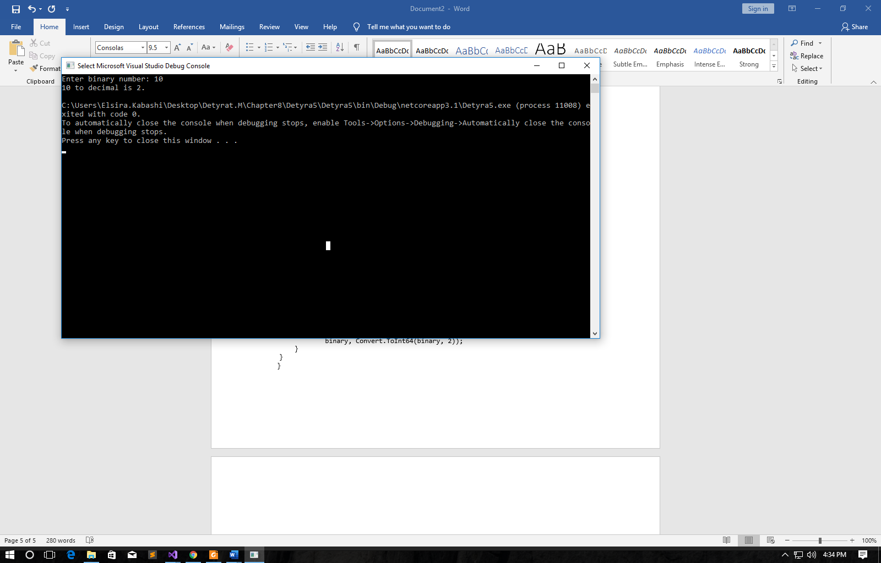

1. Write a program that converts a **decimal number to hexadecimal one**.

using System;

namespace Detyra6

{

class Program

{

static void Main(string[] args)

{

Console.Write("Enter decimal number: ");

int deci = Int32.Parse(Console.ReadLine());

Console.WriteLine("{0} to hexadecimal is {1}.",

deci, deci.ToString("X"));

}

}

}

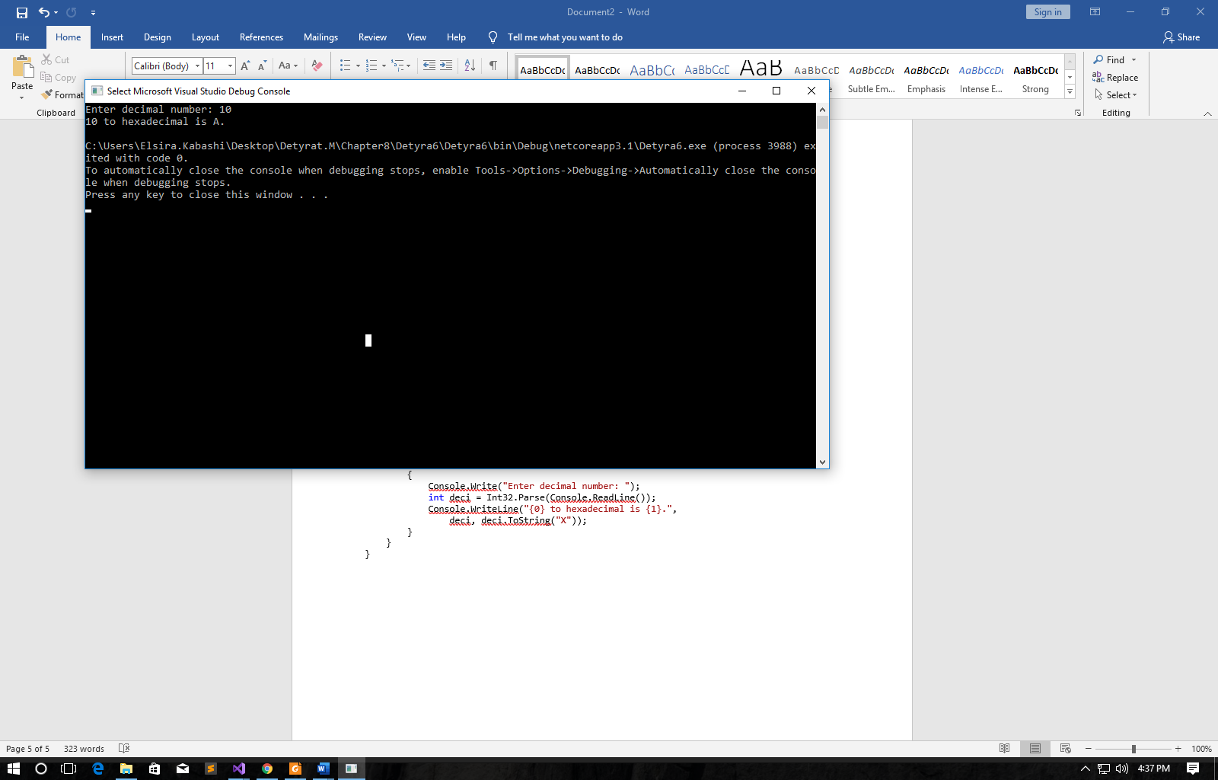

1. Write a program that converts a **hexadecimal number to decimal one**.

using System;

namespace Detyra7

{

class Program

{

static void Main(string[] args)

{

Console.Write("Enter hexadecimal number: ");

string hexa = Console.ReadLine();

Console.WriteLine("{0} to decimal is {1}.",

hexa, Convert.ToInt32(hexa, 16));

}

}

}

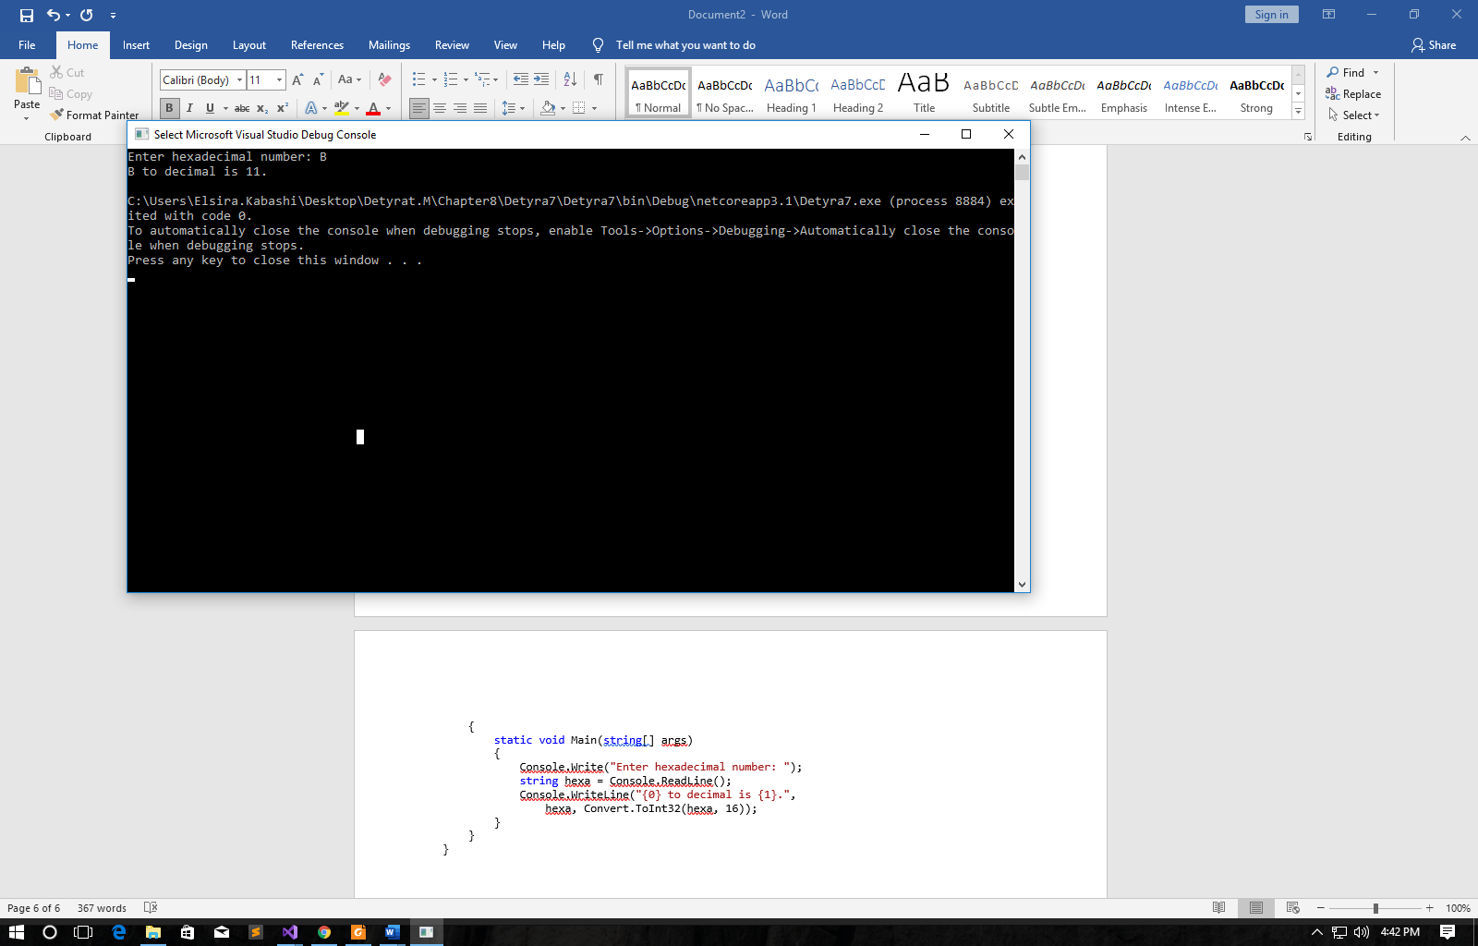

1. Write a program that converts a **hexadecimal number to binary one.**

using System;

namespace Detyra8

{

class Program

{

static void Main(string[] args)

{

Console.Write("Enter hexadecimal number: ");

string hexa = Console.ReadLine();

Console.WriteLine("{0} to binary is {1}.",

hexa, Convert.ToString(Convert.ToInt32(hexa, 16), 2));

}

}

}

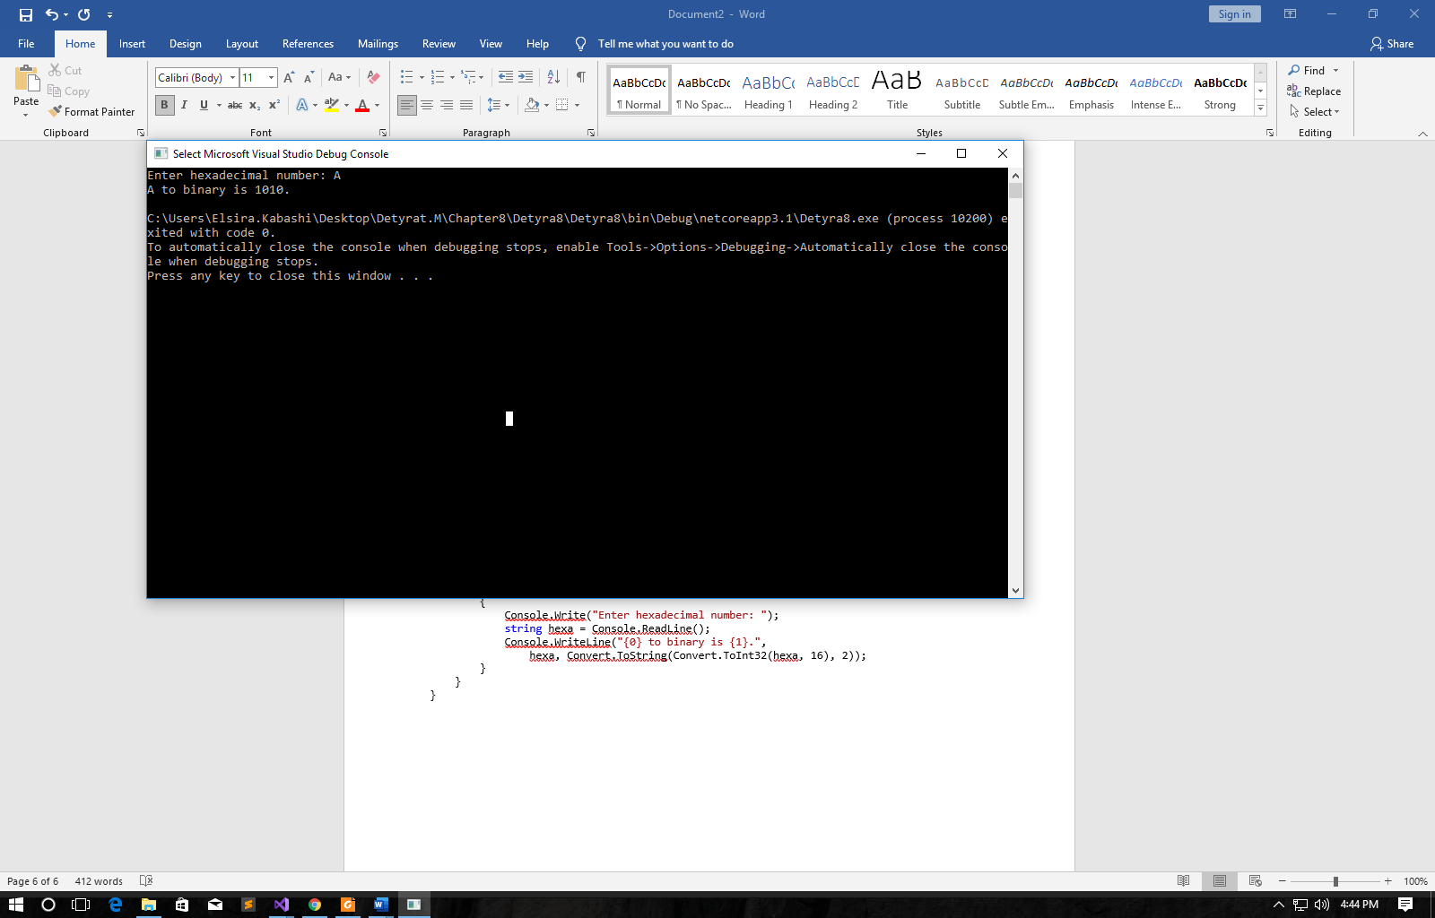

1. Write a program that converts a **binary number to hexadecimal one**.

using System;

namespace Detyra9

{

class Program

{

static void Main(string[] args)

{

Console.Write("Enter binary number: ");

string binary = Console.ReadLine();

Console.WriteLine("{0} to hexadecimal is {1}.",

binary, Convert.ToInt32(binary, 2).ToString("X"));

}

}

}

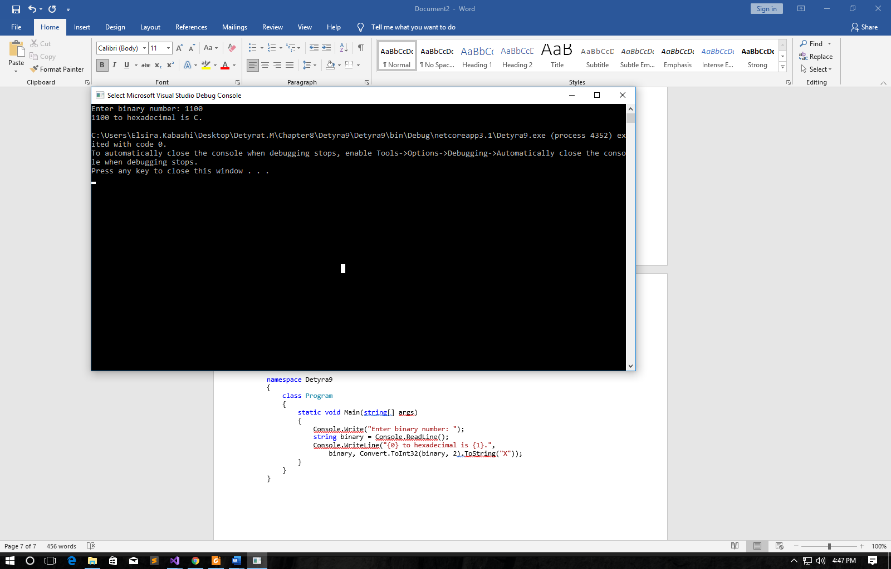

1. Write a program that converts a **binary number to decimal** using the Horner scheme.

using System;

namespace Detyra10

{

class Program

{

static void Main(string[] args)

{

int deci = 0;

Console.Write("Enter binary number: ");

string binary = Console.ReadLine();

int length = binary.Length;

int power = length - 1;

for (int i = 0; i < length; i++)

{

deci += (int)(int.Parse(binary[i].ToString()) * Math.Pow(2, power));

power--;

}

Console.WriteLine("Result is {0}.", deci);

}

}

}

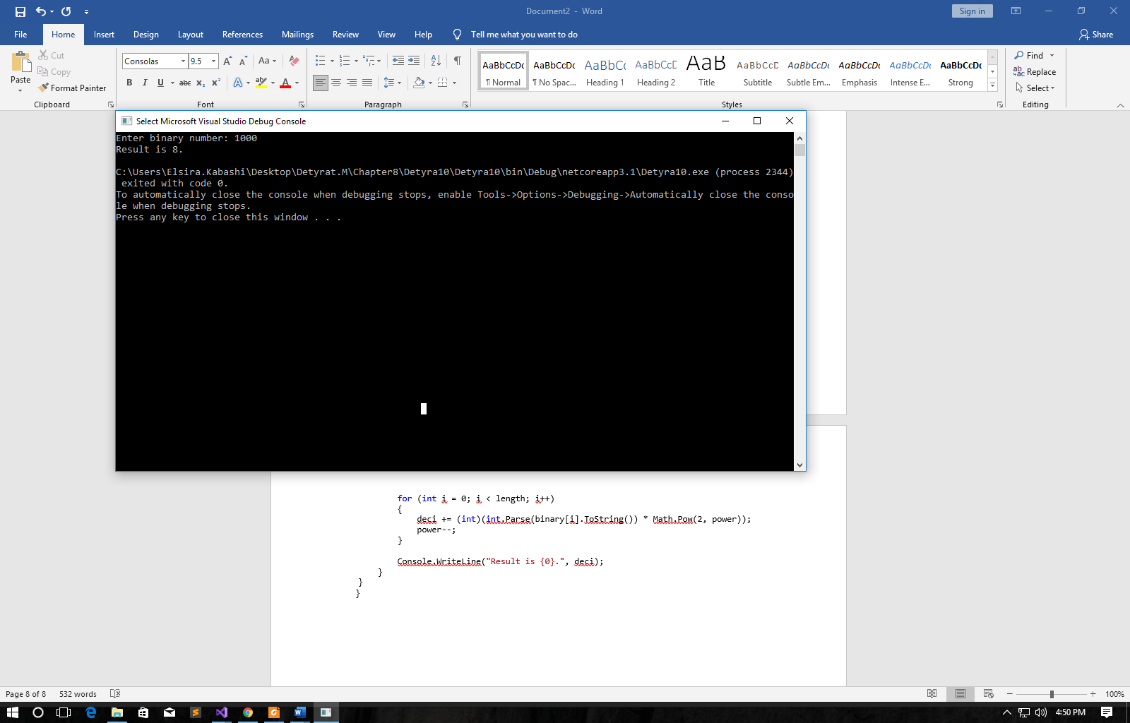

1. Write a program that converts **Roman digits to Arabic** ones.
2. Write a program that converts **Arabic digits to Roman ones**.

using System;

namespace Detyra12

{

class Program

{

static void Main(string[] args)

{

String result = "";

Console.Write("Enter Arabic number: ");

int i = Convert.ToInt32(Console.ReadLine());

int thousands = i / 1000, hundreds = (i / 100) % 10, tens = (i / 10) % 10, ones = i % 10;

switch (thousands)

{

case 1: result += "M"; break;

case 2: result += "MM"; break;

case 3: result += "MMM"; break;

}

switch (hundreds)

{

case 1: result += "C"; break;

case 2: result += "CC"; break;

case 3: result += "CCC"; break;

case 4: result += "CD"; break;

case 5: result += "D"; break;

case 6: result += "DC"; break;

case 7: result += "DCC"; break;

case 8: result += "DCCC"; break;

case 9: result += "CM"; break;

}

switch (tens)

{

case 1: result += "X"; break;

case 2: result += "XX"; break;

case 3: result += "XXX"; break;

case 4: result += "XL"; break;

case 5: result += "L"; break;

case 6: result += "LX"; break;

case 7: result += "LXX"; break;

case 8: result += "LXXX"; break;

case 9: result += "XC"; break;

}

switch (ones)

{

case 1: result += "I"; break;

case 2: result += "II"; break;

case 3: result += "III"; break;

case 4: result += "IV"; break;

case 5: result += "V"; break;

case 6: result += "VI"; break;

case 7: result += "VII"; break;

case 8: result += "VIII"; break;

case 9: result += "IX"; break;

}

Console.WriteLine("Roman number is " + result);

}

}

}

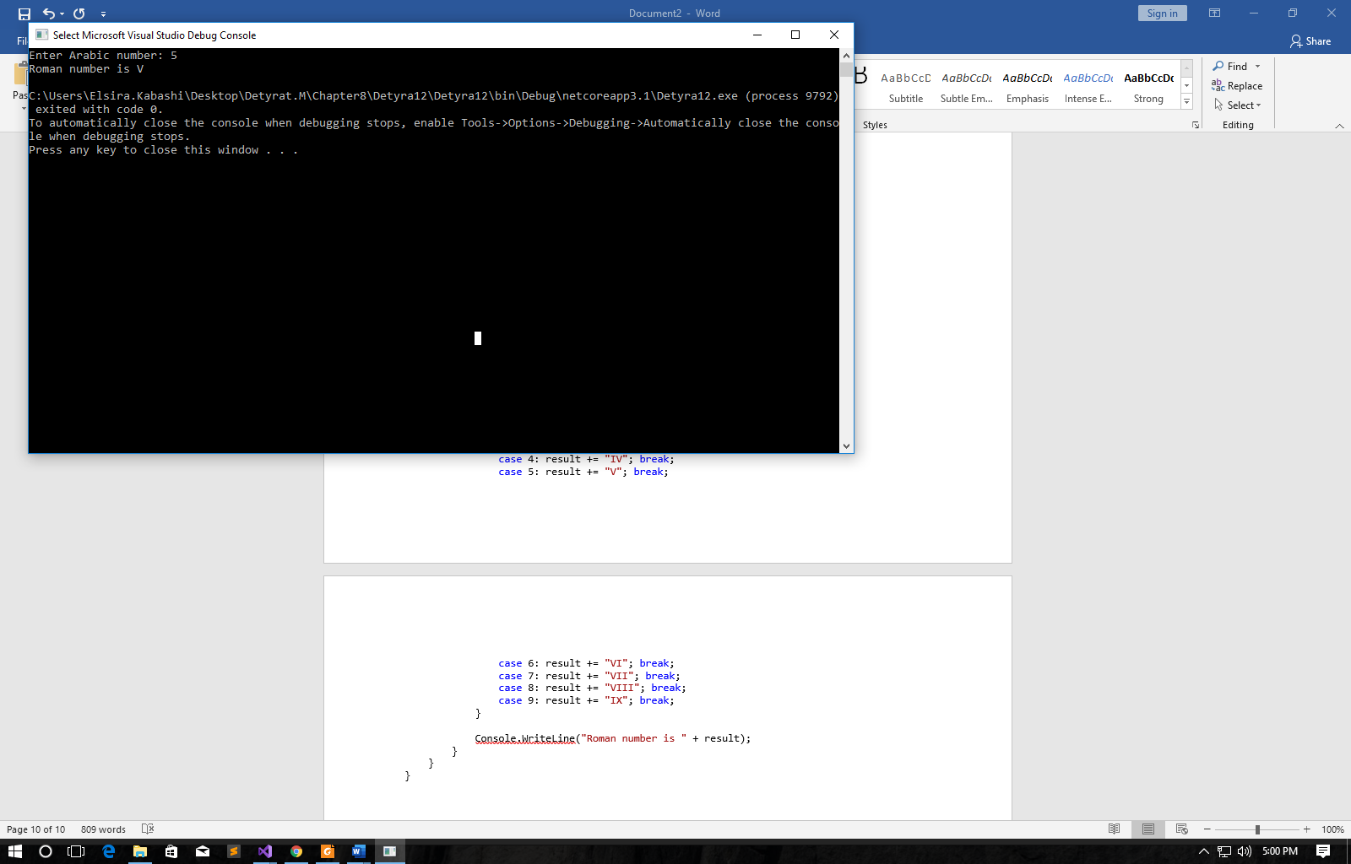

1. Write a program that by given N, S, D converts the number N from an S-based numeral system to a D based numeral system.

using System;

namespace Detyra13

{

class Program

{

static void Main(string[] args)

{

int s, d;

Console.Write("Enter N: ");

string n = Console.ReadLine();

do

{

Console.Write("Enter S (S == 2, 8, 10 or 16): ");

s = Int32.Parse(Console.ReadLine());

} while (s != 2 && s != 8 && s != 10 && s != 16);

do

{

Console.Write("Enter D (D == 2, 8, 10 or 16): ");

d = Int32.Parse(Console.ReadLine());

} while (d != 2 && d != 8 && d != 10 && d != 16);

n = Convert.ToString(Convert.ToInt32(n, s), d);

Console.WriteLine("Result is {0}.", n);

}

}

}

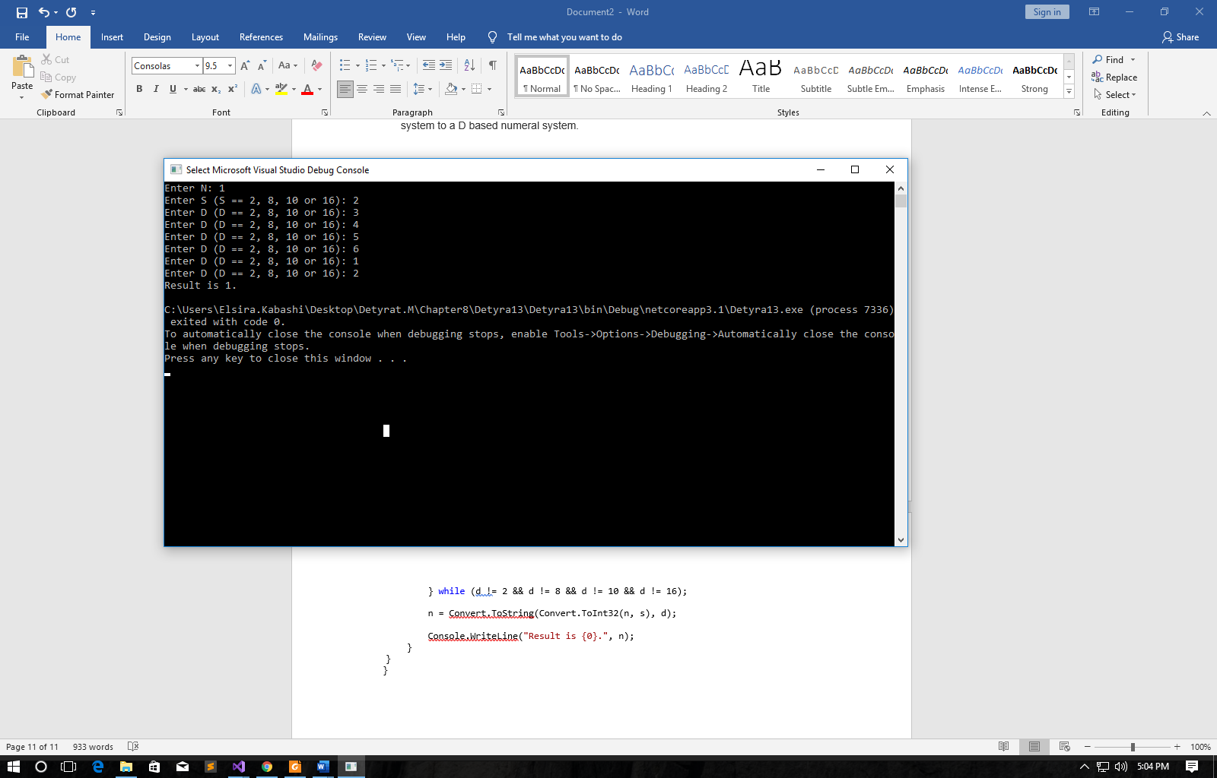

1. Try adding up 50,000,000 times the number 0.000001. Use a loop  
   and addition (not direct multiplication). Try it with float and double and  
   after that with decimal. Do you notice the huge difference in theresults and speed of calculation? Explain what happens.

using System;

namespace Detyra14

{

class Program

{

static void Main(string[] args)

{

Console.WriteLine("EX:14 compare result for float, double and decimal");

Console.WriteLine("Add real number 0.000001 50 000 000 times using float, double and decimal type:");

float numberFloat = 0.0f;

for (int i = 0; i < 50000000; i++)

{

numberFloat += 0.000001f;

}

Console.WriteLine($"Float: {numberFloat} not accurate result, but the high speed.");

double numberDouble = 0.0d;

for (int i = 0; i < 50000000; i++)

{

numberDouble += 0.000001d;

}

Console.WriteLine($"Double: {numberDouble} not accurate result, but the high speed.");

decimal numberDecimal = 0.0M;

for (int i = 0; i < 50000000; i++)

{

numberDecimal += 0.000001M;

}

Console.WriteLine($"Decimal: {numberDecimal} the resault is accurate, but the speed is slowest.");

}

}

}

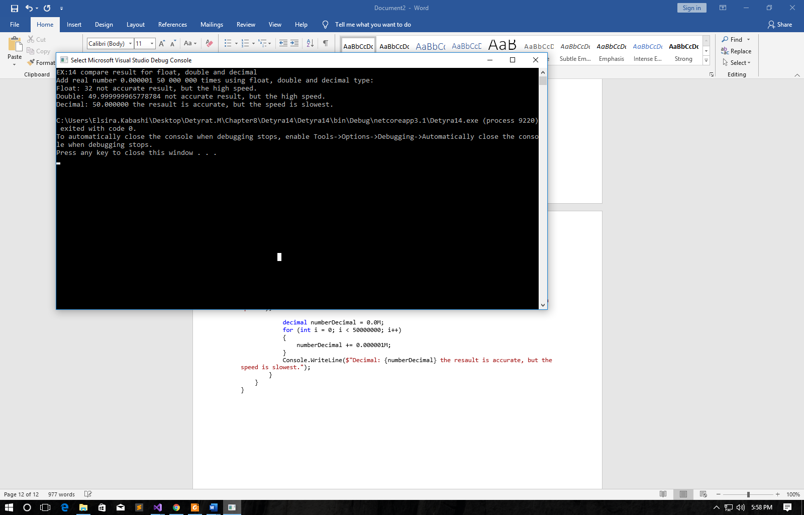

1. * Write a program that prints the value of the mantissa, the sign of themantissa and exponent in float numbers (32-bit numbers with a  
   floating-point according to the IEEE 754 standard). Example: for the  
   number -27.25 should be printed: sign = 1, exponent = 10000011,  
   mantissa = 10110100000000000000000.

using System;

namespace Detyra15

{

class Program

{

static void Main(string[] args)

{

Console.WriteLine(new String('#', 80));

Console.WriteLine();

}

}

}

