 | FRAMEWORK COCOTB | CNES
Référence | 23-9482-ED_0001 | Révision | 1.1
Date d’édition | 17/11/2023
Confidentialité | NOT RESTRICTED

FRAMEWORK COCOTB
USER MANUAL

 | Nom | Fonction | Date | Visa
Rédigé par | Paul SUAU | FPGA Engineer | 17/11/2023
Vérifié par | Arnaud DANIEL | Technical Director | 17/11/2023
Approuvé par | Arnaud DANIEL | Technical Director | 17/11/2023

Historique du document

Révision | Date | Auteur | Description de l’évolution
1.0 | 31/10/2023 | Paul SUAU | Document creation
1.1 | 17/11/2023 | Paul SUAU | Update after first implementation

Contents

1. APPLICABLE & REFERENCE DOCUMENTS 7
2. Environment setup 8
2.1. oss-cad-suite 8
2.1.1. oss-cad-suite’s environment 8
2.2. Cocotbext.axi 8
2.3. Xilinx’s unisim library 8
2.3.1. Why compile unisim 8
2.3.2. Find unisim 9
2.3.3. Compile unisim 9
2.3.4. Use unisim 9
2.4. VHDL generation from vivado Block design 10
2.5. gtkwave 11
3. Testbench 12
3.1. DUT 12
3.2. Makefile 12
3.3. Testbench class 13
4. Tests 14
4.1. Building input objects 14
4.1.1. From a file 15
4.1.2. Using random generators 15
4.1.3. Directly in python 16
4.2. Driving the inputs 16
4.2.1. Python tasks 16
4.2.2. Simple example 16
4.2.3. General example 16
4.2.4. Passing simulation time 17
4.3. Outputs 18
4.3.1. Stimuli logs 18
4.3.2. Results 18
4.3.3. Framework general logs 18
4.4. Verifying the DUT 18
4.4.1. Manual (then automatic) verification 18
4.4.2. Scoreboard 19
5. Dut compilation and test launch 20
5.1. DUT compilation using cocotb’s Makefile 20
5.2. Launching tests 20
6. Simple tests examples 21
6.1. Examples structure 21
6.1.1. Testbench structure 21
6.1.2. Tests structure 21
6.2. Interconnect example 22
6.3. Interconnect_stream example 22

Tables list

Table 1 - Applicable documents 7
Table 2 - Reference documents 7

Figures list

Figure 1 - Setting Vivado's project target language 10
Figure 2 - Generating output products 11
Figure 3 - Block diagram of the interconnect example's DUT 22
Figure 4 - Block diagram of the interconnect_stream(_tlast) example's DUT 22

APPLICABLE & REFERENCE DOCUMENTS
Table 1 - Applicable documents
Name | Description | Reference
Cocotb documentation | Documentation of the cocotb framework | https://docs.cocotb.org/en/stable/
Cocotbext.axi’s README | Documentation of the cocotbext.axi library | README.md
JSON specification | Specification of the Json standard | https://www.json.org/json-en.html

Table 2 - Reference documents
Name | Description | Reference
Initial specifications | First specification document  Edition 1, Revision 0  Date: 25/05/2023  Authors:  - Florent MANNI  - Aurélien ODOUNDE | DTN/TVO/ET/2023-07171
Detailed specifications | Specification of Stimuli and Data file formats  Date: 30/10/2023  Author: Florent MANNI | Gitlab 30/10/2023

Environment setup

oss-cad-suite
The first thing to install is oss-cad-suite. There are releases that can be downloaded for different OS. here: https://github.com/YosysHQ/oss-cad-suite-build/releases/tag/2023-10-23.
The installation procedure has been performed on Manjaro 22.0 and on Debian 11 installed as WSL (Windows Subsystem for Linux).

oss-cad-suite’s environment
Once the archive extracted into an oss-cad-suite directory, we can enter this environment using
“source oss-cad-suite/environment”. This adds every program we need to the PATH (and changes the prompt).

Some programs that might be present in your system can cause confusion.
For instance, python3.8 is included in oss-cad-suite BUT python isn’t. If your system as a “python” in the PATH that can be called, typing “python main.py” will call the system’s python and not oss-cad-suite’s. To call oss-cad-suite’s, it’s important to call “python3.8” (or the exact name that is in “oss-cad-suite/pybin”).
In this example, not using oss-cad-suite’s python will not give access to oss-cad-suite’s libraries such as cocotb (so an “import cocotb” in a python script will fail).
This is the case for other programs such as pip/pip3.8 (pip installs libraries in the system while pip3.8 installs them in oss-cad-suite environment).

Cocotbext.axi
To install cocotbext.axi, we need to:
- Enter oss-cad-suite’s environment (“source oss-cad-suite/environment”)
- Execute “pip3.8 install cocotbext-axi”
Note: be careful about the “pip” version, it must be one that is printed when executing
“ls <oss-cad-suite_install_dir>/py3bin | grep pip”

Xilinx’s unisim library

Why compile unisim
Xilinx IPs cannot be simulated directly with ghdl because they are not described in “high level” VHDL but only as netlists.
These netlists use primitives that come from Xilinx’s Unisim library.
This library isn’t supported by ghdl out of the box so to simulate a design containing IPs using it, we need to:
- Find the Unisim library
- Compile it with ghdl
And then, when we need to simulate a design containing Xilinx IPs, we can just tell ghdl to use this compiled library.

Find unisim
This library can be found in Vivado’s install directory: « <vivado_install_dir>/data/vhdl/src/unisims » (this path is for a windows vivado installation).
Note: It seems complex to get this directory without Vivado. Since we only need this directory, it can be zipped and sent to another computer that doesn’t have Vivado.

Compile unisim
Once the library directory found, we can compile it using the “compile-xilinx-vivado.sh” script that can be found in “<ghdl_install_dir>/vendors/”:
compile-xilinx-vivado.sh –unisim –source <path_to_unisim_PARENT_directory> –output compiled_unisim

This command takes the path to unisim’s parent directory and builds a compiled_unisim directory.
It can take a while to finish depending on the computer’s hardware (between 5 and 30 minutes).
There can be some errors at the beginning of the compilation (Example: “10ns” -> ghdl script says a space is needed between number and unit, this needs to be fixed by hand in the library files).

Use unisim
The option « -P<path_to_compiled_unisim>/unisim/v93/ » must be used to tell ghdl to compile a design with the unisim library.
Example : « -P../vivado_lib/compiled_unisim/unisim/v93/ ».
Note : There is no space between the « -P » and the path.

VHDL generation from vivado Block design
Before generating the sources, the project target language should be set to VHDL:
Figure 1 - Setting Vivado's project target language
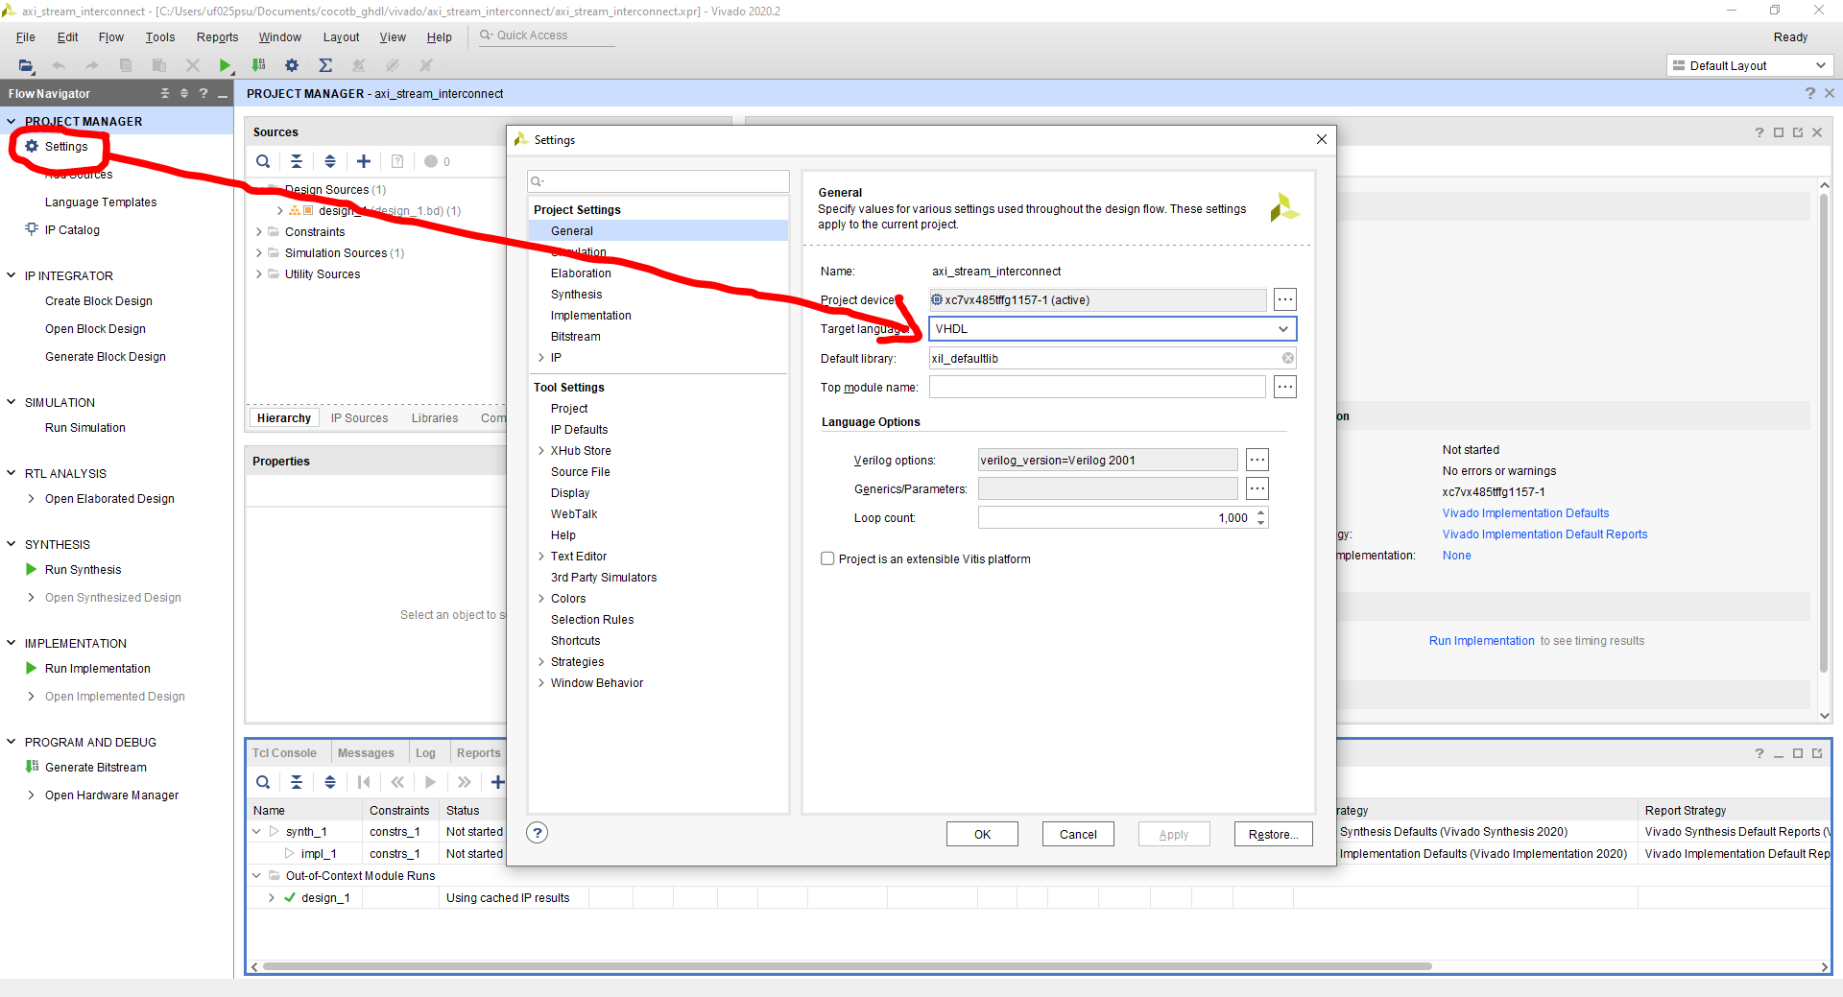
VHDL sources of a Vivado block design can be generated using the “Generate Output Products” option.
The sources can then be found in the project directory under: project_name.gen/sources_1/bd/design_name/
- sim/design_name.vhd: top simulation source
- ip/*/design_name_***_sim_netlist.vhdl: ip simulation sources
Figure 2 - Generating output products
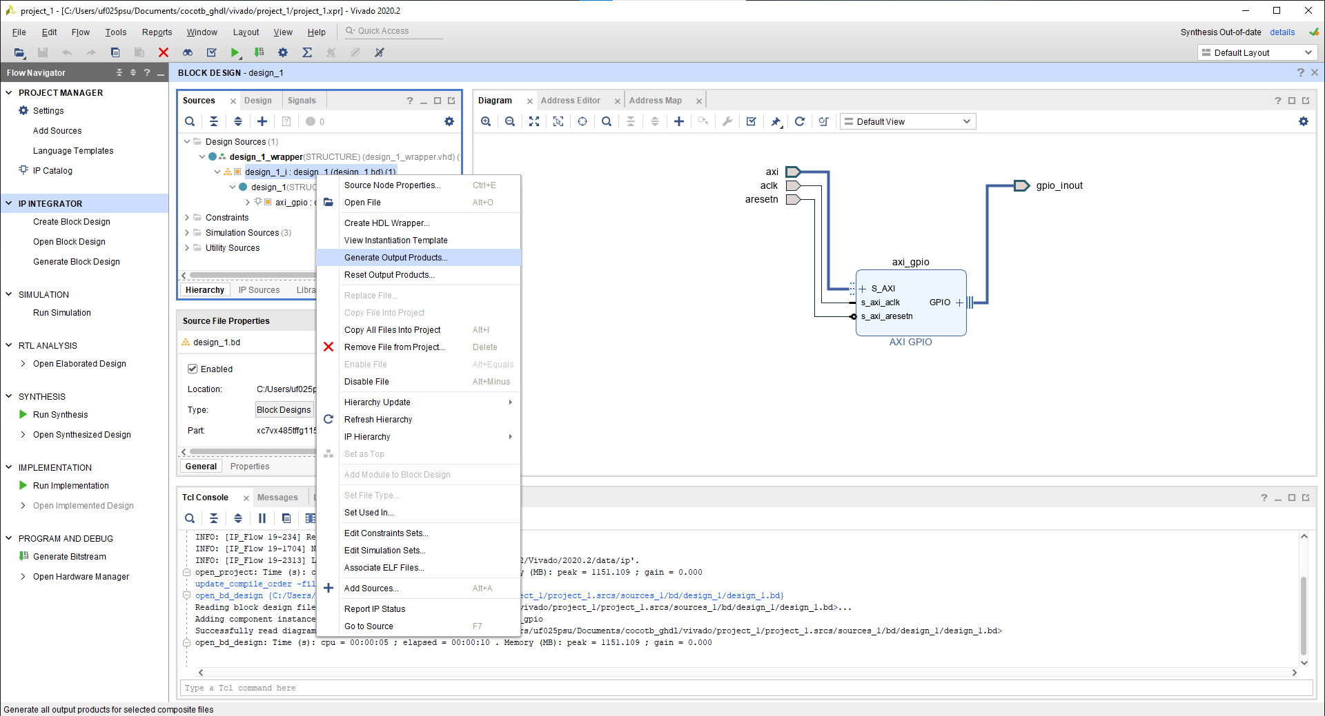

gtkwave
Files like .ghw and .vcd can be opened using gtkwave (in oss-cad-suite) with : “gtkwave wave.ghw”.
In gtkwave, after adding signals (left panel) we can go to “File -> Write Save File” save the signal list to a .gtkw file.
In subsequent launches of gtkwave, we can call “gtkwave wave.ghw config.gtkw” to get the same list of signals.

Testbench
The testbenches use Makefiles and can take many forms. The testbench structure used in the framework’s tests is presented below.

DUT
There is one directory (called top directory) per Design Under Test. The simulation sources for this design can be under src/ but they could be outside the directory if needed.

Makefile
We use the base cocotb Makefiles as they allow to meet the specifications with no other external libraries.
Here the Makefile is in the top directory.
Example:
“””
TOPLEVEL_LANG = vhdl
VHDL_SOURCES = $(PWD)/src/*
TOPLEVEL = design_1
MODULE = "tests.dma_copy.main, tests.special_cases.main "

SIM = ghdl
COMPILE_ARGS = -fsynopsys -P../../../vivado_lib/compiled_unisim/unisim/v93/
SIM_ARGS = --wave=wave.ghw –vcd=wave.vcd

COCOTB_RESULTS_FILE = $(PWD)/results.xml

export RANDOM_SEED = 123456789

include $(shell cocotb-config --makefiles)/Makefile.sim
“””
NOTE: The given examples given under “examples/” all include the “examples/base.make” file which contains the default configuration for all examples. For most tests, only the MODULE variable actually differs from this default configuration.
NOTE 2: The current Makefiles also support simulation with NVC (see “base.make”). A simplified version that can only use GHDL is presented here.

In this example, all the sources are under the src/ directory (and only the sources are there).

The tests are under the tests directory and we can specify as many as needed.
If a specific test is to be executed, make MODULE=”path.name” will override the MODULE variable defined in the Makefile.

In COMPILE_ARGS, we need to specify the path to the compiled Unisim library if we want to simulate Xilinx blocks.

COCOTB_RESULTS_FILE allows to set a results file for all tests.
Note: Tests may start with “os.chdir(os.path.abspath(os.path.dirname(__file__)))” to change the current directory to the test directory so that file paths are relative to the test directory. This however also changes the path of cocotb’s results.xml file because it’s by default just “results.xml” so it’s not an absolute path but one relative to the current directory. To keep the results of all tests in a single results.xml file, we need to set an absolute path to it (see example above).

export RANDOM_SEED sets the RANDOM_SEED environment variable that cocotb uses to seed python’s random module. We need the “export” keyword because this is not a Makefile variable but on that belongs to the current environment.

Testbench class
The testbench construction, reset, outputs to file and any function that will be shared by multiple tests should be in a TB class. Examples of a TB class can be found in examples/interconnect/tb.py or in examples/interconnect_stream/tb.py.

The TB.__init__(dut) method should:
- get the cocotb AXI buses handles
- build the AXI masters and slaves
- build the AXI monitors

Tests
Tests are under a tests directory and are composed of at least one function decorated with “@cocotb.test()”. These functions are called when the Makefile’s MODULE contains the path to the python test script (ex: “tests.stimulis_inputs.main” for tests/stimulis_inputs/main.py).
A test usually does the following:
- Change the current directory to the test’s directory (optional, allows filenames to be relative to the test’s directory instead of the Makefile’s)
- Create a TestBench object
- Reset the DUT (using a Testbench method)
- Builds the input objects
- Does the actual test:
  - Drives the inputs on drivers
  - Writes the monitored stimulis to files
- Optionally does some final verifications (sometimes it’s easier to verify the stimulis when the simulation is over)
Example:
```
@cocotb.test()
async def cocotb_run(dut):
# Changing current directory to the one of the test
# Not necessary but it makes all filepaths relative to the current
# directory instead of relative to the directory where make was called
os.chdir(os.path.abspath(os.path.dirname(__file__)))

tb = TB(dut)
await tb.reset()

# Building Data, DataList, Stimuli, StimuliList input objects
…
# Driving these objects with the drivers
…

# Writing monitored Stimulis to files
tb.write_monitor_logs()
```

Building input objects
Input objects are Data, DataList, Stimuli or StimuliList objects.
A StimuliList can represent a whole scenario but if we want to generate Stimulis based on the response to previous read Stimuli, we might need to generate Stimulis one after the other manually.
Moreover, using Data or DataList classes directly might simplify the description of inputs in some cases.

From a file
Stimuli JSON files can be parsed using StimuliList.from_file(“filename.json”). It returns a StimuliList object that contains all the Stimulis specified in the file (it parses the data files linked in the Stimulis too).
A Data file can be parsed with DataList.from_file(“filename.dat”). It returns a DataList object that contains all the Datas specified in the file.

Using random generators
```
# Building Data generator
data_gen = framework.DataDefaultGenerator(
min_addr = 0x44A20000,
max_addr = 0x44A4FFFF,
size_range = range(1, 0x20),
word_size_range = [2**i for i in range(4)]
)

# Building DataList generator using the Data generator
datalist_gen = framework.DataListDefaultGenerator(
data_gen,
[1]
)

# Building Stimuli generator using the DataList generator
stimuli_gen = framework.StimuliDefaultGenerator(
datalist_gen,
delay_range = range(0, framework.Time(100, 'ns').value)
)

# Building the StimuliList generator using the Stimuli Generator
stimulilist_gen = framework.StimuliListDefaultGenerator(
stimuli_gen,
size_range = [4]
)
```

In this example, the callable objects data_gen, datalist_gen, stimuli_gen and stimulilist_gen can be used to generate random Data, DataList, Stimuli or StimuliList objects. This is done simply by calling them (like if they were functions), exemple: ```stimuli = stimuli_gen()```

Directly in python
These Data, DataList, Stimuli or StimuliList objects can be built directly in the test or in the testbench if needed.
An example of StimuliList construction directly in python can be found in tests/parsing/predefined/stimuli/parsing/test_main.py.

Driving the inputs

Python tasks
There is a support for “asynchronous” function execution in python. This means that multiple functions can be executed “in parallel”. This is not an actual parallelisation on multiple CPU but a design pattern that simplifies some types of code (see https://docs.python.org/3.8/library/asyncio-task.html, the principle is the same in cocotb but with different functions such as cocotb.start_soon to start a task).
Cocotb extensively uses that mechanism for the simulation time:
Everything happens in “tasks” which are asynchronous functions that are executing in parallel (the same function can be used to create 2 different tasks). The key point is that simulation time passes only when all tasks are waiting for an event such as the rising edge of a signal or the end of a timer. In a lot of cases, tasks drive or read signals on a bus and wait for the next cycle (rising edge of the clock). When all tasks are done and waiting, cocotb’s scheduler goes to the next event that is waited (which could be the next rising edge of the clock).

Simple example
The simplest way to drive signals is to use a StimuliList (here built from a file) and run it on a driver in a new task.
```
stimlist = StimuliList.from_file("driver_stimulis.json")
task = cocotb.start_soon(stimlist.run(driver))
# is equivalent to
task = driver.init_run("filename.json")
```
init_run is an helper method shared by all drivers that allows to drive a StimuliList on a driver directly from a file.

General example
Stimulis and StimuliLists can be executed on a driver but this needs to happen in another task.
Data and DataList do not contain information about the access (read or write) so specific methods of the drivers need to be called to drive them directly.

```
async def drive_driver(driver):
# build stimuli_list, stimuli, data_list, data
# ...

# With a StimuliList
await stimuli_list.run(driver)
# With a Stimuli
await stimuli.run(driver)
# With a DataList to write
await driver.write_datalist(data_list)
# With a Data to write
await driver.write_data(data)
# With a Data to read
await driver.read_data(data)
```
In the example above we consider that we already are in a task that is specific to the driver (drive_driver). This task can be created with:
driver = AxiMaster(...)
task = cocotb.start_soon(drive_driver(driver))

It’s an async function because we want to execute it in parallel with the other tasks that drive other drivers.
The ‘await’ keyword can only be used in async functions/methods and on async functions/methods calls. It specifies that we wait for the async methods call to really finish before going to the next. If it wasn’t here, the drive_driver function would end without passing simulation time and all the calls to run/write_data/read_data would execute in parallel.

Passing simulation time
The creation of a task for each driver usually happens in the main function of the test (the one annotated with @cocotb.test()). This function is actually a task too and it must be ‘async’ for cocotb to ‘await’ it.
Moreover, there is no ‘await’ during the creation of these tasks (see above) so no simulation time passed.
To actually make these task execute, we must make the last task that is executing wait. That last task is the main function of the test.
What we usually want to do is simply make this task wait until the end of the simulation so that it never blocks it again. Waiting for the end of the simulation usually means waiting for all driver tasks to be over.
To wait for the end of a task, we can use cocotb.triggers:
```
await Join (task) # waits until the task is over
await Combine (task0, task1, task2) # waits until all the tasks in parameter are over
```
Note: if there are interesting transactions happening that do not depend on a driver task (example: a VHDL DMA in the DUT that copies data from a memory to another), waiting for the end of the driver tasks may cut the simulation short because these transactions might still be happening even though the drivers have nothing else to send. To monitor these transactions, we can wait an arbitrary amount of time with:

```
await Timer(1000, units=’ns’) # waits for 1000 ns
```

Outputs

Stimuli logs
Monitor’s stimuli log files are written in a directory that has by default the name of the monitor (using the monitor’s default StimuliLogger).

Results
The results.xml file (COCOTB_RESULTS_FILE option) is an xml file where the results of all tests launched during the last run are stored. It’s generated in the directory where make was called (the ‘top’ directory).
This file also contains the RANDOM_SEED used during the simulation.

Framework general logs
A framework.log file was generated in the directory where make was called. It contains a general log of the framework that quickly describes everything that happened during the last run.

Disabling general logs
The framework’s logs can be disabled with:
```
logging.getLogger("framework").setLevel(logging.CRITICAL + 1)
```
And cocotb’s logs can be disabled with:
```
logging.getLogger("cocotb").setLevel(logging.CRITICAL + 1)
```

Verifying the DUT

Manual (then automatic) verification
One can proceed to a manual verification by comparing the DUT’s inputs (already in files or randomly generated and written to files) with the monitored outputs (written by StimuliLoggers).
Once they are manually verified, one may copy the monitored outputs into a golden directory and create an automatic test that compares the generated output files with the golden ones.

Scoreboard
The monitors have AnalysisPorts that can be connected to any function or method. A scoreboard is a class that uses that functionality to receive stimulis from monitors placed on the DUT’s buses and verifies it behaves as expected.
It should have one method per AnalysisPort it’s connected to and may use cocotb.queue to store items until they can be processed.

Dut compilation and test launch
See https://gitlab.cnes.fr/dso-tb-et/fpga_ip/Tools/framework_simulation_cocotb_axi/-/blob/9ec27ee5a8447d7a867f190c997da022bf28f4cf/examples/README.md (this section is the same as the last part of this README).

DUT compilation using cocotb’s Makefile
Cocotb recompiles the DUT's VHDL design at every simulation (instead of only when the design changes) (see https://github.com/cocotb/cocotb/issues/1527 and #20).
A simple fix is to
vim $(cocotb-config --makefiles)/simulators/Makefile.ghdl
and change the last target from:
$(COCOTB_RESULTS_FILE): analyse $(CUSTOM_SIM_DEPS)
to
$(COCOTB_RESULTS_FILE): $(CUSTOM_SIM_DEPS)
Once that is done, we can use make analyse to compile the design (from an example directory such as 'interconnect/'). With this solution, make analyse has to be called manually every time the design changes.

Launching tests
make in an example directory (interconnect or interconnect_stream for instance) will launch all the tests specified in the Makefile's MODULE variable.
make MODULE=tests.dma_copy.main will only launch the dma\_copy test.
make MODULE="tests.dma_copy.main, tests.file_write.main" will only launch the dma\_copy and the file\_write tests.
Note: Multiple tests launched at once will result in a single waveform with each test running separately.
Since we reset the testbench at every test, we can separate them on the waveform with the reset signal.

Simple tests examples
The examples under the examples/ directory exist to test the framework.
However, they can also be seen as examples on how to use it.

Examples structure
See https://gitlab.cnes.fr/dso-tb-et/fpga_ip/Tools/framework_simulation_cocotb_axi/-/blob/9ec27ee5a8447d7a867f190c997da022bf28f4cf/examples/README.md (this section is the same as Structure section of this README).

Testbench structure
All testbench examples follow the same structure:
- block_design.png: screenshot of the Vivado block design that represents the DUT
- address_map.png: map of AXI addresses (not for interconnect_stream since there is only AXI-Stream interfaces)
- src/: contains vhdl sources
- tests/: contains different tests directories (see 'Test directories' below)
- tb.py: the testbench. Its purpose it to avoid code duplication (see 'Testbench usage').
- Makefile: allows to
  - compile the design with GHDL using make analyse
  - run the tests listed in the Makefile's MODULE variable using make
  - run all tests in a file using make MODULE=tests.testname
- wave.ghw and wave.vcd: signal dump that can be opened with gtkwave. It contains all the tests launched during the last run, each separated by a reset.
- results.xml contains the results of all the last tests launched

Tests structure
Each test directory contains:
- main.py: the test script (the method called is the one decorated with @cocotb.test())
- inputs/: if present, it contains handwritten data and/or stimuli files used as inputs in the test
- generated_inputs/: if present, it contains randomly generated data and/or stimuli files used as inputs in the test
- stimlogs/: contains the monitor outputs, each directory contains the log of the monitor of the same name
- golden_stimlogs/: stores manually checked monitor logs to be automatically compared with stimlogs/
  - for random tests, it contains directories named after the random seed used, all of which have contents similar to stimlogs/
  - for regular tests, it's directly like stimlogs/ but manually checked
- read_data: present only for read tests, contains the data read
- golden_read_data: stores manually checked read data (with the same distinction as golden_stimlogs for random tests)

Interconnect example
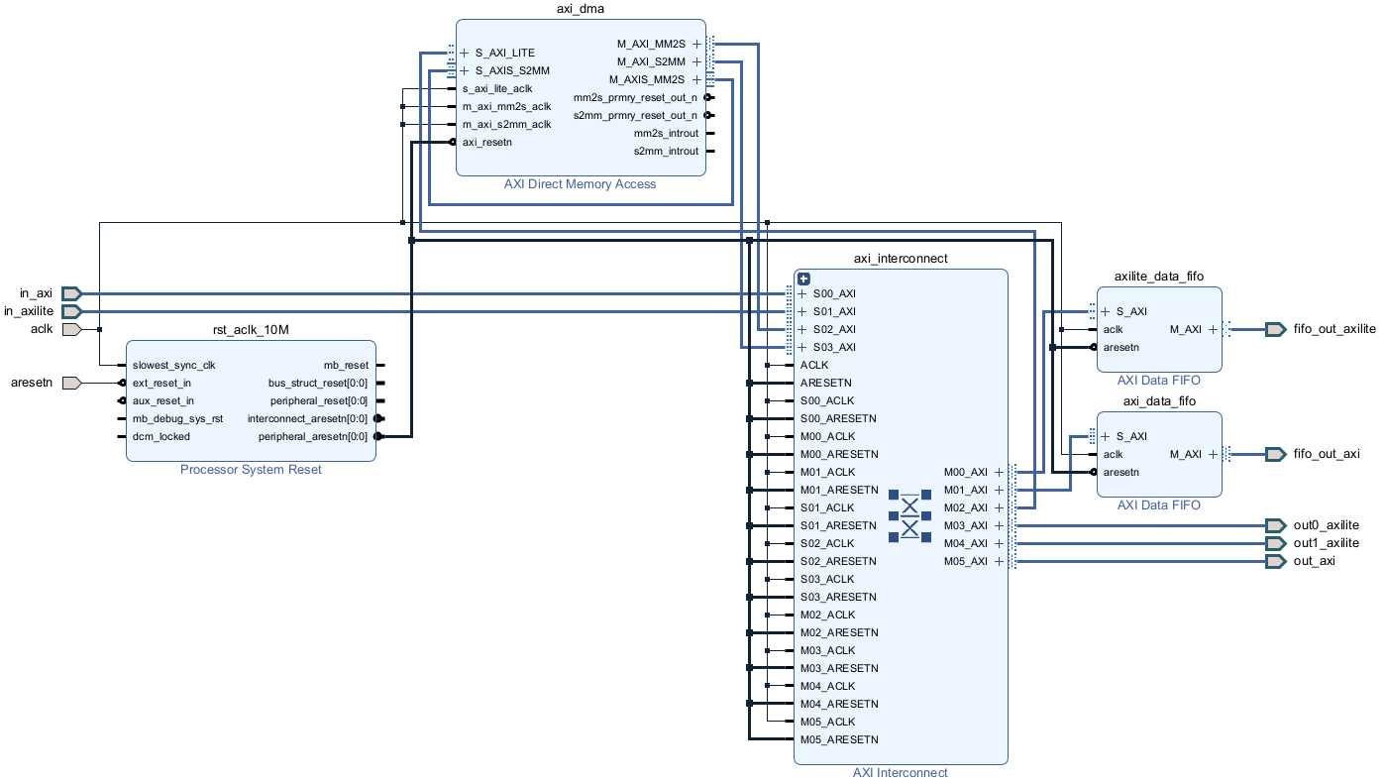
Figure 3 - Block diagram of the interconnect example's DUT
Can be found in examples/interconnect.
The TB (testbench) class for this DUT can be found in tb.py and the tests in tests/.
The dma_copy test is a quite simple test example that can be copied to create other tests. The inputs are all specified in the inputs/ directory as stimuli and data files. This tests uses a framework.AxiLiteMaster connected to the in_axilite interface to control the axi_dma. It makes the axi_dma copy the data from a framework.AxiLiteRam connected to the out0_axilite interface to a framework.AxiLiteRam connected to the out1_axilite interface. It then verifies the copy worked as expected by directly comparing the 2 memories (with no axi transactions, directly by accessing the memories in python).

Interconnect_stream example
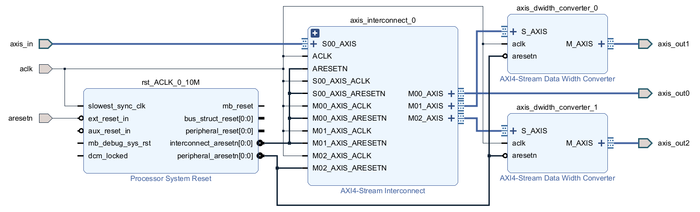
Figure 4 - Block diagram of the interconnect_stream(_tlast) example's DUT
Can be found in examples/interconnect_stream or examples/interconnect_stream_tlast.
The testbench class for this DUT can be found in tb.py and the tests in tests/.
The interconnect_stream and interconnect_stream_tlast examples have a very similar DUT and almost the same tests.
The difference is that the interconnect_stream DUT has no tlast and no tkeep signals on all axi stream buses while the interconnect_stream_tlast has those signals.
The Data Width Converters are present to test the change of bus size (axis_in and axis_out0 have a size of 32 bits, axis_out1 has a size of 16 bits and axis_out2 has a size of 8 bits).
The stimulis_inputs test is quite simple and can be copied to create other tests.
The unit_write_read test is an example of a test fully written in python (no stimuli or data file needed).

End of document

